Event

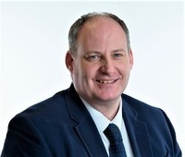

**Stephen Kelso**2 hours ago

Good Morning from CALA Group, we are keen to explore new innovative ways to reduce our carbon footprint, from both embodied and operational with a focus on building better more environmentally efficient homes. Looking forward to some innovating speakers and picking up on new ideas moving forward.

.

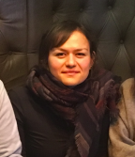

**Gozel Shakeri**2 hours ago

Good morning, I am researcher in Sustainable Food-Human-Computer Interaction at the University of Glasgow. Looking forward to making lots of new connections today!

.

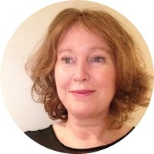

**Jo Green**2 hours ago

Hi. Jo Green, Chief Officer at SEPA here. What an agenda. fab speakers and what a great audience! Looking forward to this, Jo

.

**Catherine Preston**2 hours ago

Good morning everyone from the Scottish Environment Protection Agency, great to be here and looking forward to an exciting conference.

.



**John Bynorth**2 hours ago

Good morning from John @ Environmental Protection Scotland. Here's more about our organisation & forthcoming 'Better Places for Public Health' Zoom webinar on Nov 18th <https://www.ep-scotland.org.uk/events/>

.

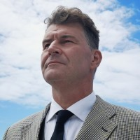

**Steven Ismail**2 hours ago

Good Morning from Stavanger, Norway SDI Energy is here to wish you a great day.

.

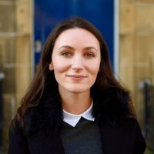

**Kate Chambers**2 hours ago

Morning all! Kate Chambers here from Resource Futures, working as part of our Circular Economy team in Scotland. I see a few familiar "faces" already and looking forward to catching up and hearing a lot of interesting speakers.

.



**Grant Reilly**2 hours ago

To learn more about the Digital Health & Care Innovation Centre (DHI) make sure you drop by our expo stand, we'd love to chat!

.

**Kirsty Webster**2 hours ago

Good Morning from Glasgow Airport. Looking forward to an interesting day and hopefully take information away that will help us on our journey to Net Zero.

.

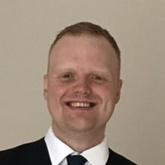

**Jamie Hutcheon**2 hours ago

Good Morning all from Robert Gordon University, looking forward to the day!

.



**Kevin Mackay**2 hours ago

Morning everyone from Rethink Food, based in Leeds but working across Scotland with primary schools on an educational programme in the build up to COP 26. Looking forward to making some new connections. Have a good day everyone. www.rethinkfood.co.uk

.

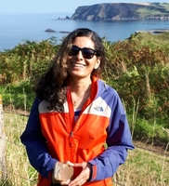

**Pantea Cameron**2 hours ago

Good morning. Looking forward to the event. Will recordings of the themed sessions be available after the event since one can only go to one themed session?

.

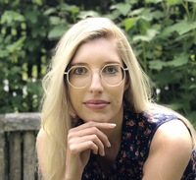

**Elena Höge**2 hours ago

Morning! I'm the founder of Yaldi Games and I'm working on an educational foraging game to increase interest in nature and inspire outdoor activities and analogue craft and play. After all, raising awareness of nature and getting people to care about their local surroundings can have great impact on their sustainability practices! Looking forward to the talks!

.

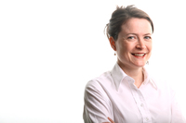

**Geraldine Boylan**2 hours ago

Greetings from Glasgow, Scotland - Geraldine Boylan from environmental consultancy Mabbett www.mabbett.eu here online and looking forward to lively debate in the sessions! Also looking for new impactful project opportunities, whether big or small!

.

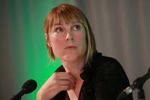

**Beate Kubitz**2 hours ago

Hello from sunny (!) Todmorden

.

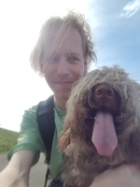

**Keith Baker**2 hours ago

Morning all :) I'm based at the Built Environment Asset Management (BEAM) Centre at Glasgow Caledonian University and also here on behalf of Common Weal's Energy Working Group (www.commonweal.scot) and my org, the Energy Poverty Research initiative (www.energypovertyresearch.org ). Currently looking for partners and funders to develop Scotland's first 'Danish model' district heating system, working with AES Solar. Please feel free to contact me about any of this :) keith.baker@gcu.ac.uk Keith

.

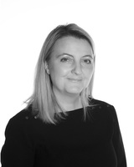

**Helen Maguire**2 hours ago

Good morning from Construction Scotland Innovation Centre. We're hosting theme 1 on the built environment from 1-3pm. Connect with our team and visit our exhibition area where you can access a virtual tour of our innovation factory. Hope you enjoy!

.



**Cameron Gordon**2 hours ago

Morning from The Data Lab! Looking forward to seeing you at our Energy Stage at 1pm

.

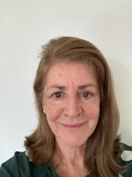

**Brenda Joyce**2 hours ago

Good morning from Construction Scotland Innovation Centre. I work as an Innovation Manager delivering exciting projects, I'm looking forward to the day.

.

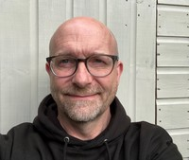

**Deryck Irving**2 hours ago

Morning all - Deryck Irving here from the Green Action Trust (<https://greenactiontrust.org/>) really looking forward to this morning's sessions

.

**Sarah Riddle**2 hours ago

Good morning all, I am the Director of Business Engagement at SAIC and looking forward to the event.

.



**Tyler C Lott**2 hours ago

Good morning everyone. BEFS Trustee and Scotland Officer for the SPAB here. I'm based in Edinburgh but work across Scotland. I'm here to connect and learn more about how we can utilise existing structures and data as a solution in our current climate crisis. Look forward to meeting y'all.

.



**Rachael Wakefield**2 hours ago

Good morning, I'm one of the CENSIS team, looking forward to today and catching up. Drop in to have a chat with us at our booth.

.

**Emma Lindsay**2 hours ago

Morning everyone from Aberdeen International Airport! Really looking forward to today and excited to learn from and share ideas with you all!

.

**Olivia Olivarius**2 hours ago

Good morning! I am a Behavioural Scientist with a passion for using behavioural science to steer people's behaviour towards more environmentally sustainable choices. Looking forward to making new connections today. <https://www.linkedin.com/in/oliviaolivarius/>

.

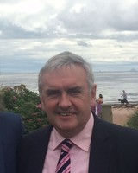

**Kenny Cameron**2 hours ago

We are Glasgow-based and specialise in smart-charging households with electric storage heating and hot water systems to free them from the shackles of 40 years of bad Economy 7 type charging tariffs - this improves comfort, alleviates fuel poverty and aligns charging with renewable energy. What an opportunity in Scotland with over 250,000 existing households that can benefit! Happy to talk to anyone who wants to know more - kennycameron@connectedresponse.co.uk

.



**Stephen Good**2 hours ago

Morning everyone. Great to see so many of you from across the world engaging around this event. Looking forward to an inspiring, provocative, challenging day then lots of purposeful action..! Have a great day & well done to colleagues in all the innovation centres and the team at The Herald for their hard work in pulling everything together to make this possible..🙏

.



**jennifer smart**2 hours ago

Jennifer Smart - Innovation Manager at the Construction Scotland Innovation Centre - Looking forward to today and delighted to see so many like minded people on here supporting the journey to net zero not only from a business point of view but also a personal one. We have one planet - working together we CAN make a difference!

.

**Chris Hanlon**2 hours ago

Hi, I'm a policy development volunteer inside the SNP. I made the initial proposals that led to the Citizens' Assembly of Scotland's Future and I serve on the party's Policy Development Committee and on Conference Committee. I'm currently seeking election to be the party's overall Policy Development Convener and am keen to hear what frustrations people have with the scale and pace of change coming out of the Scottish Government and what remedial action needs to be taken in that regard.

.



**Benedikte Ranum**2 hours ago

Good morning from Team SAIC! If you're interested in how we feed the planet in a sustainable way - and perhaps help solve some of the other climate-related challenges while we're at it - come to 'Sustainable Food from Land and Sea' on Stage 5 from 1pm!

.

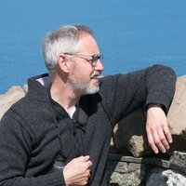

**Kevin Learmonth**2 hours ago

Hi from Shetland Islands. I'm one of the founder members of Sustainable Shetland. Interested in local based solutions that have the consent and involvement of communities.

.

**Severine Monvoisin**2 hours ago

Good morning! Severine Monvoisin here from Edinburgh College. Looking forwards to hearing from all the interesting speakers.

.

**Liza Moran**2 hours ago

Good morning, Liza Moran from Scottish Land and Estates. A membership organisation representing landowners across the whole of Scotland. My region is Clydeside and Argyll. Nice to meet you all.

.



**Steven Whyte**2 hours ago

Good morning all, looking forward to the day and hearing from some fantastic speakers. If anyone is interested in opportunities to collaborate with the PNDC please get in touch. Enjoy the day, Steven.

.

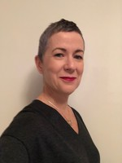

**Deborah Creamer**2 hours ago

Good Morning everyone. I am a Director at Optimat, a boutique consultancy specialising in the innovation life cycle and sustainability. Really looking forward to today's interesting and stimulating event.

.

**Angela Pllu**2 hours ago

Hello. I'm Angela Pllu, Environment and Sustainability Manager for Balfour Beatty. I work for the UKCS division, covering projects in Scotland and Ireland. Look forward to the day.

.

**Roland Chaplain**2 hours ago

Good morning everyone

.

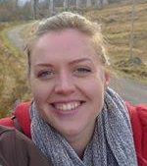

**Joanna Gosling**2 hours ago

Joanna here from ARCH-UK (Aquaculture Research Collaborative Hub for the UK) - very much looking forward to hearing about wider opportunities for collaboration across the agri-food sector.

.

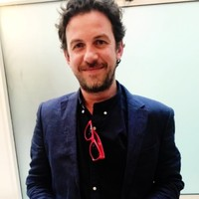

**Matthew Black**2 hours ago

Good Morning everyone. Matthew Black here from The Kensa Group. We deliver Shared Ground Loop Arrays and Fifth Generation Heat Networks to reduce carbon emissions and alleviate fuel poverty in housing (<https://www.kensacontracting.com/>).

.

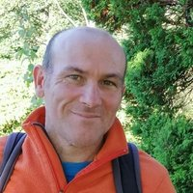

**David Payne**2 hours ago

Hello all- environmentalist of...oh some 40 yrs settting up own sustainability business. sustainbusiness.co.uk (soon online)

.

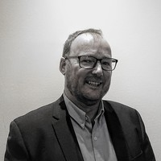

**Donald Bell**2 hours ago

Good morning from S82 Consulting in Glasgow - a SME delivering better infrastructure outcomes in Scotland and globally.

.

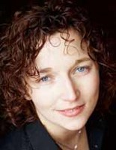

**Ruth Cochrane**2 hours ago

Morning from the School of Arts and Creative Industries at Edinburgh Napier University

.

**Martin Brown**2 hours ago

Good Morning from the Forest of Bowland, Lancashire. Sustainability Provoacteur with Fairsnape. I am looking forward to learning and sharing @ todays sessions, innovations and collaboration, particularly around regenerative solutions in the built environment.

.

**James Potter**2 hours ago

Good Morning and nice to e meet everyone. I'm a founding partner of Eureka!Europe. We teach a smarter and faster way to innovate. Looking forward to a day of learning and sharing

.

**Michael Cook**2 hours ago

Michael here from Community Resources Network Scotland, really looking forward to this event <https://www.crns.org.uk>

.



**Maureen Stevenson**2 hours ago

Good morning, intrigued to hear todays sessions and be involved in the discussions.

.

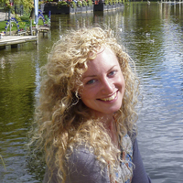

**Josephine Flood**2 hours ago

Good morning everyone. Looking forward to hearing about opportunities to collaborate within sustainable food and transport.

.

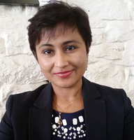

**Dr Poonam Malik**2 hours ago

good morning all. Welcome to the day where action begins

.

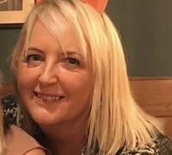

**Lynda Nicolson**2 hours ago

There are so many of us in the chat already, this is fantastic and so inspiring. Please don't worry if you don't get an immediate answer to your question - the Innovation Centres will receive a transcript of the chat so we'll be able to follow up after today. Lynda from CENSIS

.

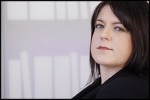

**Louise Macdonald**2 hours ago

Good morning everyone - Louise from the charity Young Scot here. So interested to learn from this event and of course we are particularly interested in how young people can be offered more opportunities to connect with innovation and how decision makers can make space for young people to share their own insight and expertise. Hope everyone has a great day.

.

**Steve Skill**2 hours ago

Madainn mhath madainn. Steve Skill here from Greenskill. We're an SME applying microalgae to carbon capture and wastewater treatment.

.

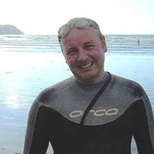

**Scot Mathieson**2 hours ago

A sunny good morning from Stirling, in the heart of Scotland. Working to promote biodiversity recovery through the Scottish EPA's One Planet Prosperity Strategy, and collaborating with Stirling Council and partners to tackle the twin crises of climate and biodiversity at the city region scale.

.

**Olivia Lassiere**2 hours ago

Hello, hello hello. This is great to be collaborating across the airwaves. As Environment Manager at Scottish Canals I am excited about hearing from so many experts today.

.

**Roland Chaplain**2 hours ago

I set up the "weather watchers network" with the help of BBC Radio Scotland in 1984. I'm now semi-retired but still very much involved in anything to do with tackling the climate and related emergencies. Particularly keen to see Scotland's renewable energy generation and future storage potential being a catalyst for re-populating rural areas and creating sustainable green jobs as near as possible wo where energy is generated.

.

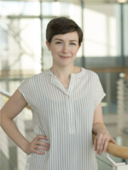

**Orla Kelly**2 hours ago

Good morning all! I'm Collaboration Manager for the University Innovation Fund (6 month secondment), supporting collaborative activities across Scottish universities and other partners. It's a great line up today, I'm excited to join in.

.

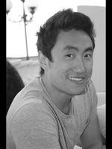

**Jonathan Lau**2 hours ago

Morning All!

.



**Ingrid Berkeley**2 hours ago

Good morning everyone. Ingrid here from Max Fordham's Scottish office! Looking forward to hearing some interesting talks & great to see so many like minded people here

.

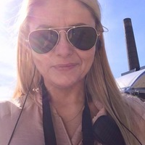

**Krista MacDonald**2 hours ago

Good morning from Cullen! We are a corrugate and moulded pulp manufacturers using a closed-loop system and specialising in eco-friendly packaging and with some very exciting projects about to be launched. A Glasgow company for nearly 100 years, we are excited and proud to have our city host COP26.

.

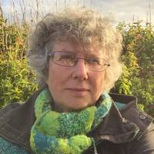

**Fiona Grahame**2 hours ago

Hello from Orkney. I am lead journalist with The Orkney News. We are community based online media. Looking forward to hearing the speakers and reporting on this conference

.

**Allan West**2 hours ago

Hi. Good morning from sunny Govan and H&K Glasgow. <http://www.hulley.co.uk/>

.

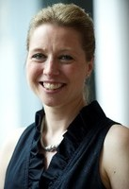

**Rebecca Ricketts**2 hours ago

Good morning from the Circular Glasgow team, an initiative of Glasgow Chamber of Commerce. We’re looking forward to understanding how COP26 and the adoption of the circular economy can create a long-lasting legacy for our cities and business communities.

.



**David Payne**2 hours ago

interested to hear about... population, fairer trade, re-wilding. My big 3 for change. Discussions...

.



**Kirsty Loughlin**2 hours ago

For any technical issues relating to this virtual conference and your remote experience we have a delegate support booth in the expo area.

.

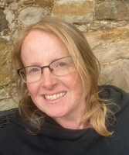

**Anne Henderson**2 hours ago

Good morning everyone, looking forward to some inspiring sessions today!

.

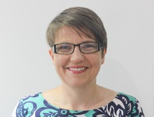

**Allison Strachan**2 hours ago

Hello everyone, I'm a PhD student at Strathclyde University, researching connection of low carbon technologies to residential electricity networks. Previously worked in the electricity & gas sectors for 15 years. Looking forward to getting involved and seeing how we can help Scotland meet its climate goals!

.



**Allan Cannon**2 hours ago

Hi all, I will be on stage 5 this afternoon discussing how digitisation can unlock sustainability in agriculture and aquaculture. check out more about us on our website <https://r3-iot.com/>

.

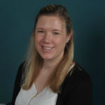

**Heather Rattray**2 hours ago

Hi everyone, looking forward to tuning in to todays sessions and speakers - great line up!

.

**Sue Paterson**2 hours ago

Good morning everyone - I'm very much looking forward to this great start to a year long effort towards COP26

.



**Daryl McKelvie-Whyte**2 hours ago

Good morning from Glasgow-based tech Startup, Vistalworks. We know that the impact of illicit trade directly impacts our current Net Zero ambitions. Having developed risk-scoring technology to help enforcement agencies detect and prevent online illicit trade, we are interested in the roles that innovation and collaboration plays in this area. Pop me a message if you'd like to hear more.

.

**Tony Fitzpatrick**2 hours ago

HI All.....Tony Fitzpatrick from the deep south....Dumfries!! Chair of the Stove Network and Director of TFS Consultancy.

.

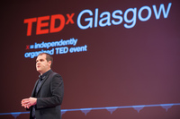

**Jamie Cooke**2 hours ago

Morning everyone, Jamie Cooke Head of RSA Scotland here. Huge congrats to Martin and the team for pulling this event together. For me, I'm particularly interested in circular economy ideas; Doughnut Economics and what that can offer; the role of cities; new social policies such as Basic Income; and Scotland's relationship with the rest of the world. Have a great day everyone!

.

**Douglas Maclachlan**2 hours ago

Hi everyone. We design and manufacture commercial catering equipment and are striving to deliver a connected kitchen which can assist in Health and Wellbeing, Sustainability and Food Waste. Looking forward to todays event.

.



**Rebecca Wade**2 hours ago

Good morning from Dundee. I am an Academic at Abertay university, passionate about people & planet focused solutions & training the next generation of civil and environmental engineers to hit-the-ground-running with sustainability knowledge and solutions!

.

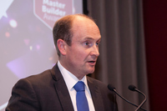

**Gordon Nelson**2 hours ago

Good morning everyone, I'm representing the Federation of Master Builders: our members are construction SME's. Looking forward to what promises to be a day full of insights and positive discussion.

.

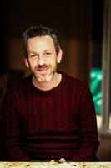

**William Clark**2 hours ago

Hi All...if anyone wants to see the report on unlocking Scotlands sustainability potential through the circular bioeconomy its available at <https://www.zerowastescotland.org.uk/sites/default/files/ZWS1508%20The%20Future%20of%20Food%20%5BProtein%5D%20FINAL.pdf>

.

**David Smith**2 hours ago

Morning. I've run out of coffee! :(

.



**Jonathan Lau**2 hours ago

#CountUsIn is a climate activism initiative focussing on 16 steps that we can all take to reduce our carbon footprint. I would love to network with anyone with ideas on how to promote it to more people.  <https://www.count-us-in.org/project/> :)

.

**Pauline Silverman**2 hours ago

I'm keen to hear thoughts on how we move to a decarbonised future whilst bringing communities and industries steeped in a high carbon past with us - fairly, justly and in collaboration. Working on theleven.org just now with SEPA and many other partners.

.

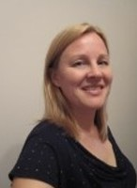

**Amanda Ingram**2 hours ago

Good morning from Zero Waste Scotland. I am the Bioeconomy Sector Manager within our Circular Economy team and am very much looking forward to hearing from speakers across the event especially with links to the Bioeconomy.

.

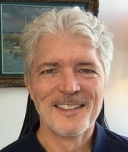

**Richard Harrison**2 hours ago

Good morning. Ensovi is developing a regenerative, cell-free biomanufacturing platform for producing fine and commodity chemicals from light, water and CO2. We are looking forward to bringing this technology to Scotland next year.

.

**Chris Hanlon**2 hours ago

Sorry David, that's horrible.

.



**Nasira Bradley**2 hours ago

Good morning from innovation & growth think-tank , looking forward to presentations and discussions adn hopign it will lead to connections which will drive the zero carbon agenda forward.

.

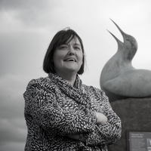

**Susan Davies**2 hours ago

Hi everyone, I'm CEO at the Scottish Seabird Centre in East Lothian. I am looking forward to hearing a diversity of perspectives today on addressing the climate challenge. Especially looking forward to contributions about the blue recovery given the importance of Scotland's coastal and marine environments to economy, nature and society. <https://www.seabird.org/>

.

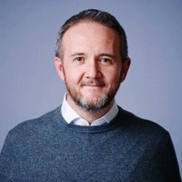

**David Howe**2 hours ago

Good morning from Microsoft. I'm here to listen and learn from the fabulous line-up we have today.

.

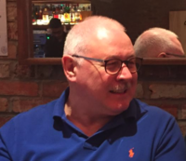

**Andy Hastings**2 hours ago

Morning All. Andy Hastings, freelance Data Centre consultant working in Nuclear and Defence. Interested in collaboration in the built environment and the utilisation of AI

.

**Clive Mitchell**2 hours ago

Hi! Clive Mitchell here from NatureScot - advising Scottish Government on climate-nature matters and working to a nature-rich future - look forward to working with you all through the day

.

**Neil McKie**2 hours ago

I've been looking forward to this conference for a while. So much opportunity to have focused minds collaborating on the big challenges. I'm the founder and CEO of Stance, a design & innovation company based in Glasgow. We help purposeful organisations sustainably innovate, change behaviour & identify new opportunities. We are particularly focused on low/no carbon mobility and help organisations accelerate their net-zero transition. Keen to speak to people working on or facing those challenges.

.



**Elaine Morrison**2 hours ago

Good morning from Scottish Enterprise. Excited by the opportunity for Scotland to show that we care about the health & wellbeing of our communities and have an eco-system that comes together to implement innovations that support a sustainable future.

.

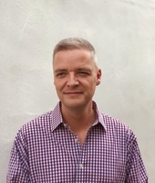

**Jonathan Bourke**2 hours ago

Good morning

.

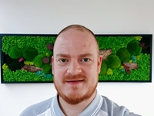

**Stephen McTaggart**2 hours ago

Hi – Stephen from The Herald. I hope you enjoy our event today! Would be great to connect with some of you around your plans for COP26, to tie in with our steering group and editorial coverage over the next 12 months. Feel free to message me at stephen.mctaggart@heraldandtimes.co.uk or connect with me on LinkedIn <https://www.linkedin.com/in/stephenmctaggart/>

.

**Rachel Helliwell**2 hours ago

Morning! I manage the Centre of Expertise for Waters (providing the evidence to support the development and implementation of water policy in Scotland). Interested to see how we can coordinate activities/strengthen networks in the run up to COP26 to make an impact on the world stage!!

.

**Kristin Hopfe**2 hours ago

Good morning everyone!

.

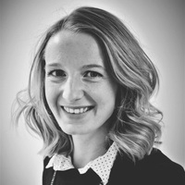

**Lucy Stanfield**2 hours ago

Good morning - I'm Lucy, Chair of 2050 Climate Group and circular economy analyst at University of Edinburgh. Looking forward to the event.

.



**Chaz Watson**2 hours ago

Hi everyone, I work for the Engineering Development Trust, a charity that works with industry mentors to provide pathways into STEM careers for young people. Looking forward to learning about Scotland's role in COP26, and exploring ways we could integrate the themes into our content.

.

**David Petrie**2 hours ago

Good morning all. Hope you all have a worthhwhile day.

.

**Katy Guthrie**2 hours ago

Wow - looks like a great agenda. Looking forward to today!

.



**Rebecca Wade**2 hours ago

Wonderful to see so many familar folks here - and so many new names too! Hello everyone!

.



**Scot Mathieson**2 hours ago

Does anyone know if there is a social media hashtag for today's event please?

.

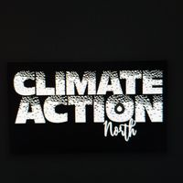

**Sharon Lashley**2 hours ago

Good Morning all, I am MD of Community Interest Company/Social Enterprise Climate Action North taking action in the climate emergency through our range of projects - we are sponsored by businesses through their corporate social responsibility/CSR funds - looking forward to this event, great speakers, agenda and exhibitors. Thanks!

.



**Polly Douglas**2 hours ago

Morning! Deep Branch and the REACT-FIRST team will be showcasing our project this afternoon on Stage 5, 2pm. <https://deepbranchbio.com/react-first/>

.



**Hazel Peat**2 hours ago

@Scot Mathieson it's #COPCountdown

.



**Kirsty Loughlin**2 hours ago

Head over to stage 1 as we begin Scotland's Countdown to COP26. #COPCountdown

.

**Alasdair Mackay**2 hours ago

Good Morning everyone

.



**Jeni Haggarty (IBioIC)**2 hours ago

Good morning all! I'm a Business Engagement Manager for the Industrial Biotechnology Innovation Centre (IBioIC). Looking forward to hearing some interesting talks on sustainability and the circular economy. Please feel free to come and chat to see how IBioIC can support your business

.

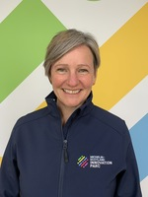

**Sarah Petrie**2 hours ago

Congratulations to the team for pulling together such a brilliant agenda. The importance of this whole area is demonstrated by the breadth of the audience that is participating today.

.

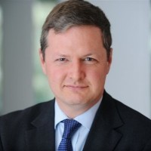

**Richard Cork**2 hours ago

Good morning everyone. I run the 'Sustainable and Innovative Construction' module on the Masters programme at UCEM. I'm always on the lookout for good case studies to highlight in my webinars.

.

**Polly Purvis**2 hours ago

Hi everyone, I work with IGS Scotland's worldclass vertical farming specialists. Looking forward to today's event

.

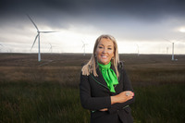

**Marie Macklin CBE**2 hours ago

Morning from HALO Urban Regeneration Co. Looking forward to listening and learning more from a great line up of International Speakers , putting Scotland ahead of the Net Zero challenge. Good Luck Chair Martin !

.

**John McLean**2 hours ago

Good morning folks, looks to be an exciting and interesting day

.

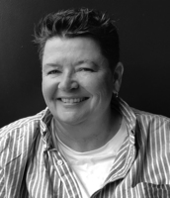

**Ed Synnott**2 hours ago

Hi everyone. Fantastic to 'be' here this morning!

.

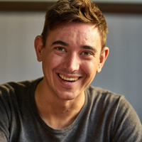

**Sam Turner**2 hours ago

Good morning, I'm sneaking in from South of the border on my canal boat in London. Looking forward to some great presentations and meeting wonderful people. I've just founded my company to help spread carbon literacy through the construction industry and research low impact and regenerative building.

.

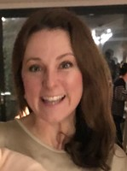

**Kirsty MacArthur**2 hours ago

Morning folks! What an excellent community here. MacArthur Green is a carbon negative environmental consultancy based in Glasgow. If you are looking at going carbon negative, check out our short film setting out how we made the change last year, and (for those who like more detail!) our website shares our Advice Note setting out how we became carbon negative. Enjoy today! <https://www.macarthurgreen.com/our-carbon-negative-business-model>

.

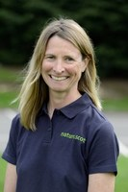

**Francesca Osowska**2 hours ago

Morning all, Francesca Osowska from NatureScot here. Looking forward to the day!

.



**Karen Peattie**2 hours ago

Good morning. Karen Peattie here, journalist covering the event for The Herald. Reach out at karen.peattie@heraldandtimes.co.uk

.



**Dr Poonam Malik**2 hours ago

Welcome Martin. Good to get it all kickstarted. Well done & thank you for pushing the COP agenda on USA Election Day. Hope 👍

.

**Laura Olarte Fernandez**2 hours ago

Good morning everyone ! Looking forward to the event.

.

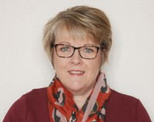

**Carol Sinclair**2 hours ago

Morning. Carol Sinclair, Associate Director in Public Health Scotland here. I'll be dipping in and out during the day so please message me if you want to chat.

.

**Graham Ross**2 hours ago

Austin-Smith:Lord delighted to be attending today's event. As a Glasgow based design practice we are leading a creative international team, appointed by Glasgow City Council, to develop Regeneration Frameworks for Glasgow City Centre. We are collaborating with communities exploring innovative ways to embed sustainable urbanism and climate adaptation in to our future vision and action plan. Get in touch, check out project websites and share your ideas! <https://yourcitycentre2020.commonplace.is/>

.

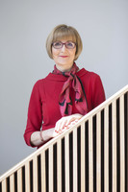

**Maggie Cusack**2 hours ago

Good morning everyone I’m Dean of Natural Sciences at the University of Stirling (<https://www.stir.ac.uk/people/257194>) and involved in Scotland’s international Environment Centre through City Region Deal (<https://www.stir.ac.uk/about/city-region-deal/>) Author of the ‘Stirling Protocol – Putting the environment at the heart of prosperity and social inclusion.’ (<http://doi.org/10.1016/j.scitotenv.2020.140079>). Well done to the organisers and especially Martin Valenti –going to be a great day!

.

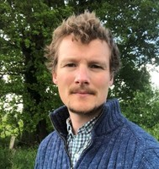

**Chris Leakey**2 hours ago

Good morning. Chris Leakey here, from People Ocean Planet: a new initiative from Scotland's marine science community... we want to underpin systemic change and innovation with behavioural, social and cultural change that can catalyse and help lock-in the big changes. www.peopleoceanplanet.com Twitter: @OceanBehaviours

.

**Ian Archer**2 hours ago

Morning folks, I'm the Technical Director of the Industrial Biotech Innovation Centre. Well done all on pulling together such a broad event. REally looking forward to seeing how all of our work interacts to address Climate Change

.

**Lucy Espeland**an hour ago

Morning All. Lucy here from DTA Scotland. Looking forward to hearing about how communities can be at the centre of climate action and the lead up to COP. Thanks for putting on such a fantastic event!

.

**Paul Dumble**an hour ago

Hello everyone. I am based near Melrose. My most recent tasks have been in reviewing recent AR6 Working Group drafts and the IPCC Special Paper on Climate Change and Land. Also a independant reviewer of the UNEP GEO6 Global Assessment, and the UNEP GCOII. Scotland needs to get its fingers out of North Sea fossil fuels and use its huge renewable potential to transition jobs as net exporter of renewable energy.

.

**David Denholm**an hour ago

Good morning all, I am here representing Glasgow's TallShip Glenlee. As a sailing cargo vessel, Glenlee is representative of much of what we are aiming for regarding Climate Change. Being very prominent in the host City of COP26 we would love to explore opportunities with everyone involved with COP26 to showcase Scotland, Glasgow, the Clyde and of course Glenlee.

.

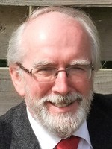

**John Lamond**an hour ago

Good morning. I'm chair of Jubilee Scotland, we have worked with Oxfam, SCIAF & SCCS to produce a report last week, Financing Climate Justice which urges that the developed world support the global south where the effects of global warming are literally life-threatening. I am here to learn how we in Scotland can reverse the trend which is destroying the planet.

.

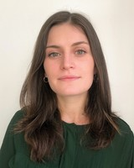

**Veni Kojouharova**an hour ago

Good morning, Veni Kojouharova from Scottish Cities Alliance here. Looking forward to the discussions today, very interesting programme.

.

**Rachel Moir**an hour ago

Hi. Will these sessions be available to view post event? I'd love some of our students to view as a starter for discussion.

.

**O'Neill David**an hour ago

Good Morning, I represent the 'clean emission' project that is based around using heritage, through the tall ship 'Falls of Clyde' to produce a Hydrogen powered ship offering clean cargo in Scotland, clean oceans, education at sea and start up opportunities.

.

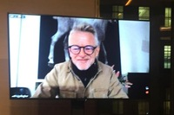

**KJ Gallagher**an hour ago

Hello, owner of well established private travel consultancy recently pivoted to exclsuively carbon negative projects. Looking to network / learn about nature based offset projects in Scotland and Scottish luxury tourism sustainability initiatives.

.

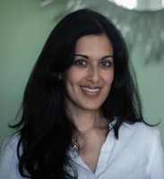

**Jillian Couto-Phoenix**an hour ago

Morning everyone, I am the founder of Couto Phoenix Consulting – a socially focused innovation consultancy with a mission to help individuals and organisations focused on science and technology drive positive social and environmental change by embedding practices that engage the public.

.

**L C**an hour ago

Greetings from Copenhagen. I am a Senior Trade Advisor at Scottish Development International. I offer expertise in helping Scottish companies do business with the Nordics. My focus is on circular economy and green transition. Looking forward to a great program today - thank you!

.

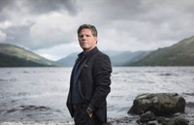

**Martin Valenti**an hour ago

Hi John Lamond climate justice critically important in these talks

.

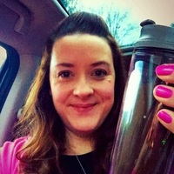

**Alison Loveday**an hour ago

Good morning everyone. I'm here representing Unlocking Ambition. We have just announced a brand new cohort of 40 exceptional entrepreneurs we will be working with over the next 6 months. UA is funded by S Govt and will invest 1.5m this year in entrepreneurs focused on scaling green energy, low carbon and enabling tech start-ups. Delighted to connect with anyone interested in the programme.

.

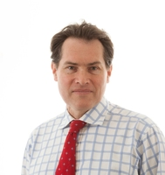

**Ran Boydell**an hour ago

Hello everyone, my name is Ran Boydell, I am an architectural and sustainable development consultant now based near Edinburgh, from Australia originally. My specific interest is delivering low carbon and sustainable homes in the mass market and would welcome a discusion with anyone in that supply chain, a homebuilder or affordable housing provider.

.



**Francesca Osowska**an hour ago

If you have questions for Kate which I can put to her at the end of the session, please type in the chat.

.



**Martin Valenti**an hour ago

Great to see you here Maggie Cusack

.

**Sam Hart**an hour ago

Morning Ran, hope you well and plans are progressing well....?

.

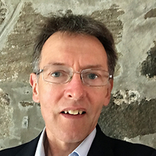

**Howard Perkins**an hour ago

Absolutely inspiring stuff from Kate Raworth !!

.

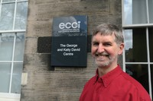

**David Somervell**an hour ago

How can we establish a multi-sectoral adaptation of City Portraits tool [ <https://kateraworth.com/2020/07/16/so-you-want-to-create-a-city-doughnut/> ] to bring all together locally within Scotland? Who is catalysing this? At Scottish Communities Climate Action Network (SCCAN) we have several local initiatives working on these ideas - Sustaining Dunbar, Aberdeen Climate Action, Transition Edinburgh, Greener Melrose and others - Can we work together to bring civil society actors to the table?

.



**Sophie Simpson**43 minutes ago

Hi, I represent the sustainability lead in Scotland for Cundall – our engineering consultancy represents the first in the world first to achieve Carbon Trust carbon neutral certification -<https://cundall.com/News/Cundall-achieves-world-first-carbon-neutral-certification.aspx>. Really looking forward to some interesting discussions today – and would be delighted to discuss what we can do to support buildings, developments and organisations achieve Net Zero Carbon.

.

**Jordan Mongan**42 minutes ago

Let Construction Scotland Innovation Centre hear your thoughts and engage with us in our conversation for COP26. Twitter: @CScotIC LinkedIn: @Construction Scotland Innovation Centre

.



**Martin Valenti**41 minutes ago

Hello Kirsty MacArthur great to see you here and participating in the most optimistic gathering in Scotland for decades

.

**Neil Johnson-Symington**37 minutes ago

I learnt last year about Jawbrew, a small Glasgow brewery which uses the waste from Aulds Bakers for their beer - perfect model of circular economy. Would love to see more of this happening and for companies to factor this into their everyday practices.

.

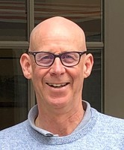

**Alastair Brown**37 minutes ago

Where will these presentations be available - please can the web address be released now ?

.



**Martin Valenti**33 minutes ago

This is the moment to re-build and transform for the benefit of the many -great shout out from Peter Lacy

.

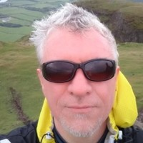

**Scott Restrick**29 minutes ago

Unfortunately not all State actors are working to positively impact on the Household/Commons domains <https://twitter.com/newscientist/status/1323582516041863168>

.

**Heather Jones**27 minutes ago

If you are interested in #sustainablefood then please join our panel of experts in protein production. Stage 5 starting at 1300.

.



**Martin Valenti**24 minutes ago

Scott that may be true but it mustn't stop driving forward for solutions. We cant fixate on the race to the bottom because doing good is good for business

.

**Olivia Olivarius**17 minutes ago

Hi. I am a behavioural scientist, looking to connect with business and policy makers that are looking to engage customers, clients and users in making more environmentally sustainable choices. Without understanding how people make decisions, in context, you will only engage a fraction of your population of interest. Please message me for a chat or contact me on LinkedIn <https://www.linkedin.com/in/oliviaolivarius/>

.



**Allan Cannon**15 minutes ago

Hi all, I will be on stage 5 this afternoon discussing how digitisation can unlock sustainability in agriculture and aquaculture. check out more about us on our website <https://r3-iot.com/>