Block elements:

Standalone elements who have their own area,

Eg:

May you <span id=”one”>be blessed</span>

Here span is an inline element so height and width can’t be applied.

But if:

#one{

Display: block;}

Is applied in css, then the span will have its own area thus any attribute can be placed.

Another approach is to use display: inline-block; which keeps the element in a single line while at the same time applying all possible attributes as a block element.

Same way a block can be converted to inline using display:inline;

Margin and Padding:

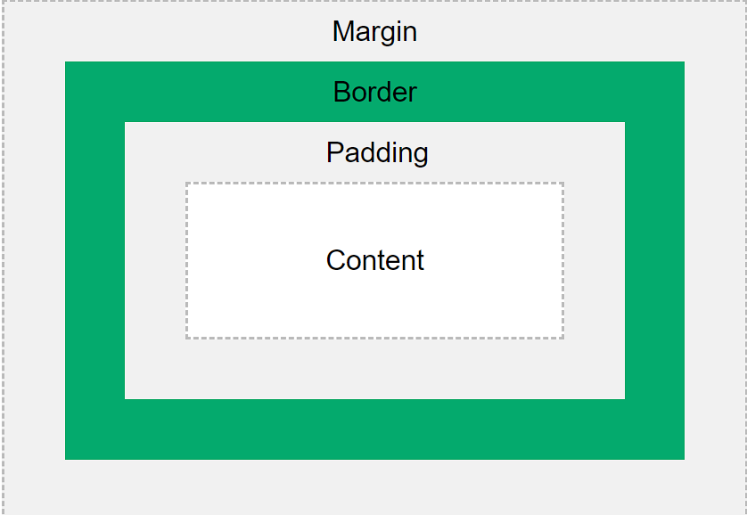

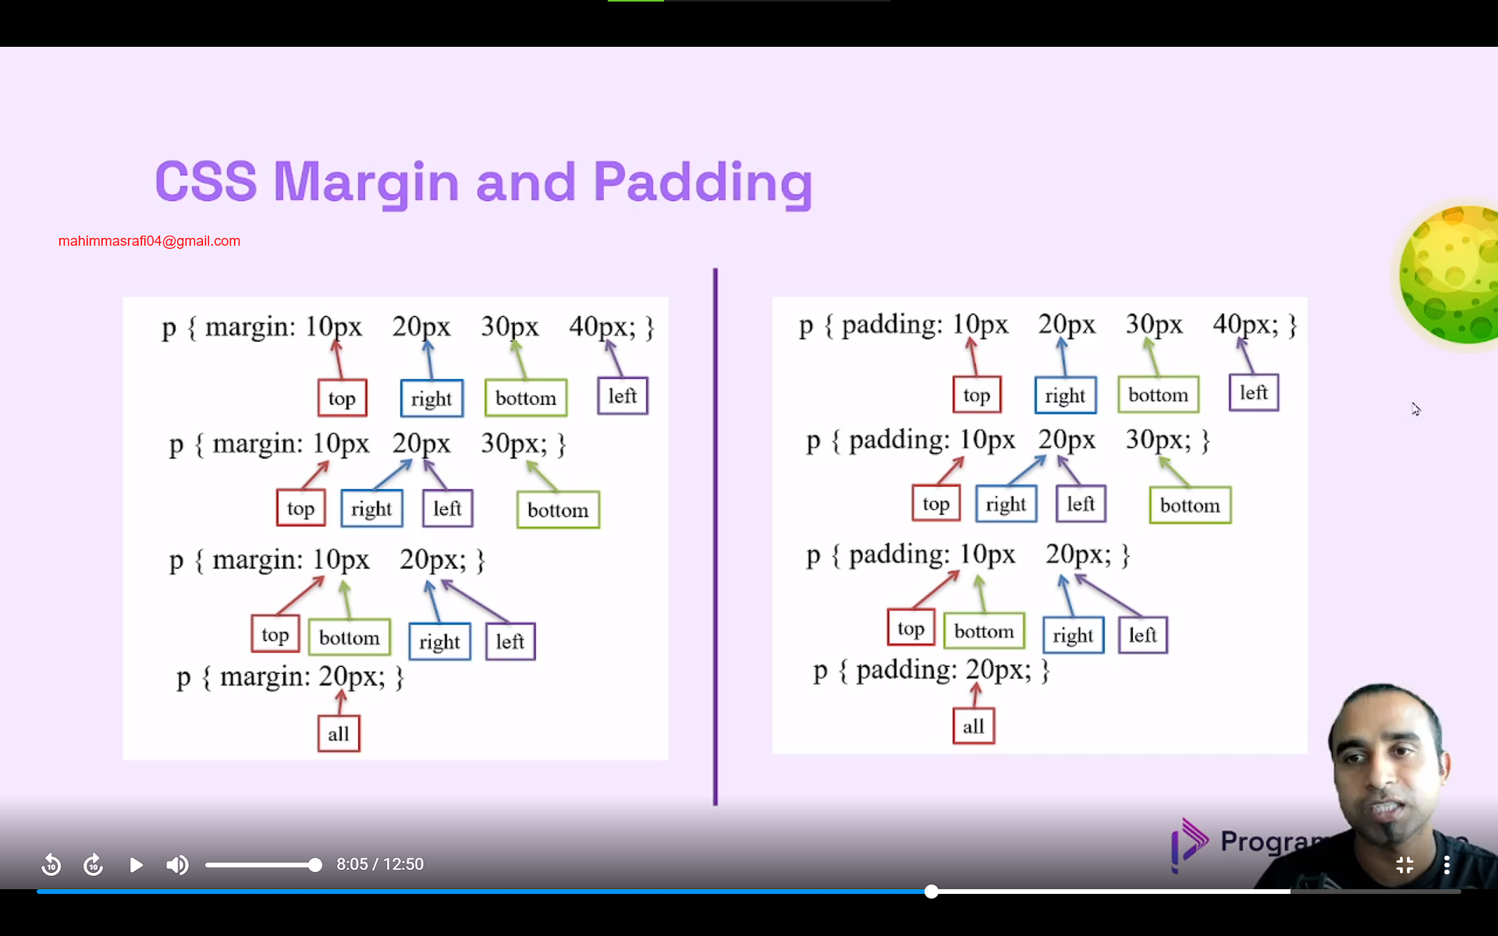

Width:

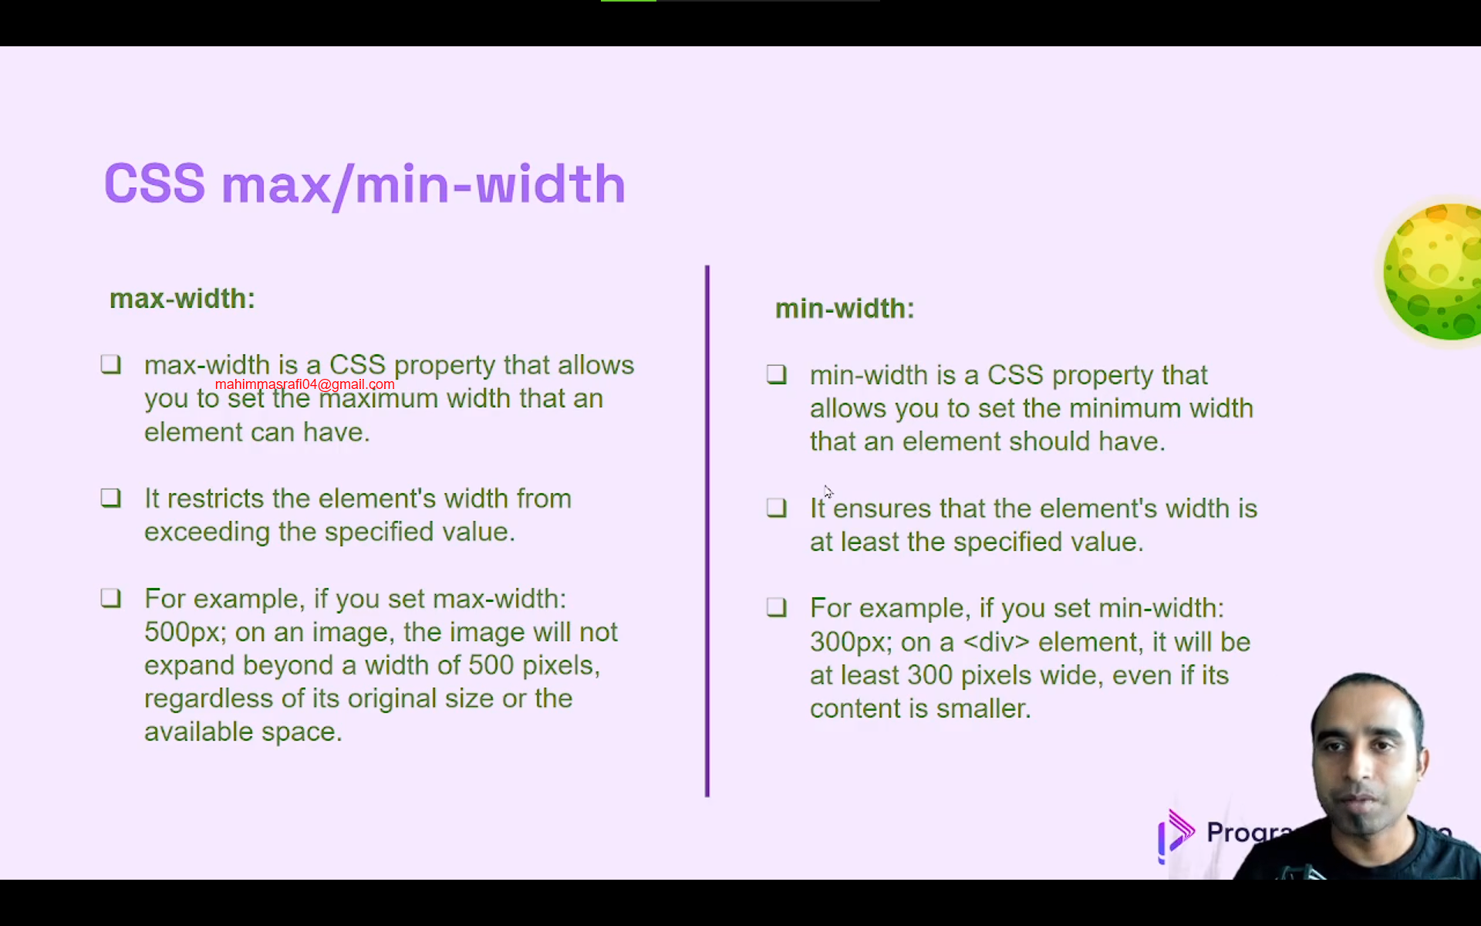

Border-radius:

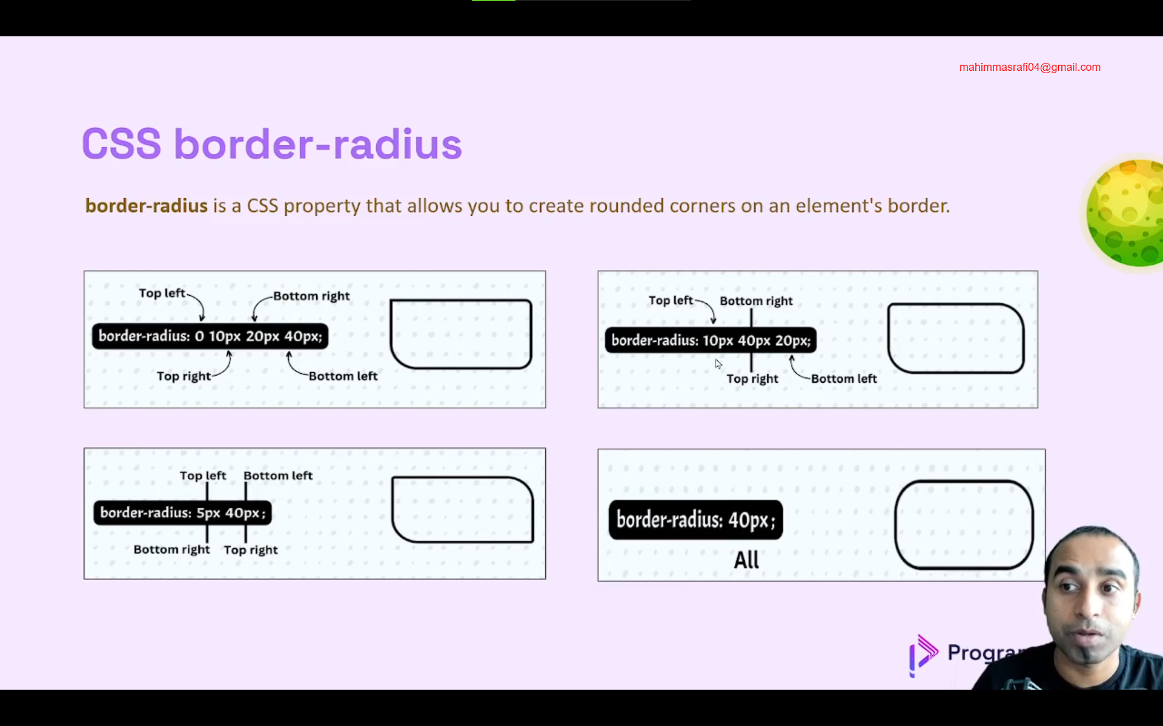

Box-shadow:

Box-shadow: x y z color;

Here x,y,z refers to pixels. X is the horizontal deviation, y is the vertical deviation and z is the fuzziness or the spread