Given 3 contestants and answers [correct/wrong] the result was

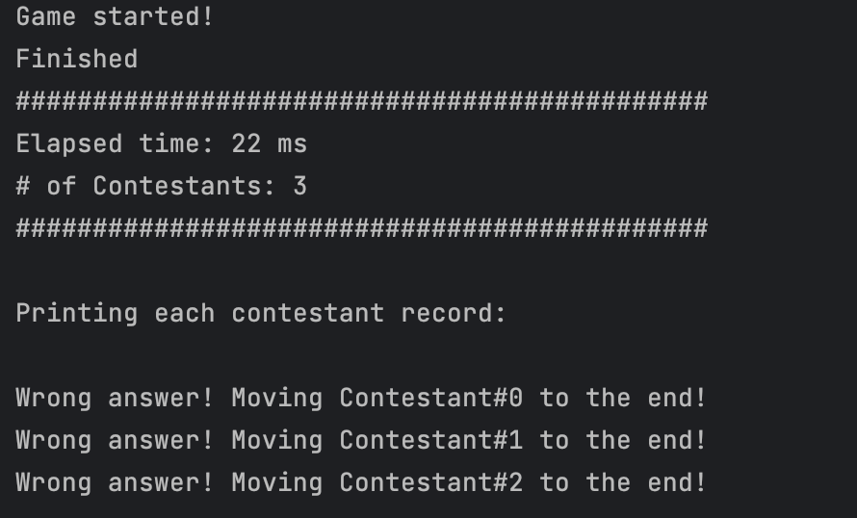

And it took 22 ms.

For 10 it took 22 ms

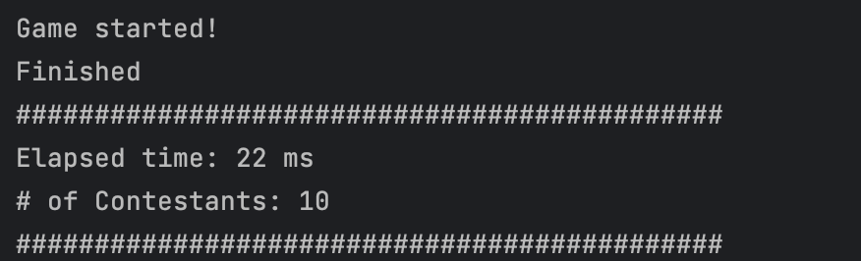

For 100 it took 21ms.

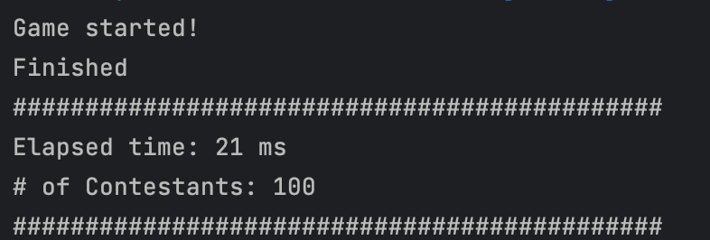

For 1000 it took 34 ms.

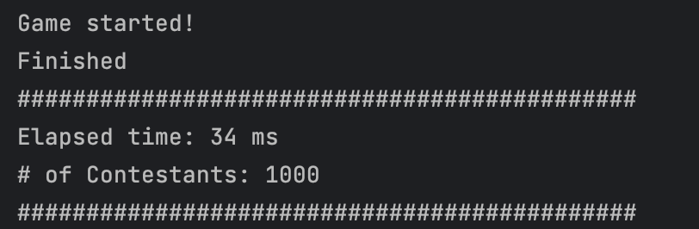

For 10000 it took 80 ms.

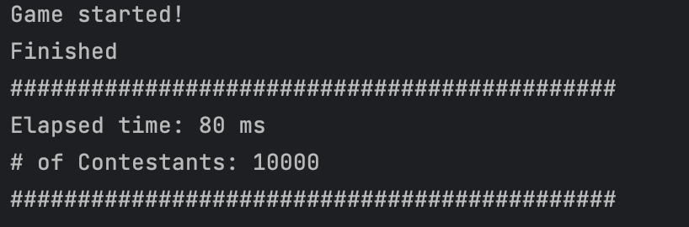

For 45000 it took 624 ms.

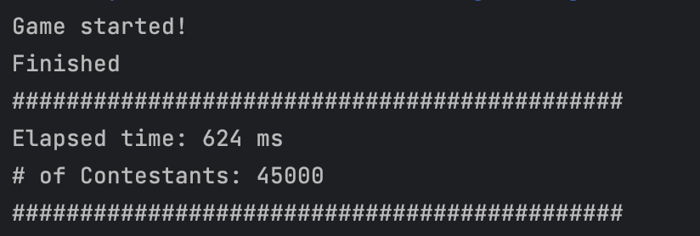

In a sentence or two, what did you learn?

I learned inheritance, extending existing class and adding more functionality to it.

In a sentence or two, what did you like about this project?

It took a lot of thinking on how to structure an object and print out the proper order of the contestants.

In a sentence or two, what did you find confusing or would like to see done differently regarding this project?

Nothing was confusing, but it was challenging to keep track of winning contestants and moving on to the next contestant was tricky.

In a sentence or two, if you had another hour or two, what would you like to add to the project or how would you do things differently?

If I had more time I would try to figure out the average position of contestant, I didn’t have much time left to work on it