

User Manual

By David Olesko - V1.2.13

Contents

1. Overview 2

2. The Database 2

3. Navigation 3

1. SearchBox 3

2. Data Management 4

Adding 4

a. Updating 4

b. Deleting 5

c. Importing/Exporting 5

3. User Management 5

4. Programme Management 5

5. Event Management 6

6. Requests 7

7. Calendar View 8

8. FAQ 9

# Overview

This manual will guide you through the process of managing TimeTables web software.

# The Database

Managing TimeTables will require basic knowledge of the relational database used within the system. Creating events depends on multiple tables within the database, i.e. each of the events must be connected to the module assigned to one of the programmes. Students are enrolled in programmes which can have a couple of modules per semester. Each module might have a few different recurring events during the semester.

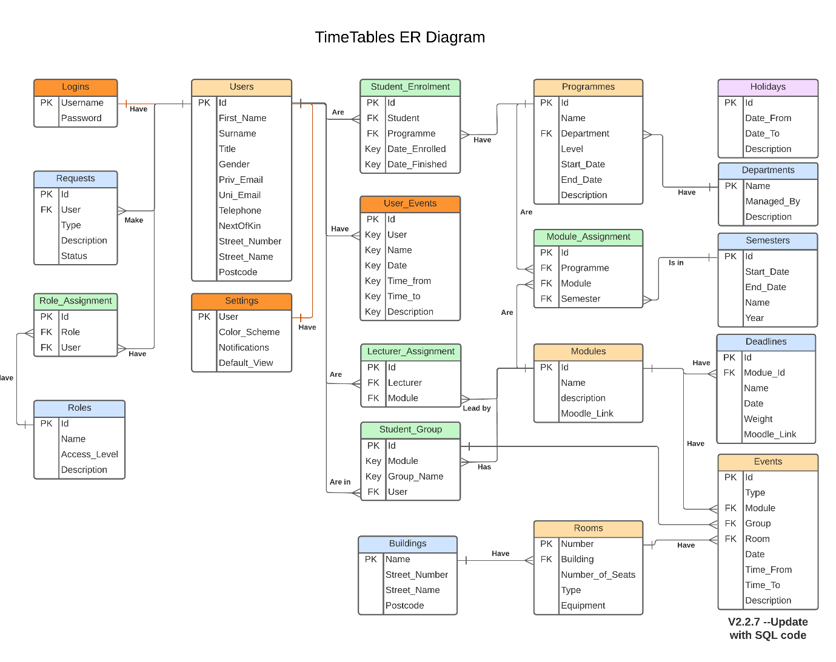

Figure 1: TimeTables database ER Diagram

# Navigation

Please use the navigation menu below the logo to navigate the portal (see Figure 2). Please use the Home button or the TimeTables logo to return to the main page. It might be helpful to try out the different pages to get yourself familiar with the content.

Figure 2: main navigation bar

# SearchBox

The SearchBox function allows you to quickly search through the database for required events, modules, modules, requests, or users. To use it, select the type of search needed on the left of the search bar (see Figure 3) and type searched phrase in the search bar. Data can be searched in any field, including dates and times.

To sort the results by room, name, or date, press the header of the results table. It can be pressed once to arrange in ascending order or twice in descending order.

The search box can fill form fields by simply clicking on required fields.

Figure : SearchBox section

# Data Management

Data within the database can be managed by adding, updating or deleting rows in the tables. Still, our user interface will make it a bit easier in many ways.

## Adding

To add an entry to the database, enter the data in specified text fields (see Figure 4) and press Add button at the bottom of the form section of the page (see Figure 5).

Figure 4: Form text fields

Figure : Form submit buttons

## Updating

To update the entry in the database, it has to be retrieved by the search box (see Figure 3). Any fields can be updated with the required information and applied by pressing the Update button.

## Deleting

To delete the entry from the database, retrieve it by the SearchBox and press the Delete button to remove it.

## Importing/Exporting

To import the updated data from the university database, please navigate to the Import Data tab and select the required type of import or export before selecting the file. Press load to display the file in the editor and confirm by pressing the Confirm button or cancel the operation by pressing the Cancel button. Only XML files are supported at the moment.

To export data, on any page containing the SearchBox, select the type of data to export and click the export button to download the prepared XML file.

# User Management

This section allows adding, updating or removing users from the TimeTables system. It can also reset the user’s password or set the user’s default settings in case of system failure.

# Programme Management

You can add, update or delete programmes within this section, and assign modules to them. To avoid mistakes, you can choose to automatically set the start and end date of the programme by selecting the required academic year (see Figure 6).

Figure 6: Academic year-selector

To assign modules to the selected programme, first select the programme from the SearchBox, search for the required module, and press it in the SearchBox to add to the list (see Figure 7). Please mind the semester selector at the top of the section. Make sure all semesters have modules assigned before saving changes. To delete the module from the list, click on it and save the changes.

Figure 7: Programme modules assignment section

# Event Management

To create the event, first, select the type of event. Session events refer to the recurring module-based sessions. In contrast, user events are private events visible only to specific users.

Figure 8: Event type selector

To avoid human error, the Start of Semester function was created. This allows to automatically set the beginning of recurring events to the first day of the semester they are assigned to. If this function is not setting the date, it has to be confirmed if the selected module is assigned to the programme.

Figure 9: Date section

To see rooms available. Enter the date and time of the event and press the refresh button.

Figure 10: Room Availability

To create recurring events, select the weekly option from the Recurring window. This will create a series of events recurring weekly, starting on a chosen start date and ending at the end of the semester.

Figure 11: recurring events option

# Requests

To complete, or delete the request select it from the SearchBox, add a comment and press the related button. The typed message will automatically be sent to the specified user by email.

Figure 12: Request management buttons

# Calendar View

To view the calendar of ant of the modules, programmes or rooms, search for it in the SerachBox and select it.

Figure 13: Searching for calendar

Figure 14: Calendar view

# FAQ

1. Can I export a search results list only instead of a full list?
   1. No, this function is not supported in this version.
2. Can I add modules while creating a programme?
   1. This functon is not supported in this version, see patch notes for more details.
3. Can I create a single events without recurring for modules?
   1. Yes, just select option Once from Recurring selector at events page
4. Can I create recurring user evets?
   1. This function is not supported yet.