|  |  |
| --- | --- |
| **Section** | **Group** |
|  |  |

**GEN 121 Learning and Problem Solving Skills**

**Week 11 Assignment: Problem Identification**

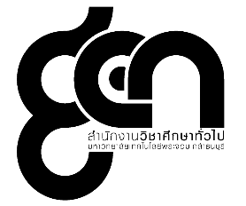

**๑๒๑**



**GEN 121 Learning and Problem Solving Skills : Learning Reflection**

**Week 11 Creative Problem Solving #2 : Consultation Memo 1**

1. What you have learnt today?

…………………………………………………………………………………………………………………………………………………………………………………………………………………………………………………………………………………………………………………………………………………………………………………………………………………………………………………………………………………………………………………………………………………………………………………………………………………………………………………………………………………………………………………………………………………………………………………………………………………………………………………………………………………………………………………………………………………………………………………………………………………………………………………………………………………………………………

2. The problem you found during the process of problem solving activity

…………………………………………………………………………………………………………………………………………………………………………………………………………………………………………………………………………………………………………………………………………………………………………………………………………………………………………………………………………………………………………………………………………………………………………………………………………………………………………………………………………………………………………………………………………………………………………………………………………………………………………………………………………………………………………………………………………………………………………………………………………………………………………………………………………………………………………

3. How did you solve the problems? If the problems were not solved, how can you possible solve it?

…………………………………………………………………………………………………………………………………………………………………………………………………………………………………………………………………………………………………………………………………………………………………………………………………………………………………………………………………………………………………………………………………………………………………………………………………………………………………………………………………………………………………………………………………………………………………………………………………………………………………………………………………………………………………………………………………………………………………………………………………………………………………………………………………………………………………………