DIGITAL DESIGN SAP VERILOG ASSIGNMENT REPORT
IMT2016129
Ananth Shreekumar
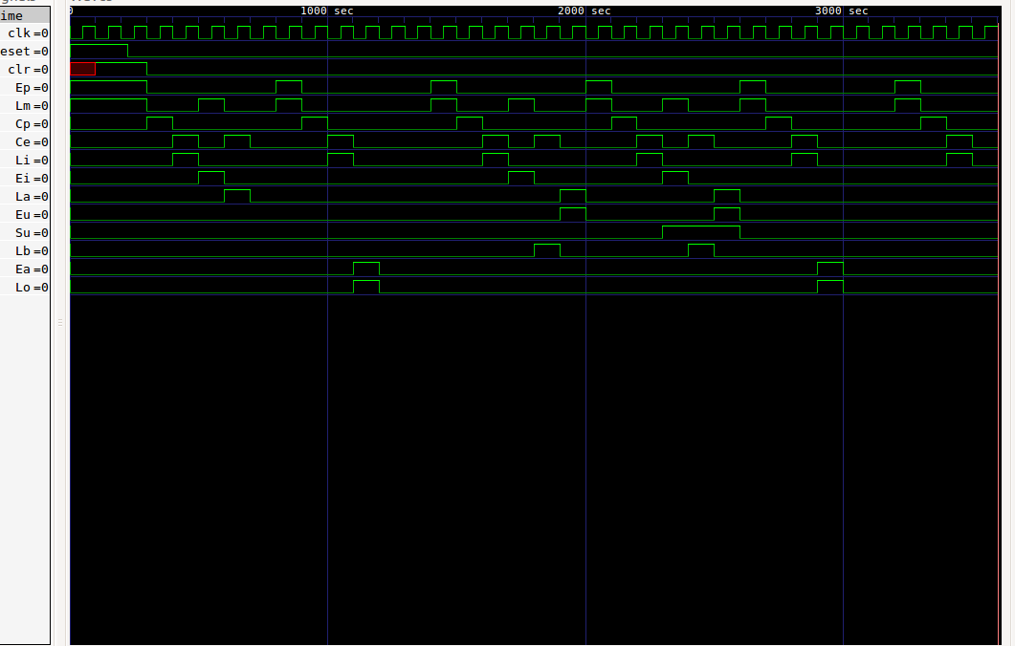

The above image shows the signals of SAP as a function of time. The reset is asynchronous. All signals

The below image shows the values held by all the registers – Program counter, MAR, RAM, Instruction register, Controller, Accumulator, Adder/Subractor, B register and Output register (IN THAT ORDER) as a function of time. All the values are in HEXADECIMAL.
Hence the final value 82 in hex is 130 in decimal.

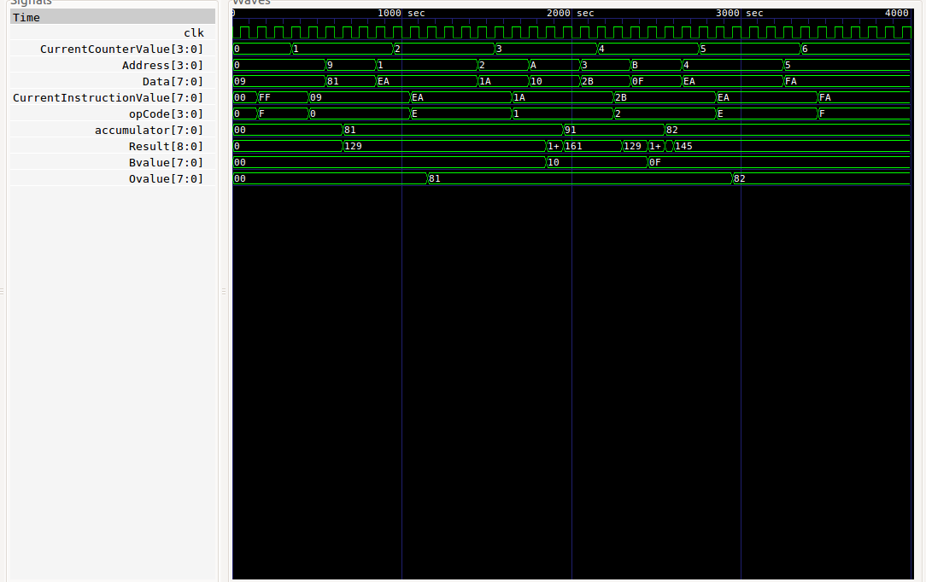

The below image shows the value of the Wire Bus as a fucntion of time.All values are in hexadecimal.

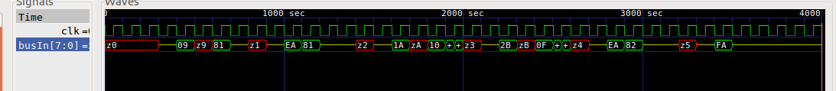

Output=0 occurs at the beginning just to indicate that the SAP is starting from scratch.
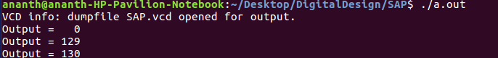
Output=129 occurs after loading 129 (my roll number). Then, ADD 16 and SUB 15 gives 130 which is displayed by Output=130.

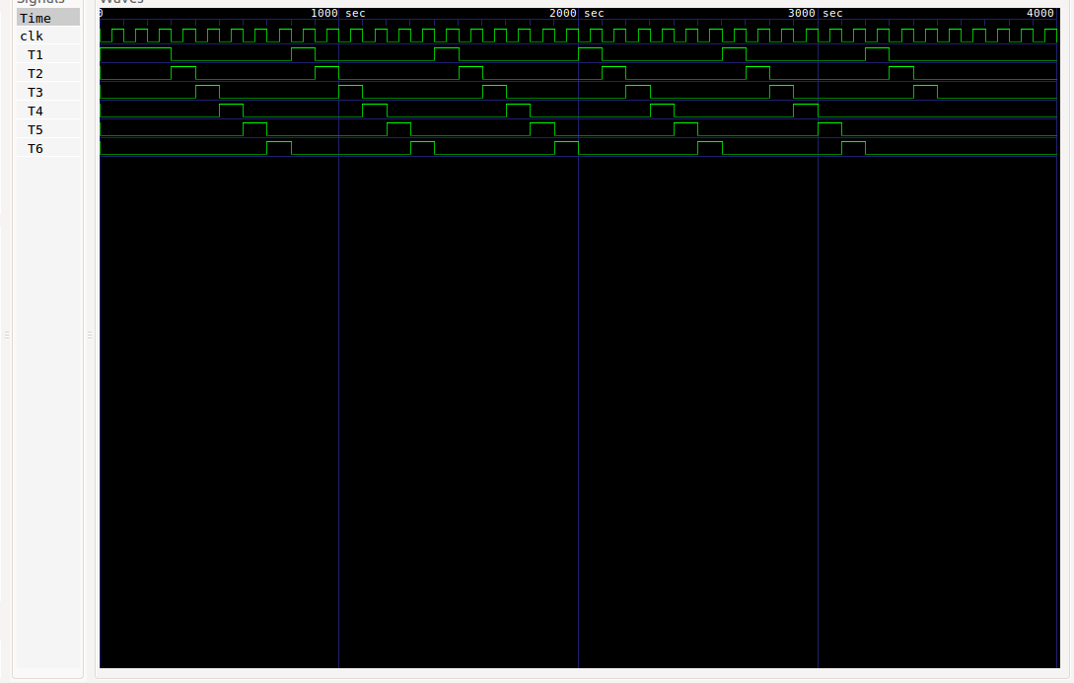
The below image shows the ring counter generated in Controller/Sequencer.
The last cycle does NOT have the 3 execute cycles because it is OUT instruction.

Source Code:

Program Counter

module ProgramCounter (
clk, // <i
clr, // <i
Ep, // <i
Cp, // <i
busOut // >o
);

input clk, clr, Ep, Cp;
output [3:0] busOut;

reg [3:0] CurrentCounterValue;

initial begin
CurrentCounterValue = 4'd0;
end

always @(posedge clk) begin
if (clr) begin // reset
CurrentCounterValue = 4'd0;
end
else begin
if (Cp) begin
CurrentCounterValue = CurrentCounterValue + 4'd1;
end
else begin
CurrentCounterValue = CurrentCounterValue;
end
end
end

// output
assign busOut = (Ep)? CurrentCounterValue : 4'bz;
endmodule

Memory Address Register

module MemoryAddressRegister (
clk, // <i
Lm, // <i
busIn, // <i
Address // >o
);

input clk, Lm;
input [3:0] busIn;
output [3:0] Address;

reg [3:0] Address;

initial begin
Address = 4'd0;
end

always @(posedge clk) begin
if (Lm) begin
Address = busIn;
end
else begin
Address = Address;
end
end

endmodule

RAM

module Ram (
Address, // <i
Ce, // <i
busOut // >0
);

input [3:0] Address;
input Ce;
output [7:0] busOut;

wire [7:0] Mem [0:15];

wire [7:0] Data;

assign busOut = (Ce)? Data : 8'bz;

assign Data = Mem[Address];

endmodule
Instruction Register

module InstructionRegister (
clk, // <i
clr, // <i
Ei, // <i
Li, // <i
busIn, // <i
busOut, // >o
opCode // >o
);

input clk, clr, Ei, Li;
input [7:0] busIn;
output [3:0] busOut;
output [3:0] opCode;

reg [7:0] CurrentInstructionValue;

initial begin
CurrentInstructionValue = 8'd0;
end

always @(posedge clk) begin
if (clr) begin // reset
CurrentInstructionValue = 8'hFF; // halt instruction by default
end
else begin
if (Li) begin
CurrentInstructionValue = busIn;
end
else begin
CurrentInstructionValue = CurrentInstructionValue;
end
end
end

// output
assign busOut = (Ei)? CurrentInstructionValue : 4'bz;
assign opCode = CurrentInstructionValue[7:4];
endmodule

Controller

module Controller (
opCode, // <i
reset, // <i
Ce, // >o
Cp, // >o
Ea, // >o
Ei, // >o
Ep, // >o
Eu, // >o
La, // >o
Lb, // >o
Li, // >o
Lm, // >o
Lo, // >o
Su, // >o
clk, // >o
clr // >o
// we // >o
);

input [3:0] opCode;
input reset;
output Ce;
output Cp;
output Ea;
output Ei;
output Ep;
output Eu;
output La;
output Lb;
output Li;
output Lm;
output Lo;
output Su;
output clk;
output clr;
//output we;

reg Ce;
reg Cp;
reg Ea;
reg Ei;
reg Ep;
reg Eu;
reg La;
reg Lb;
reg Li;
reg Lm;
reg Lo;
reg Su;
reg clr;
// reg we;

ClockGen clkgen0 (
.clk(clk)
);

reg [5:0] T;

initial begin
T = 6'd1;
end

always @(negedge clk) begin
clr = 0;
if (reset) begin
T = 6'd1;
clr = 1;
end
else if (T[2] && opCode == 4'hF) begin
T = 6'd0;
end
else if (T[5]) begin
T = 6'd1;
end
else begin
T = T << 1;
end
end

wire T1 = T[0];
wire T2 = T[1];
wire T3 = T[2];
wire T4 = T[3];
wire T5 = T[4];
wire T6 = T[5];

// T1 state
always @(T1) begin
Ep = 0;
Lm = 0;
if (T1) begin
Ep = 1;
Lm = 1;
end
end

// T2 state
always @(T2) begin
Cp = 0;
if (T2) begin
Cp = 1;
end
end

// T3 state
always @(T3) begin
Ce = 0;
Li = 0;
if (T3) begin
Ce = 1;
Li = 1;
end
end

// T4 state
always @(T4 or T5 or T6) begin
Ei = 0;
Lm = 0;
Ce = 0;
La = 0;
Lb = 0;
Su = 0;
Eu = 0;
Lo = 0;
Ea = 0;
// we = 0;

case (opCode)
4'h0:
if (T4) begin
Ei = 1;
Lm = 1;
end
else if (T5) begin
Ce = 1;
La = 1;
end
4'h1:
if (T4) begin
Ei = 1;
Lm = 1;
Su = 0;
end
else if (T5) begin
Ce = 1;
Lb = 1;
Su = 0;
end
else if (T6) begin
Eu = 1;
La = 1;
Su = 0;
end
4'h2:
if (T4) begin
Ei = 1;
Lm = 1;
Su = 1;
end
else if (T5) begin
Ce = 1;
Lb = 1;
Su = 1;
end
else if (T6) begin
Eu = 1;
La = 1;
Su = 1;
end
/*
4'h3:
if (T4) begin
Ei = 1;
Lm = 1;
end
else if (T5) begin
Ea = 1;
we = 1;
end
*/
4'hE:
if (T4) begin
Ea = 1;
Lo = 1;
end
endcase
end

endmodule

Accumulator

module Accumulator (
clk, // <i
Ea, // <i
La, // <i
busIn, // <i
Avalue, // >o
busOut // >o
);

input clk, Ea, La;
input [7:0] busIn;
output [7:0] busOut;
output [7:0] Avalue;

reg [7:0] accumulator;

initial begin
accumulator = 8'd0;
end

always @(posedge clk) begin
if (La) begin
accumulator = busIn;
end
else begin
accumulator = accumulator;
end
end

// output
assign busOut = (Ea)? accumulator : 8'bz;
assign Avalue = accumulator;
endmodule

Adder/Subtracter(ALU)

module AdderSubractor (
Eu, // <i
Su, // <i
Ain, // <i
Bin, // <i
Output // >o
);

input Eu, Su;
input [7:0] Ain;
input [7:0] Bin;
output [7:0] Output;

wire [8:0] Result;

// Arithmetic logic
assign Result = (Su)? Ain - Bin : Ain + Bin;

// output
assign Output = (Eu)? Result[7:0] : 8'bz;
endmodule

B Register

module Bregister (
clk, // <i
Lb, // <i
busIn, // <i
Bvalue // >o
);

input clk, Lb;
input [7:0] busIn;
output [7:0] Bvalue;

reg [7:0] Bvalue;

initial begin
Bvalue = 8'd0;
end

always @(posedge clk) begin
if (Lb) begin
Bvalue = busIn;
end
else begin
Bvalue = Bvalue;
end
end
endmodule
Output Register

module OutputRegister (
clk, // <i
Lo, // <i
busIn, // <i
Ovalue // >o
);

input clk, Lo;
input [7:0] busIn;
output [7:0] Ovalue;

reg [7:0] Ovalue;

initial begin
Ovalue = 8'd0;
end

always @(posedge clk) begin
if (Lo) begin
Ovalue = busIn;
end
else begin
Ovalue = Ovalue;
end
end
endmodule

Binary Display

module BinaryDisplay (
Ovalue // <i
);

input[7:0] Ovalue;

always @(*) begin
$display ("Output = %d", Ovalue);
end

endmodule

SAP This module binds together all other individual modules

`include "Accumulator.v"
`include "AdderSubtractor.v"
`include "BinaryDisplay.v"
`include "Bregister.v"
`include "ClockGen.v"
`include "Controller.v"
`include "InstructionRegister.v"
`include "MemoryAddressRegister.v"
`include "OutputRegister.v"
`include "ProgramCounter.v"
`include "Ram.v"

module SAP (
reset // <i
);

input reset;

wire [7:0] Wbus;
wire Ce, Cp, Ea, Ei, Ep, Eu, La, Lb, Li, Lm, Lo, Su, clk, clr;
wire [3:0] Address;
wire [3:0] opCode;
wire [7:0] Avalue;
wire [7:0] Bvalue;
wire [7:0] Ovalue;

// wire We; TODO use this to enhance the "SAP"

Accumulator A0(
.clk(clk), // <i
.Ea(Ea), // <i
.La(La), // <i
.busIn(Wbus), // <i
.Avalue(Avalue), // >o
.busOut(Wbus) // >o
);

AdderSubractor ALU0(
.Eu(Eu), // <i
.Su(Su), // <i
.Ain(Avalue), // <i
.Bin(Bvalue), // <i
.Output(Wbus) // >o
);

BinaryDisplay DISP0(
.Ovalue(Ovalue) // <i
);

Bregister B0(
.clk(clk), // <i
.Lb(Lb), // <i
.busIn(Wbus), // <i
.Bvalue(Bvalue) // >o
);

InstructionRegister IR0(
.clk(clk), // <i
.clr(clr), // <i
.Ei(Ei), // <i
.Li(Li), // <i
.busIn(Wbus), // <i
.busOut(Wbus[3:0]), // >o
.opCode(opCode) // >o
);

MemoryAddressRegister MAR0(
.clk(clk), // <i
.Lm(Lm), // <i
.busIn(Wbus[3:0]), // <i
.Address(Address) // >o
);

OutputRegister O_R0(
.clk(clk), // <i
.Lo(Lo), // <i
.busIn(Wbus), // <i
.Ovalue(Ovalue) // >o
);

ProgramCounter PC0(
.clk(clk), // <i
.clr(clr), // <i
.Ep(Ep), // <i
.Cp(Cp), // <i
.busOut(Wbus[3:0]) // >o
);

Ram RAM0(
//.clk(clk), // <i TODO use this to enhance the "SAP"
//.We(We), // <i TODO use this to enhance the "SAP"
//.busIn(Wbus), // <i TODO use this to enhance the "SAP"
.Address(Address), // <i
.Ce(Ce), // <i
.busOut(Wbus) // >0
);

Controller CONTROL0(
.opCode(opCode), // <i
.reset(reset), // <i
.Ce(Ce), // >o
.Cp(Cp), // >o
.Ea(Ea), // >o
.Ei(Ei), // >o
.Ep(Ep), // >o
.Eu(Eu), // >o
.La(La), // >o
.Lb(Lb), // >o
.Li(Li), // >o
.Lm(Lm), // >o
.Lo(Lo), // >o
.Su(Su), // >o
.clk(clk), // >o
.clr(clr) // >o
// .we(we) // >o
);

endmodule

Clock Generator

module ClockGen (
clk // >o
);

output clk;

reg clk;

initial begin
clk = 0;
forever begin
#50 clk = !clk;
end
end

endmodule

Test Bench

`include "SAP.v"

module tb();

reg reset;

SAP SAP0 (
.reset(reset)
);

initial begin
reset = 1;

// RAM data initializations
// PROGRAM MEMORY
force SAP0.RAM0.Mem[0] = {4'h0, 4'h9};
force SAP0.RAM0.Mem[1] = {4'hE, 4'hA};
force SAP0.RAM0.Mem[2] = {4'h1, 4'hA};
force SAP0.RAM0.Mem[3] = {4'h2, 4'hB};
force SAP0.RAM0.Mem[4] = {4'hE, 4'hA};
force SAP0.RAM0.Mem[5] = {4'hF, 4'hA};
force SAP0.RAM0.Mem[6] = {4'hA, 4'hA};
force SAP0.RAM0.Mem[7] = {4'hA, 4'hA};
force SAP0.RAM0.Mem[8] = {4'hA, 4'hA};

// DATA MEMORY
force SAP0.RAM0.Mem[9] = {8'd129};
force SAP0.RAM0.Mem[10] = {8'd16};
force SAP0.RAM0.Mem[11] = {8'd15};
force SAP0.RAM0.Mem[12] = {8'hAA};
force SAP0.RAM0.Mem[13] = {8'hAA};
force SAP0.RAM0.Mem[14] = {8'hAA};
force SAP0.RAM0.Mem[15] = {8'hAA};

#225

reset = 0;

#5000
$finish;

end

initial
begin
$dumpfile("SAP.vcd");
$dumpvars(0,SAP0);
end

endmodule
To run the program, create files for each module and type the command

iverilog tb.v

in the terminal to create an instance a.out.

The command

a.out

gives the output.

