**1. ER Diagram:**

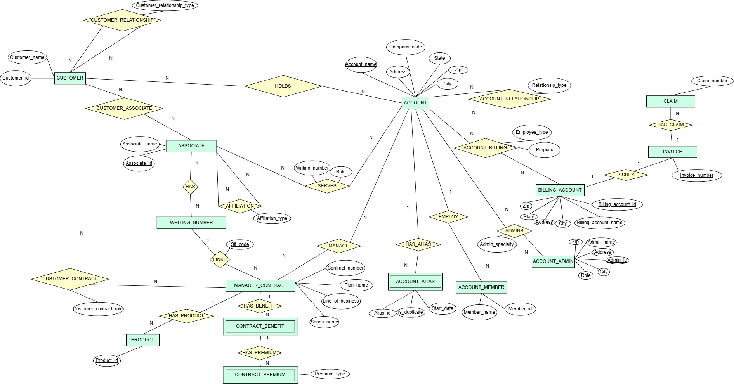

**2. Full Documentation**

**Entities and Primary Attributes**

The core entities in this ER diagram include Customer, Associate, Account, Writing_Number, Manager_Contract, Contract_Benefit, Contract_Premium, Account_Admin, Billing_Account, Account_Alias, and Account_Member.

Each entity has a unique primary key to ensure data integrity. For example, Customer_id is the primary key for Customer, while Account uses a composite key (Account_name, Address, Company_code).

The Manager_Contract entity, identified by Contract_number, represents insurance contracts managed by associates and linked to specific benefits and premiums. Similarly, Account_Admin and Billing_Account are linked to Account for administrative and billing purposes, identified by Admin_id and Billing_account_id, respectively.

The attributes within each entity capture essential information for business operations. For instance, Contract_Premium includes Premium_type (Commissions, Production Credit) to categorize premium payments. Account_Alias includes Is_duplicate, which flags duplicate entries, supporting account auditing and data integrity.

Additionally, Account_Member represents individuals affiliated with an account, connected via the Account_Member relationship, which tracks members or employees linked to specific accounts.

Invoice: Records information related to billing or customer transactions. Key attribute is Invoice_number (primary key). Each invoice is associated with a Billing_Account and may be linked to one or more claims, capturing transaction details and statuses.

Product: Represents various products or services offered by the enterprise. Key attribute is Product_id (primary key). Products can be associated with Contracts, indicating specific products included within each contract.

Claim: Records claim information for invoices. Key attribute is Claim_number (primary key). The Claim entity is linked to Invoice to track related claims.

**Key Relationships and Cardinalities**

Customer_Relationship defines connections between customers, allowing for relationships such as family or trust-based associations, using Customer_relationship_type to clarify the nature of each relationship.

Customer_Contract links Customer and Manager_Contract with a Customer_contract_role attribute, indicating roles like Policy Owner or Beneficiary. The Holds relationship between Customer and Account reflects customers’ ownership of multiple accounts.

Associates are integral to this model, connected to Account and Manager_Contract entities through several relationships. For instance, Serves connects Associate to Account with a Role attribute (e.g., Broker, Recruiter), defining their responsibilities.

Writing_Number links to Associate via Affiliation, establishing business affiliations based on geographic or departmental distinctions.

HAS links Associate to Writing_Number, supporting multiple writing numbers per associate.

**Contracts, Benefits, and Premiums**

The Manager_Contract entity is central to the insurance offerings, connected to specific benefits and premiums.

The HAS_BENEFIT relationship links Manager_Contract to Contract_Benefit, supporting one-to-many relationships to accommodate various benefit types within a contract.

Similarly, HAS_PREMIUM connects Contract_Benefit to Contract_Premium, allowing each benefit to have multiple premium types.

**Administrative and Billing Functions**

To manage accounts, the model incorporates Account_Admin and Billing_Account entities.

The Employ relationship connects Account_Admin with Account, capturing admin responsibilities with a Role attribute that specifies expertise, such as FSA administration.

Account_Billing links Account to Billing_Account entities, with attributes like Purpose and Employee_type to differentiate between billing accounts used for various purposes (e.g., Life Insurance, Health Insurance) or employee categories.

**3. Case Verifications:**

**3.1 Cases Supporting Account Design Decisions**

* **Account (n..n) BillingAccount**

The Account_Billing relationship links Account to Billing_Account, with attributes like Purpose and Employee_type. This structure supports multiple billing accounts for the same account based on different purposes (FSA, Life, A&H) or employee categories (salaried, hourly).

* **Account (n..n) Account**

The Account_Relationship relationship, with Relationship_type as an attribute, enables linking Account entities with various relationship types like GroupMaster and FlexMaster.

* **Account (n..n) AccountAdmin**

The Employ relationship between Account_Admin and Account, with the Admin_specialty attribute, allows each account to have multiple administrators with defined specialties.

* **Account (1..n) AccountMember**

The Account_Member relationship enables accounts to have multiple members.

* **AccountAlias**

The HAS_ALIAS relationship between Account and Account_Alias allows the storage of alternate names with the Is_duplicate attribute, supporting auditing and data cleansing.

* **Account (CompanyCode as part of the logical primary key)**

The inclusion of Company_code as part of the Account primary key differentiates otherwise identical accounts by region (e.g., Columbus vs. NY groups at the same address).

**3.2 Cases Supporting Associate Design Decisions**

* **Account (n..n) ManagerContract**

The Manage relationship connects Associate and Manager_Contract with Role attributes, allowing a single account to have multiple associates with different roles (Original Servicing, Assisting).

* **Associate (1..n) ManagerContract**

The Writing_Number entity links to Associate through HAS and Affiliation relationships, with Affiliation_type and Sit_code attributes capturing formal and informal arrangements.

* **Associate Commissions vs. Production Credit**

The Contract_Premium entity has a Premium_type attribute that distinguishes between commission and production credit accounting, capturing both forms of associate compensation.

* **Associate (n..n) Associate**

The Affiliation relationship with Affiliation_type attribute (Broker/ Recruiter) supports connections between associates, differentiating between Broker and Recruiter roles.

**3.3 Cases Supporting Contract Design Decisions**

* **Contract (1..n, 1..n) ContractPremium**

The HAS_BENEFIT and HAS_PREMIUM relationships link Manager_Contract to Contract_Benefit and then to Contract_Premium, respectively. This structure supports multiple benefits per contract and multiple premium options for each benefit.

* 1. **Cases Supporting Customer Design Decisions**
* **Customer (n..n) Customer**

The Customer_Relationship relationship links Customer entities with Customer_relationship_type, supporting family, beneficiary, and trust relationships.

* **Customer (n..n) Contract**

The Customer_Contract relationship between Customer and Manager_Contract includes the Customer_contract_role attribute, supporting various roles (Owner, Payer).

* **Customer (n..n) ContractBenefit**

The HAS_BENEFIT relationship links Manager_Contract to Contract_Benefit, allowing specific benefits to be assigned to individual family members.

* **Customer (n..n) Account**

The Account_Member relationship connects Customer to Account, supporting multiple affiliations and part-time arrangements.

* **Customer (n..n) Associate**

The Customer_Associate relationship between Customer and Associate supports the transfer of commissions to family members after an associate's death.