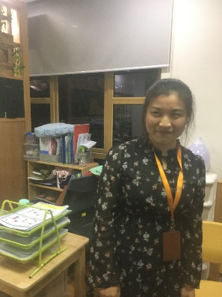

Name: Rachel（王虹/Wanghong）

Work at: WIS KG-B

Age: 26

Live in: Hangzhou

Tittle: English Teacher

Professional: Pre-school education

Graduated: Anhui Normal School

Tommy: What is the average salary for someone in this job?

Rachel: Sorry, this is a secret. I don’t want to say.

(I find the answer, it’s about 10,000 RMB per month)

Tommy: Do you have a lot of vacation?

Rachel: Yes sure. I have a lot of vacation.

Tommy: How do the kids behave?

Rachel: Some kids you know they can’t focus, So they will look other places when we have class. Some students obey the rules, very good. For those who can’t obey rules, we just let them timeout or something else.

Tommy: How much Chinese do you need to teach them?

Rachel: How much? Usually kids need to study more than 300 plus or more Chinese words.

Tommy: What do you do when kids are misbehaving?

Rachel: At first, we try to let them know it’s not their right way to do something and if they are not listening, then we will let them timeout

Tommy: Ok, how do you make kids happy in class?

Rachel: Kids are very easy to be happy. So sometimes when we have class, we just play some fun videos or some interesting cartooem.

Tommy: How do you feel about this job?

Rachel: It’s good. Not so much pressure maybe.

Tommy: How did you get to this job?

Rachel: I apply for my job online.

Tommy: Why you want this job? Or not.

Rachel: Why I need this job? Because my major is pre-school education, so I need to look work in kindergarten.

Tommy: How do you teach them to behave well?

Rachel: Every kids are special. Umm… Some of them are will know how to behave. For those who (are) who can’t behave themself , umm… You just give them some Umm… instructions

that they need to obey.

Tommy: What is the (?) you go?

Rachel: Sorry?

Tommy: What university did you go to?

Rachel: Anhui normal university.

Tommy: Ok, What’s your major?

Rachel: My major is per-school education.

Tommy: Umm. What’s your favorite part about your job?

Rachel: My favorite part. Umm… It’s umm… We can play with kids..

Tommy: Ok, do you think the salary is enough for your family?

Rachel: Of course not!

Tommy: Um, what will you do during vacation time?

Rachel: I will spend more time with my family, sometimes I will go abroad.

Tommy: What is the most challenging part of your job?

Rachel: We have too much activities in kindergarten.

Tommy: Did you get very good grades in university?

Rachel: I think so.

Tommy: What is the basic requirement for you to get his job?

Rachel: Uhh. I think maybe cause I had overseas working experience and my major was per-school education.

Tommy: Ok, Thank you.

Rachel: You’re welcome.