Nexora POS — Infrastructure Cost Breakdown
Annual hosting cost by platform (infrastructure only — excludes development/service fees)
Prepared: 24 August 2026
System flow — domain, server, and database
How a request travels across the three platforms below, end to end.
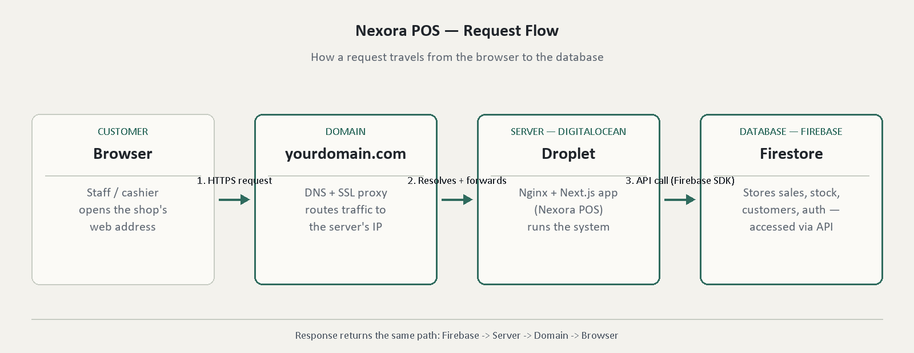

1. Domain — two registrar options
Option A - .com via Cloudflare Registrar
Detail | Value
Platform | Cloudflare Registrar
Product | .com domain registration
Requirements | None - pay and register instantly
Pricing model | At-cost (no markup), same price on renewal
Annual price | $9.77 / year
Option B - .lk via LK Domain Registry (or authorized reseller)
Detail | Value
Platform | LK Domain Registry (domains.lk) or a local reseller (e.g. LankaHost, SriLankaHost)
Product | .lk domain registration
Requirements | NIC (individual) or business registration number (company) submitted at signup
Pricing model | Fixed annual fee - varies by registrar
Annual price | $40.00 / year (typical mid-range; local resellers range approx. $27-$130/yr)

Note: Cloudflare Registrar does not support .lk (it requires the local-presence documents above, which Cloudflare does not process). Either way, the domain's DNS can still be pointed at Cloudflare's free DNS and SSL proxy after registration - the registrar and the DNS provider do not have to be the same company.
2. Server — DigitalOcean (low-budget plan)
Detail | Value
Platform | DigitalOcean (Droplet)
Plan | Basic Droplet - Regular, smallest usable tier
Specification | 1 shared vCPU / 1 GB RAM / 25 GB SSD, Ubuntu 22.04 LTS
Pricing model | Fixed monthly rate - $6.00/month
Annual price | $72.00 / year ($6 x 12 months)

Budget tier note: DigitalOcean's cheapest plan is $4/mo (512 MB RAM) but is too small to reliably build/run Next.js - not recommended. The $6/mo (1 GB RAM) plan works but building the app on-server may need a temporary swap file added, or the app can be built locally and only the finished build uploaded to the server, since running the app takes far less memory than building it. The $12/mo (2 GB RAM) plan avoids this workaround entirely and is the safer choice if the budget allows. Choice of domain (.com vs .lk) has no effect on this step.
3. Database — Firebase (Google, Blaze plan)
Detail | Value
Platform | Firebase (Google Cloud) - Blaze pay-as-you-go plan
Includes | Firestore database, Authentication, Cloud Storage
Free quota | 50,000 reads/day, 20,000 writes/day, 1 GiB storage, 10 GiB egress/month - no charge within this
Overage pricing | $0.06 / 100k reads, $0.18 / 100k writes, $0.18 / GiB stored
Pricing model | Pay-as-you-go - billed only for usage above free quota
Estimated annual price | $15.00 / year (estimate at current usage level)

Totals
TOTAL - .com domain + $6/mo server | $96.77 / year (LKR 32,418)

.lk domain + $6/mo server | $127.00 / year (LKR 42,545)

.com domain + $12/mo server | $168.77 / year (LKR 56,538)

.lk domain + $12/mo server | $199.00 / year (LKR 66,665)

Exchange rate used: 1 USD = 335 LKR (approx., 24 August 2026). LKR figures are indicative and will shift with the exchange rate.
Note: Figures above are raw platform costs only - domain registration, server hosting, and database usage. This total does not include development time, setup labor, ongoing maintenance, or support - those are a separate cost to be added on top when pricing the system for a customer.

