# Deep Learning - Lab 2- IT20636524

1. Upload the Backprop.ipynb to Jupyter notebook (or google colab) and see if you can understand the code. Increase the number of iterations (epochs) and see whether it improves the prediction accuracy.

Note: You may have to copy the image.png file to the home directory

No of Iterations = 150

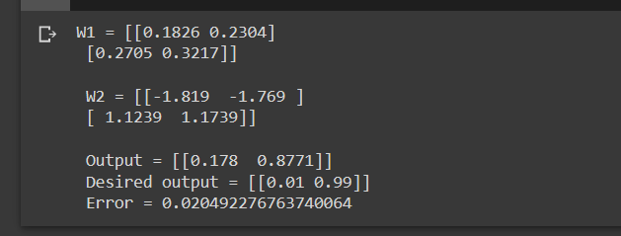

No of Iterations = 100

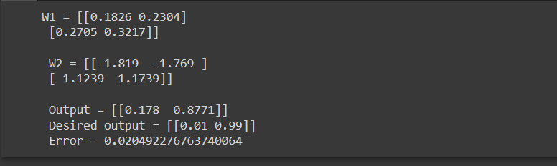

No of Iterations = 500

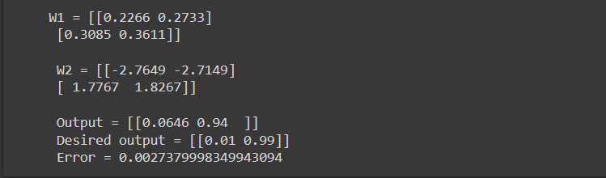

No of Iterations = 5000

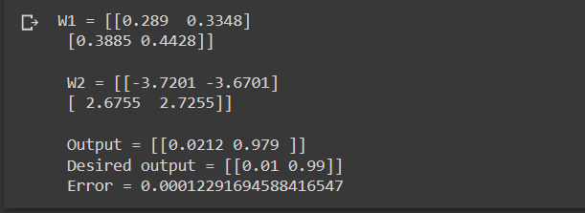

* **When we are increasing the number of iterations the output getting closed to desired output and the error getting decreased.**

1. Upload the NN_sample.ipynb to Jupyter notebook (or google colab) and see if you can understand the code. Add the following text cell and the code cell to the notebook and run it again.
   1. 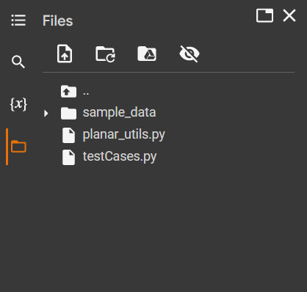What happens when the number of hidden nodes increase?

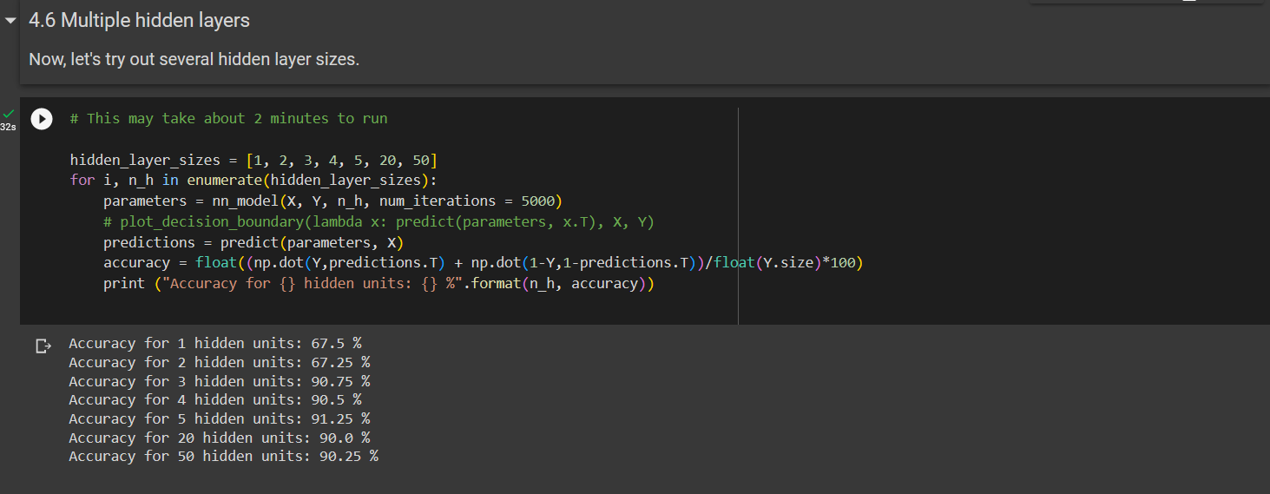

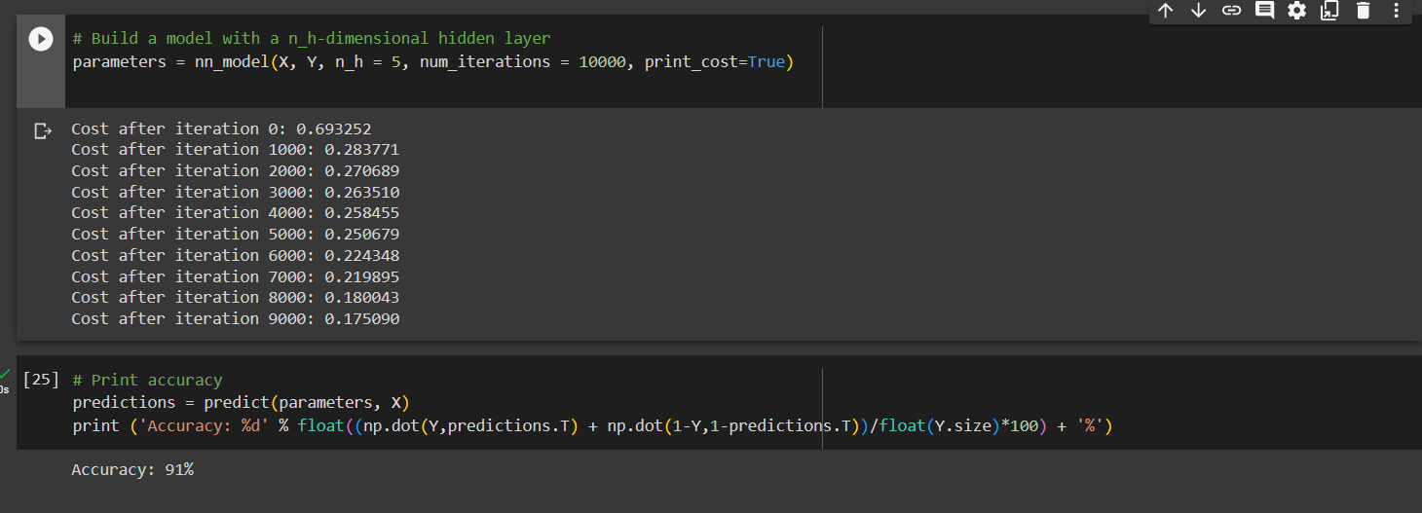

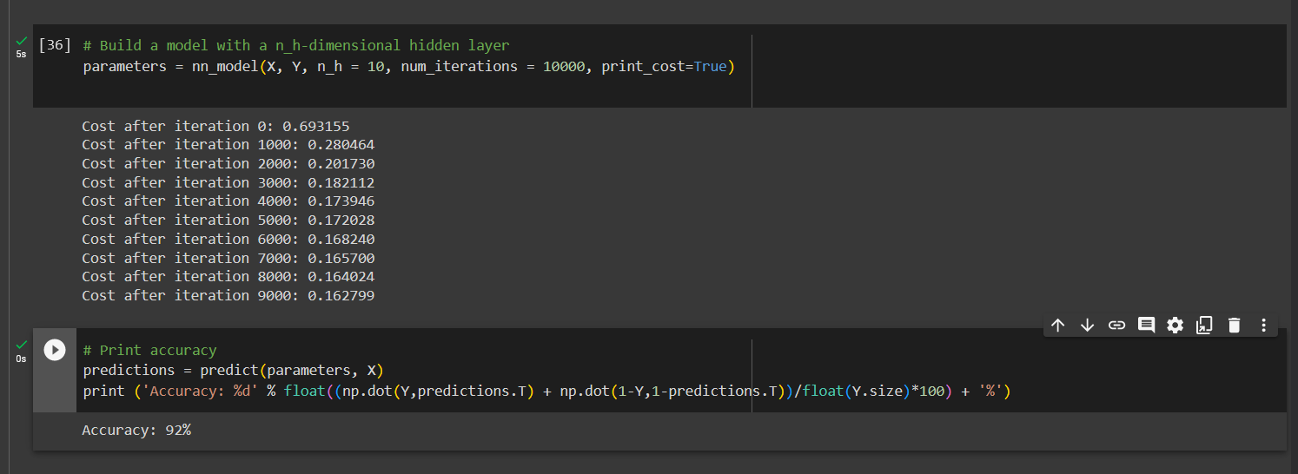

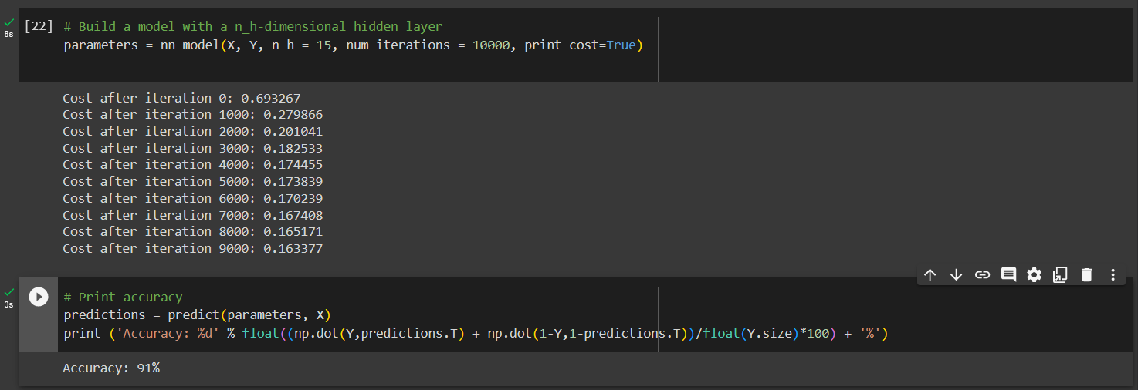

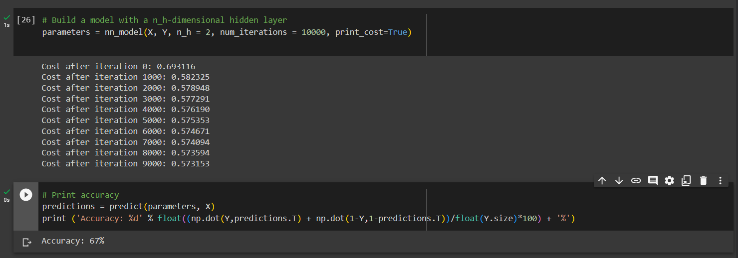

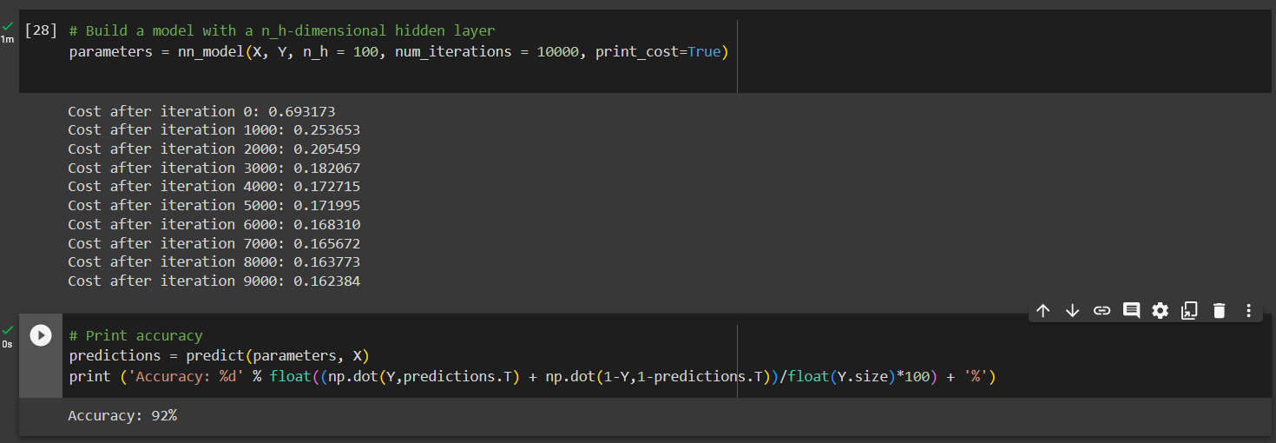

* 1. Can you explain the pattern of the accuracy when the hidden nodes increase?

Note: Copy the planar_utils.py and testCases.py files to the home directory.

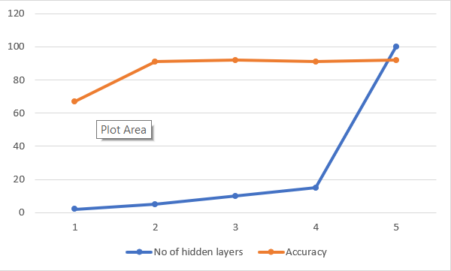

* **Based on the values that got when changing the number of hidden layers(n_h) is showing in above diagram.**
* **So, we can conclude that when number of hidden layers getting decreased like 2 the accuracy is less value like 67%. But when increasing number of hidden layers(n_h) is gradually increasing like 5,10,15 we can see a high accuracy rate like 91%, 92%. Then we increasing number hidden layers to values like 100 it is not showing a much effect on accuracy still 92%**

1. Run the MLP_with_MNIST_dataset.ipynb using Jupiter notebook (or google colab) and see if you can understand the code.
   1. Improve the test accuracy of the model by changing the hyperparameters.

* **Changing epoch size**

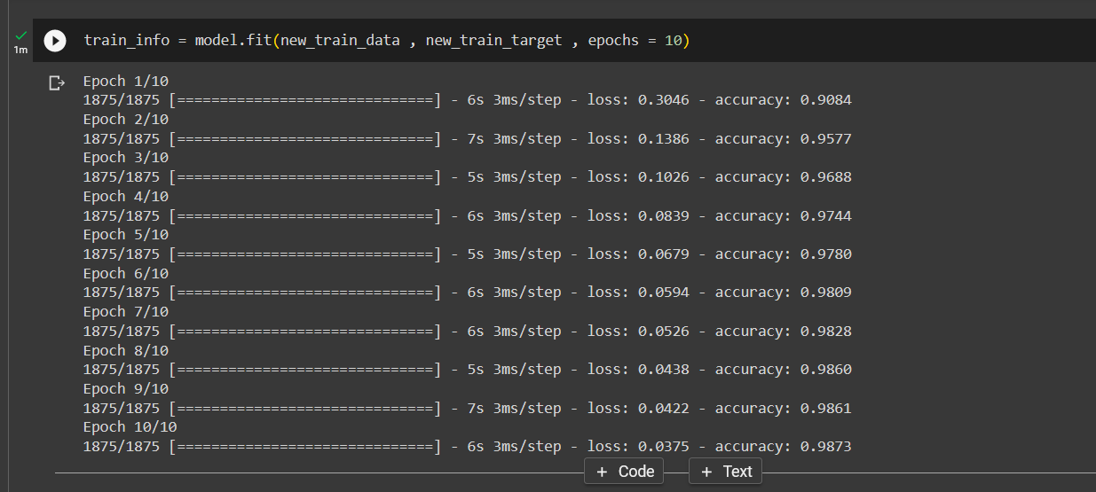

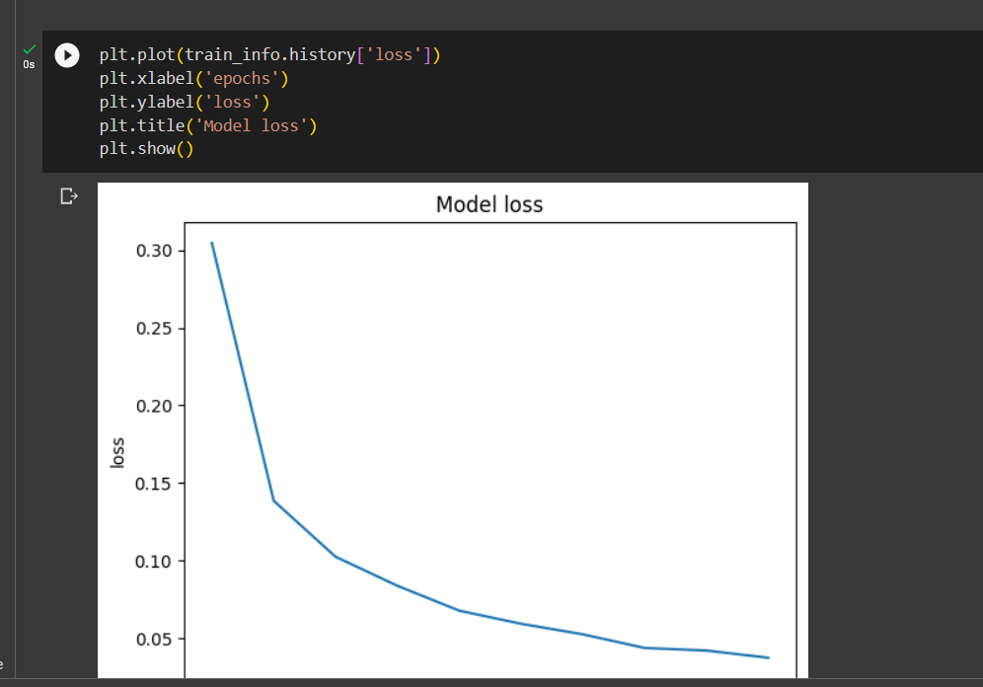

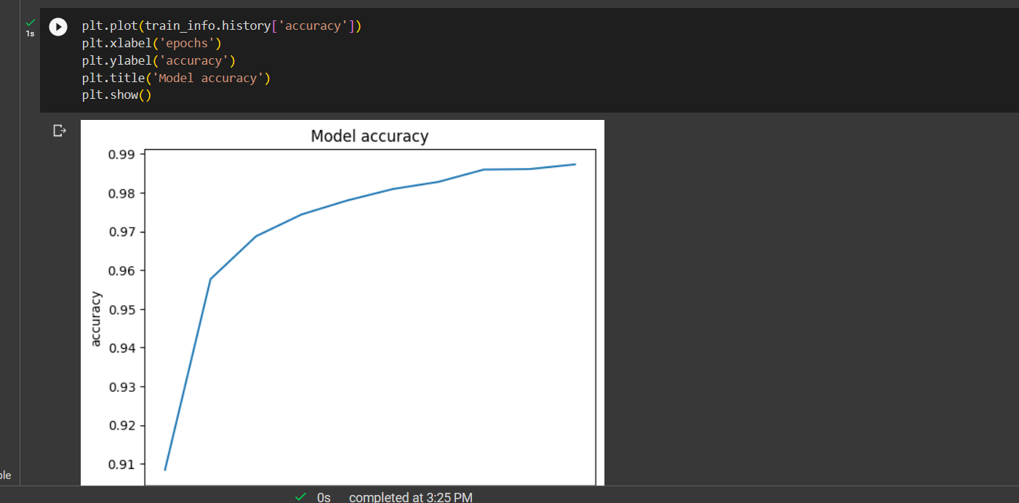

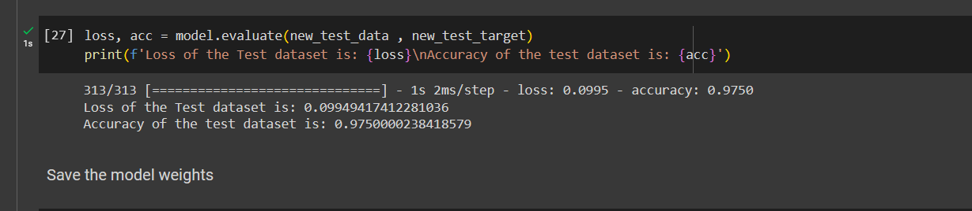

**No of Epochs = 7**

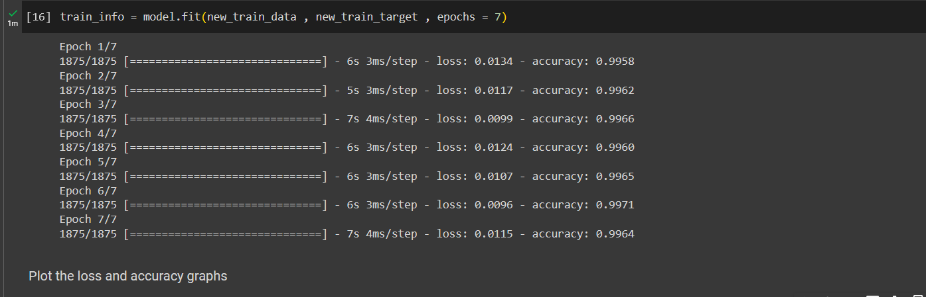

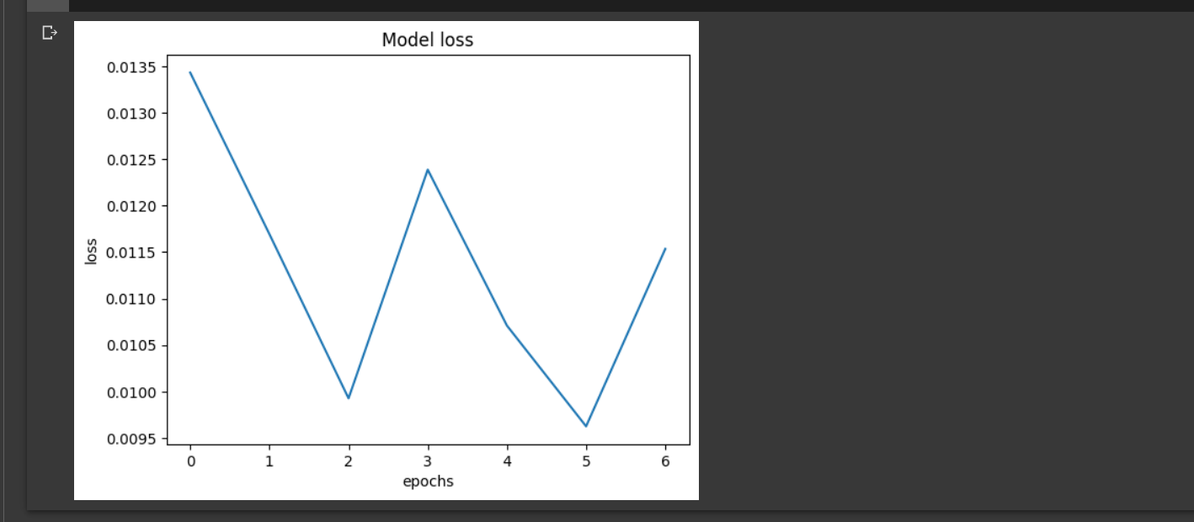

**No of Epochs = 11**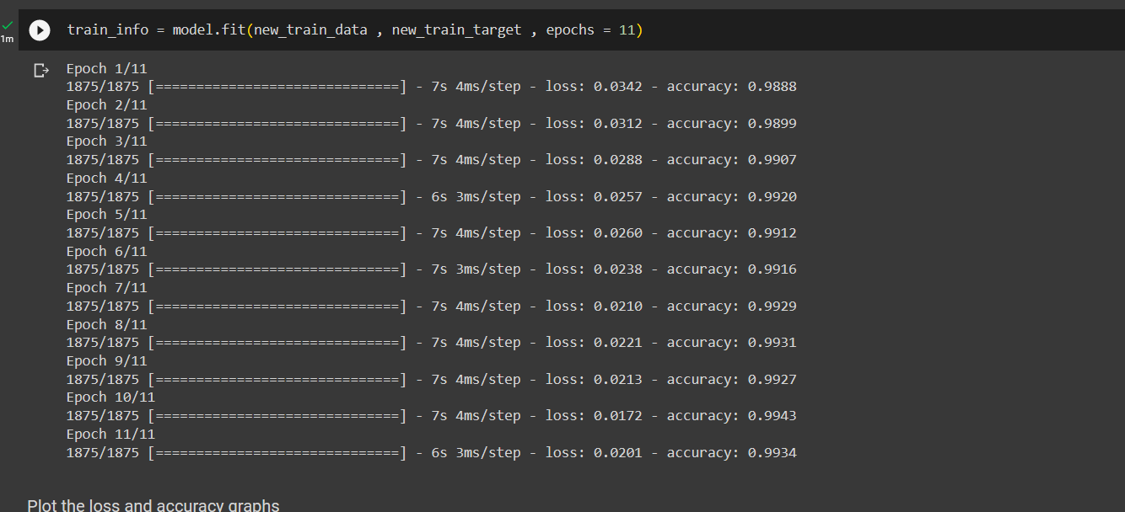

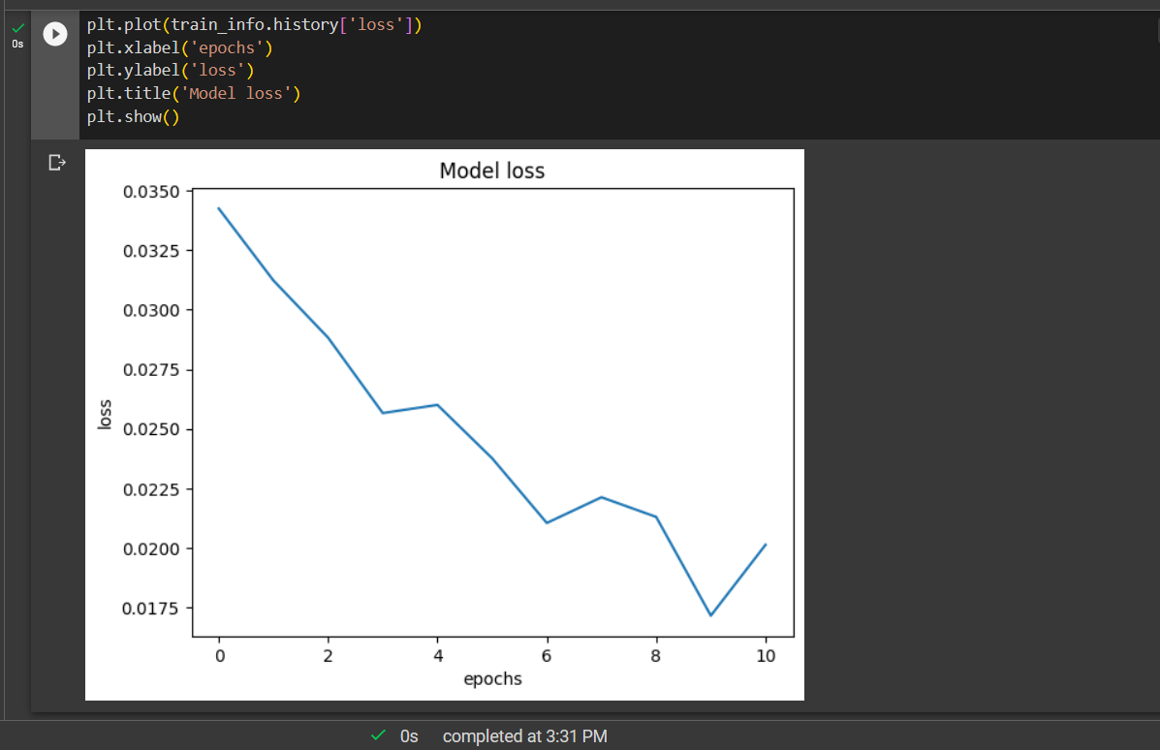

**No of Epochs = 12**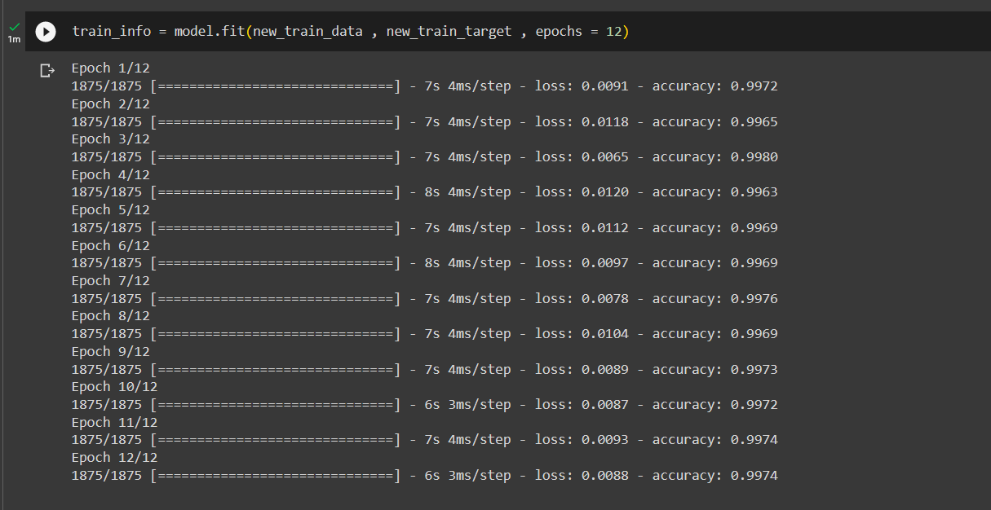

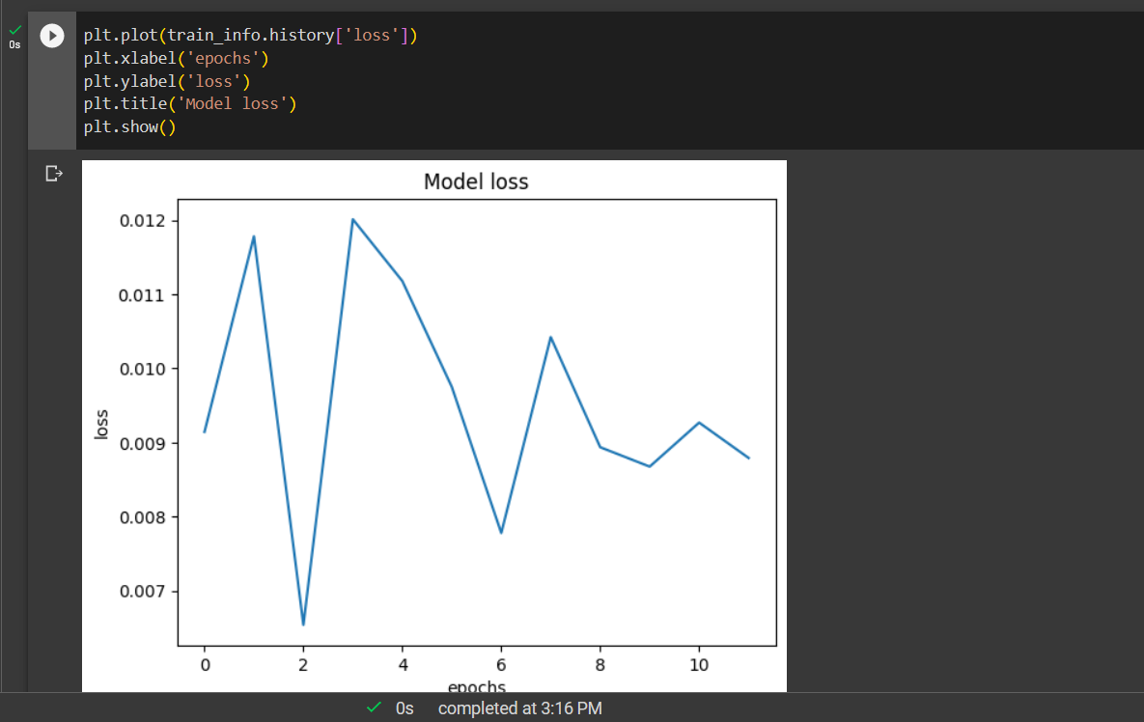

* Changing Number of perceptron in dense layer

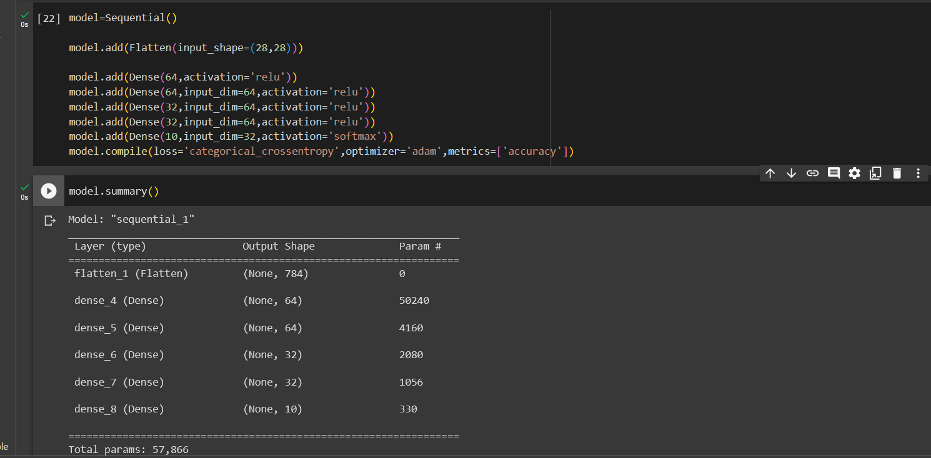

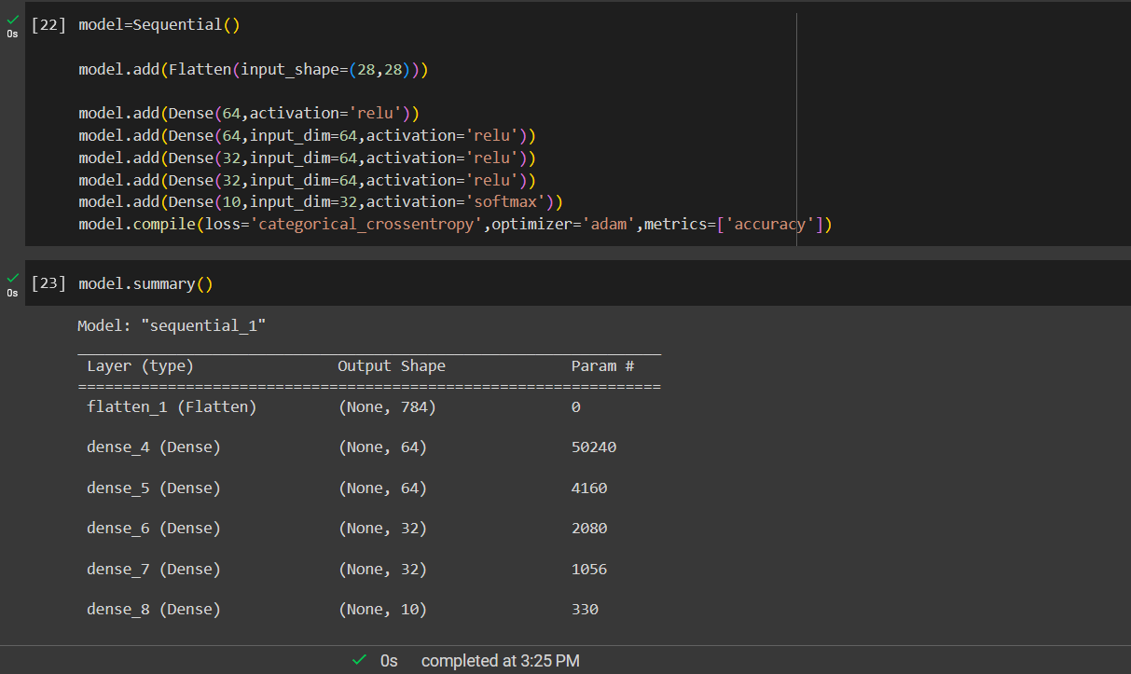

* 1. Add L1 and L2 regularization terms to the model and retrain the model.

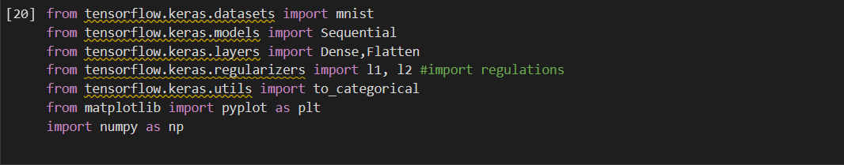

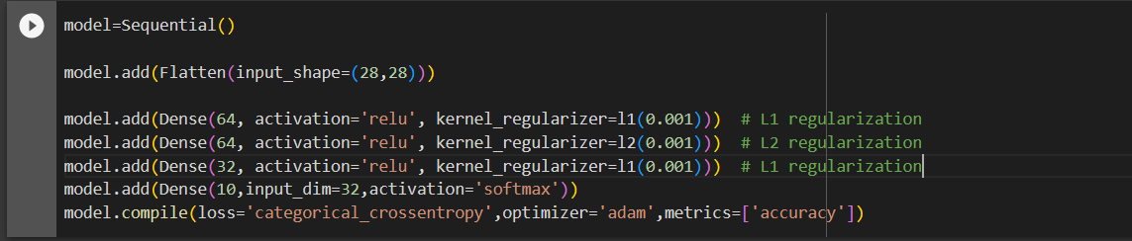

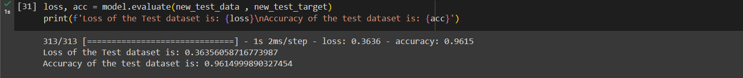

* 1. Visualize class-wise test dataset performance using a confusion matrix.

