## Lab 3 – IT20649562

1. Open Google colab. Upload the 1D_Convolution.ipynb to colab. Run all cells. Based on the result, explain how 1D convolution can be used to identify the edges in an image.

**The oneD_filter [1, -1] in the code is a simple filter that figures out how different adjacent pixels are. This filter efficiently amplifies areas where there is a sharp change in intensity between nearby pixels when it is applied to a signal or image. This shift in intensity could indicate the presence of an edge.**

1. Upload the Image_Filtering_(Convolution).ipynb file to colab. Change the filters and see if you can obtain different kinds of edges from the image. Download the modified ipynb file.

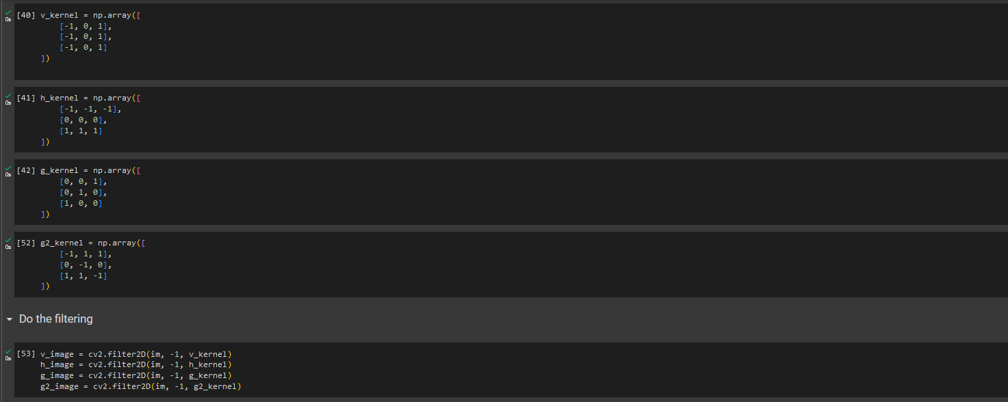

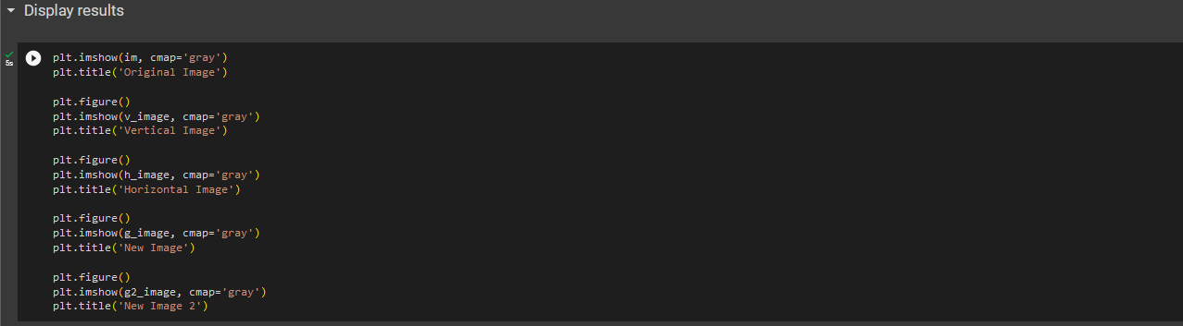

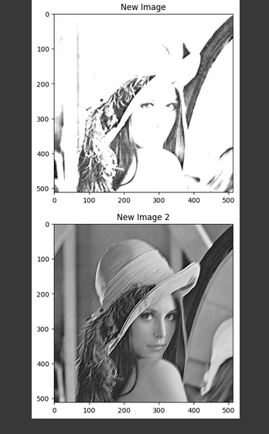

1. Upload the CNN_with_keras3.ipynb file to colab. Increase the number of epochs to 50.

Why does the validation error increases when the number of epochs is increased? Explain how you can modify the training process to stop that from happening.

**This validation error increases because the model is overfitting to the data set. We can prevent that by,**

* + **Regularization (dropout, L1 and L2 regularization, batch normalization)**
  + **Tuning Hyperparameters (learning rate, batch size, optimizer type)**
  + **Use pretrained models, instead of creating model from the scratch.**

Explain how the mini batch SGD (Stochastic Gradient Descent) algorithm can converge faster than the batch Gradient Descent algorithm.

**Since batch gradient descent computes the gradient using the whole training dataset in each iteration, it takes longer to converge. On the other hand, stochastic gradient descent can converge more quickly since it updates the model parameters after evaluating each case.**