4. Business Recommendations
Our analysis showed that the technology IIT needs is mature and affordable, so the challenge is joining it up (PEST T1, T2, T4), that there are strong opportunities in rankings, green skills and the new Ratmalana campus (SWOT O1, O2, O4), and that IIT's biggest internal gaps are Structure and Systems (7S). Our five-year programme is built to close these gaps first.
4.1 Long list of initiatives and how we chose between them
We started with ten credible initiatives from the brief, our research and team ideas, and compared them using five weighted criteria. Impact and fit with our analysis carry the most weight, because an initiative that does not fix IIT's real gaps will not last.
Sustainability impact (30%): how much it moves IIT's seven draft goals. Fit with our analysis (20%): whether it closes the Structure and Systems gaps or uses an opportunity we found. Cost and feasibility (20%): whether it fits the LKR 80 million three-year budget, reuses existing systems and can be built by one developer and final-year students. Digital dependence (15%): the spec asks for initiatives that are driven by digital technology. Speed to value (15%): how quickly it gives results that can be measured and reinvested.
The team scored each initiative from 1 (poor) to 5 (strong). The scores are our judgement based on our analysis, so they guide the decision rather than make it.
Table 1: Long list of initiatives scored against our criteria
# | Initiative | Impact  30% | Fit  20% | Cost and feasibility 20% | Digital  15% | Speed  15% | Weighted score | Decision
1 | Campus Sustainability Data Hub (energy, water and waste in one place) | 5 | 5 | 5 | 5 | 5 | 5.00 | Selected
2 | IT Asset Lifecycle and E-waste Tracker | 4 | 4 | 5 | 4 | 4 | 4.20 | Selected
3 | Smart Energy and Water Management at Ratmalana | 5 | 4 | 3 | 5 | 3 | 4.10 | Selected
4 | GreenIIT engagement app with a reuse marketplace | 4 | 4 | 4 | 5 | 3 | 4.00 | Selected
5 | Open Reporting, Rankings and Living Lab | 3 | 5 | 4 | 4 | 3 | 3.75 | Selected
6 | Smart transport and car-pooling app | 3 | 2 | 4 | 5 | 3 | 3.30 | Not selected
7 | Buying a ready-made commercial sustainability software suite | 4 | 3 | 1 | 5 | 2 | 3.05 | Not selected
8 | Digital-skills outreach platform for 5,000 young people | 3 | 2 | 3 | 4 | 3 | 2.95 | Not selected
9 | AI digital twin of the whole Ratmalana campus | 4 | 3 | 1 | 5 | 1 | 2.90 | Not selected
10 | Blockchain 'green tokens' to reward students | 2 | 1 | 2 | 5 | 1 | 2.10 | Not selected

The five initiatives that scored 3.7 or above form our final programme. The gap between them and the rest is fairly clear: the initiatives we rejected were either too expensive for the budget (7 and 9), did little to close IIT's internal gaps (6 and 8), or used technology for its own sake (10).
4.2 The recommended strategic programme
Our programme is called "Measure, Manage, Engage, Share". IIT cannot improve what it does not measure, so the programme starts with data and builds outwards (Table 2).
Table 2: The recommended five-year programme
# | Initiative | What it does | Why it is right for IIT | Goals | When
1 | Campus Sustainability Data Hub (MVP) | One cloud dashboard for existing smart meters plus monthly waste and fuel data, with CO2e conversion and alerts. | Closes the Systems gap: no baseline, no joined-up data (7S). Reuses meters IIT owns (PEST T1). | 1, 3, 4, 7 | Year 1
2 | IT Asset Lifecycle and E-waste Tracker | QR-tagged register of every device, tracking age, repairs and end-of-life route. | Computing institute with fast device turnover and no end-of-life process (PEST T4). Cheap, quick, visible. | 2, 3 | Year 1–2
3 | Smart Energy and Water at Ratmalana | Sub-meters, solar monitoring and rainwater sensors designed into the new campus; AI forecasting added later. | Monitoring can be designed in, not retrofitted (SWOT O4). Electricity is likely IIT's largest emissions source. | 1, 4 | Year 2–3
4 | GreenIIT app with reuse marketplace | Mobile web app with building-level energy challenges, club activity logging and a textbook and equipment swap. | Coordinates scattered club activity. Energy feedback cut use by 32% in student halls (Petersen et al., 2007). | 3, 5 | Year 2–3
5 | Open Reporting, Rankings and Living Lab | Annual GRI-aligned report, UI GreenMetric entry by 2028, campus data opened to student projects, tools later offered to others. | Uses the rankings opportunity (SWOT O1) and IIT's software skills (7S). Creates income and reputation. | 5, 7 | Year 3–5

The Data Hub comes first because every other initiative depends on its data, and it is the cheapest way to get early results. The Ratmalana energy work has the largest carbon impact, but it scored lower on cost and speed because it depends on hardware and the construction timetable, so it is placed in Years 2 and 3.
4.3 How the initiatives fit together
The initiatives are designed as a set rather than a list. The Data Hub is the foundation: Initiatives 3, 4 and 5 all use its data, so building it first avoids paying for the same thing twice. There are also synergies between the others. Devices that the Asset Tracker marks as reusable can be donated to IIT's schools outreach work through DDL, which supports the inclusion goal at almost no extra cost. Savings from Initiatives 1 and 3 are reinvested into 4 and 5, and the Living Lab gives final-year students real projects, adding capacity beyond the one developer IIT plans to hire.
A non-digital enabler is also needed. Our structure analysis showed that the Sustainability Office has an owner but no power. Technology alone will not fix this. We therefore recommend that IIT sets up a cross-functional sustainability steering group in Year 1, chaired by senior management, with a named data owner from facilities, IT, each school and the student body. This costs very little, but without it the dashboards would show problems that nobody has the authority to fix.
Alternatives we did not select
A commercial sustainability suite would be quick, but licence fees would eat much of the budget and build no capability IIT could later share. An AI digital twin needs data IIT does not have yet, so it is a possible extension of Initiative 3 after Year 3. Blockchain tokens add energy use without solving the real problem of missing data. The outreach platform matters, but DDL already runs outreach, so we link it to the Asset Tracker instead. A transport app mainly affects Scope 3 emissions, which are outside IIT's current targets.
Trade-offs and refinements to the draft goals
We balanced impact against cost by starting with cheap, data-first initiatives. For privacy under Sri Lanka's Personal Data Protection Act No. 9 of 2022, the app uses building-level data and opt-in accounts. For accessibility it is a light, mobile-first web app in English, Sinhala and Tamil, and for security meters sit on a separate network.
We also suggest three changes to the draft goals. Goal 1 uses a 2025 baseline that does not exist, so IIT should use the first full year of Data Hub data (2027) or estimate 2025 from bills and say so. Goal 2 should start by tagging every device, because IIT cannot manage what it has not counted. Goal 7 should target UI GreenMetric first in 2028, since it focuses on campus operations, before THE Impact Rankings.
4.4 The MVP: Campus Sustainability Data Hub
The Data Hub is the MVP because it scored highest on every criterion, can be live in six to nine months by reusing existing meters and cloud services, and every other initiative depends on it. Version one covers electricity and water from existing meters, waste and fuel through a monthly form, alerts, and dashboards for the Sustainability Office, facilities and the public.
MVP value proposition
We used the Value Proposition Canvas (Osterwalder et al., 2014), which matches users' jobs, pains and gains with what the product offers. The main users are the Head of Sustainability and facilities; management and students are secondary.
Table 3: Value Proposition Canvas for the Campus Sustainability Data Hub
Customer profile (what users need) | Value map (what the Data Hub offers)
Jobs: set a baseline and track targets (Head of Sustainability); cut costs and fix faults (facilities); justify the LKR 80m (management); see their impact (students). | Products and services: one dashboard for meter, waste and fuel data; CO2e conversion; alerts; public building dashboard; monthly report template.
Pains: data scattered across meters, bills and spreadsheets; waste only noticed when the bill arrives; slow manual reports; club effort goes unseen. | Pain relievers: reuses existing meters so the baseline starts at once; alerts within hours; automatic monthly figures; checks for missing readings.
Gains: proof of savings to reinvest; credible data for GRI and rankings; recognition as a leading sustainable technology campus. | Gain creators: savings shown in rupees and carbon; data mapped to GRI and UI GreenMetric; public dashboard to show partners and applicants.

The fit is strong for the client: having no reliable data is their biggest pain, and proof of savings unlocks the rest of the programme. The fit is weakest for students, whose main gains come with the GreenIIT app in Year 2.
MVP business process map
Figure 1 shows the Data Hub's main monthly process as a swimlane diagram. Meters send readings every 15 minutes and facilities enter waste and fuel monthly. The Hub has two decision points: whether the data is valid (if not, facilities fix it) and whether use is above target (if so, facilities investigate). Actions are logged, the Sustainability Office reports monthly and the steering group reviews targets quarterly.

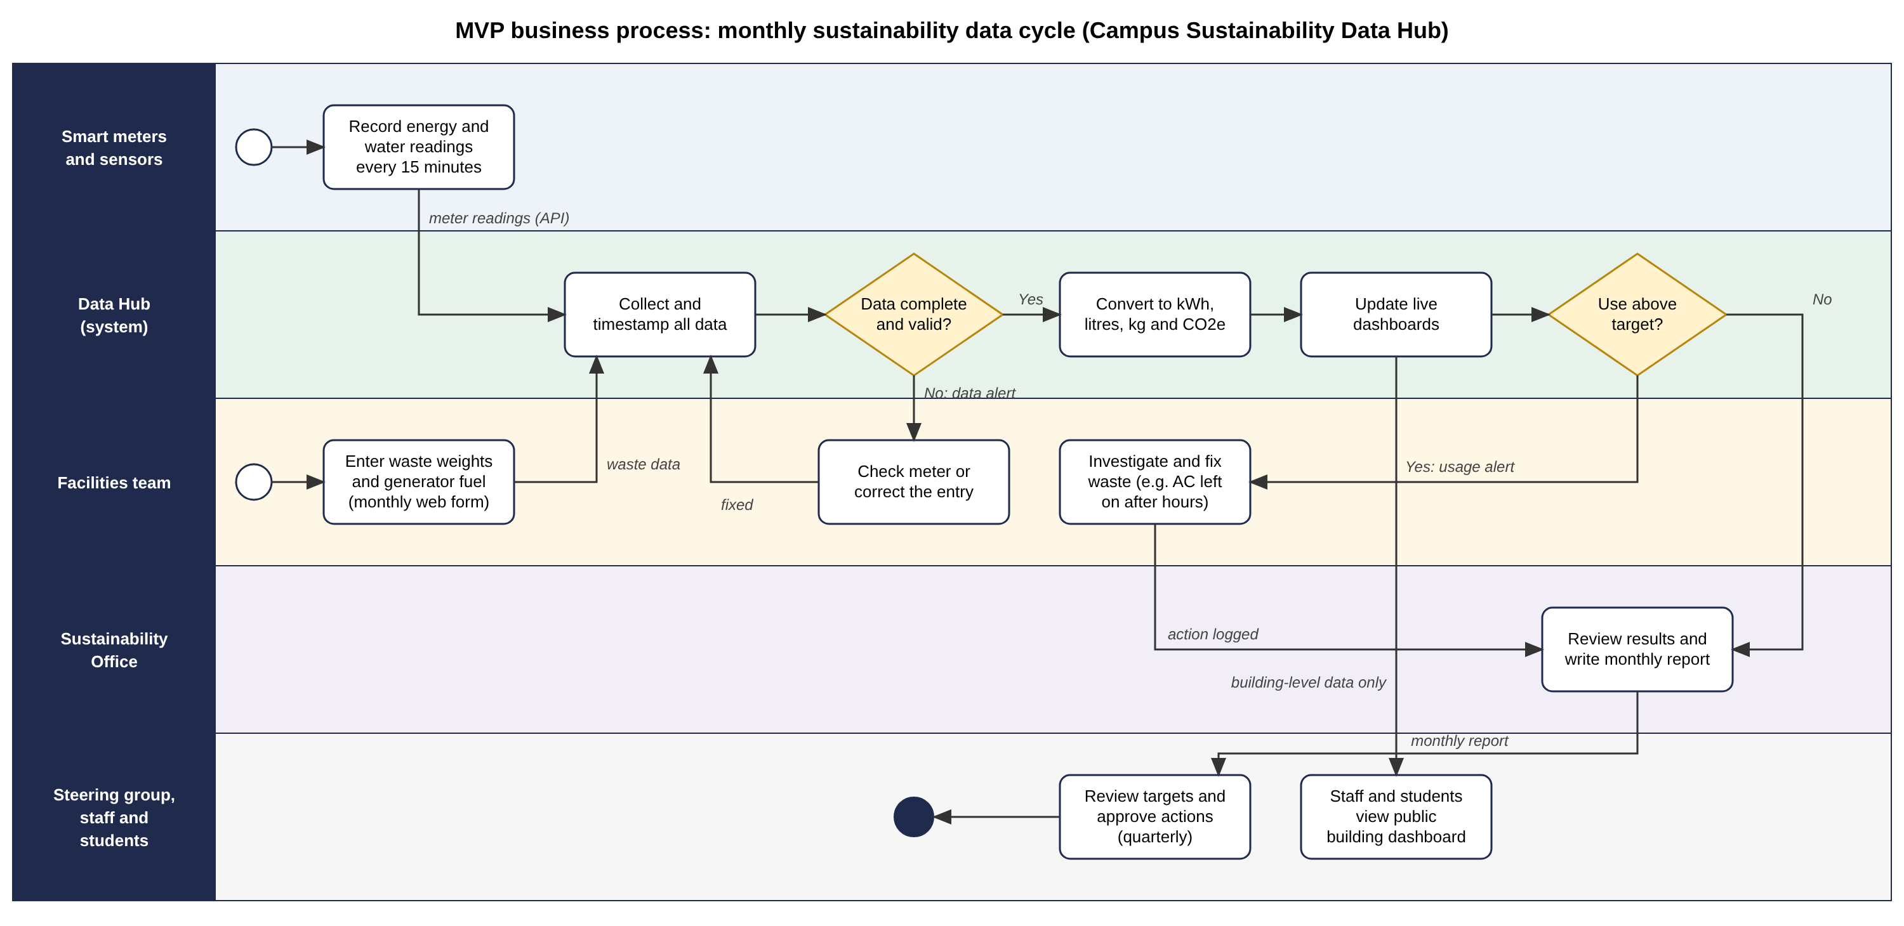
Figure 1: Business process map for the MVP, the Campus Sustainability Data Hub (our own diagram)

AI Interaction Evaluation Box (draft for the team to complete)
[Draft only. Edit this so it describes what your team actually did, max 250 words.]
We used a GenAI assistant (Claude) to help generate an initial long list of initiatives from our PEST, SWOT and 7S findings. We did not accept the list as it was: we removed ideas that did not fit IIT's budget or context and added the IT Asset Tracker after discussing IIT's device turnover. We also asked the tool to challenge our scoring criteria, which led us to add 'fit with our analysis' so that our choices stayed linked to the 7S gaps. GenAI helped us draft the first version of the Value Proposition Canvas, which we then checked against the client brief and our own campus observations. All statistics and sources were checked against the original documents before use. The final choice of initiatives, the weights and the MVP were decided by the team.
References
IIT (2026a) 6BUIS019C Digital Strategy: Assessment Specification 2026/27. Colombo: Informatics Institute of Technology / University of Westminster.
Osterwalder, A., Pigneur, Y., Bernarda, G. and Smith, A. (2014) Value Proposition Design: How to Create Products and Services Customers Want. Hoboken, NJ: Wiley.
Parliament of the Democratic Socialist Republic of Sri Lanka (2022) Personal Data Protection Act, No. 9 of 2022. Colombo: Government Publications Bureau.
Petersen, J.E., Shunturov, V., Janda, K., Platt, G. and Weinberger, K. (2007) 'Dormitory residents reduce electricity consumption when exposed to real-time visual feedback and incentives', International Journal of Sustainability in Higher Education, 8(1), pp. 16–33. Available at: https://doi.org/10.1108/14676370710717562 (Accessed: 2 November 2026).
UI GreenMetric (2025) UI GreenMetric World University Rankings: Guideline 2025. Depok: Universitas Indonesia. Available at: https://uigreenmetric.com/wp-content/uploads/2025/10/UI-GreenMetric-Guideline-2025.pdf (Accessed: 2 November 2026).
Note: sources already cited in the Strategic Analysis (PEST, SWOT and 7S sections) are listed in those sections' reference lists and should be merged into the final report's single reference list.

