Appendices A–E
Group C6 · 6BUIS019C Digital Strategy · compiled 5 November 2026 · part of 00_C6_Report_Compiled_Draft.docx

Appendix A: Group Work Plan
GUIDANCE FOR THE TEAM (delete before submission)
- Mandatory. The spec wants key tasks and deadlines, the roles each member took in each key task, and meetings planned and held, with attendees, purpose and outcomes.
- Table A1 is exported from your Notion 'Coursework Tasks' tracker as it stood on 5 November 2026. Notion has no owner field, so fill in 'Who' and update the status before you submit.

Table A1: Key tasks and deadlines (from the team's Notion tracker, 5 November 2026)
Task | Section | Priority | Due | Status | Who (team to add)
PEST: Technological factors | Strategic Analysis | — | — | Done
SWOT: Opportunities | Strategic Analysis | — | — | Done
McKinsey 7S internal analysis | Strategic Analysis | — | — | Done
IIT corporate structure critical analysis | Strategic Analysis | — | — | Done
Decide internal framework: 7S or SWOT Strengths/Weaknesses | Strategic Analysis | High | 24 Oct 2026 | Not started
Strategic Analysis: GenAI Use Evaluation Box | Strategic Analysis | High | 28 Oct 2026 | Not started
Business Recommendations: programme of initiatives | Business Recommendations | High | 4 Nov 2026 | In progress
MVP: value proposition and Business Process Map | Business Recommendations | High | 6 Nov 2026 | In progress
Introduction and Strategy Development Approach | Intro & Approach | Medium | 7 Nov 2026 | Not started
Digital Strategy: app portfolio, architecture and implementation plan | Digital Strategy | High | 10 Nov 2026 | Not started
Project Review for Professional Learning | Project Review | Medium | 12 Nov 2026 | Not started
Appendices A, B and C (mandatory) | Appendices | High | 14 Nov 2026 | Not started
Final assembly, word count check and submit | Final | Urgent | 16 Nov 2026 | Not started

Table A2: Meetings held [team to complete]
Date | Meeting (team or Strategic Review) | Attendees | Purpose | Outcomes and actions
 | Strategic Review 1 (Weeks 3–4) |  | Work plan
 | Strategic Review 2 (Week 5) |  | Analysis and emerging recommendations
 | Strategic Review 3 (Week 7) |  | Final recommendations and digital strategy
 | Project review meeting |  | Section 6

Appendix B: Feedback Action Log
GUIDANCE FOR THE TEAM (delete before submission)
- Mandatory. For each Strategic Review Meeting give the main feedback, the action agreed, who was responsible and what changed in the report.
- Action plans were due on Blackboard within five days of each meeting, so use them as your evidence.

Table B1: Feedback action log [team to complete]
Meeting | Main feedback | Action agreed | Responsible | What we changed
Weeks 3–4: work plan
Week 5: analysis and emerging recommendations
Week 7: final recommendations and digital strategy

Appendix C: Individual Contribution Statements
GUIDANCE FOR THE TEAM (delete before submission)
- Mandatory. Each member writes their own statement on the work they did for each key task: Strategic Analysis, Business Recommendations and Digital Strategy.
- Statements must match the Blackboard discussion-area evidence and the authors table at the start of the report.

Rachel Merrion
[Rachel Merrion to write their own statement]
Ranuli Alahakoon
[Ranuli Alahakoon to write their own statement]
Manthi Gunaratne
[Manthi Gunaratne to write their own statement]
Thisen Senarathna
[Thisen Senarathna to write their own statement]

Appendix D: Assumptions used in the 7S analysis
IIT does not publish an organisation chart or internal performance data, and the brief states that no measured data is available (IIT, 2026a). Where we could not find firm evidence we made the assumptions below. Each one is marked * in Table 2 or Figure E1.
Table D1: Assumptions, why they are reasonable and how they could be checked
# | Assumption | Why it is reasonable | How it could be checked
1 | Most decisions are made centrally by senior management ("fast, top-down decisions"). | IIT is a founder-led private company within the Informatics Group, whose chairman founded IIT (IIT, n.d.d). The Sustainability Office and LKR 80m budget were approved as top-level decisions (IIT, 2026a). | Ask the Head of Sustainability how the programme and budget were approved.
2 | The Sustainability Office has no line authority over schools, IT or facilities. | The office is new, and the brief says sustainability activity is run by clubs and lecturers and is not coordinated (IIT, 2026a). | Confirm the office's reporting lines and decision rights with the Head of Sustainability.
3 | Finance, HR and Admin, IT Services, and Facilities and Estates exist as separate corporate functions (Figure 2). | Every multi-campus institution of IIT's size needs these functions, and the brief refers to IT equipment and facilities being managed (IIT, 2026a). | Check against IIT's staff directory or ask IIT administration.
4 | Lecturers focus mainly on teaching and have little spare time outside it. | Most of IIT's degrees are taught programmes validated by partner universities (IIT, n.d.a), and the brief plans to rely on one developer and students rather than staff time (IIT, 2026a). | Short interview with two or three lecturers, or IIT's workload model.
5 | IIT relies on a small number of senior people for major decisions. | This is typical of founder-led organisations with a strong strategic apex (Mintzberg, 1979). | Discuss with the Lead Consultant or the Head of Sustainability.

Appendix E: IIT organisational structure
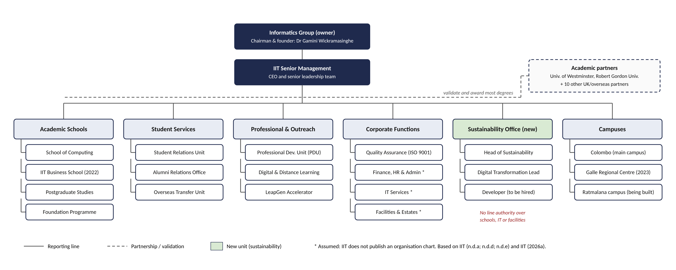
Figure E1: Organisational structure of IIT (2026)
Boxes marked * are assumed, because IIT does not publish an organisation chart (see Appendix D).
Table E1: Critical assessment of IIT's corporate structure (Mintzberg, 1979; Johnson et al., 2020)
Part of the structure | Current situation | Critical analysis | Rating
Ownership and governance | Private BOI-registered company within the Informatics Group, with the founder as group chairman. | Long-term owner commitment and fast decisions, as shown by the quick approval of the Sustainability Office and the LKR 80m budget. But a private group has no duty to report publicly, and sustainability spending competes with commercial priorities across the group. | Mixed
Top management | Central senior management, with most decisions made at the top. | Clear direction and quick action. However, it depends on a few people, and new ideas from lecturers or clubs have no formal route upwards, so many good activities stay small. | Mixed
Academic schools | Split by subject: Computing, Business School, postgraduate and Foundation. | Strong specialist expertise in each school. But the schools work in silos, and there is no shared structure for a cross-cutting goal like embedding sustainability in every programme by 2027. | Mixed
Partner university model | Most degrees are validated by partners, mainly Westminster and RGU, among twelve partners. | Brings international quality and reputation. But course content partly depends on partner approval, which slows curriculum change. IIT's own UGC-approved BBA, launched in September 2026 (IIT, 2026c), gives it more freedom from now on. | Mixed
Support and specialist units | SRU, Alumni, Overseas Transfer, PDU, DDL, LeapGen and other units. | These give IIT ready-made channels: DDL for schools outreach, PDU for corporate training and LeapGen for green start-ups. But they were added one by one and no one coordinates them, so their sustainability work is not joined up. | Strength
Campuses | Colombo campus, a regional centre in Galle, and the new Ratmalana campus under construction. | More sites mean more students reached. But each site needs its own energy, water and waste data, which makes measurement harder. The move to Ratmalana is a rare chance to design data and processes in from the start. | Mixed
Sustainability Office | New office: Head of Sustainability and Digital Transformation Lead, one developer to be hired. | Sustainability finally has an owner. But it is a small staff unit with no authority over facilities, IT buying or courses, and much of the activity sits with clubs and lecturers. Without backing from the top, it could be sidelined. | Weakness
Quality and compliance | ISO 9001:2015 certified, UGC recognised, TVEC registered and BCS accredited. | IIT already runs a documented, audited management system. Sustainability procedures, and later ISO 14001, can be added to it instead of being built from scratch. | Strength
Rating: Strength means this part of the structure already helps the sustainability ambition. Mixed means it helps in some ways but holds IIT back in others. Weakness means it is a barrier that needs to change.

References for this section
IIT (2026a) 6BUIS019C Digital Strategy: Assessment Specification 2026/27. Colombo: Informatics Institute of Technology / University of Westminster.
IIT (2026c) IIT launches its own UGC-approved BBA and Sri Lanka's first British FinTech degree. 30 September. Available at: https://www.iit.ac.lk/iit-news/iit-launches-its-own-ugc-approved-bba-and-sri-lankas-first-british-fintech-degree/ (Accessed: 22 October 2026).
IIT (no date a) About IIT. Available at: https://www.iit.ac.lk/about/ (Accessed: 22 October 2026).
IIT (no date d) Informatics Group. Available at: https://www.iit.ac.lk/about/informatics-group/ (Accessed: 22 October 2026).
Johnson, G., Whittington, R., Regnér, P., Angwin, D. and Scholes, K. (2020) Exploring Strategy: Text and Cases. 12th edn. Harlow: Pearson.
Mintzberg, H. (1979) The Structuring of Organizations. Englewood Cliffs, NJ: Prentice-Hall.

