Internal Analysis: McKinsey 7S Model
Why we used the McKinsey 7S model
The brief allows one internal framework. We chose the McKinsey 7S model, which examines three "hard" elements (strategy, structure, systems) and four "soft" ones (shared values, style, staff, skills) (Waterman, Peters and Phillips, 1980). It is purely internal, so it complements our PEST analysis; it covers the whole organisation; and, most importantly, it tests how well the elements fit together. IIT's problem is not ambition but fit, which a list of strengths and weaknesses would not reveal.
We rejected the value chain (Porter, 1985), which suits product firms rather than universities, and VRIO (Barney, 1991), which tests competitive advantage rather than readiness for change. The 7S is a qualitative snapshot that ignores external forces, so we pair it with PEST, support each element with evidence and benchmarks, and declare our assumptions (Appendix D).
Table 1 compares IIT today with its target of regional excellence (IIT, n.d.a) and becoming Sri Lanka's leading sustainable technology campus by 2030 (IIT, 2026a). Gaps are rated Large (blocks the goal now), Medium (slows progress) or Small (already supports it).
Table 1: McKinsey 7S analysis of IIT: current status, enablers and barriers, and size of the gap
7S element | Current status | Enablers (+) and barriers (–) | Gap to 2030 target
Strategy  Hard S | 35-year provider of British IT and Business degrees via twelve partners, now with its own UGC-approved BBA (IIT, n.d.a; IIT, 2026c). Seven draft sustainability goals; LKR 80m over three years (IIT, 2026a). | + A clear market position and a distinctive 2030 goal.  + Funding committed to a phased programme.  – No baseline, so progress cannot be measured.  – A fixed budget and one developer force tight choices. | MEDIUM  Ambition is clear; a costed, measurable plan is not.
Structure  Hard S | Functional structure with a strong strategic apex (Mintzberg, 1979): central management, subject-based schools and units added over time (Figure 2). New Sustainability Office (IIT, 2026a). | + Fast, top-down decisions.*  + The Ratmalana move allows a fresh operating model.  – Silos between schools, IT and facilities (Johnson et al., 2020).  – The Sustainability Office has no authority over schools, IT or facilities.* NSBM runs its sustainability policy under its Vice-Chancellor (Iddawela and Yatawara, 2021). | LARGE  Sustainability has an owner but no power.
Systems  Hard S | ISO 9001:2015, UGC, TVEC and BCS approvals (IIT, n.d.a). Smart-meter and recycling data not consolidated; no baseline, IT end-of-life process or public reporting (IIT, 2026a). | + An audited quality system that sustainability procedures can join.  + Existing IT infrastructure and meters can be reused (IIT, 2026a).  – No joined-up data. Monash measured and reported its emissions for a decade before committing to net zero (UNFCCC, 2018). | LARGE  IIT cannot manage what it does not measure.
Shared values  Soft S | Regional-excellence vision; eleven values, including community engagement, which mentions sustainable development (IIT, n.d.a). | + Lived through the SDGP module, which builds apps for the UN SDGs (IIT, n.d.b), and ICSE 2026 (IIT, 2026b).  – Eleven values are too many to guide choices; sustainability is not core. NSBM made a sustainability module compulsory for all first-years (Iddawela and Yatawara, 2021). | SMALL  The 2030 goal fits who IIT already is.
Style  Soft S | Entrepreneurial, founder-led and first to market; runs LeapGen (IIT, n.d.a; IIT, n.d.c). Sustainability work is bottom-up via clubs and lecturers (IIT, 2026a). | + Quick, committed decisions, such as ring-fencing LKR 80m.  – No middle layer turns activity into measured results.  – Relies on a small number of senior people.* | MEDIUM  The energy is there; accountability is not.
Staff  Soft S | Engaged students and award-winning clubs (IIT, n.d.a); teaching-focused lecturers*; small Sustainability Office plus final-year students (IIT, 2026a). | + Growing concern about climate change (IIT, 2026a).  + Final-year projects add low-cost capacity.  – Little spare staff time outside teaching.*  – Students leave yearly, so knowledge is lost. | MEDIUM  Motivated people, limited capacity.
Skills  Soft S | Software engineering, AI, data science and analytics; national competition winners (NBQSA, IEEE Innovation Nation) (IIT, n.d.a). | + The skills needed to build data tools in-house.  – No carbon accounting, GRI reporting or e-waste expertise. | MEDIUM  A strong technical base, but missing specialist knowledge.
Key: + enabler – barrier * assumption, explained in Appendix D
[TEAM TO ADD BEFORE SUBMISSION: two or three points from our own campus observation, e.g. in the Systems or Staff rows, cited as (team campus observation, November 2026). Delete this note once done.]
How the elements fit together
The 7S assumes the elements must reinforce each other (Waterman, Peters and Phillips, 1980). Figure 1 shows three misfits:
M1 Strategy and Systems: targets exist, but no system produces the data to track them.
M2 Style and Structure: activity relies on clubs and lecturers, but no one has authority to coordinate it.
M3 Skills and Staff: the skills to build tools sit largely with students who leave each year.
Strong shared values mean these gaps can be closed without changing IIT's identity.
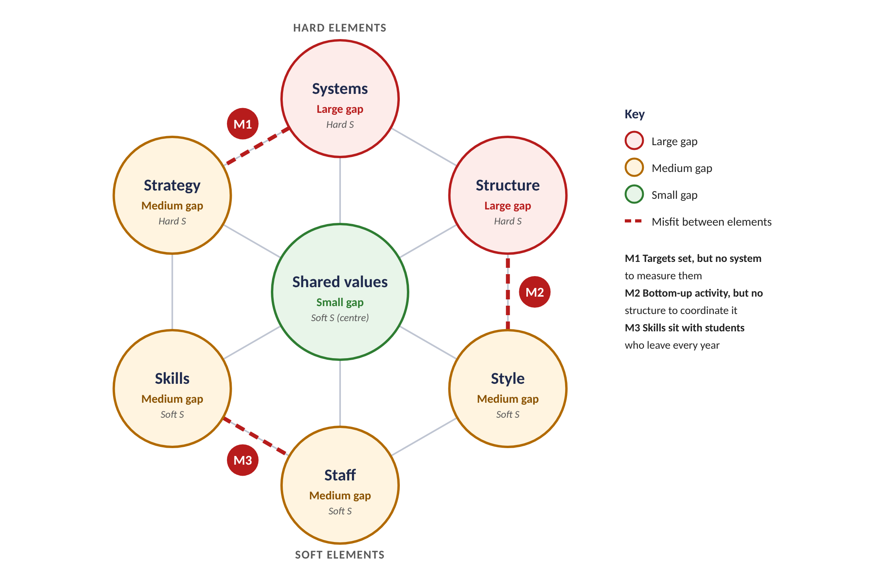
Figure 1: 7S fit: gap per element and the three main misfits (own analysis)
Key insights for the strategy
I1 Measure first. Systems is the largest gap and blocks every goal, so data consolidation comes first.
I2 Give sustainability authority, not just an owner. A cross-functional mechanism is needed, not a costly restructure.
I3 Use IIT's own skills, but keep the knowledge. Document and hand over work between cohorts, and add specialist skills through training or the Westminster partnership.
Our recommendations refer to these as 7S I1–I3. Appendix E gives a fuller assessment of IIT's structure.
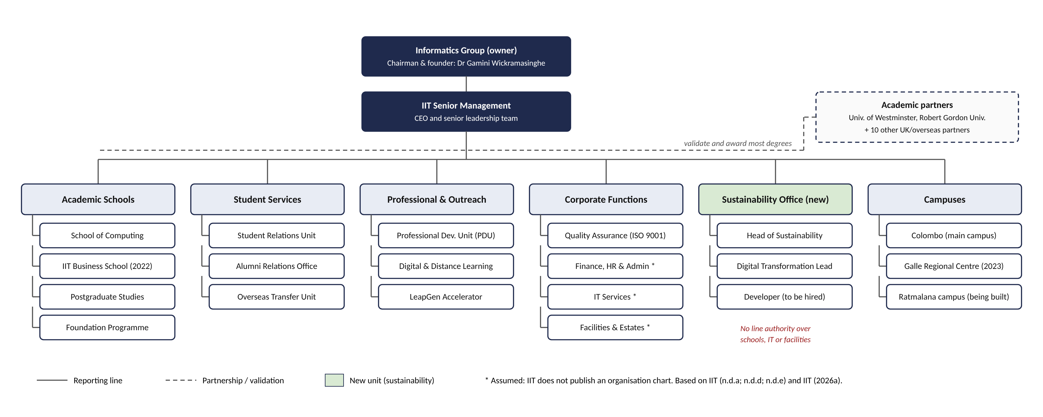
Figure 2: Organisational structure of IIT (2026)
Boxes marked * are assumed, because IIT does not publish an organisation chart (see Appendix D).

Appendix D: Assumptions used in the 7S analysis
IIT does not publish an organisation chart or internal performance data, and the brief states that no measured data is available (IIT, 2026a). Where we could not find firm evidence we made the assumptions below. Each one is marked * in Table 1 or Figure 2.
# | Assumption | Why it is reasonable | How it could be checked
1 | Most decisions are made centrally by senior management ("fast, top-down decisions"). | IIT is a founder-led private company within the Informatics Group, whose chairman founded IIT (IIT, n.d.d). The Sustainability Office and LKR 80m budget were approved as top-level decisions (IIT, 2026a). | Ask the Head of Sustainability how the programme and budget were approved.
2 | The Sustainability Office has no line authority over schools, IT or facilities. | The office is new, and the brief says sustainability activity is run by clubs and lecturers and is not coordinated (IIT, 2026a). | Confirm the office's reporting lines and decision rights with the Head of Sustainability.
3 | Finance, HR and Admin, IT Services, and Facilities and Estates exist as separate corporate functions (Figure 2). | Every multi-campus institution of IIT's size needs these functions, and the brief refers to IT equipment and facilities being managed (IIT, 2026a). | Check against IIT's staff directory or ask IIT administration.
4 | Lecturers focus mainly on teaching and have little spare time outside it. | Most of IIT's degrees are taught programmes validated by partner universities (IIT, n.d.a), and the brief plans to rely on one developer and students rather than staff time (IIT, 2026a). | Short interview with two or three lecturers, or IIT's workload model.
5 | IIT relies on a small number of senior people for major decisions. | This is typical of founder-led organisations with a strong strategic apex (Mintzberg, 1979). | Discuss with the Lead Consultant or the Head of Sustainability.

References
Barney, J. (1991) 'Firm resources and sustained competitive advantage', Journal of Management, 17(1), pp. 99–120.
Iddawela, J. and Yatawara, T. (2021) 'NSBM Green University: a hallmark of sustainability and green practices', Business Dialogue. Homagama: NSBM Green University. Available at: https://www.nsbm.ac.lk/wp-content/uploads/2021/10/NSBM-GREEN-UNIVERSITY-A-HALLMARK-OF-SUSTAINABILITY-AND-GREEN-PRACTICES.pdf (Accessed: 5 November 2026).
IIT (2026a) 6BUIS019C Digital Strategy: Assessment Specification 2026/27. Colombo: Informatics Institute of Technology / University of Westminster.
IIT (2026b) IIT to host the 3rd International Conference on Sustainable Education 2026 (ICSE 2026) in Colombo. Available at: https://www.iit.ac.lk/iit-events/iit-to-host-the-3rd-international-conference-on-sustainable-education-2026-icse-2026-in-colombo/ (Accessed: 21 October 2026).
IIT (2026c) IIT launches its own UGC-approved BBA and Sri Lanka's first British FinTech degree. 30 September. Available at: https://www.iit.ac.lk/iit-news/iit-launches-its-own-ugc-approved-bba-and-sri-lankas-first-british-fintech-degree/ (Accessed: 22 October 2026).
IIT (n.d.a) About IIT. Available at: https://www.iit.ac.lk/about/ (Accessed: 22 October 2026).
IIT (n.d.b) SDGP: Software Development for Global Progress. Available at: https://sdgp.iit.ac.lk/ (Accessed: 21 October 2026).
IIT (n.d.c) LeapGen IIT Accelerator. Available at: https://leapgen.iit.ac.lk/ (Accessed: 21 October 2026).
IIT (n.d.d) Informatics Group. Available at: https://www.iit.ac.lk/about/informatics-group/ (Accessed: 22 October 2026).
Johnson, G., Whittington, R., Regnér, P., Angwin, D. and Scholes, K. (2020) Exploring Strategy: Text and Cases. 12th edn. Harlow: Pearson.
Mintzberg, H. (1979) The Structuring of Organizations. Englewood Cliffs, NJ: Prentice-Hall.
Porter, M.E. (1985) Competitive Advantage: Creating and Sustaining Superior Performance. New York: Free Press.
UNFCCC (2018) Monash's Net Zero Initiative | Australia. Momentum for Change: 2018 Lighthouse Activity. Available at: https://unfccc.int/climate-action/momentum-for-change/climate-neutral-now/monash-s-net-zero-initiative (Accessed: 5 November 2026).
Waterman, R.H., Peters, T.J. and Phillips, J.R. (1980) 'Structure is not organization', Business Horizons, 23(3), pp. 14–26.

