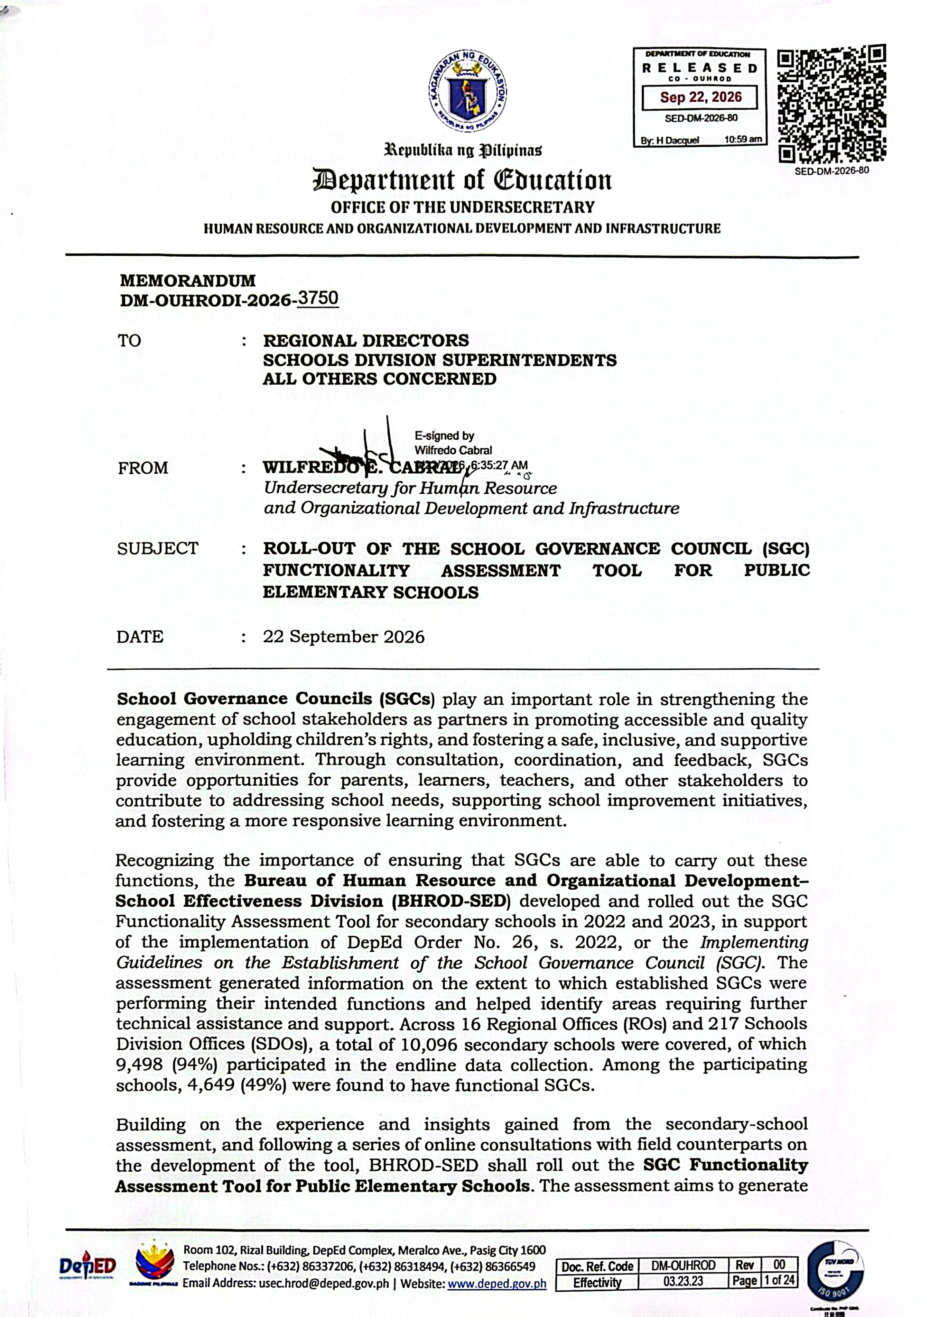
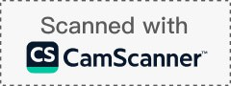



baseline information on the functionality of SGCs in public elementary schools, identify areas for improvement, and inform the provision of appropriate technical assistance and support. The data to be generated shall serve as a reference for monitoring progress and guiding succeeding efforts to strengthen SGC implementation and stakeholder participation at the school level.
Doc. Ref. Code | DM-OUHROD | Rev | 00
Effectivity | 03.23.23 | Page | 2 of 24

For 2026, the SGC Functionality Assessment Tool shall be implemented exclusively for public elementary schools. For public secondary schools, the provision of sustained and strengthened technical assistance, including validation and monitoring, shall continue through appropriate modalities based on the needs and capacities of the Regional Office (RO) and Schools Division Office (SDO) SGC Composite Teams. These efforts shall support the continued functionality of SGCs and provide accurate, updated, and reliable information to inform planning and decision-making across governance levels.

In line with the rollout of SGC Functionality Assessment Tool for Public Elementary Schools, the following enclosed documents are issued for guidance and reference:

Enclosure No. | Attachment
1 | SGC Functionality Assessment Tool User Guide Volume 1 and 2
2 | SGC Functionality Assessment Tool (printable for reference)
3 | Process Flow of the Data Collection and Monitoring of the SGC Functionality Assessment Tool
4 | Roles and Responsibilities per Governance Level as Mandated by DepEd Order 26, s. 2022
5 | Roles and Responsibilities per Governance Level in the  implementation of the SGC Functionality Assessment Tool
6 | SDO Spreadsheet: SDO Validation Sheet and SDO Monitoring Sheet
7 | RO Spreadsheet: RO Monitoring Sheet and RO Multiple Submission Deletion Log
8 | Timeline of Activities relative to the Roll-Out of the SGC  Functionality Assessment Tool
9 | Links: SGC Functionality Assessment Tool, SDO Spreadsheet, RO Spreadsheet, SGC Functionality Assessment Tool Backend Sheet (to be provided to the RO in a separate email to ensure  the confidentiality of the links).

Please be informed that all personal information collected pursuant to this memorandum shall be treated with utmost confidentiality and processed in accordance with the Data Privacy Act of 2012 (RA 10173). The data collected shall be used solely for official purposes related to this activity and shall be protected through appropriate security measures.

For guidance and references, you may access the following links:
- SGC Policy: bit.ly/SGC-FAQs

Roll-Out on the SGC Functionality Assessment Tool for ES:
tinyurl.com/DMSGCE

For other concerns or inquiries, you may contact Ms. Joloren A. Luya of BHROD-SED through the landline number (02) 8633-5397 or via email at bhrod.sed@deped.gov.ph.
Doc. Ref. Code | DM-OUHROD | Rev | 00
Effectivity | 03.23.23 | Page | 3 of 24

Copy furnished:

Office of the Secretary
Office of the Undersecretary for Field Operations

Enclosure No. 1 to DM-OUHRODI-2026- 3750_ USER GUIDE VOL. 1 and 2
Doc. Ref. Code | DM-OUHROD | Rev | 00
Effectivity | 03.23.23 | Page | 4 of 24

This User Guide provides the procedures and reference materials for the accomplishment, validation, and monitoring of data under the SGC Functionality Assessment Tool for Public Elementary Schools.
The User Guide consists of two (2) volumes:
Volume 1: Prepare and Respond – for Public Elementary Schools Provides guidance to school heads and SGCs on the preparation and submission of required data and supporting documents.
Volume 2: Validate and Monitor – for SDO and RO Provides guidance to SDO and RO SGC Composite Teams on the validation, monitoring, and review of submitted SGC data.
The complete User Guide may be accessed through the following link:

tinyurl.com/DMSGCES

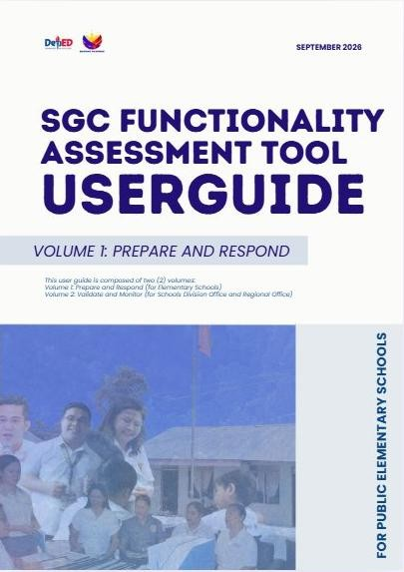
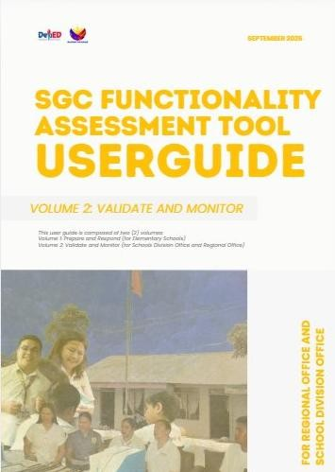

Enclosure No. 2 to DM-OUHRODI-2026- 3750_

Room 102, Rizal Building, DepEd Complex, Meralco Ave., Pasig City 1600 Telephone Nos.: (+632) 86337206, (+632) 86318494, (+632) 86366549
Email Address: usec.hrod@deped.gov.ph | Website: www.deped.gov.ph

Printable Form of the SGC Functionality Assessment Tool
The Printable Form of the SGC Functionality Assessment Tool may be used as a reference and offline copy of the assessment tool for the accomplishment and review of the required assessment information. It contains the assessment of indicators and corresponding fields to guide schools in documenting and completing the SGC functionality assessment.

The printable form may be accessed through the following link:

tinyurl.com/DMSGCES

Doc. Ref. Code | DM-OUHROD | Rev | 00
Effectivity | 03.23.23 | Page | 5 of 24

Enclosure No. 2 to DM-OUHROD-2026- 3750
Implementing Guidelines on the Establishment of School Governance Council (DO 26, s. 2022)

SGC FUNCTIONALITY ASSESSMENT TOOL
For Public Elementary Schools • 2026 Rollout
In relation to the mandate of DO. 26, s. 2022 on the establishment of School Governance Council (SGC) and to ensure that all public schools are able to create functional SGCs, the Bureau of Human Resource and Organizational Development – School Effectiveness Division (BHROD-SED) shall conduct a monitoring and evaluation of SGCs through the SGC Functionality Assessment Tool ("SGC Tool").
UNDERSTANDING THE SGC FUNCTIONALITY ASSESSMENT TOOL
This SGC Functionality Assessment Tool aims to assess the functionality of SGCs in secondary schools. The Tool consists of the following components:

- Two (2) Main Purposes
  - To provide structure for shared governance
  - To provide a feedback mechanism

- Twelve (12) Functionality Indicators
Functionality indicators are anchored on the two main purposes of the SGC and can be found in Section VII of DO 26, s. 2022. In this SGC Tool, these indicators are grouped according to the functions per purpose. Additionally, a brief description on how the Functionality Indicator can be observed is also included to provide schools with further guidance in establishing functional SGCs.

- Nineteen (19) Functionality Sub-indicators
In this SGC Tool, there are seven (7) functionality indicators that have sub-indicators. Sub-Indicators are the specific activities that enable the achievement of their corresponding functionality indicator. These are divided into:

- Primary Sub-Indicators, which are the sub-indicators that determine the achievement of their corresponding Functionality Indicators, and thus must be met; and
- Other Sub-Indicators, which are the sub-indicators that SGCs may comply with, only when the Primary Sub-Indicator is met and applicable.

The result of the assessment shall be used as information in identifying priority areas that may need support and assistance from the different governance levels.

Determining a Functional SGC Through the SGC Functionality Assessment Tool
For an SGC to be considered functional, the Council must be able to comply with at least 10 out of the 12 (at least 80%) Functionality Indicators based on the minimum MOVs submitted. Thus, at a minimum, functional SGC complies with the following requirements:

- Functionality Indicators without sub-indicators are observed (Yes to all Functionality Indicators without sub-indicators);
- Primary Sub-Indicators, under Functionality Indicators with sub-indicators, are observed (Yes to all Primary Sub-Indicators);
- Minimum MOVs are submitted.

The Other Sub-Indicators are also recommended to be attained to further strengthen the SGC’s functionality. Additional MOVs may be submitted when available to showcase its advanced practices. In addition, ensure that the MOVs are complete and readily available during data validation of the SDOs and/or BHROD-SED.


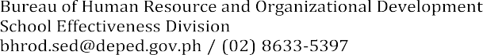
1

Implementing Guidelines on the Establishment of School Governance Council (DO 26, s. 2022)

SGC FUNCTIONALITY ASSESSMENT TOOL
For Public Elementary Schools • 2026 Rollout
SCHOOL PROFILE

School Name :

School ID : Region :
Contact
Number : Division :
SGC PROFILE

Establishment of SGC Date of Establishment
- Newly-Established SGC
The school has formed the SGC after the issuance of DO 26, s. 2022.

The SGC was established in SY 2022-2023 or later.

- With Existing SGC
The school already has an SGC before the issuance of DO 26, s. 2022 The SGC was restructured in accordance with DO 26, s. 2022.
( Month and Year )

Name of SGC :

HOW TO ANSWER THE SGC FUNCTIONALITY ASSESSMENT TOOL (PRINTED)
- Functionality Indicators
Put a check mark ( / ) on the appropriate box:
  - YES (if the indicator is met)
  - NO (if the indicator is not met)
- Sub-Indicators
If the Primary Sub-Indicator is not met, no need to proceed to complying with Other Sub-Indicator/s.
- Means of Verification (MOVs)
Put a check mark ( / ) on the box that corresponds to the available MOV.
If YES to the Functionality Indicator, prepare the corresponding minimum MOVs. To showcase the SGC’s advanced practices, Additional MOVs may also be submitted. If NO, no need to prepare or present any MOVs. In addition, ensure that the MOVs are complete and readily available when answering the ONLINE SGC Functionality Assessment Tool and during data validation of the SDOs and / or BHROD-SED
2

Implementing Guidelines on the Establishment of School Governance Council (DO 26, s. 2022)

SGC FUNCTIONALITY ASSESSMENT TOOL
For Public Elementary Schools • 2026 Rollout

MAIN PURPOSE: STRUCTURE FOR SHARED GOVERNANCE
As a structure for shared governance, the SGC shall be an avenue where the democratic process of consultation with the school’s internal and external stakeholders in the decision-making will be observed.

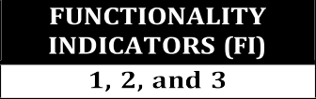
FUNCTION 1:
The SGC serves as a collective and consultative body for school plans, programs, activities, and strategic directions.

FI1 FUNCTIONALITY INDICATOR 1
THE SGC HAS MEMBERS WHO ARE INFORMED OF AND GIVEN THE OPPORTUNITY TO EXERCISE THEIR ROLES AND RESPONSIBILITIES IN THE COUNCIL.
A functional SGC has members who participate in the decision-making process.
FI1A | PRIMARY SUB-INDICATOR
- YES  - NO | The SGC has called meetings in order to create a venue for its decision-making process.
If YES, prepare the following MOVs:
Minimum MOVs Additional MOVs
- Notice of meeting (at least 1 of 4 Regular Meetings) □ Notices of meetings (2 to 4 Regular Meetings)

NOTE If the Primary Sub-Indicator is not met (NO), no need to comply with the Other Sub-Indicators.

FI1B | Other Sub-Indicator  SGC members have been inducted and oriented of their roles and responsibilities as members and officers of the Council.
- YES
- NO
- YES  - NO | If YES, prepare the following MOVs:  Minimum MOVs Additional MOVs  - Membership / Induction Certificates □ Membership / Induction Certificates (7 to 15 voting members) or (non-voting members) or  - SGC Resolution on the Official List of Voting Members □ SGC Resolution on the Official List of Members (7 to 15 voting members) (non-voting members)
FI1C | Other Sub-Indicator  The SGC has organizational chart, including non-voting members, if applicable.
- YES
- NO
- YES  - NO | If YES, prepare the following MOVs:  Minimum MOVs Additional MOVs  - Draft / Operative Organizational Chart □ Approved / Adopted Organizational Chart

FI2 | FUNCTIONALITY INDICATOR 2
THE SGC HAS ESTABLISHED ITS POSITION AS A CONSULTATIVE BODY IN DEVELOPING SCHOOL POLICIES.
A functional SGC has knowledge on the needs of the school as a result of its established connection/relationship with the school committees/associations/organizations.
FI2A | PRIMARY SUB-INDICATOR
- YES  - NO | The SGC has participated actively in the formulation of the SIP/AIP and other DepEd programs, projects, and activities.
- YES  - NO | If YES, prepare the following MOVs:
- YES  - NO | Minimum MOVs  - Minutes of Meeting with SPT on SIP / AIP (at least 1 meeting) | Additional MOVs  - Minutes of Meetings with SPT on SIP / AIP (2 or more meetings)  - Minutes of Meeting/s with SPT on other DepEd programs, projects, and activities (at least 1 meeting)  - SGC's Action Plan  - SGC Resolution relative to the indicator (at least 1)

Implementing Guidelines on the Establishment of School Governance Council (DO 26, s. 2022)

SGC FUNCTIONALITY ASSESSMENT TOOL
For Public Elementary Schools • 2026 Rollout
NOTE If the Primary Sub-Indicator is not met (NO), no need to comply with the Other Sub-Indicators.

FI2B | Other Sub-Indicator  The SGC has passed recommendations to the School Head regarding concerns, policies, programs, and/or interventions raised by stakeholders.
- YES
- NO
- YES  - NO | If YES, prepare the following MOVs:  Minimum MOVs Additional MOVs  - SGC Resolution relative to the indicator (at least 1) □ SGC Resolutions relative to the indicator (2 or more)
FI2C | Other Sub-Indicator
- YES  - NO | The SGC has attended meetings on the importance of upholding the rights of the child.
- YES  - NO | If YES, prepare the following MOVs:
- YES  - NO | Minimum MOVs Additional MOVs  - Minutes of Meeting with CPU, CPC, or other similar □ Minutes of Meetings with CPU, CPC, or other similar DepEd organizations (at least 1 meeting) DepEd organizations (2 or more meetings)  □ SGC Resolution on promoting the rights of the child (at least 1)

FI3 FUNCTIONALITY INDICATOR 3
THE SGC HAS CONDUCTED REGULAR SGC MEETINGS AS PRESCRIBED IN THE DO 26, S. 2022 (IMPLEMENTING GUIDELINES ON THE ESTABLISHMENT OF SCHOOL GOVERNANCE COUNCIL).
A functional SGC has understood the process of discussing matters that results to the formulation of action plan responsive to school concerns.
FI3A | PRIMARY SUB-INDICATOR
- YES  - NO | The SGC has decided matters through a resolution, signed by all SGC voting members.
- YES  - NO | If YES, prepare the following MOVs:  Minimum MOVs Additional MOVs  - SGC Resolution (at least 1) □ SGC Resolutions (2 or more)  □ SGC's Action Plan

NOTE If the Primary Sub-Indicator is not met (NO), no need to comply with the Other Sub-Indicators.

FI3B | Other Sub-Indicator  Agenda of meetings have included programs, projects, and activities that are supportive of the SIP, AIP, and other school priorities.
- YES
- NO
- YES  - NO | If YES, prepare the following MOVs:  Minimum MOVs Additional MOVs  - Minutes of Meeting mentioning meeting agenda □ Minutes of Meeting mentioning meeting agenda (at least 1 meeting) (2 or more meetings)
FI3C | Other Sub-Indicator  All regular meetings have been conducted with a quorum of 50%+1 of the total SGC voting membership.
- YES
- NO
- YES  - NO | If YES, prepare the following MOVs:  Minimum MOVs Additional MOVs  - Minutes of Meetings specifying required quorum □ Minutes of Meetings specifying required quorum (at least 1 of 4 Regular Meetings) (2 - 4 Regular Meetings)
FI3D | Other Sub-Indicator  Regular meetings have minutes.
- YES  - NO | Other Sub-Indicator  Regular meetings have minutes.
- YES  - NO | If YES, prepare the following MOVs:  Minimum MOVs Additional MOVs  - Minutes of Meeting (at least 1 of 4 Regular Meetings) □ Minutes of Meetings (2 - 4 Regular Meetings)

Implementing Guidelines on the Establishment of School Governance Council (DO 26, s. 2022)

SGC FUNCTIONALITY ASSESSMENT TOOL
For Public Elementary Schools • 2026 Rollout

FUNCTION 2:
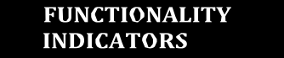
The SGC serves as the overall coordinating body that will synergize, harmonize and put together the work of the different school committees, including but not limited to the SPT, School Disaster Risk Reduction Management (DRRM) Committee, Child Protection Committee (CPC), Supreme Pupil Government / Supreme Student Government, Faculty Club, Non-teaching Association, PTA, Alumni Associations, DepEd-recognized teacher organizations, and National Employees Union at school level, among others.

FI4 | FUNCTIONALITY INDICATOR 4
THE SGC HAS ORGANIZED MEETINGS WITH AND ATTENDED MEETINGS OF DIFFERENT SCHOOL COMMITTEES AND ORGANIZATIONS TO ENSURE ALIGNMENT OF WORK.
A functional SGC has ensured the involvement of different school committees and organizations in harmonizing their proposed and existing programs, projects, and activities.
FI4A | PRIMARY SUB-INDICATOR
- YES  - NO | The SGC has organized meetings with different school stakeholders to harmonize proposed and existing programs, projects, and activities.
- YES  - NO | If YES, prepare the following MOVs:
- YES  - NO | Minimum MOVs  - Minutes of Meeting with stakeholders on programs, projects, and activities (at least 1 meeting) | Additional MOVs  - Minutes of Meetings with stakeholders on programs, projects, and activities (2 or more meetings)  - SGC's Action Plan  - SGC Resolution relative to the indicator (at least 1)

NOTE If the Primary Sub-Indicator is not met (NO), no need to comply with the Other Sub-Indicators.

FI4B | Other Sub-Indicator  The SGC has been represented in meetings organized by different school committees and organizations.
- YES
- NO
- YES  - NO | If YES, prepare the following MOVs:  Minimum MOVs Additional MOVs  - Any document reporting the discussion from the □ Any documents reporting the discussion from the meeting attended (at least 1 meeting) meeting attended (2 or more meetings) or  □ Copy of the Minutes of Meetings from school committees and organizations
FI4C | Other Sub-Indicator  The SGC has met and discussed with school stakeholders its role as oversight on school planning and resource use.
- YES
- NO
- YES  - NO | If YES, prepare the following MOVs:  Minimum MOVs Additional MOVs  - Minutes of Meetings with different school stakeholders □ Minutes of Meetings with different school stakeholders (at least 1 meeting) (2 or more meetings) or  □ SGC Resolution relative to the indicator (at least 1)

FI5 FUNCTIONALITY INDICATOR 5
THE SGC HAS COORDINATED WITH THE SCHOOL HEAD THE CONCERNS OF THE DIFFERENT SCHOOL COMMITTEES AND ORGANIZATIONS TO SYNCHRONIZE PROGRAMS, PROJECTS, AND ACTIVITIES IN THE SCHOOL.
A functional SGC has been a conduit between the different school committees and organizations and the school management.
FI5A | PRIMARY SUB-INDICATOR
- YES  - NO | The Co-Chairpersons have communicated the direction of the SGC to the School Head.
- YES  - NO | If YES, prepare the following MOVs:  Minimum MOVs Additional MOVs  - Copy of the communication / transmittal letter to the □ Atnhye dsochcuooml emnat nwaigtehmcietnatti/onSschoonoSl GHCe'asdrecommendation released by  School Head reflecting the direction of the SGC  □ School Head's acknowledgment of SGC (SOSA, speeches, newsletter, etc.)

Implementing Guidelines on the Establishment of School Governance Council (DO 26, s. 2022)

SGC FUNCTIONALITY ASSESSMENT TOOL
For Public Elementary Schools • 2026 Rollout

FUNCTION 3:
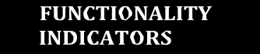
The SGC serves as a platform cultivating the spirit of bayanihan to support the school and encourage stakeholder participation in the implementation of DepEd policies and programs, while promoting equal opportunity for all regardless of age, gender, disability, marital status, ethnicity, and religious beliefs.

FI6 | FUNCTIONALITY INDICATOR 6
THE SGC HAS TAKEN PART IN THE CONDUCT OF NEEDS-BASED AND APPROPRIATE STAKEHOLDER-INITIATED PROGRAMS AND ACTIVITIES I.E., BRIGADA ESKWELA, GULAYAN SA PAARALAN, ETC..
A functional SGC has supported stakeholder-initiated programs and activities by encouraging active participation of the stakeholders.
FI6A | PRIMARY SUB-INDICATOR
- YES  - NO | The SGC has been involved in the development of stakeholder-initiated programs and activities.
- YES  - NO | If YES, prepare the following MOVs:
- YES  - NO | Minimum MOVs Additional MOVs  - Minutes of Meeting with stakeholders on stakeholder- □ Concept note / Project brief, or similar document initiated programs and activities (at least 1 meeting) (2 or more)  - Concept note / Project brief, or similar document (at □ Copy of the project proposal on stakeholder-initiated least 1) programs and activities  □ SIP, AIP, SRC, and SMEA (specify the page in the reports)
NOTE If the Primary Sub-Indicator is not met (NO), no need to comply with the Other Sub-Indicators.

FI6B | Other Sub-Indicator  The SGC has monitored and evaluated the impact/success of stakeholder-initiated programs and activities.
- YES
- NO
- YES  - NO | If YES, prepare the following MOVs:  Minimum MOVs Additional MOVs  - Report on the assessment / monitoring and evaluation □ Report on the assessment / monitoring and evaluation of stakeholder-initiated program and/or activity of stakeholder-initiated programs and/or activities (at least 1 program / activity) (for 2 or more programs / activities)  □ SIP, AIP, SRC, SMEA, and School Project Monitoring Reports
FI6C | Other Sub-Indicator  The SGC has established linkages with other stakeholders and/or referred potential partners to the School Head.
- YES
- NO
- YES  - NO | If YES, prepare the following MOVs:  Minimum MOVs Additional MOVs  - SGC resolution on the referral of the identified potential □ SGC resolution on the referral of the identified potential partner (at least 1 partner) partner (2 or more partners)  □ Copy of the MOA, DOD, DOA, etc., reflecting the name/s of the referred partner/s (at least 1 partner)

FI7 | FUNCTIONALITY INDICATOR 7
- YES  - NO | THE SGC HAS RECOMMENDED POLICIES AND PROGRAMS TO THE LOCAL SCHOOL BOARD (LSB) TO STRENGTHEN RELATIONSHIP WITH THE LGU.  A functional SGC has informed the LGU / community of the needs of the school to strengthen relationship and seek support.
- YES  - NO | If YES, prepare the following MOVs:
- YES  - NO | Minimum MOVs  - SGC Resolution recommending the SIP to LSB; or  - Any document recommending policy / program to the LSB, based on the SIP | Additional MOVs  - Proof of endorsement of the SGC Resolution to the SDS and transmittal to the LSB

Implementing Guidelines on the Establishment of School Governance Council (DO 26, s. 2022)

SGC FUNCTIONALITY ASSESSMENT TOOL
For Public Elementary Schools • 2026 Rollout

FI8 FUNCTIONALITY INDICATOR 8
- YES THE SGC HAS INVOLVED THE DIFFERENT SECTORS TO ENSURE INCLUSIVE
- NO REPRESENTATION OF STAKEHOLDERS IN THE COUNCIL.
A functional SGC has encouraged the participation of school stakeholders from all backgrounds or sectors to ensure inclusivity among members of the council.

If YES, prepare the following MOVs:
Minimum MOVs Additional MOVs
□ SGC Resolution on involving various sectors □ Official list of members with expanded membership
(inclusive and diverse in terms of age, gender, religion, ethnicity, and political beliefs)
□ SGC Resolution on inclusiveness, diversity, equity, and accessibility

MAIN PURPOSE: FEEDBACK MECHANISM
As a feedback mechanism, the SGC shall be a feedback link between the school stakeholders (learners, parents, and other school stakeholders) and school management (school head and personnel) on school performance and service quality.

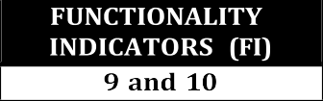
FUNCTION 1:
The SGC helps the school improve and sustain its feedback system by strengthening practices that promote stakeholders’ participation.

FI9 | FUNCTIONALITY INDICATOR 9
- YES  - NO | THE SGC HAS PARTICIPATED IN SCHOOL GENERAL ASSEMBLIES, PTA CONFERENCES, STAKEHOLDER CONVERGENCE, SOSA, AND/OR OTHER STAKEHOLDER ENGAGEMENT ACTIVITIES AND INITIATIVES.  A functional SGC has encouraged open communication among school internal and external stakeholders in order to gather feedback essential to making informed decisions and recommendations.
- YES  - NO | If YES, prepare the following MOVs:
- YES  - NO | Minimum MOVs  - SGC Report on the issues / concerns raised during school activities / events | Additional MOVs  - Minutes of Meetings (SGC meetings) where issues / concerns are discussed  - Photo documentation of school activities / events

FI10 FUNCTIONALITY INDICATOR 10
- YES  - NO | THE SGC HAS ORGANIZED DISCUSSIONS AND FORUMS THAT INVITE AND INSPIRE STAKEHOLDERS TO ENGAGE AND PARTICIPATE.  A functional SGC has established a platform for communication where school internal and external stakeholders can engage, participate, and provide feedback which will be used as basis for school improvement.
- YES  - NO | If YES, prepare the following MOVs:
- YES  - NO | Minimum MOVs Additional MOVs  - Documentation of the organized / conducted program □ Documentation of the organized / conducted program (at least 1) (2 or more), following the SGC’s Calendar of Events (as  - Minutes of the meetings where issues / concerns are provided by CO)  discussed □ Photo documentation of school activities / events

FUNCTION 2:
Implementing Guidelines on the Establishment of School Governance Council (DO 26, s. 2022)

SGC FUNCTIONALITY ASSESSMENT TOOL
For Public Elementary Schools • 2026 Rollout

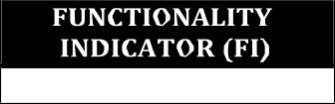
The SGC assists the school in ensuring transparency in its operations and performance, specifically school programs and resources management.

FI11 FUNCTIONALITY INDICATOR 11
THE SGC HAS ASSISTED THE SCHOOL IN COMMUNICATING INFORMATION TO THE SCHOOL STAKEHOLDERS THROUGH THE SRC, TRANSPARENCY BOARD, ETC..
A functional SGC has promoted transparency by utilizing various communication platforms to make school data and information accessible to school stakeholders.
FI11A | PRIMARY SUB-INDICATOR
- YES  - NO | The SGC has promoted access to school data and information through Transparency Board, SRC, and other reports on operations and performance of school programs and resource management.
- YES  - NO | If YES, prepare the following MOVs:
- YES  - NO | Minimum MOVs Additional MOVs  - SGC Resolution on access to information (school data □ Advocacy plan on the school's use of the Transparency and information) Board, SRC, and other reports to access school data  - SGC's Action Plan on promoting access to information □ School Head's endorsement on the use of the  Transparency Board, SRC, and other reports to access school data  □ Photo Documentation of the transparency board or bulletin board

NOTE If the Primary Sub-Indicator is not met (NO), no need to comply with the Other Sub-Indicators.

FI11B | Other Sub-Indicator
- YES  - NO | The SGC has established alternative communication platform/s (e.g., social media, such as but not limited to Facebook, Twitter, or Instagram, email or text blast, etc.) where information regarding SGC announcements and activities can be accessed from.
- YES  - NO | If YES, prepare the following MOVs:
- YES  - NO | Minimum MOVs Additional MOVs  - SGC Resolution on the use of approved alternative □ SGC's Alternative Communication Platform (with communication platform/s regular updates):  - Online (Link/s):  - Website:  - Facebook Page / Group:  - Other Platform/s:  - Offline (Copy of printed materials such as newsletters, posters, pamphlets, tarpaulin banners, etc.)

FUNCTION 3:
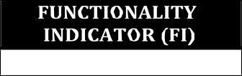
The SGC recommends ways of improving the quality of basic education services and school performance to the school management and school planning team, and its means of respecting, protecting, fulfilling, and promoting children’s rights in the education context.

FI12 | FUNCTIONALITY INDICATOR 12
- YES  - NO | THE SGC HAS SUGGESTED WAYS OF IMPROVING THE QUALITY OF SIP, AIP, AND OTHER DEPED PROGRAMS, PROJECTS, AND ACTIVITIES.  A functional SGC has communicated feedback and suggestions to school management in order to improve accomplishment of SIP, AIP, and other programs, projects, and activities.
- YES  - NO | If YES, prepare the following MOVs:
- YES  - NO | Minimum MOVs  - SGC Resolution on the recommendation on ways of improving the quality of SIP, AIP, and other DepEd programs, projects, and activities (at least 1) | Additional MOVs  - SGC Resolutions on the recommendations on ways of improving the quality of SIP, AIP, and other DepEd programs, projects, and activities (2 or more)

Enclosure No. 3 to DM-OUHRODI-2026- 3750_

Room 102, Rizal Building, DepEd Complex, Meralco Ave., Pasig City 1600 Telephone Nos.: (+632) 86337206, (+632) 86318494, (+632) 86366549

PROCESS FLOW OF THE DATA COLLECTION AND MONITORING OF THE SGC FUNCTIONALITY ASSESSMENT TOOL

To ensure smooth implementation of the SGC Functionality Assessment Tool, procedures on the Data Collection and Report Generation are stated below:

General Process Flow:
The General Process Flow below shall be broken down per Governance Level to better guide the Central Office (CO), Regional Offices (RO), Schools Division Offices (SDO), and schools of their roles and responsibilities regarding the accomplishment of the SGC Functionality Assessment Tool.
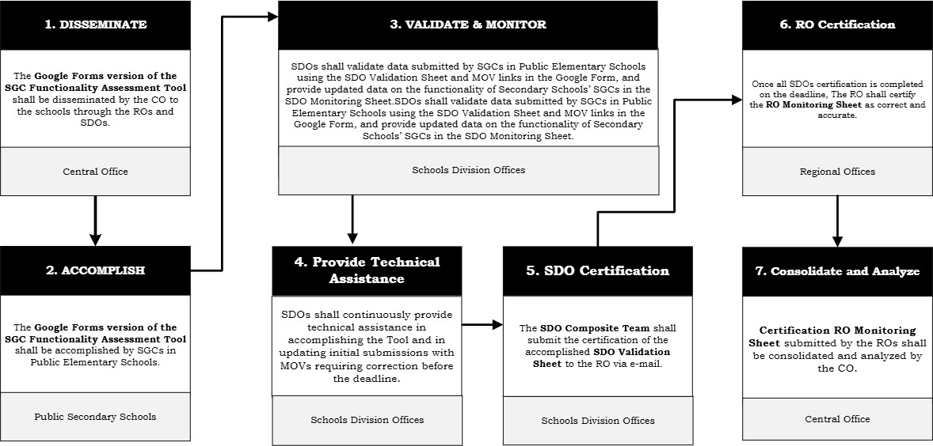

The process flow for the implementation of the SGC Functionality Assessment Tool outlines a structured and collaborative approach among the CO, RO, and SDOs to ensure accurate data collection, validation, certification, and analysis.

Dissemination
The process begins with dissemination. The CO disseminates the Google Forms version of the SGC Functionality Assessment Tool to schools through the RO and SDOs. This ensures that all concerned public elementary schools receive the official tool and proper guidance on its use. Clear communication at this stage is critical to establish uniform understanding and implementation procedures across regions and divisions.

Accomplishment
Following dissemination is the accomplishment phase. Only Public Elementary School SGCs are required to accomplish the Google Forms version of the assessment tool. At this stage, schools provide the required data and supporting Means of Verification (MOVs), ensuring that submissions are complete and aligned with the prescribed indicators of functionality.

Doc. Ref. Code | DM-OUHROD | Rev | 00
Effectivity | 03.23.23 | Page | 6 of 24

Validation and Monitoring

Room 102, Rizal Building, DepEd Complex, Meralco Ave., Pasig City 1600 Telephone Nos.: (+632) 86337206, (+632) 86318494, (+632) 86366549
Email Address: usec.hrod@deped.gov.ph | Website: www.deped.gov.ph
Once submissions are completed, the process moves to validation and monitoring at the SDO level. The SDO SGC Composite Team validates the data submitted by SGCs using the SDO Validation Sheet. In addition to validating elementary school submissions, the SDO SGC Composite Team also provides updated data on the functionality of secondary schools’ SGCs in the SDO Spreadsheet, using their own strategies for data collection. This step ensures data accuracy, completeness, and reliability prior to certification. Validation and monitoring serve as quality control mechanisms to uphold the integrity of the assessment results.

Provision of Technical Assistance
Parallel to validation, SDOs continuously provide technical assistance. This includes guiding schools in properly accomplishing the tool and correcting submissions with incomplete or inaccurate MOVs before the deadline. Technical assistance ensures that schools are supported throughout the process and are given opportunities to rectify deficiencies, thereby improving overall data quality.

RO and SDO Certification
After completing validation, the SDO SGC Focal person submits the certification of the accomplished SDO Validation Sheet to the RO via email. This SDO certification formally attests that the division has reviewed and validated all required submissions in accordance with established guidelines.

Subsequently, the RO SGC Focal person undertakes its certification process. Once all SDO certifications are completed within the deadline, the RO certifies the RO Monitoring Sheet as correct and accurate. This step confirms that the consolidated data from divisions within the region have undergone appropriate validation and meet reporting standards.

Consolidation and Analysis
The final stage is consolidation and analysis at the CO level. The certification of the RO Monitoring sheet submitted by the ROs are consolidated and analyzed by the CO. This enables the CO to generate comprehensive insights, inform planning and policy decisions, and support reporting requirements at the national level.

Overall, the process flow demonstrates a systematic framework. Each level, the school, division, region, and central office, plays a defined and complementary role. Through dissemination, accomplishment, validation, technical assistance, certification, and consolidation, the system ensures that data on SGC functionality are accurate, credible, and useful for continuous improvement and informed decision-making.

Doc. Ref. Code | DM-OUHROD | Rev | 00
Effectivity | 03.23.23 | Page | 7 of 24

Central Office

Room 102, Rizal Building, DepEd Complex, Meralco Ave., Pasig City 1600 Telephone Nos.: (+632) 86337206, (+632) 86318494, (+632) 86366549
Email Address: usec.hrod@deped.gov.ph | Website: www.deped.gov.ph
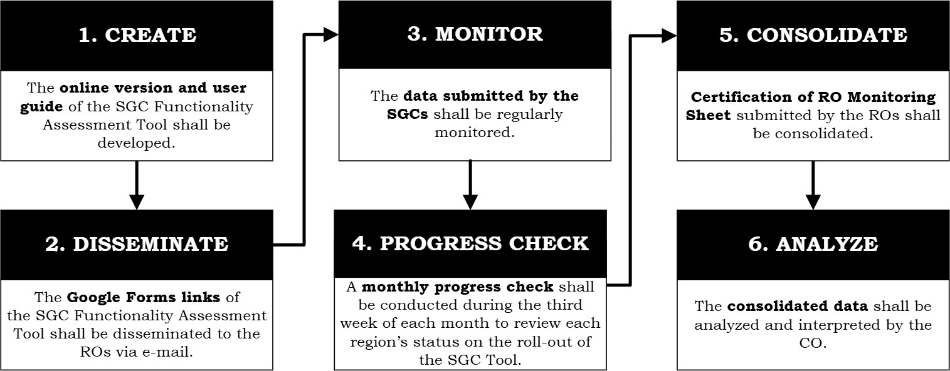
The diagram illustrates the six key responsibilities of the CO in the implementation of the SGC Functionality Assessment Tool. The process begins with the creation phase, wherein the CO develops the online version of the tool and its corresponding user guide and conducts consultations across governance levels to ensure standardized implementation and clear guidance. This foundational step ensures that the assessment instrument is technically sound, accessible, and aligned with policy objectives.

Dissemination
Following development, the CO undertakes the dissemination of the official Google Forms links to the ROs through formal communication channels. This ensures that only authorized and accurate materials are circulated and that the roll-out is properly initiated nationwide.

Monitoring
As implementation progresses, the CO performs a monitoring function by regularly tracking the data submitted by the SGCs. This oversight enables the identification of submission gaps, emerging concerns, and areas requiring technical assistance. In support of this, the CO also conducts a monthly progress check, typically during the third week of each month, to review each region’s status in implementing the tool and to ensure alignment with established timelines.

Consolidation
Subsequently, the CO facilitates the consolidation of certified RO monitoring sheets. This step ensures that all submitted data is validated, organized, and prepared for comprehensive review. Finally, the CO carries out the analysis of the consolidated data. Through systematic interpretation of results, it identifies trends, assesses the functionality of SGCs, and determines priority areas for policy guidance and targeted support. Collectively, these responsibilities demonstrate the CO’s role in ensuring a structured, accountable, and evidence-based implementation process.

Doc. Ref. Code | DM-OUHROD | Rev | 00
Effectivity | 03.23.23 | Page | 8 of 24

Regional Office
Doc. Ref. Code | DM-OUHROD | Rev | 00
Effectivity | 03.23.23 | Page | 9 of 24

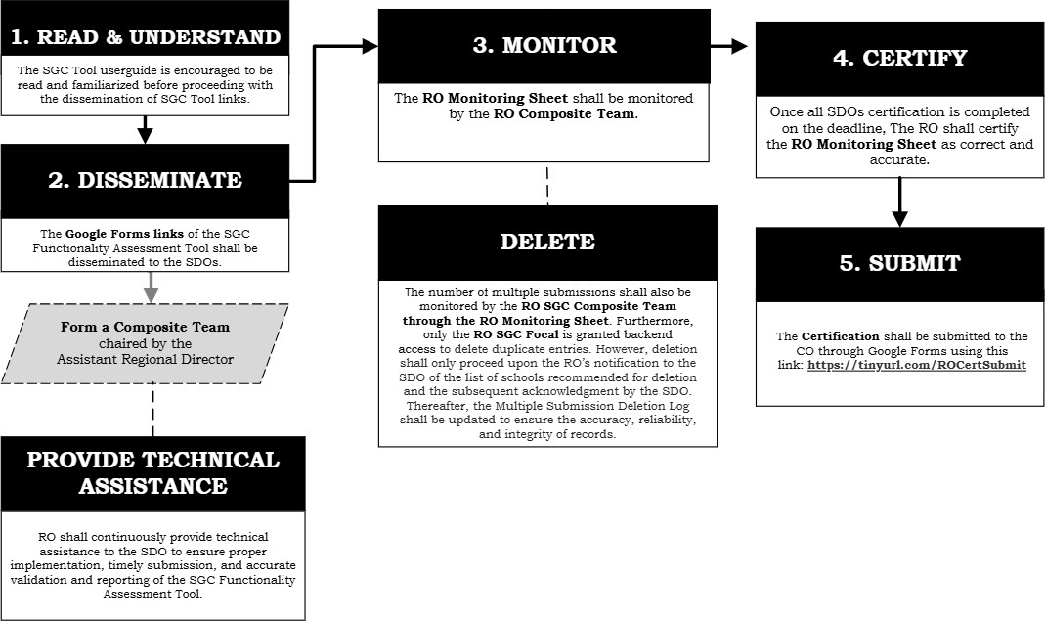

The process flow presents the role of the RO in the implementation of the SGC Functionality Assessment Tool, highlighting its oversight and coordination functions throughout the process.

Familiarization of User Guide Volume 1 and 2
The process begins with reading and understanding the SGC Functionality Assessment Tool User Guide. The RO is expected to familiarize itself with the guidelines to ensure clear direction and consistent implementation across all SDOs.

Dissemination
Next is dissemination. The RO distributes the official Google Forms links of the tool to the SDOs and organizes an RO Composite Team, chaired by the Assistant Regional Director, to oversee implementation within the region.

RO SGC Composite Team
The RO SGC Composite Team may be composed of three (3) to five (5) members, including the SGC Focal person. It may also include representatives from relevant functional units, as deemed appropriate, to promote objectivity, strengthen monitoring efforts, and ensure efficient provision of technical assistance throughout the implementation process.

Monitoring
The RO then proceeds with monitoring using the RO Spreadsheet. The RO Composite Team tracks submission status ensures timelines are met and addresses any issues that may arise during implementation.

Multiple Submission
Doc. Ref. Code | DM-OUHROD | Rev | 00
Effectivity | 03.23.23 | Page | 10 of  24

Part of the monitoring process includes the management of multiple submissions. The RO SGC Focal person is granted backend access to delete duplicate entries. However, deletion shall only proceed upon the RO’s notification to the SDO of the list of schools recommended for deletion and the subsequent acknowledgment by the SDO. Thereafter, the Multiple Submission Deletion Log shall be updated to ensure the accuracy, reliability, and integrity of records.

RO Certification and Submission to CO
Once all SDO certifications are completed, the RO SGC Focal person moves to certification, confirming that the RO Spreadsheet is correct and accurate.

Finally, the certified document is submitted to the CO through the prescribed Google Forms link, signifying the completion of the regional process.

Overall, the RO serves as the coordinating and quality-assurance body, ensuring that implementation is organized, monitored, accurate, and properly reported.

Continuous Provision of TA to SDO
Throughout the entire process, the RO SGC Composite Team continuously provides technical assistance to SDOs. This includes guidance on proper implementation, clarification of procedures, support in addressing data concerns, and reinforcement of validation standards. By sustaining technical support, the RO strengthens the capacity of divisions and promotes consistent, results-based functionality of SGCs.

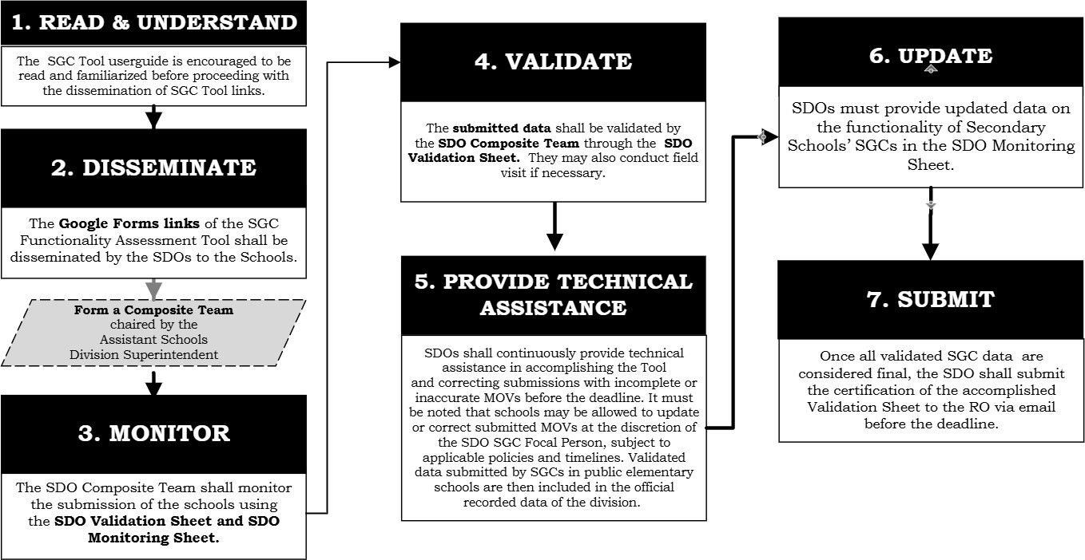
School Division Office

The process flow highlights the role of the SDO in implementing the SGC Functionality Assessment Tool. It outlines the sequence of actions from preparation to final submission and certification.

Familiarization of User Guide Volume 1 and 2
Doc. Ref. Code | DM-OUHROD | Rev | 00
Effectivity | 03.23.23 | Page | 11 of  24

The process begins with Read and Understand. The SDO is encouraged to thoroughly review and familiarize itself with the SGC Functionality Assessment Tool User Guide before disseminating the links of the too. This ensures clarity of procedures, proper guidance to schools, and consistent implementation within the division.

Dissemination
Next is Dissemination. The SDO disseminates the official Google Forms links of the SGC Functionality Assessment Tool to the public elementary schools. To effectively manage the process, the SDO forms a SDO SGC Composite Team, chaired by the Assistant Schools Division Superintendent. This team oversees monitoring, validation, and technical assistance within the division.

SDO SGC Composite Team
The SDO SGC Composite Team may be composed of three (3) to six (6) members, including the SDO SGC Focal person and the Public Schools Division Superintendent. It may also include representatives from relevant functional units, as deemed appropriate, to promote objectivity, strengthen monitoring efforts, and ensure efficient provision of technical assistance throughout the implementation process.

Monitoring
The third step is Monitoring. The SDO SGC Composite Team tracks school submissions using the SDO Spreadsheet. This allows the division to check progress, identify incomplete submissions, and ensure compliance with deadlines.

Validation
Following monitoring is Validation. The submitted data is validated by the SDO Composite Team through the SDO Validation Sheet. The team reviews the information and the MOVs. If necessary, field visits may be conducted to verify the accuracy and authenticity of submissions.

Provision of TA to Schools
Parallel to validation is the provision of Technical Assistance. The SDO SGC Composite Team continuously guides schools in properly accomplishing the tool and in correcting submissions with incomplete or inaccurate MOVs before the deadline. However, it must be noted that the SDO SGC Focal Person shall have the discretion to determine whether schools will be permitted to update or correct their submitted MOVs, subject to applicable policies and timelines. Validated data submitted by SGCs in public elementary schools are then included in the official recorded data of the division.

Updated data on the Functionality Status of SGCs in Secondary Schools
The next step is Update. The SDO SGC Composite Team provides updated data on the functionality of SGCs in Secondary Schools in the SDO Monitoring Sheet. This ensures that both elementary and secondary school data are properly captured and reflected at the division level.

Submission of SDO Certification to RO
Finally, once all validated SGC data are confirmed as complete and accurate, the SDO SGC Focal person proceeds to Submit. The certification of the accomplished SDO Spreadsheet is submitted to the RO via email before the deadline.

Overall, the SDO SGC Composite Team plays a central coordinating and quality assurance role, guiding schools, validating submissions, providing technical support, updating monitoring records, and formally certifying the division’s data for regional consolidation
Doc. Ref. Code | DM-OUHROD | Rev | 00
Effectivity | 03.23.23 | Page | 12 of  24

Public Elementary Schools
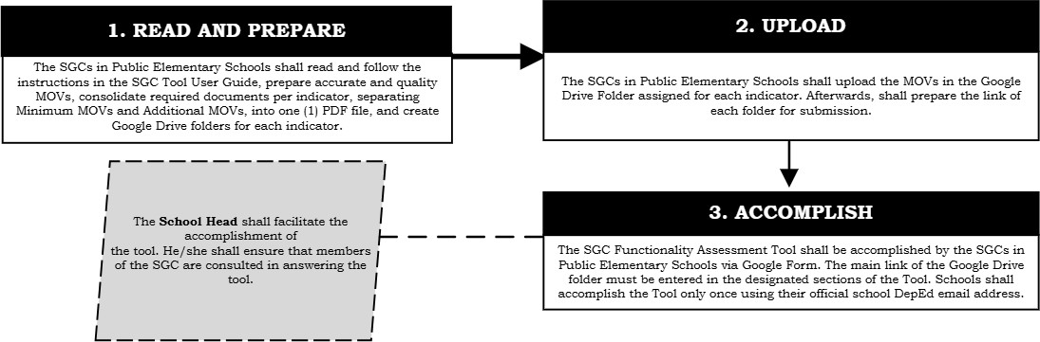

The process flow outlines the process at the school level, specifically for SGCs in public elementary schools, in accomplishing the SGC Functionality Assessment Tool.

Read the Materials and Prepare the Documents
The process begins with Read and Prepare. SGCs are expected to carefully read and follow the instructions in the SGC Functionality Assessment Tool User Guide. They must prepare accurate and quality MOVs and consolidate the required documents per indicator. Schools are instructed to separate Minimum MOVs from Additional MOVs and compile them into one (1) PDF file per indicator. In addition, Google Drive folders must be created for each indicator to organize and store the supporting documents properly.

Facilitation of Accomplishment of the SGCFAT
During this stage, the School Head plays a key role in facilitating the school’s submission. The School Head ensures that the tool is properly accomplished and that members of the SGC are consulted in answering the assessment. This promotes collaboration, transparency, and collective ownership of the submission.

Uploading of MOVs
The next step is Upload. The School Head, together with the SGC, shall facilitate the uploading of the prepared MOVs to the designated Google Drive folders assigned for each indicator. After uploading, they shall generate or copy the link to the Google Drive folder, which contains subfolders for each MOV per functionality indicator, for use in the submission to the assessment tool.

Accomplishment of the SGCFAT
Finally, the SGC proceeds to Accomplish the SGC Functionality Assessment Tool via Google Form. In accomplishing the form, the school must ensure the use of an active and official DepEd email address. The link to the corresponding Google Drive

folder must be provided in the designated section of the form. Schools are reminded that the tool shall be accomplished only once; thus, careful review and completeness of all entries must be ensured prior to final submission.
Doc. Ref. Code | DM-OUHROD | Rev | 00
Effectivity | 03.23.23 | Page | 13 of  24

Overall, the school-level process ensures that submissions are well-prepared, properly documented, collaboratively completed, and systematically organized before being formally submitted through the online assessment tool.

Enclosure No. 4 to DM-OUHRODI-2026- 3750_
Doc. Ref. Code | DM-OUHROD | Rev | 00
Effectivity | 03.23.23 | Page | 14 of  24

ROLES AND RESPONSIBILITIES PER GOVERNANCE LEVEL AS MANDATED BY DEPED ORDER NO. 26, s. 2022

ROLES AND RESPONSIBILITIES OF THE SCHOOL HEAD
The School Head shall ensure that all decisions, directions, and initiatives of the council are aligned with and responsive to the school’s needs, priorities, and context.

  - Inform SGC members of the reasons, risks, and implications of any disapproval, partial approval, or modification of recommendations during the consultation process.
  - Implement policies in partnership with SGC that are in accordance with DepEd policies, administrative instructions, and government legislation.
  - Provide accurate and timely updates on the progress of activities supporting the SIP.
  - Build inclusive school and community networks by ensuring participation and representation of all stakeholder groups in the school improvement process.
  - Forward approved SGC recommendations to the appropriate committee, office, or individual for implementation or necessary action.
  - Orient the designated and elected co-chairpersons on SGC updates and activities and ensure proper turnover of all SGC documents in case of a mid-year change in school leadership.
  - Oversee the SGC elections for Co-Chairperson and Secretary and canvass the votes before the SGC members.

ROLES AND RESPONSIBILITIES OF THE SCHOOLS DIVISION OFFICE
(Through the Schools Governance and Operations Division – SGOD)
The SDO shall provide technical assistance to schools for the proper establishment and management of School Governance Councils. Specifically, the SDO shall:

  - Orient and conduct capacity-building activities for school heads and personnel.
  - Conduct situational assessments and needs analyses of schools in implementing the guidelines.
  - Develop operational guidelines and implementation plans aligned with RO policies and national directives.
  - Provide timely and appropriate technical assistance to schools, including but not limited to providing support in resolving issues related to the conduct of SGC elections.
  - Maintain and update a database of SGC officers-elect and a list of disqualified members for reference.
  - Ensure compliance with procedures for the removal of SGC members.
  - Monitor SGC performance in implementing council programs, projects, and activities.
  - Track and analyze the implementation and results of technical assistance interventions.
  - Monitor compliance with and implementation of the guidelines.

ROLES AND RESPONSIBILITIES OF THE REGIONAL OFFICE
Doc. Ref. Code | DM-OUHROD | Rev | 00
Effectivity | 03.23.23 | Page | 15 of  24

(Through the Field Technical Assistance Division- FTAD)
The RO shall provide technical assistance to SDO for the proper monitoring of School Governance Councils. Specifically, the RO shall:

  - Ensure regional compliance with the provisions of DepEd Order No. 26, s. 2022.

  - Develop operational guidelines and implementation plans aligned with national policies

  - Conduct needs analyses of SDOs to strengthen supervision of policy implementation.

  - Facilitate quality assurance by ensuring that guidelines are implemented in a timely, relevant, and standards-compliant manner.
  - Maintain records and regional database documenting program impacts and best practices of SGC-implemented initiatives.

  - Provide relevant, timely, and needs-based technical assistance to SDOs.
  - Monitor and evaluate the implementation of technical assistance interventions through the Regional Technical Assistance Team (RFTAT) headed by the FTAD.

  - Consolidate and submit regional reports to the CO within prescribed timelines.

ROLES AND RESPONSIBILITIES OF THE CENTRAL OFFICE
(Through Bureau of Human Resources and Organizational Development-School Effectiveness Division BHROD-SED)

The CO shall provide technical assistance to RO for the proper implementation of DepEd Order 26, s. 2022. Specifically, the CO shall:

  - Provide policy direction and technical guidance on SGC implementation and functionality assessment.

  - Orient focal persons on policy implementation.

  - Conduct capacity-building activities to support effective and efficient policy implementation.

  - Facilitate periodic monitoring and evaluation of policy implementation.

  - Undertake policy reviews to strengthen the effectiveness of the guidelines.

  - Provide technical assistance to RO and other governance levels.

  - Develop and disseminate advocacy and communication materials, such as policy orientation guides, manuals, instructional videos, and other supplemental resources, to support and strengthen policy implementation.
Doc. Ref. Code | DM-OUHROD | Rev | 00
Effectivity | 03.23.23 | Page | 16 of  24

Enclosure No. 5 to DM-OUHROD-2026- 3750
Doc. Ref. Code | DM-OUHROD | Rev | 00
Effectivity | 03.23.23 | Page | 17 of  24

ROLES AND RESPONSIBILITIES PER GOVERNANCE LEVEL IN THE IMPLEMENTATION OF THE SGC FUNCTIONALITY ASSESSMENT TOOL

- ROLES AND RESPONSIBILITIES OF THE SCHOOL HEAD AND SGC
The School Head shall oversee and facilitate the completion of the SGC Functionality Assessment Tool at the school level, ensuring accurate reporting and full compliance of the SGC with the required MOVs pursuant to DepEd Order No. 26, s. 2022.
Specifically, the School Head, in collaboration with the SGC, shall:
  - Follow the User Guide Volume 1: Prepare and Respond when completing the Google Form and strictly adhere to the submission protocols specifying only one submission per school.
  - Organize and label all MOVs, create a dedicated Google Drive folder, and upload the submissions with the appropriate sharing permissions.

  - Prior to submission, conduct a school-level quality assurance review to verify that all entries and MOVs are accurate, complete, organized, and adhere to required standards.
  - Prepare links for all submitted MOVs and copy-paste them under the corresponding indicators in the Google Form.

  - Double-check the status of validated MOVs to ensure accuracy, completeness, and compliance.

  - Address and respond promptly to follow-up communications or clarifications from the SDO or RO, and proactively raise any issues or concerns encountered in accomplishing the tool or uploading MOVs for appropriate guidance.
  - In the event of a reassignment or transfer, the school head shall formally inform the concerned SDO SGC Focal Person and ensure the complete and orderly turnover of all SGC-related documents, records, information, and responsibilities to the incoming school head to ensure the continuity and effective functioning of the SGC.

ROLES AND RESPONSIBILITIES OF THE SCHOOL DIVISION OFFICE
(Through the Schools Governance and Operations Division – SGOD and the members of the SDO SGC Composite Team)
The SDO shall provide technical assistance to schools in the implementation of DepEd Order No. 26, s. 2022 and in the accomplishment of the SGC Functionality Assessment Tool.

Specifically, the SDO shall:

  - Organize an SDO SGC Composite Team chaired by the Assistant Schools Division Superintendent (ASDS). The Composite Team members shall be composed of three (3) to five (5) members, including the SDO SGC Focal Person. The team may include representatives from relevant functional units,

as deemed appropriate, to ensure objectivity and efficiency in validation and in providing technical assistance.
Doc. Ref. Code | DM-OUHROD | Rev | 00
Effectivity | 03.23.23 | Page | 18 of  24

  - Coordinate and provide guidance and technical support to schools through field visits, virtual meetings, online consultations, written advisories, and helpdesk assistance. Attend to issues raised by schools and collaborate with the RO as needed to ensure the effective implementation of the SGC Functionality Assessment Tool.

  - Follow User Guide Volume 2: Validate and Monitor in validating and monitoring submitted Means of Verification (MOVs) in accordance with the qualifications and standards mandated under DepEd Order No. 26, s. 2022.

  - Coordinate with the RO SGC focal person to obtain access to the SDO SGC Functionality Assessment Tool and SDO Spreadsheet.
  - Validate the submitted MOVs and coordinate with the schools to address any corrections or clarifications needed.

  - Double-check the status of validated MOVs to ensure accuracy, completeness, and compliance.

  - Provide guidance to schools regarding the updating or correction of submitted MOVs. The SDO SGC Focal Person shall have the discretion to determine whether schools will be permitted to update or correct their submitted MOVs, subject to applicable policies and timelines.

  - Update and accomplish the SDO Spreadsheet in a timely manner.
  - Disseminate the directions and advocacy materials produced by the CO to all concerned SDOs, public schools to ensure proper implementation and consistent understanding of the initiative.

  - Submit a certification to the RO for confirmation and official recording of validated results.

ROLES AND RESPONSIBILITIES OF THE REGIONAL OFFICE
(Through the Field Technical Assistance Division- FTAD and members of the RO SGC Composite Team)
The RO shall provide technical assistance to the SDO in the implementation of the SGC Functionality Assessment Tool. Specifically, the RO shall:
  - Organize an RO SGC Composite Team chaired by the Assistant Regional Director (ARD). The Composite Team members shall be composed of three (3) to five (5) members, including the SDO SGC Focal Person. The team may include representatives from relevant functional units, as deemed appropriate, to ensure objectivity and efficiency in validation and in providing technical assistance.

  - Coordinate and provide guidance and technical support to SDOs through various modalities, such as field visits, virtual meetings, online consultations, written advisories, and helpdesk assistance, to ensure a clear understanding

of the policy requirements under DepEd Order No. 26, s. 2022 and the proper implementation of the SGC Functionality Assessment Tool.
Doc. Ref. Code | DM-OUHROD | Rev | 00
Effectivity | 03.23.23 | Page | 19 of  24

  - Refer to User Guide Volume 2: Validate and Monitor to monitor the functionality and response rate of schools within each SDO.

  - Monitor the functionality and response rate of schools within each SDO, and conduct spot-checking of MOVs to ensure the validity, correctness, and accuracy of submitted data. However, the RO is not permitted to make changes to the validation status. In cases where discrepancies or issues are identified, the RO shall inform the SDO SGC Focal person for appropriate action.

  - Monitor, manage, and track multiple submissions from schools.
  - Disseminate the directions and advocacy materials produced by the CO to all concerned ROs, SDOs, and public elementary schools to ensure proper implementation and consistent understanding of the initiative.

  - Submit a certification of finalized results to the CO via Google Form.
  - Ensure that access to the SGC Functionality Assessment Tool and Spreadsheets are limited only to authorized personnel at each governance level. The RO must also clearly communicate and regulate who is permitted to view or edit the links prior to its dissemination. (Refer to Enclosure 9 for reference of authorized personnel at each governance level to access the links)

ROLES AND RESPONSIBILITIES OF THE CENTRAL OFFICE
(Through Bureau of Human Resources and Organizational Development-School Effectiveness Division BHROD-SED)

The CO shall facilitate the implementation of the SGC Functionality Assessment Tool and provide technical assistance to the RO.
Specifically, the CO shall:
  - Develop and roll out the SGC Functionality Assessment Tool (Online Form), including the corresponding RO and SDO Spreadsheets.

  - Develop User Guide Volume 1: Prepare and Respond and User Guide Volume 2: Validate and Monitor to support the proper and standardized implementation of the tool.
  - Coordinate regularly with RO SGC focal person to monitor the roll-out and extend technical assistance, as necessary.
  - Conduct monthly progress check-ins with RO SGC focal person to monitor implementation status, address emerging issues, and provide necessary technical assistance in a timely manner.
  - Develop and disseminate advocacy and communication materials to promote awareness and ensure effective implementation of the SGC Functionality Assessment Tool.

  - Consolidate all Certifications and official submissions from the RO regarding the roll-out of the tool.
Doc. Ref. Code | DM-OUHROD | Rev | 00
Effectivity | 03.23.23 | Page | 20 of  24

  - Conduct a comprehensive analysis of the final validated data and prepare the corresponding summary report to inform policy directions and program improvements pursuant to DepEd Order No. 26, s. 2022.

Enclosure No. 6 to DM-OUHRODI-2026- 3750_ SDO SPREADSHEET
Doc. Ref. Code | DM-OUHROD | Rev | 00
Effectivity | 03.23.23 | Page | 21 of  24

SDO VALIDATION SHEET
The SDO Validation Sheet is used by the SDO SGC Composite Team to validate the completeness and accuracy of data and supporting documents submitted by public elementary schools through the Google Forms version of the SGC Functionality Assessment Tool. It serves as the basis for documenting the results of the validation prior to SDO certification.

The SDO Validation Sheet may be accessed through the link to be disseminated by the RO SGC Focal.
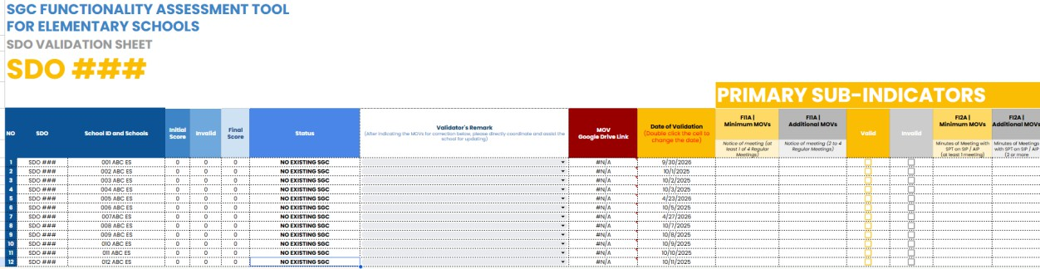

SDO MONITORING SHEET

The SDO Monitoring Sheet is used by the SDO SGC Composite Team to monitor the submission and validation status of public elementary schools, including submission rates, responding and non-responding schools, SGC functionality status, and validation concerns requiring further action or remarks.

The SDO Monitoring Sheet may be accessed through the link to be disseminated by the RO SGC Focal.
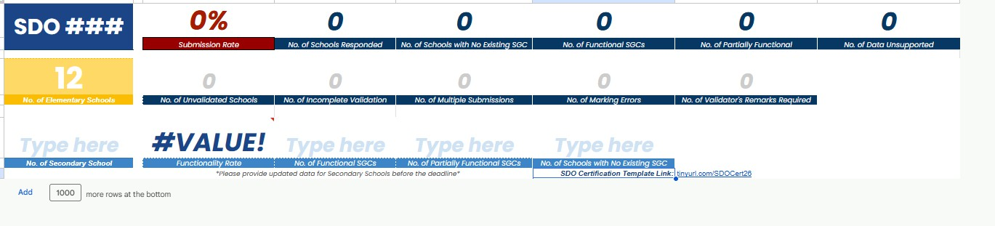

Enclosure No. 7 to DM-OUHRODI-2026- 3750_ RO SPREADSHEET
Doc. Ref. Code | DM-OUHROD | Rev | 00
Effectivity | 03.23.23 | Page | 22 of  24

RO MONITORING SHEET
The RO Monitoring Sheet is used by the RO SGC Composite Team to monitor the status of SGCs across divisions, including school responses, SGC functionality status, validation status, and concerns requiring further action or validators’ remarks.

The RO Monitoring Sheet may be accessed through the link provided in Enclosure No. 9, which will be disseminated via email to the RO SGC Focal only.
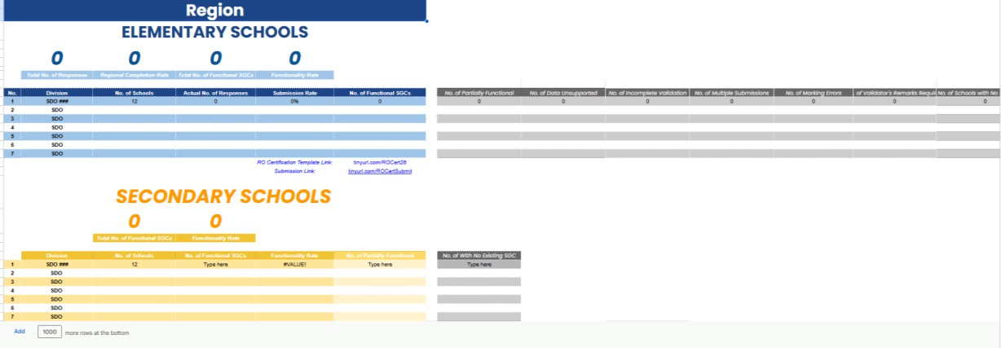

MULTIPLE SUBMISSION DELETION LOG

The Multiple Submission Deletion Log serves as a reference for the RO SGC Focal to track the deletion of duplicate submissions from schools with multiple submissions. The RO SGC Focal shall mark the corresponding checkbox for each school whose duplicate submissions have been deleted and indicate the date of deletion in Row 5 to document when the action was conducted.
The Multiple Submission Deletion Log may be accessed through the link provided in Enclosure No. 9, which will be disseminated via email exclusively to the RO SGC Focal.
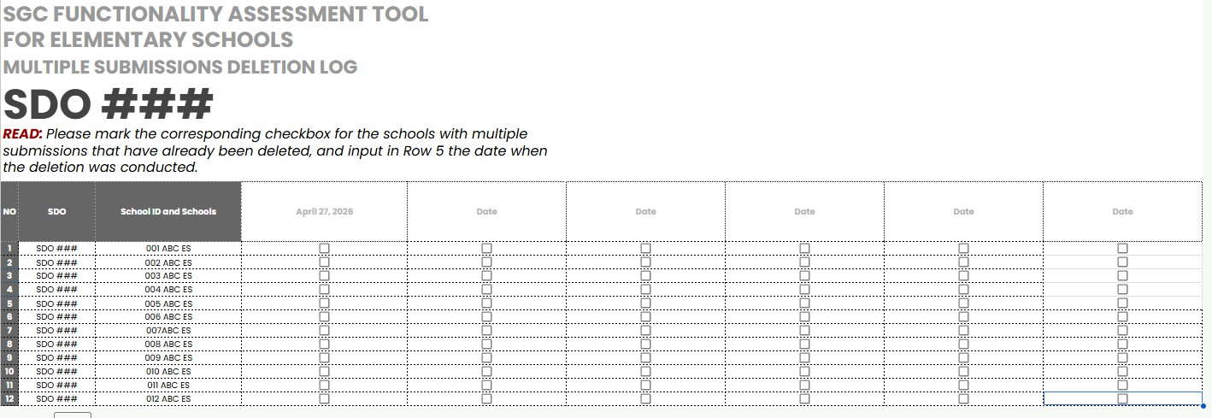

Enclosure No. 8 to DM-OUHRODI-2026- 3750_
22
Doc. Ref. Code | DM-OUHROD | Rev | 00
Effectivity | 03.23.23 | Page | 23 of  24

TIMELINE OF ACTIVITIES RELATIVE TO THE ROLL-OUT OF THE SGC FUNCTIONALITY ASSESSMENT TOOL

Date | Activity
March-April 2026 | Online Consultation on the Development of the SGC Functionality Assessment Tool
May 2026 | Pilot Testing of the SGC Functionality Assessment Tool
June-August 2026 | Technical Assistance Workshop on the SGC Functionality Assessment Tool with the RO and SDO
September 29 , 2026 | Roll-Out of the SGC Functionality Assessment Tool for Elementary School
October 2026 (3rd Week) | Monthly Progress Checking with RO SGC Focal person
November 2026 (3rd Week) | Monthly Progress Checking with RO SGC Focal person
December 2026 ( 3rd Week) | Monthly Progress Checking with RO SGC Focal person
January 2027 (3rd Week) | Monthly Progress Checking with RO SGC Focal person
February 2027 (3rd Week) | Monthly Progress Checking with RO SGC Focal person
March 2027 (3rd Week) | Monthly Progress Checking with RO SGC Focal person
March 31, 2027 | Closure of the Multiple Submission Deletion Log  (This signifies that deletion of multiple submissions will no longer be permitted after the specified date. Accordingly, SDOs are advised to coordinate with their respective RO regarding schools with multiple submissions that require deletion.  SDOs must also properly reiterate to all concerned schools the importance of avoiding multiple submissions beyond this date)
March 31, 2027 | Closure of the SGC Functionality Assessment Tool (Online Form)
April 2027 (3rd Week) | Monthly Progress Checking with RO SGC Focal person

April 30, 2027 | Closure of the SGC RO and SDO Spreadsheets  (SDOs must properly reiterate to all concerned schools that updates or corrections to submissions shall only be allowed if permitted by the SDO within the prescribed period)
May 5, 2027 | Deadline for submission of SDO Certifications to the RO.
May 14, 2027 | Deadline for submission of RO Certifications to the CO.
May 2027  (3rd Week) | Monthly Progress Checking with RO SGC Focal person
Doc. Ref. Code | DM-OUHROD | Rev | 00
Effectivity | 03.23.23 | Page | 24 of  24

Note: Each governance level is highly encouraged to use the timeline as a reference in planning and implementing technical assistance activities related to the roll-out of the SGC Functionality Assessment Tool.

