

Office of the Schools Division Superintendent

DIVISION MEMORANDUM No. 0440 , s. 2026

CONDUCT OF WORLD TEACHERS’ DAY 2026
To: Assistant Schools Division Superintendent Chief, CID and SGOD
Education Program Supervisors Public Schools District Supervisors
Public Elementary and Secondary School Heads
September 29, 2026

- The Department of Education (DepEd), through DepEd Memorandum No. 051, s. 2026, entitled “2026 National Teachers’ Month, National Teachers’ Day, and World Teachers’ Day Celebrations,” provides the guidelines and implementing arrangements for the nationwide celebration of National Teachers’ Month and World Teachers’ Day. The World Teachers’ Day shall be celebrated on October 5, 2026 in Schools.

- The school-based celebration shall be anchored on the official 2026 National Teachers’ Month and World Teachers’ Day theme, “Teacher, Ikaw Naman,” and shall complement the national activities of the Department of Education. Schools are encouraged to contextualize the celebration according to their respective school environments, resources, and traditions while ensuring that activities remain aligned with the objectives and spirit of the national celebration.

- The school-based celebration aims to:

  - recognize and celebrate the invaluable contributions, dedication, and commitment of teachers to learners, schools, families, and communities;
  - provide teachers with meaningful opportunities for appreciation, recognition, fellowship, and celebration;
  - strengthen a culture of gratitude, respect, and support for teachers and the teaching profession;
  - highlight the important role of teachers in learner development, school improvement, community building, and nation-building; and
  - promote a positive and supportive school environment that values the well-being, dignity, and professional contributions of teachers.




Plaridel Street, Centro, Mandaue City
(032) 238-4179, (032) 238-4547 | mandaue.city001@deped.gov.ph  DepEd Tayo Mandaue City 🌐 www.depedmandaue.net

- Schools are encouraged to host appropriate school-based celebrations on October 5, 2026, including reciting A Prayer for Teachers or Panalangin para sa mga Guro. Additionally, schools should integrate NTM and WTD themes, goals, and key messages into lesson plans, classroom discussions, and school activities to foster a deeper appreciation for teachers and their essential role in nation-building.

- Each school shall maintain appropriate documentation of its celebration, which may include:

  - program of activities;
  - attendance/participation documentation, as appropriate;
  - photographs and other documentation of significant activities; and
  - a brief accomplishment report.

The Schools Division Office, through the appropriate Division Unit, may request selected documentation for purposes of consolidation, reporting, and recognition of school initiatives. Upload it here: https://tinyurl.com/WTDReport2026


- All Public Schools District Supervisors, Education Program Supervisors, SGOD Personnel and concerned Division personnel are enjoined to provide appropriate technical assistance and support to schools in the implementation of this Memorandum.

- Expenses incurred in the conduct of the school-based celebration may be charged against available school other funds subject to existing budgeting, accounting, auditing, procurement, and applicable DepEd rules and regulations.

- All concerned are enjoined to give this Memorandum their full support and cooperation and to ensure a meaningful, respectful, and memorable celebration of World Teachers’ Day 2026.

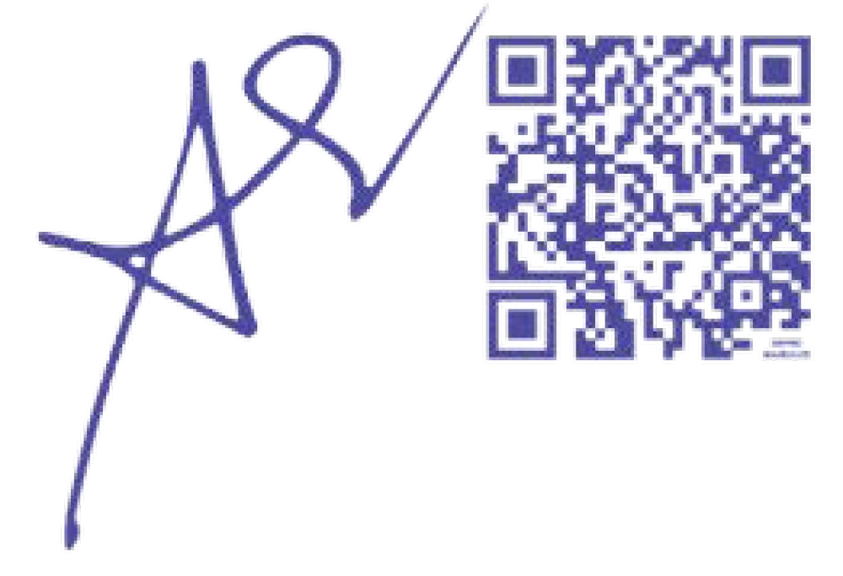
- This Memorandum shall take effect immediately upon issuance.


BIANITO A. DAGATAN EdD, CESO
V
Schools Division Superintendent
SDS/ASDS/SGOD/ACL/mcs March 10, 2026

