**TECH-HELP: YOUR ONLINE COMPUTER**

**TROUBLESHOOTING COMPANION**

A Senior Project

Presented to the Faculty of the

College of Computer Studies

Computer Arts and Technological College

In Partial Fulfillment

Of the Requirement for the Degree of

Bachelor of Science in Information Technology

by

STANLEY BAÑAGA MENDOZA

JOHN MICHAEL DEUDA ECHEMANI

May 2023

**TABLE OF CONTENTS**

Page

TITLE PAGE . . . . . . . . . . . . . . . . . . . . . . . . . . 1

TABLE OF CONTENTS . . . . . . . . . . . . . . . . . . . . . . 2

CHAPTER

1 PROJECT OVERVIEW

Background of the Study . . . . . . . . . . . . . . 4

Company Profile . . . . . . . . . . . . . . . . . . 5

Importance of the Study . . . . . . . . . . . . . . 10

Statement of the Problem . . . . . . . . . . . . . 11

Objectives of the Study . . . . . . . . . . . . . . 12

Definition of Terms . . . . . . . . . . . . . . . . 12

2 METHODOLOGY

Software Development Methodology . . . . . . . . . 15

Scope and Delimitation of the Study . . . . . . . . 21

Data Gathering Techniques . . . . . . . . . . . . . 22

Sources of Data . . . . . . . . . . . . . . . . . . 23

REFERENCES . . . . . . . . . . . . . . . . . . . . . . . . . . 25

FIGURES

Rad Model . . . . . . . . . . . . . . . . . . . . . 17

Use Case Diagram . . . . . . . . . . . . . . . . . 27

Sequence Diagram . . . . . . . . . . . . . . . . . 30

Data Flow Diagram . . . . . . . . . . . . . . . . . 31

Chapter 1

**PROJECT OVERVIEW**

**Background of the Study**

Computer system (hardware, software and network connection) is getting broader from time to time especially now that the world is in digital age. With the rapid advancement of technology, computer troubleshooting has become an essential skill in both personal and professional settings. Understanding the principles of troubleshooting and developing practical problem-solving techniques can improve efficiency and reduce downtime. Computer troubleshooting is the process of identifying and resolving problems with computer hardware or software. When a computer malfunctions or does not perform as expected, troubleshooting is necessary to diagnose and fix the issue. Common problems include system crashes, slow performance, software errors, and hardware failures. Troubleshooting may involve testing different components, performing diagnostic checks, updating or reinstalling software, and replacing faulty hardware. It requires a logical and systematic approach to isolate the root cause of the problem and find the appropriate solution. Effective troubleshooting skills are essential for anyone who uses a computer, from casual users to IT professionals. The resolution of these issues requires the expertise of Information and Communication Technology (ICT) technicians. However, the current approach utilized by these technicians to solve computer-related problems is based on traditional (manual) methods. Consequently, this approach is time-consuming and expensive, leading to prolonged problem-solving timelines and increased costs.

Expert systems (ES) are a branch of applied artificial intelligence (AI), and were developed by the AI community in the mid-1960s. The basic idea behind ES is simply that expertise, which is the vast body of task-specific knowledge, is transferred from a human to a computer. This knowledge is then stored in the computer and users call upon the computer for specific advice as needed. The computer can make inferences and arrive at a specific conclusion. Then like a human consultant, it gives advices and explains, if necessary, the logic behind the advice (Turban & Aronson, 2001). Expert systems are capable of providing robust and versatile approaches to obtaining solutions for a wide range of problems that are frequently beyond the scope of traditional or orthodox methods. Consequently, the utilization of expert systems is increasingly expanding to various domains of our social and technological landscape, where their implementation is demonstrating essential value in supporting decision-making and addressing intricate problem-solving scenarios.

People are having issues with regards to their computer and sometimes, assistance from computer literate person are what people need to solve their problem. Computer troubleshooting system will be able to help these people, whether these are technicians, students, or any interested individual. This can be a way for users to self-learn for troubleshooting personal computers. This system can be utilized for learning aids of students or for technicians to avoid more complex searches online.

The computer troubleshooting expert system presents the users with a list of guiding questions, when answered; provide the system with information about what problem sets the issue may belong to, and which ones it does not belong to. It then generates another list of questions that apply to subsets of those identified questions. After finding specific causes the system provides possible troubleshooting mechanism for the user. This process can save time, energy and cost through by saving the current list of questions and possible solutions (C. Cameron, 2005).

Self-learning expert system has ability to make computer troubleshooting process automatic and help ICT professional to find the cause within few seconds, save energy and financial cost in fault maintaining process. Computer components are classified basically into two: such as hardware and software. The hardware itself classified into different specific components and software is also classified into application software and system software. (Ergado, A. A.,2016).

According to Insorio and Macandog (2022), When video lessons are used alongside module lessons, they can aid students in better understanding concepts. Students find YouTube videos helpful because they can see the teacher visually demonstrate the subject matter. Students often ask their teacher to provide more videos with clear and concise explanations and additional examples.

According to Listiani et al. (2021), Oddone (2011), and Tadbier and Shoufan (2021), By utilizing YouTube, students have the opportunity to enhance crucial skills, including their ability to listen, expand their vocabulary, meet learning objectives, and better themselves. Through watching YouTube videos, students engage both their sight and hearing, and are exposed to real-world objects, which can aid in their understanding of concepts.

People do not use textbooks these days for guidance, they simply use online browsers to fix their problems. Filipinos are one of the people who consumes more time in social media. According to Katharina Buchholz (2020), The Philippines spent the most time connected to social networks, devoting just over four hours a day to the digital sphere. Nigerians typically spent more than three and a half hours a day on social media sites, while Indians and Chinese clocked more than 2 hours each per days.

An expert system like this will be a help for people who often use and spend their time on social media. It can reduce the hassle of searching for textbooks or asking for professional guidance and even searching on YouTube for tutorials. Local technicians, whether in a small business company or a self-taught individual from Legazpi often encounter these difficulties and to assist them, the researcher saw the trouble that these people encountered and thought of a system that can help find the faults and troubleshoot the malfunctioning computer.

The researcher proposed this study because of its timeliness. It is a common phenomenon for users with computer to encounter difficulties on identifying what to fix inside their computer. With the help of this proposed system, they will be able to determine the problem and do the proper task to take. The researcher chooses this topic because of its timeliness and one of the problems encountered by many computer users that can be prevented in a most efficient way.

**Company profile**

Denver’s Computer Shoppe, Inc. started as a small computer shop at the Mezzanine Floor of Los Bańos Building along Rizal Street in Legazpi City, on May 06, 1995.

Due to the strong demand of satisfied customers along the lines of information technology (IT), the Company slowly made its niche to become one of the most respected computer store in the area, not only in Legazpi City but the entire Bicol Region as well. The store transferred to a much bigger area at the ground floor of Los Bańos Building.

To handle the big clientele in other parts of the Bicol Region, the computer shop opened a branch in Sorsogon City on February 8, 2008, at Naga City on February 8, 2009, at Landco, Legazpi on February 8, 2012 and recently at the Ayala Malls Legazpi City, the Acer and Lenovo Exclusive Stores on May 16, 2016.

In line with its expansion program, several branches shall be opened at the right place, at the right time where big opportunity thrives.

**Importance of the Study**

The researcher in this study believes that this paper will not only serve as mere paperwork but to provide insightful information for its readers and for the future researchers and will also be beneficial for the following:

Students. The students will be introduced to and will gain more knowledge about the computer issues and the measures to fix them.

People with computers. This study benefits individuals with limited computer maintenance knowledge by empowering them, providing convenience, saving costs and time, facilitating continuous learning, and making computer troubleshooting accessible to all.

Teachers. The context of this study can be very beneficial for the teachers and take advantage of this knowledge for effective teaching with the new system.

Schools. This research will provide relevant information so that the school can make improvements to their teaching and system.

Computer Technicians. The technicians will benefit to this study and the system itself because the context is all about their expertise.

Society. The study has the potential to make a positive impact on society by increasing accessibility to technology, saving costs, improving time efficiency, fostering skill development, and contributing to the collective knowledge in the field. It enables individuals to overcome barriers, utilize technology more effectively, and participate fully in the digital society.

Researcher. The researcher can gain knowledge, skills, professional recognition, and contribute to the field while making a positive impact on users by developing a practical solution for computer troubleshooting.

Future Researcher. This study will give the impending researchers the information they might need in the future. This study can also be used as reference by the future researchers who are to conduct studies that are related to it.

**Statement of the problem**

The study shall design and develop an online computer troubleshooting system with decision support for technicians small or big businesses in Legazpi city.

Specifically, it shall seek to answer the following

questions:

1. What are the required information needed?

2. What inconvenience that the respondents encountered during the repair?

3. What intelligent model should be adopted for the

Proposed system?

4. What are the features of the system?

5. What is the level of usability of the proposed

system?

**Objective of the study**

The study aims to develop a troubleshooting application using decision support system for computer users in Legazpi city. By that, these will be the following objective of this study:

1. Identify what are the required information needed.

2. Determine the inconvenience that the respondents encountered during the repair.

3. Identify what intelligent model should be adopted for proposed system.

4. Identify the features of the system.

5. Determine the level of usability of the proposed

System.

**Definition of terms**

In order to facilitate a clear and concise discussion, it is necessary to define and explain the key terms used in this context. This part will define terminologies to help you understand more the study.

Computer Technicians.a professional who specializes in maintaining and repairing computer hardware and software systems. Their job typically involves diagnosing and troubleshooting issues that computer users may encounter with their devices, as well as upgrading and installing software, replacing hardware components, and ensuring that computer systems are secure and protected against malware and other threats.

Inconvenience. refers to any feature, functionality, or aspect of the system that causes difficulty, discomfort, or annoyance to the user or hinders the user's ability to perform tasks efficiently. Inconveniences can arise due to various factors such as poor user interface design, slow system response time, inadequate system resources, and lack of user support or documentation. Inconveniences can negatively impact the user experience and can lead to frustration, decreased productivity, and ultimately, dissatisfaction with the system.

Intelligent model.Refers to a theoretical framework or a set of assumptions and principles that attempt to explain how human intelligence works. Intelligence models are developed by researchers in the field of cognitive psychology, neuroscience, and artificial intelligence, among others.

Operation. Refers to the work of years the business has operated from the day it was formed.

System.Refers to a set of interrelated components that work together to perform a specific function or achieve a specific goal. A system can be made up of hardware, software, data, people, and processes, all working together to create a unified solution.

Usability. Refers to the ease of use and learnability of a software application or system. Usability is a measure of how well users can interact with a system to accomplish their goals efficiently and effectively, with satisfaction and minimal frustration.

Users. Refers to individuals who have limited knowledge in computer maintenance and are seeking assistance in troubleshooting basic software issues on their computers.

**Chapter 2**

**METHODOLOGY**

This chapter discusses the software development methodology, scope and delimitation of the system, data gathering techniques and sources of data.

**Software Development Methodology**

The Rapid Application Development (RAD) methodology for software development was created by James Martin in 1991, and despite being around for some time, it remains a popular approach for those seeking agile methods of application development to keep up with growing business and client needs.

One of the key advantages of RAD is its compatibility with the nature of software itself, which is constantly evolving and adaptable. Unlike other forms of development, such as constructing a tall building or designing a new car, software creation can be more flexible and quickly modified during development. This allows for iteration and experimentation, as code and the software it powers can be easily and quickly altered.

Rapid Application Development (RAD) methodology offers several benefits, such as early visibility through prototyping, greater flexibility that allows developers to redesign with ease, reduced manual coding due to code generators, reuse of code, and wizards, increased user involvement, and potentially fewer defects due to CASE tools. RAD can also reduce costs by promoting reusability and shorter development cycles by focusing on schedules rather than economy or quality.

However, like other development methodologies, RAD has its disadvantages. It can be challenging to track progress without traditional milestones, and the code generated by tools may be less efficient than hand-crafted code. Time boxing and software reuse can also limit the number of features, leading to unwanted components being used. Despite its drawbacks, RAD remains a valuable approach that can address user and developer concerns. The main advantage of RAD is its ability to increase development speed, thanks to the use of CASE tools.

The RAD methodology integrates end-users directly into the application development process by involving them in the prototyping stage. This allows each prototype to be tested by end-users and returned to the development team for adjustments, making RAD more adaptable to changes and flexible overall. As prototypes are reworked based on feedback from end-users, the quality of the final product is increased. In summary, RAD allows users to develop high-quality products in a shorter amount of time and promotes collaboration between stakeholders during prototyping. Figure 1 illustrates the phases of the RAD model.

Figure 1.

RAD Model

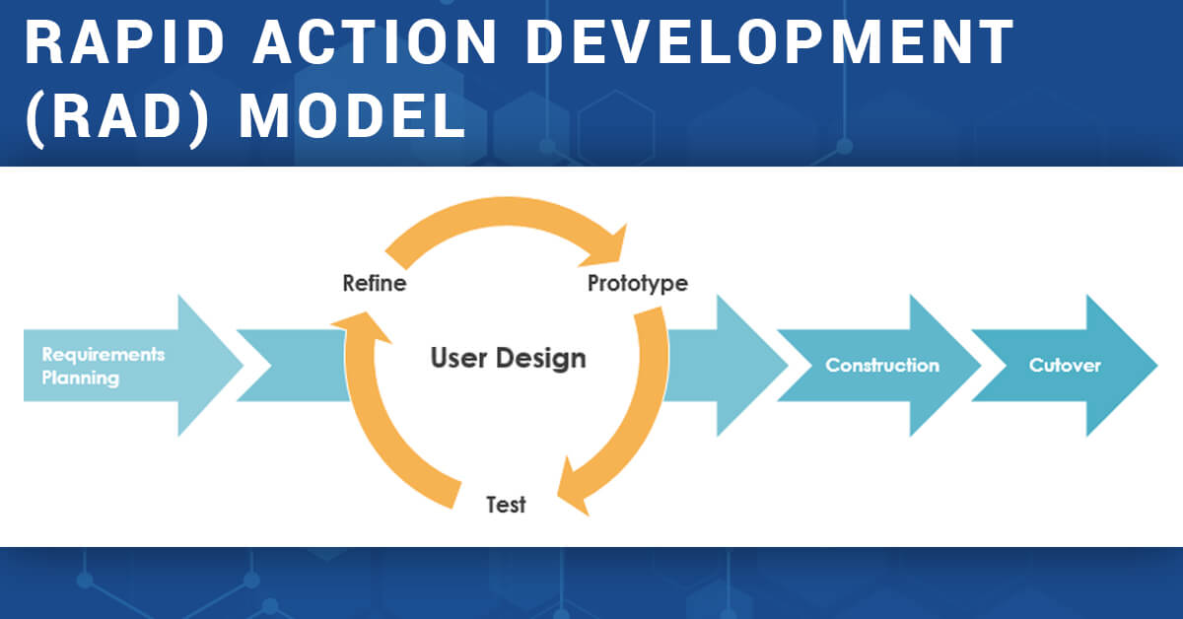

The Rapid Application Development (RAD) life cycle involves several phases, starting with requirement planning.

Requirement planning. Although the planning phase is shorter than in other project management methodologies, it is crucial for the project's success. During this phase, the stakeholders communicate to determine the project's goals, expectations, and potential issues that may arise during development. The phase involves researching the current problem, defining project requirements, and finalizing requirements needed for an expert system. After the interview process, researchers analyze the manual process in an expert system and propose a layout based on what problems the respondents are encountering. It is important to ensure that everyone involved has the opportunity to evaluate the project's goals and expectations to ensure success.

User design. The second stage of the RAD approach involves diving into the development process once the project has been defined. This phase is what sets RAD apart from other project management methodologies. It entails creating multiple prototypes of the user interface through iterative design, with the client and developer working closely together to ensure that the client's requirements are met at every step of the process. The software development process is highly customizable, and users can test each prototype to ensure that it meets their expectations, providing feedback to the developers about what works and what doesn't. This process allows for the resolution of bugs and issues in an iterative manner, with the developer designing a prototype, the user testing it, and then both parties collaborating on the results to improve the design. This approach enables the developers and clients to learn from the experience, ensuring that nothing is overlooked. In this phase, technicians will test the system's capabilities while the developers will allow each user to use the system and provide feedback. This feedback will be used to develop the system until it meets the user's satisfaction. This phase serves as a test run to identify any errors that need to be debugged to create a reliable and functional system for the organization.

Rapid Construction. The third stage of RAD involves converting the prototypes and beta systems from the design phase into a fully functional working model. As most issues and changes were addressed during the iterative design phase, developers can construct the final working model much more quickly than traditional project management approaches. This phase comprises several smaller steps, including preparation for rapid construction, program and application development, coding and unit integration, and system testing. During this phase, the software development team, including programmers, coders, testers, and developers, collaborate to ensure that everything is working efficiently and that the end result meets the client's expectations and objectives. The client can still provide input throughout the process, suggesting alterations, changes, or new ideas to resolve issues as they arise. This phase is crucial because it allows us to verify whether our system is running correctly. All team members, including users, developers, and coders, will utilize beta testing to assess our system's performance. This phase will evaluate our system to identify errors or changes that the team wants to make to enable the system to be used in the institution.

Cutover. The fourth phase of RAD involves the implementation of the finished product, including data conversion, testing, changeover to the new system, and user training. All final changes are made while coders and clients continue to search for bugs in the system. This phase is the last stage of our system and allows users to determine if the system is functioning properly for our institution. It is also the final test for developers to identify any additional changes that need to be made to the system. This phase showcases the finished product for the institution, demonstrating the final outcome of the system development. It serves as the final dry run of the system to ensure that it is qualified for use by technicians.

**Scope and Delimitation**

This section will highlight the key aspects of the proposed online computer troubleshooting system with decision support system, as well as its scope and limitations. Additionally, it will cover the services that are offered through the use of the proposed system. The main focus of the study is to develop an existing manual computer troubleshooting system, with the aim of assisting computer users in identifying the underlying issue with a computer. The study is designed to help the society maximize efficiency and provide a fast and convenient solution for fixing computers.

The proposed system will provide information and guidance for users to base their knowledge with and so they can have mor alternative ways of dealing with the problem the are having at hand.

This study will mainly focus to the users with limited knowledge in computer maintenance and are seeking assistance in troubleshooting basic software issues on their computers.

The scope of this system proposed will includes the following: Users can view and select solutions provided by the system, both User and admin can log in to the system, The CMS site is for the maintenance of the system which includes add, edit, and delete of data, the system will be browsed in Mozilla Firefox, Google Chrome and Internet explorer, the administration can add and delete the information provided in the system, only the administration can manipulate the data that will show in the front end, the system will have history module where in the user can review their previous searches, The system will have search engine where in the user can input their concern or computer issues.

**Data Gathering Techniques**

In order to effectively gather appropriate information, and determine information needed for the study, the researcher used the following data gathering techniques:

Structured Interviews. To highlight and prioritize the responses of the participants, an open-close interview approach was employed. The interview was conducted using a guide, which aided the researcher in identifying the critical aspects of the current process. The participants were made up of technicians from small businesses, as well as those from Denver's computer shoppe.

Document Analysis. The data of all expert system with decision support provides an in-depth information about what to put in our system and how it works. This will determine the feasibility of the proposed system. These contain needed information in the development of the system. The output of the survey questionnaires is used for analysis, interpretation and presentation of the data.

Survey. The survey questionnaire will be used to determine what often the technicians’ found faults on fixing a computer.

Interview. This method will provide more detailed and thorough answers directly from the respondents and so the proposed system can have a more efficient features and will be able to be a helpful one.

**Sources of Data**

The following are the sources of data applied by the researcher.

Denver’s Computer Shoppe, Inc. The technicians of Denver’s will be the respondent of this study because of their years of operation and expert opinions that is relevant in this study.

Self-taught computer technicians from small businesses. Several self-taught technicians also encounter this major problem and so their opinion on this matter is relevant.

Computer users. The respondents of this study are mainly computer users.

Online Studies and research. Available documents online are one of a handful instrument that can help the development of this system.

Textbooks. Manuals is the traditional source of data where studied things are found.

**REFERENCES**

Turban, E. and Aronson, J. (2001) Decision Support Systems and

Intelligent Systems. Prentice Hall, Upper Saddle River.

Insorio, A. O., & Macandog, D. M. (2022). Video lessons via

YouTube channel as mathematics interventions in modular distance learning. Contemporary Mathematics and Science Education, 3(1), ep22001. <https://doi.org/10.30935/conmaths/11468>.

Listiani, N. K. M., Suwastini, N. K. A., Dantes, G. R.,

Adnyani, N. L. P. S., & Jayantini, I. G. A. S. R. (2021, April). YouTube as digital learning resources for teaching bilingual young learners. In Proceedings of the 2nd International Conference on Technology and Educational Science (ICTES 2020) (Vol. 540, pp. 156-162).

Oddone, C. (2011). Using videos from YouTube and websites in

the CLIL classroom. Studies About Languages, 0(18). https://doi.org/10.5755/j01.sal.0.18.417.

Tadbier, A. W., & Shoufan, A. (2021). Ranking educational

channels on YouTube: Aspects and issues. Education and Information Technologies, 26(3), 3077-3096.

Ergado, A. A. (2016). Self learning computer troubleshooting

expert system.International Journal of Artificial Intelligence & Applications (IJAIA), 7(1), 45-58.

Buchholz, K (2020). Which country spent the most and least

time on social media

**se**

Chapter 3

**DISCUSSION OF FINDINGS**

The requirements necessary for the development of the system are presented and discussed in this chapter. Along with the system design and physical design, the discussion also includes the required information, the features of the proposed system, the intelligent model used, and the suggested system’s level of usability.

The proposed system has a process in which the users will be able to see upon opening it. It requires information in order to go and use it. The following information requirements needed to develop the system:

Common Computer Issues. Identify the most frequent computer problems users encounter, such as hardware failures, software glitches, networking issues, etc. Through identifying these, the system will allow the user to find the issues encountered without difficulty.

User profiles. This refers to the information that is needed to log in to the system. Basic information such as their email address and password will be asked by the system to enter the main page. By obtaining this information needed the user will be able to see their recent history and personal recommendation.

Knowledge Base. Build a comprehensive knowledge base containing troubleshooting guides, FAQs, tutorials, and solutions to common computer problems. This will be the key for users to easily find their concern in the system.

**Inconvenience that the respondents encountered during the repair**

In order to identify what mostly is the inconvenience did the computer users encounter during the repair process in local physical shops and repair services, the researchers conducted a small survey. The researcher then able to gather information from 20 selected computer users with experience of repair.

Table 1.

Inconvenience rank

|  |  |  |  |
| --- | --- | --- | --- |
| Inconvenience | No. of respondents voted | Percentile | Rank |
| 1. Lack of updates on repair progress | 3 | 15% | 3 |
| 1. Delays in repair timeline | 5 | 25% | 2 |
| 1. Difficulty in communication with repair service | 2 | 10% | 4 |
| 1. Additional unexpected expenses | 8 | 40% | 1 |
| 1. Quality issues with repaired product/device | 2 | 10% | 4 |

The survey results indicate that among the respondents who are computer users, the most common inconvenience encountered during the repair process was additional unexpected expenses where it has 8 votes. This suggests that a significant portion of the respondents experienced unexpected costs associated with the repair of their computers, which could have been a source of frustration or dissatisfaction.

Following behind was delays in repair timeline where it has 5 votes, which ranked second. This suggests that another prevalent issue among respondents was experiencing delays in getting their computers repaired within the expected timeframe. Delays in repair timeline can disrupt users' productivity and cause inconvenience, leading to dissatisfaction with the repair service.

Lack of updates on repair progress ranked third which has 3 votes. This indicates that while delays and unexpected expenses were more common concerns, a notable portion of respondents also expressed dissatisfaction with the lack of communication or updates regarding the status of their repair. This suggests a need for repair services to improve their communication practices to keep users informed throughout the repair process.

On the other hand, quality issues with the repaired product/device and difficulty in communication with the repair service ranked lower, at fourth place, respectively with 2 votes each. This suggests that while these issues were still experienced by some respondents, they were less prevalent compared to unexpected expenses, delays in repair timeline, and lack of updates on repair progress. Overall, these survey results highlight areas where repair services can focus on improving the user experience and addressing common pain points among computer users. By identifying these issues encountered by users in repair shops, the system can help community not only by efficiency but also cost and environmentally. According to Manish Panchal(2023), the benefits of digital systems, such as their accuracy, adaptability, dependability, signal processing abilities, storage, interoperability, and cost effectiveness, have helped them rule many industries and permeate our daily lives.

**Intelligent model of the proposed system**

An intelligent model is a computer program or system designed to mimic human intelligence in solving problems or performing tasks. These models use algorithms and data to make decisions, learn from experience, and adapt to new situations. They can analyze large amounts of information, recognize patterns, and make predictions or recommendations. Intelligent models are used in various fields, including artificial intelligence, machine learning, and data science, to automate tasks, improve efficiency, and make better decisions.

LDA, or Latent Dirichlet Allocation, is a model used in natural language processing to find topics in a collection of documents. It doesn't directly give specific results or predictions. Instead, it learns hidden topics in the documents and assigns probabilities to each document's belonging to those topics. Each document is seen as a mix of topics, and each topic is defined by a distribution of words. LDA helps identify which topics are likely present in each document and which words are most relevant to those topics. While it doesn't offer direct outputs, LDA provides insights into the themes of text data, useful for tasks like document organization, information retrieval, and understanding content.

For algorithm, the researcher used Jaro-Winkler distance algorithm. It is a method used to measure the similarity between two strings of characters. It was developed by William E. Winkler, as an extension to the Jaro distance metric proposed by Matthew A. Jaro. The algorithm calculates a similarity score between 0 and 1, where 1 indicates a perfect match between the strings. The Jaro-Winkler distance considers the number of matching characters between the strings, as well as the order in which they appear. Additionally, it gives higher weight to matching characters that occur at the beginning of the strings, assuming that differences at the beginning are more significant than those occurring later in the strings. The Jaro-Winkler distance is particularly useful for applications such as record linkage and deduplication, where it helps identify similar records or entries in datasets, even when there are slight variations or typographical errors between them. This algorithm applied using the similar_text() PHP Function. By employing this function, the system can automatically correct typos and match user queries with existing solutions more accurately. This ensures that users receive relevant troubleshooting steps tailored to their specific issues, improving the efficiency of problem resolution. Additionally, the function aids in analyzing common problems reported by users, allowing system administrators to identify trends and address widespread issues effectively.

Another algorithm used in the system for more precise and accurate result is the backtracking algorithm. It is a systematic approach to problem-solving that involves recursively exploring potential solutions by making choices and backtracking when necessary. At each decision point, the algorithm selects one of the available options and proceeds to explore the consequences of that choice. If the chosen option leads to a dead end or an invalid solution, the algorithm backtracks to the previous decision point and tries another option. This process continues recursively until a valid solution is found or all possible options have been exhausted. Backtracking algorithms are commonly used to solve problems like maze-solving, the N-Queens problem, Sudoku, and graph coloring, among others. While effective for systematically exploring large solution spaces, backtracking algorithms can be computationally expensive and inefficient for certain problems.it uses permutation to identify the best result.

The backtracking algorithm finds utility in online computer troubleshooting systems due to its systematic approach in exploring and resolving complex computer issues encountered by users. By navigating through multiple potential solutions, the algorithm efficiently identifies viable troubleshooting steps or solutions to address user-reported problems. This is particularly valuable in scenarios where computer issues have multiple paths to resolution, intricate dependencies between components, or incomplete user information. Additionally, the algorithm aids in error correction by iteratively refining the troubleshooting process based on user feedback, ensuring accuracy and completeness in problem-solving efforts. Through its systematic exploration and efficient problem-solving capabilities, the backtracking algorithm enhances the effectiveness of online computer troubleshooting systems, ultimately leading to faster resolution times and improved user satisfaction.

# Flow of Data of the Proposed System

An online computer troubleshooting system data flow diagram (DFD) illustrates the flow of information within the system. The DFD will show the movement of data regarding user queries, diagnostic processes, and recommended solutions. It would map out the pathways through which user input, such as problem descriptions and error messages, traverses the system to reach the troubleshooting engine. This engine stores a wealth of troubleshooting knowledge and methodologies. The diagram would further delineate how the troubleshooting engine processes user input to generate tailored recommendations. Ultimately, this DFD provides a holistic overview of information flow within the online computer troubleshooting system, facilitating the identification of bottlenecks and avenues for system improvement.

Figure 2.

Data Flow Diagram – Level 0

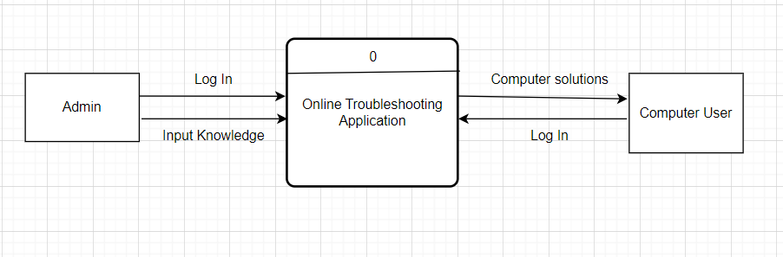

the online computer troubleshooting system begins with the admin logging in and inputting knowledge, which is stored in the system's database. Computer users then log in to access troubleshooting solutions, retrieving relevant information from the database. This process forms a seamless interaction loop between admins and users, ensuring efficient access to solutions and continuous improvement of the system's knowledge base.

Figure 3.

Data Flow Diagram – Level 1

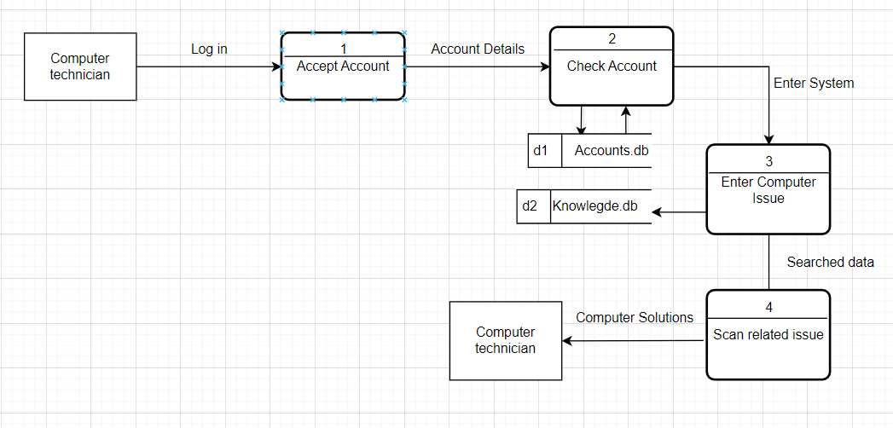

This diagram begins with the technician logging in, followed by options to accept new accounts or check existing ones. New account details are stored in the Accounts database, while existing account details are retrieved from the same database. Upon entering the system, the technician can access the Knowledge database containing information on common computer issues. When addressing a computer problem, the technician can scan related issues and search the Knowledge database for potential solutions.

Figure 4

Data Flow Diagram – Level 2

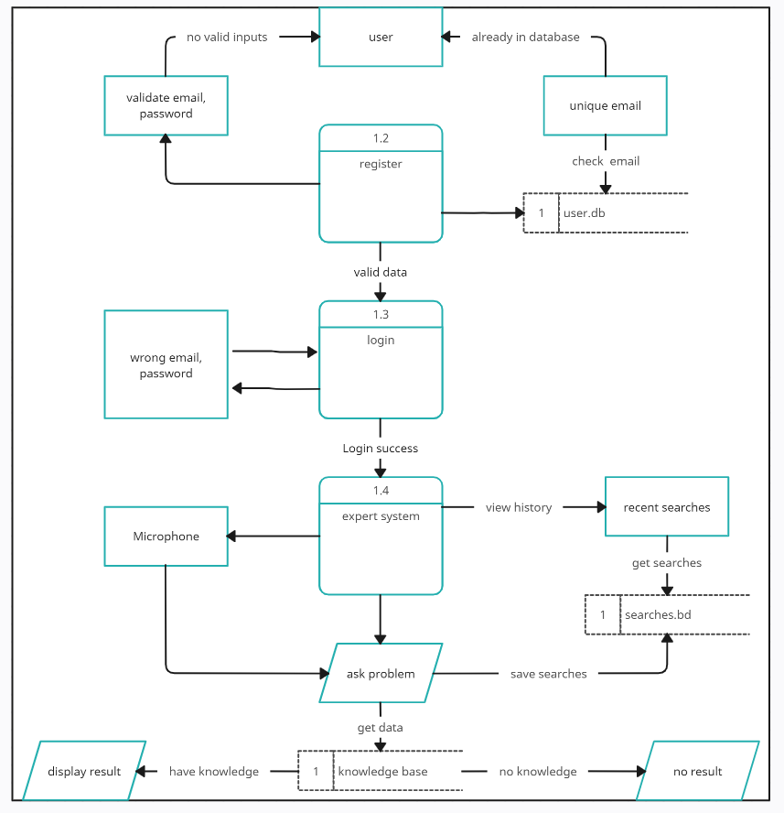

This data flow diagram outlines the user registration and expert system processes. Firstly, for user registration, the system validates email and password inputs, registers new users with unique emails and valid inputs, and allows existing users to log in with valid credentials. Once logged in, users can access the expert system, where they can view recent search history, ask questions via microphone input, and the system checks its knowledge base for relevant information. If found, it displays the result; otherwise, it indicates no result. User searches are saved in the searches database. Entities involved include the user, user database, searches database, and knowledge base. Overall, the diagram showcases user authentication, search history management, voice input handling, knowledge retrieval, and result display within the expert system.

To begin the process of troubleshooting a computer using the system, the user must first open the website on their device. The user must click log in or register to enter it. The user will then see a field where they are asked for their credentials. Once logged in, the user will be directed to the main dashboard of the system and see the search function.

**The features of the proposed system**

This section will show and discuss each feature that the system has. Each figure that will be presented are the features that the users can see in the system.

Figure 5

Online Computer Troubleshooting Homepage

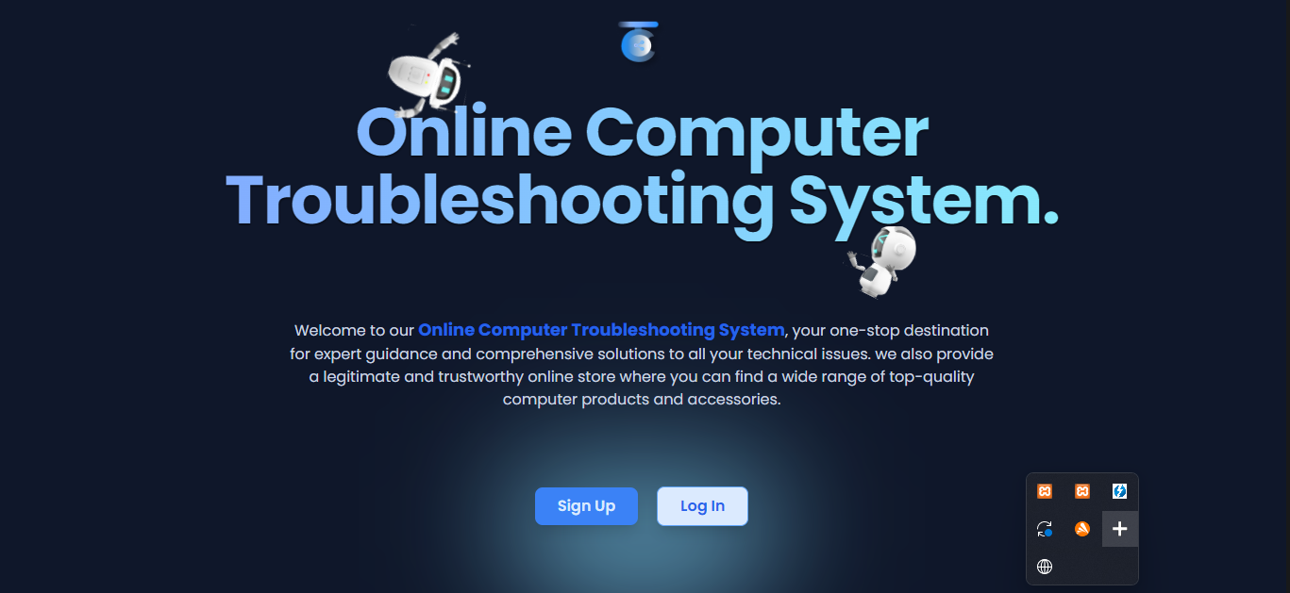

The first interface that will be shown to the user of the system will have the option of Log in and Sign up where in the sign up button is for registration of new account while in Log in button is for logging of account that is already registered to the system.

Figure 6.

Registration Form

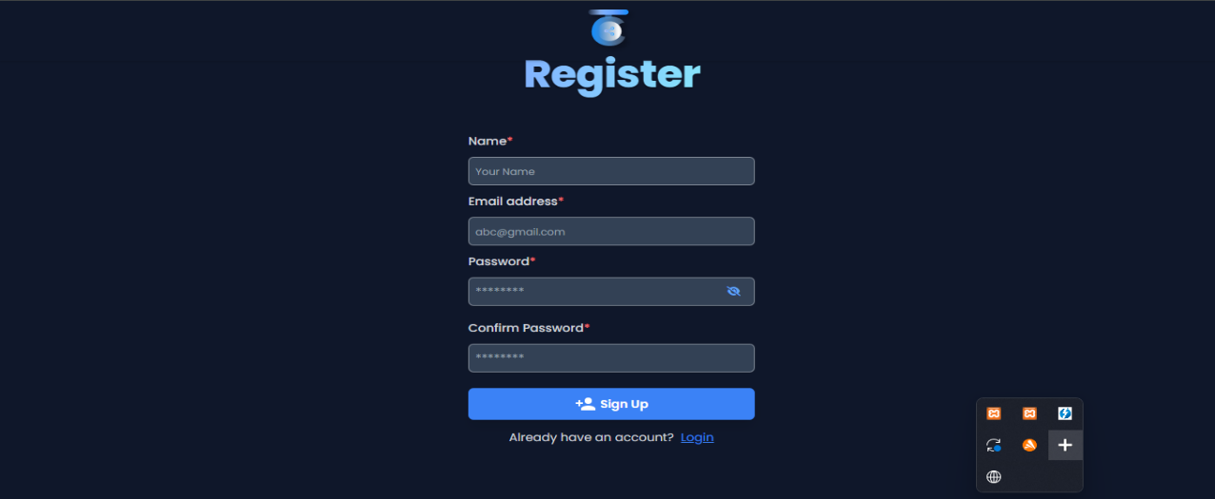

In this registration form, the user is required to input their information such as their Name, Email Address, Password. It also has the confirm password where in the user have to retype the password.

Figure 7.

Log In Form 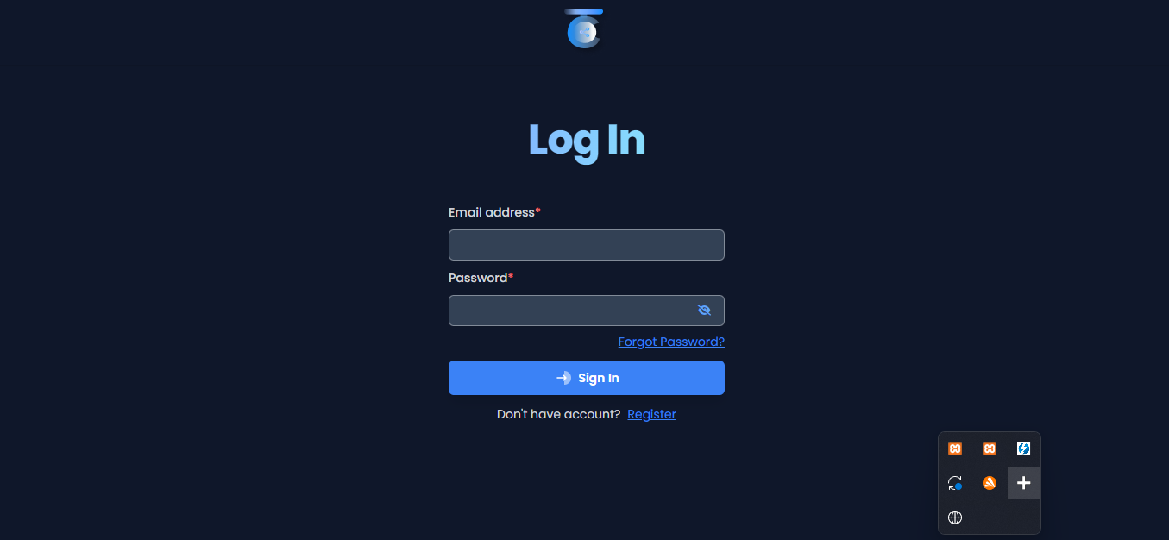

In this image shows the log in form of the system. In order to enter the system, The users will be required to input their particular information such as email address and the password their registered account. It also has the forgot password feature which will help the user redirect to another page and retrieve their account.

Figure 8.

Change Password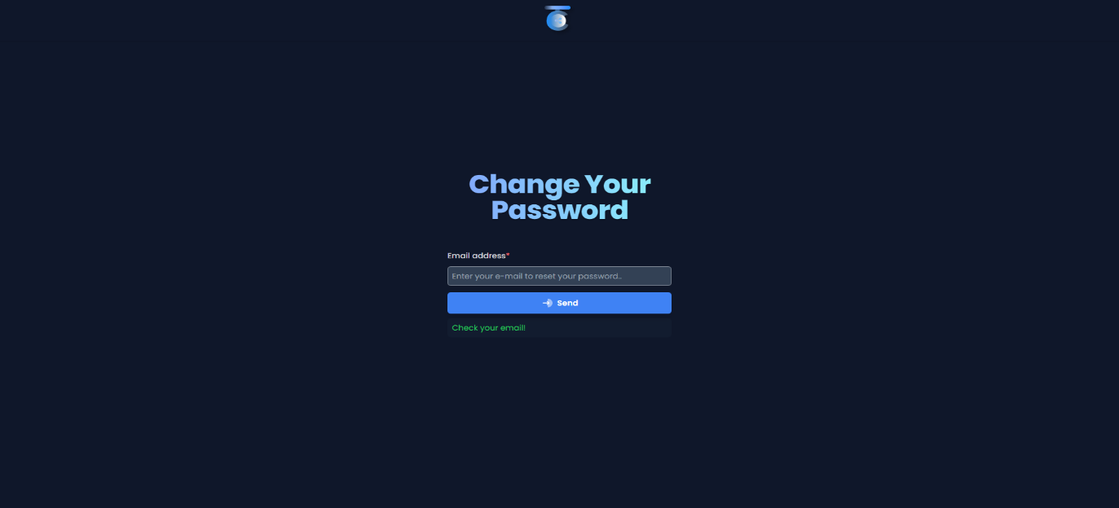

In this figure shows the UI of the system after clicking the forgot password button just in case the user of the system forgot their passwords and wanted to change it. The system will automatically send a link that will redirect the user to change their password.

Figure 9.

Email confirmation

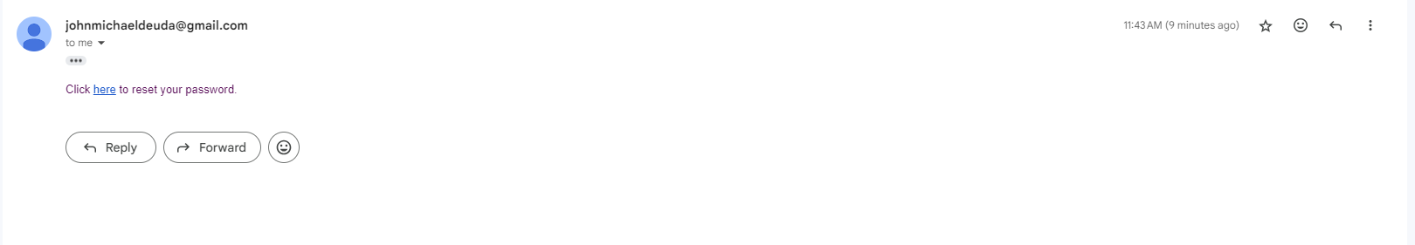

Upon clicking the send button from the UI of changing passwords, the email will be sent to you for you to change your existing password. The word reset is presented and is clickable by the user. After clicking the word reset, the user will be redirected to a link for changing their passwords.

Figure 10.

Reset Password



The image shows the interface for resetting password. The user will be asked to input their preferred new password. It also has a feature wherein the user will need to confirm and retype the password inputted above. If the two did not match, the password will not change.

Figure 11.

Main Dashboard

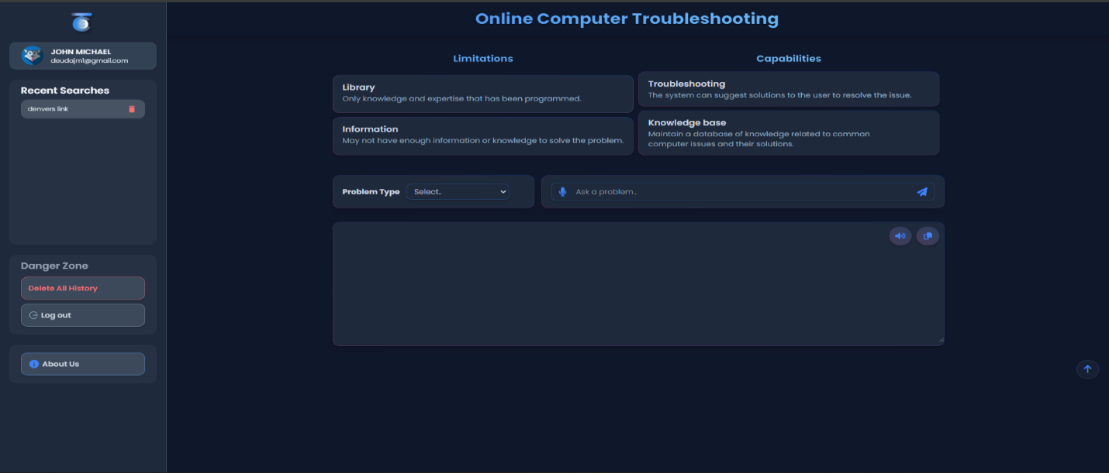

The image above shows the main interface of the system. This is where the user will be able use the features designed to help them solve their concerns regarding computer issues. The features include selecting problem type, search field with microphone for live speech queries, search history and the button to delete search history.

Figure 12

Log out Feature

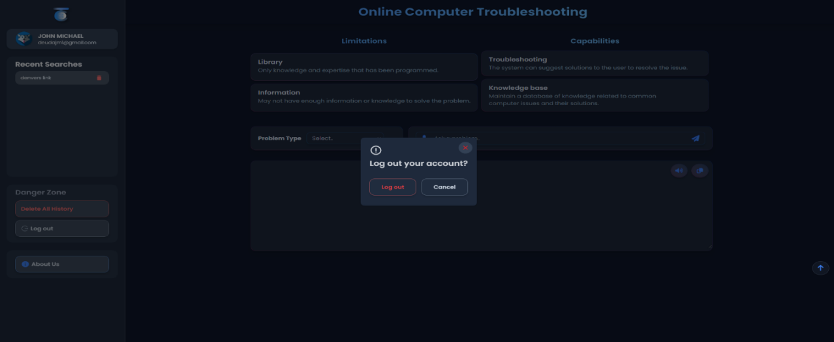

The log out button will allow user to log out and exit the system by signing out their account. The image above shows a small prompt that provides option for user to log their account out or cancel the action.

Figure 13

About Us

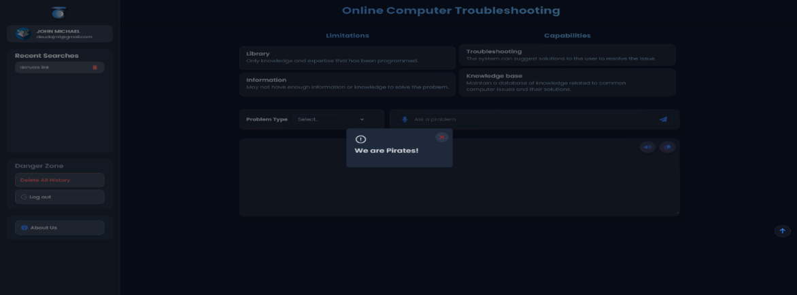

The about us button will provide the information about the founder and the developer of the system. It is a small introduction for credits. While the above figures present the user interface for clients only, the following are the figures that shows the admin’s side:

Figure 14

Admin Dashboard

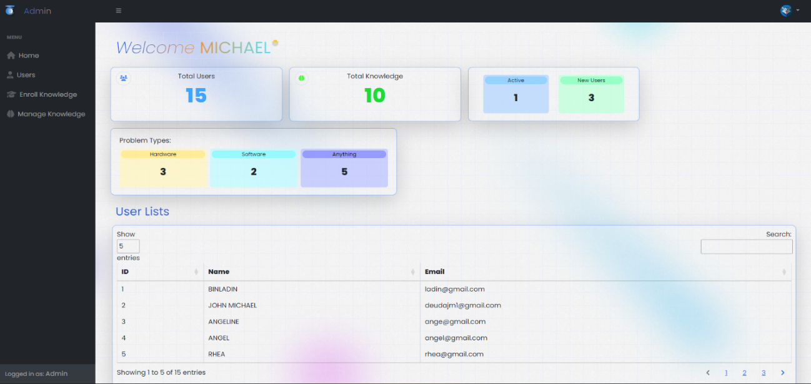

This interface shows the first thing that the admin will see after successfully logged in. It displays the username of the user on the top. It also displays the total users of the system, number of knowledges enrolled by the admin, Active users as well as the new users of the system. Beneath it, the system will display the problems and solution in a categorized manner. The problems include hardware, software and anything which means it could be anything from the two. Below shows admin the table lists of users along with their user ID, Name and email used. The table also has a feature for searching users.

Figure 15

User manager

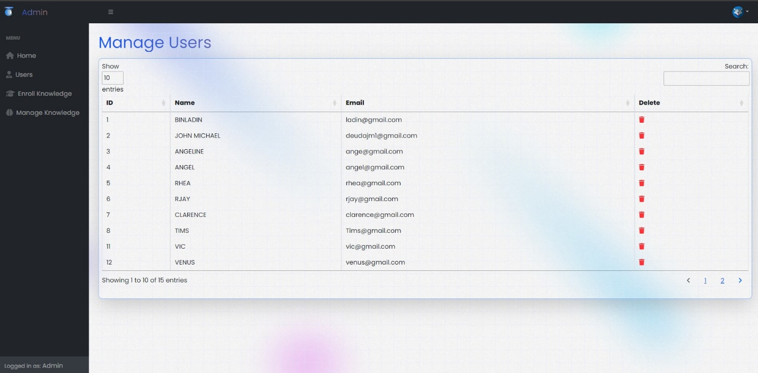

The image depicts an interface that let admins to manage users. Admins have the ability to see lists of users and delete users. It also has a feature for searching users.

Figure 16

Knowledge Enrollment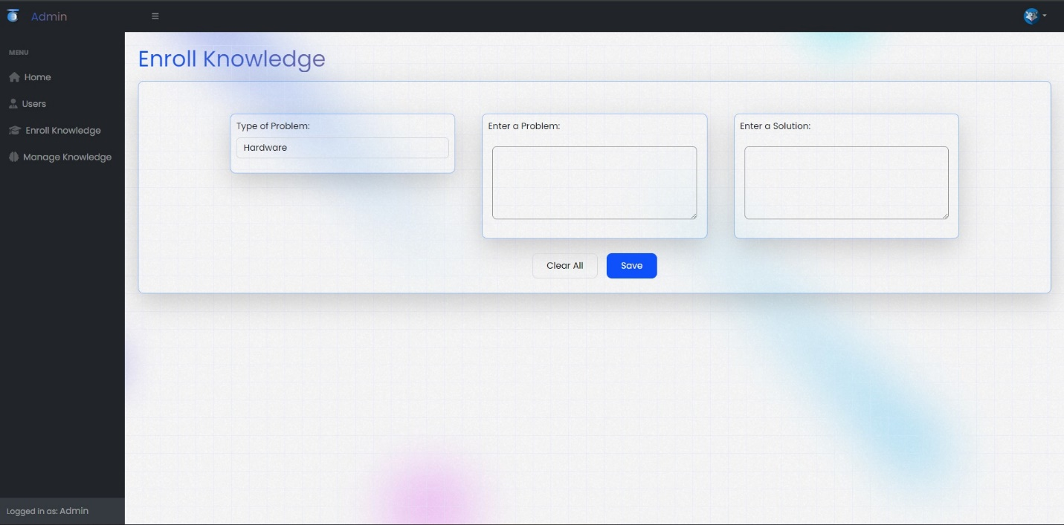

This part shows the design for enrolling knowledge to the system. It enables administrators to log and categorize user-reported problems, specifically related to hardware and software. It includes a text area for describing the problem and enrolling related knowledge for system reference. Admins can input solutions for future troubleshooting. This structured approach enhances problem resolution efficiency within the system.

Figure 17

Knowledge Management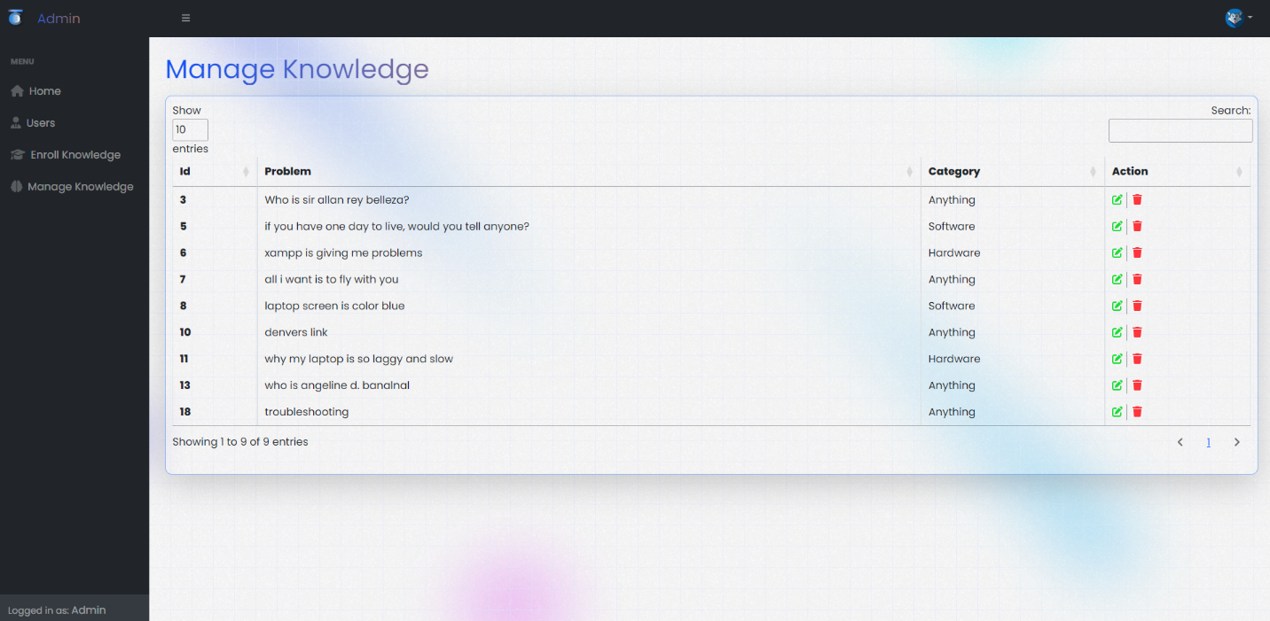

The UI presents system knowledge in a categorized table format, featuring entries with a knowledge ID, problem description, and respective solutions. Administrators can utilize delete and edit features to manage entries, allowing them to remove outdated information and update content as needed, ensuring the knowledge base remains accurate and relevant.

Figure 18

Delete Knowledge

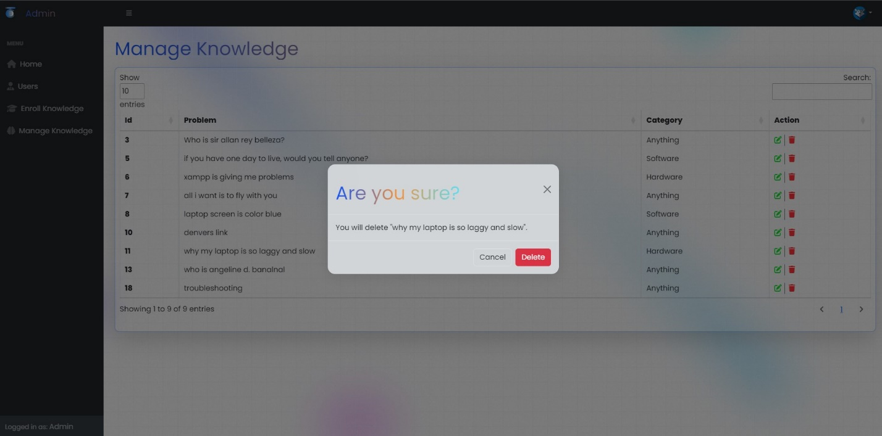

The "delete" feature in knowledge management for administrators allows them to remove entries from the system's knowledge base. Administrators can utilize this feature to eliminate outdated, incorrect, or irrelevant information from the database. By deleting entries, administrators ensure that users are not provided with inaccurate or obsolete solutions when encountering similar problems. This feature helps maintain the integrity and relevance of the knowledge base, facilitating effective problem-solving and enhancing user satisfaction.

# Level of Usability of the Propose System

In this section, the researchers evaluated the usability of the proposed system during its execution based on stakeholders' perceptions. To assess usability, a survey was conducted using a questionnaire comprising ten items rated on a scale of 1 to 5, with response options spanning from strongly agree to strongly disagree. The intended beneficiaries of the system are people with the little knowledge about computer in general and its system. The researchers employed the System Usability Scale (SUS) to gauge the system's usability level. Figure illustrates the ten SUS questions incorporated in the survey.

Figure 19

System Usability Scale Questionnaire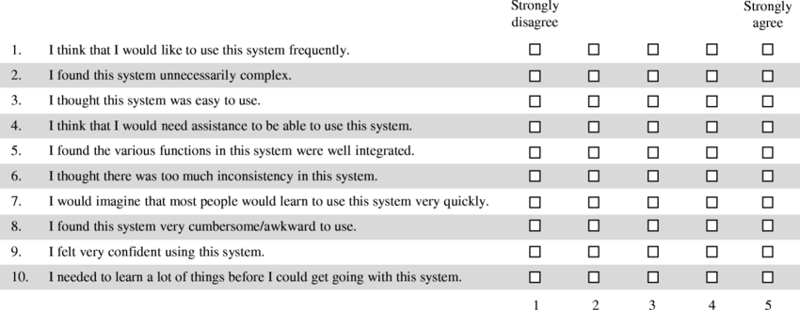

The related grades and adjective ratings of each survey conducted with the SUS questionnaire can be further analyzed by referring to Table 1, which presents the interpretation of the system usability scale score.

Table 2

Interpreting System Usability Scale (SUS) Score

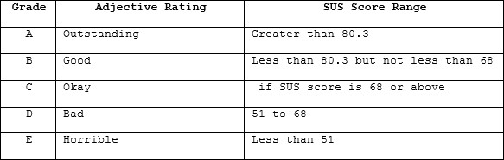

According to the chart, if the SUS score is greater than 80.3, the adjective rating is outstanding or grade A. If the SUS score is less than 80.3 but not less than 68, the adjective rating is good or grade B. If the SUS score is equal to 68 or above, the adjective rating is okay or grade C. However, if the SUS score is between 51 and 68, the adjective rating is bad or grade D. If the SUS score is less than 51, the adjective rating is horrible or grade F.

These ratings signify whether the system was usable for its beneficiaries, with higher ratings indicating better usability and lower ratings indicating poor usability.

Figure 20

SUS Score Representation

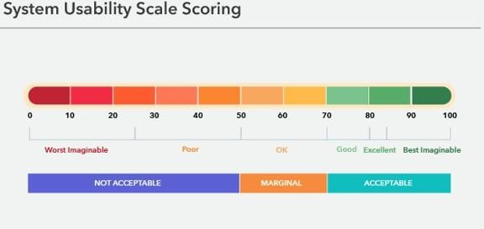

**System Architecture**

A comprehensive conceptual model that portrays the configuration, functionalities, and diverse viewpoints of a given system is called System architecture. It serves as a blueprint that delineates the arrangement of components, their interactions, and the overall behavior of the system. This architectural representation offers a structured approach to understanding the intricate workings of the system, enabling stakeholders to grasp its complexities from various angles.

By employing standardized notations and methodologies, an architecture description captures the essential attributes of the system, making it easier to comprehend and evaluate. Moreover, an architecture description serves as a communication tool, allowing stakeholders to communicate effectively about the system's design, functionality, and requirements. It provides a common language that bridges the gap between technical experts, decision-makers, and other stakeholders, fostering collaboration and alignment towards achieving common objectives.

The researchers utilized a combination of PHP framework and Bootstrap for efficient PHP application development, simplifying setup and minimizing dependencies. They employed PHP and Bootstrap on the administrative side, while incorporating PHP, JavaScript, and Tailwind CSS for client-side functionality to enhance user experience. Development was streamlined using Visual Studio Code (VSCode) as the primary application.

Figure 21

Model-View-Controller

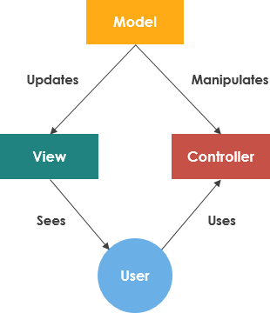

Model-View-Controller

The Model component of the system would consist of the database or data storage system where all information related to reported issues, troubleshooting guides, user profiles, and system configurations are stored. It also includes the business logic responsible for processing and manipulating this data, such as creating new troubleshooting tickets, updating ticket statuses, and providing solutions based on predefined rules and algorithms. The View component represents the user interface through which users interact with the system. This includes web pages, forms, graphical interfaces, and any other visual elements that users use to report computer issues, browse troubleshooting guides, communicate with support personnel, or view the status of their reported tickets. The Controller acts as an intermediary between the Model and the View. It receives user input from the View, processes it, interacts with the Model to perform necessary operations, and then updates the View to reflect any changes. In the context of the online troubleshooting system, Controllers would handle actions such as submitting new troubleshooting issues, retrieving troubleshooting guides based on user queries.

**Architectural views**

Architectural views encompass the diverse angles from which a system is elucidated to stakeholders, including end-users, developers, system engineers, and project managers. The system's proposed perspective is depicted through a use case diagram.

Use Case Diagram. A use case provides a detailed explanation of how individuals navigate and utilize a system to accomplish particular objectives or tasks. It breaks down the sequence of actions users undertake, along with the corresponding responses from the system, to achieve a defined goal. Use cases are typically visualized through diagrams or flowcharts, serving as invaluable tools in the realm of software development. By articulating user interactions and system behaviors, they play a vital role in ensuring that the resulting software aligns effectively with user needs and requirements. Through this structured approach, use cases aid in identifying functional necessities, refining system design, and ultimately delivering a product that meets user expectations.

**Use Case Diagram**

1. Use Case Name: Troubleshooting Computer Issues
2. Actor: User
3. Entry Condition: The user encounters a problem with the computer and needs assistance.
4. Flow of Events:

* User logs into the online troubleshooting system and inputs computer issues.
* System generates and displays possible solutions.
* User selects the best solution.
* System provides step-by-step instructions for resolution, which the user follows.

1. Exit Condition: The computer issue is resolved, and it is now working normally.
2. Special Requirements:

* The online troubleshooting system must have a knowledge base information.
* The system should provide clear and concise instructions for troubleshooting steps.
* The user should have a stable internet connection to access the online troubleshooting System.

Figure 22.

Use Case Diagram

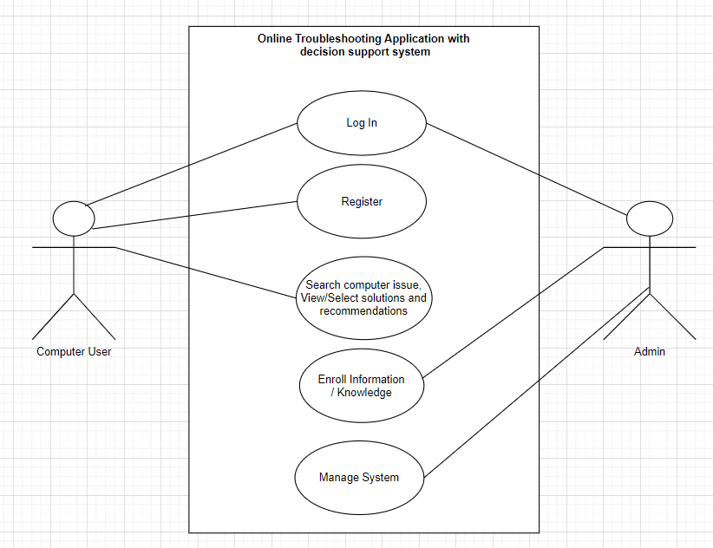

A use case diagram is a graphical representation of the interactions between users (actors) and a system to achieve specific goals or tasks. It illustrates the different use cases (actions or functionalities) of the system and how various actors interact with those use cases.

In the scenario provided, the use case diagram would depict the interactions between the user and the online troubleshooting application to resolve computer issues.

Figure 23

Class Diagram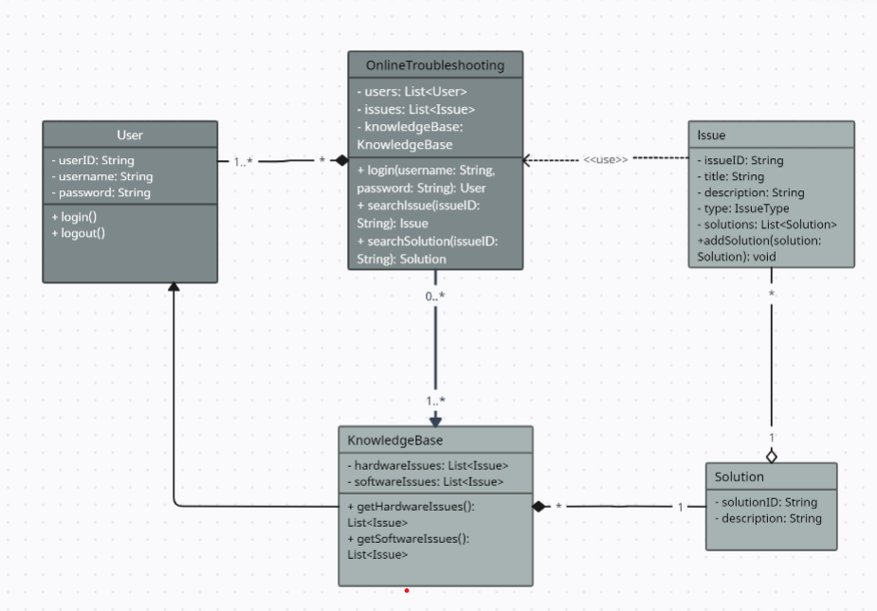

The Class Diagram is a key component in object-oriented modeling, depicted with boxes divided into three sections. The first section denotes the class name, the second lists its attributes, and the third outlines its operations. It serves to illustrate the components within a system, their attributes, functionalities, and interactions.

Figure 24

Sequence Diagram (Log in)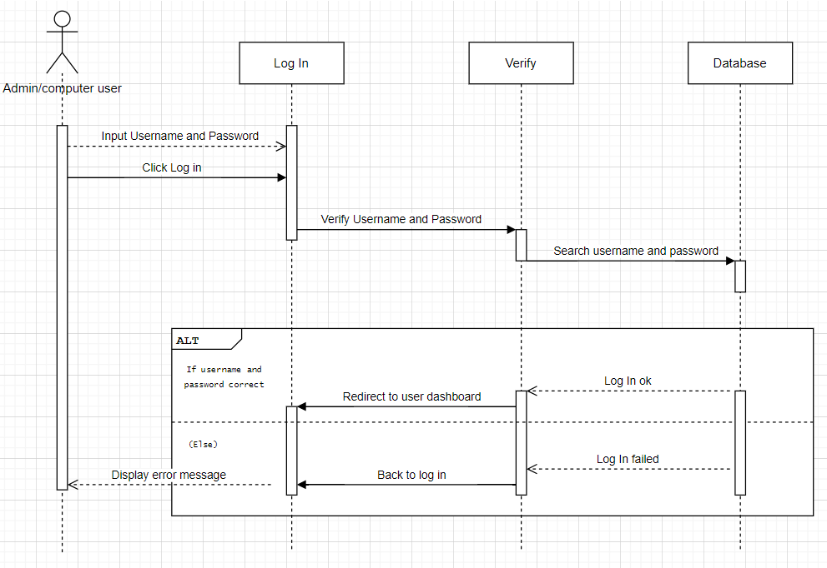

In the sequence diagram illustrating the login process for an online computer troubleshooting system, the sequence begins as the computer user initiates the login procedure by engaging with the login interface provided by the system. Subsequently, the login component of the system receives the login request and forwards it to the verification component to authenticate the user's credentials. The verification component, upon receiving the request, interacts with the database to retrieve the user's login credentials stored within the system. After retrieving the credentials, the verification component proceeds to compare them with the credentials provided by the user during the login attempt. Following the comparison, a response message is sent back to the login component, indicating either successful authentication if the credentials match or authentication failure if they do not. Based on this response, the login component updates the user interface accordingly, granting access to the system upon successful authentication or displaying an error message prompting the user to retry or seek further assistance in case of authentication failure.

Figure 25

Sequence Diagram (Registration)

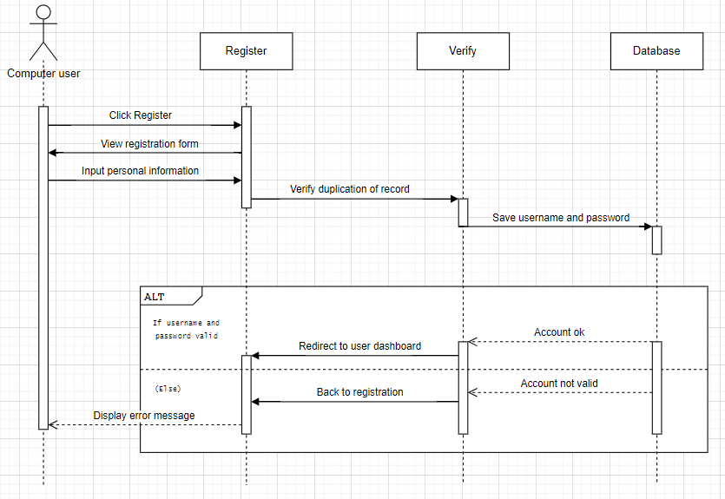

In the registration sequence for the online computer troubleshooting system, the process begins with the user accessing the registration interface provided by the system. The user then inputs their details, including username, email, and password. Upon submission, the registration component verifies the input and interacts with the database to store the user's information. Once the registration is successful, the system confirms and provides feedback to the user, indicating completion of the registration process.

Figure 26

Sequence Diagram (Search)

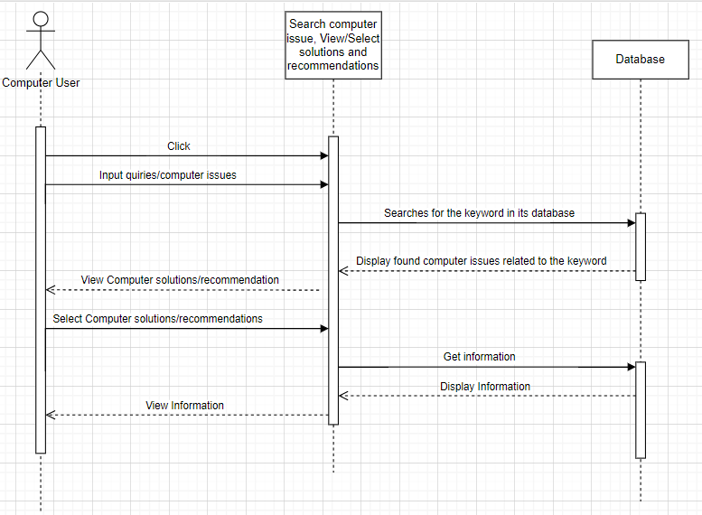

In the sequence of searching for computer issues within the system, the process unfolds as follows: the computer user initiates a search by inputting relevant keywords or criteria into the search interface provided by the system. The search request is then forwarded to the search issues view component, which retrieves and displays a list of relevant issues based on the user's input. The user selects an issue from the list, prompting the system to present potential solutions associated with the selected issue. Finally, the user reviews the solutions and selects the most appropriate one to resolve the computer issue.

Figure 27

Sequence Diagram (Enroll Knowledge)

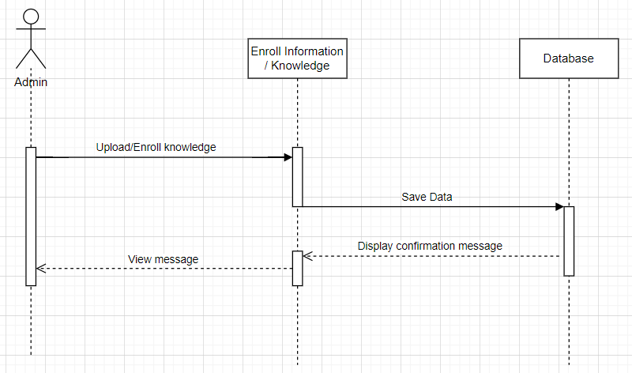

In the sequence diagram for admin-enrolled knowledge into the system with a database, the process begins as the admin logs in and accesses the knowledge enrollment interface. The admin inputs the knowledge and submits it to the system. The system then stores the knowledge in the database and confirms the enrollment to the admin. This diagram illustrates the flow of interactions between the admin, system, and database during the knowledge enrollment process.

Figure 28

Sequence Diagram (Manage system)

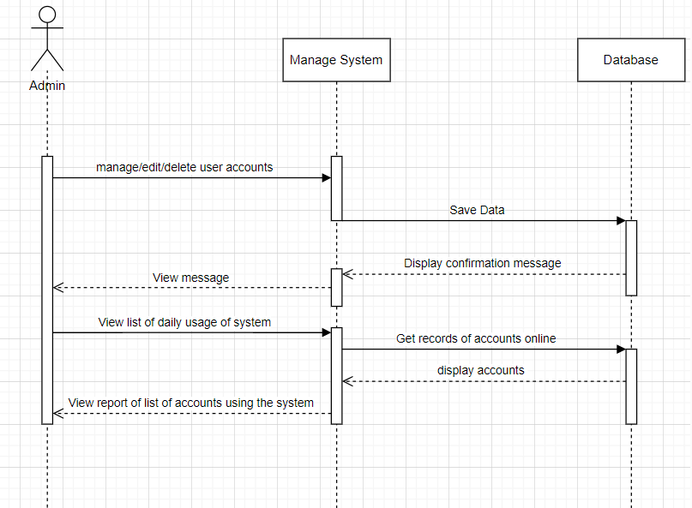

In the sequence diagram depicting admin management of the system, the process begins with the admin logging in and accessing the admin panel. From there, the admin can choose to edit or delete user accounts. Upon selecting either action, the system updates the database accordingly. Additionally, the admin has the option to view daily system usage statistics. Upon selection, the system retrieves and displays these statistics to the admin. This diagram illustrates the flow of interactions between the admin, system functionalities, and the database during the management of user accounts and viewing of daily usage statistics.

**Software Requirement.** Table 1 below shows the list of software requirement needed to install the application. The application is a windows-based, the operating shall be a windows OS with the minimum version of windows 8. The system proposed is recommended to be displayed using google chrome web browser. The computer should have XAMPP program with a supported php 7 version.

Table 3:

**Software Requirement**

|  |  |
| --- | --- |
| **Software Required** | **Description** |
| Operating System | Windows 8 or higher |
| Web browser | Google Chrome, Mozilla Firefox, Internet Explorer |
| XAMPP | XAMPP 7.0 or higher |
| VSCode | Version 1.87 |

**Hardware Requirement.** The hardware requirement describes the hardware specifications of the system in order to solve the objectives. Table 2, shows the recommended hardware. The table includes the processor, memory, display card, HDD, and the internet service provider. The system can run on any local

internet service provider or wireless connection.

Table 4:

**Hardware Requirement**

|  |  |
| --- | --- |
| **Hardware Required** | **Recommended** |
| Processor | AMD Quad Core or Core i3 64bit |
| Disk Space Requirement | 500GB SATA |
| Memory  Requirement | 2GB DDR2 |
| Display Card | 2GB built-in |
| Internet Connection | Wired (the better)  Globe Tattoo  SmartBro, Converge, Globe at Home, PLDT. |

**Chapter 4**

# CONCLUSIONS AND RECOMMENDATIONS

This chapter presents the conclusions of the undertaking, as well as recommendations for future related research.

**Conclusions**

After conducting this study, the researchers came up with the conclusions below:

1. Emphasize the importance of addressing common computer issues, establishing user profiles, and building a comprehensive knowledge base to reduce cost and for convenience. By identifying frequent computer problems such as hardware failures, software glitches, and networking issues, the system can effectively assist users in finding solutions to their specific issues. Additionally, implementing user profiles with basic information like email addresses and passwords enables personalized user experiences, including accessing recent history and receiving tailored recommendations. Furthermore, the development of a robust knowledge base containing troubleshooting guides, FAQs, tutorials, and solutions serves as a valuable resource for users to easily find relevant information within the system. Overall, the conclusion highlights the significance of these data requirements in creating a user-friendly and efficient computer troubleshooting system.
2. The survey results reveal that computer users' primary inconveniences during the repair process are centered around financial and communication-related issues. The most significant complaint was additional unexpected expenses, indicating the need for repair services to be more transparent about potential costs upfront. Delays in the repair timeline were also a major concern, highlighting the importance of adhering to estimated turnaround times. Lack of updates on the repair progress was another prevalent issue, suggesting that repair services should focus on improving communication practices to keep customers informed throughout the process. While quality issues and difficulty in communication were less frequently reported, they still represent areas for improvement. By addressing these key pain points around cost, timeliness, and communication, repair services can enhance the overall user experience and better meet the expectations of their computer-owning customers.
3. The integration of Latent Dirichlet Allocation (LDA) for topic modeling alongside algorithms such as the Jaro-Winkler distance and the backtracking algorithm represents a comprehensive approach to text analysis and problem-solving within online computer troubleshooting systems. LDA facilitates the extraction of hidden themes from textual data, providing valuable insights for document organization and information retrieval. Meanwhile, the Jaro-Winkler distance algorithm enhances accuracy by measuring similarity between strings, aiding in tasks like record linkage and deduplication. The backtracking algorithm, known for its systematic exploration of solution spaces, effectively addresses complex computer issues by recursively navigating potential solutions and refining the troubleshooting process based on user feedback. Together, these methodologies streamline problem resolution, ensuring efficient and accurate assistance for users while enhancing the overall effectiveness of online computer troubleshooting systems.

* Panchal, M. (2023) Advantages of Digital Systems. Tutorialspoint. https://www.tutorialspoint.com/advantages-of-digital-systems