HOWEWORK_01

1. JAVA

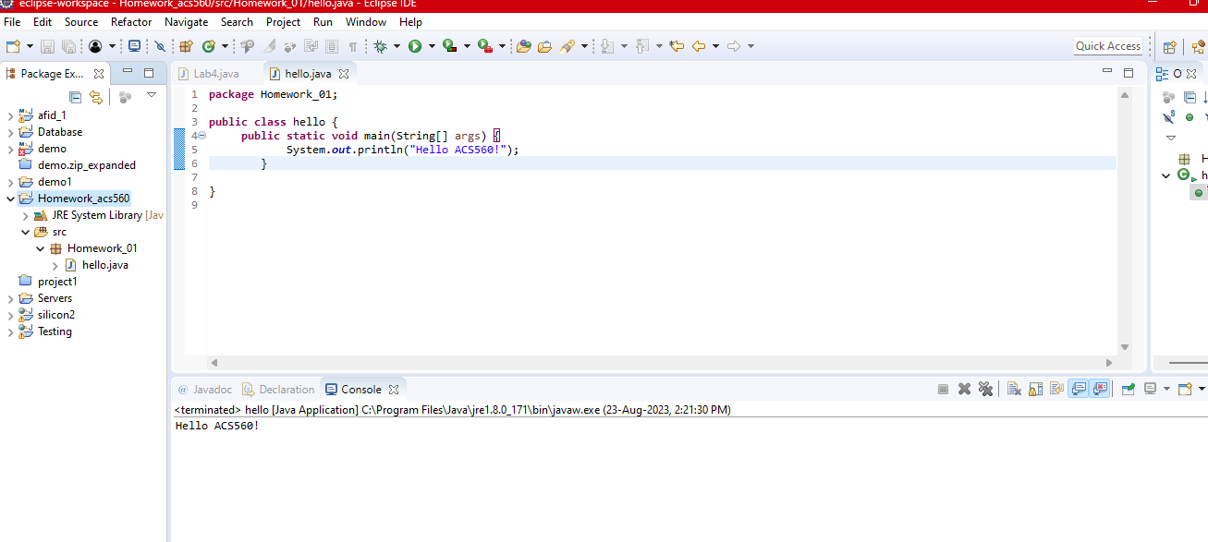

1. PYTHON

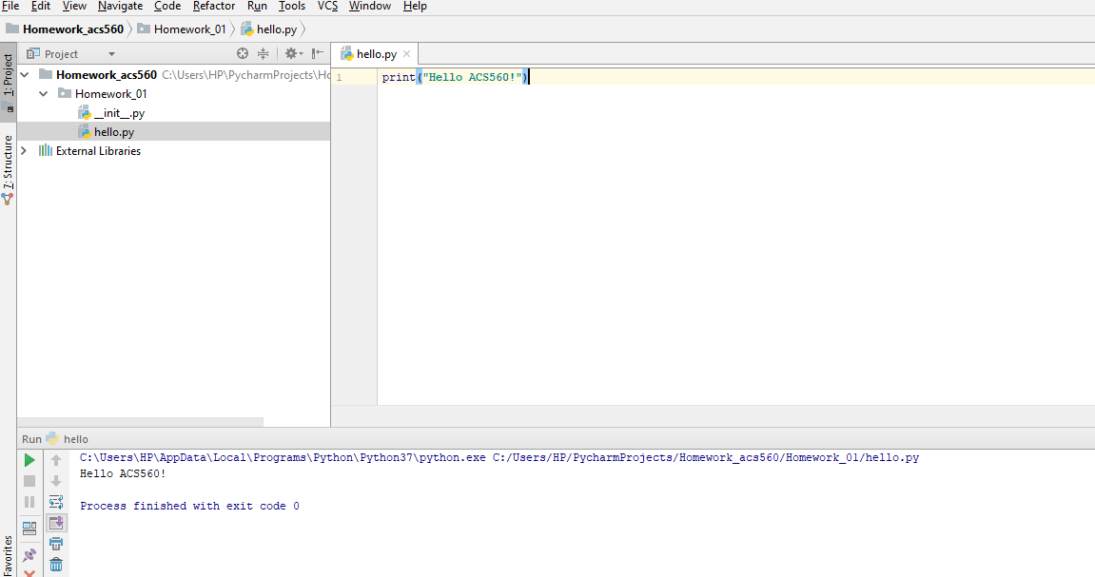

1. OS SHELL SCRIPT

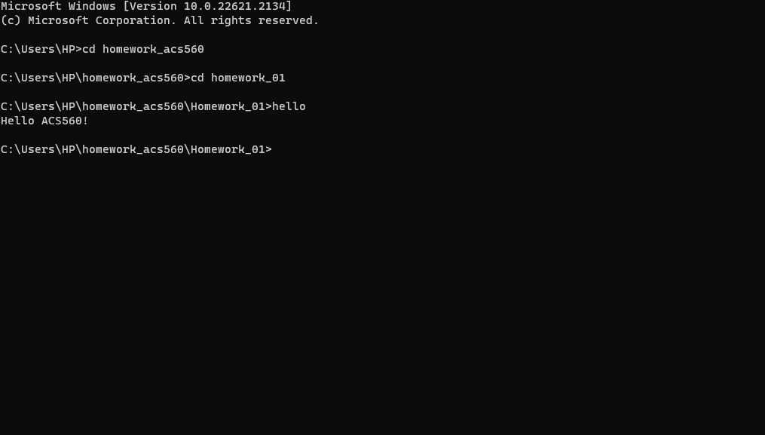

1. JAVASCRIPT

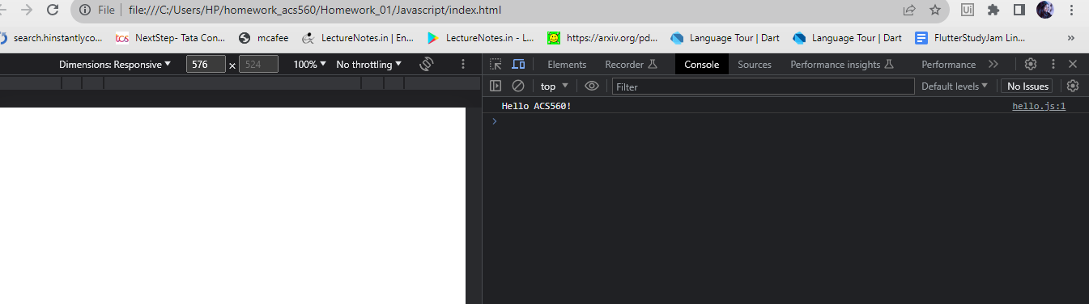

1. HTML

