SUMMARY:

1. Project Development: First of all, the maven project was configured using spring.io. using language java with spring boot version 3.1.3.

Project Metadata:

* Group: com.sports
* Artifact: goteam
* Name: goteam
* Description: SportsData project for Spring Boot
* Packaging: jar
* Package name for main class: com.sports.goteam.GoTeamApplication
* Java version: 8
* Dependencies: Spring Boot Dev Tools, Lombok, Spring Web, Rest Repositories, Spring Data JPA, H2 Database

Then, the zip file containing the spring boot project was imported into eclipse ide. The code was added, maven cleaned and installed, and the application was run.

1. Project Purpose: The project aims to manage information about Football team players. It is designed to interact with a database to store and retrieve player data. We can create, read, update, and delete player records in the database. We can use either Id or team name to read and delete players.

SCREENSHOTS:

1. Application Running

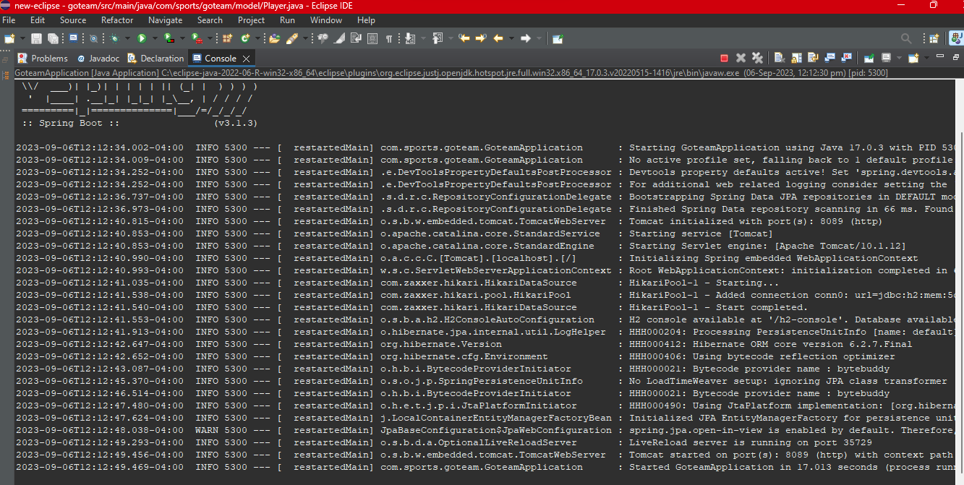

1. createManyPlayers

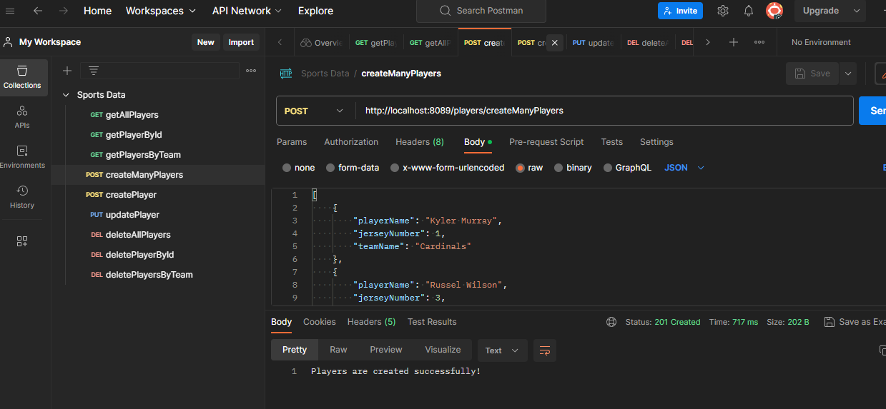

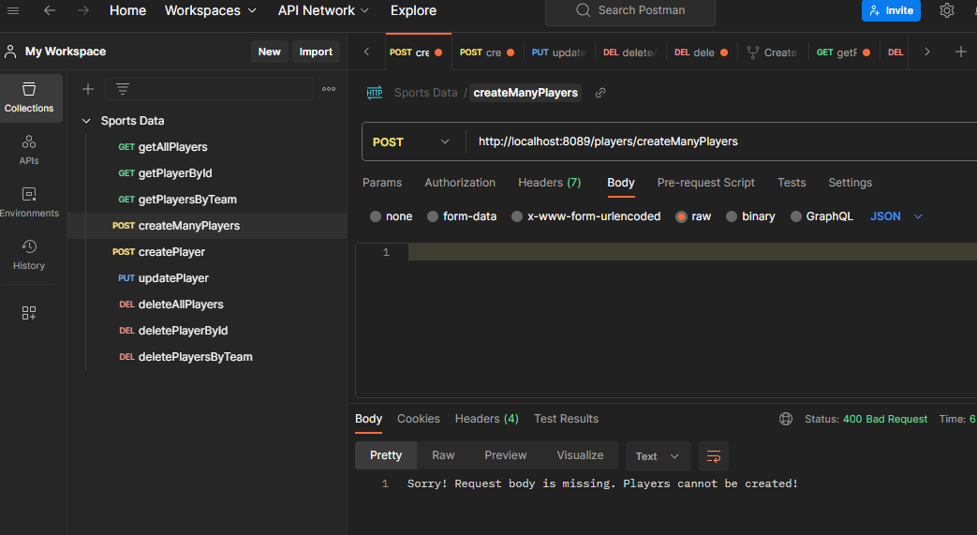

1. createPlayer

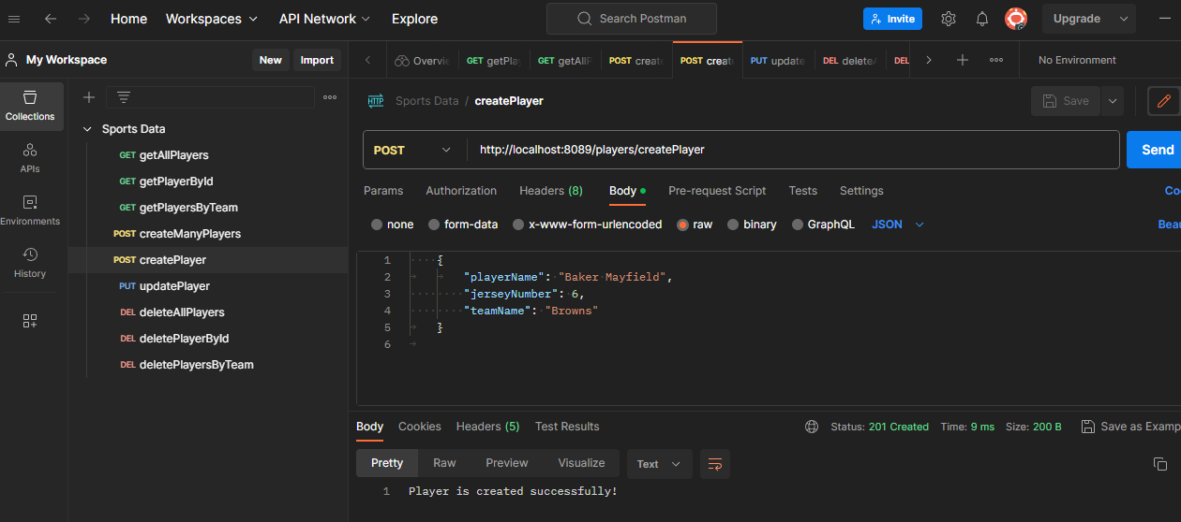

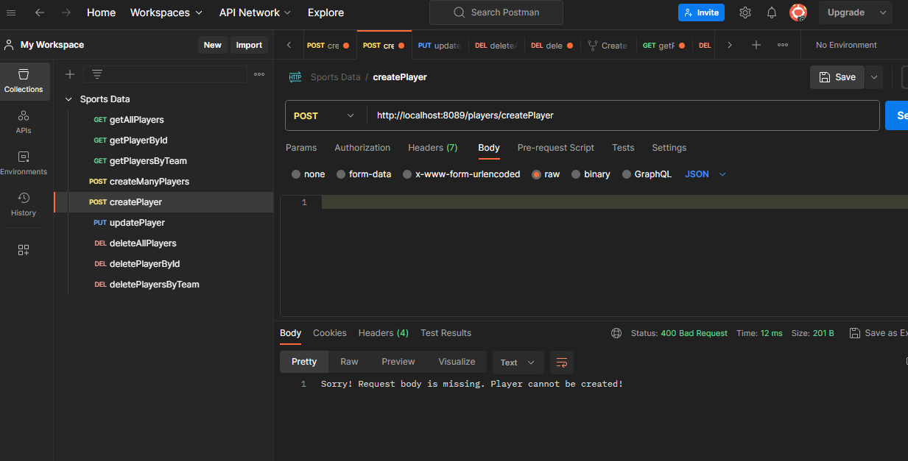

1. getAllPlayers

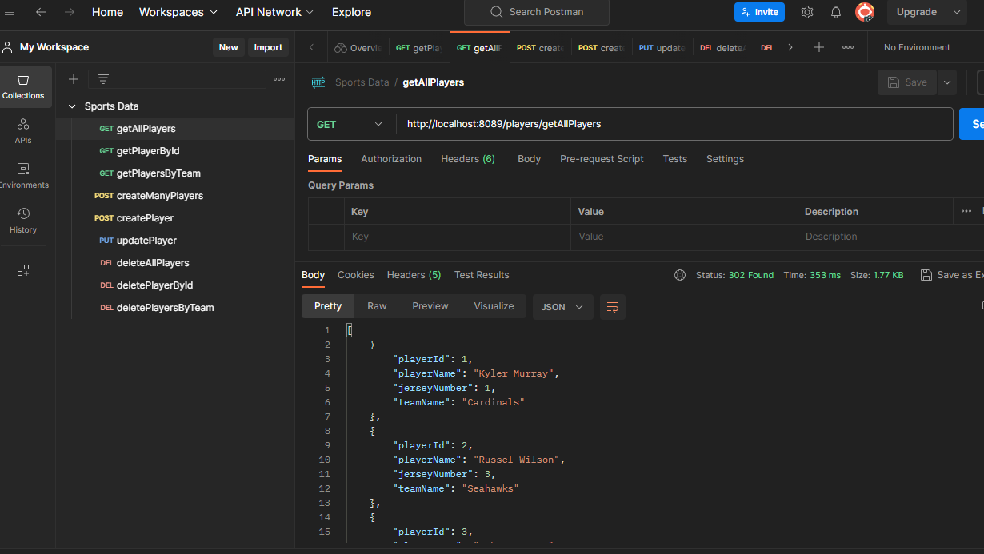

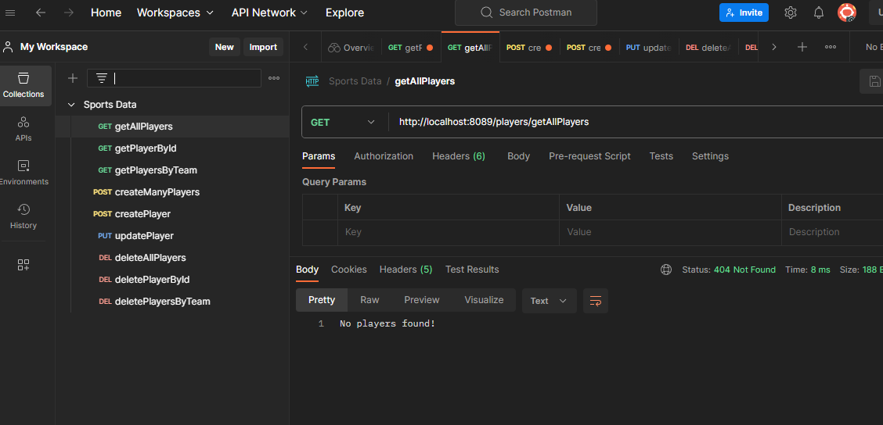

1. getPlayerById

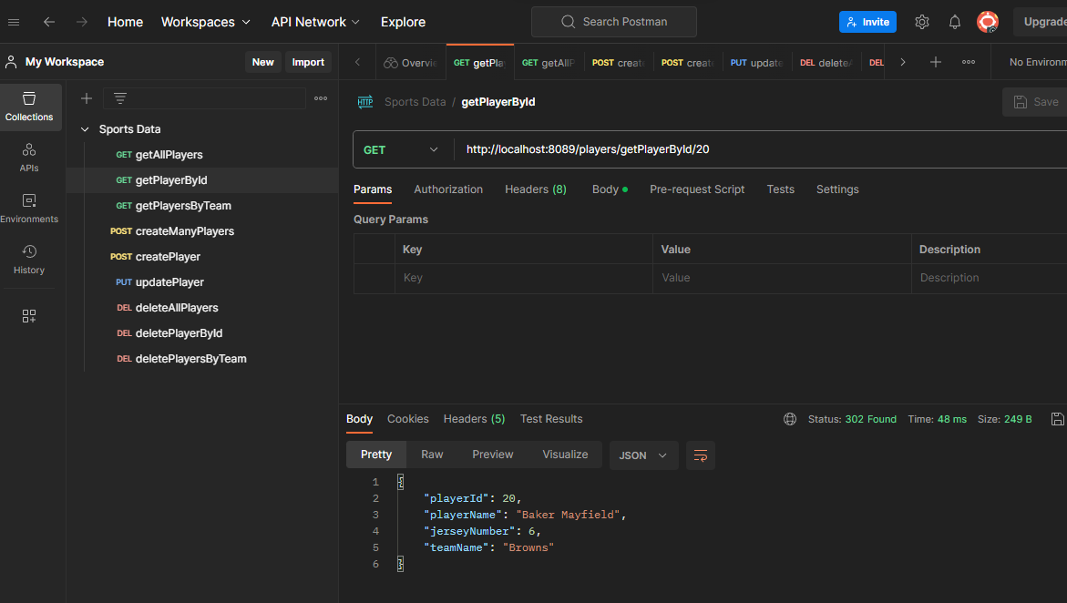

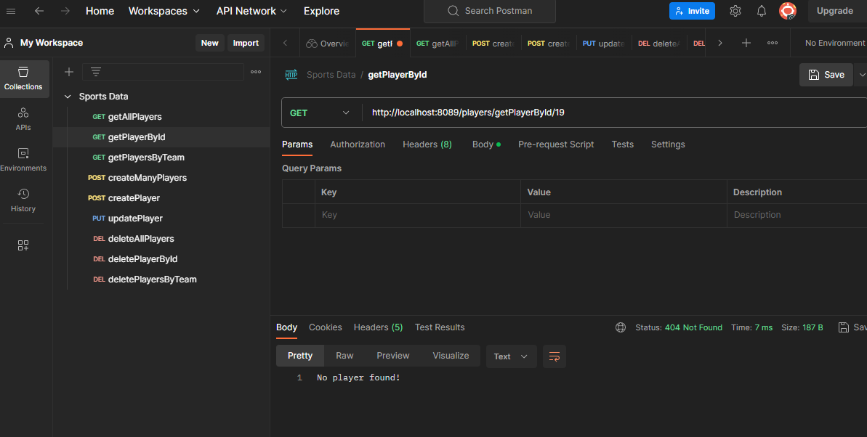

1. getPlayersByTeam

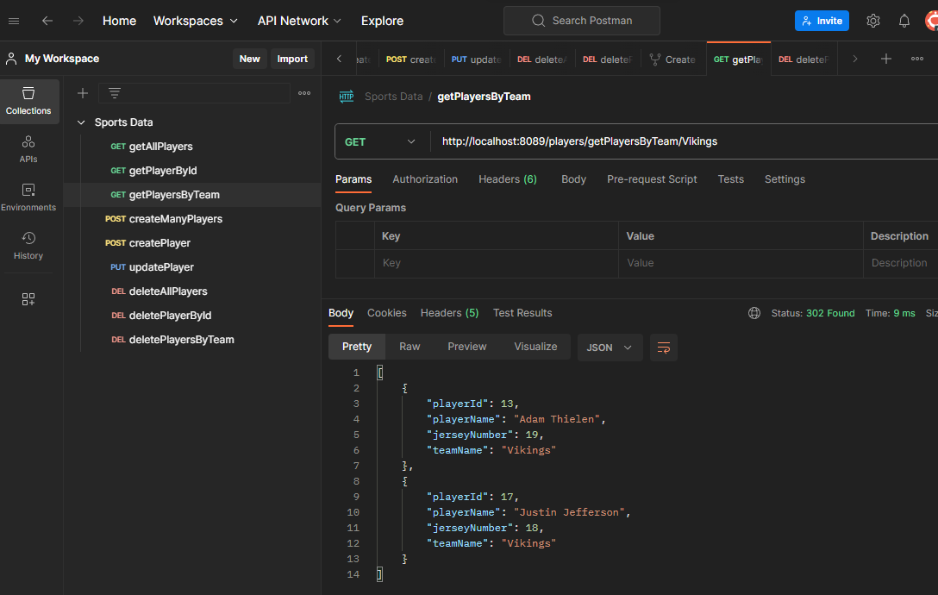

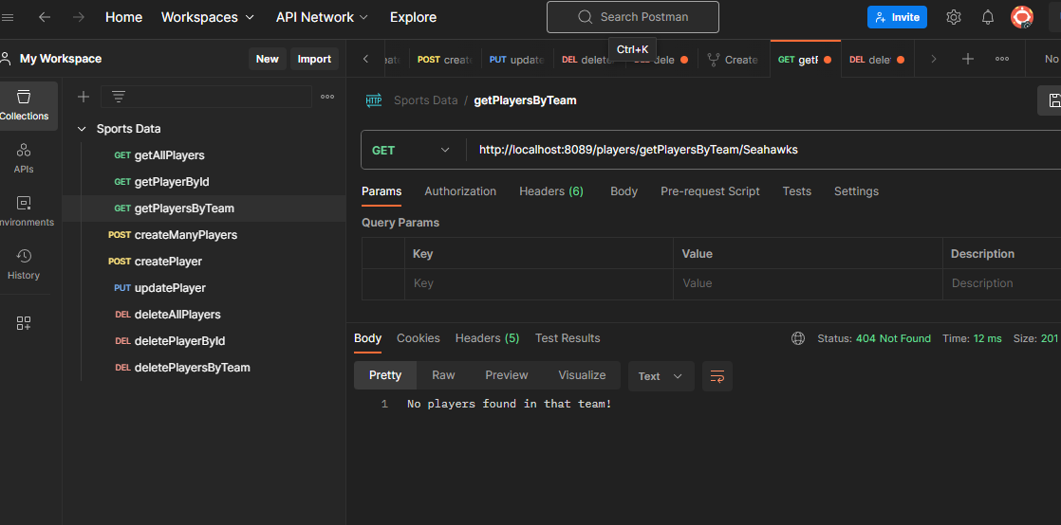

1. updatePlayer

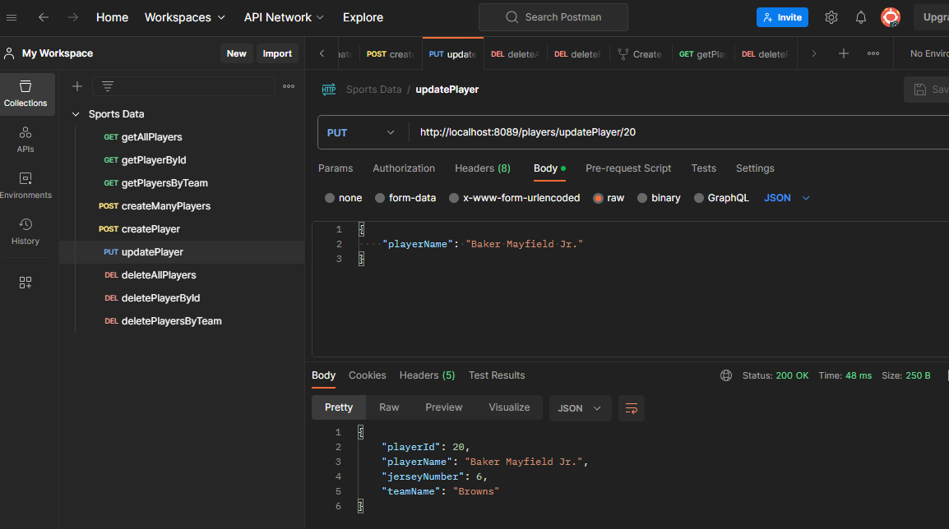

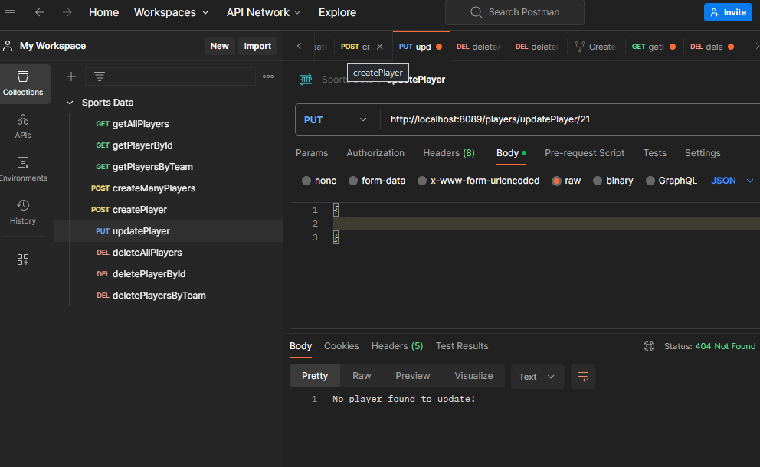

1. deletePlayerById

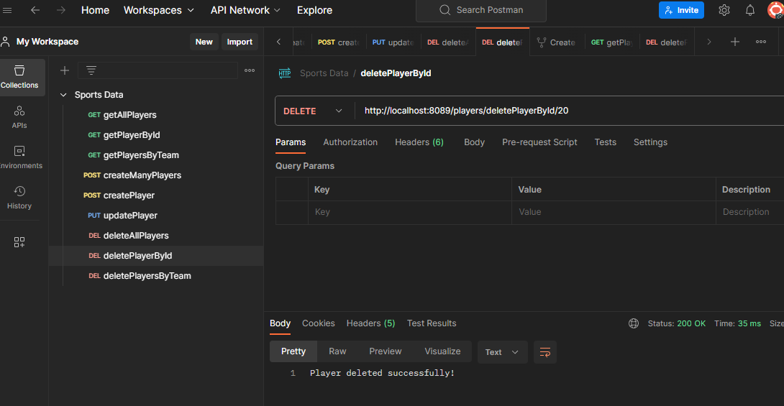

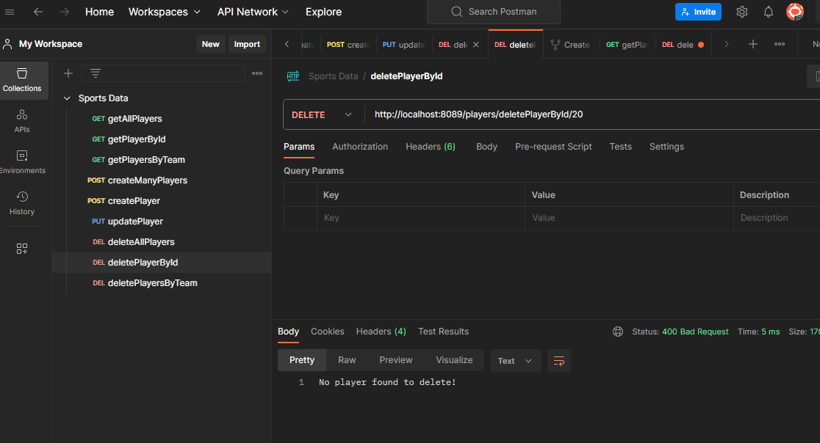

1. deletePlayersByTeam

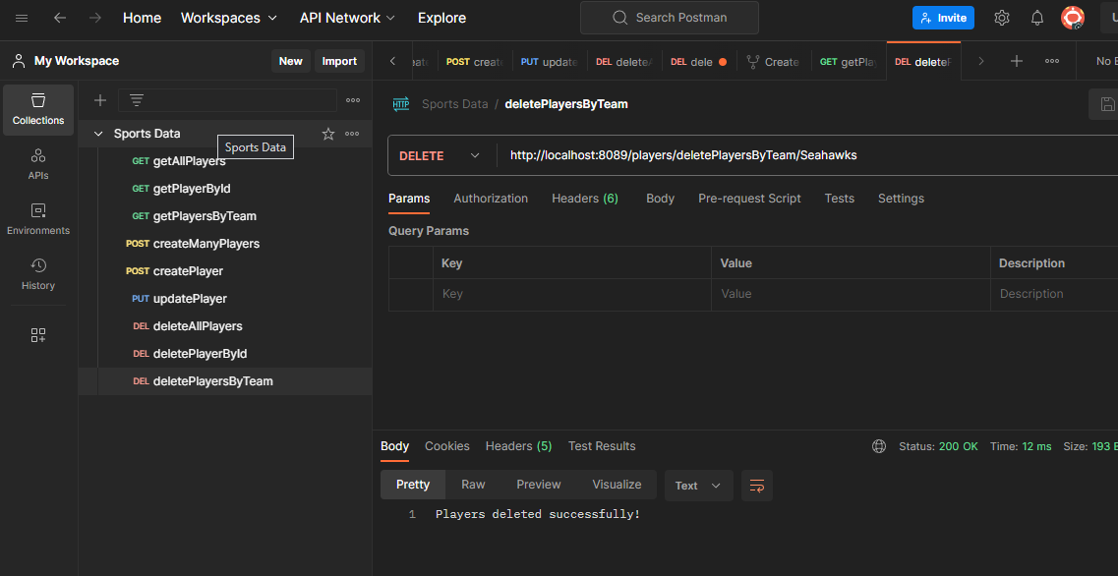

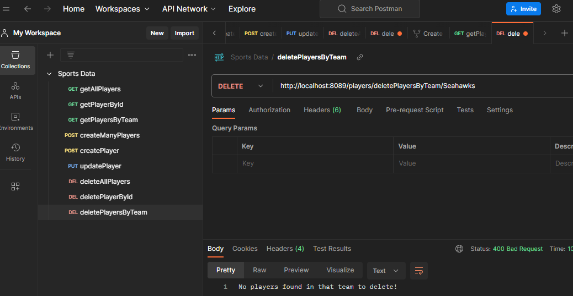

1. deleteAllPlayers

