SCREENSHOTS

1. Application Up and Running:

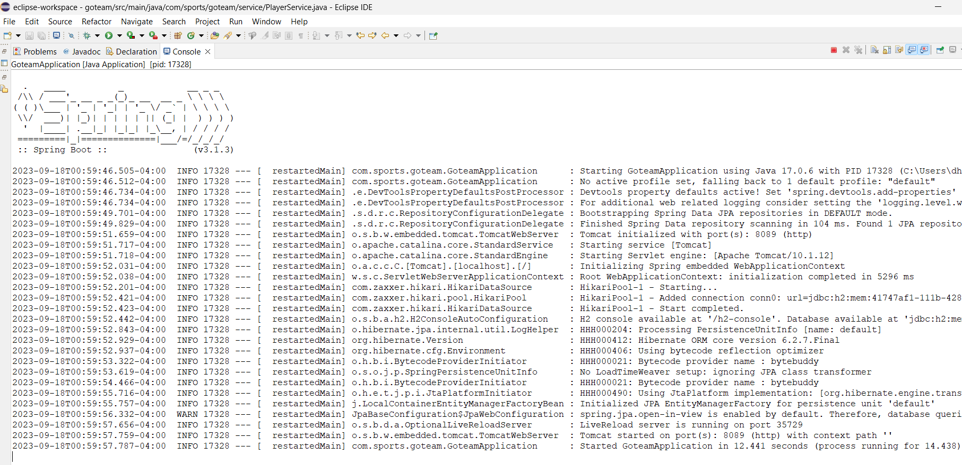

1. Screenshots of implemented functionalities:

* Player Statistic Tracking:

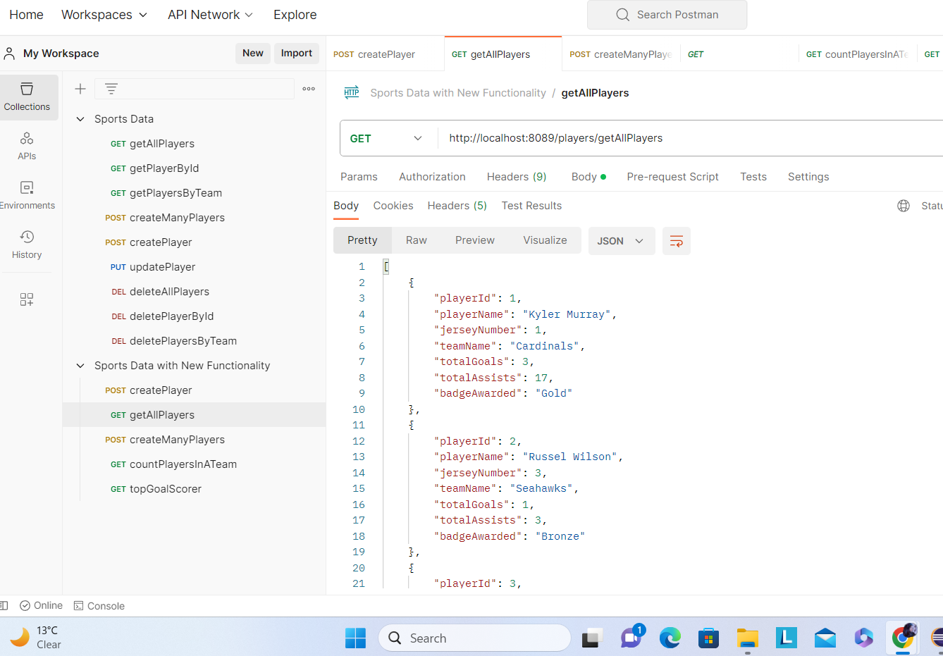

* Count Players by Team:

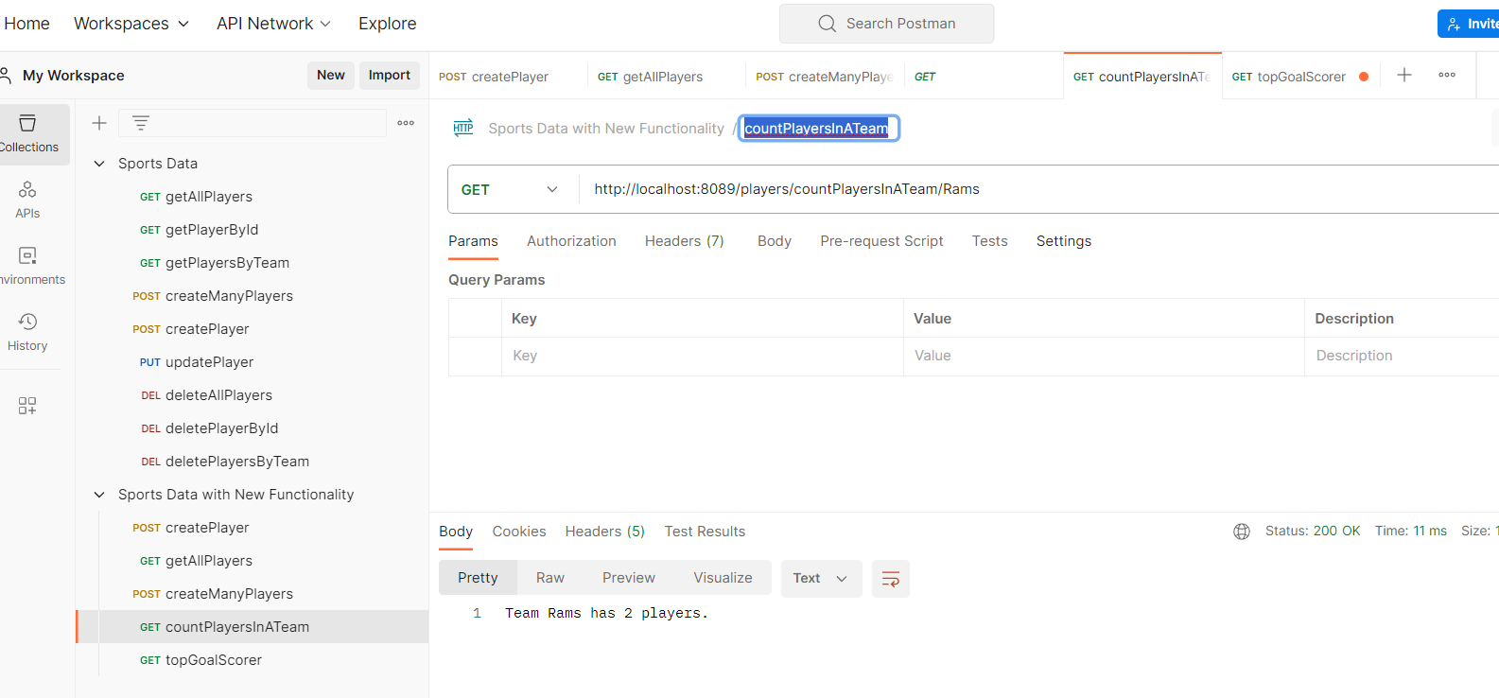

* Top Goal Scorer:

