SCREENSHOTS

1. CrossCountryRaceScoringTest.java

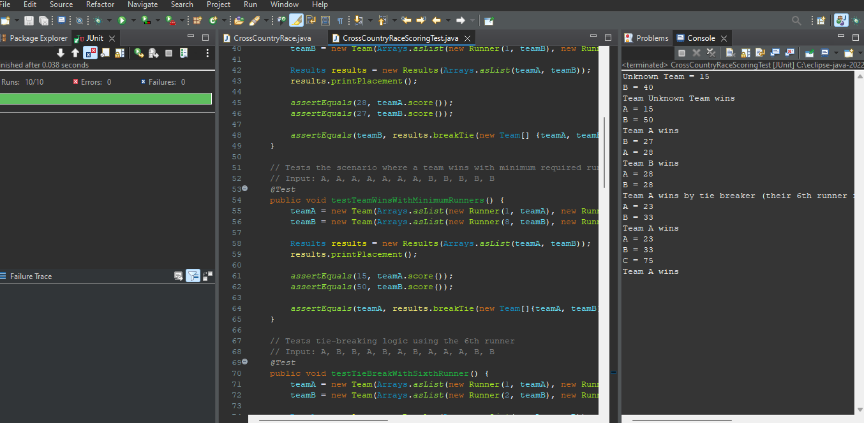

1. TeamConstructorTest.java

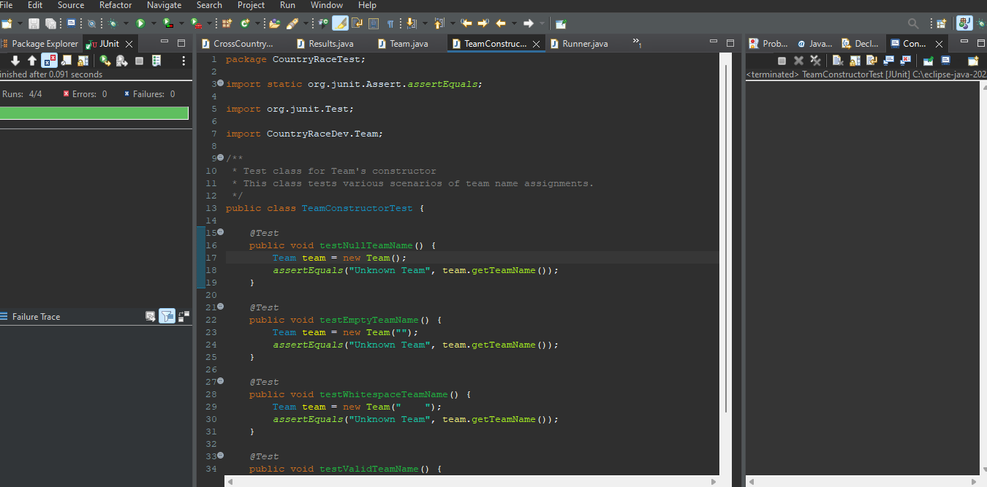

1. CrossCountryRace.java
2. testBasicTeamScoring:

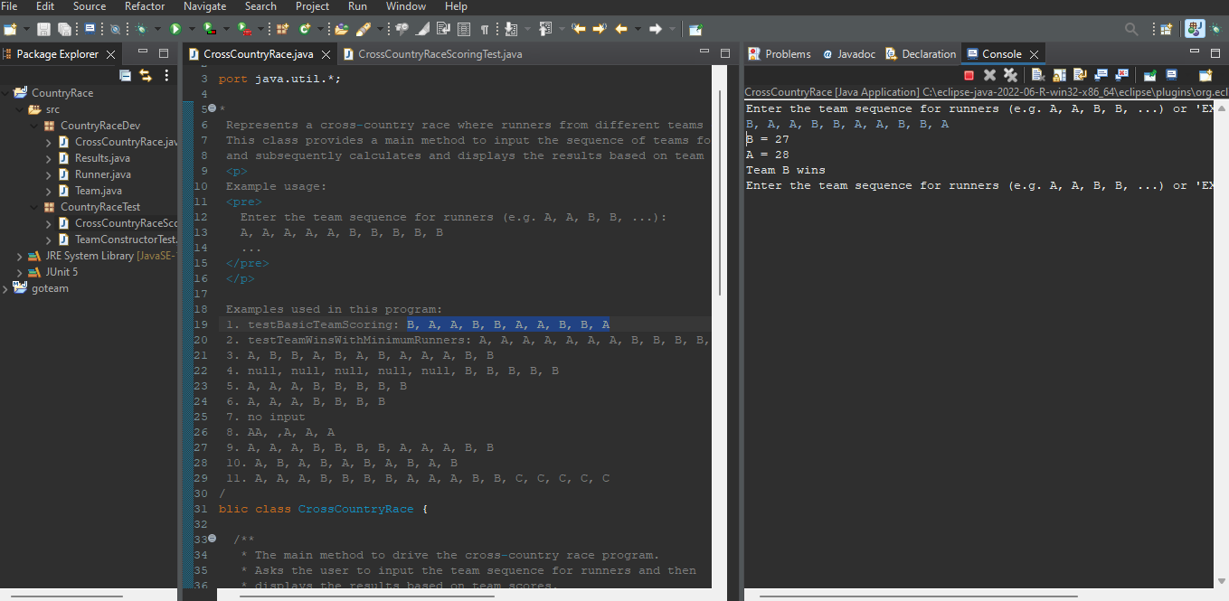

1. testTeamWinsWithMinimumRunners:

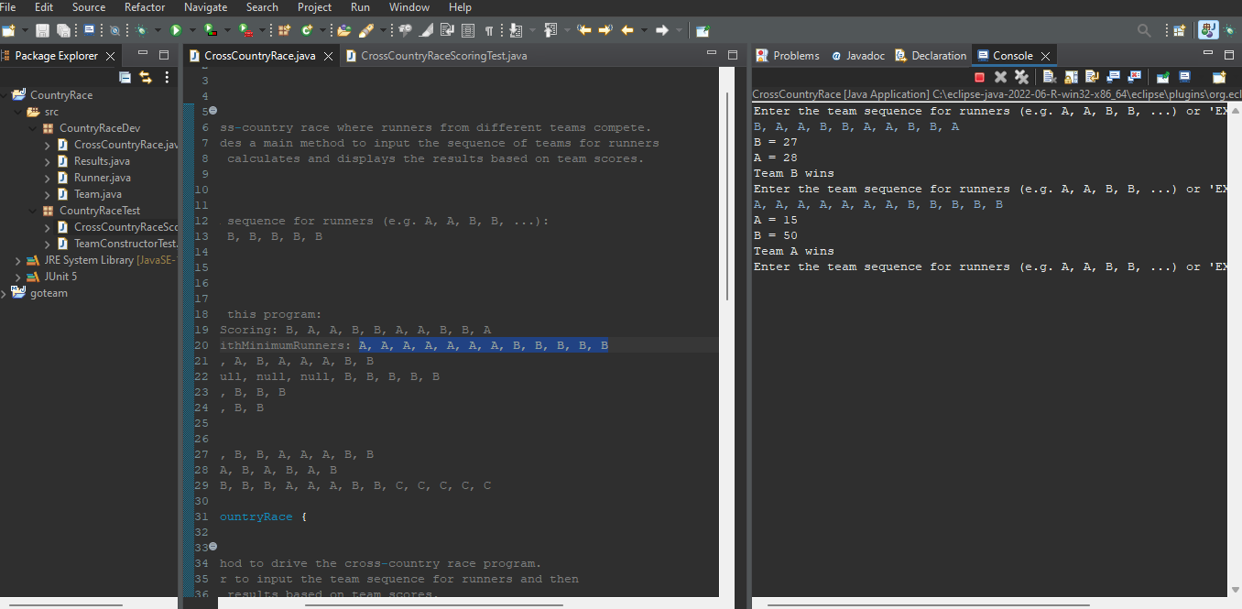

1. testTieBreakWithSixthRunner:

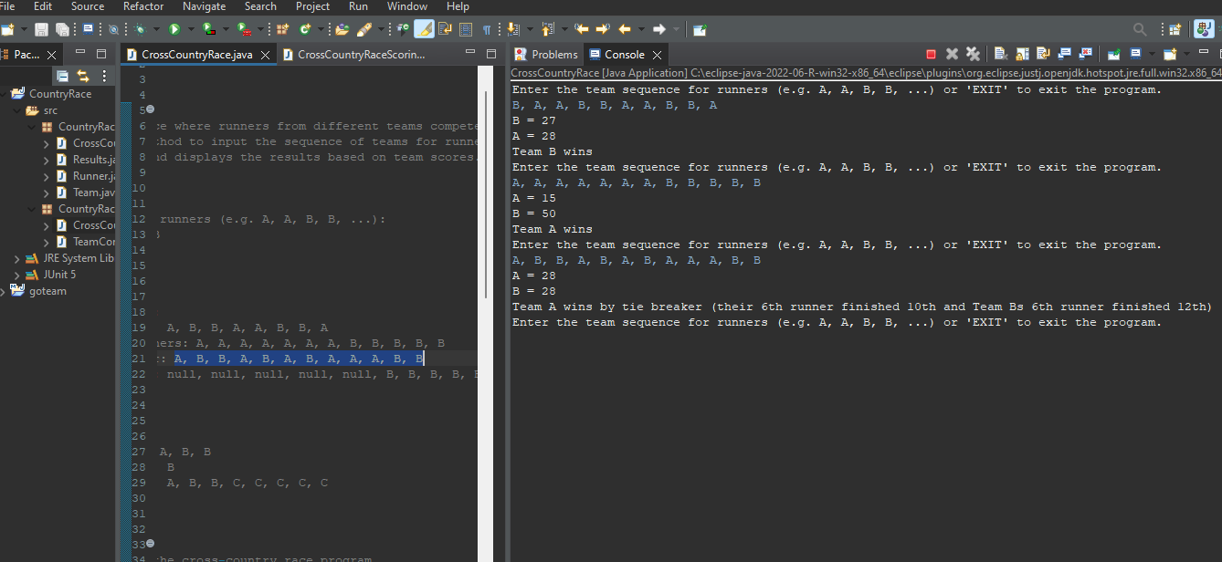

1. testTeamWithUnknownRunners:

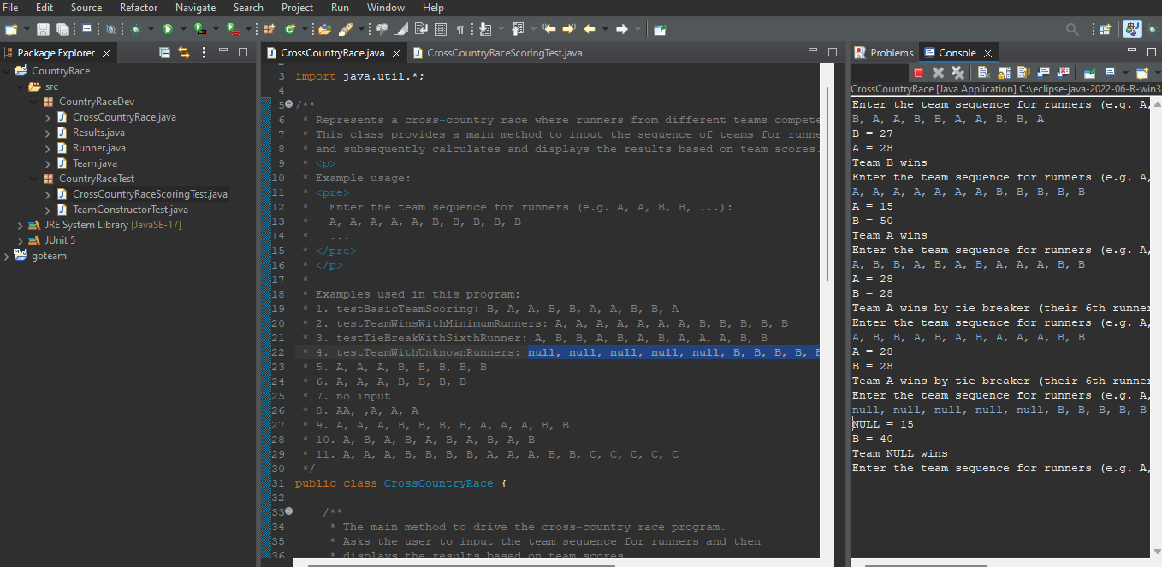

1. testLessThan5Runners:

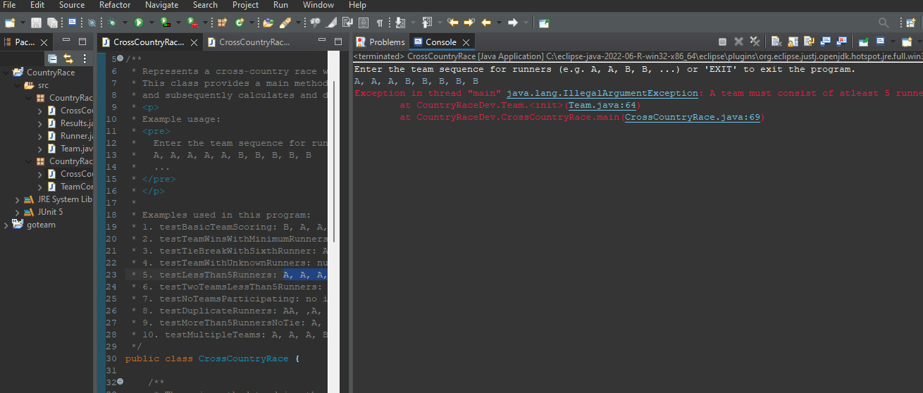

1. testTwoTeamsLessThan5Runners:

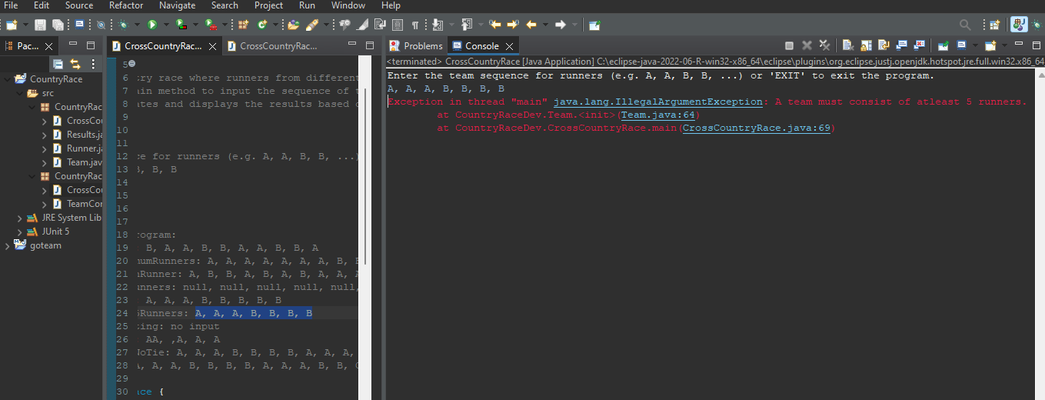

1. testNoTeamsParticipating:

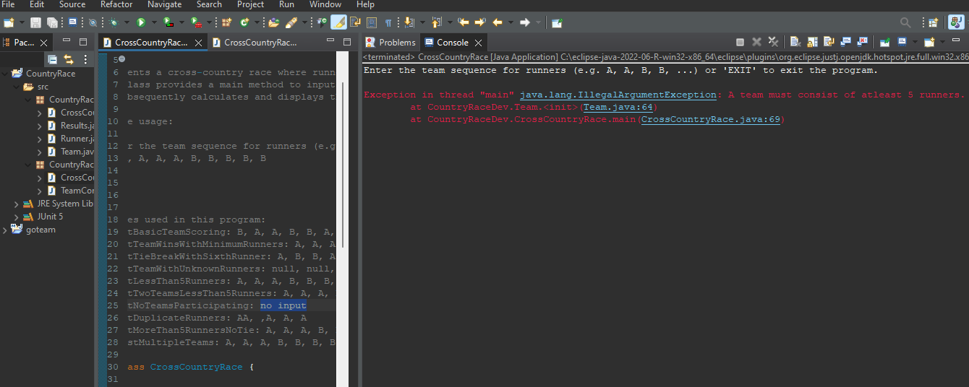

1. testMoreThan5RunnersNoTie:

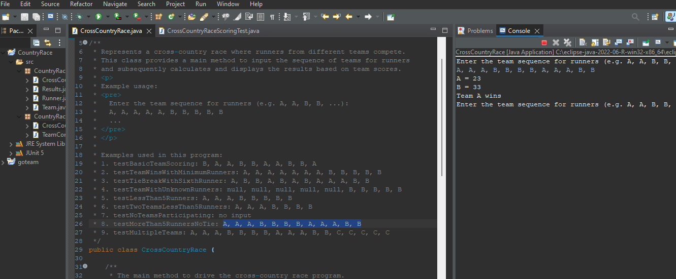

1. testMultipleTeams:

