HW10 – SQLITE

Todo database

**Steps done to achieve what is needed:**

1. **Dropping the ‘Completed’ column and adding ‘StartDate’ and ‘EndDate’ columns.**

* downloaded and installed DB Browser for SQLite.
* launched the application.
* clicked on ‘Open Database’ and selected ‘TodoDemo.db’ file.
* clicked on the ‘database structure’ and right-clicked on the table ‘Todo’ -> selected ‘modify table’ to modify the Todo table.
* Selected ‘Completed’ field, clicked on ‘remove field’ button.
* clicked on ‘add field’ button and added ‘StartDate’ and ‘EndDate’ fields with datatype as text (as ISO8601 strings – ‘YYYY-MM-DD’).

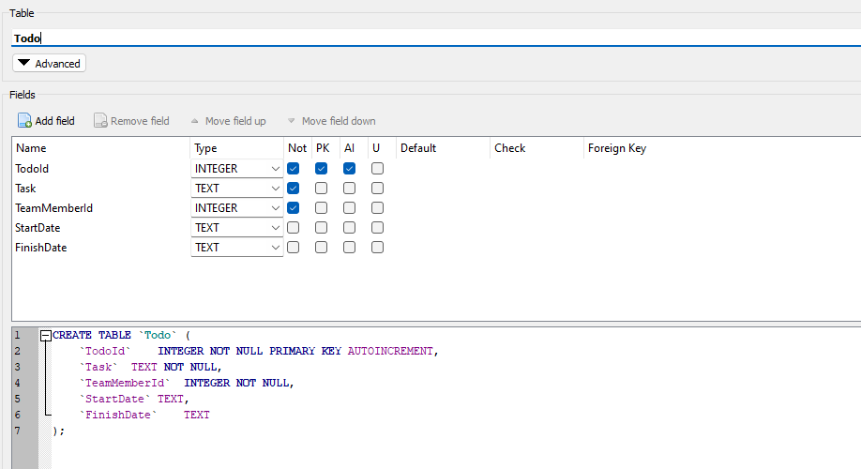

* clicked on ‘ExecuteSQL’ tab and then on ‘Write Changes’ button to save changes.
* **SQL Statement:** select * from Todo

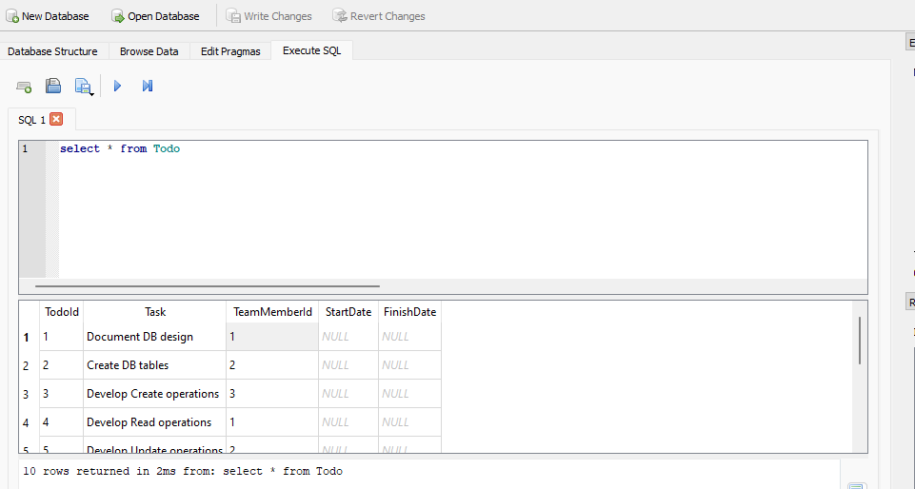

1. **Updating the table ‘Todo’ to insert values in ‘StartDate’ and ‘EndDate’.**

* **SQL Statement:**

UPDATE Todo SET StartDate = '2023-10-01', FinishDate = '2023-10-04' WHERE TodoId = 1;

UPDATE Todo SET StartDate = '2023-10-02', FinishDate = '2023-10-04' WHERE TodoId = 2;

UPDATE Todo SET StartDate = '2023-10-03', FinishDate = '2023-10-06' WHERE TodoId = 3;

UPDATE Todo SET StartDate = '2023-10-04', FinishDate = '2023-10-07' WHERE TodoId = 4;

UPDATE Todo SET StartDate = '2023-10-05', FinishDate = '2023-10-09' WHERE TodoId = 5;

UPDATE Todo SET StartDate = '2023-10-06', FinishDate = '2023-10-08' WHERE TodoId = 6;

UPDATE Todo SET StartDate = '2023-10-07', FinishDate = '2023-10-10' WHERE TodoId = 7;

UPDATE Todo SET StartDate = '2023-10-08', FinishDate = '2023-10-12' WHERE TodoId = 8;

UPDATE Todo SET StartDate = '2023-10-09', FinishDate = '2023-10-11' WHERE TodoId = 9;

UPDATE Todo SET StartDate = '2023-10-10', FinishDate = '2023-10-14' WHERE TodoId = 10;

* clicked on ‘ExecuteSQL’ tab and then on ‘Write Changes’ button to save changes.

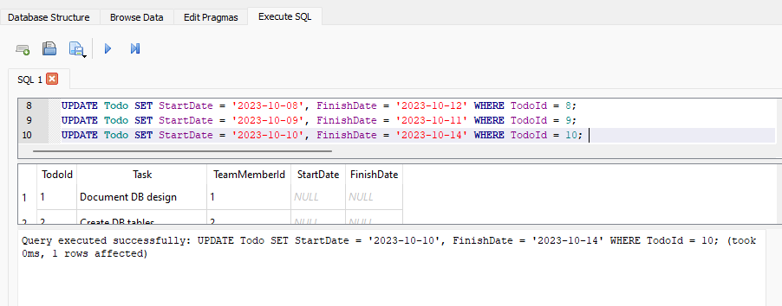

* **SQL Statement:**

Select * from Todo

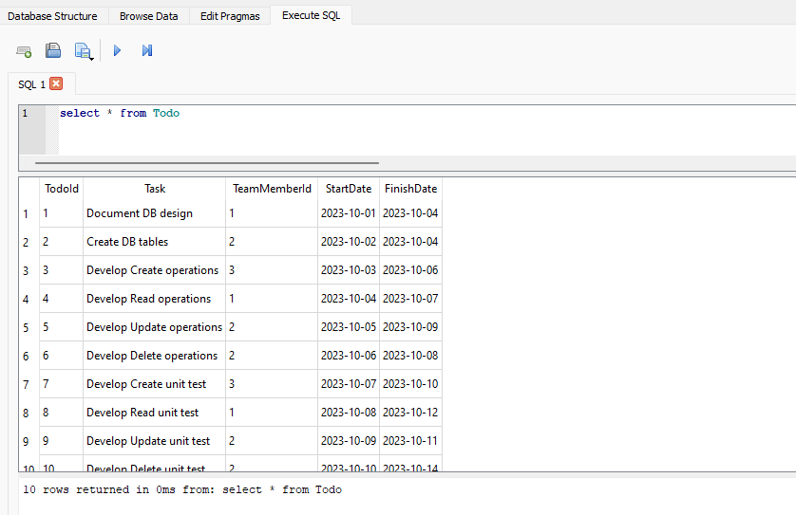

1. **SQL statement to calculate the average number of days to complete a task for all team members.**

* **SQL Statement:**

SELECT AVG(DaysToComplete) AS OverallAvgDaysToComplete

FROM (

SELECT julianday(t.FinishDate) - julianday(t.StartDate) AS DaysToComplete

FROM todo t

) SubQuery;

**Explanation:**

**Inner subquery:** For each task, it calculates the number of days taken to complete it, resulting in a temporary table with **‘TeamMemberId’** and **‘DaysToComplete’**.

**Outer Query:** calculates the average of **‘DaysToComplete’** from the inner subquery’s results, giving the overall average task completion time across all team members and tasks.

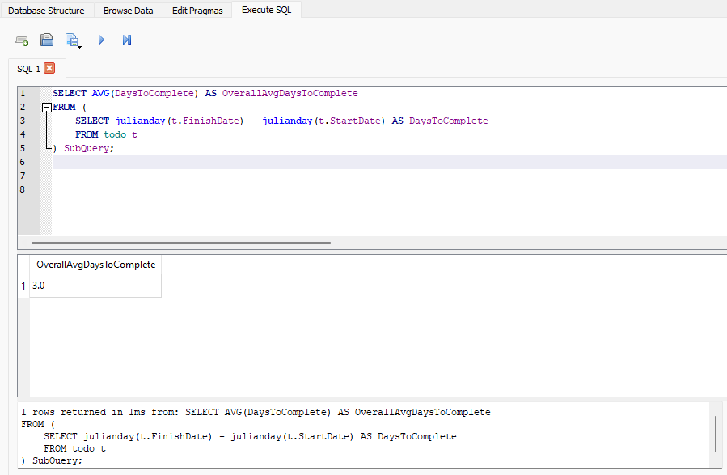

1. **SQL statement to show the list of team members whose average task completion was less than the average task completion of all team members.**

* First, let’s calculate the average completion time of each member.

**SQL Statement:**

SELECT tm.LastName || ', ' || tm.FirstName AS FullName,

ROUND(AVG(julianday(t.FinishDate) - julianday(t.StartDate)), 1) AS AvgCompletionTime

FROM todo t

JOIN teammember tm ON t.teammemberid = tm.teammemberid

GROUP BY t.teammemberid, FullName

ORDER BY AvgCompletionTime;

**Explanation:**

**Join Operation:** The query joins the **‘Todo’** and **‘TeamMember’** tables to combine task information with team member details.

**Average Calculation:** For each team member, it calculates the average time taken to complete their assigned tasks, rounding the result to one decimal place.

**Group By and Order By:** The results are then grouped by team member and displayed in ascending order of average completion time, showing each team member’s full name alongside their average task duration.

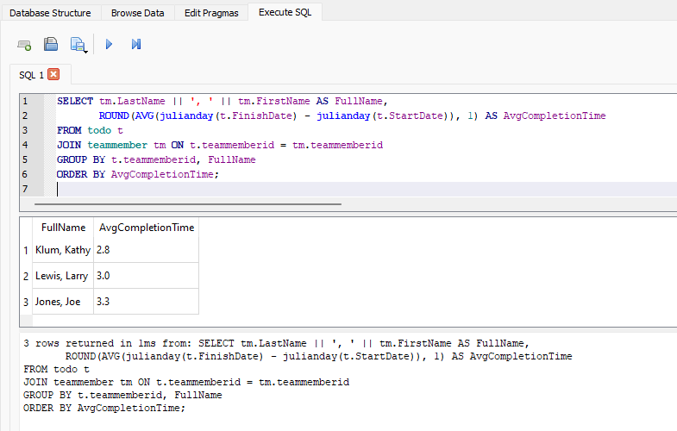

* Now, let’s find the members with below-overall average completion time.

**SQL Statement:**

WITH MemberAvgCompletionTime AS (

SELECT tm.LastName || ', ' || tm.FirstName AS FullName,

AVG(julianday(t.FinishDate) - julianday(t.StartDate)) AS AvgCompletionTime

FROM todo t

JOIN teammember tm ON t.teammemberid = tm.teammemberid

GROUP BY tm.teammemberid

)

SELECT *

FROM MemberAvgCompletionTime

WHERE AvgCompletionTime < (SELECT OverallAvgCompletionTime FROM (SELECT AVG(julianday(FinishDate) - julianday(StartDate)) AS OverallAvgCompletionTime FROM todo));

**Explanation:**

**MemberAvgCompletionTime CTE:** A common table expression calculates the average completion time for each team member, grouping by their ID and displaying their full name.

**Overall Average Calculation:** A subquery calculates the overall average completion time across all tasks and team members.

**Filtering:** The main query selects team members from the CTE whose average completion time is below the overall average, displaying their names and average completion times.

