Class Diagram- server side

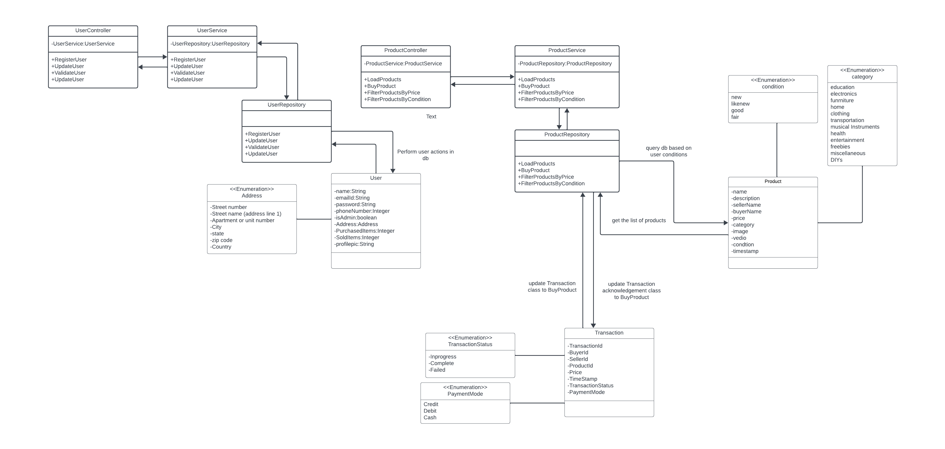

Class Diagram - client side

