**SEQUENCE DIAGRAM**

1. **User Registration**

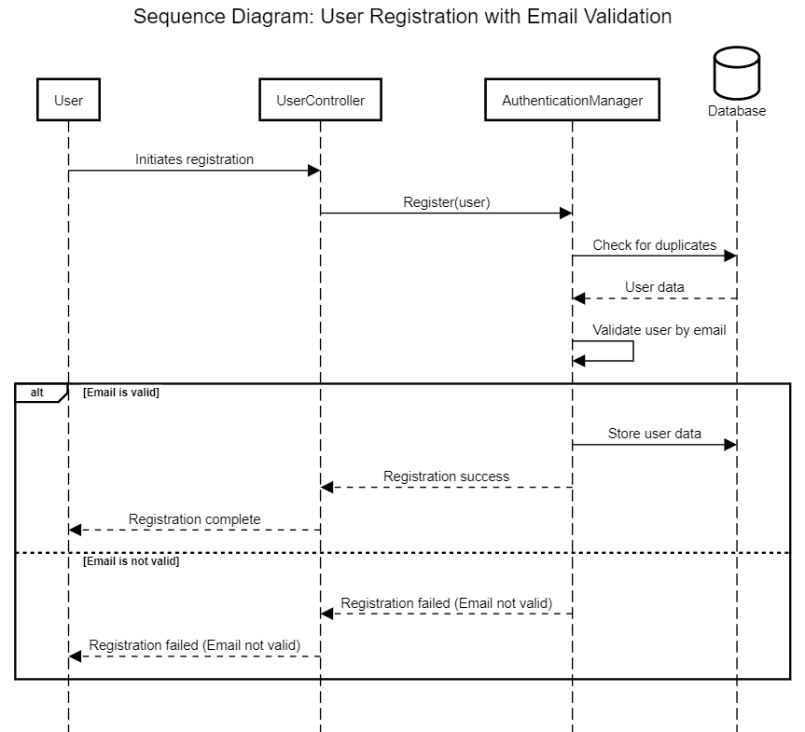

1. **User Log in**

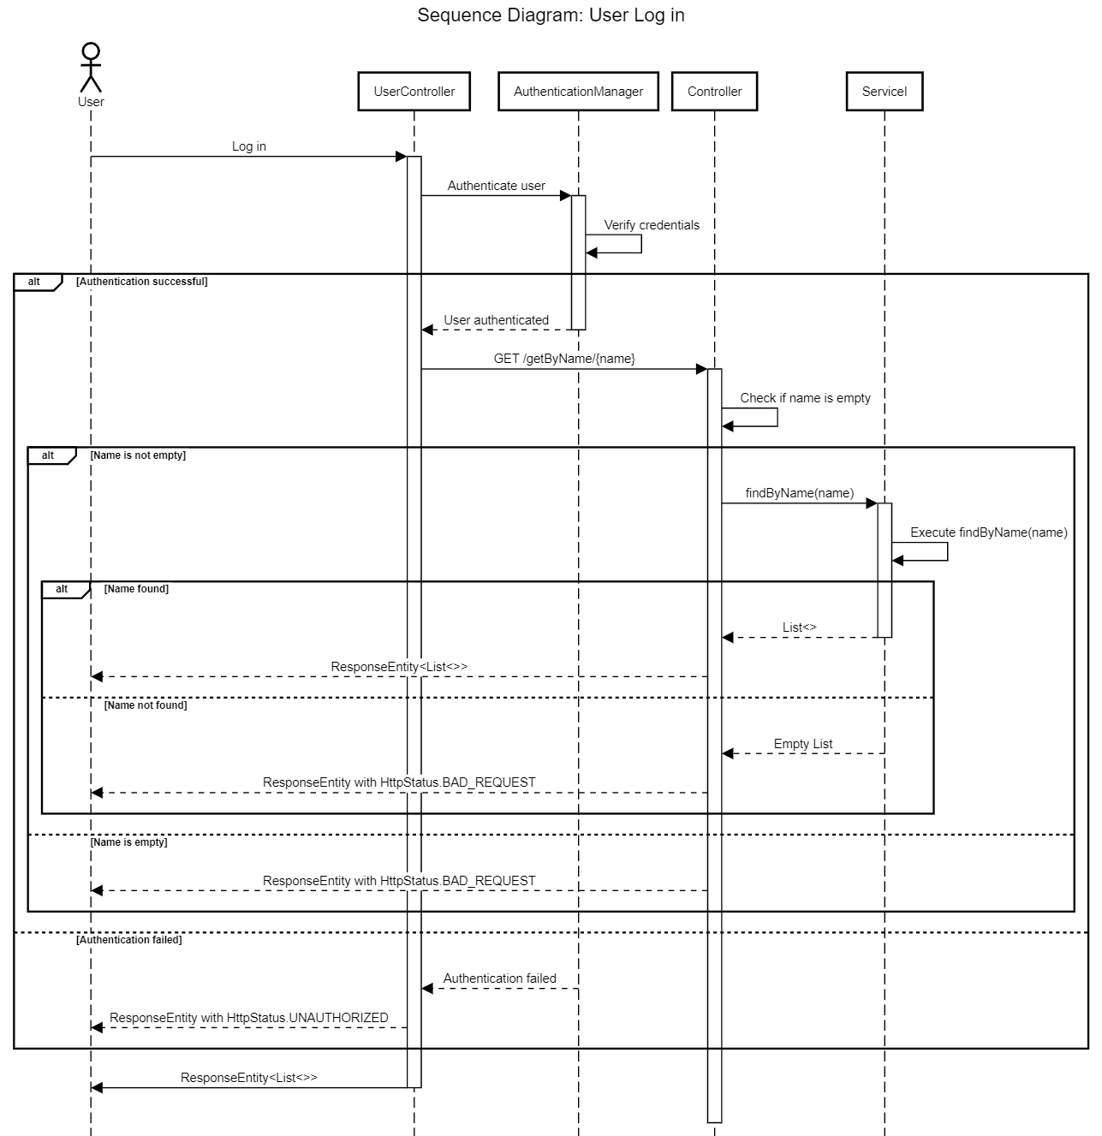

1. **Filter Products by category (good, likenew, new, fair)**

