INTRODUCTION

Here we are trying to implement B+Tree using Python language. Here we will try to deep dive into B+Tree’s structure, creation of Tree to Node to Sub-node level. And it would be a discussion on:
1. What problem we faced,
2. What solutions we thought of,
3. and Why we selected and rejected them?
And lastly, How we Implemented them using Python.

The later part of this plan is to intregate C code with python to have lightweight dataStructure and Objects. ####Not Clear####

STRUCTURE

The Structure Of B+Tree is dicided into 3 parts:
1. Tree Root
2. Node of the Tree
3. Sub-node of the Sub-node

Description:
NOTE: Assuming reader is aware of the B+Tree structure.
Similar to Binary Search Tree, B+Tree also holds the Smaller-LEFT--Larger-RIGHT property. But in B+Trees there generally more than 1 key in a node. A node of B+tree can have upto thousands of Keys.
####Describe here more##

Sub-node level architecture

The following were thought as the subnode structure of B+Trees.

1. An object with 2 pointers and 1 key in a sequential manner: [P1-K1-P2]
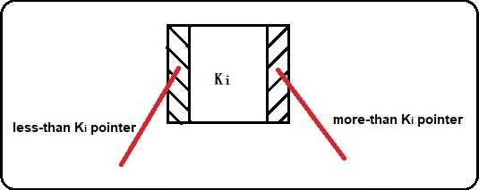

The sub-node diagram with Pointer-Key-Pointer structure

2. An object with 1 pointer and 1 key as mentioned sequence: [P1-K1]

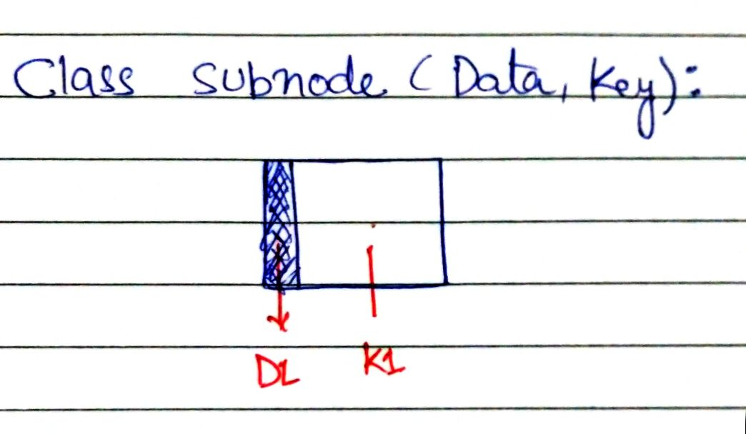

The sub-node for P1-K1 structure

In this structure we would be requiring a pointer sub-node as last sub-node, which will be handled at Node level object. Hence the structure of a Node of a B+Tree can be completed*1.

Node level architecture

Out of above mentioned sub-nodes structure, the [ Pointer-Key + Pointer ] structure for Node is most preferred to make the node as light-weight as possible.

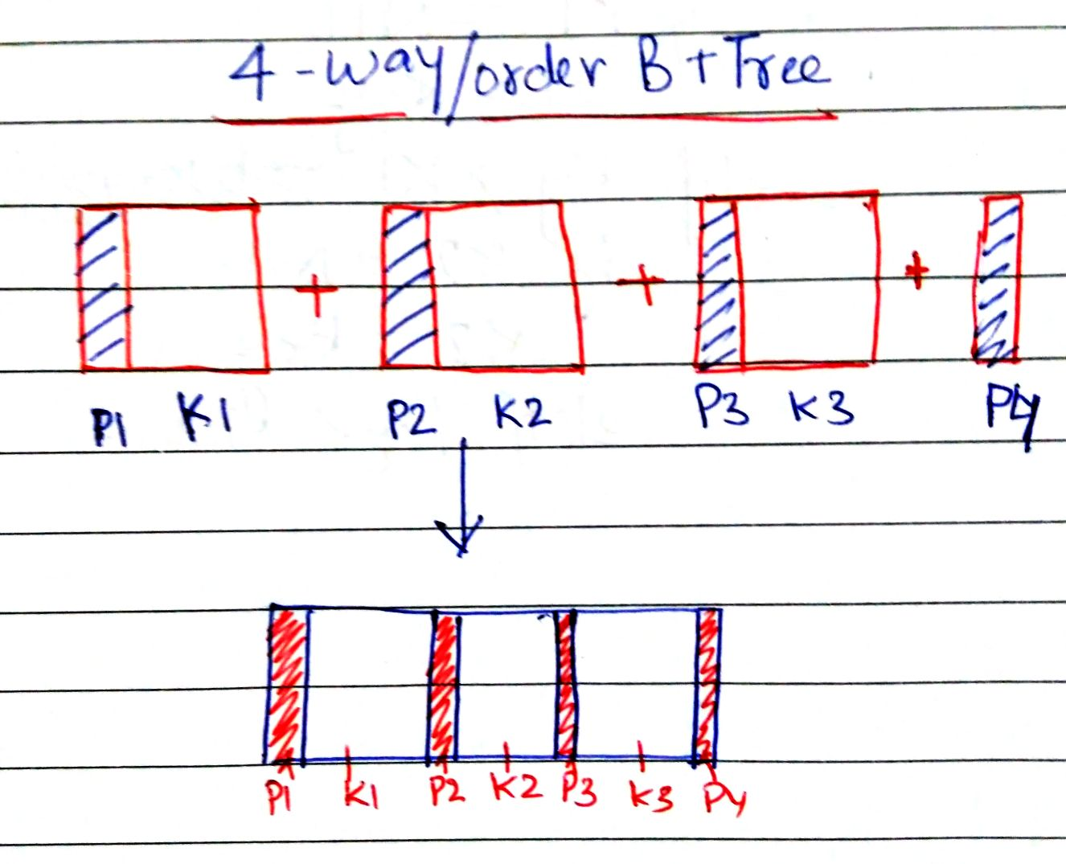
Fig: Concatenation of 3 (P1K1-P2K2-P3K3) sub-nodes and 1 Pointer (P4) sub-node to create a Node of 4-way B+Tree

Initially Python’s in-built List data structure is used to maintain the sequence of subnodes including the last only-pointer sub-node.

Considering 3-way B+Tree nodes with
Here following are the two structures of node proposed to create a Node for a B+Tree:

1. Dynamic size-list Node

2. Static size-list node

Annotations:

*1: In P1-K1 structure, a pointer sub node would be required to complete the structure of a Node of a B+Tree.

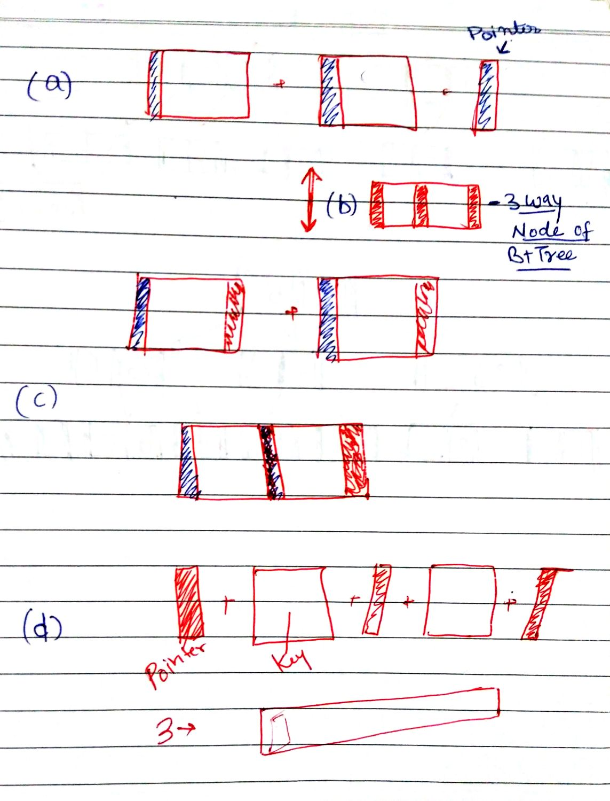
Fig: Different Sub-nodes structures of a order-3 B+Tree.
a) Summation of 2 Pointer-Key sub-nodes and 1 Pointer sub-node and thus making (b)

b) A 3-way B+tree node with
P1-K1—P2-K2--P3 representation

c) Summation of 2 Pointer-Key-Pointer sub-nodes to make (b), Here right pointer of 1st sub-node and left pointer of right

d) Another structure of node which was initially rejected because Data-pointer and its corresponding key are always related and must be considered as a single entity.

