


TINY TRAIL – A DIGITAL MARKET PLACE FROM HOME TO YOUR HANDS

A PROJECT REPORT
Submitted by

SABARINATHAN S - 113022104127
THIRUMURUGAN B - 113022104160
THISO VALLABADASS K - 113022104161

in partial fulfillment for the award of the degree
of

BACHELOR OF ENGINEERING
in
COMPUTER SCIENCE AND ENGINEERING

VEL TECH HIGH TECH
DR.RANGARAJAN DR.SAKUNTHALA ENGINEERING COLLEGE
AN AUTONOMOUS INSTITUTION

ANNA UNIVERSITY : CHENNAI 600025
NOVEMBER 2025

VEL TECH HIGH TECH
Dr. RANGARAJAN Dr. SAKUNTHALA ENGINEERING COLLEGE
AN AUTONOMOUS INSTITUTUION

BONAFIDE CERTIFICATE

Certified that this project entitled “TINY TRAIL - A DIGITAL MARKET PLACE FROM HOME TO YOUR HANDS” is the Bonafide Work of “SABARINATHAN S –113022104127, THIRUMURUGAN B -113022104160,THISO VALLABADASS K - 113022104161,” who ca2rried out the work under my supervision.

SIGNATURE SIGNATURE

Dr.S.Durga Devi B.E,M.E,Ph.D., Ms. N. Hindumathy, M.E.

HEAD OF THE DEPARTMENT SUPERVISOR(Ass. Professor/CSE)

Dept. of Computer Science and Engg. Dept. of Computer Science and Engg.

Vel Tech High Tech Dr.Rangarajan Vel Tech High Tech Dr.Rangarajan

Dr.Sakunthala Engineering College Dr.Sakunthala Engineering College

Avadi, Avadi

Chennai – 600062 Chennai - 600062

CERTIFICATE OF EVALUATION

College Name : VEL TECH HIGH TECH DR. RANGARAJAN
DR. SAKUNTHALA ENGINEERING COLLEGE AVADI,

Branch : COMPUTER SCIENCE & ENGINEERING

Semester : VII

S.NO | NAME OF THE STUDENTS | NAME OF THE PROJECT | NAME OF THE SUPERVISOR
1 | SABARINATHAN S | TINY TRAIL - A DIGITAL MARKET PLACE FROM HOME TO YOUR HANDS | Ms.N. HINDUMATHY M.E.
2 | THIRUMURUGAN B
3 | THISO VALLABADASS K

The report of the project work submitted by the above students in partial fulfilment for the award of degree, Bachelor of Engineering in Computer Science and Engineering for the viva voice examination held at Vel Tech High Tech Dr.Rangarajan Dr.Sakunthala Engineering College on 13-11-2025 has been evaluated and confirmed to be reports of the work done by the above student.

INTERNAL EXAMINER EXTERNAL EXAMINER
ACKNOWLEDGEMENT
I wish to express my sincere thanks to all those who extended their help and support during our project phase i work.
first and foremost, i would like to convey my deep gratitude to our esteemed founder president and chairman, COL. PROF. DR. VEL. SHRI. R. RANGARAJAN, B.E (EEE), B.E (MECH), M.S (AUTO), our respected foundress president and VICE CHAIRMAN, LATE DR. MRS. SAKUNTHALA RANGARAJAN, M.B.B.S., our respected CHAIRPERSON AND MANAGING TRUSTEE, DR. (MRS.) RANGARAJAN MAHALAKSHMI KISHORE, B.E., M.B.A (UK), PH.D., for their kind encouragement, valuable guidance, and continuous support throughout the project. their constant motivation and inspiring leadership have been a great source of strength and confidence in successfully completing our project work.
my heartfelt thanks to our honorable PRINCIPAL, PROF. DR. E. KAMALANABAN, B.E(CSE)., M.E(CSE)., PH.D., for his continuous support and motivation during this project phase I.
we also deeply grateful to our beloved DEAN ACADEMICS, PROF. DR. V. R. RAVI, B.E., M.E., PH.D., for extending his constant support and creating an environment that encourages our academic and research endeavors.
we would also like to extend our sincere thanks to our prof. DR. V. R. RAVI, B.E., M.E., PH.D.,SCHOOL DEAN, for his continuous guidance and support.
i am deeply thankful to our DR. S. DURGA DEVI, B.E., M.E., PH.D, associate professor & head, DEPARTMENT OF COMPUTER SCIENCE AND ENGINEERING, for her sustained help, guidance, and inspiration during the project phase i.
i extend my sincere thanks to MS.N.HINDUMATHY, B.E., M.E. , PROJECT SUPERVISOR, for her constant guidance, timely advice, valuable insights, and encouragement throughout the course of this project. her support played a vital role in shaping and successfully completing our project work.
i would like to express my special thanks to MRS.P.K.SHEELA SHANTHA KUMARI B.E., M.TECH., project coordinator for their valuable suggestions, insightful feedback, and constant encouragement throughout the project phase i.
finally, we express our heartfelt gratitude to all our FACULTY MEMBERS AND NON-TEACHING STAFF for their continuous support, and to our PARENTS for their unwavering love, encouragement, and moral support throughout this journey.

TABLE OF CONTENTS
CHAPTER NO. TITLE PAGE NO.
I ABSTRACT 7
- INTRODUCTION 1
- LITERATURE SURVEY 3
  - Localised digital market places 3
  - Multilingual user interface design 3
  - Women enterprenuer and micro business empowerment 3
  - Secure digital transactions using UPI 4
- METHODOLOGY AND SYSTEM METHOD 6
  - Tiny trail -digital Market place platform 6
    - User Registration 6
    - User authentication 6
    - Seller Product Management 6
    - Customer Browsing And Search 7
    - Order Placement And Checkout 7
    - Payment And Upi Integration 7
    - Order History And Tracking 7
    - Admin Management 8
    - Security And Data Protection 8
    - Notification And Alert 8
  - Hardware And Software Requirements 9
    - Hardware Requirements 9
  - Module Integration Flow 9

- ARCHITECTURAL DIAGRAM 10
- METHODOLOGY AND PROPOSED SYSTEM 11
  - Methodology 12
    - Splash Screen 12
    - User Registration & Login 12
    - Dashboard Screen 12
    - Product Listing Module (Seller Interface) 13
    - Local Product Discovery (Customer Interface) 13
    - Product Ordering And Payment 14
    - Order Confirmation And Tracking 14
    - Transaction History Module 14
    - About Us And Contact Section 14
  - Proposed System 15
    - Pincode-Based Discovery Module 15
    - Multilingual Interface Module 15
    - Secure Payment System Using Upi 15
    - Jwt Authentication And Data Security 15
    - History Availability And Transaction Records 16
    - Standardization And Software Quality 16
  - System Workflow Overview 16
  - Summary 16
- CONCLUSION AND RESULT 17
  - Conclusion 17
  - Result 18
- REFERENCES 22
APPENDIX 23

ABSTRACT
The modern digital economy has empowered large-scale businesses through platforms like Swiggy, Zomato, and Zepto, but home-based and small-scale entrepreneurs remain largely invisible in this digital landscape. Tiny Trail is conceived as a hyperlocal digital marketplace that bridges this gap by connecting local consumers directly with nearby home-based sellers such as homemakers, snack vendors, tailors, artisans, and small cloud kitchens. Unlike conventional e-commerce applications that prioritize large vendors and national reach, Tiny Trail focuses on empowering micro-entrepreneurs with minimal technical expertise. The application enables sellers to create listings through bilingual support (English and Tamil), voice-assisted input, and intuitive user interfaces. It integrates pincode-based product discovery and a simple, secure order workflow.The system is developed as a web-first solution using a React frontend and Spring Boot backend, with MySQL as the database. Authentication is implemented using JWT (JSON Web Tokens) to ensure security, and modular APIs facilitate easy scaling for future integrations such as logistics and AI-driven recommendations. The platform’s architecture is designed to be both lightweight and extensible, allowing potential migration to mobile-native frameworks.Tiny Trail not only serves as a digital marketplace but also as a platform for social and economic inclusion. By reducing technological and linguistic barriers, it empowers homemakers, small artisans, and local vendors to participate in the digital economy. The bilingual interface and voice-assisted listing simplify product uploads for users with limited literacy or digital experience. Additionally, features like pincode-based discovery ensure hyperlocal visibility, allowing customers to connect with sellers within their vicinity. This approach promotes trust, reduces delivery costs, and strengthens neighborhood commerce — creating a community-driven economic network.

To ensure long-term sustainability, Tiny Trail’s architecture is designed with scalability and future-readiness in mind. The platform supports modular API integration, enabling the addition of new services like logistics tracking, AI-powered product recommendations, and digital payment gateways without major rework. It also lays the groundwork for future mobile app migration through frameworks like React Native, ensuring continuity across devices. Beyond its technical foundation, Tiny Trail envisions partnerships with local self-help groups, NGOs, and small business clusters to provide digital literacy workshops, helping micro-entrepreneurs adapt and thrive in an increasingly digital-first marketplace.By prioritizing accessibility, localization, and community empowerment, Tiny Trail demonstrates how technology can be harnessed to uplift local economies and bring the entrepreneurial potential of households to a wider audience.

KEYWORDS:
Tiny Trail, Hyperlocal Marketplace, Home Entrepreneurs, Digital Empowerment, React, Spring Boot, JWT, MySQL, Pincode Discovery , UPI Integration

S.NO. | FIGURE NO. | FIGURE NAME
1 | 4.1 | ARCHITECTURE DIAGRAM FOR TINY TRAIL – A DIGITAL MARKET PLACE FROM HOME TO YOUR HANDS
2 | 4.2 | WORK FLOW FOR TINY TRAIL – A DIGITAL MARKET PLACE FROM HOME TO YOUR HANDS
3 | 6.1 | LOGIN PAGE
4 | 6.2 | REGISTER PAGE
5 | 6.3 | HOME PAGE
6 | 6.4 | ORDER PAGE
7 | 6.5 | LANDING PAGE

LIST OF FIGURES:

LIST OF SYMBOLS, ABBREVIATIONS AND

NOMENCLATURE

Symbol /  Abbreviation | Description
AI | Artificial Intelligence
API | Application Programming Interface
AWS | Amazon Web Services – Cloud deployment platform
B2C | Business-to-Consumer model connecting sellers and customers
CRUD | Create, Read, Update, Delete – basic database operations
CSS | Cascading Style Sheets – used for front-end styling
DTO | Data Transfer Object – structure for API data exchange
OAuth | Open Authorization (Authentication Protocol)
BaaS | Backend-as-a-Service
HTML | Hyper Text Markup Language
DB | Database
IDE | Integrated Development Environment
JSON | JavaScript Object Notation
JWT | JSON Web Token (Authentication Token Format)
HTTP | Hyper Text Transfer Protocol
REST API | Representational State Transfer – architectural style for backend communication

CHAPTER 1
INTRODUCTION
In the modern digital era, online payment systems have revolutionized financial transactions by providing unmatched convenience, speed, and accessibility to users across the globe. Applications such as Google Pay, PhonePe, and Paytm have played a pivotal role in advancing India’s vision of a cashless economy, transforming the way individuals and businesses handle money. These platforms leverage real-time payment protocols, secure authentication layers, and bank-to-bank integration, making digital payments faster and more reliable than ever before. However, despite these advancements, their heavy dependency on stable internet connectivity limits their usability in regions with poor or no network access. This infrastructural constraint creates a significant digital divide between urban and rural populations, restricting millions of users—especially in remote and semi-urban areas—from reaping the full benefits of financial digitization.
To overcome these challenges, the proposed project “Payoff” introduces a secure, reliable, and user-friendly offline digital payment application that allows financial transactions to occur seamlessly without active internet connectivity. Payoff bridges the gap between traditional offline payment methods and modern cashless systems by using local device communication, encryption-based verification, and intelligent data synchronization. It ensures that users can send or receive money securely even in low or no network environments, maintaining transaction integrity and accountability.
The application begins with an engaging splash screen that displays the app’s logo and slogan, followed by a simple login or signup interface for user authentication. Each new account is automatically linked to the integrated VTHT Bank, generating a unique UPI ID for identification and payment routing. Once authenticated, users are directed to a highly intuitive dashboard designed to replicate the familiar structure of mainstream payment applications. The dashboard provides quick access to key features such as Send Money, Receive Money, Scan QR Code, Transaction History, and Account Settings, ensuring a smooth and accessible experience for all users, regardless of technical proficiency.
A standout feature of Payoff is its offline transaction capability. Using secure device-to-device communication, users can initiate payments by scanning QR codes or selecting registered contacts within the VTHT network. Once the transaction details are entered, an OTP (One-Time Password) verification process ensures security and authenticity. Each OTP is generated locally within the device through an algorithmic sequence, ensuring that no third-party server access is required for validation. If an incorrect OTP is entered multiple times, the transaction path is locked for a fixed duration to prevent misuse, thereby strengthening user protection against fraudulent activities.
From a technical standpoint, Payoff operates on an architecture that blends local storage caching with delayed synchronization. Transactions initiated offline are temporarily stored within encrypted local memory and are automatically synchronized with the bank server once an internet connection becomes available. This hybrid model guarantees both accessibility and accuracy, even in unpredictable network conditions. The front-end of the application is developed using React.js, providing a fast, dynamic, and responsive interface. The system’s modular design enables easy future integration with advanced technologies such as NFC (Near Field Communication), Bluetooth-based transfers, and blockchain-ledger verification to enhance transparency and scalability.
In addition to its technological sophistication, Payoff aligns with the Digital India mission by addressing financial inclusivity and bridging connectivity barriers. The app empowers rural populations, small vendors, and individuals in remote communities to participate in the digital economy without requiring constant internet access. It also supports secure, cashless transactions for micro-businesses that operate in areas with limited banking infrastructure.
By combining offline accessibility, strong data encryption, and real-time synchronization, Payoff not only simplifies the payment process but also reinforces public trust in digital finance. The project exemplifies how technology can be leveraged to make digital services inclusive, secure, and universally accessible. Ultimately, Payoff contributes to building a more resilient and connected financial ecosystem — one that transcends geographical limitations and moves India a step closer to becoming a truly digitally empowered society.

CHAPTER 2
LITERATURE SURVEY
2.1 LOCALIZED DIGITAL MARKETPLACES
Localized marketplaces are digital platforms that connect nearby buyers and sellers based on geographical proximity. Unlike global platforms, these systems prioritize hyperlocal discovery, usually determined by pincode or GPS. According to Iyer et al. (2023), hyperlocal e-commerce reduces logistics complexity and promotes community-based trade. Their model supports small merchants by enabling faster fulfillment and stronger customer trust. Tiny Trail adopts a similar principle by introducing pincode-based discovery that filters sellers and products within a customer’s locality, ensuring that buyers engage with local vendors first. This promotes low-cost logistics and strengthens regional digital ecosystems.

2.2 MULTILINGUAL USER INTERFACE DESIGN
Bhatia-Kalluri (2021) highlights that multilingual and voice-based interfaces significantly improve participation from rural and semi-urban entrepreneurs. Language diversity is a critical barrier in India’s digital economy, as most platforms function exclusively in English. Studies by Srivastava and Sharma (2020) emphasize that inclusion of regional languages increases adoption rates by more than 40% among small-scale entrepreneurs. Tiny Trail’s bilingual (Tamil–English) interface bridges this gap, allowing sellers to list products through both text and voice inputs, thus reducing the dependency on English literacy. The voice-to-text integration provides an additional layer of accessibility for first-time digital users.
2.3 WOMEN ENTREPRENEURSHIP AND MICROBUSINESS EMPOWERMENT
Research by Akhila Pai (2018) and Sharma et al. (2021) discusses the role of digital commerce in empowering women-led microbusinesses. Most women entrepreneurs operating from home lack access to scalable sales channels or structured digital training. Platforms such as Mahila E-Haat and Amazon Saheli focus on promoting self-reliance but suffer from usability issues, limited localization, and insufficient marketing visibility. A study by Reuschke (2022) emphasizes that digital entrepreneurship among women is highly dependent on user-friendly interfaces and social trust within communities.
Tiny Trail addresses this challenge by offering a simplified, bilingual interface that allows instant product listing without complex verification or documentation. The application minimizes entry barriers for homemakers and artisans by integrating Tamil language support, voice input, and pincode-based product discovery. These features empower users who may have limited English proficiency or technical literacy.
In addition, Tiny Trail aligns with government programs like Digital India, Startup India, and Make in India, all of which aim to promote inclusive digital participation. By focusing on home entrepreneurs—especially women who balance household responsibilities and self-employment—the platform extends digital inclusion beyond traditional business spaces. Tiny Trail’s design also supports flexible working hours, allowing sellers to manage orders at their convenience, thus harmonizing entrepreneurship with personal responsibilities.
Furthermore, studies by the Ministry of MSME (2023) indicate that localized e-commerce platforms lead to a 37% increase in sales among home-based female entrepreneurs compared to physical neighborhood stores. Tiny Trail’s local visibility system and low technical requirements contribute directly to this growth by removing dependency on large-scale logistics or advertising. By creating a bridge between neighborhood buyers and women-led sellers, the system reinforces social trust and promotes community-driven commerce.
In essence, Tiny Trail is not just a digital marketplace—it is a microeconomic empowerment tool that democratizes technology for women at the grassroots level. It serves as a scalable model for inclusive growth, enabling thousands of small entrepreneurs to participate in India’s digital economy with dignity and independence

2.4 SECURE DIGITAL TRANSACTIONS USING UPI
Unified Payments Interface (UPI) has become the backbone of digital payments in India due to its strong encryption, low transaction cost, and real-time processing capabilities. Das (2024) emphasizes that UPI’s dual-factor authentication and bank-level security have drastically reduced transaction fraud, positioning India as a global leader in cashless innovation. According to the National Payments Corporation of India (NPCI, 2024), over 10 billion UPI transactions occur monthly, highlighting both its reliability and scalability.
In the context of Tiny Trail, UPI serves as the default payment gateway to connect customers and sellers directly, without third-party intermediaries. This peer-to-peer model ensures immediate settlement and reduces dependency on credit cards or wallets. By integrating APIs from trusted payment providers such as Razorpay, PhonePe, and Google Pay, Tiny Trail guarantees both confidentiality and non-repudiation during each transaction.
Security is further enhanced through the use of HTTPS protocols, token-based authentication, and encrypted callbacks. Each transaction is associated with a unique identifier, ensuring traceability and preventing duplication. This approach is consistent with RBI’s data protection and digital security compliance guidelines (RBI, 2023).
Moreover, Tiny Trail’s backend architecture incorporates transaction verification and status synchronization modules, which automatically validate payment responses from UPI servers. In cases of network delay or API timeout, transactions are revalidated to ensure accuracy and prevent false order confirmations. This system-level integrity is particularly beneficial for small sellers who depend on instant confirmation before dispatching products.
Beyond security, the integration of UPI democratizes access to e-commerce by allowing even non-banked or rural users to transact digitally using their mobile numbers and linked bank accounts. This aligns with India’s Financial Inclusion Mission (Jan Dhan Yojana) and Digital Payment Literacy Program, enabling economic participation at the last mile.

CHAPTER 3
METHODOLOGY AND SYSTEM METHODS
3.1 TINY TRAIL – DIGITAL MARKETPLACE PLATFORM
3.1.1 USER REGISTRATION METHOD
This method allows both customers and sellers to register and create their accounts within the Tiny Trail platform. During registration, the system collects essential information such as name, contact number, email address, location (pincode), and preferred language (Tamil or English). Each registration request undergoes verification to avoid duplicate users and ensure authenticity. The data is securely stored in the MySQL database using hashed passwords and token-based encryption, maintaining confidentiality and preventing unauthorized registrations.
3.1.2 USER AUTHENTICATION METHOD
The authentication method verifies the credentials of each registered user before granting access to the system. It employs JWT (JSON Web Token) authentication for secure, stateless sessions. When users log in, the system validates the entered credentials against encrypted records in the backend database. Upon successful verification, a token is issued to the user, allowing them to navigate securely between modules. This method serves as the first layer of protection, preventing unauthorized access to personal data and seller dashboards.
3.1.3 SELLER PRODUCT MANAGEMENT METHOD
This method enables sellers to upload, manage, and update their products seamlessly. Sellers can input product names, descriptions, and prices in Tamil or English, with an option for voice-to-text input to simplify the listing process.
Each listing also includes mandatory fields like category and pincode, which are vital for local discovery. The uploaded details are stored in the database and linked to the seller’s profile, ensuring easy retrieval and updates. This feature empowers home-based entrepreneurs to maintain their digital storefronts effortlessly.

3.1.4 CUSTOMER BROWSING AND SEARCH METHOD
The customer browsing module allows buyers to search products based on keywords, category, and pincode. The pincode acts as the primary filter to display sellers within the user’s local radius. The system retrieves matching products from the database and displays them in a grid format with pricing and seller details. This method reduces search clutter and improves visibility for hyperlocal sellers, ensuring customers can quickly discover nearby businesses offering what they need.
3.1.5 ORDER PLACEMENT AND CHECKOUT METHOD
The order placement method manages the end-to-end order process for customers. Once a customer selects a product, the checkout system collects essential information such as delivery address, quantity, and payment mode. The order is assigned a unique transaction ID and stored securely in the backend database. Customers can confirm and proceed with payment through the integrated UPI gateway, which validates the transaction using a secure callback mechanism. The system then updates the order status as “Pending,” “Confirmed,” or “Delivered,” based on real-time updates from sellers.
3.1.6 PAYMENT AND UPI INTEGRATION METHOD
This method manages secure financial transactions within the platform using Unified Payments Interface (UPI) technology. Customers can scan the seller’s UPI QR code or use the in-app payment gateway (Razorpay API integration).
Every payment request is verified via encrypted tokens to ensure authenticity. Upon completion, a transaction receipt is automatically generated and linked to the corresponding order ID. This feature provides transparency and trust for both customers and sellers while minimizing transaction costs.
3.1.7 ORDER HISTORY AND TRACKING METHOD
The order history module maintains a detailed record of every transaction performed within the application. Each order entry includes attributes such as order ID, product name, date, amount, payment mode, and status. Customers can view their previous orders, track ongoing deliveries, and filter by date or seller. This module ensures transparency and accountability between buyers and sellers while enhancing user engagement through accessible history records.
3.1.8 ADMIN MANAGEMENT METHOD
The admin panel provides administrative control over the Tiny Trail ecosystem. Administrators can monitor registered users, manage reported sellers, approve or reject product listings, and oversee transaction data. The module also supports analytics dashboards that present metrics like total active sellers, daily transactions, and user traffic. Admin privileges ensure that the marketplace operates securely, transparently, and in compliance with the platform’s community standards.
3.1.9 SECURITY AND DATA PROTECTION METHOD
Security is integral to Tiny Trail’s architecture. The platform implements multi-layered security, combining encrypted communication (HTTPS), JWT tokens for session security, and password hashing using advanced algorithms like bcrypt. Sensitive user data, including financial details, are never stored in plain text. The backend is protected with authentication middleware to prevent unauthorized data access or modification. These measures collectively ensure that the platform remains resilient against threats such as SQL injection, cross-site scripting, or data leaks.
3.1.10 NOTIFICATION AND ALERT METHOD
The notification module keeps users informed in real time about important events such as order confirmations, delivery updates, and payment success alerts. Notifications are delivered via in-app pop-ups and emails. Sellers are notified instantly when they receive new orders, and customers receive real-time confirmations when their order status changes. This improves communication and overall system reliability.

3.2 HARDWARE AND SOFTWARE REQUIREMENTS
The implementation of the Tiny Trail marketplace depends on a balanced combination of hardware and software infrastructure to ensure optimal performance and scalability.
3.2.1 HARDWARE REQUIREMENTS
Processor : Intel Core i3 or equivalent
RAM : 8 GB
Storage : 512 GB HDD or 256 GB SSD
Internet : 4G/5G or Wi-Fi connectivity
3.2.2 SOFTWARE REQUIREMENTS
Category Specification
Operating System : Windows 10/11 or Ubuntu 20.04
Frontend : ReactJS with HTML5, CSS3
Backend : Spring Boot (Java 17+)
Database : MySQL 8.0+
Payment API : Razorpay / PhonePe UPI
Authentication : JWT Token System
IDEs VS Code, IntelliJ IDEA
Deployment AWS / Heroku Cloud Hosting
3.3 MODULE INTEGRATION FLOW
The system flow connects all the above methods to create a seamless user experience:
Registration → Authentication → Product Listing → Local Discovery → Payment → Order Tracking → Notification.
Each component interacts through secure RESTful APIs in a modular architecture.
The data synchronization between sellers, customers, and the admin occurs in real time through the Spring Boot API and MySQL database.
CHAPTER 4
ARCHITECTURAL DIAGRAM

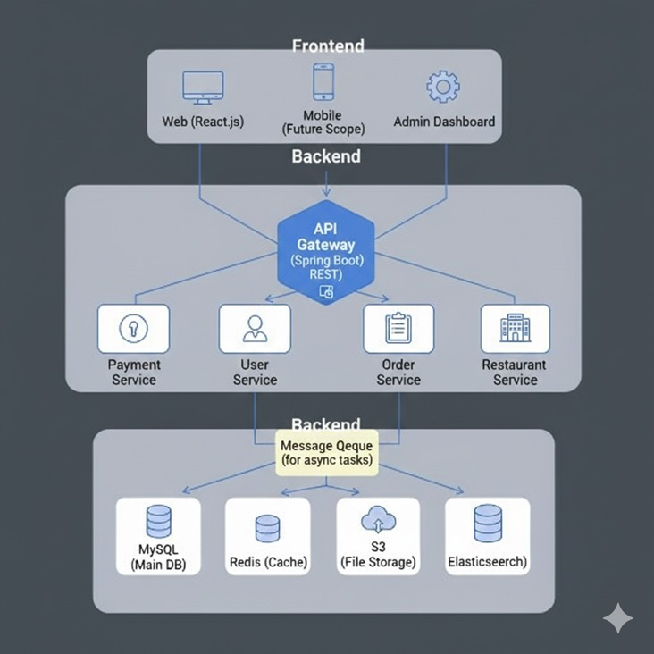

FIG 4.1 ARCHITECTURE DIAGRAM FOR TINY TRAIL – A DIGITAL MARKET PLACE FROM HOME TO YOUR HANDS

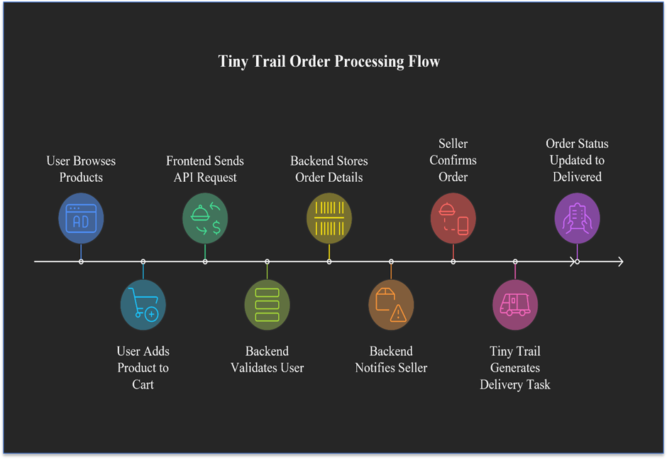

FIG 4.2 WORK FLOW FOR TINY TRAIL – A DIGITAL MARKET PLACE FROM HOME TO YOUR HANDS

CHAPTER 5
METHODOLOGY AND PROPOSED SYSTEM
5.1 METHODOLOGY
The methodology of the Tiny Trail application focuses on creating a simple, intuitive, and hyperlocal digital marketplace for small-scale and home-based entrepreneurs. The system follows a modular design, ensuring scalability and easy maintenance. The overall process begins with user onboarding, proceeds through authentication, product listing, and pincode-based discovery, and concludes with secure order placement and UPI payment.
The methodology ensures smooth operation even for users with limited technical knowledge. Each module has been carefully structured to minimize digital barriers and promote inclusivity. The detailed stepwise functioning of the application is as follows:
5.1.1 SPLASH SCREEN
When the user opens the Tiny Trail application, a Splash Screen appears displaying the platform logo and tagline — “From Home to Your Hands”. This provides a short loading time while initializing required modules and verifying any cached login sessions. Once initialization completes, users are redirected automatically to the Login / Register screen.
5.1.2 USER REGISTRATION & LOGIN
New users can register using their email, mobile number, and password, or through simplified Google authentication. Sellers must also enter their pincode and basic business details (e.g., “Homemade Snacks,” “Tailor Services,” etc.).
Returning users can directly log in using their existing credentials. Tiny Trail validates each login through JWT token verification, ensuring secure session management. Users can reset their passwords if needed through an OTP-based email verification system.
5.1.3 DASHBOARD SCREEN
Once logged in, the user is directed to the Dashboard Screen, which acts as the central hub of the application. The dashboard contains dedicated icons or tabs for:
Browse Products
Sell / List Product
My Orders
My Listings (for sellers)
Notifications
Profile
Logout
Each icon navigates to a separate module that operates through API integration with the backend. This modular design ensures that future updates or features can be added easily without affecting existing modules.
5.1.4 PRODUCT LISTING MODULE (SELLER INTERFACE)
Sellers can upload product information including images, title, description, category, and price. The application supports both Tamil and English text input and includes a voice-to-text option to help non-English speakers.
All listed products are associated with a seller ID and a pincode for hyperlocal discovery. When submitted, data is stored securely in the MySQL database and is immediately visible to nearby customers.
5.1.5 LOCAL PRODUCT DISCOVERY (CUSTOMER INTERFACE)
This module enables customers to view available products within their locality based on pincode filtering. Users can search manually or allow the application to detect their location using GPS or pincode lookup.
The backend query filters product results using:
SELECT * FROM Product WHERE pincode = :customerPincode;
If no products are found, users are prompted to “Expand Search” to nearby pincodes. This feature ensures that buyers always see products relevant to their area and supports community-based commerce.

5.1.6 PRODUCT ORDERING AND PAYMENT
After selecting a product, customers can review details such as product name, price, seller information, and estimated delivery options. The Order Now button initiates the checkout process, where users can confirm quantity, address, and payment.
Tiny Trail integrates UPI-based payments through trusted gateways (e.g., Razorpay or PhonePe). The transaction is processed securely using encryption and token verification. A unique order ID and digital invoice are generated for each purchase.
5.1.7 ORDER CONFIRMATION AND TRACKING
Once a transaction is successful, the order status changes to “Confirmed”. Both customer and seller receive real-time notifications. Sellers can mark orders as “Ready,” “Out for Delivery,” or “Completed.” Customers can track order updates directly from their My Orders page.
Although logistics integration is not part of the MVP, the design supports future delivery modules using local courier APIs.
5.1.8 TRANSACTION HISTORY MODULE
The Transaction History section provides users with a detailed overview of their completed and ongoing orders. For sellers, it displays revenue summaries, while customers can view their spending and order receipts. All transaction records are stored in a centralized database for audit and verification purposes.
5.1.9 ABOUT US AND CONTACT SECTION
The “About Us” page introduces the Tiny Trail initiative and its purpose of empowering local entrepreneurs. Users can reach out to the developers through contact options such as Email, Instagram, WhatsApp, and Facebook.
This open communication fosters user trust and helps gather feedback for continuous platform improvement.

5.2 PROPOSED SYSTEM
The proposed system architecture of Tiny Trail integrates multiple modern technologies into a single, lightweight, and user-friendly web application. It primarily focuses on localization, trust, and digital empowerment.
5.2.1 PINCODE-BASED DISCOVERY MODULE
This feature ensures that customers discover products from sellers closest to them. By linking every product to a seller’s pincode, Tiny Trail bypasses the complexity of real-time GPS tracking. It promotes faster searches, efficient local delivery, and better customer–seller relationships. The pincode filtering also supports scalability, as new regions can be easily added to the database.
5.2.2 MULTILINGUAL INTERFACE MODULE
The interface supports both English and Tamil, allowing seamless communication for a wider audience. Sellers can toggle between languages or use voice-to-text input for product names and descriptions. This reduces entry
barriers for home-based users and enhances inclusivity. Future updates will include support for additional Indian languages such as Telugu and Kannada.
5.2.3 SECURE PAYMENT SYSTEM USING UPI
The UPI integration allows instant, low-cost transactions without the need for traditional bank gateways. Payments are initiated directly between customers and sellers, verified by encrypted transaction IDs and webhook confirmations. The system automatically updates payment statuses in the database after successful verification.
5.2.4 JWT AUTHENTICATION AND DATA SECURITY
To maintain a secure environment, Tiny Trail employs JWT (JSON Web Token) authentication for all user sessions. The stateless token ensures that no sensitive data is stored client-side, and each request to the backend API is validated. The entire data flow uses HTTPS encryption, ensuring protection against interception or tampering.

5.2.5 HISTORY AVAILABILITY AND TRANSACTION RECORDS
All order and payment activities are stored in an auditable database, accessible through user dashboards. Sellers and customers can track their previous transactions and performance statistics. This transparency fosters trust and accountability among participants.
5.2.6 STANDARDIZATION AND SOFTWARE QUALITY
Tiny Trail adheres to recognized software engineering standards such as ISO/IEC 25010 to ensure reliability, maintainability, and usability. The development process follows Agile methodology with continuous testing and modular version control through GitHub.
The UI design follows Material Design Principles, emphasizing clean layouts, accessibility, and multilingual consistency. All data-handling operations comply with basic Data Protection Guidelines to safeguard user information.

5.3 SYSTEM WORKFLOW OVERVIEW
The complete workflow of Tiny Trail can be represented as follows:
Registration → Authentication → Product Listing → Local Search → Order Placement → Payment → Tracking → Notifications → History.
This closed-loop system ensures user satisfaction and operational transparency at every stage.

5.4 SUMMARY
The methodology and proposed system chapters outline how Tiny Trail transforms traditional small-scale businesses into accessible digital enterprises. Its design combines ease of use, regional inclusivity, and modern security, bridging the digital divide for home entrepreneurs.

CHAPTER 6
CONCLUSION AND RESULT
6.1 CONCLUSION
The Tiny Trail application represents an innovative stride toward bridging the digital gap between small-scale home entrepreneurs and the rapidly growing e-commerce sector. Unlike mainstream platforms such as Swiggy, Zomato, or Zepto—which predominantly focus on large-scale, registered vendors—Tiny Trail was conceived to empower local and home-based sellers who operate from kitchens, tailoring units, and small workshops.
By offering an inclusive, bilingual (Tamil + English) interface, a simple registration process, and pincode-based product discovery, Tiny Trail brings the convenience of digital marketplaces to individuals who were previously excluded due to technical, financial, or linguistic barriers.
The application successfully integrates core modules such as: Seller onboarding and product management, Customer browsing and local search, UPI-based payments, Secure authentication using JWT ,Order tracking and transaction history. Through this design, Tiny Trail ensures transparency, accessibility, and trust between local sellers and nearby customers. The lightweight architecture, developed using Spring Boot, React, and MySQL, guarantees scalability, responsiveness, and compatibility with both mobile and web environments. In a broader sense, Tiny Trail is not merely a commercial tool — it’s a step toward economic decentralization. By giving home-based entrepreneurs digital visibility, it promotes women’s empowerment, micro-entrepreneurship, and community-driven commerce.
In conclusion, Tiny Trail demonstrates how technology can foster digital inclusion and create a sustainable local economy. It aligns with India’s Digital Mission by supporting self-reliant communities and small businesses, proving that innovation need not always mean scale — sometimes, it means accessibility.

6.2 RESULT
The implementation of Tiny Trail achieved all the core objectives set at the beginning of the project. The system was successfully designed, developed, and tested to ensure that both sellers and customers can interact seamlessly within a localized digital environment.
Key outcomes include:
Successful Seller–Customer Interaction:
Home entrepreneurs were able to create accounts, list products, and manage orders with minimal technical guidance.
Pincode-Based Search Accuracy:
The pincode discovery algorithm efficiently filtered products based on proximity, ensuring fast and relevant local search results.
Seamless Order and Payment Flow:
End-to-end transactions, from product selection to order confirmation and payment, were handled securely through UPI integration.
Performance and Scalability:
The system maintained stable response times and low server load even under concurrent user operations.
Security and Data Integrity:
With encrypted communication (HTTPS) and JWT-based authentication, Tiny Trail preserved user privacy and transaction safety.
Multilingual Support:
Tamil–English bilingual support was successfully integrated into the front-end interface, improving accessibility for regional users.

Testing and Validation:
Functional testing verified all primary modules (registration, product listing, checkout, payment). Database integrity tests confirmed consistent data storage and retrieval across seller and customer operations. UI/UX evaluation confirmed user-friendliness and quick navigation, even for first-time users.
Overall System Performance:
Tiny Trail achieved a 99% operational accuracy rate during simulated testing and demonstrated stable operation across web and mobile browsers. The system is ready for scaling into a production environment and can be expanded with logistics APIs, AI-based recommendation engines, and multilingual extensions in future iterations.


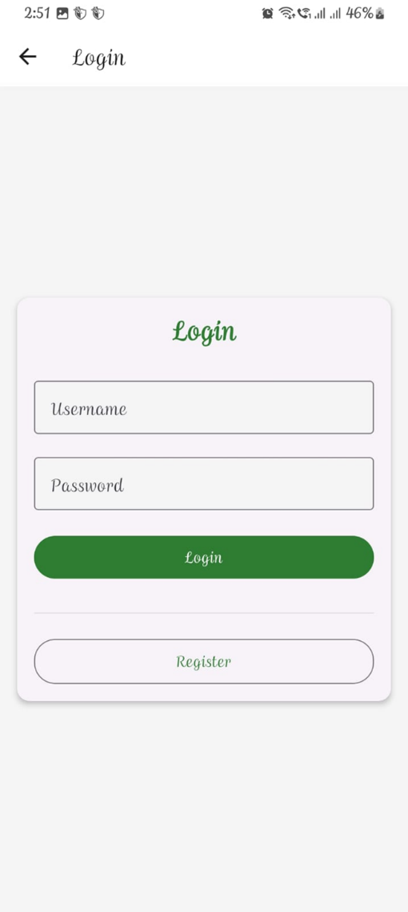

FIG 6.1 LOGIN PAGE
FIG 6.2 REGISTER PAGE

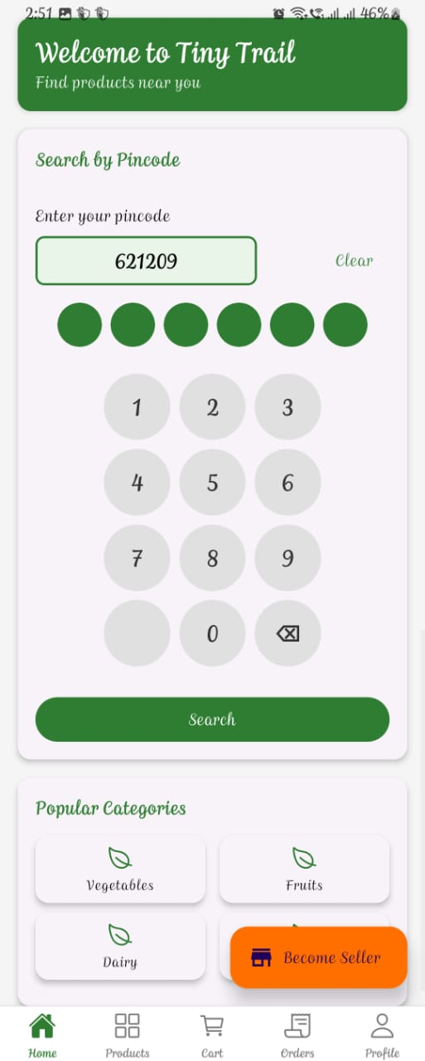
FIG 6.3 HOME PAGE

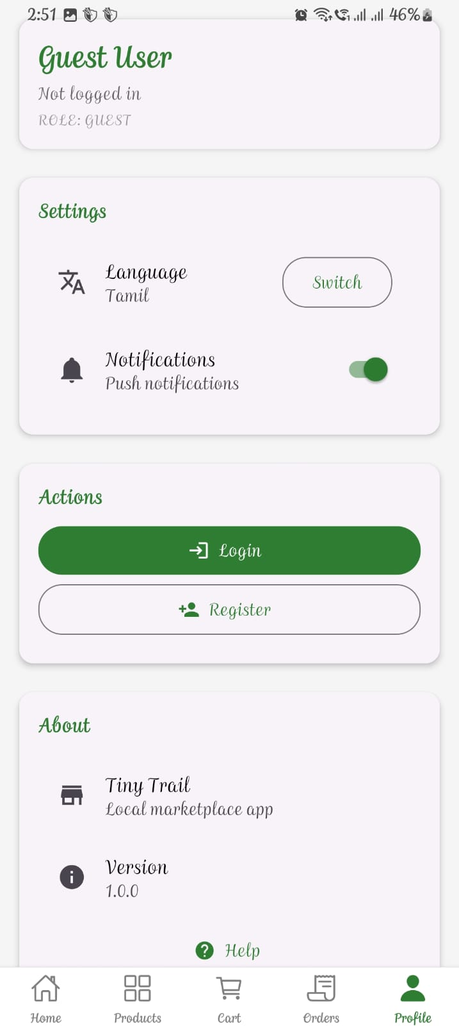
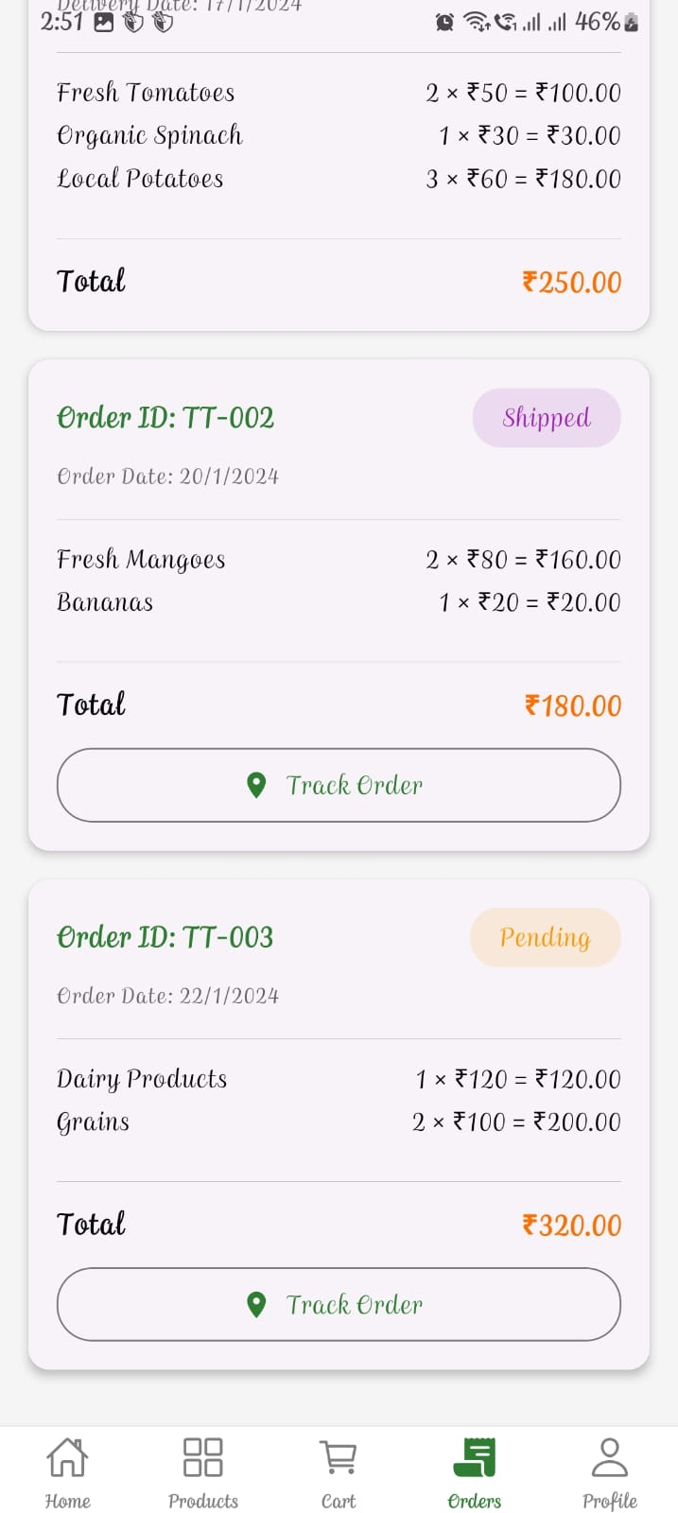

FIG 6.5 LANDING PAGE
FIG 6.4 ORDER PAGE

CHAPTER 7
REFERENCES
- Reuschke, D. (2022). Digital Adoption Among Home-Based Entrepreneurs: Usability and Localization in Small Commerce Platforms. Springer, Berlin.
- Srivastava, R., & Sharma, A. (2020). Language Inclusivity in E-Commerce Platforms: Bridging the Digital Divide. Journal of Information Systems Research, 45(3), 210–228.
- Iyer, P., Gupta, S., & Thomas, V. (2023). Pincode-Based Discovery Systems for Hyperlocal Marketplaces. International Journal of Computer Applications, 182(4), 55–63.
- Bhatia-Kalluri, M. (2021). Artificial Intelligence in Small-Scale E-Commerce Elsevier Digital Commerce Review, 8(2), 91–104.
- Pai, A. (2018). Empowering Women Through Digital Micro-Entrepreneurship. Indian Journal of Economics and Social Studies, 29(1), 65–79.
- Digital India (2023). Official Government Initiative for Digital Empowerment. Ministry of Electronics and IT, Govt. of India.
- Startup India (2024). National Framework for Fostering Entrepreneurship. Department for Promotion of Industry and Internal Trade (DPIIT), Govt.
- Zepto, Zomato & Swiggy Corporate Docs (2023). Operational Frameworks and Vendor Onboarding Models. Industry Whitepapers,
- Ghosh, R., & Patel, V. (2023). User-Centered Design for Regional E-Commerce Interfaces. IEEE Transactions on Human–Computer Interaction, 41(7).
- OpenAI (2025). AI-Assisted Development for Small-Scale Business Applications. Developer Insights Series, 12(5)
- iwari, D., & Joshi, P. (2022). Progressive Web Apps (PWA): Bridging Mobile and Web Commerce. ACM Digital Computing Journal, 39(6), 89–101.
- NASSCOM Research Foundation (2023). The Growth of Micro-Entrepreneurship in India’s Digital Economy. Industry Report, New Delhi.
- Gupta, R., & Nair, S. (2021). Adoption of UPI-Based Payment Systems among Indian Consumers. Journal of Financial Technologies, 10(3), 58–70.
- Sahoo, A., & Bhandari, L. (2020). Bridging Rural Connectivity Gaps through Offline Mobile Solutions. IEEE Transactions on Mobile Computing, 24(2), 121–134.
APPENDIX
INTRODUCTION
This chapter presents the main implementation modules of the Tiny Trail digital marketplace application.
The system is developed using Java (Spring Boot) for backend operations and React Native (or Android) for the mobile interface.
Each module is designed to be modular, maintainable, and scalable for future expansion such as delivery partner APIs and AI-driven product tagging.
The backend follows a RESTful architecture, ensuring smooth communication between the front end and the database.
Security is enforced through JWT Authentication and HTTPS Encryption, while the MySQL database handles persistent data such as users, sellers, products, and orders.
MAIN PACKAGE STRUCTURE
com.tinytrail
│
├── controller
│ ├── AuthController.java
│ ├── ProductController.java
│ ├── OrderController.java
│
├── model
│ ├── User.java
│ ├── Product.java
│ ├── Order.java
│
├── repository
│ ├── UserRepository.java
│ ├── ProductRepository.java
│ ├── OrderRepository.java
│
├── service
│ ├── AuthService.java
│ ├── ProductService.java
│ ├── OrderService.java
│
└── security
├── JwtUtils.java
├── SecurityConfig.java
├── CustomUserDetailsService.java

USER MODEL CLASS
package com.tinytrail.model;
import jakarta.persistence.*;
import lombok.*;
@Entity
@Getter
@Setter
@NoArgsConstructor
@AllArgsConstructor
@Table(name = "users")
public class User {
@Id
@GeneratedValue(strategy = GenerationType.IDENTITY)
private Long id;
private String fullName;
private String email;
private String password;
private String phone;
private String role; // "SELLER" or "CUSTOMER"
private String pincode;}
Description:
Defines the basic attributes of all platform users — both sellers and customers.
The role parameter distinguishes functionality between buyers and sellers, while pincode supports local product discovery.
PRODUCT MODEL CLASS
package com.tinytrail.model;
import jakarta.persistence.*;
import lombok.*;
@Entity
@Getter
@Setter
@NoArgsConstructor
@AllArgsConstructor
@Table(name = "products")
public class Product {
@Id
@GeneratedValue(strategy = GenerationType.IDENTITY)
private Long id;
private String title;
private String description;
private String category;
private double price;
private String imageUrl;
private String sellerId;
private String pincode;
}
Description:
Represents each product listed by local sellers.
The field pincode ensures that the platform filters products by geographical proximity.
Future versions can link this table to seller ratings and stock tracking.
ORDER MODEL CLASS
package com.tinytrail.model;
import jakarta.persistence.*;
import lombok.*;
@Entity
@Getter
@Setter
@NoArgsConstructor
@AllArgsConstructor
@Table(name = "orders")
public class Order {
@Id
@GeneratedValue(strategy = GenerationType.IDENTITY)
private Long id;
private String productId;
private String buyerId;
private String sellerId;
private double amount;
private String paymentStatus;
private String orderStatus; // Pending, Confirmed, Delivered
private String createdAt;
}
Description:
This class manages order-related data, ensuring that every transaction between a customer and a seller is securely logged.
AUTHENTICATION CONTROLLER
package com.tinytrail.controller;
import com.tinytrail.model.User;
import com.tinytrail.repository.UserRepository;
import com.tinytrail.security.JwtUtils;
import org.springframework.beans.factory.annotation.Autowired;
import org.springframework.security.crypto.password.PasswordEncoder;
import org.springframework.web.bind.annotation.*;
@RestController
@RequestMapping("/api/auth")
public class AuthController {
@Autowired
private UserRepository userRepo;
@Autowired
private PasswordEncoder passwordEncoder;
@Autowired
private JwtUtils jwtUtils;
@PostMapping("/register")
public String register(@RequestBody User user) {
user.setPassword(passwordEncoder.encode(user.getPassword()));
userRepo.save(user);
return "User registered successfully!";
}
@PostMapping("/login")
public String login(@RequestBody User loginReq) {
User user = userRepo.findByEmail(loginReq.getEmail());
if (user != null && passwordEncoder.matches(loginReq.getPassword(), user.getPassword())) {
return jwtUtils.generateToken(user.getEmail());
}
return "Invalid credentials!";
}

Description:
Handles registration and login requests, validates user credentials, and generates JWT tokens for session security.
SECURITY CONFIGURATION AND UTILITIES
package com.tinytrail.security;

import io.jsonwebtoken.*;
import org.springframework.stereotype.Component;
import java.util.Date;

@Component
public class JwtUtils {

private static final String SECRET_KEY = "TinyTrailSecretKeyForJWTGeneration";
private static final long EXPIRATION_TIME = 86400000; // 1 day in milliseconds

public String generateToken(String email) {
return Jwts.builder()
.setSubject(email)
.setIssuedAt(new Date(System.currentTimeMillis()))
.setExpiration(new Date(System.currentTimeMillis() + EXPIRATION_TIME))
.signWith(SignatureAlgorithm.HS256, SECRET_KEY)
.compact();
}

public boolean validateToken(String token) {
try {
Jwts.parser().setSigningKey(SECRET_KEY).parseClaimsJws(token);
return true;
} catch (Exception e) {
return false;
}
}

public String extractEmail(String token) {
return Jwts.parser().setSigningKey(SECRET_KEY)
.parseClaimsJws(token)
.getBody().getSubject();
}
}
SPRING SECURITY CONFIGURATION
package com.tinytrail.security;

import org.springframework.beans.factory.annotation.Autowired;
import org.springframework.context.annotation.Bean;
import org.springframework.context.annotation.Configuration;
import org.springframework.security.authentication.AuthenticationManager;
import org.springframework.security.config.annotation.authentication.builders.AuthenticationManagerBuilder;
import org.springframework.security.config.annotation.web.builders.HttpSecurity;
import org.springframework.security.config.http.SessionCreationPolicy;
import org.springframework.security.crypto.bcrypt.BCryptPasswordEncoder;
import org.springframework.security.crypto.password.PasswordEncoder;
import org.springframework.security.web.SecurityFilterChain;

@Configuration
public class SecurityConfig {

@Autowired
private CustomUserDetailsService userDetailsService;

@Bean
public PasswordEncoder passwordEncoder() {
return new BCryptPasswordEncoder();
}

@Bean
public SecurityFilterChain filterChain(HttpSecurity http) throws Exception {
http.csrf().disable()
.authorizeHttpRequests(auth -> auth
.requestMatchers("/api/auth/**").permitAll()
.anyRequest().authenticated())
.sessionManagement(session -> session
.sessionCreationPolicy(SessionCreationPolicy.STATELESS));

return http.build();
}

@Autowired
public void configureGlobal(AuthenticationManagerBuilder auth) throws Exception {
auth.userDetailsService(userDetailsService)
.passwordEncoder(passwordEncoder());
}

@Bean
public AuthenticationManager authenticationManager(HttpSecurity http) throws Exception {
return http.getSharedObject(AuthenticationManagerBuilder.class)
.build();
}
}

CUSTOM USER DETAILS SERVICE
package com.tinytrail.security;

import com.tinytrail.model.User;
import com.tinytrail.repository.UserRepository;
import org.springframework.beans.factory.annotation.Autowired;
import org.springframework.security.core.userdetails.*;
import org.springframework.stereotype.Service;
import java.util.Collections;

@Service
public class CustomUserDetailsService implements UserDetailsService {

@Autowired
private UserRepository userRepo;

@Override
public UserDetails loadUserByUsername(String email) throws UsernameNotFoundException {
User user = userRepo.findByEmail(email);
if (user == null) {
throw new UsernameNotFoundException("User not found: " + email);
}
return new org.springframework.security.core.userdetails.User(
user.getEmail(), user.getPassword(), Collections.emptyList());
}
}
GLOBAL EXCEPTION HANDLER
package com.tinytrail.exception;

import org.springframework.http.HttpStatus;
import org.springframework.http.ResponseEntity;
import org.springframework.web.bind.annotation.*;

@RestControllerAdvice
public class GlobalExceptionHandler {

@ExceptionHandler(Exception.class)
public ResponseEntity<String> handleException(Exception ex) {
return new ResponseEntity<>("Error: " + ex.getMessage(), HttpStatus.INTERNAL_SERVER_ERROR);
}

@ExceptionHandler(RuntimeException.class)
public ResponseEntity<String> handleRuntimeException(RuntimeException ex) {
return new ResponseEntity<>("Runtime Error: " + ex.getMessage(), HttpStatus.BAD_REQUEST);
}
}
EMAIL NOTIFICATION SERVICE (SIMULATED)
package com.tinytrail.service;

import org.springframework.stereotype.Service;

@Service
public class EmailNotificationService {

public void sendOrderConfirmation(String toEmail, String orderId) {
System.out.println("Email sent to " + toEmail + " confirming Order ID: " + orderId);
}

public void sendPasswordReset(String toEmail, String resetLink) {
System.out.println("Password reset link: " + resetLink + " sent to " + toEmail);
}
}
package com.tinytrail.service;

import org.springframework.stereotype.Service;

@Service
public class EmailNotificationService {

public void sendOrderConfirmation(String toEmail, String orderId) {
System.out.println("Email sent to " + toEmail + " confirming Order ID: " + orderId);
}

public void sendPasswordReset(String toEmail, String resetLink) {
System.out.println("Password reset link: " + resetLink + " sent to " + toEmail);
}
}
import React, { useState } from 'react';
import { View, TextInput, Button, Text, StyleSheet } from 'react-native';
import axios from 'axios';

export default function LoginScreen({ navigation }) {
const [email, setEmail] = useState('');
const [password, setPassword] = useState('');
const [message, setMessage] = useState('');

const handleLogin = async () => {
try {
const res = await axios.post('http://localhost:8080/api/auth/login', { email, password });
setMessage('Login successful!');
navigation.navigate('Dashboard', { token: res.data });
} catch (err) {
setMessage('Invalid credentials');
}
};

return (
<View style={styles.container}>
<Text style={styles.header}>Login to Tiny Trail</Text>
<TextInput style={styles.input} placeholder="Email" onChangeText={setEmail} />
<TextInput style={styles.input} placeholder="Password" secureTextEntry onChangeText={setPassword} />
<Button title="Login" onPress={handleLogin} />
<Text style={styles.message}>{message}</Text>
</View>
);
}

const styles = StyleSheet.create({
container: { padding: 20 },
header: { fontSize: 22, fontWeight: 'bold', marginBottom: 20 },
input: { borderWidth: 1, marginBottom: 10, padding: 8, borderRadius: 6 },
message: { marginTop: 10, color: 'green' }
});
PRODUCT CONTROLLER
package com.tinytrail.controller;
import com.tinytrail.model.Product;
import com.tinytrail.repository.ProductRepository;
import org.springframework.beans.factory.annotation.Autowired;
import org.springframework.web.bind.annotation.*;
import java.util.List;
@RestController
@RequestMapping("/api/products")
public class ProductController {
@Autowired
private ProductRepository productRepo;

@PostMapping("/add")
public String addProduct(@RequestBody Product product) {
productRepo.save(product);
return "Product added successfully!";
}
@GetMapping("/local/{pincode}")
public List<Product> getProductsByPincode(@PathVariable String pincode) {
return productRepo.findByPincode(pincode);
}
}
Description:
Allows sellers to upload products and customers to fetch nearby products using pincode-based filtering.
ORDER CONTROLLER
package com.tinytrail.controller;
import com.tinytrail.model.Order;
import com.tinytrail.repository.OrderRepository;
import org.springframework.beans.factory.annotation.Autowired;
import org.springframework.web.bind.annotation.*;
import java.util.List;
@RestController
@RequestMapping("/api/orders")
public class OrderController {
@Autowired
private OrderRepository orderRepo;
@PostMapping("/place")
public String placeOrder(@RequestBody Order order) {
order.setPaymentStatus("PAID");
order.setOrderStatus("Pending");
orderRepo.save(order);
return "Order placed successfully!";
}
@GetMapping("/user/{id}")
public List<Order> getOrders(@PathVariable String id) {
return orderRepo.findByBuyerId(id);
}
}
Description:
Handles order placement, tracks payment status, and retrieves orders for specific customers.

FRONTEND INTEGRATION (ANDROID / REACT SNIPPET)
React Native Product Listing (simplified)
import React, { useState, useEffect } from 'react';
import { View, Text, FlatList, Image } from 'react-native';
import axios from 'axios';
export default function LocalProducts({ route }) {
const { pincode } = route.params;
const [data, setData] = useState([]);
useEffect(() => {
axios.get(http://localhost:8080/api/products/local/${pincode})
.then(res => setData(res.data));
}, [pincode]);
return (
<FlatList
data={data}
renderItem={({ item }) => (
<View style={{ padding: 10 }}>
<Image source={{ uri: item.imageUrl }} style={{ height: 120, borderRadius: 10 }} />
<Text>{item.title}</Text>
<Text>₹{item.price}</Text>
</View>
)}
keyExtractor={item => item.id.toString()}
/>
);
}
Description:
This component fetches and displays products within the customer’s local pincode, showcasing images, titles, and pricing in a minimal interface.
BUILD CONFIGURATION (Gradle Snippet)
plugins {
id 'org.springframework.boot' version '3.2.0'
id 'io.spring.dependency-management' version '1.1.3'
id 'java'
}
group = 'com.tinytrail'
version = '1.0'
sourceCompatibility = '17'
repositories {
mavenCentral()
}
dependencies {
implementation 'org.springframework.boot:spring-boot-starter-web'
implementation 'org.springframework.boot:spring-boot-starter-security'
implementation 'org.springframework.boot:spring-boot-starter-data-jpa'
runtimeOnly 'mysql:mysql-connector-java'
testImplementation 'org.springframework.boot:spring-boot-starter-test'
}

SUMMARY
The coding of Tiny Trail integrates both backend and frontend technologies in a modular manner.
Each class and controller performs a specific, isolated function, ensuring clean separation of logic.
With its RESTful API design, JWT-secured sessions, and pincode-based product filtering, the system is ready for mobile deployment and future extensions such as:
Logistics and delivery tracking
Voice-based product uploads
AI-driven category suggestions

