Inventory System

An inventory and crafting system I built for my Complex Game Systems assessment at AIE.

# Quick Start

To see an expected setup for the scripts included in this system, open the sample scene, which can be found in the UnityExample unity package.

# API

This Inventory System consists of 7 classes.

* 4 are required to make the system work
  + The **Item** class contains variables that each item that can be collected and/or interacted with in the system should have associated with them. NOTE: Currently, for readability, this script relies on the [**NaughtyAttributes**](https://github.com/dbrizov/NaughtyAttributes/tree/master/Assets/NaughtyAttributes) extension, which will be explained in further detail later.

Ex:

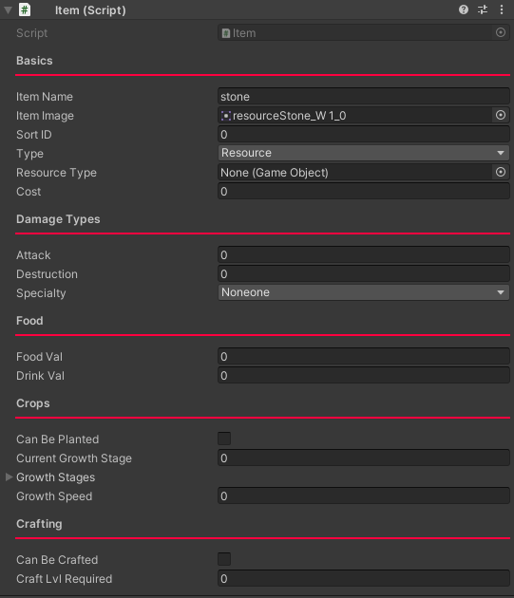

* + The **PlayerInventory** class stores information about all item prefabs that can/do exist in the scene(s). It also controls the player’s current inventory, as well as the ability to sort said inventory.

Ex:

* + The **Recipe** class contains two arrays. It should be applied to any prefabs with the **Item** class that can be crafted by the player. Though it holds so little information, it is required for the **Crafting** class to work as intended.

Ex:

* + The **Crafting** class contains the logic to craft any items that have the **Recipe** class attached.

Ex:

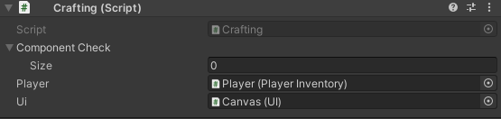

* 3 are used only in the Survival scene for the purpose of showing how the inventory works
  + The **PlayerController** class controls the player’s movements and tracks input.
  + The **UI** classis in charge of updating the UI in the scene appropriately.
  + The **FollowCam** class makes the camera in the scene follow the player.

When it comes to the first 4 classes, the values which need to be adjusted within the engine are noted in the comments beside the variable in question. I have not listed which variables need to be assigned to objects in the scene, but Unity should tell you if it needs a reference.

# Third Party

I used the Naughty Attributes extension for Unity in this project. It is only used in the Item script, and although it is not required to make the script work, some adjustments may have to be made to the script to avoid errors if you do not use the extension. The github with relevant scripts and links to documentation can be found here: [dbrizov/NaughtyAttributes: Attribute Extensions for Unity (github.com)](https://github.com/dbrizov/NaughtyAttributes). The extension is included in the InventorySystem unity package, but can also be downloaded for free from the Unity asset store here: [NaughtyAttributes | Utilities Tools | Unity Asset Store](https://assetstore.unity.com/packages/tools/utilities/naughtyattributes-129996). The Naughty Attributes extension uses the MIT license.