Title: Clustering Countries by Population Pyramids Using Machine Learning Techniques

W.A.T.Wijesingheª, R.Godaliyadda^{b}, V.Herath^{b} and P.Ekanayake^{b}*

ªKandy Innovation Centre, National Institute of Business Management, Peradeniya, SriLanka
^{b}Department of Electrical and Electronic Engineering, Faculty of Engineering,University of Peradeniya, Peradeniya 20400, SriLanka

*Email correspondence: thisumi.nimsani@gmail.com

Abstract
The objective of our project was to cluster countries by their demographic profiles using 2021 age-disaggregated population data. Starting from a multi-year dataset containing population counts for 21 age groups, the data was filtered to retain only 2021 and 146 valid individual countries, excluding regions and aggregates. Each country’s population pyramid was normalized to represent proportions rather than absolute counts, and Principal Component Analysis(PCA) was applied to reduce dimensionality for visualization. Three unsupervised clustering algorithms were implemented. K-means (K=4), DBSCAN(ε =0.8,min_samples=7),and Spectral Clustering with the number of clusters determined via the eigengap heuristic. Kmeans revealed four distinct demographic structures: Cluster 0 showed youthful and expansive pyramids with examples such as Nigeria and Afghanistan. Cluster 1 reflected transitioning populations including India and Brazil. Cluster 2 showed aging and constrictive pyramids such as Japan and Germany. Cluster 3 represented mixed transitions with examples such as USA and UK. DBSCAN identified meaningful clusters despite noise, grouping countries with similar transition stages. For example, India and Nigeria clustered together under youthful growth patterns, while Japan and Germany clustered under aging trends. Spectral Clustering, guided by the eigengap heuristic, produced clear groupings as well. For instance, Nigeria and Uganda formed part of a youthful cluster, while Germany and Italy represented aging profiles. These results demonstrate how different clustering algorithms capture varying perspectives of demographic structures, providing deeper insight into global population dynamics and transitions. Similar clusters of countries can guide policymakers in designing targeted strategies for healthcare, education, labor markets, and social welfare. As future work, this framework can be extended to include multi-year trend analysis and additional socioeconomic indicators to improve forecasting and policy planning.

Keywords: population pyramid; unsupervised learning; pca; spectral clustering

Introduction
Our project highlights the importance of population pyramids in understanding demographic trends and their impact on economic, health and social policies. While previous research often focuses on simple demographic measures, our study uses three clustering methods such as K-Means, DBSCAN and Spectral Clustering to analyze the full population pyramid shape across countries.
This multi-method approach uncovers detailed demographic patterns, enabling policy makers to design targeted strategies for diverse population challenges, such as aging or youthful societies. Our work fills a gap in comprehensive clustering of population pyramids, offering a variable tools for demographic analysis and policy planning.

Materials and Methods
Data Collection
The raw dataset was obtained from the United Nations World Population Prospects (2022), which contains demographic data for many countries, regions, and aggregates across multiple years. From this, 180 recognized countries were identified and further filtered to 146 valid entries for the year 2021, excluding regions and aggregates. Each country’s population was categorized into 21 disjoint age groups (0-100+ years), with variables including location, age group starting point, and total population count. These counts were normalized into proportions to capture the relative population pyramid shape, and Principal Component Analysis (PCA) was applied to reduce dimensionality for visualization.
Clustering Methods
Three unsupervised clustering methods were implemented using Python’s scikit-learn library to identify demographic archetypes based on population pyramid shape.
K-Means Clustering Method
Implemented via K-Means with n_clusters=4 and a fixed random state for reproducibility. This centroid-based technique minimizes the within cluster sum of squares, grouping countries into clusters with similar age structure shapes. K-Means was chosen for its simplicity and interpretability in handling convex clusters.
DBSCAN Clustering Method
DBSCAN was implemented with parameters eps =0 0.8 and min_samples =7. this density-based method grouped countries in high- density regions and identified outliers as noise.
Spectral Clustering Method
Performed using a nearest neighbors affinity matrix(n_neighbors=10) followed by graph Laplacian computation and eigenvalue decomposition. The optimal number of clusters was determined using the eigengap heuristic. This approach leverages graph theory to capture complex relationships between countries and is effective for non- convex cluster structures often found in demographic data.

Results and Discussion

This analysis successfully segmented 146 countries into distinct demographic profiles using three algorithms. The following sections break down the results from each stage of the analysis.
K-means Clustering
The K-Means clustering divided countries into four distinct groups based on their population pyramids structures. One cluster represents youthful populations with broad bases and high proportions of younger age groups. Another cluster reflects transitioning populations with a more balanced age distribution. The aging populations are grouped in a cluster characterized by a narrow base and wider top, while a mixed cluster includes countries exhibiting both youthful and aging demographic traits. This demonstrates K-Means’ ability to effectively differentiate diverse demographic profiles.
DBSCAN Clustering
DBSCAN clustering identified a main dense cluster of countries alongside a group labeled as noise. The noise group shows irregular and atypical demographic patterns that differ from common global structures. The main cluster exhibits a youthful, expansive population pyramid with a wide base, indicating a high proportion of younger individuals. These findings highlight DBSCAN’s strength in detecting core clusters while isolating countries with unique or outlier demographic characteristics.
Spectral Clustering
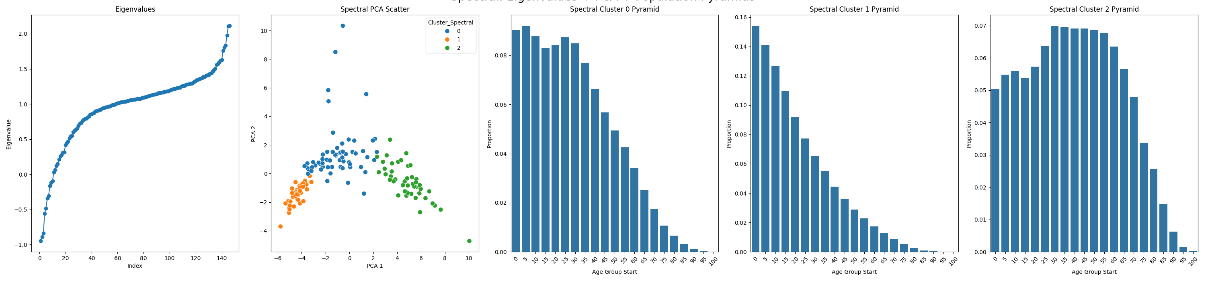
This figure shows the spectral clustering results on normalized population pyramids for 146 countries in 2021. The left plot displaly the eigenvalues of the graph Laplacian, with a clear gap after the third eigenvalue, supporting the choice of three clusters. The middle plot is a PCA scatter showing countries grouped into three distinct clusters. The three bar charts depict the average population pyramids of each cluster: cluster 0 represents youthful,growing populations. Cluster 1 reflects aging populations with low fertility and Cluster 2 shows more balanced, transitional age structures. These clusters reveal meaningful demographic patterns useful for targeted poilcy planning.
Principal Component Analysis (PCA)
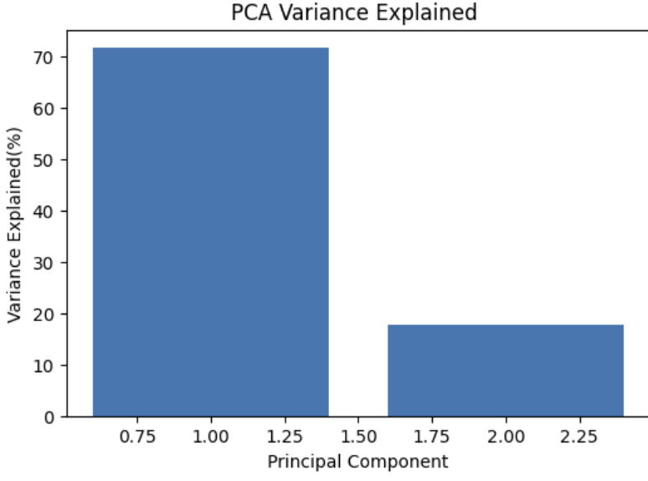

The PCA Variance Explained chart demonstrates that the first two principal components together account for nearly 90% of the total variance in the 21 age-group population data. This confirms that projecting the high-dimensional data onto two dimensions for visualization retains most of the important information. The first component, capturing over 70% of variance, likely reflects the general age profile of the population, while the second component highlights finer structural differences between countries’ demographic patterns.
Comparison of Clustering Results for selected Countries

Country | KMeans Cluster | DBSCAN Cluster | Spectral Cluster
Sri Lanka | 0 (Transitional) | -1 (Noise) | 0 (Transitional)
Nigeria | 2 (youthful) | 0 (Youthful) | 1 (Youthful)
Japan | 1 (Aging) | -1 (Noise) | 2 (Aging)
Singapore | 0 (Transitional) | -1 (Noise) | 0 (Transitional)
United Kingdom | 1 (Aging) | -1 (Noise) | 2 (Aging)
The comparison table presents the cluster assignments of selected key countries across the three clustering algorithms. Notably, countries wih distinct demographic profiles, such as Nigeria, are consistently classified as “Youthful” by all methods, demonstrating strong agreement. Transitional countries like SriLanka and Singapore show consistency between K-Means and Spectral Clustering but were marked as noise by DBSCAN, reflecting DBSCAN’s sensitivity to data density variations. Aging populations such as Japan and the United Kingdom were grouped similarly by K-Means and Spectral Clustering, while DBSCAN again designated them as noise. This comparison underscores the value of using multiple clustering approaches , as it highlights both consensus in identifying clear demographic archetypes and differences attributable to each algorith’s strengths and limitations.
Conclusion
Our study demonstrates how clustering techniques, particularly K-Means, can be effectively applied to analyze global population age structures. By forming meaningful age-based groups, the results highlight both similarities and differences among countries, offering insights into demographic transitions and development patterns. The findings are valuable for policymakers and researchers, as they provide a clearer understanding of how nations are positioned in terms of population dynamics. While the study was limited to data from 2021, the approach can be extended to future datasets and combined with other socio-economic indicators to deepen the analysis.

Conflict of Interest
The Authors declare that they have no known competing financial interests or personal relationships that could have appeared to influence the work reported in our paper.

Acknowledgement

References

[1] I.T.Jolliffe, Principal Component Analysis, 2nd ed. New York, USA: Springer,2002.
[2] J.MacQueen, “Some methods for classification and analysis of multivariate observations,”in Proc. 5th Berkeley Symp.Math.Stat.Prob., 1967,pp.281-297
[3] U.Von Luxburg, “A tutorial on spectral clustering,” Statistics and Computing, vol.17, no.4,pp. 395-416,Dec.2007, doi: 10.1007/s11222-007-9033-z.
[4] United Nations,”World Population Prospects 2022:Data Sources,” United Nations Department of Economic and Social Affairs, Population Division, https://population.un.org/wpp/
(Retrieved Aug.15,2025)

