Ticket Title: User unable to log in
User Problem: User reported they were unable to log into their Windows account due to an incorrect password.

Questions Asked:
- Username
- Last successful login time
- Whether Caps Lock was enabled
- Any recent password changes

Checks Performed:
- Verified user account status in Computer Management
- Checked for account lock or disable status
Root Cause: User entered incorrect password multiple times, causing login failure.
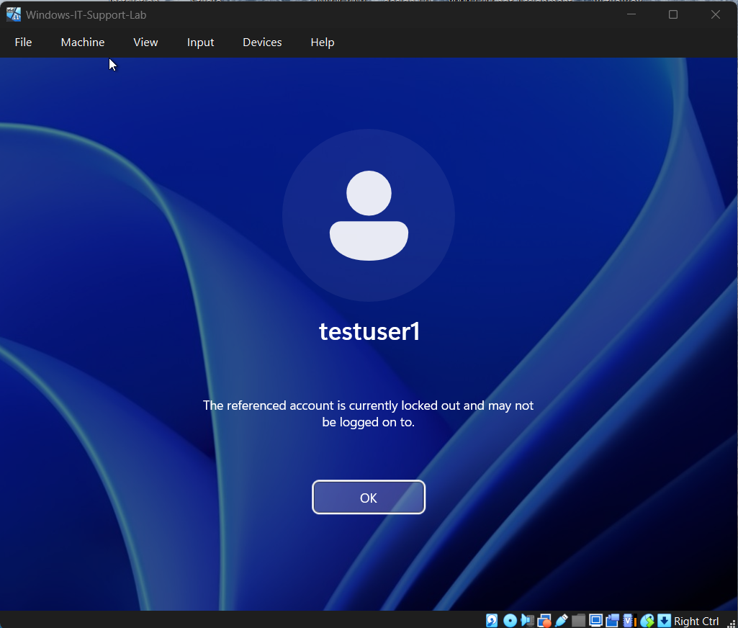
Steps Taken to Fix:
1. Logged in as administrator
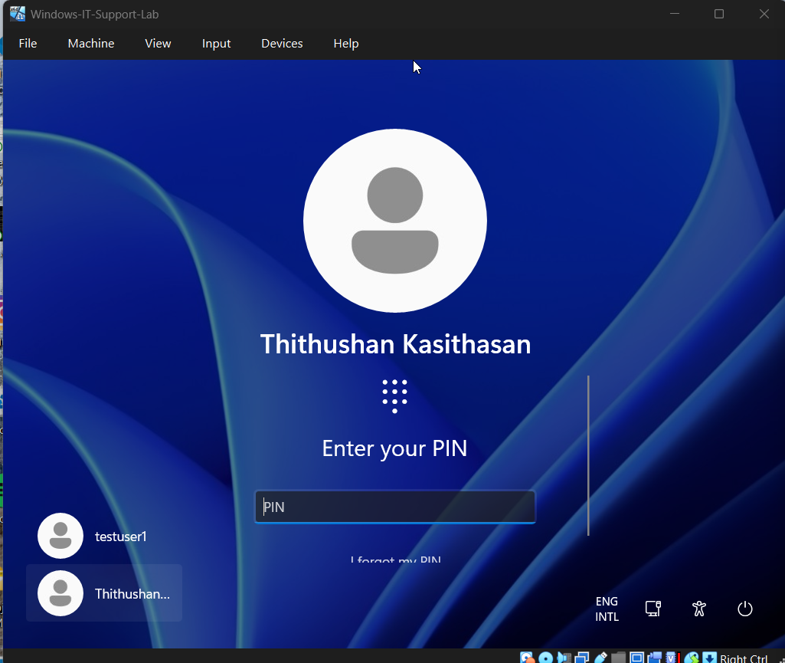
Admin Account
2. Accessed Local Users and Groups
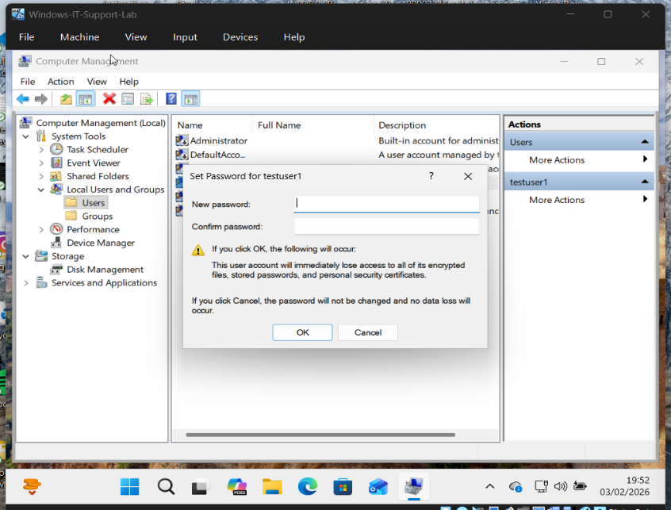
3. Reset the user password
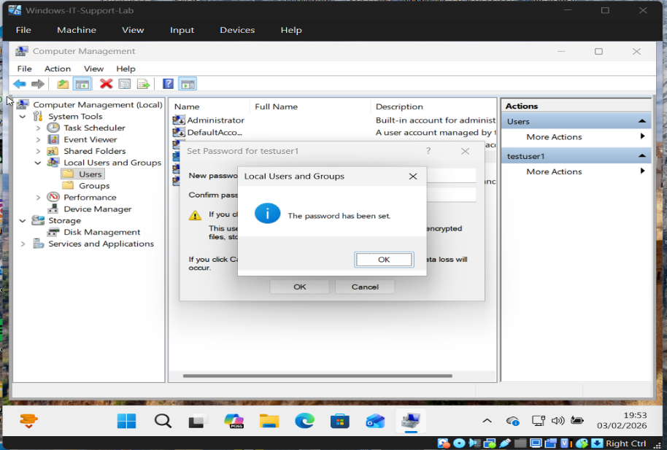
4. Tested login successfully
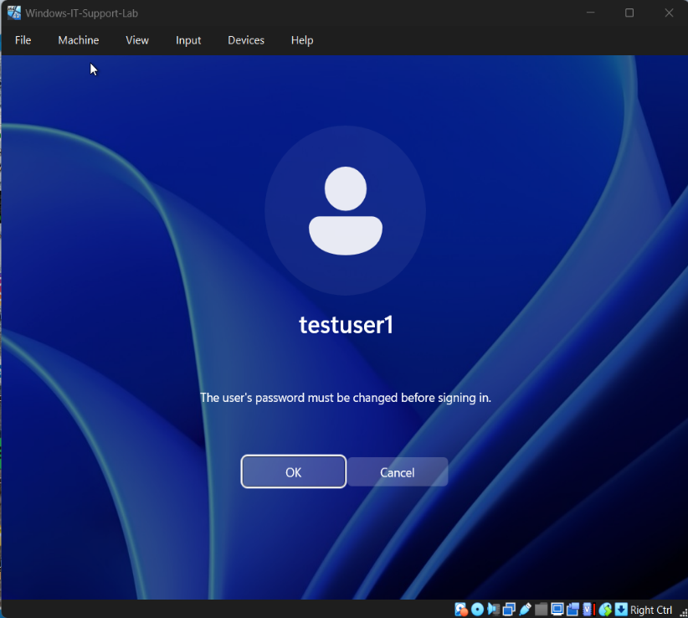 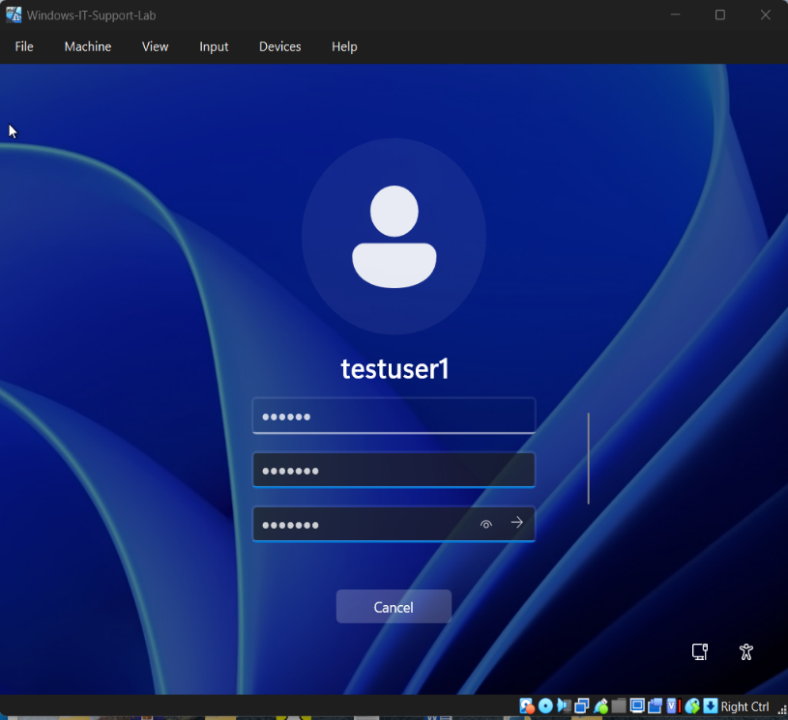

Result:
User was able to log in successfully after password reset.

Prevention / Best Practice:
- Educate users on password policies
- Recommend password manager usage
- Avoid repeated incorrect attempts

Tools Used:
- Computer Management
- Local Users and Groups

