Ticket Title: No network connectivity on user system

User Problem:
User reported that their system was unable to access the internet.

Questions Asked:
- Is the network cable or connection active?
- Are other systems affected?
- When did the issue start?
- Any recent system or network changes?

Checks Performed:
- Verified network adapter status
- Checked IP address assignment using ipconfig
- Confirmed network connectivity via browser

Root Cause: The network adapter was disabled, preventing the system from obtaining network connectivity.
Steps Taken to Fix:
1. Accessed Network & Internet settings
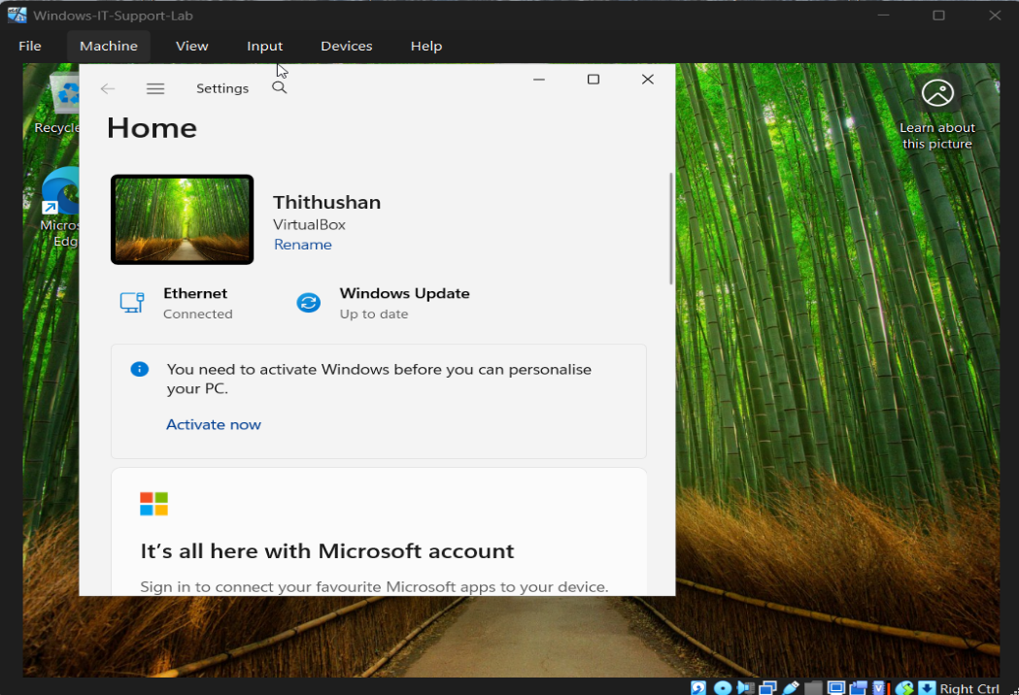
2. Identified disabled Ethernet adapter
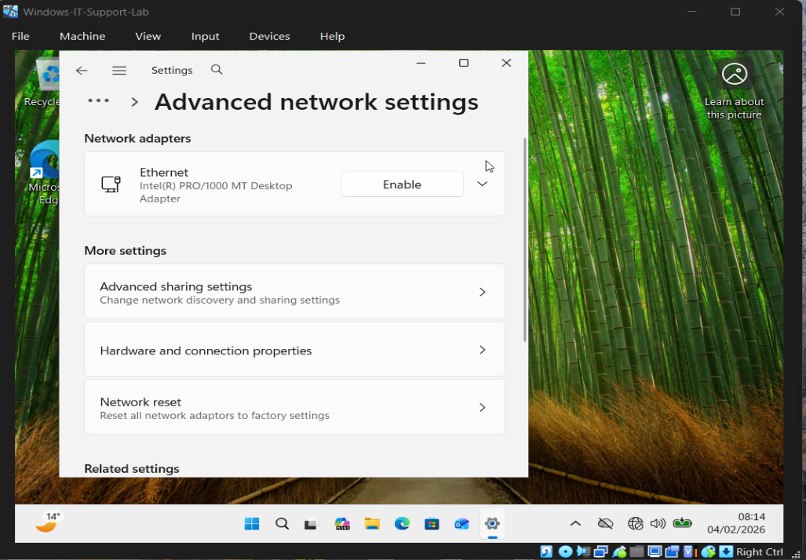

3. Re-enabled the network adapter
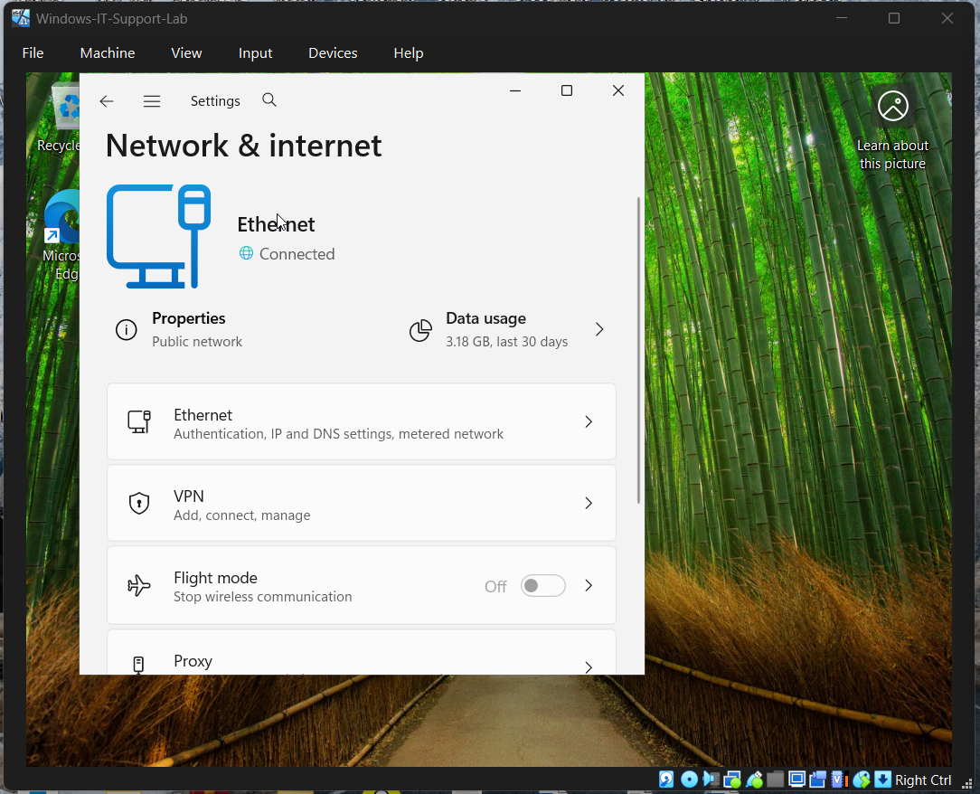

4. Verified IP configuration and confirmed internet access via web browser
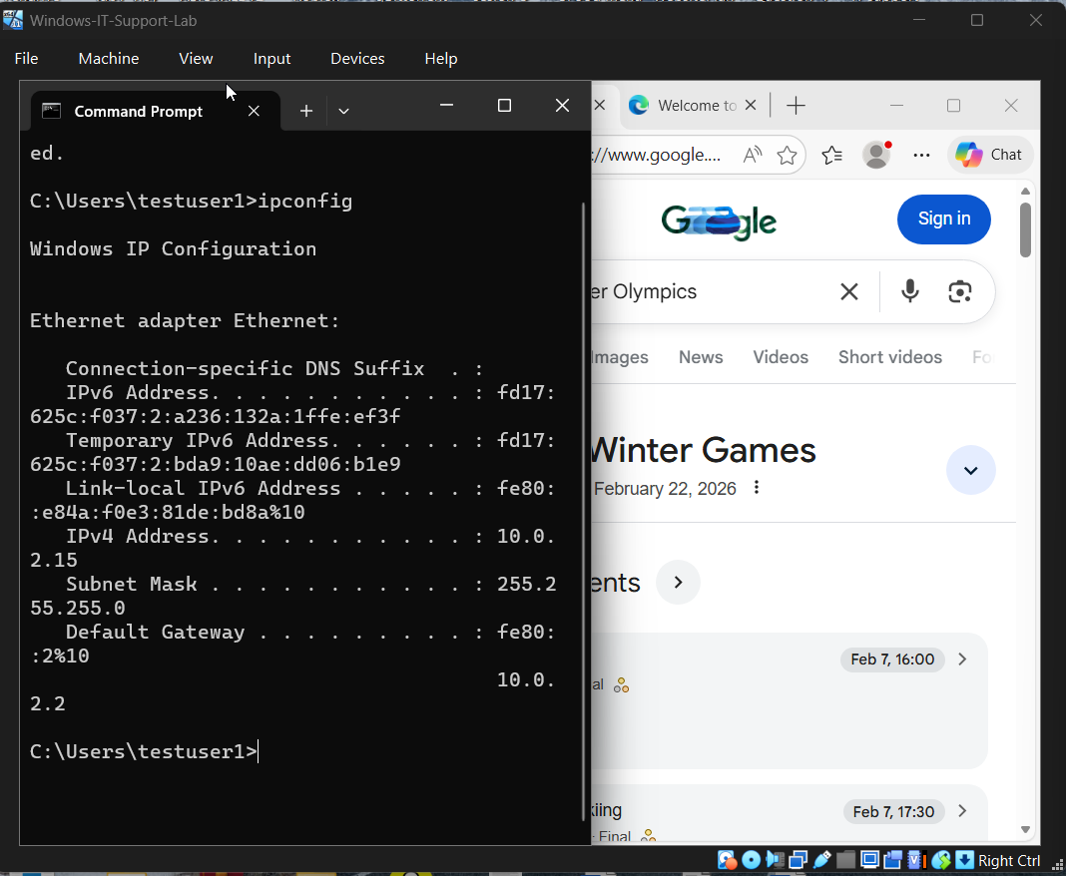

Result: Network connectivity was successfully restored.

Prevention / Best Practice:
- Ensure network adapters are enabled before escalating issues
- Educate users on basic network settings
- Recommend checking physical or virtual network connections

Tools Used:
- Windows Network & Internet Settings
- Network Adapter Configuration
- Command Prompt (ipconfig)
- Web Browser

