Scenario 2: Unauthorized Folder Access (NTFS Permissions)

Issue: User testuser1 was unable to access a protected folder and received an access denied message.

Checks Performed: Reviewed NTFS permissions on the Secure-Data folder.
Root Cause: User did not have sufficient permissions to access the folder.

Resolution Steps:
1. Logged in as administrator (Thithushan)
2. Modified NTFS permissions on the folder
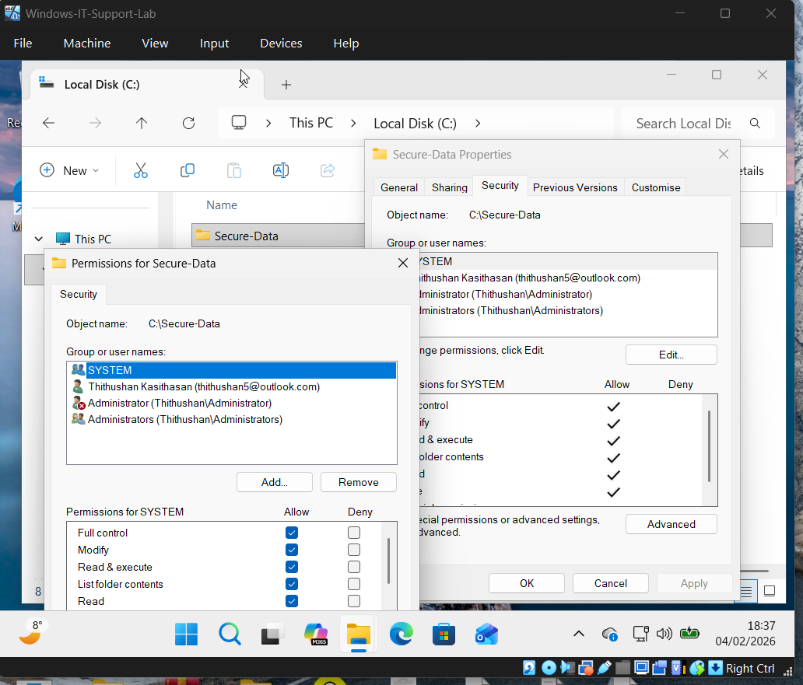
3. Granted read access to testuser1
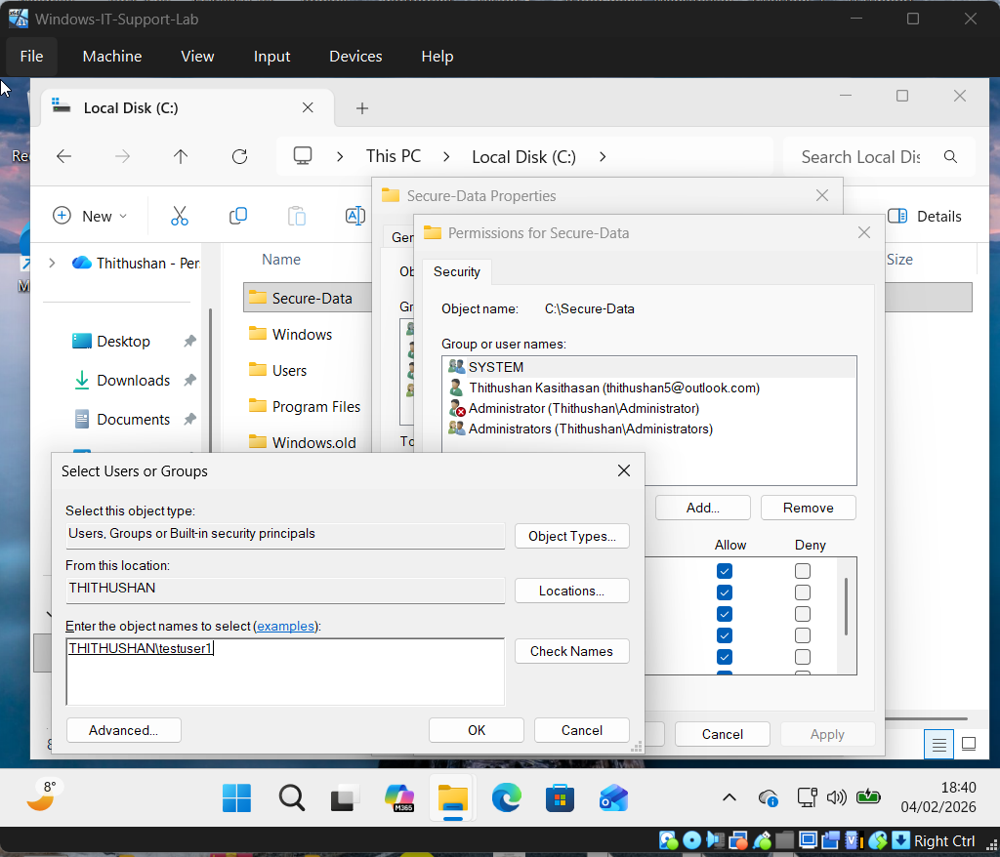
4. Verified access was restored
Result: User was able to access the folder successfully.
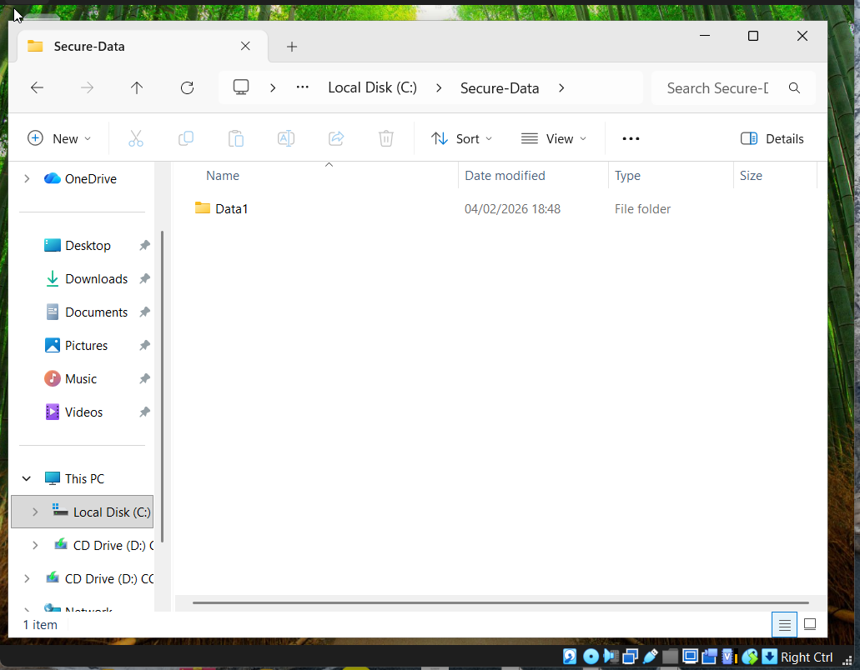

Security Consideration: Applied least-privilege access to ensure security.

