Ticket Title: Installed application not opening

User Problem: User reported that an installed application failed to open when launched from the desktop shortcut.

Questions Asked:
- Has the application worked previously?
- When did the issue first occur?
- Were any recent system or application updates installed?
- Is any error message displayed when launching the application?

Checks Performed:
- Verified application installation status
- Checked Task Manager for application process behavior
- Reviewed application compatibility and security settings

Root Cause: Incorrect application configuration and permission settings prevented the software from launching correctly.
Steps Taken to Fix:
1. Verified application behavior using Task Manager
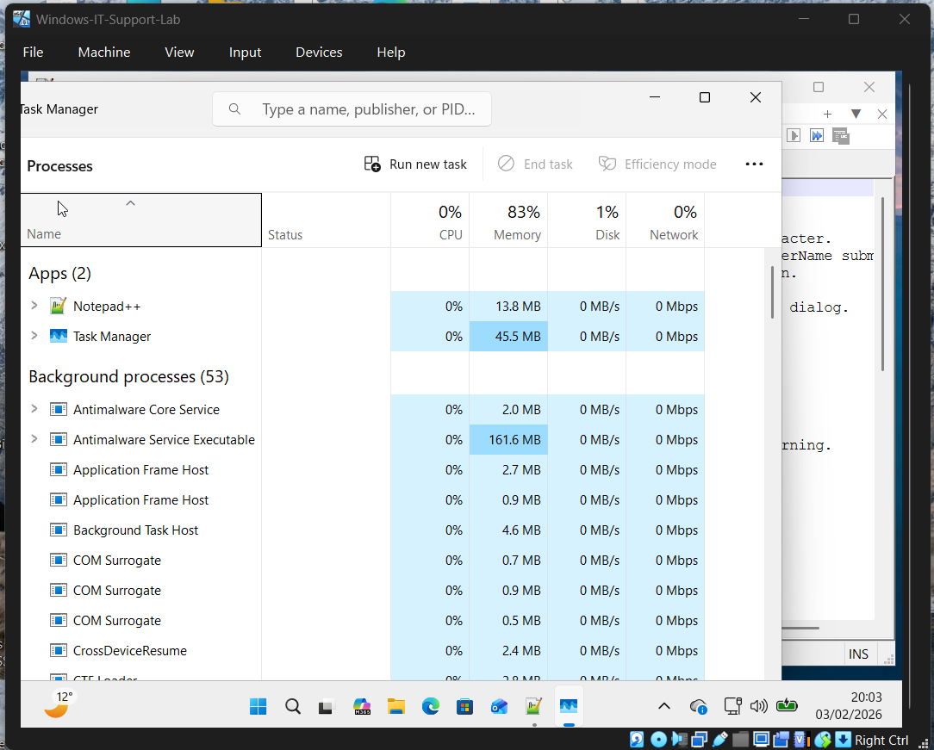

2. Checked application properties and configuration settings
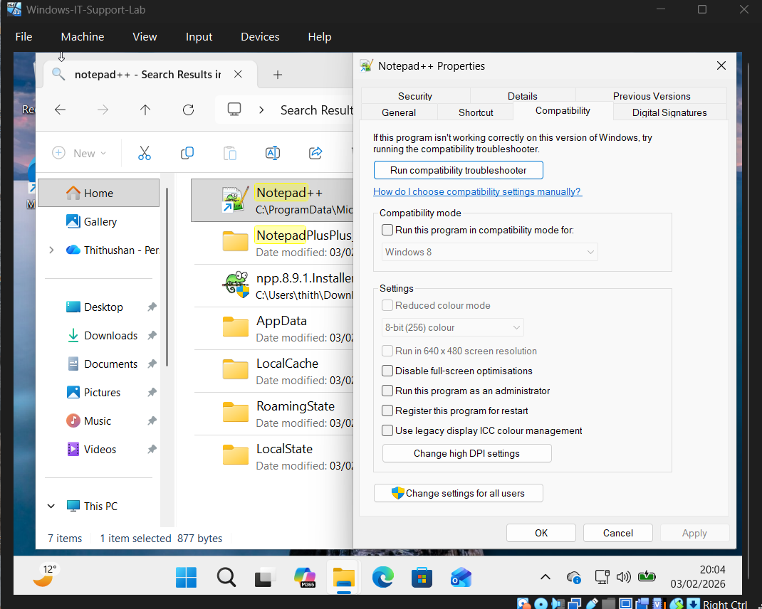
3. Corrected incompatible settings and permissions
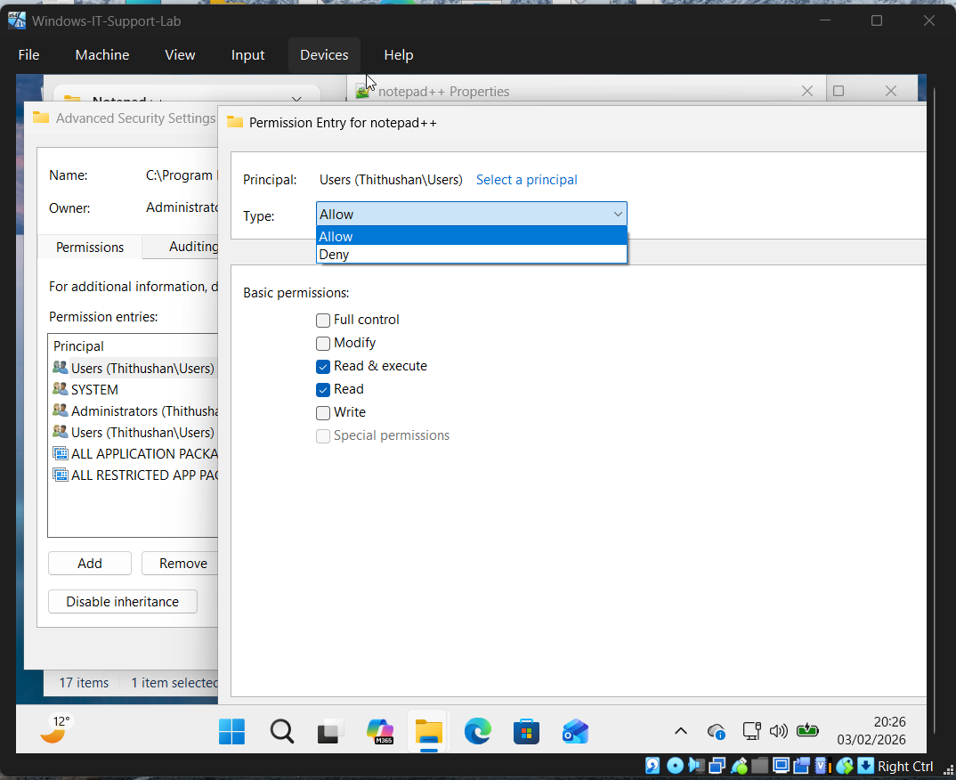
4. Relaunched the application to confirm functionality
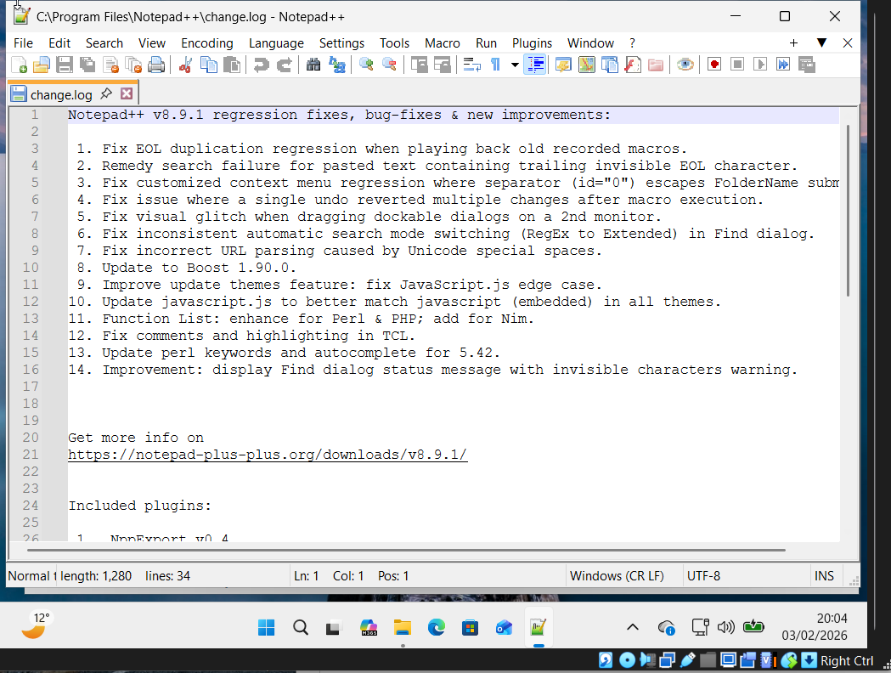

Result:
Application opened successfully and functioned as expected.

Prevention / Best Practice:
- Avoid modifying application compatibility or permission settings unnecessarily
- Keep applications updated to supported versions
- Install software using standard installation procedures

Tools Used:
- Application Properties
- Task Manager
- Apps & Features
- Web Browser

