Ticket Title: Windows updates not installing due to paused updates

User Problem: User reported that Windows updates were not downloading or installing on their system.

Questions Asked:
- When did the update issue start?
- Is the system showing any error messages?
- Has the system been restarted recently?
- Were updates intentionally paused?

Checks Performed:
- Checked Windows Update status in Settings
- Verified update history and update configuration
- Identified that Windows updates were paused

Root Cause: Windows updates were paused in system settings, preventing the system from checking for and installing updates.

Steps Taken to Fix:
1. Accessed Windows Update settings
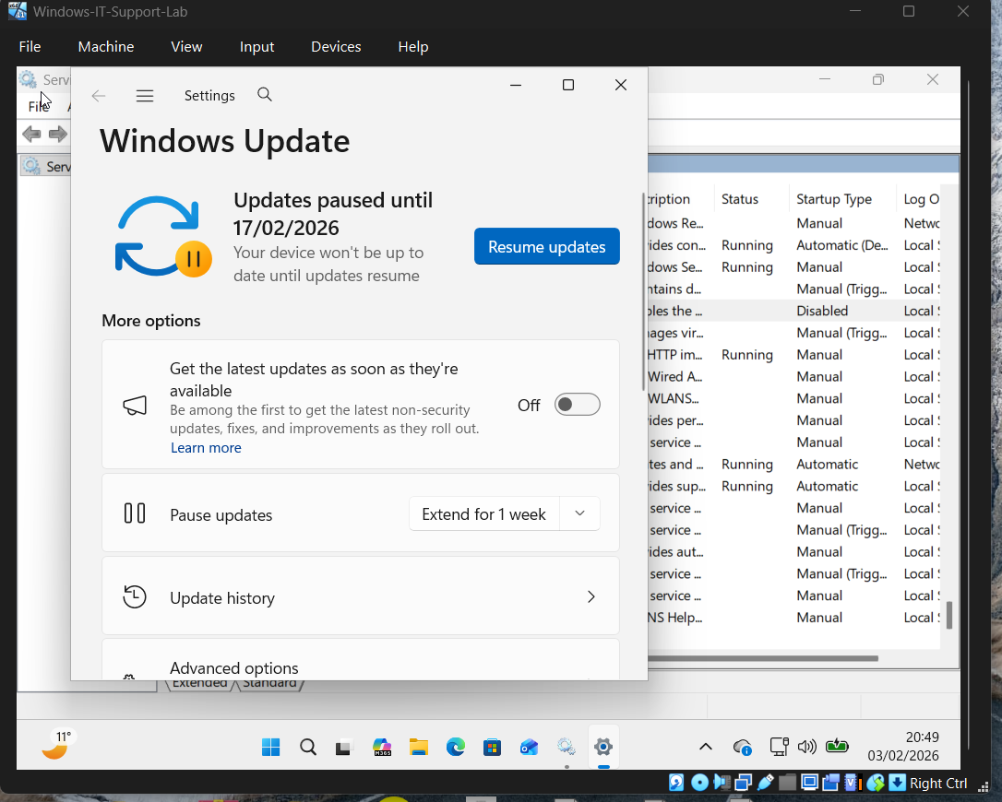

2. Identified that updates were paused
3. Resumed Windows updates
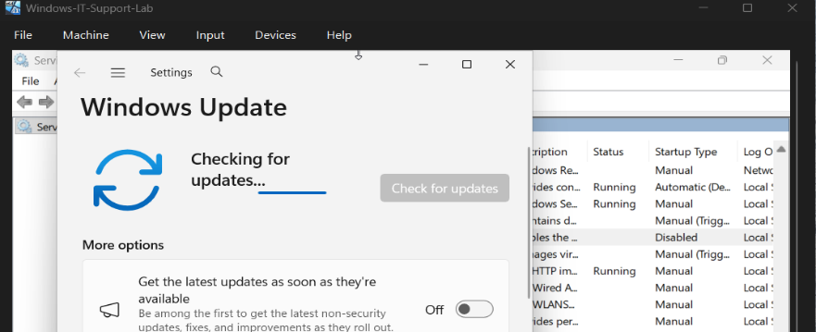
4. Rechecked for updates to verify functionality
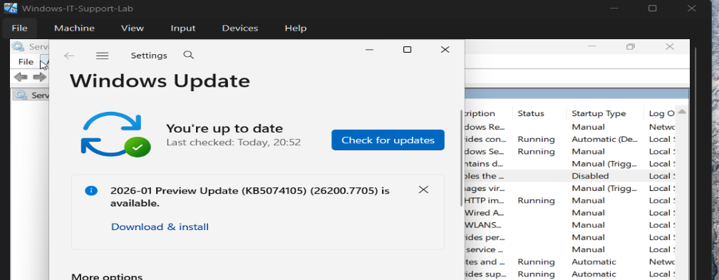
Result: Windows Update functionality was restored and the system was able to check for updates successfully.
Prevention / Best Practice:
- Avoid pausing updates unless required
- Resume updates after temporary pauses
- Perform regular system maintenance and updates

Tools Used:
- Windows Update Settings
- Windows Settings application

