Ticket Title: System running slow and delayed startup

User Problem:
User reported that the system was running slowly and applications were taking a long time to open, especially after startup.
Questions Asked:
- When did the performance issue start?
- Is the slowness constant or only after startup?
- Any recent software installations or updates?
- Does the system freeze or just respond slowly?

Checks Performed:
- Reviewed CPU, memory, and disk usage via Task Manager
- Identified multiple unnecessary startup applications
- Checked disk space and temporary files

Root Cause: Excessive startup applications and high background resource usage were impacting system performance.
Steps Taken to Fix:
1. Opened Task Manager and analyzed resource usage
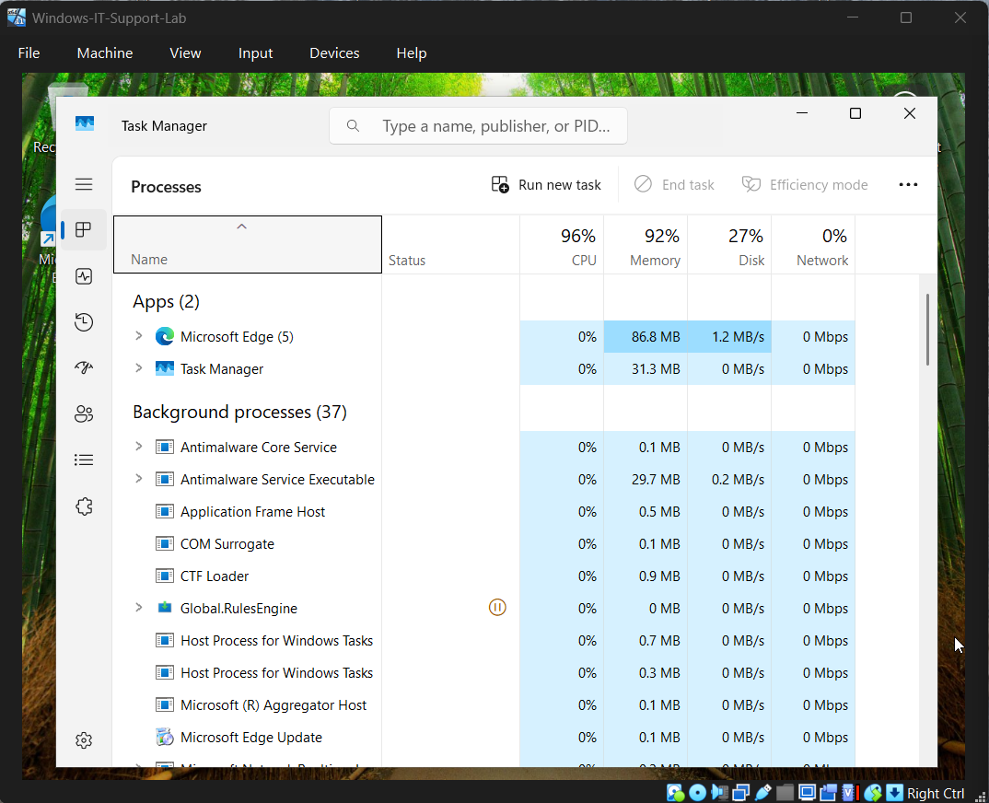
2. Identified non-essential startup applications
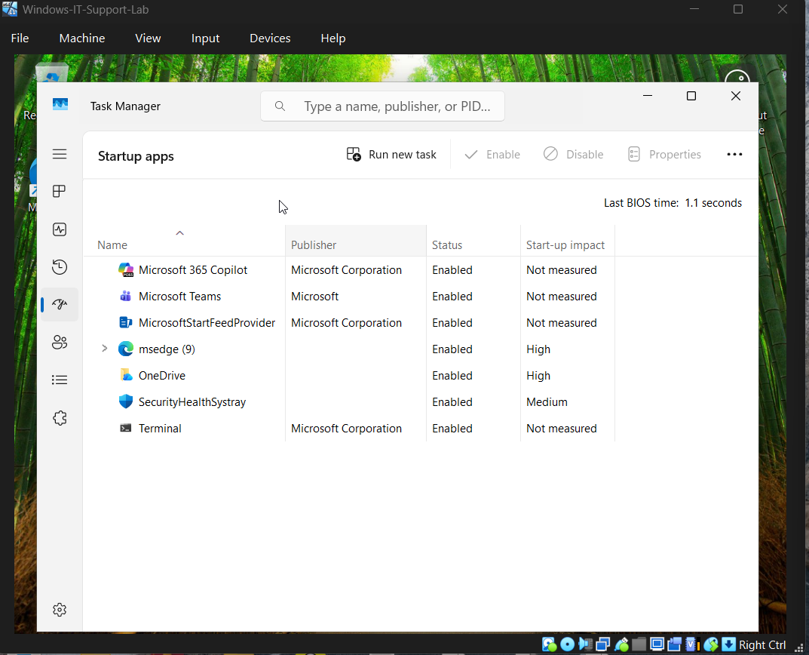
3. Disabled unnecessary startup programs
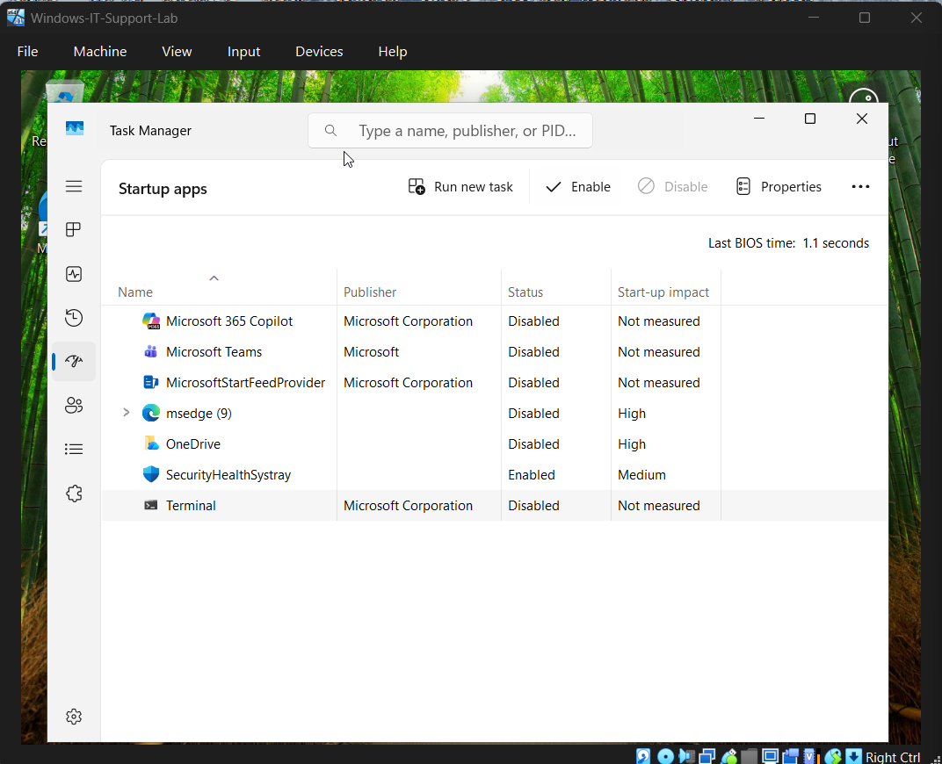
4. Performed disk cleanup to remove temporary files
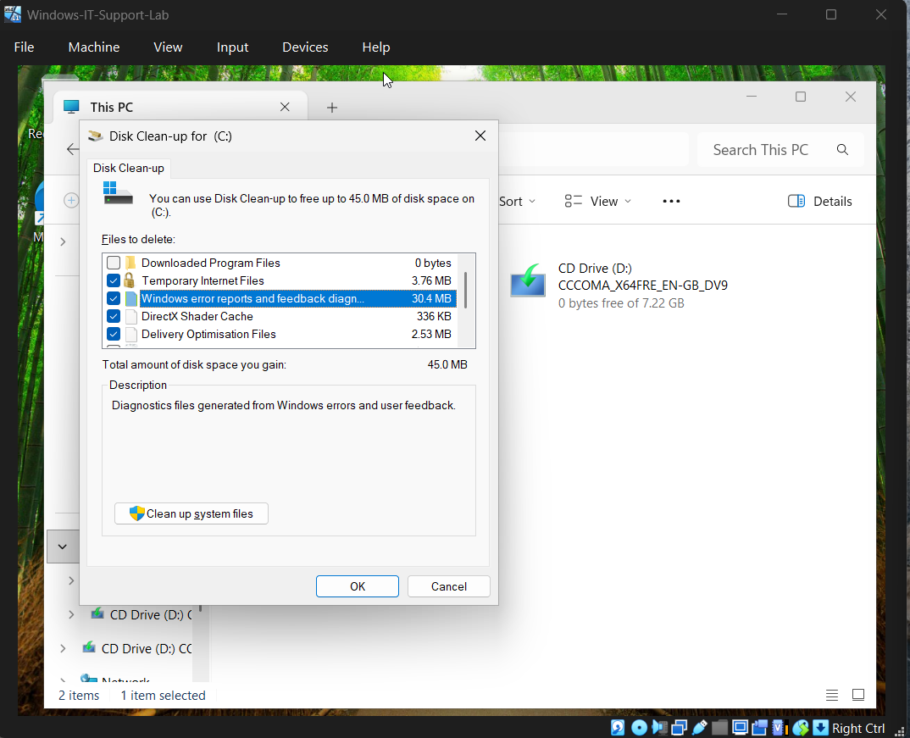

5. Restarted the system to apply changes
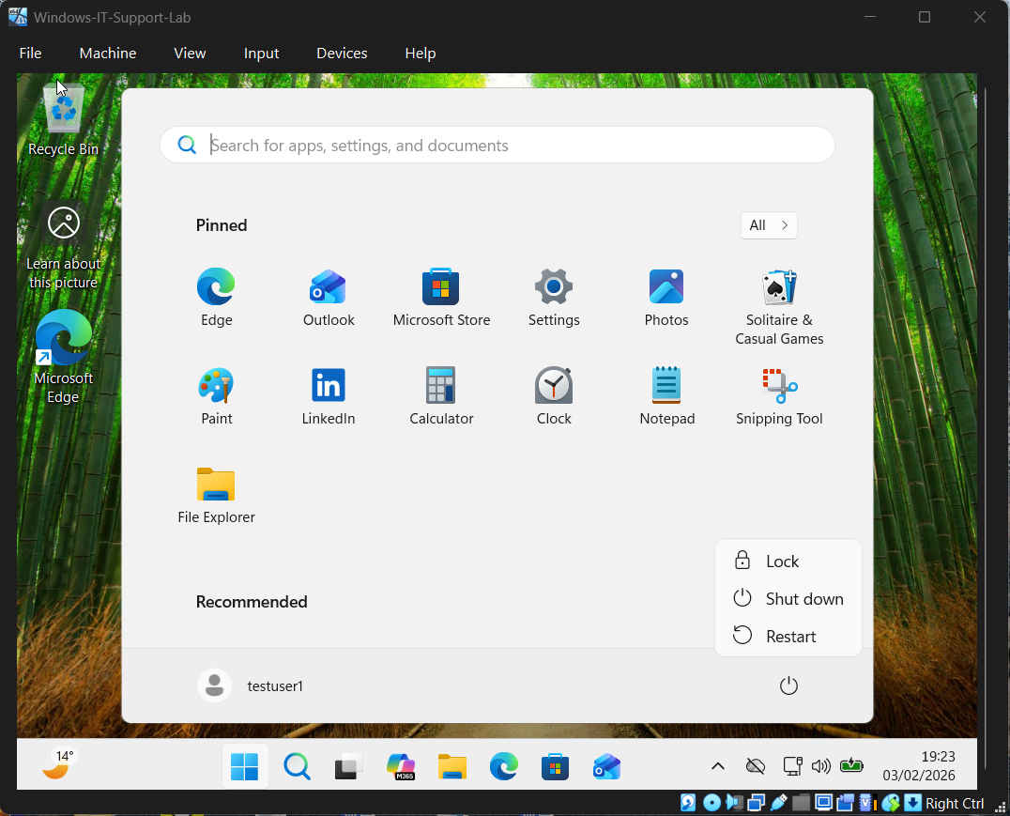

Result: System performance improved, startup time reduced, and applications responded faster.

Prevention / Best Practice:
- Limit startup applications to essential software only
- Perform regular disk cleanup
- Monitor system resource usage periodically

Tools Used:
- Task Manager
- Startup Applications
- Disk Cleanup Utility
- File Explorer

