**SCHOOL BUS TRACKING AND ATTENDANCE CHECKING**

Project Plan

**By**

Thitipun Tojareonvanich 552115018

Puttipong Tadang 552115054

Department of Software Engineering

College of Arts, Media, and Technology

Chiang Mai University

**Project Advisor**

Parinya Suwansrikham

**Document History**

|  |  |  |  |  |  |  |
| --- | --- | --- | --- | --- | --- | --- |
| Document Name | Detail | Status | Date | Viewable | Editable | Responsible |
| School Bus Tracking and Attendance Checking-ProjectPlan-V.0.1.docx | -Introduction  -Schedule and Milestones | Reviewed | 20/7/2015 | TT, PT, PS | TT, PT | TT, PT |
| School Bus Tracking and Attendance Checking-ProjectPlan-V.0.2.docx | -Infrastructure  -Identification of Project Risks | Reviewed | 23/7/2015 | TT, PT, PS | TT, PT | TT, PT |
| School Bus Tracking and Attendance Checking-ProjectPlan-V.0.3.docx | -Appendix  -Update Schedule and Milestones  -Update Introduction | Reviewed | 27/7/2015 | TT, PT, PS | TT, PT | TT, PT |
| School Bus Tracking and Attendance Checking-ProjectPlan-V.1.0.docx | -Update Quality Planning  -Update Schedule and Milestones | Released | 29/7/2015 | TT, PT, PS | TT, PT | TT, PT |
| School Bus Tracking and Attendance Checking-ProjectPlan-V.1.1.docx | -Update Estimated Effort and Cost | Reviewed | 25/8/2015 | TT, PT, PS | TT, PT | TT, PT |

\***TT** = Thitipun Tojareonvanich, \***PT** = Puttipong Tadang, \***PS** = Parinya Suwansrikham

**Document Designed by**

Mr.Thitipun Tojareonvanich

Mr.Puttipong Tadang

**Table of Contents**

Chapter One | Introduction 1

1.1 Identification 1

1.2 Project Scope 1

1.3 Document Overview 2

1.4 Objectives 3

1.5 Work Products to be Develop 4

1.6 Acronyms and Definitions 5

Chapter Two | Infrastructure 6

2.1 Software Development Life Cycle 6

2.2 Development Tools 7

2.3 Hardware and Material Resources 8

Chapter Three | Management Procedures 8

3.1 Project Team Structure 9

3.2 Monitoring and Controlling Mechanisms 9

Chapter Four | Quality Planning 10

4.1 Quality Standard 10

4.2 Reviews/Responsibility 12

4.3 Testing 12

4.4 Quality Factors 12

Chapter Five | Schedule and Milestones 13

5.1 Project Schedule 13

Chapter Six | Software Configuration Management 19

6.1 Software Configuration Management 19

6.2 Filename Format 20

6.3 Change Management 20

6.4 Software Configuration Item Table 20

Chapter Seven | Estimated Effort and Cost 22

Chapter Eight | Risk Management 22

8.1 Risk Management Process 22

8.2 Risk Identification and Solutions 1

Chapter Nine | Reference 5

Chapter One | Introduction

1.1 Identification

“School Bus Tracking and Attendance Checking” is an Android application that uses the location service of mobile phone to track the school bus and use the built-in camera to scan the QR code for checking the student attendance. The parent can track the school bus, can see their child attendance record, can get notification when their child enter or get off the bus, and can send the alert sound to alert the driver when they drive the school over the speed limit. For reducing the parent worrying about their children.

This project plan is the document for planning, scheduling activities and evaluating overall of the project so that the project will complete as successfully as possible in spite of all risks. The project plan is to use for track the progress and monitor whether the project follows the plan.

1.2 Project Scope

“School Bus Tracking and Attendance Checking” is a mobile application which uses Android OS. This application can help to improve the school bus system and reduce the parent worrying about their children. The parent can track the school bus position, can see their child attendance record, and get a notification message when their child enters or get off the school bus. In addition, the driver can check the student attendance by scan the QR code and can get the alert sound when the driver drives the bus over the speed limit.

The main features of “School Bus Tracking and Attendance Checking” are as follows:

**Tracking system**

Parents can track their child by the school bus position via Google Maps that they’re in. The school bus driver’s phone would send the position on to the database and can provide them to the parent.

**Attendance checking system**

School bus driver can check the children attendance via QR code when they enter and get off the bus. Moreover, parents can check whether their children are on the bus or not.

**Canceling the school bus ride system**

Parent can cancel the school bus ride on the special case. For example, the children get sick, parent wants to pick their child by yourself.

**Notifying system**

System can notify the parent when their child enters and get off the bus. In addition, system can notify children when the school bus nearby school.

**Speeding alert system**

System can warn school bus driver when drive over the speed limit that defined by the school bus appropriate speed survey.

1.3 Document Overview

The purpose of the “School Bus Tracking and Attendance Checking” project plan is to guide the project team members during the development of the project.

**Progress Report I：**

**Feature #1:** Member System

1.1: School bus driver can register to the application.

1.2: School bus driver can register the parents to the application.

1.3: School bus driver can register the children to the application.

1.4: Parents can login to the application.

1.5: Parents can logout from the application.

1.6: Children can login to the application.

1.7: Children can logout from the application.

1.8: Registered (School bus driver) user can login to the application.

1.9: Registered (School bus driver) user can logout from the application.

**Feature #2:** Checking attendance system

2.1: Registered (Parent) user can checking their children's attendance.

2.2: School bus driver can scan QR code for checking attendance.

**Progress Report II：**

**Feature #3:** Notifying System

3.1: Registered (Parent) user can cancel the schedule.

3.2: Registered (Children) user can receive the message when the bus is nearby

3.3: Registered (Parent) user can receive the message when their children arrive the school or home.

**Feature #4:** Tracking System

4.1: Registered (Parent) user can view their route.

4.2: Registered (Children) user can receive the message when the bus is nearby

4.3: Registered (Parent) user can receive the message when their children arrive the school or home.

**Progress Report III：**

**Feature #5:** Speed limit alert system

5.1: School bus driver can receive an alert message from the system when they drive over the speed limit.

5.2: School bus driver can turn on the application.

5.3: School bus driver can turn off the application.

1.4 Objectives

1. To develop a mobile application that reduce the parent worrying about their child with the school bus system with the followings:

- Checking attendance system: sending the message to the parent when their child enters and get off the school bus.

- Tracking system: a parent can monitor the school bus position to know where exactly the bus is.

1. To develop a mobile application that help to reduce car accidental with Speed Control Alert System for warning the driver when they drive over the speed limit that defined by the school bus appropriate speed survey in 90 people.
2. To offer the features that provide more convenience compared to calling the school bus driver:

- Canceling the school bus ride in the special case. For example, the child gets sick, the parent wants to pick their child by yourself.

1.5 Work Products to be Develop  
 1.5.1 Deliverables

|  |  |  |  |  |
| --- | --- | --- | --- | --- |
| **No.** | **Deliverables/Release** | **Media** | **No. of Copies** | **Date** |
| 1 | **Project Proposal**  • Proposal version 1.0 | Hard Copy | 3 | 10/6/2015 |
| 2 | **The Progress Report I**  Project Management Plan version 1.0  • Software Requirement  Specification version 1.0  • Software Design  Document version 1.0  • Test Plan version 1.0  • Traceability Record version 1.0 | Hard Copy | 3 | 29/7/2015 |
| 3 | **The Progress Report II**  • Project Management Plan version 2.0  • Software Requirement Specification version 2.0  • Software Design  Document version 2.0  • Test Plan version 2.0  • Traceability Record version 2.0 | Hard Copy | 3 | 23/9/2015 |
| 4 | **The Progress Report III (ShowPro)**  • Project Management Plan version 3.0  • Software Requirement Specification version 3.0  • Software Design Document version 3.0  • Test Plan version 3.0  • Traceability Record version 3.0  • Video presentation  • Poster presentation | Hard Copy  File  Poster | 3  1  1 | 4/11/2015 |
| 5 | **The Final Progress Report**  • Project Management Plan version 4.0  • Software Requirement Specification version 4.0  • Software Design Document version 4.0  • Test Plan version 4.0  • Traceability Record version 4.0  • Software Source code version 1.0 | Hard Copy  Software | 3  1 | 25/11/2015 |

1.6 Acronyms and Definitions

**1.6.1 Acronyms**

TT Thitipun Tohareonvanich

PT Puttipong Tadang

PS Parinya Suwansrikham  
 VSE Very Small Entity

**1.6.2 Definitions**

**Project Plan** Project plan is part of [project management](http://en.wikipedia.org/wiki/Project_management), which relates to the use of [schedules](http://en.wikipedia.org/wiki/Schedule_(project_management)) such as [Gantt charts](http://en.wikipedia.org/wiki/Gantt_chart) to plan and subsequently report progress within the project environment.

**Risk**  Anuncertain event or condition that, if it occurs, has a positive or negative effect on a project’s objectives. It is a function of the probability of occurrence of a given threat’s occurrence. [1]

**Risk Management**  Risk management is a software engineering practice with processes, methods, and tools for managing risks in a project. It provides a disciplined environment for proactive decision-making to assess continuously what can go wrong; determine what risks are important to deal with, and implement actions to deal with those risks. [2]

**Traceability** In [software development](http://en.wikipedia.org/wiki/Software_development), the term traceability (or [Requirements Traceability](http://en.wikipedia.org/wiki/Requirements_Traceability)) refers to the ability to link product requirements back to stakeholders' rationales and forward to corresponding design artifacts, code, and [test cases](http://en.wikipedia.org/wiki/Test_case).[3]

**Unit Test** In [computer programming](http://en.wikipedia.org/wiki/Computer_programming), unit testing is a [software testing](http://en.wikipedia.org/wiki/Software_testing) method by which individual units of [source code](http://en.wikipedia.org/wiki/Source_code), sets of one or more computer program modules together with associated control data, usage procedures, and operating procedures are tested to determine if they are fit for use.[[1]](http://en.wikipedia.org/wiki/Unit_testing#cite_note-kolawa-1) Intuitively, one can view a unit as the smallest testable part of an application. [4]

**Configuration Item** [Component](http://www.businessdictionary.com/definition/component.html) of an [information technology (IT)](http://www.businessdictionary.com/definition/information-technology-IT.html) [structure](http://www.businessdictionary.com/definition/structure.html) or [system](http://www.businessdictionary.com/definition/system.html) under the [control](http://www.businessdictionary.com/definition/control.html) of [configuration management](http://www.businessdictionary.com/definition/configuration-management.html).[5]

Chapter Two | Infrastructure

2.1 Software Development Life Cycle

Iterative model start with a simple implementation of a small part set of the software requirements and iteratively enhances the evolving versions until the complete system is implemented and ready to be deployed.

Iterative life cycle model does not attempt to start with a full specification of requirements. Instead, development begins by specifying and implementing just part of the software, which can then be reviewed in order to identify further requirements. This process is then repeated, producing a new version of the software for each cycle of the model.

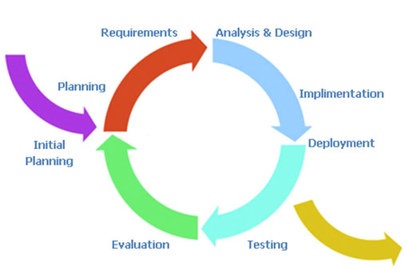

Figure 1: Iterative model [6]

2.2 Development Tools

**Android Studio**

Android Studio is an IDE tool([integrated development environment](http://en.wikipedia.org/wiki/Integrated_development_environment) tool) from Google for developing on the [Android](http://en.wikipedia.org/wiki/Android_(operating_system)), Based on [Jet Brains](http://en.wikipedia.org/wiki/JetBrains)' [IntelliJ IDEA](http://en.wikipedia.org/wiki/IntelliJ_IDEA) software; Android Studio is designed specifically for Android development. [7]

**MySQL**

MySQL is an open-source relational database management system which. It can create both standalone and server database. Moreover, it also supports many development tools. [8]

**Google Maps API**

Google Maps API is a programming API that Google provides to developers. It allows developers to embed data of Google Maps into their web or application. And it helps developers provide the location services to users. In addition, Google Maps API not only helps developers to embed maps into their application but also allows developers use JavaScript to expand their applications. [9]

**GitHub**

GitHub is a Web-based Git repository hosting service, which offers all of the distributed revision control and source code management. [10]

**Visual Paradigm for UML**

Visual Paradigm for UML is a software for model diagram and it can reverse engineer diagrams from code.

2.3 Hardware and Material Resources

* **Laptops**
* **Lenovo Y5070**

Processor: Intel(R) Core(TM) i7-4710HQ @ 2.50GHz

Memory: 8 GB DDR3

Graphics: NVIDIA GeForce GTX 860M

Operating System: Window 8.1 Professional

* **Dell Inspiron N7420**

Processor: Intel(R) Core(TM) i7-3612QM @ 2.10GHz

Memory: 8 GB DDR3

Graphics: NVIDIA GeForce GT 640M

Operating System: Windows 7 Ultimate

* **Internet**
* **Mobile Phone**: Android Operating System
  + - **Asus Zenfone5**

CPU: Intel Atom Z2580 Dual-core 2 GHz

Memory: 2 GB

Operating System: Android OS 4.3

Chapter Three | Management Procedures



3.1 Project Team Structure

|  |  |
| --- | --- |
| **Activities** | **Participants** |
| Feasibility Study | Thitipun Tojareonvanich  Puttipong Tadang |
| Project Proposal |
| Project Requirement |
| Project Plan |
| Software Architectural Design |
| Software Detailed Design |
| Implementation |
| Testing |
| Review |

3.2 Monitoring and Controlling Mechanisms

**3.2.1 Project Meeting**

|  |  |
| --- | --- |
| Participants | Roles |
| Thitipun Tojareonvanich | Development team member |
| Puttipong Tadang | Development team member |
| Parinya Suwansrikham | Project Advisor |

**3.3 Change Management**

Change Management manages and controls all of the changes that happen during the project development process. The change requests will be recorded into the change management document. Here are the steps of our strategy for change management:

1. Analyze the change request (How necessary it is and the impact to

the other part of the system).

2. Set a change request form.

3. Approve the change request by the project advisor.

4. Change the project according to the approved change request.

Chapter Four | Quality Planning

4.1 Quality Standard

• **ISO 29110 for Very Small Entity (VSE)**

ISO 29110 is a software processes and guidelines for very small entities. A very small entity is mean an enterprise, organization, department or project having up to 25 people. The guide are based on subsets of appropriate standards elements, referred to as VSE profiles. The purpose of a VSE profile is to define a subset of ISO/IEC standards relevant to the VSE.

**4.1.1 Basic Profile Guide Processes**

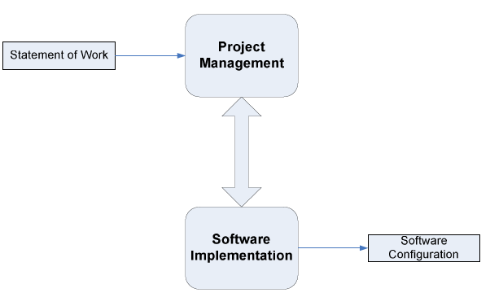

***Figure 2:*** *Basic Profile Guide Process*

Project Management (PM) process uses the customer’s statement of work to elaborate the project plan. The PM project assessment and control tasks compare the project progress against the project plan and actions are taken to eliminate deviations or incorporate changes to the project plan. The PM project closure activity delivers the software configuration, produced by SI and gets the customer’s acceptance to formalize the end of the project. A project repository is established to save the work products and to control its versions during the project.

The execution of the Software Implementation (SI) process is driven by the project plan. SI process starts with an initiation activity of the project plan review. The project plan will guide the execution of the software requirements analysis, software architectural and detailed design, software construction, and software integration and test, and product delivery activities.

**4.1.2 Project Management Process**

The purpose of the project management process is to establish and carry out in a systematic way the tasks of the software implementation project, which allows complying with the project’s objectives in the expected quality, time and cost.

**Selected processes**

4.1.2.1 Project planning process

4.1.2.2 Project plan execution process

4.1.2.3 Project assessment and control process

4.1.2.4 Project closure process

**4.1.3 Software Implementation Process**

The purpose of the software implementation process is the systematic performance of the analysis, design, construction, integration and tests activities for new or modified software products according to the specified requirement.

**Selected processes**

4.1.3.1 Software implementation initiation process

4.1.3.2 Software requirement analysis process

4.1.3.3 Software architectural and detailed design process

4.1.3.4 Software construction process

4.1.3.5 Software integration and test process

4.1.3.6 Software delivery process

4.2 Reviews/Responsibility

|  |  |  |  |
| --- | --- | --- | --- |
| **Stage Exit Review** | | | |
| **No.** | **Stage** | **Software Items** | **Responsibility** |
| 1 | Requirement gathering | Project Proposal, Survey | Thitipun Tojareonvanich  Puttipong Tadang  Parinya Suwansrikham |
| 2 | Project Planning | Project Plan |
| 3 | Requirement Analysis and Specification | Software Requirement  Specification |
| 4 | Architecture and Detailed Design | Software Design Document |
| 5 | Software Implementation | Source Code |

4.3 Testing

|  |  |  |
| --- | --- | --- |
| **No.** | **Test** | **Responsibility** |
| 1 | Unit Testing | Thitipun Tojareonvanich  Puttipong Tadang  Parinya Suwansrikham |
| 2 | System Testing |
| 3 | User Acceptance Test |

4.4 Quality Factors

**4.4.1 Product Operation Factors**

**Correctness**

The software should provide more than 90% of data as the user requested correctly.

**Usability**

The software should provide understandable and easy-to-use GUI and language.

**Reliability**

The software should perform with more than 80% of usual activities, and with less than 10% of failure.

**Integrity**

The software should be able to identify between authorized and unauthorized users, and also between each type of users

**4.4.2 Product Revision Factors**

**Maintainability**

The software should contain 20-30% of comments from the total LOC to support furthermore maintenance.

**Testability**

The software should be 100% tested.

**4.4.3 Product Transition Factors**

**Reusability**

More than 50% of the complete software should be able to be reused in the future.

Chapter Five | Schedule and Milestones

5.1 Project Schedule

**Member System**

Feature#1: Registration system

Feature#2: Login system

**Checking attendance system**

Feature#3: QR code reader

Feature#4: QR generator

Feature#5: Checking attendance system

**Notifying System**

Feature#6: Parent notifying message system

Feature#7: Cancelling the school bus ride system

**Tracking System**

Feature#8: Tracking system

Feature#9: Calculating Approximate arrival time system

**Speeding Alert System**

Feature#10: Send alert message system

According to the architecture of our project and the time schedule for the senior project, we separated the whole project to five processes. The description is shown below:

1. **Proposal phase**

Create proposal document.

1. **Progress I**

Create Development Plan, Quality Plan, Software requirement specification, Software design document and some part of Test document. Start creates member system and checking attendance system.

1. **Progress II**

Create a notifying system and tracking system, overall of the system should be higher than 65%. And Test document.

1. **Progress III**

Create a speed control alert system and integrate all features. Overall of the system should be complete or nearly. And Test document.

1. **Final progress**

Integrate and review all document. Make sure all system and document are complete.

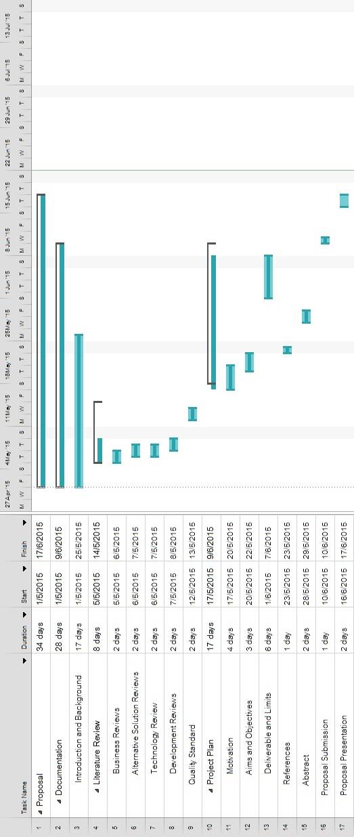

Figure 2 Proposal phase

Figure 3 Proposal phase

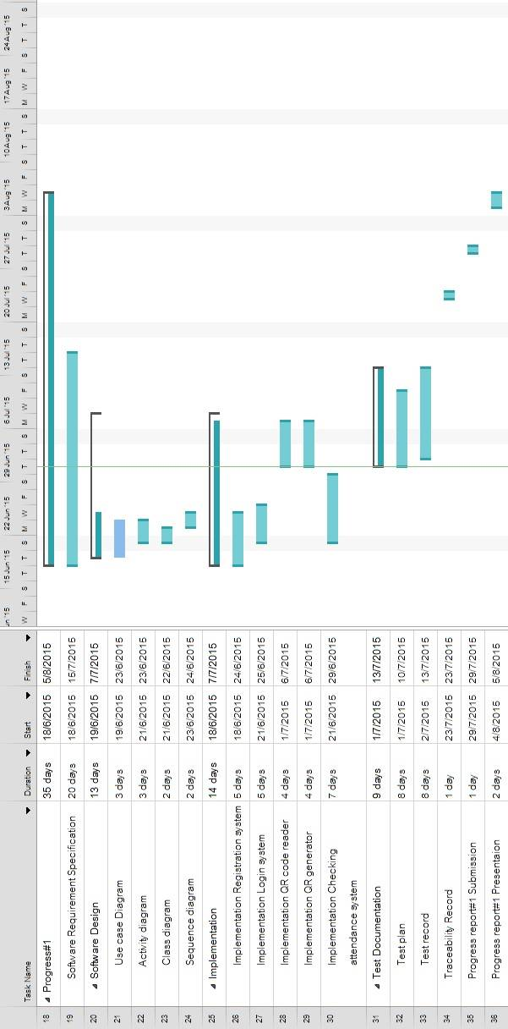

Figure 3 Progress I

Figure 4 Progress I

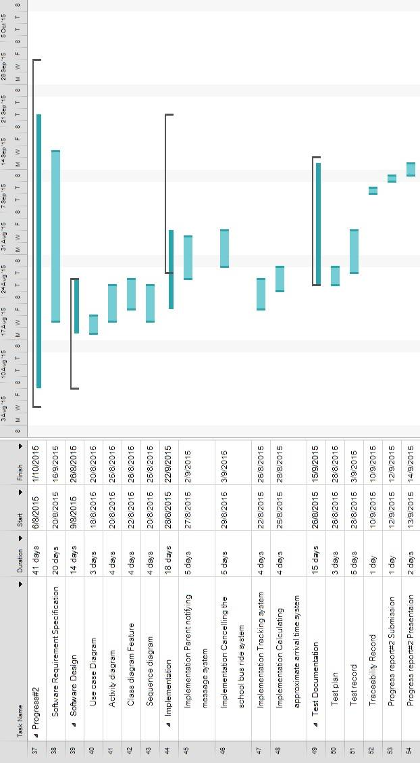

Figure 4 Progress II

Figure 5 Progress II

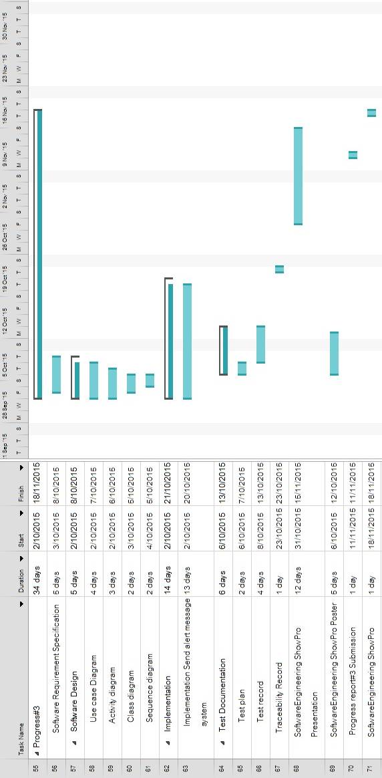

Figure 5 Progress III

Figure 6 Progress III

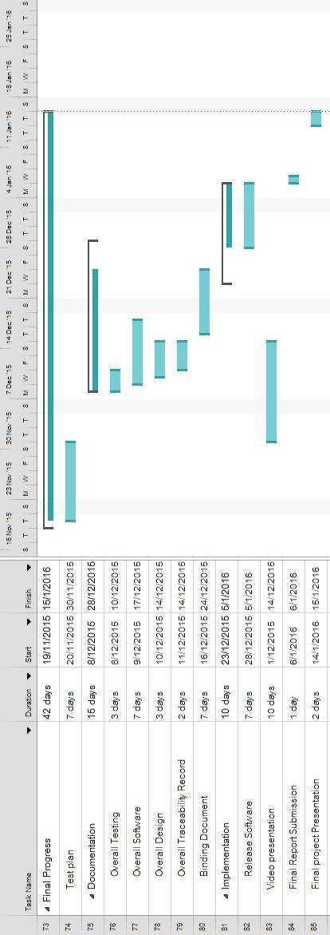

Figure 5 Final Progress

Figure 7 Final Progress

Chapter Six | Software Configuration Management

6.1 Software Configuration Management

Software Configuration Management can coordinate the software management, which can minimize the confusion in the development. It is a set of activities designed to control changes by identifying the parts of the development that is likely to be changed, establishing relationships among them, defining mechanisms for managing different versions of them, controlling the changes imposed, and auditing and reporting on the changes made. In a word, Software Configuration Management is a methodology to control and manage a software development with its configuration. It can determine what to change and who to be responsible for the change when something goes wrong.

6.2 Filename Format  
 For the filename format that we use for all project documents is:

School Bus Tracking and Attendance Checking _ [Document name] _V [Version].file type

6.3 Change Management

Change Management manages all the changes in the software development of the project. All the change requests will be recorded in the Change Request Document. We use the strategy for change management as following steps:

1. Analyzing the change.

2. Designing the change plan.

3. Requesting for the change.

4. Approving the change request by project advisor.

5. Implementing the change as the approved change request.

6.4 Software Configuration Item Table

|  |  |  |  |  |  |  |
| --- | --- | --- | --- | --- | --- | --- |
| **No.** | **Item** | **Filename** | **File Type** | **Owner** | **Path** | **Baseline Version** |
| 1 | Project Proposal | School Bus Tracking and AttendanceChecking-ProjectProposal-V.1.2 | .docx | TT, PT | School Bus Tracking and Attendance Checking  /Proposal | 1.2 |
| 2 | Project Plan | School Bus Tracking and AttendanceChecking-ProjectPlan-V.1.0 | .docx | TT, PT | School Bus Tracking and Attendance Checking  /Project Plan | 1.0 |
| 3 | Software Requirement Specification | School Bus Tracking and AttendanceChecking-SoftwareRequirementSpecification-V.1.0 | .docx | TT, PT | School Bus Tracking and Attendance Checking  /Software Requirement Specification | 1.0 |
| 4 | Software Design | School Bus Tracking and AttendanceChecking-SoftwareDesign -V.1.0 | .docx | TT, PT | School Bus Tracking and Attendance Checking  /Software Design | 1.0 |
| 5 | Test Plan | School Bus Tracking and AttendanceChecking-TestPlan-V.1.0 | .docx | TT, PT | School Bus Tracking and Attendance Checking  /Teat Plan | 1.0 |
| 6 | Test Record | School Bus Tracking and AttendanceChecking-TestRecord-V.1.0 | .docx | TT, PT | School Bus Tracking and Attendance Checking  /Test Record | 1.0 |
| 7 | Traceability Record | School Bus Tracking and AttendanceChecking-TraceabilityRecord-V.1.0 | .docx | TT, PT | School Bus Tracking and Attendance Checking  /Traceability Record | 1.0 |
| 8 | Executive Summary | School Bus Tracking and AttendanceChecking-ExecutiveSummary-V.1.0 | .docx | TT, PT | School Bus Tracking and Attendance Checking  /Executive Summary | 1.0 |
| 9 | Project Status Report | School Bus Tracking and AttendanceChecking-ProjectStatusReport-V.1.0 | .docx | TT, PT | School Bus Tracking and Attendance Checking  /Project Status Report | 1.0 |

Chapter Seven | Estimated Effort and Cost

Most cost will come from learning materials and the hard copy documents. Because for this project, we develop our application with open source tools. So the most cost will be spent on buying some learning textbooks and printing the documents.

|  |  |
| --- | --- |
| **Item** | **Approximately Cost (THB)** |
| Text Books | 1,000 |
| Android Device for testing the system | 4,500 |
| Document Printing | 1,000 |
| Poster Presentation | 500 |

Chapter Eight | Risk Management

8.1 Risk Management Process

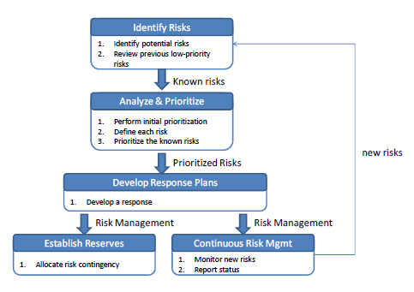

Figure 6: Risk Management Process

**First step**, identify project and business risks that have the potential of affecting the project and documenting the risk’s characteristics.

**Second step**, Identify and assess the probability and impact of the risks.

**Third step**, come up with plans that will minimize or avoid threats and maximize opportunities.

**a**. Accepting the risk

**b**. Avoid the risk

**c**. Contingency plans

**d**. Transfer the risk

**e**. Mitigate the risk

8.2 Risk Identification and Solutions

**Three criterion:**

**L-**Low, **N**-Normal, **H**-High

**Technology failure**

|  |  |  |  |  |  |  |
| --- | --- | --- | --- | --- | --- | --- |
| **Risk ID** | **Headline** | **Description** | **Priority Level** | **Impact** | **Likelihood**  **of Event** | **Mitigation Strategy** |
| 1 | Server fail | Some factors lead to the situation where the server cannot provide accurate data. | N | Users may not be satisfied with the application. | Certainty | Exception Handling. Displaying proper messages for the users. |

**Human failure**

|  |  |  |  |  |  |  |
| --- | --- | --- | --- | --- | --- | --- |
| **Risk ID** | **Headline** | **Description** | **Priority Level** | **Impact** | **Likelihood**  **of Event** | **Mitigation Strategy** |
| 2 | Lack of responsibility of team’s member | A member of the team cannot finish her task on time, or cannot meet the requirement of the project. | H | The project cannot be delivered in time. | Somewhat likely | Report every team member’s work at project meetings, and discuss what should they finish before next meeting. |
| 3 | Lack of skills | A member of the team does not have experience and skill to do the project. To find/create certain functions, developers take a longer time since they need to gather knowledge first. | H | It may lead to the situation where the project cannot finish in time. | Certainty | Practice and training |
| 4 | A team member gets sick or has an accident | A team member may get sick or has an accident, and cannot work on the project. | L | It may lead to the situation where the project cannot finish in time. | Somewhat likely | · Adjust the plans and schedules.  · The absent member should assign works to the other member who can continue work on the project |

**Process failure**

|  |  |  |  |  |  |  |
| --- | --- | --- | --- | --- | --- | --- |
| **Risk ID** | **Headline** | **Description** | **Priority Level** | **Impact** | **Likelihood**  **of Event** | **Mitigation Strategy** |
| 5 | Project schedule changes. | Some factors may force the project schedule to change. | H | Influence progress | Certainty | Create comprehensive project timeline and adjust the project schedule according to the requirements. |
| 6 | The system faces reliability or stability | Users cannot use the application or cannot get complete information because of unexpected external factors. | N | Users may not be satisfied with the application. | Somewhat likely | Manage the application and maintain the system timely. |
| 7 | Requirements might change. | New ideas from stakeholders make the project requirements change. | H | Affect the process of the application development. | Certainty | · Before developing each function, understand the needs as much as possible. · Meet and discuss with other stakeholders. |
| 8 | Tasks are not completed in time. | Some factors may lead to the situation where the team members cannot finish their work in time | N | Influence progress, and affect the delivery time. | Somewhat likely | · In project planning, team members should reserve buffer time. · Meet with team members and find solutions. |
| 9 | Work cannot be traced. | The change of the requirement may lead us to change our previous work | H | Spend a lot of time to trace back the changes. | Somewhat likely | Create the traceability record. |
| 10 | Works do not meet the requirements. | Team members did not understand the requirement clearly. | L | · Spend a lot of time to change. · Cannot deliver the project in time. | Somewhat likely | Have a frequent meeting and share members’ understanding of the requirements. |

Chapter Nine | Reference

[1] [*"A Production Model for Construction: A Theoretical Framework"*](http://www.mdpi.com/2075-5309/5/1/209). [Online]. Retrieved June 21, 2015, from <http://en.wikipedia.org/>?title=Risk

[2] *Definition of risk management.* [Online]. Retrieved June 21, 2015, from

<http://energy.gov/sites/prod/files/cioprod/documents/Risk_Management.pdf>

[3] *Definition of traceability.* [Online]. Retrieved June 21, 2015, from

<http://en.wikipedia.org/wiki>/Traceability

[4] *Definition of unit test.* [Online]. Retrieved June 21, 2015, from

<http://en.wikipedia.org/wiki>/Unit_testing

[5] Definition of configuration item

<http://www.businessdictionary.com/definition/configuration-item.html>

[6] *Iterative model.* [Online]. Retrieved June 21, 2015, from <http://www.voltreach.com/Development_Methodologies.aspx>

[7] *Android Studio*. [Online]. Retrieved 5 June 2015, from <https://cetatech.ceta-> ciemat.es/2015/02/atajos-imprescindibles-en-android-studio

[8] *MySQL*. [Online]. Retrieved June 7, 2015, from <https://www.otreva.com/blog/mysql-> execute-immediate-solution

[9] *What is the* *Google Maps API?.* (2015). [Online]. Retrieved June 10, 2015, from [http://en.wikipedia.org/wiki/Google_Maps](http://en.wikipedia.org/wiki/Google_Maps/)