**SCHOOL BUS TRACKING AND ATTENDANCE CHECKING**

Project Proposal

**By**

Mr. Thitipun Tojareonvanich 552115018

Mr. Puttipong Tadang 552115054

Department of Software Engineering

College of Arts, Media, and Technology

Chiang Mai University

**Project Advisor**

Mr. Parinya Suwansrikham

**Document History**

|  |  |  |  |  |  |  |
| --- | --- | --- | --- | --- | --- | --- |
| Document Name | Version | Status | Date | Viewable | Editable | Responsible |
| School Bus Tracking and Attendance Checking-Proposal-V.0.1.docx | 0.1 | Reviewed | 6/6/2015 | TT, PT, PS | TT, PT | TT, PT |
| School Bus Tracking and Attendance Checking-Proposal-V.0.2.docx | 0.2 | Reviewed | 8/6/2015 | TT, PT, PS | TT, PT | TT, PT |
| School Bus Tracking and Attendance Checking-Proposal-V.0.3.docx | 0.3 | Reviewed | 7/6/2015 | TT, PT, PS | TT, PT | TT, PT |
| School Bus Tracking and Attendance Checking-Proposal-V.0.4.docx | 0.4 | Reviewed | 8/6/2015 | TT, PT, PS | TT, PT | TT, PT |
| School Bus Tracking and Attendance Checking-Proposal-V.0.5.docx | 0.5 | Reviewed | 9/6/2015 | TT, PT, PS | TT, PT | TT, PT |
| School Bus Tracking and Attendance Checking-Proposal-V.1.0.docx | 1.0 | Released | 10/6/2015 | TT, PT, PS | TT, PT | TT, PT |
| School Bus Tracking and Attendance Checking-Proposal-V.1.1.docx | 1.1 | Reviewed | 17/6/2015 | TT, PT, PS | TT, PT | TT, PT |
| School Bus Tracking and Attendance Checking-Proposal-V.1.2.docx | 1.2 | Released | 1/7/2015 | TT, PT, PS | TT, PT | TT, PT |

\***TT** = Thitipun Tojareonvanich, \***PT** = Puttipong Tadang, \***PS** = Parinya Suwansrikham

**Document Designed by**

Mr.Thitipun Tojareonvanich

Mr.Puttipong Tadang

**Topic** School Bus Tracking and Attendance Checking

**Author** Mr. Thitipun Tojareonvanich

Mr. Puttipong Tadang

**Degree** Bachelor of Science

Software Engineering Program

**Project Advisor** Mr. Parinya Suwansrikum

**ABSTRACT**

A school bus is popular of school transportation for the parents have no time to take their children to and from school. Most students waste time waiting for the bus and sometimes they even miss it. Moreover, accidents in 2013 and 2014, was when the school bus driver left the children in the bus then they suffocated and died. This project combined navigation and QR code technology to make a mobile application for tracking the school bus and checking the children attendance that is called “School Bus Tracking and Attendance Checking.”. First, every user will have an own account. This application can notify the approximate arrival time and can track the school bus. Then check the children attendance by QR code technology. Additionally, the application can alert the school bus driver when they drive faster than 80 kilometers per hour follow the school law. Finally, notify the parent when the children get on and get off the bus. In the special case, the parent can cancel the school bus ride on the application.

**Table of Contents**

Chapter One | Introduction and Background 1

Chapter Two | Literature Review 2

2.1 Business review 2

2.2 Technology Review 6

2.3 Developer Tool Review 10

2.4 System Architecture Review 12

Chapter Three | Quality Standard 13

3.1 ISO29110 for Very Small Entity (VSE) 13

3.1.1 Project Management Process 13

3.1.2 Software Implementation process 13

Chapter Four | Project Plan 14

4.1 Motivation 14

4.2 Aims and Objective 14

4.2.1 Aims 14

4.2.2 Objective 14

4.3 Deliverables and Limits 15

4.3.1 Deliverable 15

4.3.2 Limits 16

4.4 Future Work 16

4.5 Software Process Model 16

4.6 Schedule and Milestones 17

Chapter Five | References 23

Chapter One | Introduction and Background

Most parents have no time to take their children to and from school, the distance between the house and school is very far, along with problem of traffic. Using the school bus service can solve this problem, but the service is unreliable, parents have no confidence with the school bus service, safety, bus condition, often is an accident, and they want to take care of their children by themselves. A school bus is a bus for carrying the student to and from school. The bus and the driver have to be approved by the federal law and regulation. School buses provide an estimated 10 billion student trips every year.[1]Thai school bus are commonly supported by the van and limited to not more than 12 people. Moreover,They have to have the school bus sign on the front and back of the car and it should be visible, also have the yellow or red light to inform other car drivers that drive behind the bus, audit can be seen no less than 150 meters.

The disadvantages of school bus service system are that most students waste time waiting for the school bus and sometimes they even miss the bus. Moreover, accidents in 2013 and 2014, was when the school bus driver left the children in the bus then they suffocated and died. If the school bus delivers the children to their house later than the expected time, the parents might be worried as they do not know exactly where the bus is and when it will be back home.

School Bus Tracking and Attendance Checking application is developed to solve these problems. We have seen an increasing number of people using smartphone that have the ability of location service. So we apply this ability to the parents for track the school bus and also use the QR code technology on the children attendance checking by the school bus driver scans the QR code of the children when they get on and get off the bus . Furthermore, it is fast and easy to use.

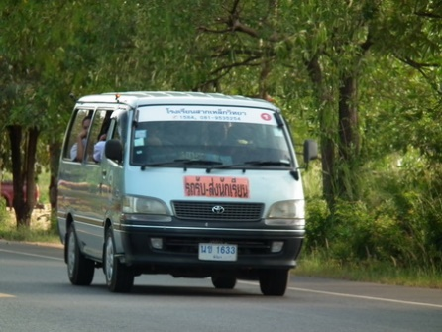 In addition, this application can notify the parents when the children arrives at the school, notify the arrival time of the school bus for both trips from and to school, and can cancel the bus ride by the parents in a special case. For example, the children gets sick, the parent wants to take them by themselves. Finally, we hope this application can improve the standard of Thai school bus, make the parents confident with the school bus system, and also make the system reliable.

Figure 1 Thai school bus [2]

Chapter Two | Literature Review

2.1 Business review

**Overview**

A school bus is popular of school transportation for the parent who have no time to take their children to school or the distance between houses, and school is very far. A school bus is the best way to reduce the time and transport cost for that family. School bus divided into two categories; 1.) The bus takes control by the school. 2.) The bus takes control by private business. According to the department of transport regulations of Thailand;

Regular person

* Photo identification cards of car owners.
* Manual vehicle registration

Corporation

* Certificate of Corporation
* Photo identification cards of car owners.
* Manual vehicle registration

For the register to the school bus driver.

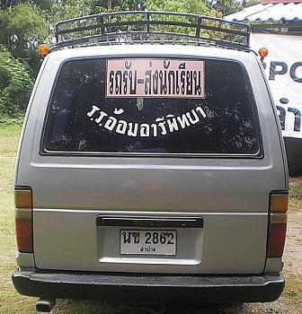

Figure 2 School Bus sticker and light sign [3]

For the school bus system is a lack of reliable, according to the Thailand school bus statistics between 1999 and 2003 found the total injury student 2,817 people and died 156 people. From the research shown the accident with the school bus is usually in the evening, 76 percent of accident occur on 3 to 5 pm. and 24 percent occur on 6 to 8 pm. Moreover, the age group of those injured, Primary school (between 6-12 years old) is about 71 percent and high school (between 13-18 years old) is about 18 percent. [4]And the accident in 2013 and 2014, the school bus driver left the children on the bus then they suffocated and died.

**Target**

The main goal of school bus be a representative as parents to pick up or drop their children to school

**Benefit**

* Parent do not waste time to pick their children or take their children to school.
* Reduce the load of the parent to take their children to school.

**2.1.1 GPS application on smartphone**

GPS application on a smartphone is an application that use GPS to track the location. It can replace the big map to navigate the users the place that user want. The smartphone make users convenient and easier than carry the big map.

There is two example of the interested GPS application

**2.1.1.1 GPS Phone Tracker – GPS Tracking**

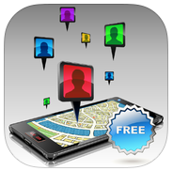

Figure 3 GPS Tracker [5]

**GPS Phone Tracker** is a free application. It gives a service by turn your smartphone into the GPS tracking device to follow the multiple people and see their locations, also show the hour of movements.

**Pros**

- Simple interface makes the user easy to understand

- GPS Phone Tracker can attach photos to identify users on maps

- Select time frame to see other's movements

- Map people's movements for the prior 24 hours

- Can help to find lost or stolen phones

**Cons**

- Use only the e-mail to create the contact

- The application cannot change your name after you register with the system

- The application does not provide notification when your contacts and you are nearby

**2.1.1.2 Google Maps**

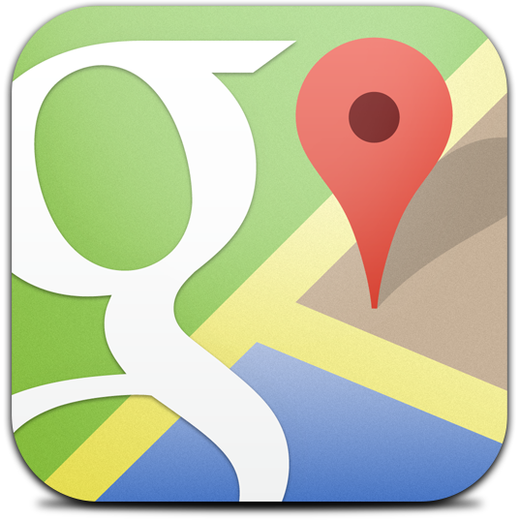

Figure 4 Google Maps [6]

**Google Maps** is an application that navigating your world faster and easier. Find the best spots in town and the information you need to get there**.**

**Pros**

- Google map provide the location around the world

- Simple function, easy to understand

- Google map allow user to define a destination

**Cons**

- Inaccurate

- No notification to user when arrive or nearby

**2.1.1.3 Foursquare**



Figure 5 Foursquare [7]

**Foursquare** is a local search and discovery service [mobile app](http://en.wikipedia.org/wiki/Mobile_app) which provides a personalized local search experience for its users. By taking into account the places a user goes, the things they have told the app that they like, and the other users whose advice they trust, Foursquare aims to provide highly personalized recommendations of the best places to go around a user's current location. [8]

**Pros**

- Foursquare help user to find the best spot

- Foursquare provide the categories to user, food, drink or nearby

- Foursquare review function, user can see the overall before user goes there

**Cons**

- Available in Thai only

- Some spot is not related to the categories

- User cannot create a route by yourself, it has only checked in place

**2.1.1.4 CMTRANSIT**



Figure 6 CMTRANSIT [9]

**CMTRANSIT** is the monitoring application that provide the taxi map and taxi  location to user and check the user spot that in the taxi location or not ,also the QR code for scanning to specify the taxi which run in different line.

**Pros**

- Specify the bus line clearly, comfortable for user to get the services

- CMTRANSIT provide the bus stop to user for waiting the bus

**Cons**

- Available in Thai language

- The map support Chiang Mai only

2.2 Technology Review

**2.2.1 Android Mobile operating system**



Figure 7 Android [10]

**Android** is a [mobile operating system](http://en.wikipedia.org/wiki/Mobile_operating_system) (OS) based on the [Linux kernel](http://en.wikipedia.org/wiki/Linux_kernel) and currently developed by Google. It free (open source). Android mainly designed for touchscreen devices. Such as smartphone and tablet.[11]

**Advantage of Android**

1. Open-source

2. Work efficiently with Google service

Moreover, from the Thailand survey shown the growth rate of Android users are more and more over every year.

**Alternative Technology**

1. IOS (Apple)

2. Windows Phone from Microsoft

3. Symbian (Nokia)

4. Blackberry OS

**Reason we choose this technology**

1. According to the survey (Dec 2008 to Jan 2014), the number of Android users are increased every year. [12]

2. Android is open source, it free to use and familiar with JAVA language.

**2.2.2 QR Code**



Figure 8 QR Code [13]

**QR Code** stands for Quick Response Code, is a two-dimensional barcode that consists of black modules arranged together in a square grid with the white background. QR Code can be readable by QR scanners in the mobile phone with cameras and smartphone. It fast in readability and large storage capacity. QR code can be read even some part of codes are damaged.[14]

**Advantage of QR code**

1. QR can be applied to use for anything and everything.

2. Fast to readable and comparatively large storage capacity

**Alternative Technology**

Barcode

**Reason we choose this technology**

QR code can be read quickly, average time is 1-2 second and QR code can be decoded even some part of codes are damaged, it suit to our application

**2.2.3 Google Maps API**



Figure 9 Google Maps API [15]

**Google Maps** is a web mapping service application and technology provide by google. It offers satellite imagery, street maps, and Street View perspectives, as well as functions such as a [route planning](http://en.wikipedia.org/wiki/Route_planner) for traveling by foot, car, bike (in [beta](http://en.wikipedia.org/wiki/Beta_test)), or via [public transportation](http://en.wikipedia.org/wiki/Public_transportation). Google Maps offers an [API](http://en.wikipedia.org/wiki/Application_programming_interface) that allows maps to be embedded on third-party websitesand offers a locator for urban businesses and other organizations in numerous countries around the world.[16]

**Alternative Technology**

Bing Map

**Reason we choose this technology**

Google Maps API provide a lot of information, such as source code and Google Map API provide the complete code to apply for our project, So we save time to write the source code about this part.

**2.2.4 Java**



Figure 10 Java [17]

**Java** is a general-purpose [computer programming language](http://en.wikipedia.org/wiki/Programming_language) that is [concurrent](http://en.wikipedia.org/wiki/Concurrent_computing), [class-based](http://en.wikipedia.org/wiki/Class-based_programming), oriented and specifically designed to have as few implementation dependencies as possible. It is intended to let application developers "[write once, run anywhere](http://en.wikipedia.org/wiki/Write_once,_run_anywhere)" (WORA), meaning that [compiled](http://en.wikipedia.org/wiki/Compiler) Java code can run on all platforms that support Java without the need for recompilation.Java applications are typically compiled to [bytecode](http://en.wikipedia.org/wiki/Java_bytecode) that can run on any [Java virtual machine](http://en.wikipedia.org/wiki/Java_virtual_machine) (JVM) regardless of [computer architecture](http://en.wikipedia.org/wiki/Computer_architecture). [18]

**Alternative technology**

* C++
* C#

**Reason we choose this technology**

Java is an object-oriented language with high security more than another and open source, also the platform-Independent

2.3 Developer Tool Review

**2.3.1 Android Studio**



Figure 11 Android Studio [19]

**Android Studio** is an IDE tool([integrated development environment](http://en.wikipedia.org/wiki/Integrated_development_environment) tool) from Google for developing on the [Android](http://en.wikipedia.org/wiki/Android_(operating_system)), Based on [Jet Brains](http://en.wikipedia.org/wiki/JetBrains)' [IntelliJ IDEA](http://en.wikipedia.org/wiki/IntelliJ_IDEA) software; Android Studio is designed specifically for Android development. [20]

**Alternative tool**

Eclipse

**Reason we choose this technology**

Android Studio was built to develop Android application in particularly. It is all been well designed to make Android applications more efficiently**.** Moreover, Android Studio isolated each part of the code clearly, did not mingle piled rally**.**

**2.3.2 MySQL**



Figure 12 MySQL [21]

MySQL is an open-source relational database management system which. It can create both standalone and server database. Moreover, it also supports many development tools. [22]

**Alternative tool**

* SQLite
* Oracle

**Reason we choose this technology**

MySQL is a high-performance open source database and reliable suit to store the medium to a large database and support many platforms, In the case in the future we to develop this application into iOS platform, MySQL can be used.

2.4 System Architecture Review

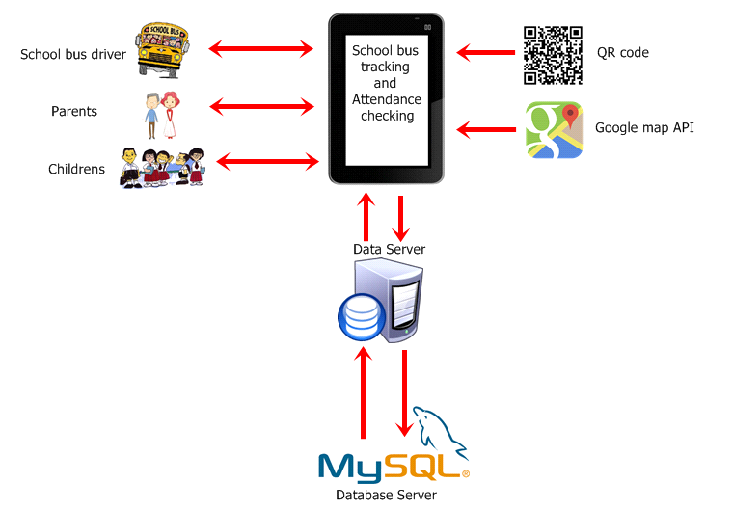

Figure 13 System review

School Bus Tracking and Attendance Checking application is a tracking and attendance checking application on Android smartphones. Whenever Parents interact with the application, the system will provide the bus position and children attendance to the user. Every time that QR code was scanned on the application, it will record to the database (date, time, bus position, children ID, and children name)

For the picture shown, three types of user; School bus driver, Parents, and Children

* The School bus driver has to assign the parent to the bus system.
* The Parents can view the position and check their children attendance.
* The children can receive the message when the coming nearby their school.

Chapter Three | Quality Standard

3.1 ISO29110 for Very Small Entity (VSE)

ISO/IEC 29110 Systems and Software Life Cycle Profiles and Guidelines for Very Small Entity (VSE). A Very Small Entity (VSE) is an enterprise, organization, department or project having up to 25 people. The target of VSE involved in the development or maintenance of software has been published by ISO. The guide provides project management and software implementation processes.

**3.1.1 Project Management Process**

The purpose of the Project Management process is to establish and carry out in a systematic way the tasks of the software implementation project, which allows complying with the project’s objectives in the expected quality, time and cost.

Selected process

3.1.1.1 Project Planning Process

3.1.1.2 Project Assessment and Control Process

3.1.1.3 Software Review Process

3.1.1.4 Software Configuration Management Process

3.1.1.5 Software Quality Assurance Process

3.1.2 Software Implementation process

The purpose of the Software Implementation process is the systematic performance of the analysis, design, construction, integration and tests activities for new or modified software products, according to the specified requirements.

Selected process

3.1.2.1 Software Requirements Analysis Process

3.1.2.2 Software Architectural Design Process

3.1.2.3 Software Construction Process

3.1.2.4 Software Qualification Testing Process

3.1.2.5 Software Verification Process

3.1.2.6 Software Validation Process

Chapter Four | Project Plan

4.1 Motivation

Most student waste time waiting for the school bus and sometimes they even miss the bus. Moreover, the accident in 2013 and 2014, the school bus driver left the children on the bus then they suffocated and died. Moreover, if the school bus delivers the children to their house later that expected time, the parents might be worried as they do not know the exactly where the bus is.

Moreover, when we develop this application, we have practice about JAVA to develop an android application and learn about applying about Google API about Google map on the mobile phone. Moreover, we expected that we would get the experience with the software development process and how to work as a team. So we can use those experience to apply for work in the software jobs.

4.2 Aims and Objective

4.2.1 Aims

The aim of this project is to develop mobile application for dealing with concern of children safety from their parent. Additionally, the accident of excessive speed maybe reduced by using this application. Moreover, it may be a useful tool for solving the problem about leaving children at school or school bus. Finally, this application may shorten the time that your children have to waiting for the school bus.

4.2.2 Objective

1. To provide the school bus position and children attendance.
2. To notify parents when their children get on and get off the bus
3. To warn the school bus driver in the case of speed is more than 80 kilometers/hours.

4.3 Deliverables and Limits

4.3.1 Deliverable

1. **Progress #1**

**Member System**

* + - * Registration system
      * Login system

**Checking attendance system**

* QR code reader
* QR generator
* Checking attendance system

1. **Progress #2**

**Notifying System**

* + - Parent notifying message system
    - Cancelling the school bus ride system

**Tracking System**

* + - Tracking system
    - Calculating approximate arrival time system

1. **Progress #3**

**Speed Control Alert System**

* Send alert message system

1. **The document and other material**

* Proposal.
* Project plan.
* Quality plan.
* Software requirement specification.
* Traceability record.
* Software design document.
* Testing document.
* Test plan.
* Unit test report.
* System Test report.
* One DVD stores client source code, relate file, all documents, and poster files in PDF format.
* One Project poster.
* Application.

4.3.2 Limits

* The application requires Android operating system mobile phone.
* The application requires an internet connection.
* The school bus driver requires a GPS enabled device.
* The school bus driver requires a camera.
* The application supported Thai and English languages.
* The application limit two parents can track one child.

4.4 Future Work

* Be able to operate on IOS platform.
* Be support all of the ASEAN languages.
* Be make the QR tag for the children who has not get the smartphone

4.5 Software Process Model

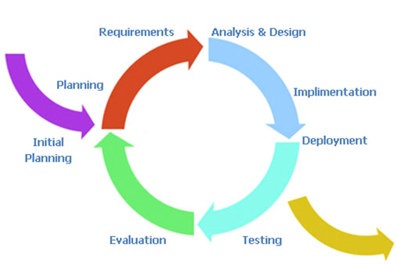

Figure 14 Iterative model [23]

Iterative model start with a simple implementation of a small part set of the software requirements and iteratively enhances the evolving versions until the complete system is implemented and ready to be deployed.

Iterative [life cycle mod](http://istqbexamcertification.com/what-are-the-software-development-models/)el does not attempt to start with a full specification of requirements. Instead, development begins by specifying and implementing just part of the software, which can then be reviewed in order to identify further requirements. This process is then repeated, producing a new version of the software for each cycle of the model. [24]

4.6 Schedule and Milestones

**Member System**

* Feature#1: Registration system
* Feature#2: Login system

**Checking attendance system**

* Feature#3: QR code reader
* Feature#4: QR generator
* Feature#5: Checking attendance system

**Notifying System**

* Feature#6: Parent notifying message system
* Feature#7: Cancelling the school bus ride system

**Tracking System**

* Feature#8: Tracking system
* Feature#9: Calculating approximate arrival time system

**Speed Control Alert System**

* Feature#10: Send alert message system

**4.6.1 Schedule Plan**

* **Proposal phase**

Create proposal document.

* **Progress I**

Create Development Plan, Quality plan, Software requirement specification, Software design document and some part of Test document. Start creates member system and checking attendance system.

* **Progress II**

Create notifying system and tracking system, overall of the system should be higher than 65%. And Test document.

* **Progress III**

Create speed control alert system and integrate all features. Overall of the system should be complete or nearly. And Test document.

* **Final progress**

Integrate and review all document. Make sure all system and document are complete.

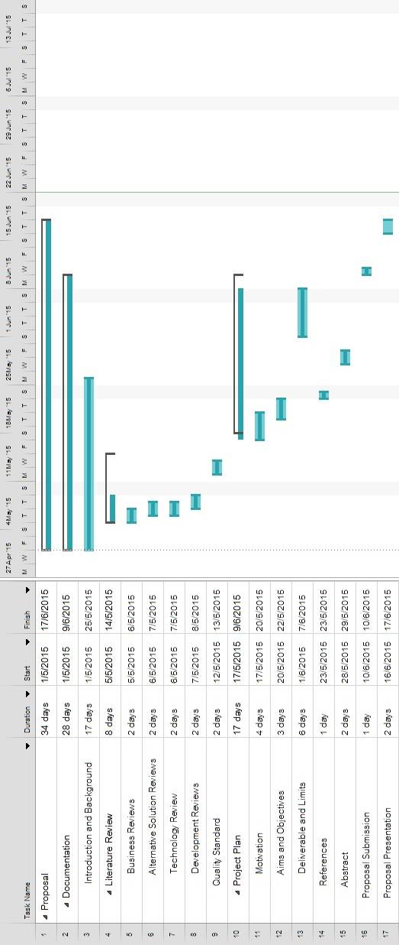

Figure 15 Proposal phase

Figure 16 Proposal phase

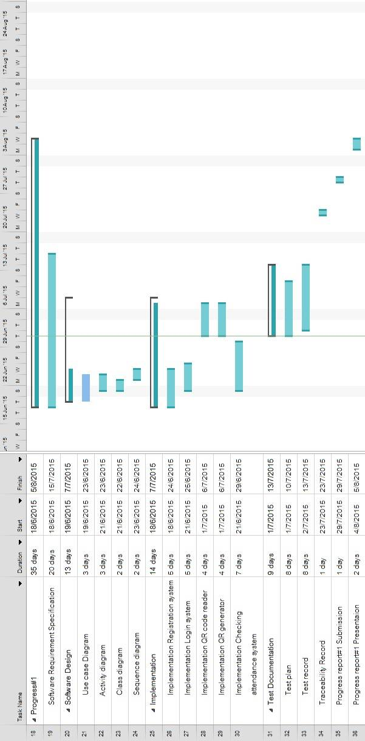

Figure 17 Progress I

Figure 18 Progress I

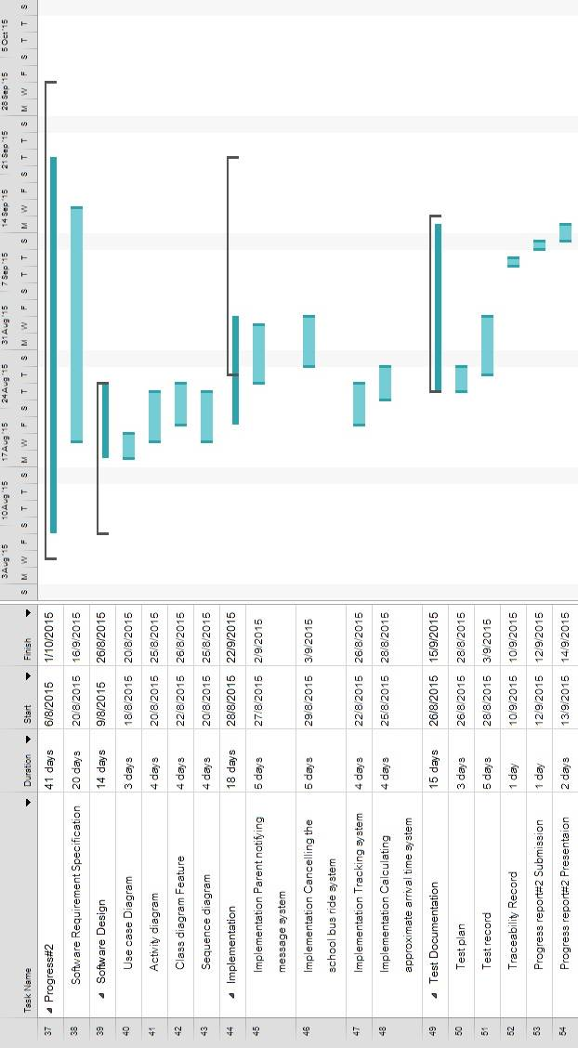

Figure 19 Progress II

Figure 20 Progress II

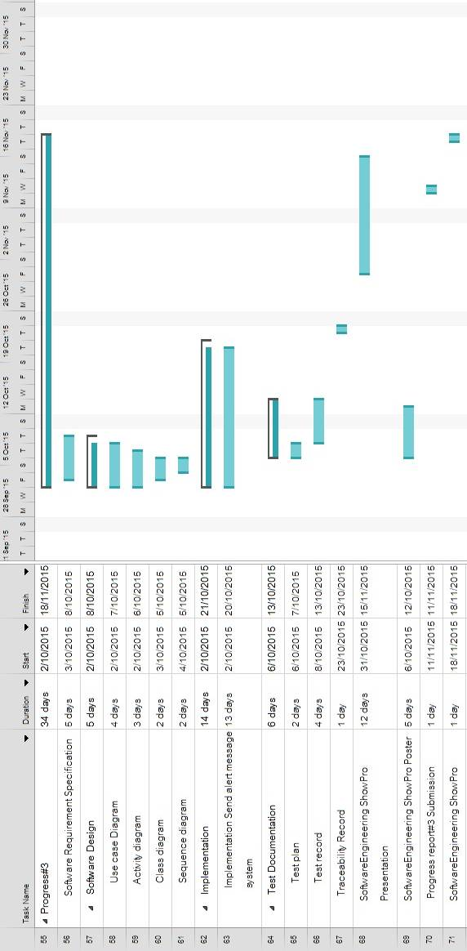

Figure 21 Progress III

Figure 22 Progress III

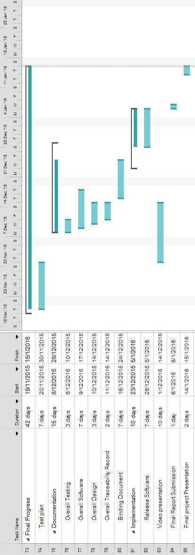

Figure 23 Final Progress

Figure 24 Final Progress

Chapter Five | References

[1] *School statistics*. (2014). [Online]. Retrieved May 5, 2015, from National Center for Education Statistics Website: <http://en.wikipedia.org/wiki/School_bus>

[2] *School bus sticker and light sign*.[Online]. Retrieved May 5, 2015, from [http://www.cm-club.com/forum/showthread.php?t=649026](%20%09http://www.cm-club.com/forum/showthread.php?t=649026%20)

[3] *Thai school bus*. [Online]. Retrieved May 5, 2015, from <http://www.oknation.net/blog/phichittoday/2011/03/12/entry-1>

[4] Premwadee, K. (2004). *รถโรงเรียน หรือ รถรับส่งนักเรียน (school bus) โครงการความ ปลอดภัยในการ เดินทางไปกลับโรงเรียนด้วยรถรับส่งนักเรียนในกรุงเทพมหานคร*. [Online]. Retrieved May 10, 2015, from Road Safety Thailand Website: http://www.roadsafetythai.org/node/8

[5] *GPS Tracker*. [Online]. Retrieved May 5, 2015, from <https://itunes.apple.com/gb/app/gps-> phone- tracker-gps-tracking/id460832829?mt=8

[6] *Google Maps*. [Online]. Retrieved May 5, 2015, from <http://graphicdesign.stackexchange.com/question/3592/google-map-icon-is-it->free-to-use

[7] *Foursquare*. [Online]. Retrieved May 6, 2015, from [http://imobizone.com/foursquare- reveals-](http://imobizone.com/foursquare-%09reveals-)a-new-logo-and-previews-its-overhauled-discovery-app

[8] *Foursquare*. (2012). [Online]. Retrieved May 6, 2015, from http://en.wikipedia.org/wiki/Foursquare

[9] *CMTRANSIT*. [Online]. Retrieved May 6, 2015, from http://chiangmaibus.org

[10] *Android*. [Online]. Retrieved May 6, 2015, from [http://www.ubergizmo.com/how- to/backup-](http://www.ubergizmo.com/how-%09to/backup-)android-phone-for-free

[11] Manjoo, Farhad (May, 2015). [*A Murky Road Ahead for Android, Despite Market Dominance*](http://www.nytimes.com/2015/05/28/technology/personaltech/a-murky-road-ahead-for-android-despite-market-dominance.html). The New York Times. [ISSN](https://en.wikipedia.org/wiki/International_Standard_Serial_Number) [0362-4331](https://www.worldcat.org/issn/0362-4331)

[12] ***IDC Worldwide Mobile Phone Tracker.* (May, 2014)**. [Online]. Retrieved May 10, 2015, from http://droidsans.com/idc-android-2014-2018-forecast

[13] *QR Code.* [Online]. Retrieved May 10, 2015, from <http://keremerkan.net/qr-code-and-2d-> code-generator

[14] [*QR Code features*](http://archive.is/20120915/http:/www.qrcode.com/en/qrfeature.html). (September, 2012). Denso-Wave. Retrieved May 10, 2015.

[15] *Google Maps API.* [Online]. Retrieved June 10, 2015, from http://www.gisth.com/document

[16] *What is the* *Google Maps API?.* (2015). [Online]. Retrieved June 10, 2015, from [http://en.wikipedia.org/wiki/Google_Maps](http://en.wikipedia.org/wiki/Google_Maps/)

[17] *Java*. [Online]. Retrieved June 7, 2015, from [https://blog.newrelic.com/2014/12/08/10- ways-](https://blog.newrelic.com/2014/12/08/10-%09ways-)java-money

[18] [*Write once, run anywhere?*](http://www.computerweekly.com/Articles/2002/05/02/186793/write-once-run-anywhere.htm). (May, 2002). [Computer Weekly](https://en.wikipedia.org/wiki/Computer_Weekly)

[19] *Android Studio*. [Online]. Retrieved 5 June 2015, from <https://cetatech.ceta-> ciemat.es/2015/02/atajos-imprescindibles-en-android-studio

[20] *Download android studio*. (2015). [Online]. Retrieved June 7, 2015, from https://developer.android.com/sdk/index.html

[21] *MySQL*. [Online]. Retrieved June 7, 2015, from <https://www.otreva.com/blog/mysql-> execute-immediate-solution

## [22] *The World's Most Popular Open Source Database*. (2014). [Online]. Retrieved June 7, 2015, from http://www.oracle.com/us/products/mysql/overview/index.html

[23] *Iterative model.* [Online]. Retrieved June 9, 2015, from <http://www.voltreach.com/Development_Methodologies.aspx>

# [24] *What is Iterative model- advantages, disadvantages and when to use it?.* (2012). [Online]. Retrieved June 9, 2015, from [http://istqbexamcertification.com/what-is-iterative-model- advantages-disadvantages-and-](http://istqbexamcertification.com/what-is-iterative-model-%09advantages-disadvantages-and-)when-to-use-it