**SCHOOL BUS TRACKING AND ATTENDANCE CHECKING**

Software Design Document

**By**

Mr. Thitipun Tojareonvanich 552115018

Mr. Puttipong Tadang 552115054

Department of Software Engineering

College of Arts, Media, and Technology

Chiang Mai University

**Project Advisor**

Mr. Parinya Suwansrikham

**Document History**

|  |  |  |  |  |  |  |
| --- | --- | --- | --- | --- | --- | --- |
| Document Name | Version | Status | Date | Viewable | Editable | Responsible |
| School Bus Tracking and Attendance Checking-SoftwareDesign-V.0.1.docx | 0.1  - Chapter 1  - Chapter 2 | Reviewed | 20/7/2015 | TT, PT, PS | TT, PT | TT, PT |

\***TT** = Thitipun Tojareonvanich, \***PT** = Puttipong Tadang, \***PS** = Parinya Suwansrikham

**Document Designed by**

Mr.Thitipun Tojareonvanich

Mr.Puttipong Tadang

**Table of Contents**

Chapter One | Introduction 1

1.1 Objective 1

1.2 Project Scope 1

1.3 Acronyms and Definitions 1

Chapter Two | System Architecture 2

Chapter Three | Detailed Design 2

3.1 Class Diagram 2

3.2 Class Description 2

Chapter Four | Database Design 2

4.1 ER Diagram 2

4.2 Table Description 2

Chapter Five | Sequence Diagram 2

Chapter Six | User Interface Design 2

Chapter Seven | Reference 2

Chapter One | Introduction

1.1 Objective

The objective of the Software Design Document for “School Bus Tracking and Attendance Checking” Android application is to provide a desription of the design of a system fully enough to allow software development to proceed with an understanding what is to be built and how it is expected to be built. Once the software design document is approved, it becomes a baseline for limiting changes in the scope of the project.

The Software Design Document provides necessary information, description of the details for the software and system to be built. This documennt is based on the project proposal, project plan and software requirement specification. It contains detailed design, method design, class design, sequence diagram, entity relationship diagram and user interface design. It help developers to understand work, and guide them to implement the right software.

1.2 Project Scope

“School Bus Tracking and Attendance Checking” is a mobile application which uses Android OS. This application can help to improve the school bus system and reduce the parent worrying about their children. The parent can track the school bus position, can see their child attendance record, and get a notification message when their child enters or get off the school bus. In addition, the driver can check the student attendance by scan the QR code and can get the alert sound when the driver drives the bus over the speed limit.

The main features of “School Bus Tracking and Attendance Checking” are as follows:

**Tracking system**

Parents can track their child by the school bus position via Google Maps that they’re in. The school bus driver’s phone would send the position on to the database and can provide them to the parent.

**Attendance checking system**

School bus driver can check the children attendance via QR code when they enter and get off the bus. Moreover, parents can check whether their children is on the bus or not.

**Canceling the school bus ride system** Parent can cancel the school bus ride on the special case. For example, the children get sick, parent wants to pick their child by yourself.

**Notifying system**

System can notify the parent when their child enters and get off the bus. In addition, system can notify children when the school bus nearby school.

**Speed limit alert system**

System can warn school bus driver when drive over the speed limit that defined by the school bus appropriate speed survey in 90 people.

1.3 Acronyms and Definitions

**1.3.1 Acronyms**

SDD Software Design Document

CD Class Diagram

SD Sequence Diagram

SRS Software Requirement Specification

URS User Requirement Specification

UI User Interface

**1.3.2 Definitions**

**Feature** Transformation of input parameters to output parameters based on a specified algorithm. It describes the functionality of a product in the language of the product. Used for requirements analysis, design, coding, testing or maintenance.

**Sequence diagram** A sequence diagram is an interaction diagram that shows how processes operate with one another and in what order. A sequence diagram shows object interactions arranged in time sequence. It depicts the objects and classes involved in the scenario and the sequence of messages exchanged between the objects needed to carry out the functionality of the scenario.

**Class diagram** Class diagrams are an aspect of UML that describe a static design of the objects, and their relationships to each other, in an application. During analysis, class diagrams may just be the names of objects and how they interact, but as the design develops the details of each class, including attributes and methods, are displayed in the diagram. A class is represented by a rectangle divided into three rows. The top row contains the name of the class. The middle row lists the attribute names, while the third row lists the method names for the class.

**User interface** User interface (UI) is everything designed into an informa-tion device with which a human being may interact -including display screen, keyboard, mouse, light pen, the appearance of a desktop, illuminated characters, help messages, and how an application program or a Web site invites interaction and responds to it.

**UML** The Unified Modeling Language (UML) is a general-purpose modeling language in the field of software engineering, which is designed to provide a standard way to visualize the design of a system.

Chapter Two | System Architecture

# 

Figure 1: System Architecture (Overview)

**Google Maps API**

Google Maps API is a programming API that Google provides to developers. It allows developers to embed data of Google Maps into their web or application. And it helps developers provide the location services to users. In addition, Google Maps API not only helps developers to embed maps into their application, but also allows developers use JavaScript to expand their applications. Developers can add labels to the map and route, respond the user click, and use popup windows to show the information.

**QR Code**

Quick Response Code, is a two-dimensional barcode that consists of black modules arranged together in a square grid with the white background. QR Code can be readable by QR scanners in the mobile phone with cameras and smartphone. It fast in readability and large storage capacity. QR code can be read even some part of codes are damaged.[14]

**MySQL**

MySQL is the world’s most popular open source database, enabling the cost-effective delivery of reliable, high-performance and scalable Web-based and embedded database applications, including all five of the top five websites. It can create both standalone and server database. Moreover, it also supports many development tools. [22]

Chapter Three | Detailed Design

3.1 Class Diagram

## This section shows the packages and their classes that support the features described in SRS for Registration system, QR code reader and generator system and attendance checking system. It describes the relationships between the classes and packages presented in diagram. The design of core APIs that support the features is also described. More detailed information of classes is in the Class Description section.

3.2 Class Description

Chapter Four | Database Design

4.1 ER Diagram

4.2 Table Description

Chapter Five | Sequence Diagram

SD-01 : UC-1

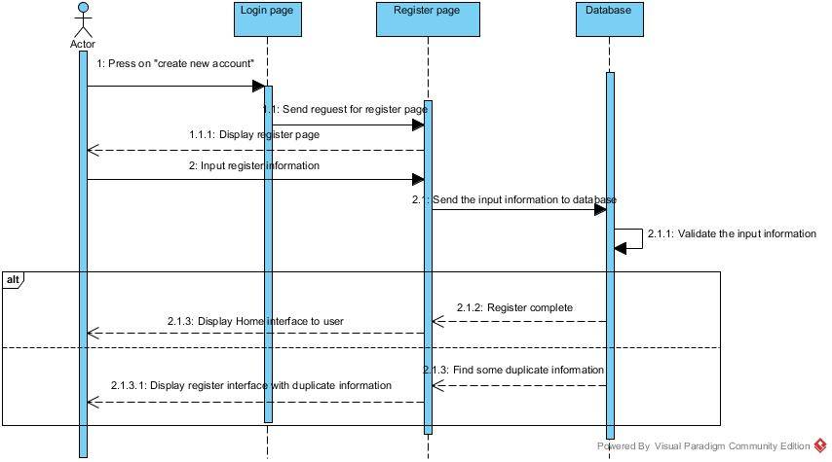

Chapter Six | User Interface Design

UI-01: Login Interface

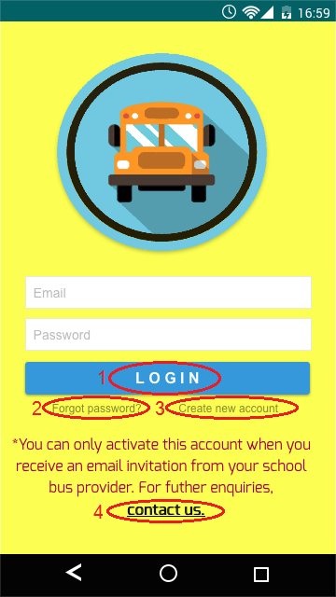

**Description:** This is the Login page of “School Bus Tracking And Attendance Checking” application. There are four function for users. They are “Login” function, user can login to application by authentication user system that check registered user’s information from the database (1). “Forgot password?” function, incase user cannot remember password to login to the application (2). “Create new account” function, this is the register function for school bus driver user.

UI-08: Reset password page

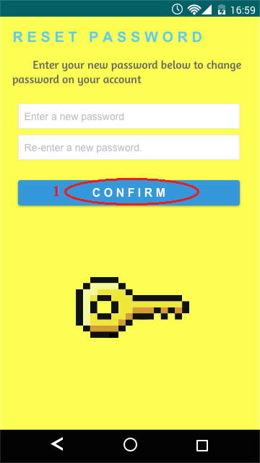

**Description:** This is reset password page of “School Bus Tracking And Attendance Checking” application. User can reset the old password

UI-07: Forget password

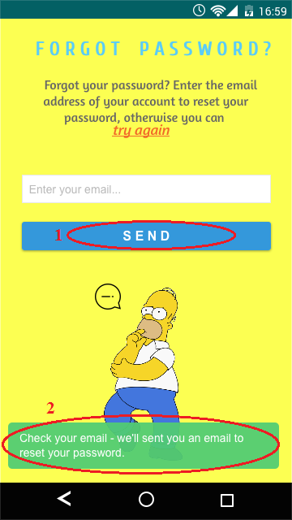

**Description:** This is forgot password page of “School Bus Tracking And Attendance Checking” application. User can get the passwords by input the user’s e-mail by press on “Send” function (1).After user press on send the pop-up mess will be shown on the screen (2).

UI-02: Register page for school bus driver

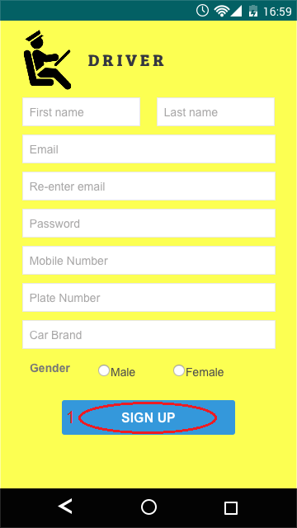

**Description:** This is register page for school bus driver of “School Bus Tracking And Attendance Checking” application. User can register to the application by fill his/her information to register as school bus driver. There is one function, “SIGN UP” function to register user to the application (1).

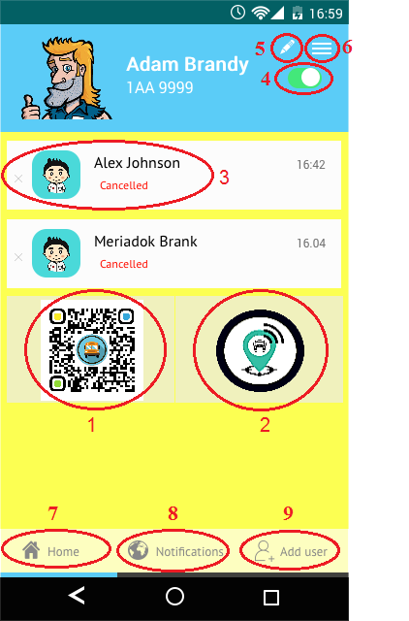

**Description:** This is school bus driver page of “School Bus Tracking And Attendance Checking” application. There are nine functions, there are “QR code scan” function, school bus driver can scan the children QR code to be the children attendance (1), “Route” function, school bus driver can view his position via google map api (2). “Message’ function, school bus driver can view the schedule that was cancel by parent (3). “Turn on/off” function, school bus driver can turn on or turn off the application by touch on this function (4). “Edit” function, school bus driver can edit his profile (5). “Children list”, school bus driver can view the children’s status (6). “Home” function, school bus driver can go to the school bus driver page by this function (7). “Notification” function, show the list of notification (8). “Add user” function, school bus driver can register the parents/children to the application (9).

UI-10: QR code scan page

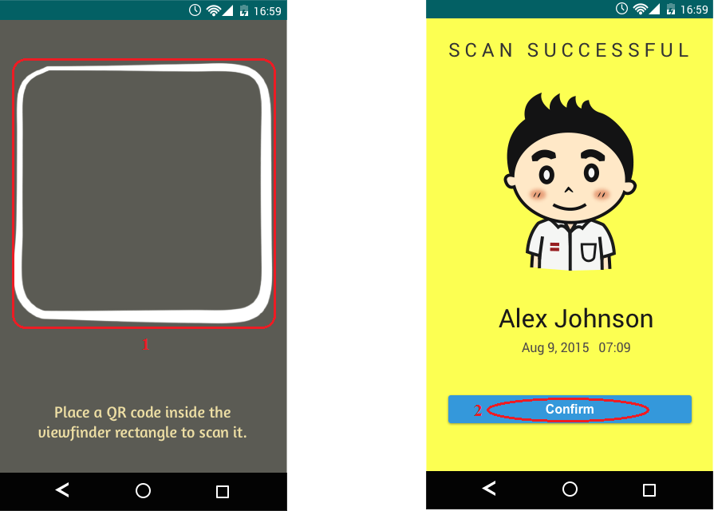

**Description:** This is QR code scan page of “School Bus Tracking And Attendance Checking” application. User as school bus driver can scan the children QR code (1).After QR code was scan school bus driver can press “Confirm” button to continue the scaming(2).

UI-05: Route page

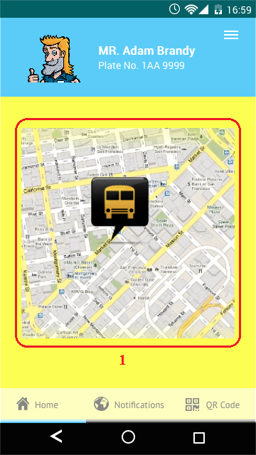

**Description:** This is route page of “School Bus Tracking And Attendance Checking” application. User can view the bus position via google map api on application (1).

UI-03: Register page for Parent/ Children

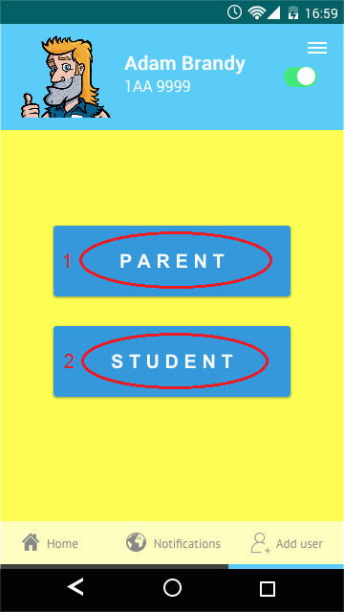

**Description:** This is register page for Parent/ Children of “School Bus Tracking And Attendance Checking” application. There are two function, they are PARENT (1) and STUDENT (2).

For function PARENT (1) register page for parents

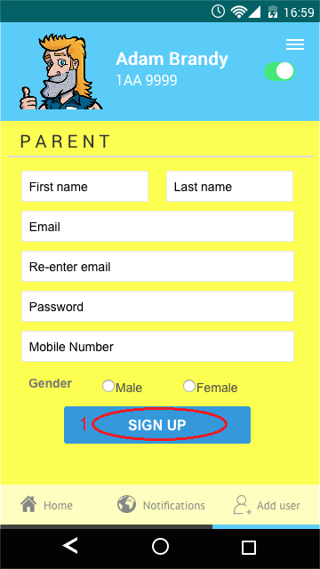

**Description:** This is register page for parent of “School Bus Tracking And Attendance Checking” application. User can register to the application by fill his/her information to register as parents. There is one function, “SIGN UP” function to register user to the application (1).

For function CHILDREN (2) register page for children.

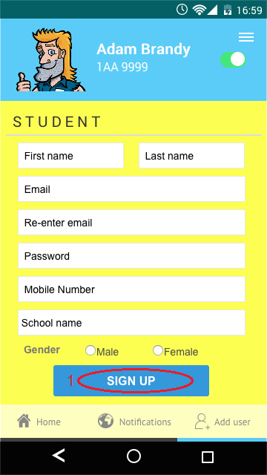

**Description:** This is register page for children of “School Bus Tracking And Attendance Checking” application. User can register to the application by fill his/her information to register as children. There is one function, “SIGN UP” function to register user to the application (1).

UI-05: Parent page

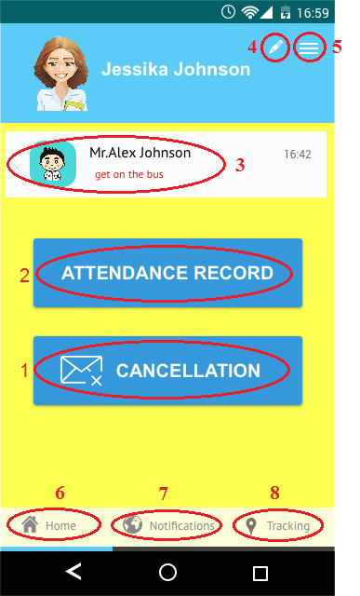

**Description:** This is parents page of “School Bus Tracking And Attendance Checking” application. There are eight functions, they are “CANCELLATION” function, parents can cancel the school bus schedule (1), “ATTENDANCE RECORD” function, parents can check their children attendance (2). “Message” function, the message will show when their children get on the bus or get off the bus (3). “Edit” function, parents can edit his profile by this function (4). “Children list”, parent can view their children status (5). “Home” function, parents can go to the parents page by this function (6). “Notification” function, the list of all notification (7). “Route” function, parents can view his position via google map api (8).

UI-06: Children interface

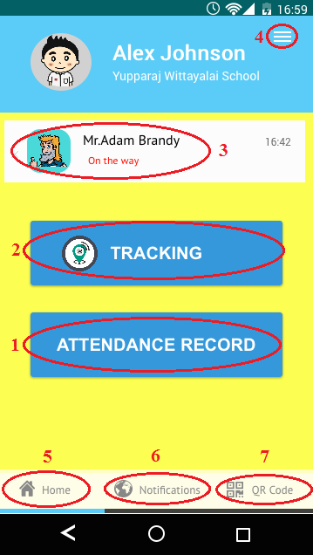

**Description:** This is children page of “School Bus Tracking And Attendance Checking” application. There are seven functions, they are “ATTENDANCE RECORD” function,เพื่อ(1), “ROUTE” function, parents can check their children attendance (2). “Message” function, the message will show when their children get on the bus or get off the bus (3). “Edit” function, school bus driver can edit his profit by this function (4). “Student list”, school bus driver can view the student who have to take in this bus (6). “Home” function, parents can go to the parents page by this function (7). “Notification” function, the list of all notification (7). “Route” function, parents can view his position via google map api (8).

UI-09: Contact us page

**Description:** This is forgot password page of “School Bus Tracking And Attendance Checking” application. User can reset the old password

UI-11:

UI-12:

UI-13:

UI-14:

Chapter Seven | Reference

[4] Google Maps Android API V2 <https://developers.google.com/maps/documentation/android/>

[14] [*QR Code features*](http://archive.is/20120915/http:/www.qrcode.com/en/qrfeature.html). (September, 2012). Denso-Wave. Retrieved May 10, 2015.

## [22] *The World's Most Popular Open Source Database*. (2014). [Online]. Retrieved June 7, 2015, from http://www.oracle.com/us/products/mysql/overview/index.html