**SCHOOL BUS TRACKING AND ATTENDANCE CHECKING**

Software Requirement Specification

**By**

Thitipun Tojareonvanich 552115018

Puttipong Tadang 552115054

Department of Software Engineering

College of Arts, Media, and Technology

Chiang Mai University

**Project Advisor**

Mr. Parinya Suwansrikham

**Document History**

|  |  |  |  |  |  |  |
| --- | --- | --- | --- | --- | --- | --- |
| Document Name | Version | Status | Date | Viewable | Editable | Responsible |
| School Bus Tracking and Attendance Checking-SoftwareRequirementSpecification-V.0.1.docx | 0.1 | Reviewed | 20/7/2015 | TT, PT, PS | TT, PT | TT, PT |

\***TT** = Thitipun Tojareonvanich, \***PT** = Puttipong Tadang, \***PS** = Parinya Suwansrikham

**Document Designed by**

Mr.Thitipun Tojareonvanich

Mr.Puttipong Tadang

**Table of Contents**

Chapter One | Introduction 3

1.1 Objective 3

1.2 Intended Audience and Reading Suggestions 3

1.2.1 Development team 3

- Reduce the development effort. 3

1.2.2 Customer 3

- Make an understanding between customer and application. 3

1.3 Project Scope 3

1.4.1 Acronyms 4

AD Activity Diagram 4

1.4.2 Definitions 4

Chapter Two | Overall Description 5

2.1 Product Perspective 5

“School Bus Tracking and Attendance Checking” is a mobile application for dealing with concern of children safety from their parent. Additionally, the accident of excessive speed maybe reduced by using this application. Moreover, it may be a useful tool for solving the problem about leaving children at school or school bus. Finally, this application may shorten the time that your children have to waiting for the school bus. 5

2.2 Project Features 5

According to our proposal, we separated into three progresses and five main features. 5

2.3 User Classes and Characteristics 5

2.4 Operation Environment 6

2.5 Design and Implementation Constrains 6

Chapter Three | Functional Requirement 7

3.1 User Requirement Specification 7

3.2 User Requirement Specification with the Software Requirement Specification 7

Chapter Four | Specific Requirement 13

4.1 Use Case Scenarios 13

4.1.1 Use Case Diagram (Entire System) 13

Chapter Five | Reference 49

Chapter One | Introduction

1.1 Objective

“School Bus Tracking and Attendance Checking” is an Android application that uses the location service of mobile phone to track the school bus and use the built-in camera to scan the QR code for checking the student attendance. The parent can track the school bus, can see their child attendance record, can get notification when their child enter or get off the bus, and can send the alert sound to alert the driver when they drive the school over the speed limit. For reduce the parent worrying about their children.

This project plan will complete as successfully as possible in spite of all risks. The project plan is use for track the progress and monitor whether the project follows the plan.

1.2 Intended Audience and Reading Suggestions

“School Bus Tracking and Attendance Checking” is a mobile application which uses Android OS. This application can help to improve the school bus system and reduce the parent worrying about their children. The parent can track the school bus position, can see their child attendance record, and get notification message when their child enter or get off the school bus. In addition, the driver can check the student attendance by scan the QR code and can get the alert sound when the driver drive the bus over the speed limit.

1.2.1 Development team

- Verifies and validate the work that associate with the document or not.

- Get the quality of the software product.

- Reduce the misunderstanding. Validate and specify all of the requirements and ensure the same understanding.

- Reduce the development effort.

1.2.2 Customer

- Help customer to understand the flow of application easily.

### - Make an understanding between customer and application.

1.3 Project Scope

School bus is popular of school transportation for the parent who have no time to take their children to school or the distance between houses and school is very far. School bus is the best way to reduce the time and transport cost for those family. School bus divided into two categories; 1.)The bus take control by school. 2.) The bus take control by private business.

The main features of “School Bus Tracking and Attendance Checking” as follows:

**Tracking system**

User can tracking the school bus position via google map api, the position provided by school bus driver phone’s.

**QR code scanning**

User can scanning the QR code via the built-in camera of their mobile phone. It took 1-2 second to read. Every time the QR code was scanning the time that QR code was scan will record it to the database.

**Attendance checking system**

User can checking their children's attendance, parents can check whether their children is on the bus or not.

**1.4 Acronyms and Definitions**

1.4.1 Acronyms

### AD Activity Diagram

SRS Software Requirement Specification

UC Use Case

URS User Requirement Specification

1.4.2 Definitions

**Interface** : Everything that designed into an information device which user may   
interact with including display screen, mouse, and keyboard. [1]

**Activity diagram** : Graphical representations of [workflows](https://en.wikipedia.org/wiki/Workflow) of stepwise activities and actions [[1]](https://en.wikipedia.org/wiki/Activity_diagram#cite_note-1) with support for choice, iteration and concurrency. In the [Unified Modeling Language](https://en.wikipedia.org/wiki/Unified_Modeling_Language), activity diagrams are intended to model both computational and organizational processes [2]

**Use case**                  : A use case is a methodology used in system analysis to identify, clarify, and organize system requirements. The use case is made up of a set of possible sequences of interactions between systems and users in a particular environment and related to a particular goal. It consists of a group of elements (for example, classes and interfaces) that can be used together in a way that will have an effect larger than the sum of the separate elements combined. The use case should contain all system activities that have significance to the users. A use case can be thought of as a collection of possible scenarios related to a particular goal, indeed, the use case and goal are sometimes considered to be synonymous. [3]

**Use case diagram**      : Simple representation of a user's interaction with the system that shows the relationship between the user and the different [use cases](https://en.wikipedia.org/wiki/Use_Case) in which the user is involved. [4]

# 

Chapter Two | Overall Description

2.1 Product Perspective

## “School Bus Tracking and Attendance Checking” is a mobile application for dealing with concern of children safety from their parent. Additionally, the accident of excessive speed maybe reduced by using this application. Moreover, it may be a useful tool for solving the problem about leaving children at school or school bus. Finally, this application may shorten the time that your children have to waiting for the school bus.

2.2 Project Features

## According to our proposal, we separated into three progresses and five main features.

**Member System**

- Registration system

- Login system

**Checking attendance system**

- QR code reader

- QR generator

- Checking attendance system

**Notifying System** ระบุว่าอะไร

- Parent notifying message system ระบุว่าอะไร

- Cancelling the school bus ride system

- Extra case message

**Tracking System**

- Tracking system

- Calculating approximate arrival time system

**Speed Control Alert System**

- Send alert message system

- Turn on system

- Turn off system

2.3 User Classes and Characteristics

The intended user separated in three types for our system

**2.3.1 School bus driver**

These are the general school bus driver who want to strengthen confidence to the parents with safety of the children.

**2.3.2 Parents**

       These are the parents who have no confident about the safety in school bus for their children.

**2.3.3 Children**

       These are the children who want to have the confident and safety in school bus system.

2.4 Operation Environment

* **Laptops**
* Lenovo Y5070

Processor: Intel(R) Core(TM) i7-4710HQ @ 2.50GHz

Memory: 8 GB DDR3

Graphics: NVIDIA GeForce GTX 860M

Operating System: Window 8.1 Professional

* Dell Inspiron N7420

Processor: Intel(R) Core(TM) i7-3612QM @ 2.10GHz

Memory: 8 GB DDR3

Graphics: NVIDIA GeForce GT 640M

Operating System: Windows 7 Ultimate

* **Internet**
* **Mobile phone**: Android Operating System
  + - AIS LAVA Iris 354

CPU: MT6572A Dual-core @ 1 GHz

Memory: 256 MB

Operating System: Android OS 4.2.2 (Jelly Bean)

2.5 Design and Implementation Constrains

- Overload data might affect to the application performance because the mobile phone have limited memory and slower CPUs than computer.

- Internet connection fail affect to the application.

Chapter Three | Functional Requirement

3.1 User Requirement Specification

**Feature #1 Member System**

URS-01 : School bus driver can register to the application.

URS-02 : School bus driver can register the parents to the application.

URS-03 : School bus driver can register the children to the application.

URS-04 : Parents can login to the application.

URS-05 : Parents can logout from the application.

URS-06 : Children can login to the application.

URS-07 : Children can logout from the application.

URS-08 : School bus driver user can login to the application.

URS-09 : School bus driver user can logout from the application.

**Feature #2 Checking attendance system**

URS-14 : Parents user can checking their children's attendance.

URS-16 : School bus driver can scan QR code for checking attendance.

**Feature #3 Notifying System**

URS-10 : Parents user can cancel the schedule.

URS-15 : Children user can receive the message when the bus are nearby

URS-18 : Parents user can receive the message when their children arrive the school or home.

URS-19 : School bus driver can send an extra case message.

**Feature #4 Tracking System**

URS-11 : Parents user can view their own route.

URS-12 : Children user can view their own route.

URS-13 : School bus driver user can view their own route.

**Feature #5 Speed Control Alert System**

URS-17 : School bus driver can receive alert message from the system when they drive over the speed limit.

URS-20 : School bus driver can turn on the application.

URS-21 : School bus driver can turn off the application.

3.2 User Requirement Specification with the Software Requirement Specification

URS-01 : Unregistered user can register as school bus driver.

SRS-01 : System shall connect to the database.

SRS-02 : System shall provide Register page for school bus driver.

SRS-03 : System shall register unregister user to database.

SRS-04 : System shall validate the input of user information.

SRS-14 : System shall generator the QR code.

SRS-25 : System shall show registration error messages.

SRS-31 : System shall provide main interface.

SRS-32 : System shall provide Register button.

SRS-33 : System shall provide Register button(For register the user data).

SRS-44 : System shall provide text field to user to input Email.

SRS-47 : System shall provide text field to user to input passwords.

SRS-48 : System shall provide Check box to user to select the gender.

SRS-49 : System shall provide text field to user to Phone number.

SRS-50 : System shall provide text field to user to input Firstname.

SRS-51 : System shall provide text field to user to input Lastname.

SRS-53 : System shall provide text field to user to input address.

SRS-54 : System shall provide text field to user to input telephone number.

SRS-55 : System shall provide button to attach the image.

SRS-57 : System shall provide text field to user to input car license plate.

SRS-58 : System shall provide select box to user to select the car brands .

SRS-59 : System shall provide select box to user to select the car colors .

SRS-63 : System shall provide “Register as School bus driver” button.

URS-02 : School bus driver can register unregister user as parent.

SRS-01 : System shall connect to the database.

SRS-03 : System shall register unregister user to database.

SRS-04 : System shall validate the input of user information.

SRS-14 : System shall generator the QR code.

SRS-25 : System shall show registration error messages.

SRS-31 : System shall provide main interface.

SRS-32 : System shall provide Register button.

SRS-33 : System shall provide Register button(For register the user data).

SRS-44 : System shall provide text field to user to input Email.

SRS-47 : System shall provide text field to user to input passwords.

SRS-48 : System shall provide Check box to user to select the gender.

SRS-49 : System shall provide text field to user to Phone number.

SRS-50 : System shall provide text field to user to input Firstname.

SRS-51 : System shall provide text field to user to input Lastname.

SRS-53 : System shall provide text field to user to input address.

SRS-54 : System shall provide text field to user to input telephone number.

SRS-60 : System shall provide Register page for Parents/Children.

SRS-61 : System shall provide select box to user to select the type of parents.

SRS-62 : System shall provide “Register as Parents/Children” button.

URS-03 : School bus driver can register unregister user as children.

SRS-01 : System shall connect to the database.

SRS-02 : System shall provide Register page for school bus driver.

SRS-03 : System shall register unregister user to database.

SRS-04 : System shall validate the input of user information.

SRS-14 : System shall generator the QR code.

SRS-25 : System shall show registration error messages.

SRS-31 : System shall provide main interface.

SRS-32 : System shall provide Register button.

SRS-33 : System shall provide Register button(For register the user data).

SRS-44 : System shall provide text field to user to input Email.

SRS-47 : System shall provide text field to user to input passwords.

SRS-48 : System shall provide Check box to user to select the gender.

SRS-49 : System shall provide text field to user to Phone number.

SRS-50 : System shall provide text field to user to input Firstname.

SRS-51 : System shall provide text field to user to input Lastname.

SRS-52 : System shall provide text field to user to input School Name.

SRS-53 : System shall provide text field to user to input address.

SRS-54 : System shall provide text field to user to input telephone number.

SRS-60 : System shall provide Register page for Children/Parents .

SRS-62 : System shall provide “Register as Parents/Children” button.

URS-04 : Parents can login to the application.

SRS-06 : System shall provide the login interface to user

SRS-07 : System shall validate username and passwords from user

SRS-08 : System shall show the login error message

SRS-10 : System shall provide login button to user.

SRS-26 : System shall provide parents interface.

SRS-64 : System shall provide text field to user to input Email(For login).

SRS-65 : System shall provide text field to user to input passwords(For login).

URS-05 : Parents can logout from the application.

SRS-09 : System shall provide logout button to user.

SRS-26 : System shall provide parents interface.

URS-06 : Children can login to the application.

SRS-06 : System shall provide the login interface to user

SRS-07 : System shall validate username and passwords from user

SRS-08 : System shall show the login error message

SRS-10 : System shall provide login button to user.

SRS-27 : System shall provide children interface.

SRS-64 : System shall provide text field to user to input Email(For login).

SRS-65 : System shall provide text field to user to input passwords(For login).

URS-07 : Children can logout from the application.

SRS-09 : System shall provide logout button to user.

SRS-27 : System shall provide children interface.

URS-08 : School bus driver can login to the application.

SRS-06 : System shall provide the login interface to user

SRS-10 : System shall provide login button to user.

SRS-28 : System shall provide school bus driver interface.

SRS-64 : System shall provide text field to user to input Email(For login).

SRS-65 : System shall provide text field to user to input passwords(For login).

URS-09 : School bus driver can logout from the application.

SRS-09 : System shall provide logout button to user.

SRS-28 : System shall provide school bus driver interface.

URS-10 : Parents can cancel the schedule.

SRS-21 : System shall cancel the school bus driver schedule.

SRS-25 : System shall provide parents interface.

SRS-34 : System shall provide the confirm pop-up.

SRS-35 : System shall provide the “Yes” button.

SRS-36 : System shall provide the “No” button.

.

URS-11 : Parents can view their own route.

SRS-11 : System shall provide a route interface to user.

SRS-12 : System shall provide a school bus position via google map api.

SRS-13 : System shall provide current location.

SRS-26 : System shall provide parents interface.

SRS-37 : System shall provide the “Close” button.

URS-12 : Children can view their own route.

SRS-11 : System shall provide a route interface to user.

SRS-12 : System shall provide a school bus position via google map api.

SRS-13 : System shall provide current location.

SRS-27 : System shall provide children interface.

SRS-37 : System shall provide the “Close” button.

URS-13 : School bus driver can view their own route.

SRS-11 : System shall provide a route interface to user.

SRS-12 : System shall provide a school bus position via google map api.

SRS-13 : System shall provide current location

SRS-28 : System shall provide school bus driver interface.

SRS-37 : System shall provide the “Close” button.

URS-14 : Parents can checking their children's attendance.

SRS-17 : System shall provide status checking for children.

SRS-26 : System shall provide parents interface.

SRS-37 : System shall provide the “Close” button.

SRS-38 : System shall provide “Check Attendance” button.

URS-15 : Children can receive the message when the bus are nearby.

SRS-17 : System shall send a message to children when the bus nearby

SRS-22 : System shall calculate approximate arrival time.

SRS-41 : System shall send the message to children.

SRS-45 : System shall provide “Message” button.

SRS-46 : System shall provide Message interface.

URS-16 : School bus driver can scan QR code for children attendance.

SRS-01 : System shall connect to the database.

SRS-15 : System shall provide a QR code scanning interface.

SRS-39 : System shall provide “Scan QR code” button.

SRS-40 : System shall send the message to parents.

SRS-66 : System shall show the error message when QR code cannot read.

URS-17 : School bus driver can receive alert message from the system when they drive over the speed limit.

SRS-24 : System shall send a speed alert message to school bus driver.

SRS-28 : System shall provide school bus driver interface.

SRS-45 : System shall provide “Message” button.

SRS-46 : System shall provide Message interface.

URS-18 : Parents can receive the message when their children arrive the school or home.

SRS-20 : System shall send a message to parents when their children arrive the school or home.

SRS-45 : System shall provide “Message” button.

SRS-46 : System shall provide Message interface.

URS-19 : School bus driver can send an extra case message.

SRS-23 : System shall send the message to the parent when have an extra case.

SRS-28 : System shall provide school bus driver interface.

SRS-34 : System shall provide the confirm pop-up.

SRS-35 : System shall provide the “Yes” button.

SRS-36 : System shall provide the “No” button.

SRS-37 : System shall provide the “Close” button.

SRS-40 : System shall send the message to parents.

SRS-43 : System shall provide extra case button.

SRS-45 : System shall provide “Message” button.

SRS-46 : System shall provide Message interface.

URS-20 : School bus driver can turn on the application.

SRS-01 : System shall connect to the database.

SRS-28 : System shall provide school bus driver interface.

SRS-29 : System shall turn on.

URS-21 : School bus driver can turn off the application.

SRS-01 : System shall connect to the database.

SRS-28 : System shall provide school bus driver interface.

SRS-30 : System shall turn off.

Chapter Four | Specific Requirement

4.1 Use Case Scenarios

4.1.1 Use Case Diagram (Entire System)

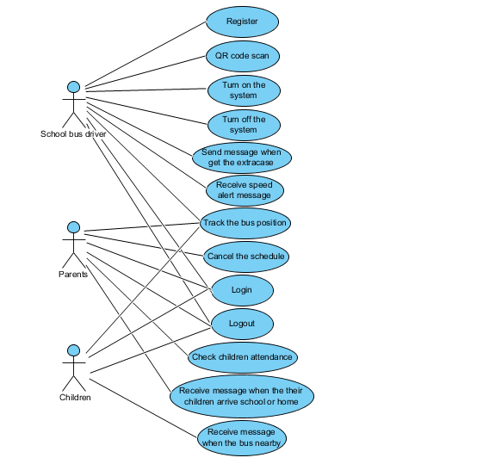

Figure 1 : Use Case Diagram of “School Bus Tracking and Attendance Checking” Entire System

4.1.2 Use case diagram (Member system)

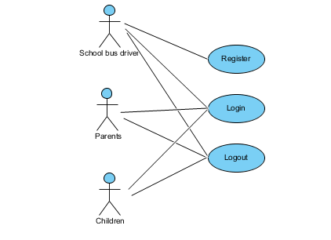

Figure 2 : Use Case Diagram of “School Bus Tracking and Attendance Checking” Member system

4.1.3 Use case diagram (Attendance checking system)

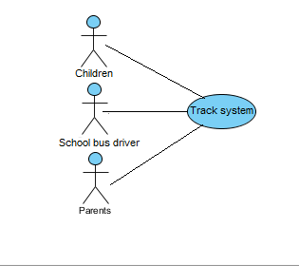

Figure 3 : Use Case Diagram of “School Bus Tracking and Attendance Checking” Attendance checking system

4.1.4 Use case diagram (Notify system)

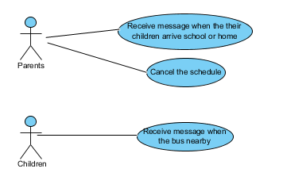

Figure 4 : Use Case Diagram of “School Bus Tracking and Attendance Checking” Notify system

4.1.5 Use case diagram (Alert system)

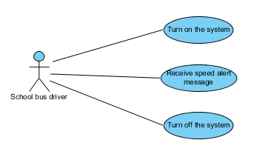

Figure 5 : Use Case Diagram of “School Bus Tracking and Attendance Checking” Alert system

**4.2 Use case description**

**4.2.1 Feature name : Register**

|  |  |  |  |  |
| --- | --- | --- | --- | --- |
| Use Case ID : | 1 | | | |
| Use Case Name : | Register as school bus driver. | | | |
| Create By : | Thitipun Tojaroenvanich | Last updated By : | |  |
| Date Created : | July 17, 2015 | Date Last Updated : | |  |
| Actor(s) : | Unregister user. | | | |
| Description : | Unregister users have to register for using application. | | | |
| Trigger : | Unregistered user is not registration yet and have to use School Bus Tracking and Attendance Checking. | | | |
| Precondition : | open application  Unregistered user is not registration. | | | |
| Normal Flow : | User | | System | |
| 2. Unregistered user press on the “Register as School bus driver” button.  4. Unregistered user input Email, password, First name, Last name, image, car information, phone number, telephone number and gender. Then, presses register button. | | 1. System provide main interface.  3. System provide register as School bus driver page.  5. System record the user information to database.  6. System login to application, go to school bus driver interface. | |
| Alternative Flow : | 1. System provide main interface.  1.1 If internet connection error, system cannot provide main interface and show error message “Internet connection fail”. Go back to normal flow step 1.  3. System provide School bus driver register page.  3.1 If internet connection error, system cannot provide School bus driver register page and show error message “Internet connection fail”. Go back to normal flow step 3.  4. Unregistered user input Email, password, First name, Last name, image, car information, phone number, telephone number and gender. Then, presses register button.  4.1 If unregistered user input invalid Email, password, phone number, or telephone. Unregistered user cannot register. Go back to normal flow step 4.  4.2 If internet connection error, unregistered user cannot register and show error message “Internet connection fail”. Go back to normal flow step 4.  5. Record the user information to database.  5.1 If internet connection error, system cannot record data to database and show error message “Internet connection fail”. Go back to normal flow step 4.  6. System login to application, go to school bus driver interface.  6.1 If internet connection error, system cannot login to the application and go to School bus driver interface and show error message “Internet connection fail”. Go back to normal flow step 4. | | | |
| Priority : | High | | | |
| Requirement : | SRS-01 : System shall connect to the database.  SRS-02 : System shall provide Register page for school bus driver.  SRS-03 : System shall register unregister user to database.  SRS-04 : System shall validate the input of user information.  SRS-14 : System shall generator the QR code.  SRS-25 : System shall show registration error messages.  SRS-31 : System shall provide main interface.  SRS-32 : System shall provide Register button.  SRS-33 : System shall provide Register button(For register the user data).  SRS-44 : System shall provide text field to user to input Email.  SRS-47 : System shall provide text field to user to input passwords.  SRS-48 : System shall provide Check box to user to select the gender.  SRS-49 : System shall provide text field to user to Phone number.  SRS-50 : System shall provide text field to user to input Firstname.  SRS-51 : System shall provide text field to user to input Lastname.  SRS-53 : System shall provide text field to user to input address.  SRS-54 : System shall provide text field to user to input telephone number.  SRS-55 : System shall provide button to attach the image.  SRS-57 : System shall provide text field to user to input car license plate.  SRS-58 : System shall provide select box to user to select the car brands .  SRS-59 : System shall provide select box to user to select the car colors .  SRS-63 : System shall provide “Register as School bus driver” button.  SRS-67 : System shall provide error message “Internet connection fail” when system cannot connect to the internet. | | | |
|
|
|

**Activity Diagram (AD-01 : Register as school bus driver)**

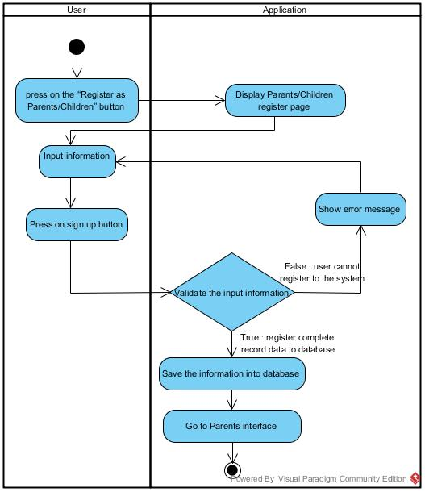

Figure 6 : Activity Diagram of “School Bus Tracking and Attendance Checking” Register as school bus driver

|  |  |  |  |  |
| --- | --- | --- | --- | --- |
| Use Case ID : | 2 | | | |
| Use Case Name : | School bus driver can register the parents to the application | | | |
| Create By : | Thitipun Tojaroenvanich | Last updated By : | |  |
| Date Created : | July 17, 2015 | Date Last Updated : | |  |
| Actor(s) : | Unregister user (Parents), School bus driver. | | | |
| Description : | Unregister users have to register for using application. | | | |
| Trigger : | Unregistered user is not registration yet and have to use School Bus Tracking and Attendance Checking. | | | |
| Precondition : | open application  Unregistered user is not registration. | | | |
| Normal Flow : | User | | System | |
| 2. Unregistered user press on the “Register as Parents/Children” button.  4. Unregistered user input Email, password, First name, Last name, phone number, telephone number, relationship and gender. Then, presses register button. | | 1. System provide main interface.  3. System provide register as Parents/Children page.  5. System record the user information to database.  6. System login to application, go to Parents interface. | |
| Alternative Flow : | 1. System provide main interface.  1.1 If internet connection error, system cannot provide main interface and show error message “Internet connection fail”. Go back to normal flow step 1.  3. System provide Parents/Children register page.  3.1 If internet connection error, system cannot provide register interface and show error message “Internet connection fail”. Go back to normal flow step 3.  4. Unregistered user input Email, password, First name, Last name, image, car information, phone number, telephone number and gender. Then, presses register button.  4.1 If unregistered user input invalid Email, password, phone number, or telephone. Unregistered user cannot register. Go back to normal flow step 4.  4.2 If internet connection error, unregistered user cannot register and show error message “Internet connection fail”. Go back to normal flow step 4.  5. Record the user information to database.  5.1 If internet connection error, system cannot record data to database and show error message “Internet connection fail”. Go back to normal flow step 4.  6. System login to application, go to school bus driver interface.  6.1 If internet connection error, system cannot login to the application and go to Parents interface and show error message “Internet connection fail”. Go back to normal flow step 4. | | | |
| Priority : | High | | | |
| Requirement : | SRS-01 : System shall connect to the database.  SRS-03 : System shall register unregister user to database.  SRS-04 : System shall validate the input of user information.  SRS-14 : System shall generator the QR code.  SRS-25 : System shall show registration error messages.  SRS-31 : System shall provide main interface.  SRS-32 : System shall provide Register button.  SRS-33 : System shall provide Register button(For register the user data).  SRS-44 : System shall provide text field to user to input Email.  SRS-47 : System shall provide text field to user to input passwords.  SRS-48 : System shall provide Check box to user to select the gender.  SRS-49 : System shall provide text field to user to Phone number.  SRS-50 : System shall provide text field to user to input Firstname.  SRS-51 : System shall provide text field to user to input Lastname.  SRS-53 : System shall provide text field to user to input address.  SRS-54 : System shall provide text field to user to input telephone number.  SRS-60 : System shall provide Register page for Parents/Children.  SRS-61 : System shall provide select box to user to select the type of parents.  SRS-62 : System shall provide “Register as Parents/Children” button.  SRS-67 : System shall provide error message “Internet connection fail” when system cannot connect to the internet. | | | |
|
|
|

**Activity Diagram (AD-02: Register as Parents)**



Figure 7 : Activity Diagram of “School Bus Tracking and Attendance Checking” Register as Parents

|  |  |  |  |  |
| --- | --- | --- | --- | --- |
| Use Case ID : | 3 | | | |
| Use Case Name : | School bus driver can register the children to the application | | | |
| Create By : | Thitipun Tojaroenvanich | Last updated By : | |  |
| Date Created : | July 17, 2015 | Date Last Updated : | |  |
| Actor(s) : | Unregister user (Children), School bus driver. | | | |
| Description : | Unregister users have to register for using application. | | | |
| Trigger : | Unregistered user is not registration yet and have to use School Bus Tracking and Attendance Checking. | | | |
| Precondition : | open application  Unregistered user is not registration. | | | |
| Normal Flow : | User | | System | |
| 2. Unregistered user press on the “Register as Parents/Children” button.  4. Unregistered user input Email, password, First name, Last name, phone number, telephone number, school name and gender. Then, presses register button. | | 1. System provide main interface.  3. System provide register as Parents/Children page.  5. System record the user information to database.  6. System login to application, go to Children interface. | |
| Alternative Flow : | 1. System provide main interface.  1.1 If internet connection error, system cannot provide main interface and show error message “Internet connection fail”. Go back to normal flow step 1.  3. System provide Parents/Children register page.  3.1 If internet connection error, system cannot provide register interface and show error message “Internet connection fail”. Go back to normal flow step 3.  4. Unregistered user input Email, password, First name, Last name, image, car information, phone number, telephone number and gender. Then, presses register button.  4.1 If unregistered user input invalid Email, password, phone number, or telephone. Unregistered user cannot register. Go back to normal flow step 4.  4.2 If internet connection error, unregistered user cannot register.  5. Record the user information to database and show error message “Internet connection fail”. Go back to normal for step .4  5.1 If internet connection error, system cannot record data to database.  6. System login to application, go to school bus driver interface and show error message “Internet connection fail”. Go back to normal for step 4.  6.1 If internet connection error, system cannot login to the application and go to Children interface and show error message “Internet connection fail”. Go back to normal for step 4. | | | |
| Priority : | High | | | |
| Requirement : | SRS-01 : System shall connect to the database.  SRS-02 : System shall provide Register page for school bus driver.  SRS-03 : System shall register unregister user to database.  SRS-04 : System shall validate the input of user information.  SRS-14 : System shall generator the QR code.  SRS-25 : System shall show registration error messages.  SRS-31 : System shall provide main interface.  SRS-32 : System shall provide Register button.  SRS-33 : System shall provide Register button(For register the user data).  SRS-44 : System shall provide text field to user to input Email.  SRS-47 : System shall provide text field to user to input passwords.  SRS-48 : System shall provide Check box to user to select the gender.  SRS-49 : System shall provide text field to user to Phone number.  SRS-50 : System shall provide text field to user to input Firstname.  SRS-51 : System shall provide text field to user to input Lastname.  SRS-52 : System shall provide text field to user to input School Name.  SRS-53 : System shall provide text field to user to input address.  SRS-54 : System shall provide text field to user to input telephone number.  SRS-60 : System shall provide Register page for Children/Parents .  SRS-62 : System shall provide “Register as Parents/Children” button.  SRS-67 : System shall provide error message “Internet connection fail” when system cannot connect to the internet. | | | |
|
|
|

**Activity Diagram (AD-03: Register as Children)**

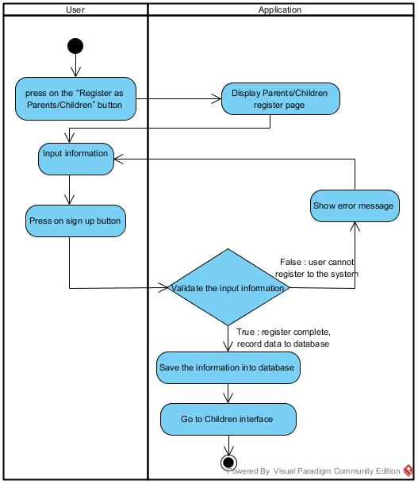

Figure 8 : Activity Diagram of “School Bus Tracking and Attendance Checking” Register as Children

|  |  |  |  |  |
| --- | --- | --- | --- | --- |
| Use Case ID : | 4 | | | |
| Use Case Name : | Login | | | |
| Create By : | Thitipun Tojaroenvanich | Last updated By : | |  |
| Date Created : | July 17, 2015 | Date Last Updated : | |  |
| Actor(s) : | School bus driver, Parents, Children | | | |
| Description : | Registered users have to enter e-mail, user, password and login to application. | | | |
| Trigger : | Registered user has to use School Bus Tracking and Attendance Checking. | | | |
| Precondition : | User already registered and must remember username and password. | | | |
| Normal Flow : | User | | System | |
| 2. Press “Login” button.  4. Registered user input Email and password. Then presses login button. | | 1. System show main interface.  3. System show Login interface.  5. System login to application, go to their interface. | |
| Alternative Flow : | 1. System show main interface.  1.1 If internet connection error, System cannot show main interface and show error message “Internet connection fail”. Go back to normal for step 1.  3. System show Login interface.  3.1 If internet connection error, System cannot show login interface and show error message “Internet connection fail”. Go back to normal for step 3.  4. Registered user input Email and password. Then presses login button.  4.1 If Registered user input invalid Email or password, registered user cannot login to application and warning message is shown. Go back to normal flow step 4.  4.2 If internet connection error, registered user cannot login and show error message “Internet connection fail”.  Go back to normal for step 4.  5. System login to application, go to their interface.  5.1 If internet connection error, System cannot login to the system and cannot go to their interface and show error message “Internet connection fail”. Go back to normal for step 4. | | | |
| Priority : | High | | | |
| Requirement : | SRS-06 : System shall provide the login interface to user  SRS-07 : System shall validate username and passwords from user  SRS-08 : System shall show the login error message  SRS-10 : System shall provide login button to user.  SRS-26 : System shall provide parents interface.  SRS-27 : System shall provide children interface.  SRS-28 : System shall provide school bus driver interface.  SRS-64 : System shall provide text field to user to input Email(For login).  SRS-65 : System shall provide text field to user to input passwords(For login).  SRS-67 : System shall provide error message “Internet connection fail” when system cannot connect to the internet. | | | |
|
|
|

**Activity Diagram (AD-04 : Login)**

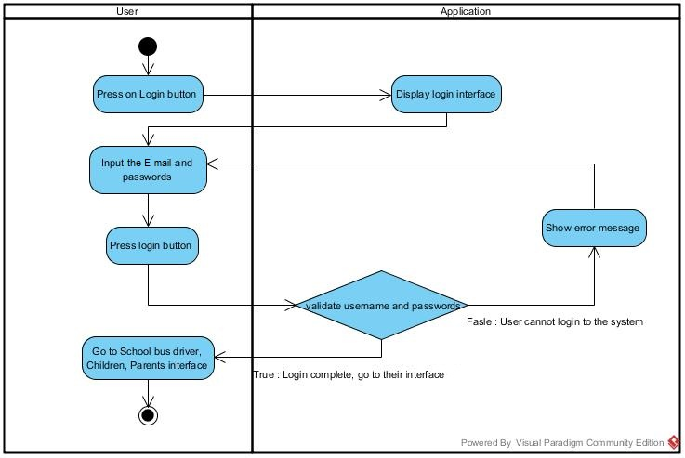

Figure 9 : Activity Diagram of “School Bus Tracking and Attendance Checking” Login

|  |  |  |  |  |
| --- | --- | --- | --- | --- |
| Use Case ID : | 5 | | | |
| Use Case Name : | Logout | | | |
| Create By : | Thitipun Tojaroenvanich | Last updated By : | |  |
| Date Created : | July 17, 2015 | Date Last Updated : | |  |
| Actor(s) : | School bus driver, Parents, Children. | | | |
| Description : | Registered users have to logout from application. | | | |
| Trigger : | Registered user has to logout from School Bus Tracking and Attendance Checking. | | | |
| Precondition : | User already login to the application. | | | |
| Normal Flow : | User | | System | |
| 2. Press “logout” button.  3. Registered user presses logout button. | | 1. System show School bus driver, Parents, Children interface. | |
| Alternative Flow : | 1. Registered user presses logout button.  1.1 If internet connection error, registered user cannot logout and show error message “Internet connection fail”. Go back to normal flow step 1. | | | |
| Priority : | High | | | |
| Requirement : | SRS-09 : System shall provide logout button to user.  SRS-26 : System shall provide parents interface.  SRS-27 : System shall provide children interface.  SRS-28 : System shall provide school bus driver interface.  SRS-67 : System shall provide error message “Internet connection fail” when system cannot connect to the internet. | | | |
|
|
|

**Activity Diagram (AD-05 : Logout)**

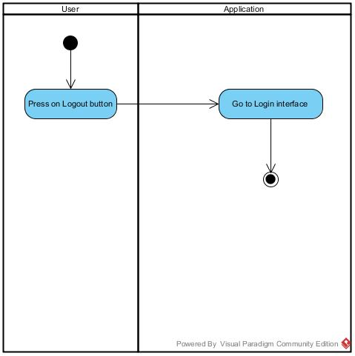

Figure 10 : Activity Diagram of “School Bus Tracking and Attendance Checking” Logout

**4.2.2 Feature name : Attendance Checking**

|  |  |  |  |  |
| --- | --- | --- | --- | --- |
| Use Case ID : | 6 | | | |
| Use Case Name : | Scan QR code for children attendance. | | | |
| Create By : | Thitipun Tojaroenvanich | Last Update By : | |  |
| Date Created : | July 17, 2015 | Last Revision By : | |  |
| Actor(s) : | School bus driver. | | | |
| Description : | School bus driver can scan the children QR code by built in camera. | | | |
| Trigger : | School bus driver can scan the children QR code by built in camera and record the data to database | | | |
| Precondition : | User already login to the application. | | | |
| Normal Flow : | User | | System | |
| 2. Press Scan QR code button.  4. School bus driver scan the children QR code. | | 1. System show School bus driver interface.  3. System open built-in camera.  5. System identify the QR code  6. Record the data (The time that QR code was scan) to database.  7. System send the message their parents. | |
| Alternative Flow : | 1. System show School bus driver interface.  1.1 If internet connection error, system cannot display the School bus driver interface and show error message “Internet connection fail”. Go back to normal flow step 1.  5. System identify the QR code  5.1 If system cannot read the QR code, system will show the error message and go back to normal flow step 3.  6. Record the data (time that QR code was scan) to database.  6.1 If internet connection error, system cannot record the data and show error message “Internet connection fail”. Go back to normal for step 3.  7.System send the message the their parents  7.1 If internet connection error, system cannot send the message to their parents. Go back to normal flow step 7. | | | |
| Priority : | High | | | |
| Requirement : | SRS-01 : System shall connect to the database.  SRS-15 : System shall provide a QR code scanning interface.  SRS-16 : System shall scanning the QR code to check children attendance.  SRS-39 : System shall provide “Scan QR code” button.  SRS-40 : System shall send the message to parents.  SRS-66 : System shall show the error message when QR code cannot read.  SRS-67 : System shall provide error message “Internet connection fail” when system cannot connect to the internet. | | | |
|
|
|

**Activity Diagram (AD-06 : Scan QR code for children attendance.)**

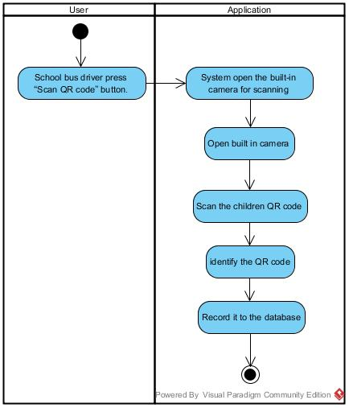

Figure 11 : Activity Diagram of “School Bus Tracking and Attendance Checking” Scan QR code for children attendance.

|  |  |  |  |  |
| --- | --- | --- | --- | --- |
| Use Case ID : | 7 | | | |
| Use Case Name : | Checking the children attendance | | | |
| Create By : | Thitipun Tojaroenvanich |  | |  |
| Date Created : | July 17, 2015 |  | |  |
| Actor(s) : | Parents. | | | |
| Description : | Parents can check their children's attendance. | | | |
| Trigger : | Registered user (Parents) press on Attendance button and see their children attendance on School Bus Tracking and Attendance Checking application. | | | |
| Precondition : | User already login to the application. | | | |
| Normal Flow : | User | | System | |
| 2. Press on Attendance button. | | 1. System show parents interface.  3. System show their children status. | |
| Alternative Flow : | 3. System show their children status.  3.1 If internet connection error, system cannot provide the children status user and show error message “Internet connection fail”. Go back to normal flow step 1. | | | |
| Priority : | High | | | |
| Requirement : | SRS-17 : System shall provide status checking for children.  SRS-25 : System shall provide parents interface.  SRS-37 : System shall provide the “Close” button.  SRS-38 : System shall provide “Check Attendance” button.  SRS-67 : System shall provide error message “Internet connection fail” when system cannot connect to the internet. | | | |
|
|
|

**Activity Diagram (AD-07 : Checking the children attendance)**

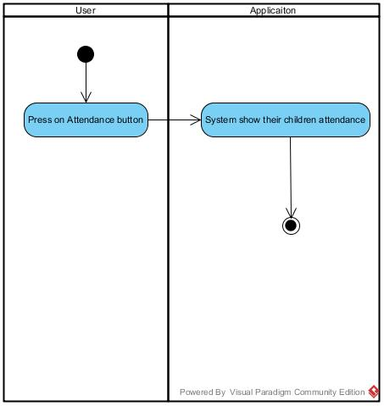

Figure 12 : Activity Diagram of “School Bus Tracking and Attendance Checking” Checking the children attendance

**4.2.3 Feature name : Notify system**

|  |  |  |  |  |
| --- | --- | --- | --- | --- |
| Use Case ID : | 8 | | | |
| Use Case Name : | Receive the message when the bus are nearby. | | | |
| Create By : | Thitipun Tojaroenvanich |  | |  |
| Date Created : | July 17, 2015 |  | |  |
| Actor(s) : | Children, School bus driver. | | | |
| Description : | Children can receive the message when the bus come nearby the children. | | | |
| Trigger : | School Bus Tracking and Attendance Checking will send the message to children when the bus come nearby automatically. | | | |
| Precondition : | User already login to the application. | | | |
| Normal Flow : | User | | System | |
| 1. The bus come nearby the children position.  3. Children press on message button.  5. Children receive the message. | | 2. System send the message to children.  4. System show the message interface. | |
| Alternative Flow : | 2. System send the message to children.  2.1 If internet connection error, system cannot send the message to children. Go back to normal flow step 2.  4. System show the message interface  4.1 If internet connection error, system cannot show message interface to children and show error message “Internet connection fail”. Go back to normal flow step 4.  5.Registered user(Children) receive the message  5.1 If internet connection error, children cannot receive message to children. Go back to normal flow step 4. | | | |
| Priority : | High | | | |
| Requirement : | SRS-17 : System shall send a message to children when the bus nearby  SRS-22 : System shall calculate approximate arrival time.  SRS-41 : System shall send the message to children.  SRS-45 : System shall provide “Message” button.  SRS-46 : System shall provide Message interface.  SRS-67 : System shall provide error message “Internet connection fail” when system cannot connect to the internet. | | | |
|
|
|

**Activity Diagram (AD-08 : Receive the message when the bus are nearby.)**

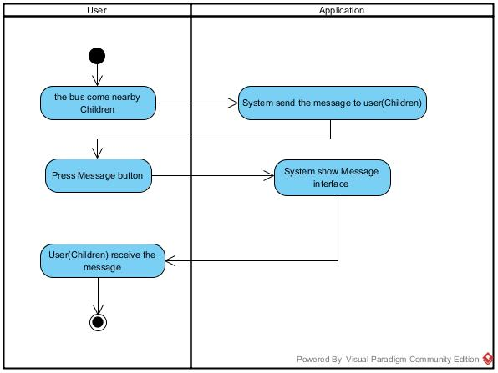

Figure 13 : Activity Diagram of “School Bus Tracking and Attendance Checking” Receive the message when the bus are nearby

|  |  |  |  |  |
| --- | --- | --- | --- | --- |
| Use Case ID : | 9 | | | |
| Use Case Name : | Receive the message when their children arrive the school or home. | | | |
| Create By : | Thitipun Tojaroenvanich | Last Update By : | |  |
| Date Created : | July 18, 2015 | Last Revision By : | |  |
| Actor(s) : | Parents. | | | |
| Description : | Parents can receive alert message when their children arrive the school or home. | | | |
| Trigger : | School Bus Tracking and Attendance Checking will send the message to parents when their children arrive the school or home automatically. | | | |
| Precondition : | User already login to the application. | | | |
| Normal Flow : | User | | System | |
| 1. Their children arrive school/home.  2. School bus driver scan children QR code.  4. Parent press notification button.  6. Parents read the message. | | 3. System send message to their parents.  5. System show notification page. | |
| Alternative Flow : | 2. School bus driver scan children QR code.  2.1 If system cannot scan the QR code, system will show the error message. Go back to normal flow step 2.  3. System send message to their parents.  3.1If internet connection error, system cannot send the message to their parents. Go back to normal flow step 3.  5. System show notification page.  5.1 If internet connection error, system cannot show message interface and show error message “Internet connection fail”. Go back to normal for step 5. | | | |
| Priority : | Medium | | | |
| Requirement : | SRS-15 : System shall provide a QR code scanning interface.  SRS-16 : System shall scanning the QR code to check children attendance.  SRS-19 : System shall send a message to parents when their children arrive the home.  SRS-20 : System shall send a message to parents when their children arrive the school.  SRS-45 : System shall provide “Message” button.  SRS-46 : System shall provide Message interface.  SRS-67 : System shall provide error message “Internet connection fail” when system cannot connect to the internet. | | | |
|
|
|

**Activity Diagram (AD-09 : Receive the message when their children arrive the school or home.)**

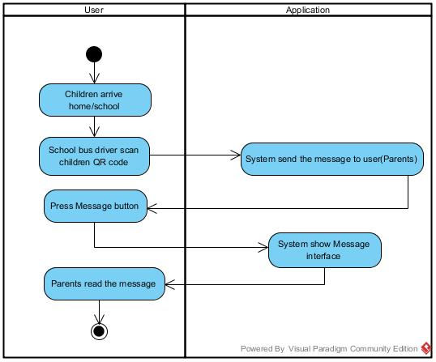

Figure 14 Activity Diagram of “School Bus Tracking and Attendance Checking” Receive the message when their children arrive the school or home

|  |  |  |  |  |
| --- | --- | --- | --- | --- |
| Use Case ID : | 10 | | | |
| Use Case Name : | Cancel Schedule. | | | |
| Create By : | Thitipun Tojaroenvanich | Last Update By : | |  |
| Date Created : | July 20, 2015 | Last Revision By : | |  |
| Actor(s) : | Parents. | | | |
| Description : | Parents can cancel the school bus schedule. | | | |
| Trigger : | School Bus Tracking and Attendance Checking will cancel the school bus schedule automatically when user press on cancel schedule and press on “yes” button on confirm pop-up. | | | |
| Precondition : | User already login to the application. | | | |
| Normal Flow : | User | | System | |
| 2. User press on the “Cancel schedule” button.  4. User press on “Yes” button. | | 1. System provide parents interface.  3. System provide confirm pop-up  5. System cancel the school bus schedule.  6. System show Parents interface. | |
| Alternative Flow : | 1. System provide parents page.  1.1 If internet connection error, system cannot display the parents interface and show error message “Internet connection fail”. Go back to normal for step 1.  3. System provide confirm pop-up.  3.1 If internet connection error, system cannot display the confirm pop-up and show error message “Internet connection fail”. Go back to normal for step 1.  4. User press on “Yes” button.  4.1 If internet press on “No” button, system display the parents interface. Go back to normal flow step 1.  6. System show Parents interface.  6.1 If internet connection error, system cannot display the Parents interface and show error message “Internet connection fail”. Go back to normal for step 1. | | | |
| Priority : | Medium | | | |
| Requirement : | SRS-21 : System shall cancel the school bus driver schedule.  SRS-25 : System shall provide parents interface.  SRS-34 : System shall provide the confirm pop-up.  SRS-35 : System shall provide the “Yes” button.  SRS-36 : System shall provide the “No” button.  SRS-67 : System shall provide error message “Internet connection fail” when system cannot connect to the internet. | | | |
|
|
|

**Activity Diagram (AD-10 : Cancel Schedule.)**

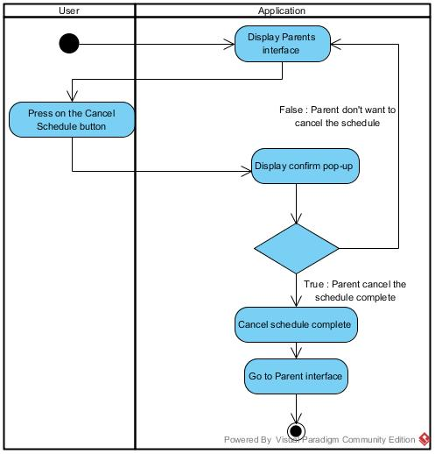

Figure 15 : Activity Diagram of “School Bus Tracking and Attendance Checking” Cancel Schedule

|  |  |  |  |  |
| --- | --- | --- | --- | --- |
| Use Case ID : | 11 | | | |
| Use Case Name : | Extra case message. | | | |
| Create By : | Thitipun Tojaroenvanich |  | |  |
| Date Created : | July 17, 2015 |  | |  |
| Actor(s) : | School bus driver. | | | |
| Description : | School bus driver can send the message to the parents when have a extra cases. | | | |
| Trigger : | School Bus Tracking and Attendance Checking can send the message to the parent when have an extra cases. | | | |
| Precondition : | User already login to the application. | | | |
| Normal Flow : | User | | System | |
| 2. School bus driver press on “Extra case” button.  4. School bus driver press on the wanted case.  6. School bus driver press on “Yes” button. | | 1. System show the school bus driver interface.  3. System show type of the case interface to user.  5. System show the confirm pop-up.  7. System send selected case as message to parent. | |
| Alternative Flow : | 1. System provide the school driver interface.  1.1 If internet connection error, school bus driver interface cannot be shown and show error message “Internet connection fail”. Go back to normal for step 1.  3. System show type of case to user.  3.1 If internet connection error, system cannot show type of the case to user and show error message “Internet connection fail”. Go back to normal for step 1.  5. System show the confirm pop-up.  5.1 If internet connection error, system cannot show the confirm pop-up and show error message “Internet connection fail”. Go back to normal for step 1.  5.2 If user press on “No” button, system will go back to the type of the case interface. Go back to normal flow step 3.  7. System send selected case as message to parent.  7.1 If internet connection error, system cannot send a message to parents. | | | |
| Priority : | Medium | | | |
| Requirement : | SRS-23 : System shall send the message to the parent when have an extra case.  SRS-28 : System shall provide school bus driver interface.  SRS-34 : System shall provide the confirm pop-up.  SRS-35 : System shall provide the “Yes” button.  SRS-36 : System shall provide the “No” button.  SRS-37 : System shall provide the “Close” button.  SRS-40 : System shall send the message to parents.  SRS-43 : System shall provide extra case button.  SRS-45 : System shall provide “Message” button.  SRS-46 : System shall provide Message interface.  SRS-67 : System shall provide error message “Internet connection fail” when system cannot connect to the internet. | | | |
|
|
|

**Activity Diagram (AD-011 : Extra case message.)**

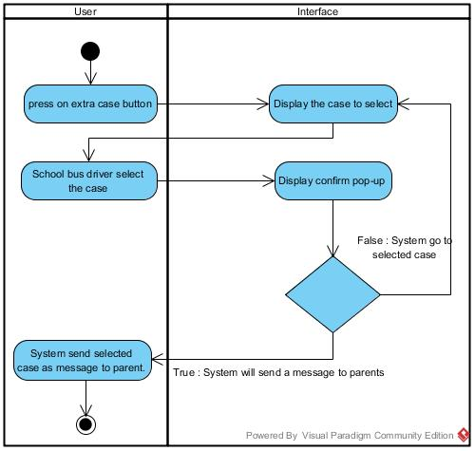

Figure 16 : “School Bus Tracking and Attendance Checking” Extra case message

**4.2.4 Feature name : Tracking system**

|  |  |  |  |  |
| --- | --- | --- | --- | --- |
| Use Case ID : | 12 | | | |
| Use Case Name : | View the route | | | |
| Create By : | Thitipun Tojaroenvanich |  | |  |
| Date Created : | July 17, 2015 |  | |  |
| Actor(s) : | School bus driver, Parents, Children, Google map api. | | | |
| Description : | Register users view the route via google map api. | | | |
| Trigger : | Registered user press tracking button and view their route on School Bus Tracking and Attendance Checking application. | | | |
| Precondition : | User already login to the application. | | | |
| Normal Flow : | User | | System | |
| 2. School bus driver, Parents, Children press on “Tracking” button. | | 1. System show School bus driver, Parents, Children interface.  3. System show the route via google map api. | |
| Alternative Flow : | 3. System show the route via google map api.  3.1 If internet connection error, system cannot provide the google map api to user and show error message “Internet connection fail”. Go back to normal flow step 1. | | | |
| Priority : | High | | | |
| Requirement : | SRS-11 : System shall provide a route interface to user.  SRS-12 : System shall provide a school bus position via google map api.  SRS-13 : System shall provide current location.  SRS-26 : System shall provide parents interface.  SRS-27 : System shall provide children interface.  SRS-28 : System shall provide school bus driver interface  SRS-37 : System shall provide the “Close” button.  SRS-67 : System shall provide error message “Internet connection fail” when system cannot connect to the internet. | | | |
|
|
|

**Activity Diagram (AD-12 : View the route)**

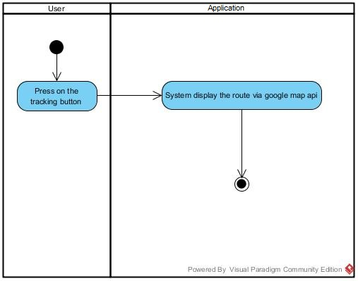

Figure 17 : “School Bus Tracking and Attendance Checking” View the route

**4.2.5 Feature name : Alert system**

|  |  |  |  |  |
| --- | --- | --- | --- | --- |
| Use Case ID : | 13 | | | |
| Use Case Name : | Speeding message. | | | |
| Create By : | Thitipun Tojaroenvanich | Last Update By : | |  |
| Date Created : | July 17, 2015 | Last Revision By : | |  |
| Actor(s) : | School bus driver. | | | |
| Description : | School bus driver can receive alert message when the speed are more than the speed limit. | | | |
| Trigger : | School Bus Tracking and Attendance Checking will send the alert message to School bus driver when the speed are more than the speeding automatically. | | | |
| Precondition : | User already login to the application. | | | |
| Normal Flow : | User | | System | |
| 1. School bus driver drive the bus more than speeding.  3. School bus driver receive the alert message. | | 2. System send alert message to school bus driver. | |
| Alternative Flow : | 2. System send alert message to school bus driver.  2.1 If internet connection error, system cannot send the alert message to school bus driver and show error message “Internet connection fail”. Go back to normal flow step 2.  3. School bus driver receive the alert message.  3.1 If internet connection error, school bus driver cannot receive the alert message and show error message “Internet connection fail”. Go back to normal flow step 3. | | | |
| Exception : | - | | | |
| Requirement : | SRS-24 : System shall send a speed alert message to school bus driver.  SRS-28 : System shall provide school bus driver interface.  SRS-45 : System shall provide “Message” button.  SRS-46 : System shall provide Message interface.  SRS-67 : System shall provide error message “Internet connection fail” when system cannot connect to the internet. | | | |
|
|
|

**Activity Diagram (AD-13 : Speed alert message**.**)**

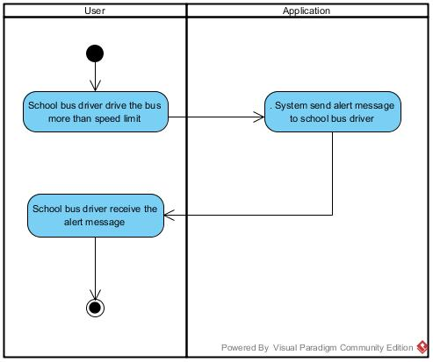

Figure 18 : “School Bus Tracking and Attendance Checking” Speed alert message

|  |  |  |  |  |
| --- | --- | --- | --- | --- |
| Use Case ID : | 14 | | | |
| Use Case Name : | Turn on application. | | | |
| Create By : | Thitipun Tojaroenvanich | Last Update By : | |  |
| Date Created : | July 17, 2015 | Last Revision By : | |  |
| Actor(s) : | School bus driver. | | | |
| Description : | School bus driver can turn on the application. | | | |
| Trigger : | School Bus Tracking and Attendance Checking can be turn on by school bus driver press on start button. | | | |
| Precondition : | User already login to the application. | | | |
| Normal Flow : | User | | System | |
| 2. School bus driver press on start button. | | 1. System provide the school bus driver interface.  3. Start all of activity in application. | |
| Alternative Flow : | 1. System provide the school driver interface.  1.1 If internet connection error, system cannot display School bus driver and show error message “Internet connection fail”. Go back to normal flow step 1.  3. Start all of activity in application.  3.1 If internet connection error, System cannot start all of activity and show error message “Internet connection fail”. Go back to normal flow step 3. | | | |
| Priority : | High | | | |
| Requirement : | SRS-01 : System shall connect to the database.  SRS-28 : System shall provide school bus driver interface.  SRS-29 : System shall turn on.  SRS-67 : System shall provide error message “Internet connection fail” when system cannot connect to the internet. | | | |
|
|
|

**Activity Diagram (AD-14 : Turn on application**.**)**

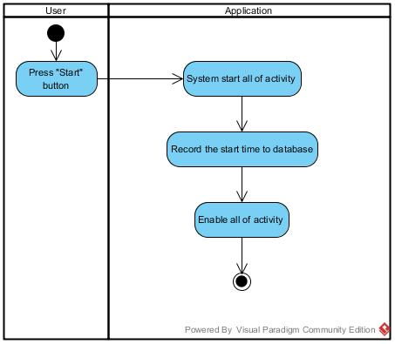

Figure 19 : “School Bus Tracking and Attendance Checking” Turn on application

|  |  |  |  |  |
| --- | --- | --- | --- | --- |
| Use Case ID : | 15 | | | |
| Use Case Name : | Turn off application. | | | |
| Create By : | Thitipun Tojaroenvanich | Last Update By : | |  |
| Date Created : | July 17, 2015 | Last Revision By : | |  |
| Actor(s) : | School bus driver. | | | |
| Description : | School bus driver can turn on the application. | | | |
| Trigger : | School Bus Tracking and Attendance Checking can be turn off by school bus driver press on start button. | | | |
| Precondition : | User already login to the application. | | | |
| Normal Flow : | User | | System | |
| 2. School bus driver press on stop button. | | 1. System provide the school bus driver interface.  3. Ending all of activity in application. | |
| Alternative Flow : | 1. System provide the school bus driver interface.  1.1 If internet connection error, system cannot display School bus driver interface and show error message “Internet connection fail”. Go back to normal flow step 1.  3. Ending all of activity in application  3.1 If internet connection error, System cannot start all of activity and show error message “Internet connection fail”. Go back to normal flow step 3. | | | |
| Priority: | High | | | |
| Requirement : | SRS-01 : System shall connect to the database.  SRS-28 : System shall provide school bus driver interface.  SRS-30 : System shall turn off.  SRS-67 : System shall provide error message “Internet connection fail” when system cannot connect to the internet. | | | |
|
|
|

**Activity Diagram (AD-15 : Turn off application.)**

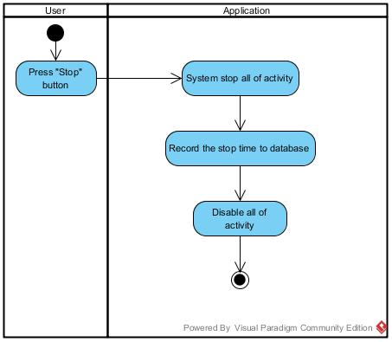

Figure 20 : “School Bus Tracking and Attendance Checking” Turn off application

Chapter Five | Reference

[1] Interface [online] <http://www.webopedia.com/TERM/I/interface.html> ( Accessed on 21 July 2015 )

[2] Activity diagram [online] <https://en.wikipedia.org/wiki/Activity_diagram> (Accessed on 21 July 2015 )

[3] Use case [online] [h](https://en.wikipedia.org/wiki/Activity_diagram)[ttp://searchsoftwarequality.techtarget.com/definition/use-case](http://searchsoftwarequality.techtarget.com/definition/use-case) ( Accessed on 21 July 2015 )

[4] Use case diagram [online] <https://en.wikipedia.org/wiki/Use_Case_Diagram> ( Accessed on 21 July 2015 )