**SCHOOL BUS TRACKING AND ATTENDANCE CHECKING**

Software Requirement Specification

**By**

Thitipun Tojareonvanich 552115018

Puttipong Tadang 552115054

Department of Software Engineering

College of Arts, Media, and Technology

Chiang Mai University

**Project Advisor**

Mr. Parinya Suwansrikham

**Document History**

|  |  |  |  |  |  |  |
| --- | --- | --- | --- | --- | --- | --- |
| Document Name | Detail | Status | Date | Viewable | Editable | Responsible |
| School Bus Tracking and Attendance Checking-SoftwareRequirementSpecification-V.0.1.docx | -Introduction | Reviewed | 1/7/2015 | TT, PT, PS | TT, PT | TT, PT |
| School Bus Tracking and Attendance Checking-SoftwareRequirementSpecification-V.0.2.docx | - Update Introduction  -User Requirement | Reviewed | 5/7/2015 | TT, PT, PS | TT, PT | TT, PT |
| School Bus Tracking and Attendance Checking-SoftwareRequirementSpecification-V.0.3.docx | -Update User Requirement  -System Features | Reviewed | 15/7/2015 | TT, PT, PS | TT, PT | TT, PT |
| School Bus Tracking and Attendance Checking-SoftwareRequirementSpecification-V.0.4.docx | -Update User Requirement  -Update Diagram | Reviewed | 20/7/2015 | TT, PT, PS | TT, PT | TT, PT |
| School Bus Tracking and Attendance Checking-SoftwareRequirementSpecification-V.0.5.docx | -Update User Requirement  -Update Overall Description | Reviewed | 25/7/2015 | TT, PT, PS | TT, PT | TT, PT |
| School Bus Tracking and Attendance Checking-SoftwareRequirementSpecification-V.1.0.docx | -Update User Requirements  -Appendix | Released | 27/7/2015 | TT, PT, PS | TT, PT | TT, PT |

\***TT** = Thitipun Tojareonvanich, \***PT** = Puttipong Tadang, \***PS** = Parinya Suwansrikham

**Document Designed by**

Mr.Thitipun Tojareonvanich

Mr.Puttipong Tadang

**Table of Contents**

Chapter One | Introduction 1

1.1 Objective 1

1.2 Intended Audience and Reading Suggestions 1

1.2.1 Development team 1

1.2.2 Customer 1

1.3 Project Scope 1

1.4 Acronyms and Definitions 1

1.4.1 Acronyms 1

Chapter Two | Overall Description 1

2.1 Product Perspective 1

2.2 Project Features 1

2.3 User Classes and Characteristics 1

2.3.1 School bus driver 1

2.3.2 Parents 1

2.3.3 Children 1

2.4 Operation Environment 1

2.5 Design and Implementation Constrains 1

Chapter Three | Functional Requirement 1

3.1 User Requirement Specification 1

Chapter Four | Specific Requirement 1

4.1 Use Case Scenarios 1

4.1.1 Use Case Diagram (Entire System) 1

4.1.2 Use case diagram (Member system) 1

4.1.3 Use case diagram (Tracking system) 1

4.1.4 Use case diagram (Notifying system) 1

4.1.5 Use case diagram (Speeding alert system) 1

4.2 Use case description 1

4.2.1 Feature name: Registration 1

Chapter Five | Reference 1

Chapter Six | Appendixes 1

• Appendix A: Requirement Survey Form 1

• Appendix B: Survey report 61

• Appendix C: Graphic Survey report 64

Chapter One | Introduction

1.1 Objective

The objective of the Software Requirement Specification document is to outline all the requirements for “School Tracking and Attendance Checking” application. Clearly and accurately describe search of the essential requirements (functions, performance and design constraints) of the system and its external interfaces. This document is based on the project proposal and project plan. It also contains a general description of the types of users who will be using or application, how it is going to work, and goals.

This document is intended to be used by the members of the project team and other stakeholders who will participate in the design and implementation phases of the project and verify the correct functionality of the system. In addition, the application will be designed following this document.

1.2 Intended Audience and Reading Suggestions

This Software Requirement Specification is designed for the people who are involved and related with the School Bus Tracking and Attendance Checking project. It may benefit to these people as followed:

1.2.1 Development team

* Verifies and validate the work that associate with the document or not.
* Get the quality of the software product.
* Reduce the misunderstanding. Validate and specify all of the requirements and ensure the same understanding.
* Reduce the development effort.

1.2.2 Customer

* Help customer to understand the flow of application easily.
* Make an understanding between customer and application.

1.3 Project Scope

“School Bus Tracking and Attendance Checking” is a mobile application which uses Android OS. This application can help to improve the school bus system and reduce the parent worrying about their children. The parent can track the school bus position, can see their child attendance record, and get a notification message when their child enters or get off the school bus. In addition, the driver can check the student attendance by scan the QR code and can get the alert sound when the driver drives the bus over the speed limit.

The main features of “School Bus Tracking and Attendance Checking” are as follows:

**Tracking system**

Parents can track their child by the school bus position via Google Maps that they’re in. The school bus driver’s phone would send the position on to the database and can provide them to the parent.

**Attendance checking system**

School bus driver can check the children attendance via QR code when they enter and get off the bus. Moreover, parents can check whether their children are on the bus or not.

**Canceling the school bus ride system**

Parent can cancel the school bus ride on the special case. For example, the children get sick, parent wants to pick their child by yourself.

**Notifying system**

System can notify the parent when their child enters and get off the bus. In addition, system can notify children when the school bus nearby school.

**Speeding alert system**

System can warn school bus driver when drive over the speed limit that defined by the school bus reasonable speed survey.

1.4 Acronyms and Definitions

1.4.1 Acronyms

AD Activity Diagram

PT Puttipong Tadang

PS Parinya Suwansrikham

SRS Software Requirement Specification

TT Thitipun Tojareonvanich

UC Use Case

URS User Requirement Specification

Chapter Two | Overall Description

2.1 Product Perspective

“School Bus Tracking and Attendance Checking” is a mobile application for dealing with concern of children safety from their parent. Additionally, the accident of excessive speed maybe reduced by using this application. Moreover, it may be a useful tool for solving the problem about leaving children at school or school bus. Finally, this application may shorten the time that your children have to waiting for the school bus.

2.2 Project Features

According to our proposal, we separated into three progresses and five main features.

**Member System**

- Registration system

- Login system

**Checking attendance system**

- QR code reader

- QR generator

- Checking attendance system

**Notifying System**

- Parent notifying message system

- School bus cancellation system

- Extra case messaging system

**Tracking System**

- Tracking system

- Calculating approximate arrival time system

**Speeding Alert System**

- Sending alert message system

2.3 User Classes and Characteristics

There are three types of user for our system. Information and characteristics are listed below:

2.3.1 School bus driver

These are the people who have registered as a school bus driver, they able to scan the children QR code for check their attendance, able to send the message in extra case. For example, Flat tires, car accidents, and so on. Moreover, if they turn on tracking system, their route will store on the route database and other user can use it for monitoring the school bus. And they also get the speeding alert sound when they exceed the speed limit.

2.3.2 Parents

These are the people who have registered as a parent. They can track and monitor the school bus and cancel the school bus ride. In addition, they also get notify message when their child enters or get off the bus and arrive the school or home and see their child attendance record.

2.3.3 Children

These are the people who have registered as a child. They can track and monitor the school bus when the bus goes to get them and can see the attendance record.

2.4 Operation Environment

* **Laptops**
* **Lenovo Y5070**

Processor: Intel(R) Core(TM) i7-4710HQ @ 2.50GHz

Memory: 8 GB DDR3

Graphics: NVIDIA GeForce GTX 860M

Operating System: Window 8.1 Professional

* **Dell Inspiron N7420**

Processor: Intel(R) Core(TM) i7-3612QM @ 2.10GHz

Memory: 8 GB DDR3

Graphics: NVIDIA GeForce GT 640M

Operating System: Windows 7 Ultimate

* **Internet**
* **Mobile Phone**: Android Operating System
  + - **Asus Zenfone5**

CPU: Intel Atom Z2580 Dual-core 2 GHz

Memory: 2 GB

Operating System: Android OS 4.3

2.5 Design and Implementation Constrains

* Overload data might affect to the application performance because the mobile phone have limited memory.
* Internet connection fail affect to the application.
* The mobile phone of who have registered as a school bus driver required a camera and Global Positioning System(GPS).

Chapter Three | Functional Requirement

3.1 User Requirement Specification

**Feature #1 Member System**

URS-01: unregistered user can register as school bus driver

URS-02: School bus driver can add unregistered user as a parent.

URS-03: School bus driver can add unregistered user as a child.

URS-04: Registered user can login to the application.

URS-05: Registered user can logout from the application.

**Feature #2 Checking attendance system**

URS-08: Parents can see their children's attendance status.

URS-10: School bus driver can scan QR code for checking children status.

**Feature #3 Notifying System**

URS-09: Children can receive the message when the bus is nearby.

URS-13: Parents can receive the message when their children arrive the school or home

URS-14: School bus driver can send an extra case message.

**Feature #4 Tracking System**

URS-07: Registered user (parent, children) can view the bus position.

**Feature #6: School bus rides cancellation system**

URS-06: Parents can cancel the school bus ride.

**Feature #5 Speed Control Alert System**

URS-12: School bus driver can receive alert message from the system when they exceed the speed.

URS-15: School bus driver can turn on the tracking system.

URS-16: School bus driver can turn off the tracking system.

**3.2 User Requirement Specification with the Software Requirement Specification**

* **URS-01: unregistered user can register as school bus driver.**

SRS-01: System shall connect to the database.

SRS-02: System shall provide register page for school bus driver.

SRS-03: System shall store the registration data to the database.

SRS-04: System shall validate the input of user information (First name, Last name, E-mail, phone number)

SRS-06: System shall provide the login page to user.

SRS-25: System shall show registration error messages.

SRS-32: System shall provide “Create new account” text.

SRS-44: System shall provide text field to input Email.

SRS-47: System shall provide text field to input passwords.

SRS-48: System shall provide check box to select the gender.

SRS-50: System shall provide text field to input First name.

SRS-51: System shall provide text field to input Last name.

SRS-53: System shall provide text field to input Re-e-mail.

SRS-54: System shall provide text field to input Mobile number.

SRS-55: System shall provide button to attach the image.

SRS-57: System shall provide text field to input car license plate.

SRS-58: System shall provide text field to input the car brands.

SRS-70: System shall provide “SIGN UP” button.

SRS-83: System shall send the message “Internet connection fail” when user no longer connect with the internet

* **URS-02: School bus driver can add Unregistered user as a parent**

SRS-01: System shall connect to the database.

SRS-03: System shall store the registration data to the database.

SRS-04: System shall validate the input of user information (First name, Last name, E-mail, phone number)

SRS-25: System shall show registration error messages.

SRS-28: System shall provide school bus driver page.

SRS-44: System shall provide text field to input Email.

SRS-47: System shall provide text field to input passwords.

SRS-48: System shall provide check box to select the gender.

SRS-49: System shall provide “Add user” button.

SRS-50: System shall provide text field to input First name.

SRS-51: System shall provide text field to input Last name.

SRS-53: System shall provide text field to input Re-e-mail.

SRS-54: System shall provide text field to input Mobile number.

SRS-59: System shall provide register page for parents.

SRS-70: System shall provide “SIGN UP” button.

SRS-71: System shall provide registration page.

SRS-73: System shall provide “PARENT” button.

SRS-83: System shall send the message “Internet connection fail” when user no longer connect with the internet

* **URS-03: School bus driver can add unregistered user as a child.**

SRS-01: System shall connect to the database.

SRS-03: System shall store the registration data to the database.

SRS-04: System shall validate the input of user information (First name, Last name, E-mail, phone number)

SRS-05: System shall add the registered user as children to the school bus driver list.

SRS-14: System shall generate the QR code.

SRS-25: System shall show registration error messages.

SRS-44: System shall provide text field to input Email.

SRS-47: System shall provide text field to input passwords.

SRS-48: System shall provide Check box to select the gender.

SRS-49: System shall provide “Add user” button.

SRS-50: System shall provide text field to input First name.

SRS-51: System shall provide text field to input Last name.

SRS-52: System shall provide text field to input School Name.

SRS-53: System shall provide text field to input Re-enter email.

SRS-54: System shall provide text field to input Mobile number.

SRS-60: System shall provide registration page for children.

SRS-70: System shall provide “SIGN UP” button.

SRS-71: System shall provide registration page.

SRS-74: System shall provide “CHILDREN” button.

SRS-83: System shall send the message “Internet connection fail” when user no longer connect with the internet

* **URS-04: Registered user (school bus driver, parent, children) can login to the application.**

SRS-06: System shall provide the login page to user.

SRS-07: System shall validate E-mail and passwords from user to login.

SRS-08: System shall show the login error message.

SRS-10: System shall provide login button.

SRS-26: System shall provide parents page.

SRS-27: System shall provide children page.

SRS-28: System shall provide school bus driver page.

SRS-62: System shall provide text field to input Email for login.

SRS-63: System shall provide text field to input passwords for login.

SRS-83: System shall send the message “Internet connection fail” when user no longer connect with the internet

* **URS-05: Registered user (school bus driver, parent, children) can logout from the application.**

SRS-09: System shall provide logout button to user.

SRS-26: System shall provide parents page.

SRS-27: System shall provide children page.

SRS-28: System shall provide school bus driver page.

SRS-83: System shall send the message “Internet connection fail” when user no longer connect with the internet

* **URS-06: Parents can cancel the ride the school bus rides.**

SRS-21: System shall cancel the school bus driver ride.

SRS-26: System shall provide parents page.

SRS-36: System shall provide the “CANCELLATION” button.

SRS-75: System shall provide school bus ride cancellation page.

SRS-76: System shall provide check box to select the day period.

SRS-77: System shall provide text field to input the date.

SRS-78: System shall provide text field to input the subject.

SRS-79: System shall provide text field to input the message.

SRS-80: System shall provide check box to select the trip.

SRS-83: System shall send the message “Internet connection fail” when user no longer connect with the internet

* **URS-07: Registered user (school bus driver, parent, children) can view their own route.**

SRS-11: System shall provide a route page to user.

SRS-12: System shall provide a school bus position.

SRS-13: System shall provide current location.

SRS-26: System shall provide parents page.

SRS-27: System shall provide children page.

SRS-28: System shall provide school bus driver page.

SRS-83: System shall send the message “Internet connection fail” when user no longer connect with the internet

* **URS-08: Parents can see their children's attendance status**

SRS-17: System shall provide status checking for children.

SRS-26: System shall provide parents page.

SRS-38: System shall provide “ATTENDANCE RECORD” button.

SRS-83: System shall send the message “Internet connection fail” when user no longer connect with the internet

* **URS-09: Children can receive the message when the bus is nearby.**

SRS-17: System shall send a message to children when the bus nearby

SRS-22: System shall calculate approximate arrival time.

SRS-45: System shall provide “Notification” button.

SRS-46: System shall provide pop-up message.

SRS-83: System shall send the message “Internet connection fail” when user no longer connect with the internet

* **URS-10: School bus driver can scan QR code for checking children attendance.**

SRS-01: System shall connect to the database.

SRS-15: System shall provide a QR code scanning page.

SRS-39: System shall provide “Scan QR code” button.

SRS-46: System shall provide pop-up message.

SRS-64: System shall show the error message when QR code cannot read.

SRS-81: System shall send the message to the parent when their children’s QR code was scanned.

SRS-83: System shall send the message “Internet connection fail” when user no longer connect with the internet

* **URS-11: School bus driver can receive alert message from the system when they drive over the speed limit.**

SRS-24: System shall send a speeding message to school bus driver.

SRS-28: System shall provide school bus driver page.

SRS-45: System shall provide “Notification” button.

SRS-46: System shall provide pop-up message.

SRS-83: System shall send the message “Internet connection fail” when user no longer connect with the internet

* **URS-12: Parents can receive the message when their children arrive the school or home.**

SRS-19: System shall send a message to parents when their children arrive home.

SRS-20: System shall send a message to parents when their children arrive school.

SRS-45: System shall provide “Notification” button.

SRS-46: System shall provide pop-up message.

SRS-83: System shall send the message “Internet connection fail” when user no longer connect with the internet

* **URS-13: School bus driver can send an extra case message.**

SRS-23: System shall send the message to the parent when they have an extra case.

SRS-28: System shall provide school bus driver.

SRS-34: System shall provide the confirm pop-up.

SRS-35: System shall provide the “Yes” button.

SRS-36: System shall provide the “No” button.

SRS-37: System shall provide the “Close” button.

SRS-40: System shall send the message to parents.

SRS-43: System shall provide extra case button.

SRS-45: System shall provide “Message” button.

SRS-46: System shall provide Message page.

SRS-83: System shall send the message “Internet connection fail” when user no longer connect with the internet

* **URS-14: School bus driver can turn on the tracking system.**

SRS-28: System shall provide school bus driver page.

SRS-82: System shall provide turn on/off toggle button.

SRS-83: System shall send the message “Internet connection fail” when user no longer connect with the internet.

* **URS-15: School bus driver can turn off the tracking system.**

SRS-28: System shall provide school bus driver page.

SRS-82: System shall provide turn on/off toggle button.

SRS-83: System shall send the message “Internet connection fail” when user no longer connect with the internet.

Chapter Four | Specific Requirement

4.1 Use Case Scenarios

4.1.1 Use Case Diagram (Entire System)

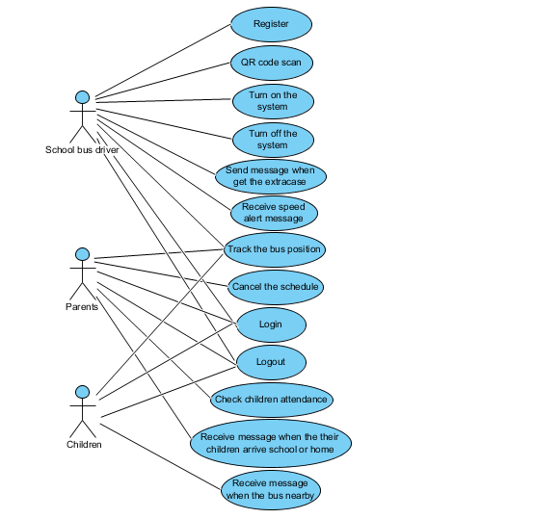

Figure 1 Use Case Diagram of Entire System

4.1.2 Use case diagram (Member system)

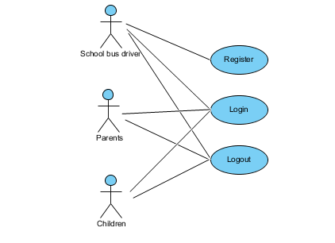

Figure 2 Use Case Diagram of Member system

4.1.3 Use case diagram (Tracking system)

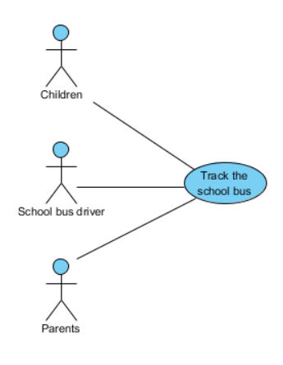

Figure 3 Use Case Diagram of Attendance checking system

4.1.4 Use case diagram (Notifying system)

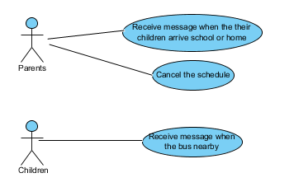

Figure 4 Use Case Diagram of Notify system

4.1.5 Use case diagram (Speeding alert system)

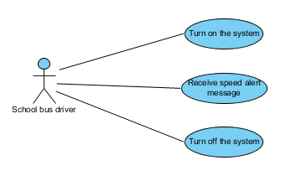

Figure 5 Use Case Diagram of Speeding alert system

4.2 Use case description

4.2.1 Feature name: Registration

|  |  |  |  |  |
| --- | --- | --- | --- | --- |
| **Use Case ID :** | UC-01 | | | |
| **Use Case Name :** | Register as school bus driver. | | | |
| **Create By :** | Thitipun T.  Puttipong T. | **Last Update By :** | | Thitipun T. |
| **Date Created :** | July 17, 2015 | **Date Last Updated :** | | August 27, 2015 |
| **Actor(s) :** | Unregistered user. | | | |
| **Description :** | Unregistered users have to register for using application. | | | |
| **Trigger :** | Unregistered user is not register yet and have to use School Bus Tracking and Attendance Checking. | | | |
| **Precondition :** | * Unregistered user is not register. | | | |
| **Normal Flow :** | **User** | | **System** | |
| 2. Unregistered user press on the “Create new account” button.  4. Unregistered user input Email, password, First name, Last name, image, Car brands, Car plate, Mobile number and gender.  5. Unregistered user press “SIGN UP” button. | | 1. System provide login page.  3. System provide register as School bus driver page.  6. System record the user information (Email, password, First name, Last name, image, Car brands, Car plate, Mobile number and gender) to database.  7. Login to application, go to school bus driver page. | |
| **Alternative Flow :** | 1. System provide login page.  1.1 If internet connection error, system cannot provide login page and show error message “Internet connection fail”. Go back to normal flow step 1.  3. System provide register as School bus driver page.  3.1 If internet connection error, system cannot provide School bus driver register page and show error message “Internet connection fail”. Go back to normal flow step 3.  5. Unregistered user press “SIGN UP” button.  5.1 If Unregistered user input invalid Email, password, First name, Last name, image, Car brands, Car plate, Mobile number and gender. Unregistered user cannot register. Go back to normal flow step 4.  5.2 If internet connection error, Unregistered user cannot register and show error message “Internet connection fail”. Go back to normal flow step 4.  6. System record the user information (Email, password, First name, Last name, image, Car brands, Car plate, Mobile number and gender) to database.  6.1 If internet connection error, system cannot record data to database and show error message “Internet connection fail”. Go back to normal flow step 4.  7. Login to application, go to school bus driver page.  7.1 If internet connection error, system cannot login to the application and cannot go to School bus driver page and show error message “Internet connection fail”. Go back to normal flow step 7. | | | |
| **Priority :** | High | | | |
| **Requirement :** | SRS-01: System shall connect to the database.  SRS-02: System shall provide register page for school bus driver.  SRS-03: System shall store the registration data to the database.  SRS-04: System shall validate the input of user information (First name, Last name, E-mail, phone number).  SRS-06: System shall provide the login page to user.  SRS-25: System shall show registration error messages.  SRS-32: System shall provide “Create new account” text.  SRS-44: System shall provide text field to input Email.  SRS-47: System shall provide text field to input passwords.  SRS-48: System shall provide check box to select the gender.  SRS-50: System shall provide text field to input First name.  SRS-51: System shall provide text field to input Last name.  SRS-53: System shall provide text field to input Re-e-mail.  SRS-54: System shall provide text field to input Mobile number.  SRS-55: System shall provide button to attach the image.  SRS-57: System shall provide text field to input car license plate.  SRS-58: System shall provide text field to input the car brands.  SRS-70: System shall provide “SIGN UP” button.  SRS-83: System shall send the message “Internet connection fail” when user no longer connect with the internet | | | |
|
|
|

**Activity Diagram (AD-01: Register as school bus driver)**

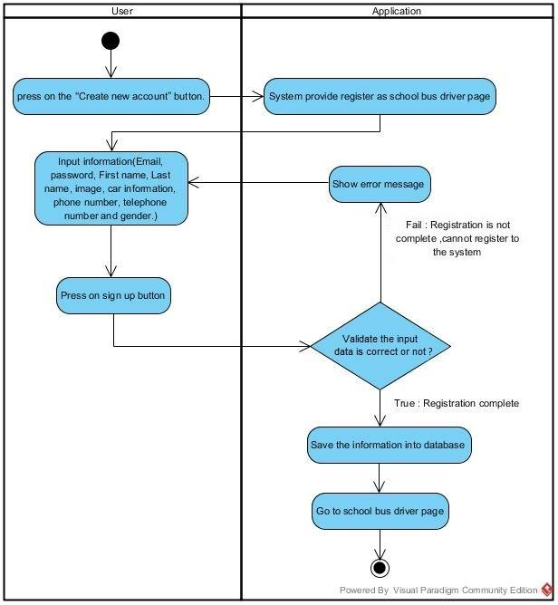

Figure 6 Activity Diagram of Register as school bus driver

|  |  |  |  |  |
| --- | --- | --- | --- | --- |
| **Use Case ID :** | UC-02 | | | |
| **Use Case Name :** | School bus driver can register the parents to the application | | | |
| **Create By :** | Thitipun T.  Puttipong T. | **Last Update By :** | | Thitipun T. |
| **Date Created :** | July 17, 2015 | **Date Last Updated :** | | August 27, 2015 |
| **Actor(s) :** | Unregistered user (Parents), School bus driver. | | | |
| **Description :** | Unregistered users have to register for using application. | | | |
| **Trigger :** | Unregistered user is not registration yet and have to use School Bus Tracking and Attendance Checking. | | | |
| **Precondition :** | open application  Unregistered user is not registration. | | | |
| **Normal Flow :** | User | | System | |
| 2. School bus driver press on the “Add user” button.  4. School bus driver press on the “PARENT” button.  6. School bus driver input parent’s e-mail, password, first name, last name, mobile number, and gender.  7. Presses “SIGN UP” button. | | 1. System provide school bus driver page.  3. System provide register as Parents/Children page.  5. System provide the register page for parent.  8. System record the user information (Email, password, First name, Last name, Mobile number, and gender.) to database.  9. Login to application, go to parent page. | |
| **Alternative Flow :** | 1. System provide school bus driver page.  1.1 If internet connection error, system cannot provide school bus driver page and show error message “Internet connection fail”. Go back to normal flow step 1.  3. System provide Parents/Children register page.  3.1 If internet connection error, system cannot provide register page and show error message “Internet connection fail”. Go back to normal flow step 3.  5. System provide the register page for parent  5.1 If internet connection error, system cannot provide the register page for parent and show error message “Internet connection fail”. Go back to normal flow step 5.  7. Presses “SIGN UP” button.  7.1 If school bus driver input invalid parent’s e-mail, password, first name, last name, mobile number, and gender. Unregistered user as parent cannot register to the application. Go back to normal flow step 6.  7.2 If internet connection error, unregistered user cannot register and show error message “Internet connection fail”. Go back to normal flow step 6.  8. System record the user information (Email, password, First name, Last name, Mobile number, and gender.) to database.  8.1 If internet connection error, system cannot record data to database and show error message “Internet connection fail”. Go back to normal flow step 6.  9. Login to application, go to parent page.  9.1 If internet connection error, system cannot login to the application and cannot go to parent page and show error message “Internet connection fail”. Go back to normal flow step 9. | | | |
| **Priority :** | High | | | |
| **Requirement :** | SRS-01: System shall connect to the database.  SRS-03: System shall store the registration data to the database.  SRS-04: System shall validate the input of user information (First name, Last name, E-mail, phone number).  SRS-25: System shall show registration error messages.  SRS-28: System shall provide school bus driver page.  SRS-44: System shall provide text field to input Email.  SRS-47: System shall provide text field to input passwords.  SRS-48: System shall provide check box to select the gender.  SRS-49: System shall provide “Add user” button.  SRS-50: System shall provide text field to input First name.  SRS-51: System shall provide text field to input Last name.  SRS-53: System shall provide text field to input Re-enter email.  SRS-54: System shall provide text field to input Mobile number.  SRS-59: System shall provide register page for parents.  SRS-70: System shall provide “SIGN UP” button.  SRS-71: System shall provide register for parent/children page.  SRS-73: System shall provide “PARENT” button.  SRS-83: System shall send the message “Internet connection fail” when user no longer connect with the internet | | | |
|
|
|

**Activity Diagram (AD-02: Register as Parent)**

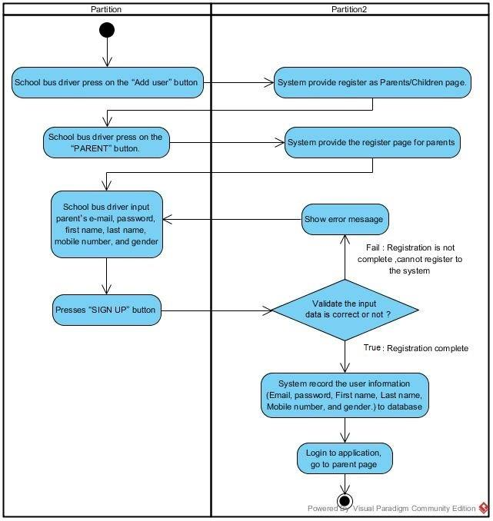

Figure 7 Activity Diagram of Register as Parent

|  |  |  |  |  |
| --- | --- | --- | --- | --- |
| **Use Case ID :** | UC-03 | | | |
| **Use Case Name :** | School bus driver can add the children to the application | | | |
| **Create By :** | Thitipun T.  Puttipong T. | **Last updated By :** | | Thitipun T. |
| **Date Created :** | July 17, 2015 | **Date Last Updated :** | | August 27, 2015 |
| **Actor(s) :** | Unregistered user (Children), School bus driver. | | | |
| **Description :** | Unregistered users have to register for using application. | | | |
| **Trigger :** | unregistered user is not registration yet and have to use School Bus Tracking and Attendance Checking. | | | |
| **Precondition :** | open application  unregistered user is not registration. | | | |
| **Normal Flow :** | **User** | | **System** | |
| 2. School bus driver press on the “Add user” button.  4. School bus driver press on the “STUDENT” button.  6. School bus driver input children’s e-mail, password, first name, last name, mobile number, school name, and gender.  7. Presses “SIGN UP” button. | | 1. System provide school bus driver page.  3. System provide register as Parents/Children page.  5. System provide the register page for children.  8. System record the user information (Email, password, First name, Last name, Mobile number, and gender.) to database.  9. Login to application, go to children page. | |
| **Alternative Flow :** | 1. System provide school bus driver page.  1.1 If internet connection error, system cannot provide school bus driver page and show error message “Internet connection fail”. Go back to normal flow step 1.  3. System provide as Parents/Children register page.  3.1 If internet connection error, system cannot provide register as Parents/Children page and show error message “Internet connection fail”. Go back to normal flow step 3.  5. System provide the register page for children.  5.1 If internet connection error, system cannot provide the register page for children and show error message “Internet connection fail”. Go back to normal flow step 5.  7. Presses “SIGN UP” button.  7.1 If school bus driver input invalid children’s e-mail, password, first name, last name, mobile number, school name, and gender. unregistered user as children cannot register to the application. Go back to normal flow step 6.  7.2 If internet connection error, unregistered user cannot register.  8. System record the user information (Email, password, First name, Last name, Mobile number, and gender.) to database.  8.1 If internet connection error, system cannot record data to database and show error message “Internet connection fail”. Go back to normal flow step 6.  9. Login to application, go to children page.  9.1 If internet connection error, system cannot login to the application and cannot go to children page and show error message “Internet connection fail”. Go back to normal flow step 9. | | | |
| **Priority :** | High | | | |
| **Requirement :** | SRS-01: System shall connect to the database.  SRS-03: System shall store the registration data to the database.  SRS-04: System shall validate the input of user information (First name, Last name, E-mail, phone number).  SRS-05: System shall add the unregistered user as children to the school bus driver list.  SRS-14: System shall generator the QR code.  SRS-25: System shall show registration error messages.  SRS-44: System shall provide text field to input Email.  SRS-47: System shall provide text field to input passwords.  SRS-48: System shall provide Check box to select the gender.  SRS-49: System shall provide “Add user” button.  SRS-50: System shall provide text field to input First name.  SRS-51: System shall provide text field to input Last name.  SRS-52: System shall provide text field to input School Name.  SRS-53: System shall provide text field to input Re-email.  SRS-54: System shall provide text field to input Mobile number.  SRS-60: System shall provide register page for children.  SRS-70: System shall provide “SIGN UP” button.  SRS-71: System shall provide register for parent/children page.  SRS-74: System shall provide “STUDENT” button.  SRS-83: System shall send the message “Internet connection fail” when user no longer connect with the internet | | | |
|
|
|

**Activity Diagram (AD-03: Register as Children)**

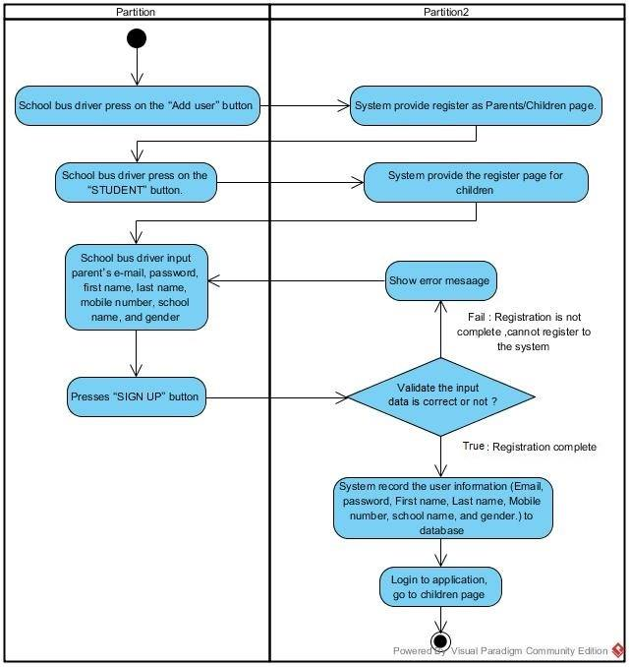

Figure 8 Activity Diagram of Register as Children

|  |  |  |  |  |
| --- | --- | --- | --- | --- |
| **Use Case ID :** | UC-04 | | | |
| **Use Case Name :** | Login | | | |
| **Create By :** | Thitipun T.  Puttipong T. | **Last Update By :** | | Thitipun T. |
| **Date Created :** | July 17, 2015 | **Date Last Updated :** | | August 27, 2015 |
| **Actor(s) :** | School bus driver, Parent, Children | | | |
| **Description :** | Registered users have to enter e-mail, user, password and login to application. | | | |
| **Trigger :** | Registered user has to use School Bus Tracking and Attendance Checking. | | | |
| **Precondition :** | User already registered and must remember username and password. | | | |
| **Normal Flow :** | **User** | | **System** | |
| 2. Registered user input e-mail and password.  3. Press on “LOGIN” button. | | 1. System provide login page.  4. Login to application, go to school bus driver/parent/children page. | |
| **Alternative Flow :** | 1. System provide login page.  1.1 If internet connection error, system cannot provide login page and show error message “Internet connection fail”. Go back to normal for step 1.  3. Press on “LOGIN” button.  3.1 If Registered user input invalid Email or password, registered user cannot login to application and warning message is shown. Go back to normal flow step 2.  3.2 If internet connection error, registered user cannot login and show error message “Internet connection fail”.  Go back to normal for step 2.  4. Login to application, go to school bus driver/parent/children page.  4.1 If internet connection error, System cannot login to the system and cannot go to school bus driver/parent/children page and show error message “Internet connection fail”. Go back to normal for step 4. | | | |
| **Priority :** | High | | | |
| **Requirement :** | SRS-06: System shall provide the login page to user.  SRS-07: System shall validate E-mail(username) and passwords from user to login.  SRS-08: System shall show the login error message  SRS-10: System shall provide login button to user.  SRS-26: System shall provide parents page.  SRS-27: System shall provide children page.  SRS-28: System shall provide school bus driver page.  SRS-62: System shall provide text field to input Email for login.  SRS-63: System shall provide text field to input passwords for login.  SRS-83: System shall send the message “Internet connection fail” when user no longer connect with the internet | | | |
|
|
|

**Activity Diagram (AD-04: Login)**

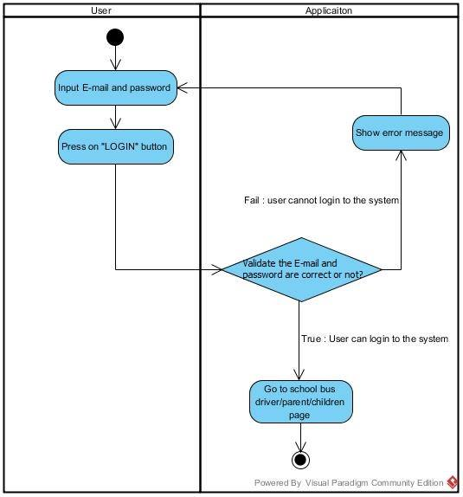

Figure 9 Activity Diagram of Login

|  |  |  |  |  |
| --- | --- | --- | --- | --- |
| **Use Case ID :** | UC-05 | | | |
| **Use Case Name :** | Logout | | | |
| **Create By :** | Thitipun T.  Puttipong T. | **Last Update By :** | | Thitipun T. |
| **Date Created :** | July 17, 2015 | **Date Last Updated :** | | August 27, 2015 |
| **Actor(s) :** | School bus driver, Parents, Children. | | | |
| **Description :** | Registered users have to logout from application. | | | |
| **Trigger :** | Registered user has to logout from School Bus Tracking and Attendance Checking. | | | |
| **Precondition :** | User already login to the application. | | | |
| **Normal Flow :** | **User** | | **System** | |
| 2. Registered user press on “logout” button. | | 1. System provide school bus driver/parent/children page.  3. Logout from application, go to login page. | |
| **Alternative Flow :** | 1. System provide School bus driver/Parent/Children page.  1.1 If internet connection error, system cannot provide school bus driver/Parent/Children page and show error message “Internet connection fail”. Go back to normal for step 1.  3. Logout from application.  3.1 If internet connection error, registered user cannot logout from application and show error message “Internet connection fail”. Go back to normal flow step 2. | | | |
| **Priority :** | High | | | |
| **Requirement :** | SRS-06: System shall provide the login page to user.  SRS-09: System shall provide logout button to user.  SRS-26: System shall provide parents page.  SRS-27: System shall provide children page.  SRS-28: System shall provide school bus driver page.  SRS-83: System shall send the message “Internet connection fail” when user no longer connect with the internet. | | | |
|
|
|

**Activity Diagram (AD-05: Logout)**

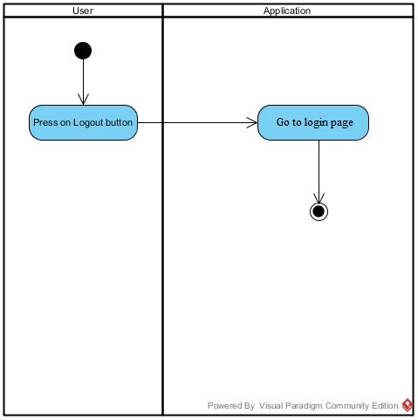

Figure 10 Activity Diagram of Logout

**4.2.2 Feature name: Attendance Checking**

|  |  |  |  |  |
| --- | --- | --- | --- | --- |
| **Use Case ID :** | UC-06 | | | |
| **Use Case Name :** | Scan QR code for children attendance. | | | |
| **Create By :** | Thitipun T.  Puttipong T. | **Last Update By :** | | Thitipun T. |
| **Date Created :** | July 17, 2015 | **Date Last Updated :** | | August 27, 2015 |
| **Actor(s) :** | School bus driver. | | | |
| **Description :** | School bus driver can scan the children QR code by built in camera. | | | |
| **Trigger :** | School bus driver can scan the children QR code by built in camera and record the data to database | | | |
| **Precondition :** | User already login to the application. | | | |
| **Normal Flow :** | **User** | | **System** | |
| 2. Press Scan QR code button.  4. School bus driver scan the children QR code. | | 1. System show School bus driver page.  3. System open built-in camera.  5. System identify the QR code  6. Record the data (The time that QR code was scan) to database.  7. System send the message their parents. | |
| **Alternative Flow :** | 1. System show School bus driver page.  1.1 If internet connection error, system cannot display the School bus driver page and show error message “Internet connection fail”. Go back to normal flow step 1.  5. System identify the QR code  5.1 If system cannot read the QR code, system will show the error message and go back to normal flow step 3.  6. Record the data (time that QR code was scan) to database.  6.1 If internet connection error, system cannot record the data and show error message “Internet connection fail”. Go back to normal for step 3.  7.System send the message the parents  7.1 If internet connection error, system cannot send the message to their parents. Go back to normal flow step 7. | | | |
| **Priority :** | High | | | |
| **Requirement :** | SRS-01: System shall connect to the database.  SRS-15: System shall provide a QR code scanning page.  SRS-39: System shall provide “Scan QR code” button.  SRS-46: System shall provide pop-up message.  SRS-64: System shall show the error message when QR code cannot read.  SRS-81: System shall send the message to parent when their children’s QR code was scan.  SRS-83: System shall send the message “Internet connection fail” when user no longer connect with the internet. | | | |
|
|
|

**Activity Diagram (AD-06: Scan QR code for children attendance.)**

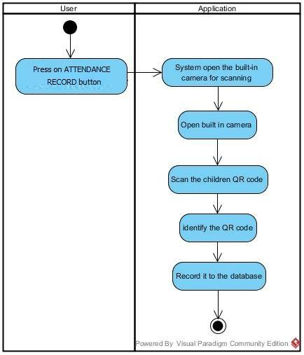

Figure 11 Activity Diagram of Scan QR code for children attendance.

|  |  |  |  |  |
| --- | --- | --- | --- | --- |
| **Use Case ID :** | UC-07 | | | |
| **Use Case Name :** | Checking the children attendance | | | |
| **Create By :** | Thitipun T.  Puttipong T. | **Last Update By :** | | Thitipun T. |
| **Date Created :** | July 17, 2015 | **Date Last Updated :** | | August 27, 2015 |
| **Actor(s) :** | Parents. | | | |
| **Description :** | Parents can check their children's attendance. | | | |
| **Trigger :** | Registered user (Parents) press on Attendance button and see their children attendance on School Bus Tracking and Attendance Checking application. | | | |
| **Precondition :** | User already login to the application. | | | |
| **Normal Flow :** | **User** | | **System** | |
| 2. Press on Attendance button. | | 1. System show parents page.  3. System show their children status. | |
| **Alternative Flow :** | 3. System show their children status.  3.1 If internet connection error, system cannot provide the children status user and show error message “Internet connection fail”. Go back to normal flow step 1. | | | |
| **Priority :** | High | | | |
| **Requirement :** | SRS-17: System shall provide status checking for children.  SRS-26: System shall provide parents page.  SRS-38 :System shall provide “ATTENDANCE RECORD” button.  SRS-83: System shall send the message “Internet connection fail” when user no longer connect with the internet. | | | |
|
|
|

**Activity Diagram (AD-07: Checking the children attendance)**

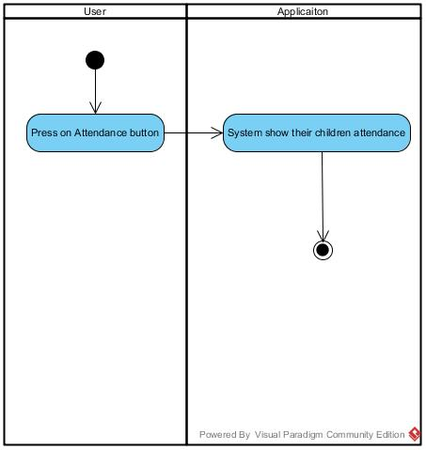

Figure 12 Activity Diagram of Checking the children attendance

**4.2.3 Feature name: Notifying system**

|  |  |  |  |  |
| --- | --- | --- | --- | --- |
| **Use Case ID :** | UC-08 | | | |
| **Use Case Name :** | Receive the message when the bus are nearby. | | | |
| **Create By :** | Thitipun T.  Puttipong T. | **Last Update By :** | | Thitipun T. |
| **Date Created :** | July 17, 2015 | **Date Last Updated :** | | August 27, 2015 |
| **Actor(s) :** | Children, School bus driver. | | | |
| **Description :** | Children can receive the message when the bus come nearby the children. | | | |
| **Trigger :** | School Bus Tracking and Attendance Checking will send the message to children when the bus come nearby automatically. | | | |
| **Precondition :** | User already login to the application. | | | |
| **Normal Flow :** | **User** | | **System** | |
| 1. The bus come nearby the children position.  3. Children press on notification button.  5. Children receive the message. | | 2. System send the message to children.  4. System show the notification page. | |
| **Alternative Flow :** | 2. System send the message to children.  2.1 If internet connection error, system cannot send the message to children. Go back to normal flow step 2.  4. 4. System show the notification page.  4.1 If internet connection error, system cannot show notification page to children and show error message “Internet connection fail”. Go back to normal flow step 4. | | | |
| **Priority :** | High | | | |
| **Requirement :** | SRS-17: System shall send a message to children when the bus nearby  SRS-22: System shall calculate approximate arrival time.  SRS-45: System shall provide “Notification” button.  SRS-46: System shall provide pop-up message. | | | |
|
|
|

**Activity Diagram (AD-08: Receive the message when the bus is nearby.)**

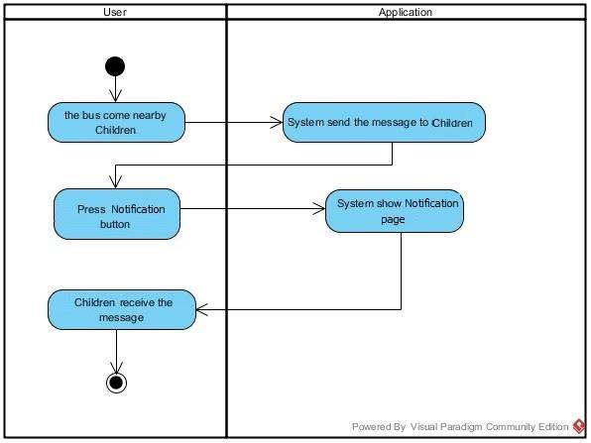

Figure 13 Activity Diagram of Receive the message when the bus are nearby

|  |  |  |  |  |
| --- | --- | --- | --- | --- |
| **Use Case ID :** | UC-09 | | | |
| **Use Case Name :** | Receive the message when their children arrive the school or home. | | | |
| **Create By :** | Thitipun T.  Puttipong T. | **Last Update By :** | | Thitipun T. |
| **Date Created :** | July 18, 2015 | **Date Last Updated :** | | August 27, 2015 |
| **Actor(s) :** | Parents. | | | |
| **Description :** | Parents can receive message when their children arrive the school or home. | | | |
| **Trigger :** | School Bus Tracking and Attendance Checking will send the message to parents when their children arrive the school or home automatically. | | | |
| **Precondition :** | User already login to the application. | | | |
| **Normal Flow :** | **User** | | **System** | |
| 1. Their children arrive school/home.  2. School bus driver scan children QR code.  4. Parent press notification button.  6. Parents read the message. | | 3. System send message to their parents.  5. System show notification page. | |
| **Alternative Flow :** | 2. School bus driver scan children QR code.  2.1 If system cannot scan the QR code, system will show the error message. Go back to normal flow step 2.  3. System send message to their parents.  3.1If internet connection error, system cannot send the message to their parents. Go back to normal flow step 3.  5. System show notification page.  5.1 If internet connection error, system cannot show message page and show error message “Internet connection fail”. Go back to normal for step 5. | | | |
| **Priority :** | Medium | | | |
| **Requirement :** | SRS-19: System shall send a message to parents when their children arrive the home.  SRS-20: System shall send a message to parents when their children arrive the school.  SRS-45: System shall provide “Notification” button.  SRS-46: System shall provide pop-up message.  SRS-83: System shall send the message “Internet connection fail” when user no longer connect with the internet. | | | |
|
|
|

**Activity Diagram (AD-09: Receive the message when their children arrive the school or home.)**

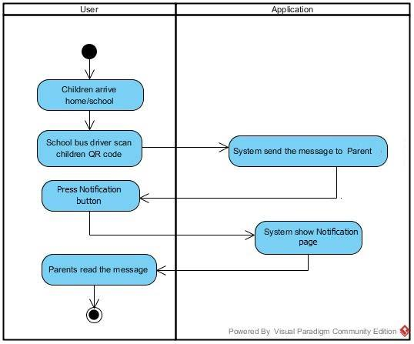

Figure 14 Activity Diagram of Receive the message when their children arrive the school or home

|  |  |  |  |  |
| --- | --- | --- | --- | --- |
| **Use Case ID :** | UC-10 | | | |
| **Use Case Name :** | Cancel the school bus ride. | | | |
| **Create By :** | Thitipun T.  Puttipong T. | **Last Update By :** | | Thitipun T. |
| **Date Created :** | July 20, 2015 | **Date Last Updated :** | | August 27, 2015 |
| **Actor(s) :** | Parents. | | | |
| **Description :** | Parents can cancel the school bus schedule. | | | |
| **Trigger :** | School Bus Tracking and Attendance Checking will cancel the school bus ride when user as parent press on “CANCELLATION” button, fill the information and press on the “SEND” button. | | | |
| **Precondition :** | User already login to the application. | | | |
| **Normal Flow :** | **User** | | **System** | |
| 2. Parent press on “CANCELLATION” button.  4. Parent in put the cancel information (Period time, date, subject, and message).  5. Press on “SEND” button. | | 1. System provide parents page.  3. System provide cancellation page.  6. System cancel the school bus ride.  7. System show Parents page. | |
| **Alternative Flow :** | 1. System provide parents page.  1.1 If internet connection error, system cannot display the parents page and show error message “Internet connection fail”. Go back to normal for step 1.  3. System provide cancellation page.  3.1 If internet connection error, system cannot display the cancellation page and show error message “Internet connection fail”. Go back to normal for step 1.  5. Press on “SEND” button.  4.1 If internet press on “No” button, system display the parents page. Go back to normal flow step 1.  6. System show Parents page.  6.1 If internet connection error, system cannot display the Parents page and show error message “Internet connection fail”. Go back to normal for step 1. | | | |
| **Priority :** | Medium | | | |
| **Requirement :** | SRS-21: System shall cancel the school bus driver schedule.  SRS-26: System shall provide parents page.  SRS-36: System shall provide the “CANCELLATION” button.  SRS-75: System shall provide cancel schedule page.  SRS-76: System shall provide check box to select the day period for cancel the schedule.  SRS-77: System shall provide text field to input the date to cancel the schedule.  SRS-78: System shall provide text field to input the subject to cancel the schedule.  SRS-79: System shall provide text field to input the message to cancel the schedule.  SRS-80 : System shall provide check box to select the trip for cancel the schedule.  SRS-83: System shall send the message “Internet connection fail” when user no longer connect with the internet. | | | |
|
|
|

**Activity Diagram (AD-10: Cancel Schedule.)**

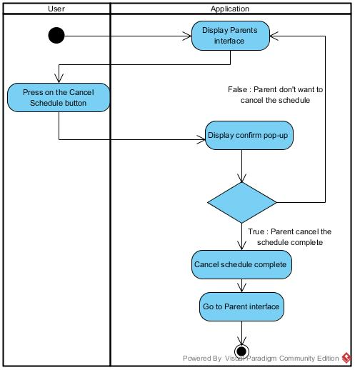

Figure 15 Activity Diagram of Cancel Schedule

|  |  |  |  |  |
| --- | --- | --- | --- | --- |
| **Use Case ID :** | UC-11 | | | |
| **Use Case Name :** | Extra case message. | | | |
| **Create By :** | Thitipun T.  Puttipong T. | **Last Update By :** | | Thitipun T. |
| **Date Created :** | July 17, 2015 | **Date Last Updated :** | | August 27, 2015 |
| **Actor(s) :** | School bus driver. | | | |
| **Description :** | School bus driver can send the message to the parents when have a extra cases. | | | |
| **Trigger :** | School Bus Tracking and Attendance Checking can send the message to the parent when have an extra cases. | | | |
| **Precondition :** | User already login to the application. | | | |
| **Normal Flow :** | **User** | | **System** | |
| 2. School bus driver press on “Extra case” button.  4. School bus driver press on the wanted case.  6. School bus driver press on “Yes” button. | | 1. System show the school bus driver page.  3. System show type of the case page to user.  5. System show the confirm pop-up.  7. System send selected case as message to parent. | |
| **Alternative Flow :** | 1. System provide the school driver page.  1.1 If internet connection error, school bus driver page cannot be shown and show error message “Internet connection fail”. Go back to normal for step 1.  3. System show type of case to user.  3.1 If internet connection error, system cannot show type of the case to user and show error message “Internet connection fail”. Go back to normal for step 1.  5. System show the confirm pop-up.  5.1 If internet connection error, system cannot show the confirm pop-up and show error message “Internet connection fail”. Go back to normal for step 1.  5.2 If user press on “No” button, system will go back to the type of the case page. Go back to normal flow step 3.  7. System send selected case as message to parent.  7.1 If internet connection error, system cannot send a message to parents. | | | |
| **Priority :** | Medium | | | |
| **Requirement :** | SRS-23: System shall send the message to the parent when have an extra case.  SRS-28: System shall provide school bus driver page.  SRS-34: System shall provide the emergency page.  SRS-35: System shall provide the “Send” button.  SRS-42: System shall provide text field to user to input subject.  SRS-43: System shall provide text box to user to input message.  SRS-45: System shall provide “Notification” button.  SRS-46: System shall provide pop-up message. | | | |
|
|
|

**Activity Diagram (AD-11: Extra case message.)**

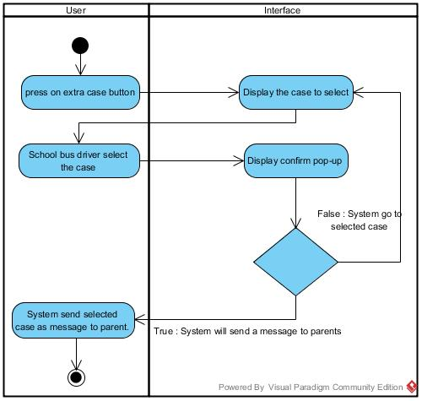

Figure 16 Activity Diagram of extra case messaging

**4.2.4 Feature name: Tracking system**

|  |  |  |  |  |
| --- | --- | --- | --- | --- |
| **Use Case ID :** | UC-12 | | | |
| **Use Case Name :** | Tracking the school bus | | | |
| **Create By :** | Thitipun T.  Puttipong T. | **Last Update By :** | | Thitipun T. |
| **Date Created :** | July 17, 2015 | **Date Last Updated :** | | August 27, 2015 |
| **Actor(s) :** | School bus driver, Parents, Children | | | |
| **Description :** | Register users view the route via google map api. | | | |
| **Trigger :** | Registered user press tracking button and view their route on School Bus Tracking and Attendance Checking application. | | | |
| **Precondition :** | User already login to the application. | | | |
| **Normal Flow :** | **User** | | **System** | |
| 2. School bus driver, Parents, Children press on “Tracking” button. | | 1. System provide School bus driver, Parents, Children page.  3. System show the route via google map api. | |
| **Alternative Flow :** | 1. System provide School bus driver, Parents, Children page.  1.1 If internet connection error, System provide School bus driver, Parents, Children page cannot be shown and show error message “Internet connection fail”. Go back to normal for step 1.  3. System show the route via google map api.  3.1 If internet connection error, system cannot provide the google map api to user and show error message “Internet connection fail”. Go back to normal flow step 1. | | | |
| **Priority :** | High | | | |
| **Requirement :** | SRS-11: System shall provide a route page to user.  SRS-12: System shall provide a school bus position via google map api.  SRS-13: System shall provide current location.  SRS-26: System shall provide parents page.  SRS-27: System shall provide children page.  SRS-28: System shall provide school bus driver page.  SRS-83: System shall send the message “Internet connection fail” when user no longer connect with the internet. | | | |
|
|
|

**Activity Diagram (AD-12: View the route)**

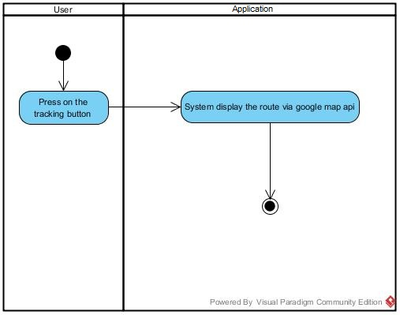

Figure 17 Activity Diagram of view the route

**4.2.5 Feature name: Alert system**

|  |  |  |  |  |
| --- | --- | --- | --- | --- |
| **Use Case ID :** | UC-13 | | | |
| **Use Case Name :** | Speeding message. | | | |
| **Create By :** | Thitipun T.  Puttipong T. | **Last Update By :** | | Thitipun T. |
| **Date Created :** | July 17, 2015 | **Date Last Updated :** | | August 27, 2015 |
| **Actor(s) :** | School bus driver. | | | |
| **Description :** | School bus driver can receive alert message when the speed are more than the speed limit. | | | |
| **Trigger :** | School Bus Tracking and Attendance Checking will send the alert message to School bus driver when the speed are more than the speeding automatically. | | | |
| **Precondition :** | User already login to the application. | | | |
| **Normal Flow :** | **User** | | **System** | |
| 1. School bus driver drive the bus more than speeding.  3. School bus driver receive the alert message. | | 2. System send alert message to school bus driver. | |
| **Alternative Flow :** | 2. System send alert message to school bus driver.  2.1 If internet connection error, system cannot send the alert message to school bus driver and show error message “Internet connection fail”. Go back to normal flow step 2.  3. School bus driver receive the alert message.  3.1 If internet connection error, school bus driver cannot receive the alert message and show error message “Internet connection fail”. Go back to normal flow step 3. | | | |
| **Priority :** | Medium | | | |
| **Requirement :** | SRS-24: System shall send a speeding message to school bus drive.  SRS-28: System shall provide school bus driver page.  SRS-45: System shall provide “Notification” button.  SRS-46: System shall provide pop-up message.  SRS-83: System shall send the message “Internet connection fail” when user no longer connect with the internet. | | | |
|
|
|

**Activity Diagram (AD-13: Speeding message**.**)**

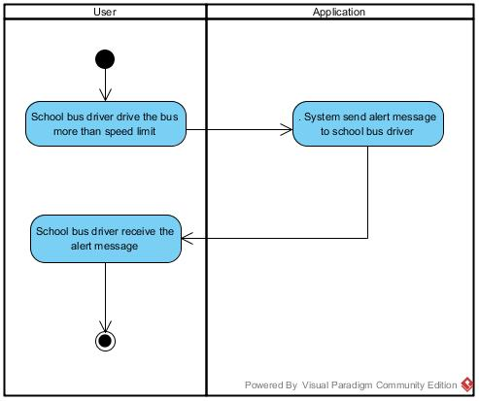

Figure 18 Activity Diagram of speeding message

|  |  |  |  |  |
| --- | --- | --- | --- | --- |
| **Use Case ID :** | UC-14 | | | |
| **Use Case Name :** | Turn on the tracking system. | | | |
| **Create By :** | Thitipun T.  Puttipong T. | **Last Update By :** | | Thitipun T. |
| **Date Created :** | July 17, 2015 | **Date Last Updated :** | | August 27, 2015 |
| **Actor(s) :** | School bus driver. | | | |
| **Description :** | School bus driver can turn on the tracking system | | | |
| **Trigger :** | School Bus Tracking and Attendance Checking can turn on the tracking system by school bus driver press on the on toggle button. | | | |
| **Precondition :** | User already login to the application. | | | |
| **Normal Flow :** | **User** | | **System** | |
| 2. School bus driver press on turn on/off toggle button. | | 1. System provide the school bus driver page.  3. Start the tracking system. | |
| **Alternative Flow :** | 1. System provide the school driver page.  1.1 If internet connection error, system cannot display School bus driver and show error message “Internet connection fail”. Go back to normal flow step 1.  3. Start the tracking system.  3.1 If internet connection error, System cannot start the tracking system and show error message “Internet connection fail”. Go back to normal flow step 3. | | | |
| **Priority :** | High | | | |
| **Requirement :** | SRS-28: System shall provide school bus driver page.  SRS-82: System shall provide turn on/off toggle button  SRS-83: System shall send the message “Internet connection fail” when user no longer connect with the internet. | | | |
|
|
|

**Activity Diagram (AD-14: Turn on tracking system**.**)**

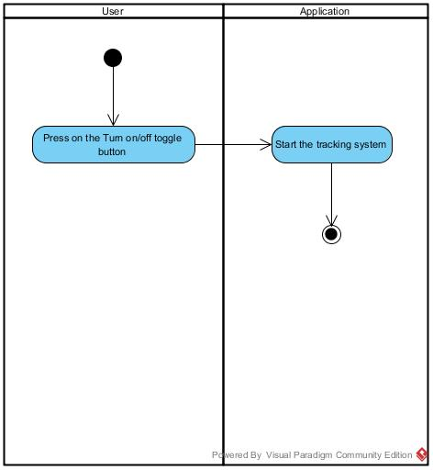

Figure 19 Activity Diagram of turn on tracking system

|  |  |  |  |  |
| --- | --- | --- | --- | --- |
| **Use Case ID :** | UC-15 | | | |
| **Use Case Name :** | Turn off tracking system. | | | |
| **Create By :** | Thitipun T.  Puttipong T. | **Last Update By :** | | Thitipun T. |
| **Date Created :** | July 17, 2015 | **Date Last Updated :** | | August 27, 2015 |
| **Actor(s) :** | School bus driver. | | | |
| **Description :** | School bus driver can turn off the tracking system | | | |
| **Trigger :** | School Bus Tracking and Attendance Checking can turn off the tracking system by school bus driver press on the off toggle button. | | | |
| **Precondition :** | User already login to the application. | | | |
| **Normal Flow :** | **User** | | **System** | |
| 2. School bus driver press on turn on/off toggle button. | | 1. System provide the school bus driver page.  3. Stop the tracking system. | |
| **Alternative Flow :** | 1. System provide the school bus driver page.  1.1 If internet connection error, system cannot display School bus driver page and show error message “Internet connection fail”. Go back to normal flow step 1.  3. Stop the tracking system.  3.1 If internet connection error, System cannot stop the tracking system and show error message “Internet connection fail”. Go back to normal flow step 3. | | | |
| **Priority:** | High | | | |
| **Requirement :** | SRS-28: System shall provide school bus driver page.  SRS-82: System shall provide turn on/off toggle button.  SRS-83: System shall send the message “Internet connection fail” when user no longer connect with the internet. | | | |
|
|
|

**Activity Diagram (AD-15: Turn off tracking system)**

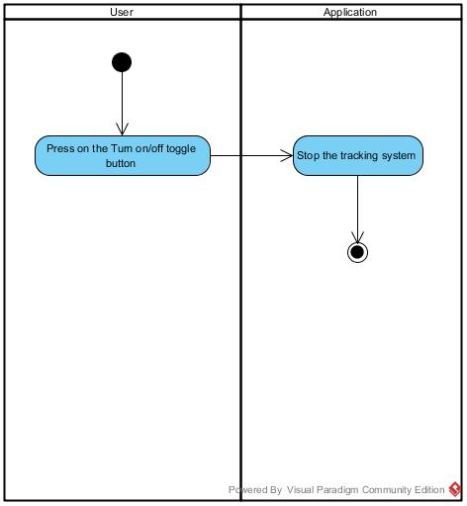

Figure 20 Activity Diagram of turn off the tracking system

Chapter Five | Reference

[1] *Interface* [Online]. Retrieved 21 July 2015,from <http://www.webopedia.com/TERM/I/interface.html>

[2] *Activity diagram* [Online]. Retrieved 21 July 2015, from <https://en.wikipedia.org/wiki/Activity_diagram>

[3] *Use case* [Online]. Retrieved 21 July 2015 ,from [h](https://en.wikipedia.org/wiki/Activity_diagram)[ttp://searchsoftwarequality.techtarget.com/definition/use-case](http://searchsoftwarequality.techtarget.com/definition/use-case)

[4] *Use case diagram* [Online]. Retrieved 21 July 2015 ,from <https://en.wikipedia.org/wiki/Use_Case_Diagram>

Chapter Six | Appendixes

Appendix is show the document that related in the Software Requirement Specification.

We divided into 3 part:

* Appendix A: Requirement Survey Form
* Appendix B: Survey report
* Appendix C: Graphic Survey report

**Appendix A**

**Requirement Survey Form**



**แบบสำรวจ และความคิดเห็นของการใช้รถรับส่งนักเรียน**

**วิทยาลัยศิลปะ สื่อ และเทคโนโลยี**

**มหาวิทยาลัยเชียงใหม่**

**คำชี้แจง แบบสอบถาม**

1. เพื่อหาความต้องการของผู้ที่เกี่ยวข้องกับระบบรถรับส่งนักเรียน
2. เพื่อให้การจัดทำโครงการมีประสิทธิภาพสูงสุด สามารถตอบสนองความต้องการของผู้ใช้งาน และผู้ที่เกี่ยวข้องกับระบบรถรับส่งนักเรียน
3. โปรดเติมเครื่องหมาย ✓ และกรอกข้อความให้สมบูรณ์

**ส่วนที่ 1 ข้อมูลทั่วไปของผู้ตอบแบบสอบถาม**

1. เพศ 🗌 ชาย 🗌 หญิง
2. สถานะ

🗌 นักเรียน 🗌 ผู้ปกครอง

🗌 ผู้ขับขี่รถรับส่งนักเรียน 🗌 ประชาชนทั่วไป

1. อายุ □ ต่ำกว่า 15 ปี □ 15-20 ปี □ 21-30 ปี □ 31-40 ปี □ 41 ปีขึ้นไป

**ส่วนที่ 2 ความพึงพอใจต่อโครงการ**

ระดับ 5 = มากที่สุดหรือดีมาก 4 = มากหรือดี 3 = ปานกลางหรือพอใช้ 2 = น้อยหรือต่ำกว่ามาตรฐาน 1 = น้อยที่สุดหรือต้องปรับปรุงแก้ไข

|  |  |  |  |  |  |
| --- | --- | --- | --- | --- | --- |
| **รายละเอียด** | **ระดับความพึงพอใจ** | | | | |
| **5** | **4** | **3** | **2** | **1** |
| **1. ความพึงพอใจต่อระบบรถรับส่งนักเรียน** | | | | | |
| 1.1 ความเหมาะสม |  |  |  |  |  |
| 1.2 ความดูแลเอาใจใส่ |  |  |  |  |  |
| 1.3 ความสะดวกสบาย |  |  |  |  |  |
| 1.4 ความพร้อม |  |  |  |  |  |
| **2. บริการของแอพพลิเคชั่น** | | | | | |
| 2.1 ระบบสมัครสมาชิก และระบบยืนยันตัวตน |  |  |  |  |  |
| 2.2 ระบบเช็คชื่อการขึ้นลงรถนักเรียนผ่าน QR Code |  |  |  |  |  |
| 2.3 ระบบแจ้งเตือนผู้ขับขี่รถนักเรียนเมื่อขับขี่เกินอัตราเร็วที่กำหนด |  |  |  |  |  |
| 2.4 ระบบติดตามรถนักเรียน เพื่อแสดงพิกัดให้กับผู้ปกครอง |  |  |  |  |  |
| 2.5 ระบบยกเลิกการใช้บริการชั่วคราว ในกรณีที่ผู้ปกครองไปรับบุตรหลานด้วยตนเอง |  |  |  |  |  |
| 2.6 ระบบแจ้งผู้ปกครองเมื่อบุตรหลานถึงจุดหมายปลายทาง |  |  |  |  |  |
| 2.7 ระบบแจ้งเด็กนักเรียนเมื่อรถนักเรียนใกล้จะถึงโรงเรียน |  |  |  |  |  |
| 2.8 ระบบแจ้งผู้ปกครองเมื่อถึงกำหนดการชำระค่าบริการรายเดือนของรถนักเรียน |  |  |  |  |  |
| **3. ความพึงพอใจของท่านต่อภาพรวมของโครงการ** |  |  |  |  |  |

**ส่วนที่ 3 คำถามทั่วไปประกอบการจัดทำโครงการ**

1. **ความเร็วที่เหมาะสมกับรถรับส่งนักเรียน**

🗌 ไม่เกิน 60 กิโลเมตร/ชั่วโมง 🗌 ไม่เกิน 80 กิโลเมตร/ชั่วโมง

🗌 ไม่เกิน 90 กิโลเมตร/ชั่วโมง 🗌 ไม่เกิน 100 กิโลเมตร/ชั่วโมง

**2. ระยะเวลาที่ใช้ในการเดินทาง**

🗌 น้อยกว่า 30 นาที 🗌 30-60 นาที 🗌 มากกว่า 1 ชม.

**3. ระยะทางระหว่างที่พักอาศัย และสถานศึกษา**

🗌 น้อยกว่า 20 กม. 🗌 20-50 กม. 🗌 51-80 กม. 🗌 มากกว่า 81 กม.

**4. ประเภทของระบบปฏิบัติการโทรศัพท์มือถือ**

🗌 Android 🗌 iOS 🗌 Windows Phone 🗌 อื่นๆ

**5. การใช้งานโทรศัพท์มือถือ**

🗌 เพื่อการรอ 🗌 เพื่อความบันเทิง 🗌 เพื่อการเรียน 🗌 เพื่อธุกิจ

**6. การเชื่อมต่อเครือข่ายอินเตอร์เน็ตบนโทรศัพท์มือถือ**

🗌 มีการเชื่อมต่อเครือข่ายอินเตอร์เน็ต 🗌 ไม่มีการเชื่อมต่อเครือข่ายอินเตอร์เน็ต

**7. ระบบระบุตำแหน่งบนพื้นโลกของโทรศัพท์มือถือ (GPS)**

🗌 มีระบบระบุตำแหน่งบนพื้นโลกบนโทรศัพท์มือถือ 🗌 ไม่มีระบบระบุตำแหน่งบนพื้นโลกบนโทรศัพท์มือถือ

**8. การใช้งานโทรศัพท์มือถือต่อวัน**

🗌 น้อยกว่า 1 ชม. 🗌 1-2 ชม. 🗌 มากกว่า 2 ชม. 🗌 มากกว่า 3 ชม.

**ส่วนที่ 4 ข้อเสนอแนะ**

4.1 ข้อเสนอแนะ

...................................................................................................................................................................................................... ......................................................................................................................................................................................................

**ขอขอบคุณเป็นอย่างสูง**

**คณะผู้จัดทำโครงการ**

**Appendix B**

**Survey report**

**Appendix C**

**Graphic Survey report**