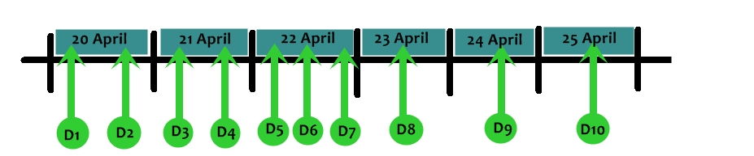***Milestone***

***On 20 April***

**D1) Requirement** - We ask for all of requirement from abbot in Chaing mang temple

**D2) Analysis** - We analyze all of the requirement to make it into the URS/SRS

***On 21 April***

**D3) Use case diagram** - We draw a use case diagram to describe about what user can do with this program

**D4) Use case description** - To explain each use case

***On 22 April***

**D5) Method design** - Explain all of work in this program

**D6) Class diagram** - To design all of method and whole structure of program

**D7) Sequence diagram** - Explain a normal flow of the program

***On 23 April***

**D8) Prototype** - review all of program and some time we adding a new requirement

***On 24 April***

**D9) Test** - Test all of function in program to defect a bug or error in the program

***On 25 April***

**D10) Present**