**Lesson 03 Demo 01**

**Executing Ad Hoc Commands**

**Objective:** To demonstrate ad hoc commands for quickly executing tasks on remote servers without writing full playbooks

**Tools required:** Ansible, Ubuntu OS

**Prerequisites:** None

Steps to be followed:

1. Generate SSH key pair on the main node
2. Copy the SSH key on the other two nodes
3. Update the host file with the host IP address
4. Establish connectivity between specified hosts and the Ansible server
5. Gather System Information Using Ad-Hoc Commands

**Step 1: Generate SSH key pair on the main node**

1. Use the following command to generate the SSH key on the main Ansible server:

**ssh-keygen**

**Step 2: Copy the SSH key on the other two nodes**

* 1. Use the following command to copy the public key in a file named **authorized_keys**

in localhost:

**cat .ssh/id_rsa.pub >> .ssh/authorized_keys**

* 1. Use the following command to check the SSH connection with localhost:  
     **ssh localhost -p 42006**  
     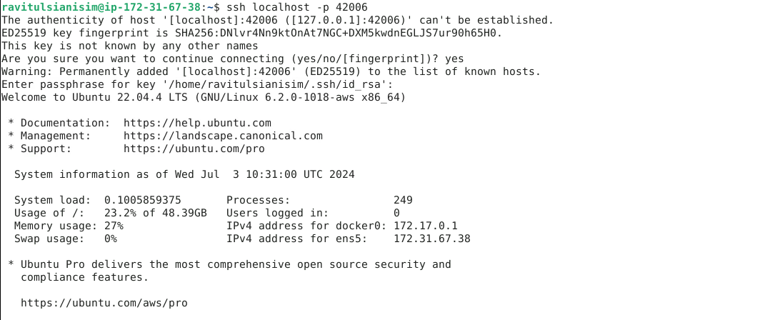
  2. Now, use the following command to exit from the localhost:

**exit**



* 1. Run the following command to go to the **.ssh** directory of the Ansible server:

**cd .ssh**



* 1. Run the following command to copy the public key to another node that will connect to the main Ansible server:

**ssh-copy-id username@ip -p 22**

* 1. Execute the following command to come out of the **.ssh** directory of the Ansible server:

**cd**



**Step 3: Update the host file with the host IP address**

* 1. Use the following command to open the Ansible inventory file and add the host localhost to it:

**sudo vi /etc/ansible/hosts**



* 1. When the file opens, add the below two lines of the code at the end of the file:

**[webservers]**

**localhost:42006**

**40.86.1.9:42006**

**Note:** Press **esc**, then write **:wq** and press **enter** to save the file.

**Step 4: Establish connectivity between specified hosts and the Ansible server**

* 1. Run the following command to verify connectivity to all servers listed under the **webservers** group in your Ansible hosts file:

**ansible -m ping webservers**



* 1. Use the following command to check the number of hosts in the host file:

**ansible all --list-hosts**



**Step 5: Gather System Information Using Ad Hoc Commands**

* 1. Run the following command to obtain the uptime from all managed hosts using an ad hoc command:

**ansible all -m shell -a uptime**



* 1. Similarly, execute the below command to obtain detailed information about memory usage on all hosts:

**ansible all -m shell -a "free -m"**

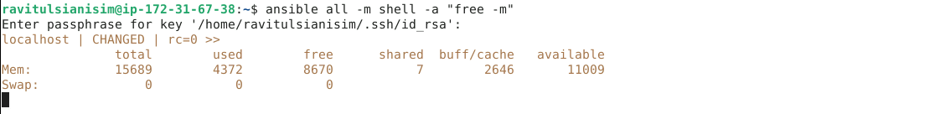

You will see that Ansible logs in to each machine in turn and runs the uptime command, returning the current uptime output.

By following these steps, you have successfully demonstrated how to use ad hoc commands for quickly executing tasks on remote servers without the need for full playbooks.