**Lesson 03 Demo 03**

**Working with Ansible Facts**

**Objective:** To demonstrate ansible facts for efficiently gathering system information to optimize playbook tasks

**Tools required:** Ansible, Ubuntu OS

**Prerequisites:** Refer demo 01 to establish connectivity between the hosts

Steps to be followed:

1. Gather all facts
2. Filter specific facts

**Step 1: Gather all facts**

1. Execute the following command to collect a comprehensive set of data from each host :

**ansible all -m setup**

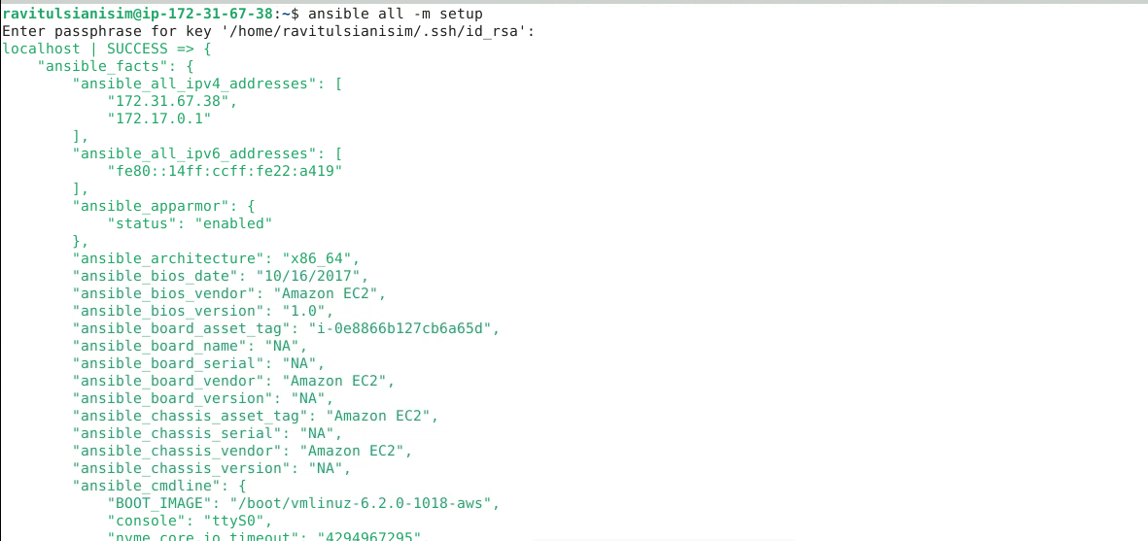

**Step 2: Filter specific facts**

* 1. Execute the following command to find out the operating system type of each host:

**ansible all -m setup -a 'filter=ansible_os_family'**

You can see that the command successfully retrieved the operating system family **Debian** for the localhost, using Python 3 as the interpreter, without making any changes to the system.

* 1. Execute the following command to gather detailed information about the storage devices on all hosts:  
     **ansible all -m setup -a 'filter=ansible_devices'**

You can see that the command successfully retrieved detailed information about the devices on localhost.

By following these steps, you have successfully demonstrated the use Ansible facts for efficiently gathering system information to optimize playbook tasks.