**Lesson 04 Demo 02**

**Configuring Apache Web Server Using Ansible**

**Objective:** To configure and validate the setup of the Apache web server using Ansible on a local node machine for automated server management

**Tools required:** Linux terminal

**Prerequisites:** None

Steps to be followed:

1. Establish connectivity between the Ansible controller and node machine
2. Configure and validate the Apache web server setup

**Step 1: Establish connectivity between the Ansible controller and node machine**

1. Run the following command to generate a new SSH key pair using the RSA encryption algorithm:   
   **ssh-keygen -t rsa**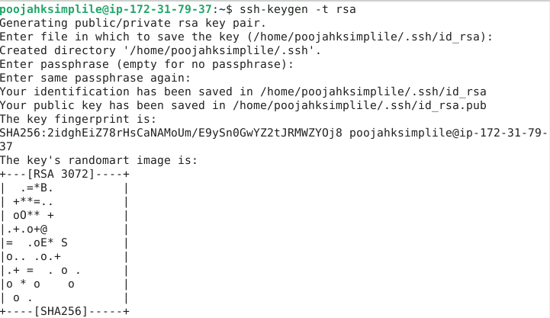
2. Run the following command to append the public key to the **authorized_keys** file: **cat .ssh/id_rsa.pub >> .ssh/authorized_keys**  
   
3. Connect to localhost via SSH port 22 using the below command:

**ssh localhost -p 22**  
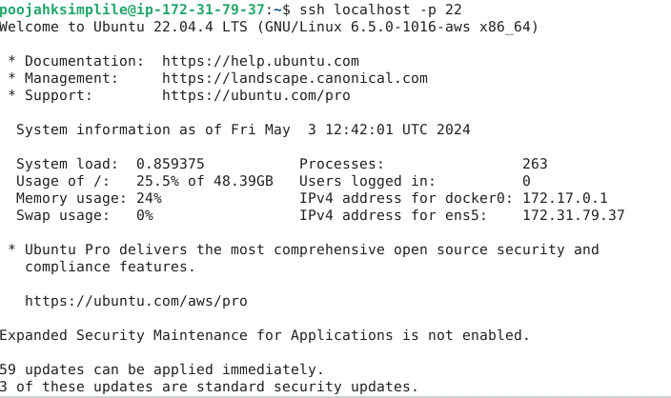

1. Run the following command to edit the Ansible **hosts** file:  
   **sudo vi /etc/ansible/hosts**  
     
   
2. Add the below two lines of the code inside the file as shown in the screenshot below:

**[webservers]**

**localhost:22**

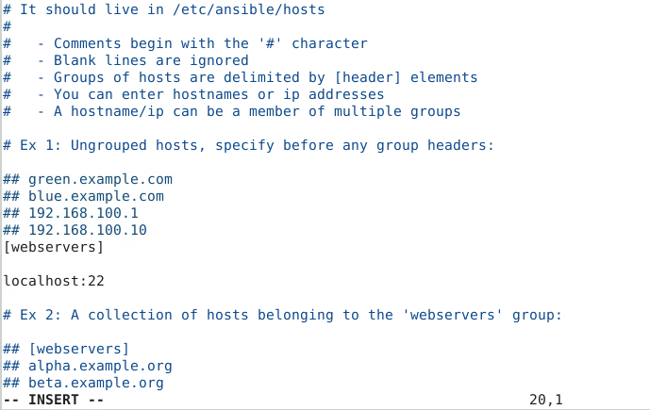

**Step 2: Configure and validate the Apache web server setup**

1. Run the following command to edit the Apache configuration file:   
   **sudo vi apache2.yaml**

1. Enter the following script into the **apache2.yaml** file: **---**

**- hosts: webservers**

**become: true**

**tasks:**

**- name: install apache2**

**apt: name=apache2 update_cache=yes state=latest**

**- name: enabled mod_rewrite**

**apache2_module: name=rewrite state=present**

**notify:**

**- restart apache2**

**handlers:**

**- name: restart apache2**

**

1. Run the Apache installation playbook using the command below: **ansible-playbook apache2.yaml**A screen shot of a computer

   Description automatically generated
2. Run the following Ansible ad hoc command to check the Apache server status:  
   **ansible -m shell -a "service apache2 status" webservers**A screen shot of a computer

   Description automatically generated

By following these steps, you have successfully configured and validated the Apache web server setup using Ansible on a local node machine for automated server management.