**Lesson 03 Demo 02**

**Executing Ansible Modules**

**Objective:** To demonstrate the use of the Ansible module for server configuration and management

**Tools required:** Linux terminal

**Prerequisites:** None

Steps to be followed:

1. Use Ansible modules for server configuration

**Step 1: Use Ansible modules for server configuration**

1. Run the following command using the **setup** module to collect and display detailed system information about the servers:   
   **ansible -m setup dbservers**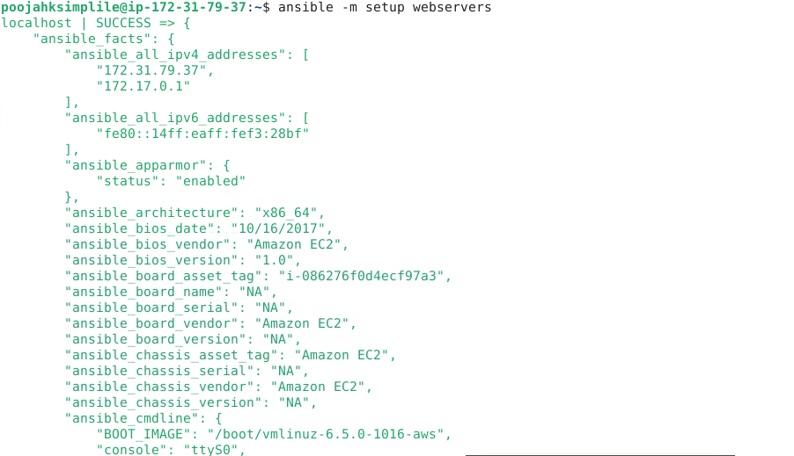
2. Run the following command using the **shell** module to retrieve server hostnames:  
   **ansible dbservers -m shell -a ‘hostname’**  
     
   
3. Run the following command using the **apt** module to install Git on servers:  
   **ansible dbservers -m apt -a 'name=git state=present' - - become**  
   A screen shot of a computer

   Description automatically generated
4. Run the following command using the **file** module to create a secured root file:

**ansible dbservers -m file -a 'dest=/root/sample.txt state=touch mode=600 owner=root group=root' --become**  
  
By following these steps, you have successfully managed server configurations using Ansible modules.