**Lesson 04 Demo 05**

**Setting up Custom SMTP to Send Email Notification**

**Objective:** To configure SMTP email notification in Jenkins for sending automated notifications and alerts

**Tools required:** Jenkins

**Prerequisites:** Jenkins must be operational.

Steps to be followed:

1. Create an app password for SMTP configuration
2. Configure SMTP configurations in Jenkins

**Step 1:** **Create an app password for SMTP configuration**

* 1. Navigate to your Google account and click on **Manage your Google Account**

* 1. Now, navigate to **Security** and make sure you have **2-Step Verification** enabled

* 1. In **Security**, search for **App passwords** and click on it

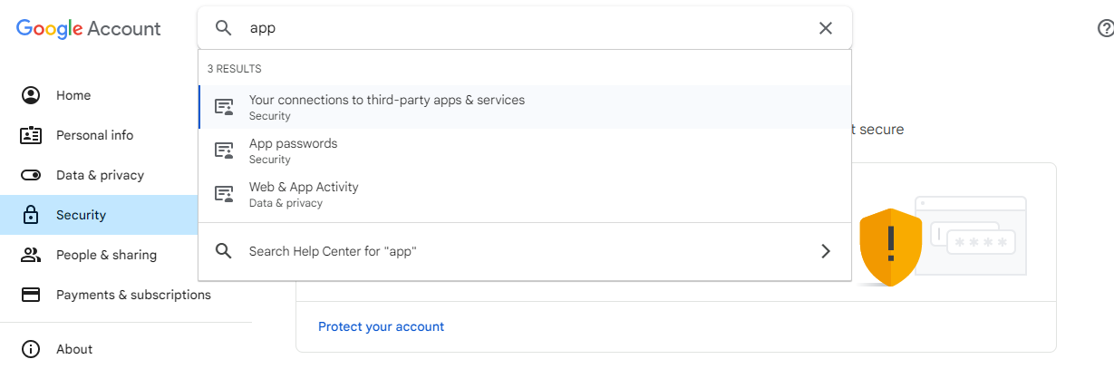

* 1. Provide the app name as **JenkinsSMTP** and click on **Create**

* 1. It will generate the app password. Copy the password and save it for future reference, then click on **Done**.

**Step 2:** **Configure SMTP configurations in Jenkins**

* 1. Sign in to **Jenkins** using your credentials

**Note:** The credentials for accessing Jenkins in the lab are Username: **admin** and Password: **admin**.

* 1. Navigate to **Manage Jenkins** in the Jenkins dashboard

* 1. Now, click on **System** under **System Configuration**

* 1. In the **System** section,scroll down to **E-mail Notification** section and provide **smtp.gmail.com** as **the SMTP server**

* 1. Click on **Advanced**, select **Use SMTP Authentication**, provide your email ID as **User Name**, and then provide previously generated App password in the **Password**

* 1. Select both **Use SSL** and **Use TLS**, and add **465** as the **SMTP Port**

* 1. Now, click on **Test configuration by sending test e-mail**, provide your email ID under **Test e-mail recipient**, then click on **Test configuration**

You can see the email has been sent successfully.

By following these steps, you have successfully configured SMTP email notification in Jenkins to send automated notifications and alerts.