Question 1
import java.util.Scanner;

public class Welcome {
public static void main(String[] args) {
Scanner scanner = new Scanner(System.in);
System.out.print("Enter your First Name: ");
String FirstName = scanner.nextLine();

System.out.print("Enter your Last Name: ");
String LastName = scanner.nextLine();

System.out.println("Welcome to the second year " + FirstName + " " + LastName);

scanner.close();
}
}

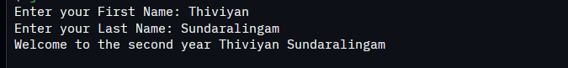

Question 2
import java.util.Scanner;

public class Question2 {
public static void main(String[] args) {
Scanner sc = new Scanner(System.in);

System.out.print("Enter number of students (n): ");
int n = sc.nextInt();

double[][] marks = new double[n + 1][3];

while (true) {
System.out.println("\nMENU");
System.out.println("1. Add student marks");
System.out.println("2. Update student mark");
System.out.println("3. Get average for a subject");
System.out.println("4. Get average for a student");
System.out.println("5. Get total mark of a student");
System.out.println("6. Exit");
System.out.print("Choose an option (1-6): ");

int choice = sc.nextInt();

if (choice == 6) {
System.out.println("Exiting program.");
break;
}

switch (choice) {
case 1:
System.out.print("Enter Student ID: ");
int id1 = sc.nextInt();
System.out.print("Enter Math mark: ");
marks[id1][0] = sc.nextDouble();
System.out.print("Enter Chemistry mark: ");
marks[id1][1] = sc.nextDouble();
System.out.print("Enter Physics mark: ");
marks[id1][2] = sc.nextDouble();
System.out.println("Marks added!");
break;

case 2:
System.out.print("Enter Student ID: ");
int id2 = sc.nextInt();
System.out.print("Enter Subject ID (1=Math, 2=Chem, 3=Phys): ");
int subId = sc.nextInt();
System.out.print("Enter new mark: ");
marks[id2][subId - 1] = sc.nextDouble();
System.out.println("Mark updated!");
break;

case 3:
System.out.print("Enter Subject ID (1=Math, 2=Chem, 3=Phys): ");
int sub = sc.nextInt();
double subjectSum = 0;
for (int i = 1; i <= n; i++) {
subjectSum += marks[i][sub - 1];
}
System.out.println("Subject Average: " + (subjectSum / n));
break;

case 4:
System.out.print("Enter Student ID: ");
int id4 = sc.nextInt();
double studentSum = marks[id4][0] + marks[id4][1] + marks[id4][2];
System.out.println("Student Average: " + (studentSum / 3.0));
break;

case 5:
System.out.print("Enter Student ID: ");
int id5 = sc.nextInt();
double total = marks[id5][0] + marks[id5][1] + marks[id5][2];
System.out.println("Total Marks: " + total);
break;

default:
System.out.println("Invalid choice. Try again.");
break;
}
}
sc.close();
}
}
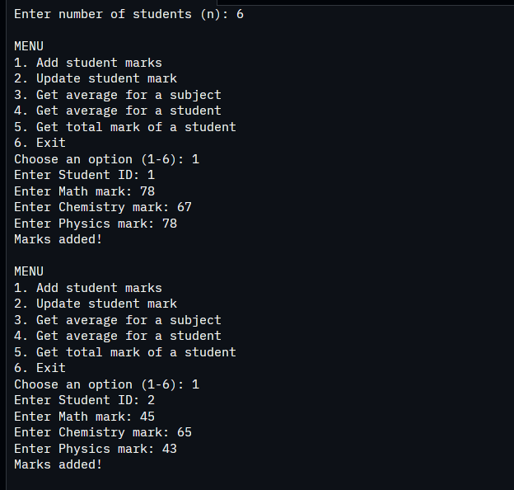
Question 3
import java.util.Scanner;

public class Question3 {
public static void main(String[] args) {
Scanner sc = new Scanner(System.in);

System.out.print("Enter number of students (n): ");
int n = sc.nextInt();

double[][] marks = new double[n + 1][3];

while (true) {
System.out.println("\nMENU");
System.out.println("1. Add student marks");
System.out.println("2. Update student mark");
System.out.println("3. Get average for a subject");
System.out.println("4. Get average for a student");
System.out.println("5. Get total mark of a student");
System.out.println("6. View grades summary table");
System.out.println("7. Exit");
System.out.print("Choose an option (1-7): ");

int choice = sc.nextInt();

if (choice == 7) {
System.out.println("Exiting program.");
break;
}

switch (choice) {
case 1:
System.out.print("Enter Student ID: ");
int id1 = sc.nextInt();
System.out.print("Enter Math mark: ");
marks[id1][0] = sc.nextDouble();
System.out.print("Enter Chemistry mark: ");
marks[id1][1] = sc.nextDouble();
System.out.print("Enter Physics mark: ");
marks[id1][2] = sc.nextDouble();
System.out.println("Marks added!");
break;

case 2:
System.out.print("Enter Student ID: ");
int id2 = sc.nextInt();
System.out.print("Enter Subject ID (1=Math, 2=Chem, 3=Phys): ");
int subId = sc.nextInt();
System.out.print("Enter new mark: ");
marks[id2][subId - 1] = sc.nextDouble();
System.out.println("Mark updated!");
break;

case 3:
System.out.print("Enter Subject ID (1=Math, 2=Chem, 3=Phys): ");
int sub = sc.nextInt();
double subjectSum = 0;
for (int i = 1; i <= n; i++) {
subjectSum += marks[i][sub - 1];
}
System.out.println("Subject Average: " + (subjectSum / n));
break;

case 4:
System.out.print("Enter Student ID: ");
int id4 = sc.nextInt();
double studentSum = marks[id4][0] + marks[id4][1] + marks[id4][2];
System.out.println("Student Average: " + (studentSum / 3.0));
break;

case 5:
System.out.print("Enter Student ID: ");
int id5 = sc.nextInt();
double total = marks[id5][0] + marks[id5][1] + marks[id5][2];
System.out.println("Total Marks: " + total);
break;

case 6:
System.out.println("\nGRADES SUMMARY");
System.out.printf("%-12s %-12s %-12s %-12s\n", "StudentID", "Math", "Chemistry", "Physics");

for (int i = 1; i <= n; i++) {
String mathGrade = getGrade(marks[i][0]);
String chemGrade = getGrade(marks[i][1]);
String physGrade = getGrade(marks[i][2]);

System.out.printf("%-12d %-12s %-12s %-12s\n", i, mathGrade, chemGrade, physGrade);
}
break;

default:
System.out.println("Invalid choice. Try again.");
break;
}
}
sc.close();
}

public static String getGrade(double score) {
if (score >= 90) {
return "Grade A";
} else if (score >= 80) {
return "Grade B";
} else if (score >= 70) {
return "Grade C";
} else if (score >= 60) {
return "Grade D";
} else {
return "Fail";
}
}
}
