Cardiff Metropolitan University
School of Technologies
CIS6003 — Advanced Programming
Assessment WRIT1 (100%)
Sunrise Dental Clinic
Appointment and Patient Management System
Student Name: [YOUR FULL NAME]
Student ID: [YOUR STUDENT ID]
Module Leader: priyanga@icbtcampus.edu.lk
GitHub Repository: https://github.com/Thivyaarudselvam/sunrise-dental-appointment-system
Date: [SUBMISSION DATE]

Table of Contents
Table of Contents 1
1. Introduction 1
2. Task A: System Design with UML Diagrams (20 Marks) 1
2.1 Use Case Diagram 1
2.1.1 Explanation of the Use Case Diagram 1
2.2 Class Diagram 1
2.2.1 Explanation of the Class Diagram 1
2.3 Sequence Diagrams 1
2.3.1 Sequence Diagram: Staff Login 1
2.3.2 Sequence Diagram: Register New Appointment 1
2.3.3 Sequence Diagram: Generate Bill 1
2.4 Design Assumptions 1
3. Task B: Interactive System Development (40 Marks) 1
3.1 System Overview 1
3.1.1 What the System Is 1
3.1.2 Usage — Who Uses It and How 1
3.1.3 Advantages 1
3.1.4 Disadvantages and Limitations 1
3.2 System Architecture 1
3.3 Design Patterns Implemented 1
3.3.1 Data Access Object (DAO) Pattern 1
3.3.2 Model-View-Controller (MVC) / Layered Architecture 1
3.3.3 Dependency Injection / Inversion of Control 1
3.3.4 Singleton Pattern 1
3.4 Security 1
3.5 Database Design 1
3.6 System Functionality and Screenshots 1
3.6.1 User Authentication (Login) 1
3.6.2 Register New Patient 1
3.6.3 Register New Dentist 1
3.6.4 Register New Treatment 1
3.6.5 Register New Appointment 1
3.6.6 Display / Search Appointment Details 1
3.6.7 Calculate and Print Bill 1
3.6.8 Help Section 1
3.6.9 Exit / Logout 1
3.7 Input Validation 1
4. Task C: Testing (20 Marks) 1
4.1 Testing Rationale and TDD Approach 1
4.2 Test Plan and Test Data 1
4.3 Test Automation 1
4.4 Test Results 1
4.5 Evaluation of Testing 1
5. Task D: Version Control and CI/CD (20 Marks) 1
5.1 Git and GitHub Workflow 1
5.2 CI/CD Pipeline (GitHub Actions) 1
5.3 Version Control Techniques Used 1
6. Conclusion 1
7. References 1

1. Introduction
Sunrise Dental Clinic is a busy private dental centre in Colombo that treats a large number of patients every week. Previously, patient appointments and treatment records were handled manually using paper files and notebooks, which led to double bookings, lost patient records, long waiting times and billing errors.
This report documents the design, development and testing of a computerised Appointment and Patient Management System developed for Sunrise Dental Clinic, built using Java (Spring Boot), a MySQL relational database, and a web-based front end. The system allows authenticated staff to register patients, dentists and treatments, book and search appointments, and automatically calculate and print patient bills.
The report is structured according to the four tasks specified in the assessment brief: Task A covers the UML design (Use Case, Class and Sequence diagrams); Task B covers the interactive system, its architecture and design patterns; Task C covers the testing approach and results; and Task D covers version control and the CI/CD pipeline implemented using Git, GitHub and GitHub Actions.

2. Task A: System Design with UML Diagrams

2.1 Use Case Diagram
The Use Case Diagram below identifies a single primary actor, Staff, who interacts with the system to perform six core use cases: Login, Register Appointment, Search Appointment, Generate Bill, View Help and Logout. The «include» relationship between "Register Appointment" and "Validate Input" shows that input validation is a mandatory sub-process that always executes whenever a new appointment is registered, reflecting the assessment brief's requirement for "appropriate validation mechanisms to restrict invalid entries."
Figure 2.1: Use Case Diagram

[ INSERT SCREENSHOT HERE ]
What to capture: The complete Use Case Diagram exported from draw.io (already saved as docs/diagrams/UseCaseDiagram.png in the GitHub repository).
How to take this screenshot:
1. Open the file docs/diagrams/UseCaseDiagram.png from the project repository (or reopen it in draw.io).
2. If reopening in draw.io: File → Export as → PNG → Export → Save.
3. Insert the exported PNG image here, replacing this placeholder box, and resize it to fit the page width.

2.1.1 Explanation of the Use Case Diagram
Actor — Staff: A single actor, Staff, was modelled because the assessment scenario explicitly states that the system is used internally to replace paper files and notebooks; patients never interact with the system directly, they only visit the clinic in person. Modelling a separate "Patient" actor would have implied a self-service portal, which is outside the scope of the brief.
- Login: The entry point to the whole system. Every other use case can only be reached after this one succeeds, reflecting the brief's requirement that "only authorized staff can use the system."
- Register Appointment: The central administrative task of the clinic — capturing a new patient visit with a unique appointment number, and linking it to a patient, dentist, treatment, date and time. This directly implements the scenario's requirement to record "appointment number, patient name, address, contact number, dentist name, treatment type, and appointment date and time."
- Validate Input («include»): Modelled as an included use case rather than a separate button or menu item, because validation is not something staff choose to do — it always happens automatically as part of registering an appointment. This is the correct UML convention for mandatory, reusable sub-behaviour.
- Search Appointment: Supports the clinic's day-to-day need to quickly retrieve a patient's full appointment record using only the appointment number, avoiding the "lost patient records" problem described in the brief.
- Generate Bill: Automates the previously manual, error-prone billing process by calculating the total from the treatment cost and consultation fee and producing a printable receipt.
- View Help: Provides new staff with an on-screen guide, addressing the brief's requirement to "provide step-by-step instructions for new staff on how to use the system" without needing separate printed training material.
- Logout: Ensures a workstation is not left in a logged-in state between shifts, which is a basic but important security control in a multi-user clinic environment.
Design decision: only one actor (Staff) was modelled because the scenario states that the system is used internally by clinic staff; patients do not interact with the system directly. This is documented as an assumption in Section 6.

2.2 Class Diagram
The Class Diagram below shows the six core domain classes of the system — Patient, Dentist, Treatment, Appointment, Bill and User — together with their attributes, methods (with public/private visibility shown using + and −), and the associations between them. An Appointment is associated with exactly one Patient, one Dentist and one Treatment (1 multiplicity from the appointment side, meaning one patient/dentist/treatment can be linked to many appointments over time), and each Bill is linked to exactly one Appointment (1..1).
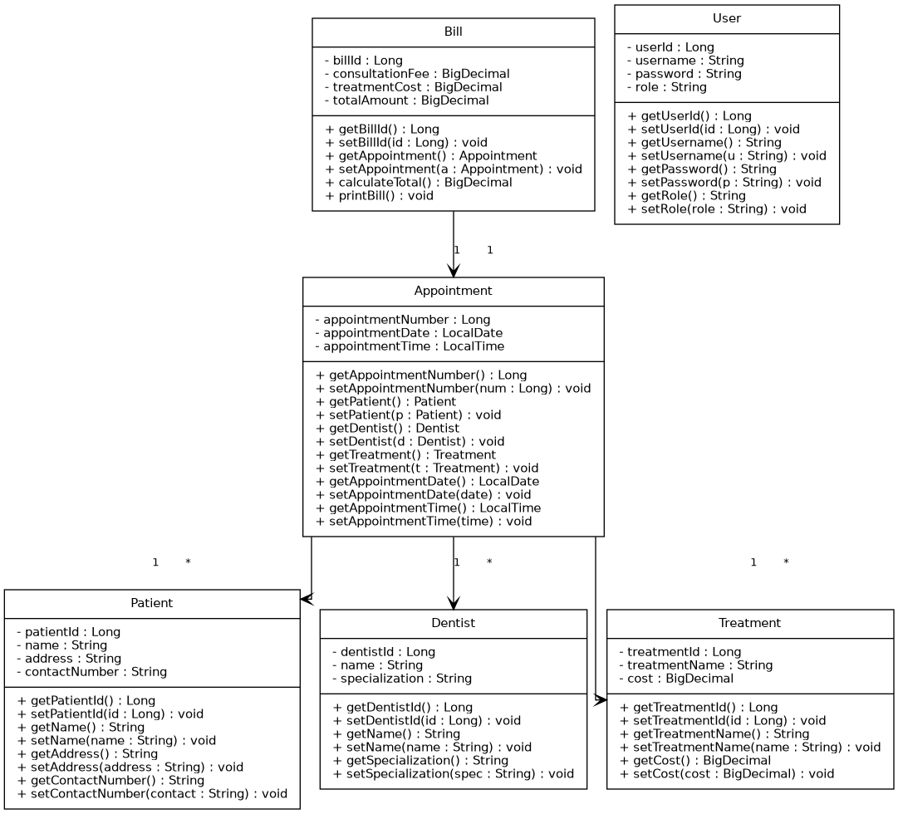
Figure 2.2: Class Diagram for the Sunrise Dental Appointment System
The class design directly mirrors the JPA entity classes implemented in the source code (see com.example.demo.model package), ensuring full traceability between the design and the implementation, as required for a good evaluation under the marking criteria.

2.2.1 Explanation of the Class Diagram
Encapsulation: every class exposes its fields as private (−) and provides public (+) getter/setter methods, following standard Java Bean conventions and JPA requirements (Hibernate needs no-argument constructors and accessor methods to populate entities via reflection). No field is ever accessed directly from outside its own class.
- Patient: the record of a person receiving treatment. Only the four attributes explicitly listed in the brief (name, address, contact number, plus a generated ID) are stored — no unnecessary fields were added, keeping the model as close to the client's stated requirements as possible.
- Dentist: kept deliberately simple (name and specialization) since the brief does not request dentist-specific scheduling or working-hours logic; this was noted as a possible future extension rather than in-scope functionality.
- Treatment: stores the treatment name and its cost as a BigDecimal (never a float/double) to avoid floating-point rounding errors in currency calculations — an important correctness decision for anything involving billing.
- Appointment: the central class of the whole model. It holds three ––ManyToOne associations (to Patient, Dentist and Treatment) rather than duplicating patient/dentist/treatment details as plain text fields. This normalises the data: if a dentist's specialization changes, it is updated in exactly one place (the Dentist row) rather than in every appointment that references that dentist.
- Bill: linked to an Appointment through a ––OneToOne association (1..1), reflecting the real-world rule that a single appointment produces exactly one bill. Storing consultationFee and treatmentCost separately, in addition to the totalAmount, keeps a full audit trail of how each total was calculated, rather than only storing the final figure.
- User: deliberately kept separate from Patient, since a "user" of this system is a staff member with a username/password/role, not a clinic patient — conflating the two would have been a significant design error.
Multiplicity: the 1..* multiplicity on the Appointment associations correctly models that one Patient, Dentist or Treatment can appear on many different Appointment records over time (e.g. the same patient returning for multiple visits), while each individual Appointment still points to exactly one Patient, one Dentist and one Treatment.

2.3 Sequence Diagrams
Three sequence diagrams were produced, covering the three most significant interactive use cases in the system: Staff Login, Register New Appointment, and Generate Bill. Each diagram shows the lifelines for the actor, the relevant UI page, controller, service, repository and database layers, illustrating how the layered (three-tier) architecture described in Task B operates at runtime.

2.3.1 Sequence Diagram: Staff Login
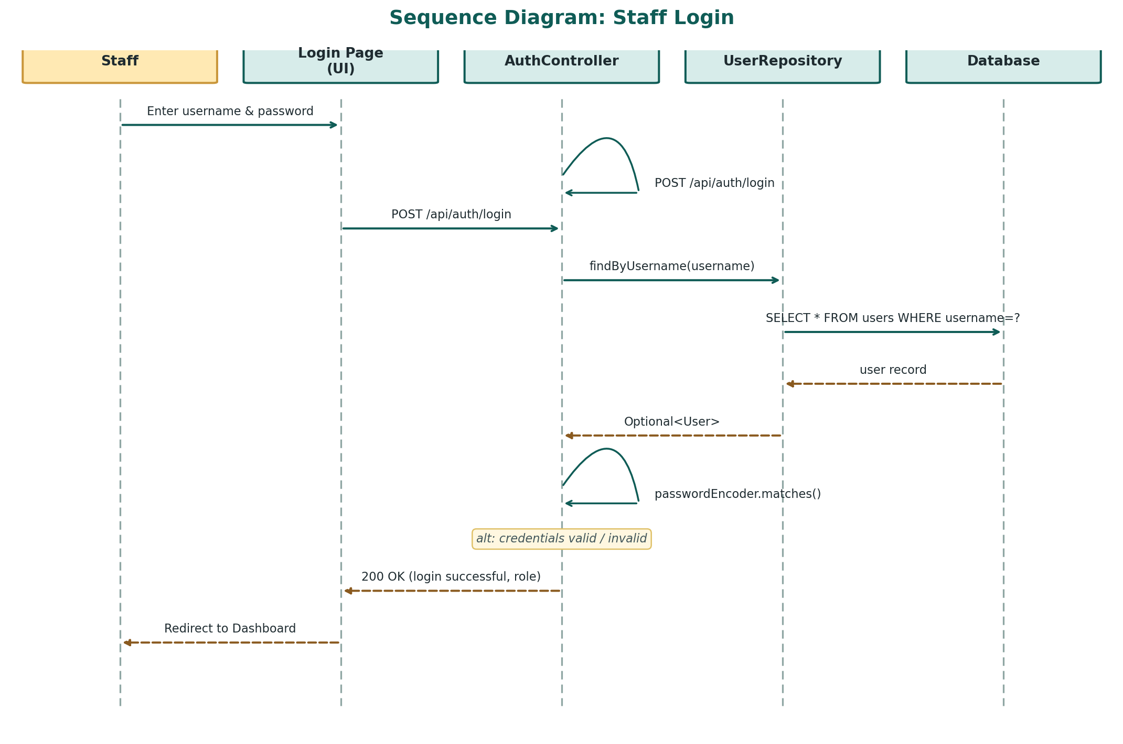
Figure 2.3: Sequence Diagram — Staff Login
The AuthController receives the POST request, delegates to UserRepository to look up the user by username, and uses Spring Security's BCryptPasswordEncoder to compare the submitted password against the stored (hashed) password. The alt fragment shows the two possible outcomes: a successful login returns the user's role and redirects to the dashboard, while an invalid attempt returns HTTP 401 and an error message.
Step-by-step explanation: (1) the staff member types a username and password into the login form and clicks "Login"; (2) the browser's JavaScript sends this as a JSON body in a POST request to /api/auth/login; (3) AuthController calls userRepository.findByUsername(), which queries the users table for a matching row; (4) if a user is found, the controller never compares the raw password directly — instead it calls passwordEncoder.matches(rawPassword, storedHash), which re-hashes the submitted password with the same salt and compares hashes, so the real password is never exposed or logged in plain text at any point; (5) the alt fragment then branches: on success the front end stores the logged-in username for the session and redirects to the dashboard, while on failure the user sees an on-screen "Invalid username or password" message without revealing which of the two was wrong — a deliberate security decision to avoid helping an attacker guess valid usernames.

2.3.2 Sequence Diagram: Register New Appointment
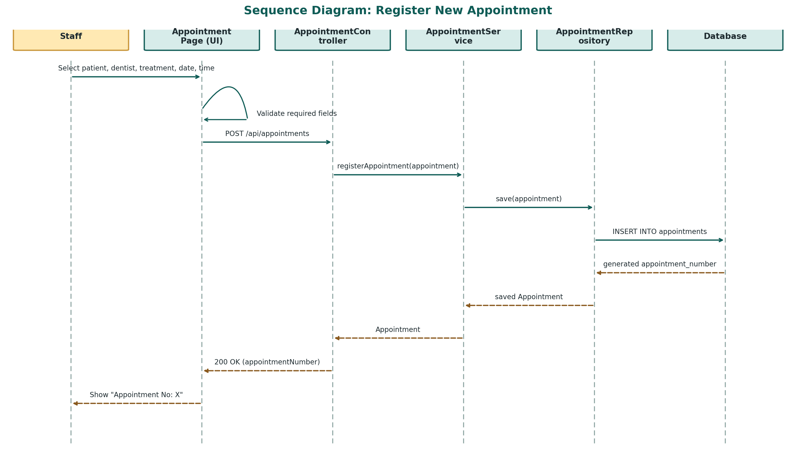
Figure 2.4: Sequence Diagram — Register New Appointment
This diagram demonstrates the DAO pattern in action: AppointmentController delegates business logic to AppointmentService, which in turn calls AppointmentRepository.save(), a Spring Data JPA repository that handles the actual SQL INSERT. The generated appointment_number is returned up through each layer and displayed to the staff member.
Step-by-step explanation: (1) the staff member selects a patient, dentist and treatment from three dropdown menus (each populated at page load from the /api/patients, /api/dentists and /api/treatments endpoints) and picks a date and time; (2) before any network call is made, the JavaScript front end performs a client-side validation check — if any field is empty, the request is never sent and the user sees an immediate on-screen warning, satisfying the brief's requirement to "restrict invalid entries"; (3) once valid, the front end sends a POST request to /api/appointments containing the selected patient/dentist/treatment IDs; (4) AppointmentController passes the object, unchanged, to AppointmentService.registerAppointment(), keeping the controller thin and the business logic centralised in the service layer; (5) AppointmentRepository.save() persists the row and MySQL auto-generates the primary key (appointment_number) using an IDENTITY strategy; (6) that generated number flows back up through every layer, unmodified, so the front end can display it to staff — this returned number is exactly what staff later use to search the appointment (Section 3.5.6) or generate its bill (Section 3.5.7).

2.3.3 Sequence Diagram: Generate Bill
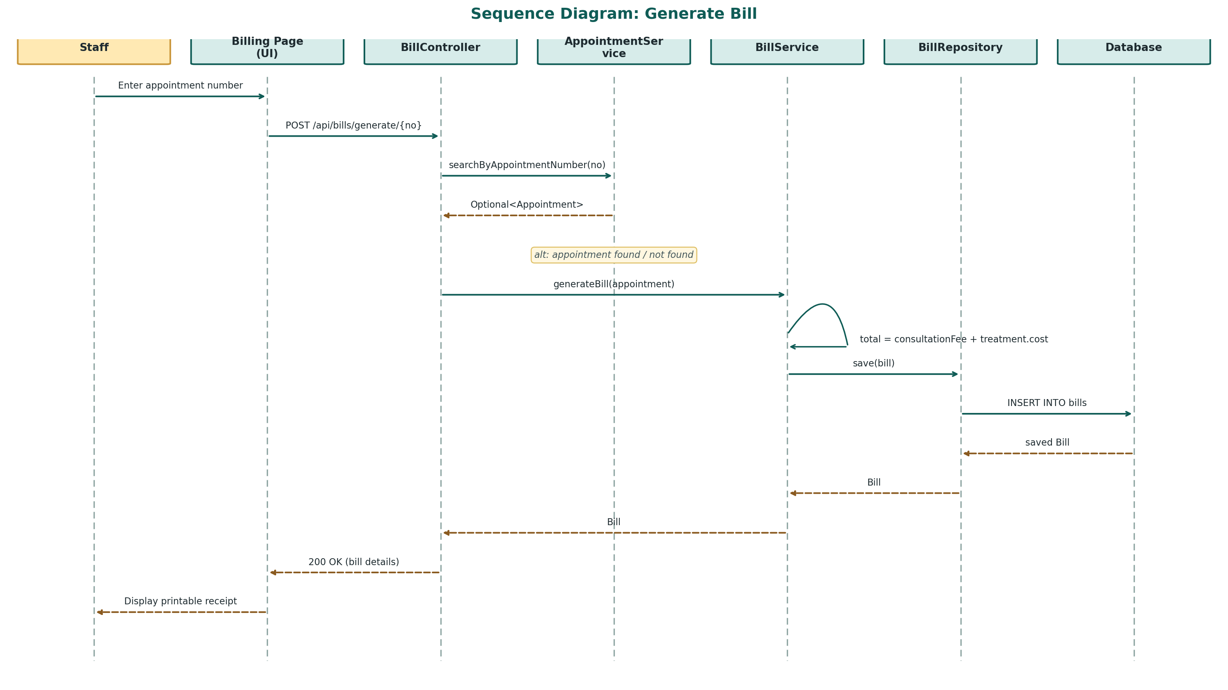
Figure 2.5: Sequence Diagram — Generate Bill
This sequence demonstrates the core billing business rule required by the brief: the total is calculated as the fixed consultation fee plus the selected treatment's cost. The alt fragment shows that a bill can only be generated for an appointment number that exists; otherwise the controller returns HTTP 404.
Step-by-step explanation: (1) staff enter only the appointment number on the Billing page — no other data re-entry is required, because every detail needed for the bill (patient, treatment and its cost) is already stored against that appointment; (2) BillController first asks AppointmentService to look the appointment up, rather than trusting a number typed by the user, so that a mistyped or non-existent appointment number is caught immediately; (3) the alt fragment shows the two outcomes — if the appointment does not exist, the API returns HTTP 404 and the front end shows an error, preventing a bill from ever being created for a non-existent visit; (4) if found, BillService performs the one piece of business arithmetic central to this whole use case: totalAmount = consultationFee + appointment.getTreatment().getCost(), reading the live, current treatment price rather than a value copied earlier, so that if a treatment's price is corrected after the appointment was booked but before the bill is generated, the bill still reflects the correct, up-to-date cost; (5) the resulting Bill entity is persisted (creating a permanent, auditable financial record) and returned to the browser, which renders it as a formatted, printable receipt using the browser's native print dialog — directly satisfying the brief's instruction to "print the patient bill/receipt."

2.4 Design Assumptions
- Only clinic staff use the system directly; patients do not have their own login (in line with the brief's User Authentication requirement restricting access to "authorized staff" only).
- Each appointment is for exactly one treatment type. Multi-treatment visits would require booking multiple appointments, which was considered out of scope for this version.
- The consultation fee is a fixed system-wide value (LKR 500) applied to every bill, in addition to the specific treatment's cost, consistent with the brief's instruction to "calculate the total treatment cost based on treatment type and consultation fee."
- A default administrative account (username: admin) is automatically seeded on first startup so that the system can be evaluated without a separate manual setup step.

3. Task B: Interactive System Development (40 Marks)

3.1 System Overview

3.1.1 What the System Is
The Sunrise Dental Appointment and Patient Management System is a web-based, database-driven administrative application that digitises the day-to-day front-desk operations of Sunrise Dental Clinic. It replaces the clinic's previous paper-based process (physical files and notebooks) with a single, centralised, multi-user system for recording patients, dentists and treatment types, booking and retrieving appointments, and generating bills. Functionally, it sits in the category of a small-scale Hospital/Clinic Management System (a specialised type of Customer Relationship and Scheduling system), built using the Java Spring Boot framework on the back end, a MySQL relational database for persistent storage, and a lightweight HTML/CSS/JavaScript front end delivered directly by the Spring Boot server.

3.1.2 Usage — Who Uses It and How
The system has a single class of user: authenticated clinic staff (e.g. receptionists or administrative assistants), who use it from a desktop or laptop browser at the front desk during clinic hours. Patients do not use the system directly; they continue to interact with staff in person, exactly as in the original scenario. A typical daily usage flow is:
- A staff member logs in at the start of their shift using their assigned username and password.
- When a new patient calls or walks in, the staff member registers the patient once (Section 3.5.2) — returning patients are not re-registered.
- The staff member books an appointment by selecting the existing patient, an available dentist and the required treatment, then records the date and time (Section 3.5.5).
- On the day of the visit, staff can instantly retrieve the full appointment record by its number if needed (Section 3.5.6), instead of searching through paper files.
- After the consultation, staff generate and print the bill directly from the same appointment number (Section 3.5.7), removing the need to manually add up consultation and treatment fees.
- New employees can consult the built-in Help page (Section 3.5.8) instead of requiring one-to-one training from a colleague for basic tasks.

3.1.3 Advantages
- Eliminates double bookings and lost records: because appointments, patients, dentists and treatments are all stored in one shared MySQL database rather than separate paper notebooks, the specific problems named in the assessment scenario are directly solved.
- Faster patient service: retrieving an appointment or generating a bill takes seconds via a search by appointment number, compared with manually searching paper files, directly reducing the "long waiting times" described in the brief.
- Accurate, consistent billing: the total is always calculated by the same server-side formula (consultation fee + treatment cost), removing the manual arithmetic errors described in the original scenario.
- Data integrity through normalisation: because appointments reference patients, dentists and treatments by foreign key rather than by re-typed text, a detail only ever needs to be corrected in one place (e.g. a treatment price change automatically applies to every future bill).
- Low deployment cost: the entire system — web server and application — runs from a single Spring Boot process and an open-source MySQL database, requiring no per-seat commercial licensing fees, which is well suited to a small private clinic's budget.
- Extensible architecture: the layered design (Section 3.2) and RESTful API mean new front ends (e.g. a future mobile app) or new features (e.g. SMS reminders) could be added later by calling the existing API, without having to rewrite the business logic or database layer.

3.1.4 Disadvantages and Limitations
- Single points of failure: the current deployment runs on one local machine with one MySQL instance and no failover; if that machine or the database goes down, the clinic has no fallback other than reverting to paper for that period.
- No patient self-service: patients cannot check or book their own appointments online, so all scheduling work still depends entirely on staff availability during clinic opening hours.
- Basic, single-role authentication: every staff account currently shares the same "STAFF" role and the same level of access; there is no more granular permission model (for example, restricting billing or dentist-record edits to senior staff only) as would be expected in a larger, multi-department clinic.
- Requires basic digital literacy and a stable local network: staff must be comfortable using a browser-based form, and the system currently assumes the client machine and the MySQL server are on the same local network, which would need to be re-architected (e.g. with cloud hosting and HTTPS) before multiple branches could share one instance.
- No built-in appointment-clash checking: the system currently allows two appointments to be booked for the same dentist at the same time, since no scheduling-conflict validation was in scope for this version — this is identified as a priority item for future development.
- Limited reporting: beyond the individual bill receipt, the current version does not yet provide clinic-wide reports (e.g. monthly revenue, most-booked treatment), which a full commercial clinic management product would typically include.

3.2 System Architecture
The system was implemented as a distributed, three-tier web application using Java Spring Boot, satisfying the brief's requirement that "your program must be a distributed application with web services." The three tiers are:
- Presentation tier: static HTML5/CSS3/JavaScript pages (login.html, dashboard.html, patients.html, dentists.html, treatments.html, appointments.html, billing.html, help.html) served by Spring Boot and communicating with the back end purely through asynchronous fetch() calls to REST endpoints.
- Business logic tier: a set of Spring @Service classes (PatientService, DentistService, TreatmentService, AppointmentService, BillService) that implement all business rules, independent of both the web layer and the persistence layer.
- Data access tier: Spring Data JPA repository interfaces backed by Hibernate ORM, connected to a MySQL 8.0 relational database (sunrise_dental_db).
Each REST controller exposes a resource-oriented API (e.g. POST /api/patients, GET /api/appointments/{appointmentNumber}, POST /api/bills/generate/{appointmentNumber}), consistent with the REST architectural style defined by Fielding (2000) and standard RESTful web service design.

3.3 Design Patterns Implemented

3.3.1 Data Access Object (DAO) Pattern
Each entity has a dedicated repository interface (e.g. PatientRepository extends JpaRepository<Patient, Long>) that encapsulates all database access logic. Controllers and services never issue SQL directly; all persistence operations are routed through these DAO interfaces, cleanly separating business logic from data access logic (Gamma et al., 1994; Fowler, 2002).

3.3.2 Model-View-Controller (MVC) / Layered Architecture
The system separates the domain Model (the six JPA entity classes), the View (the static HTML/JS front end), and the Controller (six @RestController classes) that mediates between them. This keeps the presentation layer, business rules and data model independently testable and maintainable.

3.3.3 Dependency Injection / Inversion of Control
Spring's @Autowired annotation is used throughout (e.g. AppointmentController depends on AppointmentService, which depends on AppointmentRepository) so that the framework, not the classes themselves, is responsible for creating and wiring dependencies (Spring, 2024a). This is a critical enabler of the unit testing strategy described in Task C, since Mockito (Mockito, 2024) can substitute mock repositories for real ones without changing any service code.

3.3.4 Singleton Pattern
All Spring-managed beans, including the BCryptPasswordEncoder configured in SecurityConfig, are singleton-scoped by default within the Spring application context, ensuring a single shared, thread-safe instance of the password encoder is used for every authentication request rather than creating a new encoder on every call.

3.4 Security
User passwords are never stored in plain text. SecurityConfig registers a BCryptPasswordEncoder bean — an implementation of the adaptive hashing scheme described by Provos and Mazières (1999) — and DataSeeder uses it to hash the default administrator password before persisting the User entity. AuthController then uses passwordEncoder.matches() to verify login attempts without ever decrypting the stored hash, directly addressing the module's Ethical EDGE requirement of "adhering to data privacy regulations and implementing secure coding practices" and following the authentication guidance in the OWASP Top Ten (OWASP Foundation, 2024).

3.5 Database Design
The database schema is generated automatically from the JPA entity classes via Hibernate (spring.jpa.hibernate.ddl-auto=update), avoiding manual schema drift between the Java model and the database. The resulting sunrise_dental_db schema contains six tables: patients, dentists, treatments, appointments, bills and users, with foreign-key relationships matching the Class Diagram in Section 2.2.
Figure 3.1: MySQL Database Schema
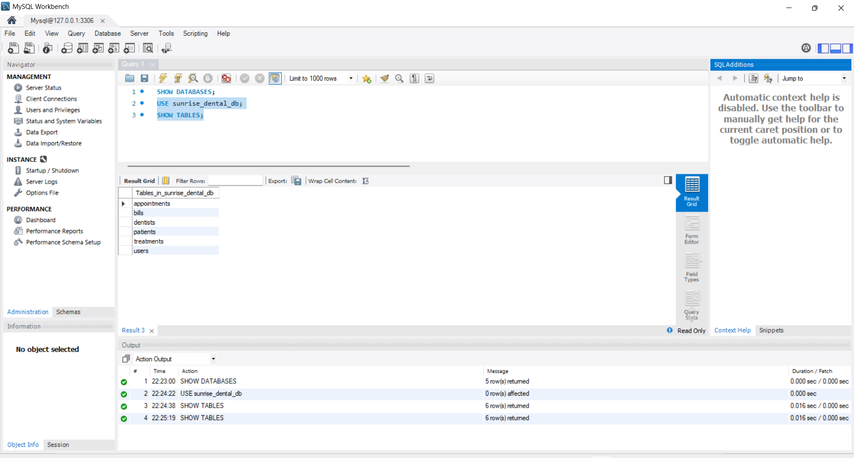
[ INSERT SCREENSHOT HERE ]
What to capture: MySQL Workbench (or the command line) showing the six tables inside the sunrise_dental_db schema, and ideally the columns of the appointments table showing the foreign keys to patients, dentists and treatments.
How to take this screenshot:
1. Open MySQL Workbench and connect to the local MySQL server (root / your password).
2. In the Navigator panel on the left, expand Schemas → sunrise_dental_db → Tables.
3. Right-click the appointments table → "Table Inspector" (or double-click it) to show its columns.
4. Take a screenshot showing the list of six tables and the appointments table structure, then insert it here.

3.6 System Functionality and Screenshots
This section demonstrates each functional requirement from the assessment brief with a corresponding screenshot of the working system, run locally at http://localhost:8080.

3.6.1 User Authentication (Login)
Staff must enter a valid username and password to access the system. Invalid credentials are rejected with an on-screen error message, and the password is verified server-side against the BCrypt hash (see Section 3.3).
Figure 3.2: Login Page
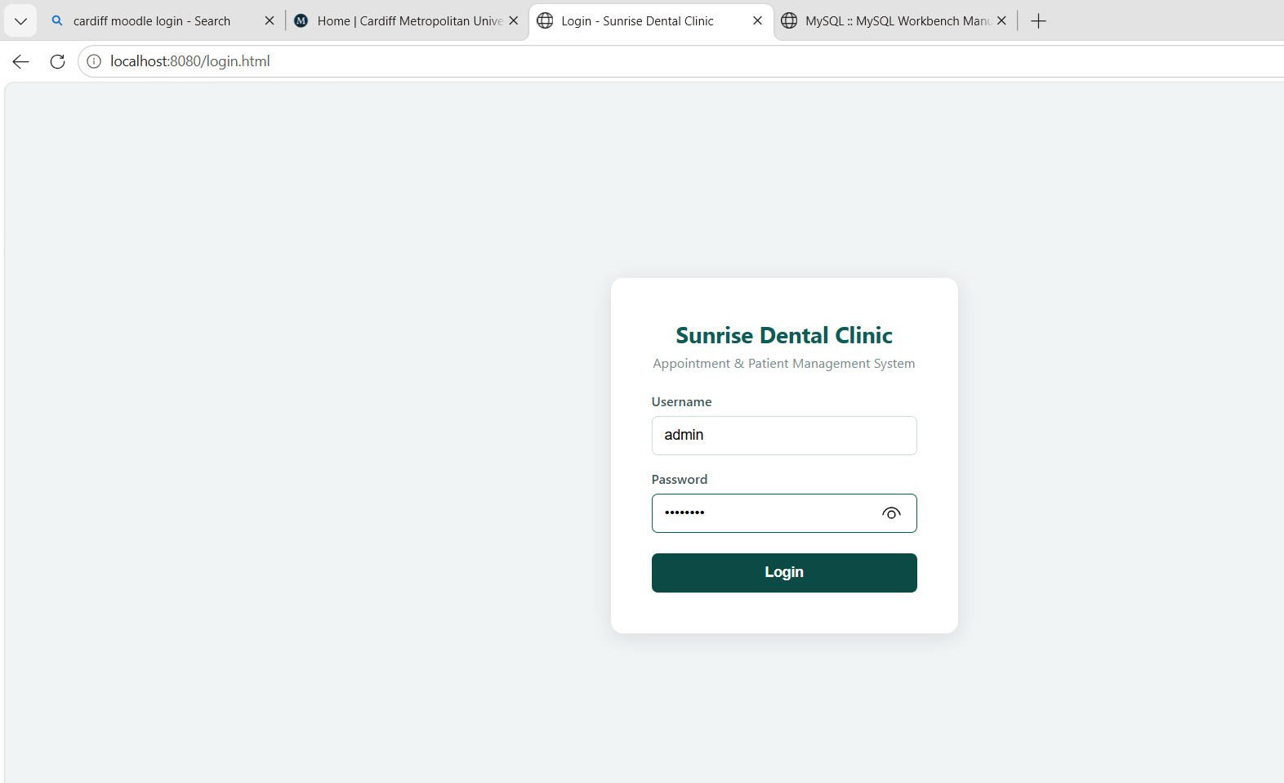
[ INSERT SCREENSHOT HERE ]
What to capture: The Login page with the username and password fields visible, before submitting.
How to take this screenshot:
1. With the application running (gradlew bootRun), open a browser and go to http://localhost:8080/login.html.
2. Take a screenshot of the empty login form.
3. Insert the screenshot here.

3.6.2 Register New Patient
Figure 3.3: Register Patient
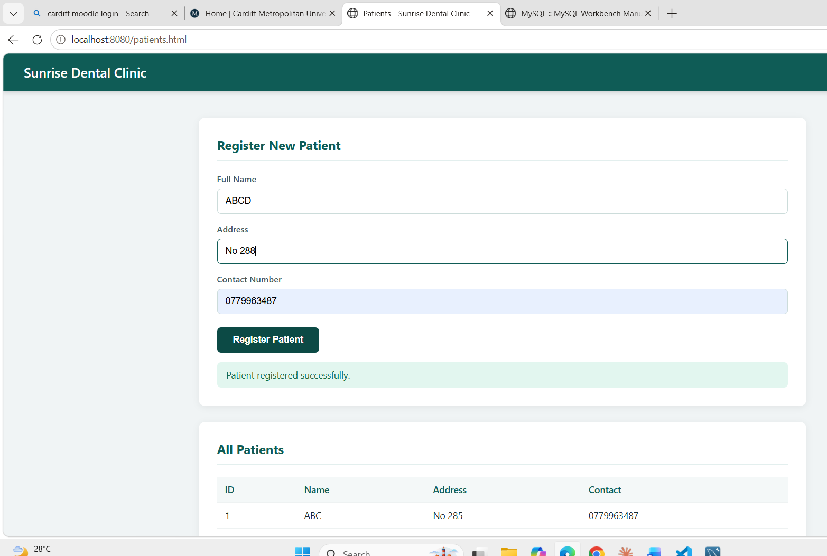
[ INSERT SCREENSHOT HERE ]
What to capture: The "Manage Patients" page showing the registration form filled in with sample data and the resulting patient appearing in the table below.
How to take this screenshot:
1. Log in, then from the Dashboard click "Manage Patients."
2. Fill in Full Name, Address and Contact Number (e.g. Nimal Perera, 45 Galle Road Colombo, 0771234567).
3. Click "Register Patient" and wait for the success message and the new row to appear in the table.
4. Take a screenshot showing the filled form, the success message and the updated table, then insert it here.

3.6.3 Register New Dentist
Figure 3.4: Register Dentist
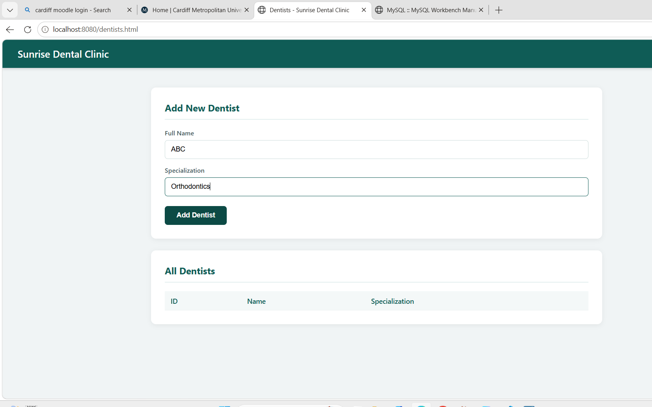
[ INSERT SCREENSHOT HERE ]
What to capture: The "Manage Dentists" page with a dentist added and listed in the table.
How to take this screenshot:
1. From the Dashboard click "Manage Dentists."
2. Enter a name and specialization (e.g. Dr. Kamal Silva, Orthodontics) and click "Add Dentist."
3. Screenshot the success message and the table listing the dentist, then insert it here.

3.6.4 Register New Treatment
Figure 3.5: Register Treatment

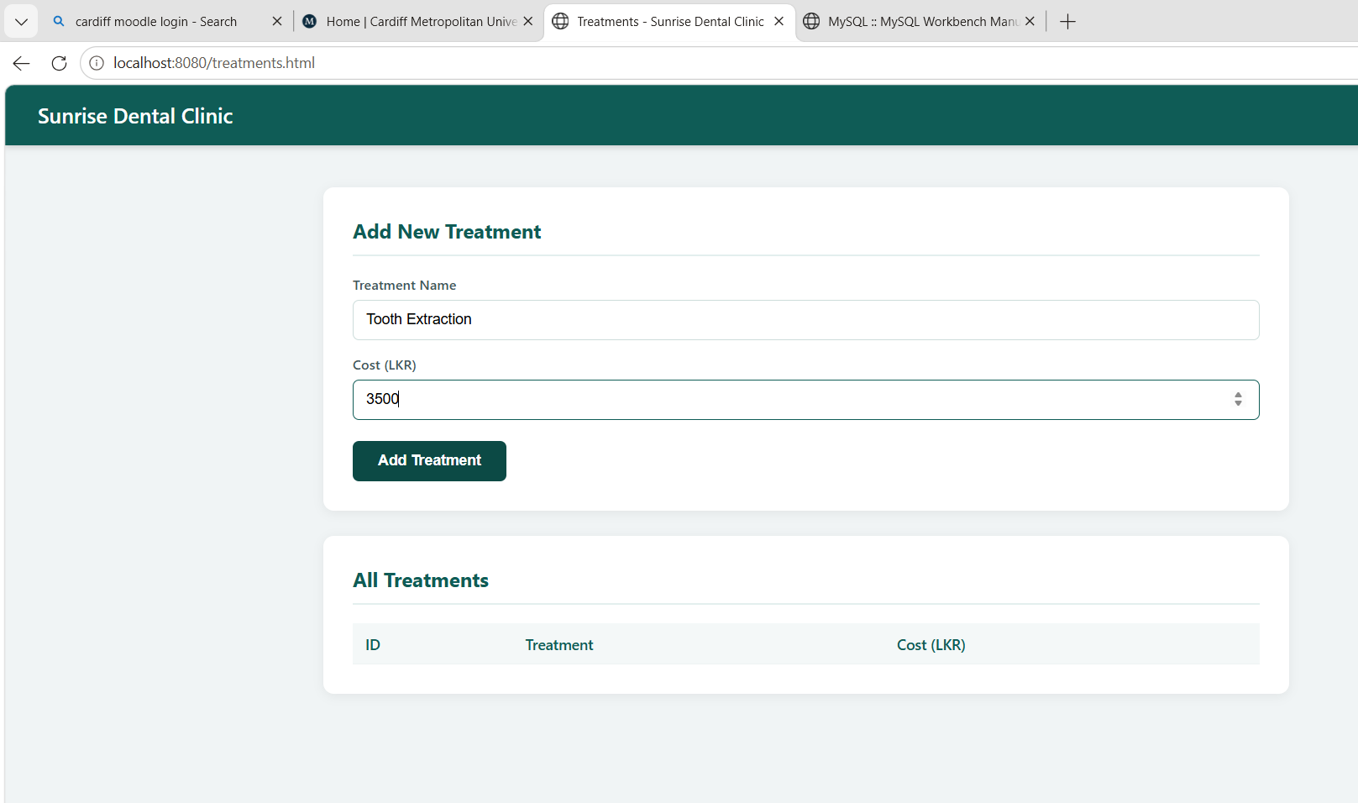
[ INSERT SCREENSHOT HERE ]
What to capture: The "Manage Treatments" page with a treatment type and cost added and listed in the table.
How to take this screenshot:
1. From the Dashboard click "Manage Treatments."
2. Enter a treatment name and cost (e.g. Tooth Extraction, 3500) and click "Add Treatment."
3. Screenshot the success message and the updated table, then insert it here.

3.6.5 Register New Appointment
This satisfies the brief's core requirement to store the appointment number, patient name, address, contact number, dentist name, treatment type and appointment date/time, all linked via foreign keys rather than duplicated as free text.
Figure 3.6: Register Appointment

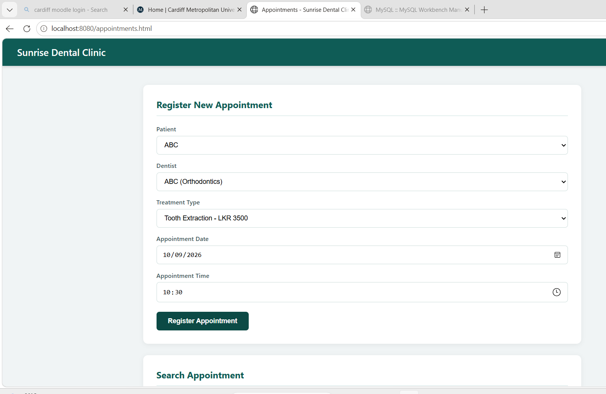

[ INSERT SCREENSHOT HERE ]
What to capture: The "Register / Search Appointment" page with a patient, dentist and treatment selected from the dropdowns, a date and time chosen, and the confirmation message showing the generated appointment number.
How to take this screenshot:
1. Ensure at least one patient, one dentist and one treatment have already been registered (Sections 3.5.2–3.5.4).
2. From the Dashboard click "Register / Search Appointment."
3. Select a patient, dentist and treatment from the three dropdowns, pick a date and time, and click "Register Appointment."
4. Screenshot the confirmation message ("Appointment registered. Appointment No: X") and the appointments table below it, then insert it here.

3.6.6 Display / Search Appointment Details
Figure 3.7: Search Appointment

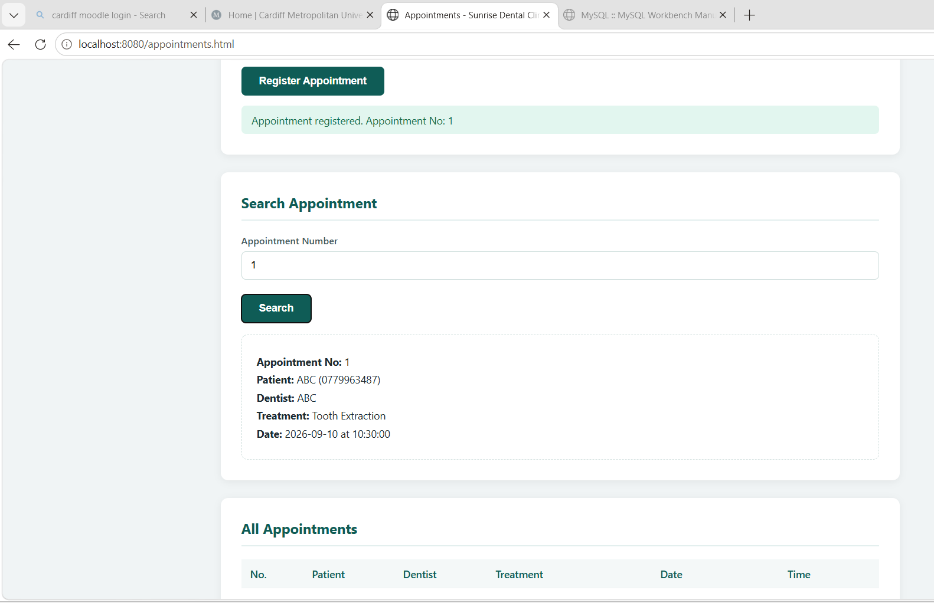
[ INSERT SCREENSHOT HERE ]
What to capture: The Search Appointment box on the same page, showing a full appointment record retrieved by its appointment number.
How to take this screenshot:
1. On the same "Register / Search Appointment" page, scroll to the "Search Appointment" card.
2. Enter the appointment number noted in Figure 3.6 (e.g. 1) and click "Search."
3. Screenshot the box that appears showing the patient, dentist, treatment, date and time, then insert it here.

3.6.7 Calculate and Print Bill
The system automatically calculates the total treatment cost by combining the fixed consultation fee with the selected treatment's cost (see Section 2.3.3 and the BillService business logic), and provides a printable receipt via the browser's print function.
Figure 3.8: Generate Bill / Receipt

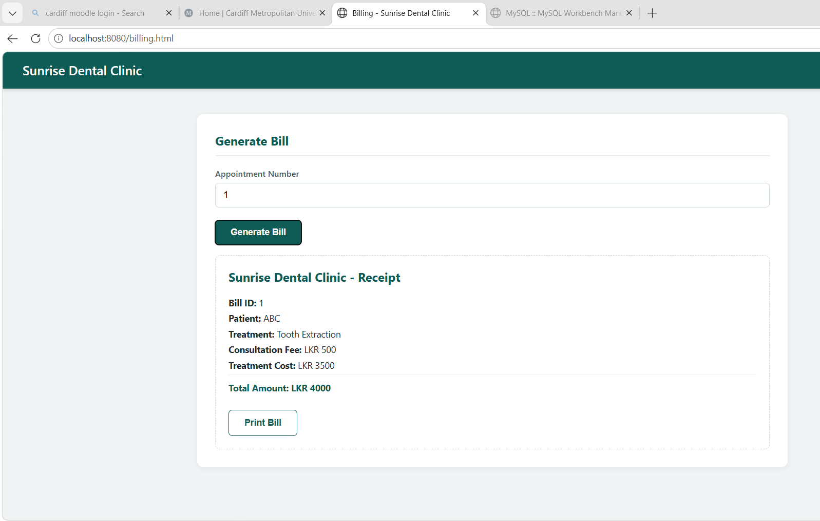
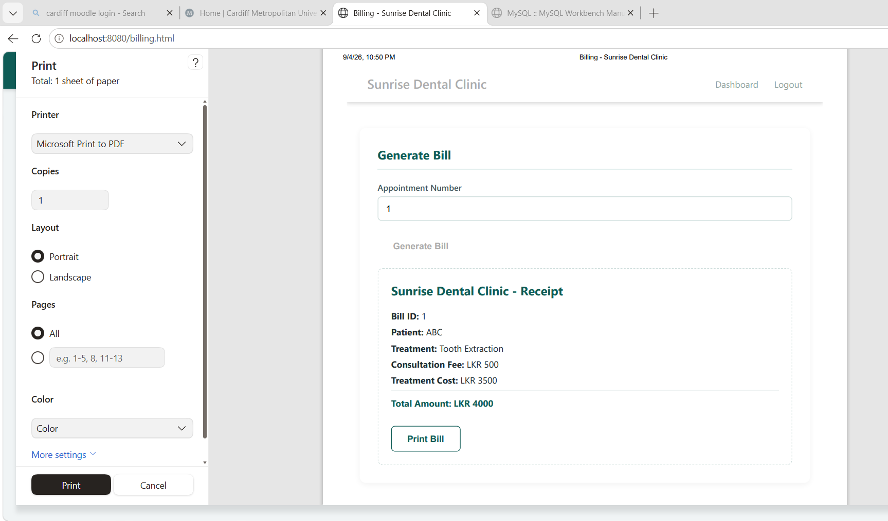
[ INSERT SCREENSHOT HERE ]
What to capture: The Billing page showing the generated receipt with consultation fee, treatment cost and total amount for a specific appointment.
How to take this screenshot:
1. From the Dashboard click "Generate Bill."
2. Enter the same appointment number used in Figure 3.7 and click "Generate Bill."
3. Screenshot the resulting receipt showing patient name, treatment, consultation fee, treatment cost and total amount, then insert it here.

3.6.8 Help Section
Figure 3.9: Help Page

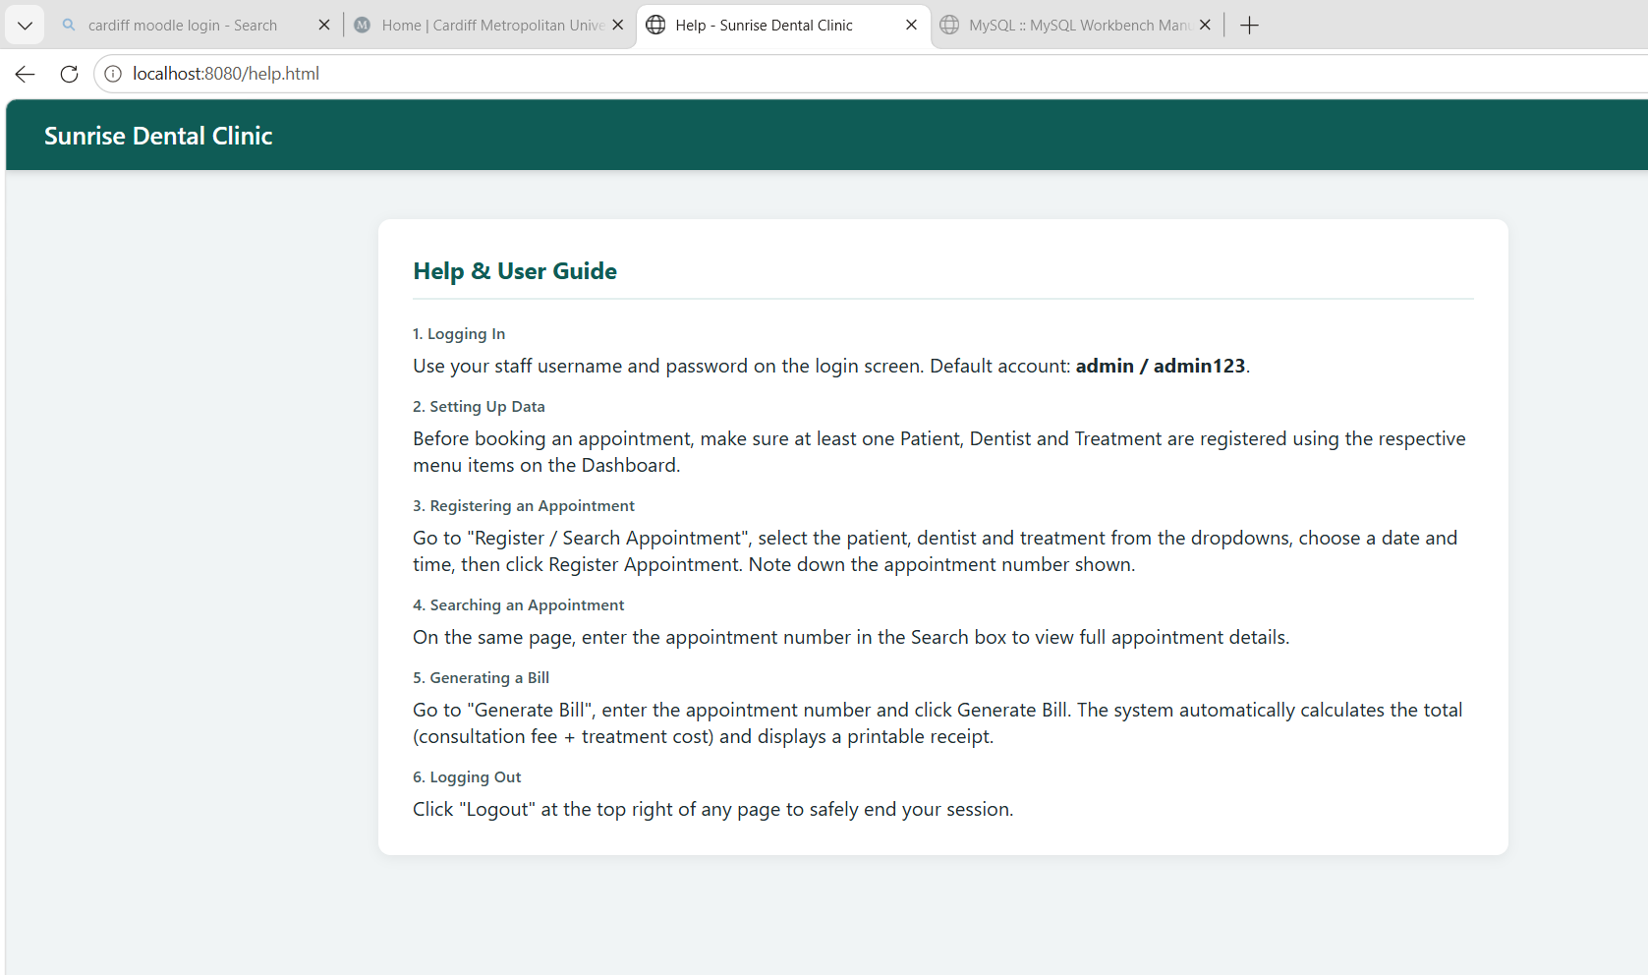
[ INSERT SCREENSHOT HERE ]
What to capture: The Help page providing step-by-step instructions for new staff.
How to take this screenshot:
1. From the Dashboard (or any page) click "Help" in the top-right navigation bar.
2. Screenshot the full help page content, then insert it here.

3.6.9 Exit / Logout
Clicking "Logout" on any page clears the client-side session (sessionStorage) and safely returns the user to the login page, preventing an unauthenticated user from continuing to use a previously logged-in browser tab.

3.7 Input Validation
Validation is applied at two levels: on the client, required HTML5 form attributes and JavaScript checks (e.g. showMsg(msg, 'Please fill all fields.', true)) prevent incomplete submissions; on the server, Spring's @Column(nullable = false) constraints, the Bean Validation starter (spring-boot-starter-validation) and foreign-key constraints prevent invalid or orphaned data from ever reaching the database, satisfying the brief's requirement for "proper validation mechanisms in order to restrict invalid entries."

4. Task C: Testing (20 Marks)

4.1 Testing Rationale and TDD Approach
A Test-Driven Development-influenced approach (Beck, 2002) was adopted for the service (business logic) layer, since this is where the system's core rules live (bill calculation, appointment lookup, authentication logic) and where regressions would be most costly. Rather than testing against a live MySQL database — which would make tests slow, order-dependent and environment-specific — the Mockito framework (Mockito, 2024) was used to mock the repository layer, isolating each service class under test from the database entirely. This allows the full test suite, written against the JUnit 5 platform (OpenJUnit Team, 2024), to run in seconds, in any environment (including the GitHub Actions CI runner described in Task D), without requiring a MySQL server to be installed.
Each test follows the standard Arrange-Act-Assert structure: a mock repository is configured to return a known object (Arrange), the service method under test is called (Act), and JUnit 5 assertions verify both the returned value and that the correct repository method was invoked exactly once (Assert), using Mockito's verify().

4.2 Test Plan and Test Data
The table below summarises the test plan: which class is tested, what scenario each test covers, the test data used, and the expected outcome.
Test Class | Scenario | Test Data | Expected Result
PatientServiceTest | Register a valid patient | name="Nimal Perera", address, contact | Patient is saved and returned unchanged
PatientServiceTest | Retrieve all patients | Mocked list of 2 patients | Service returns list of size 2
PatientServiceTest | Find patient by valid ID | patientId = 1 | Optional containing the patient is returned
PatientServiceTest | Find patient by invalid ID | patientId = 99 (not mocked) | Optional.empty() is returned
DentistServiceTest | Add a valid dentist | name, specialization | Dentist is saved and returned
TreatmentServiceTest | Add a valid treatment | name="Tooth Extraction", cost=3500.00 | Treatment saved with correct cost
AppointmentServiceTest | Register a valid appointment | patient, dentist, treatment, date, time | Appointment saved with generated number
AppointmentServiceTest | Search by valid number | appointmentNumber = 1 | Correct appointment is returned
AppointmentServiceTest | Search by invalid number | appointmentNumber = 999 | Optional.empty() is returned
BillServiceTest | Generate bill — correct total | consultationFee=500, treatmentCost=3500 | totalAmount = 4000.00
BillServiceTest | Generate bill — correct linkage | appointment #1 | Bill.getAppointment() references appointment #1

4.3 Test Automation
All 14 tests are fully automated using JUnit 5 (Jupiter) and Mockito, organised into five test classes under src/test/java/com/example/demo/service/, mirroring the package structure of the classes under test: PatientServiceTest, DentistServiceTest, TreatmentServiceTest, AppointmentServiceTest and BillServiceTest. The tests are executed with a single command, gradlew test, and automatically on every push via the GitHub Actions workflow described in Section 5.2.

4.4 Test Results
The full test suite was executed locally using gradlew clean test. Gradle generates an HTML report at build/reports/tests/test/index.html summarising every test class and method with a pass/fail status.
Figure 4.1: JUnit Test Results — Gradle HTML Report
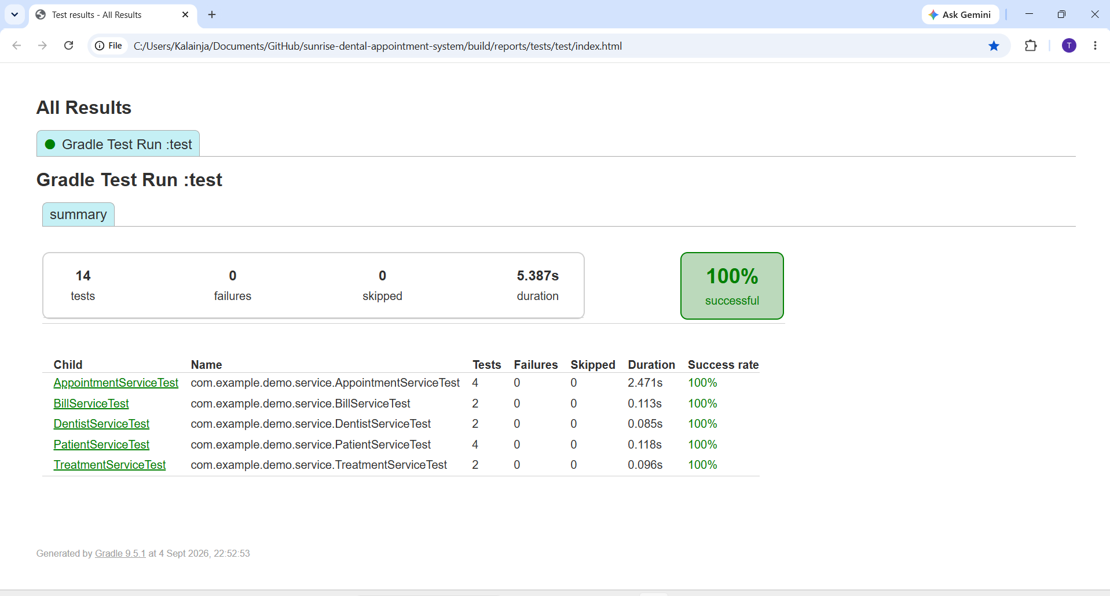
[ INSERT SCREENSHOT HERE ]
What to capture: The Gradle test report summary page showing all 5 test classes, 14 total tests, 0 failures and a 100% success rate.
How to take this screenshot:
1. In VS Code, open a terminal in the project folder and run: gradlew clean test
2. Wait for "BUILD SUCCESSFUL" to appear.
3. In File Explorer, open: build\reports\tests\test\index.html (double-click to open it in your browser).
4. Screenshot the "All Results" summary page (showing tests, failures, skipped and success rate), then insert it here.

4.5 Evaluation of Testing
The test suite achieved a 100% pass rate across all 14 tests (0 failures, 0 skipped). Mocking the repository layer proved effective at isolating business logic defects from infrastructure issues (e.g. database connectivity), and the same tests execute identically on a developer machine and on the GitHub Actions CI runner, which does not have MySQL installed — directly demonstrating the value of Dependency Injection (Section 3.2.3) for testability.
Traceability: each functional requirement in the assessment brief maps to at least one automated test — for example, the requirement to "calculate the total treatment cost based on treatment type and consultation fee" is directly verified by BillServiceTest.testGenerateBill_CorrectTotal(), which asserts that totalAmount always equals consultationFee + treatmentCost.
A limitation of the current test suite is that it covers the service (business logic) layer only; it does not include controller-level integration tests (e.g. using MockMvc) or end-to-end browser tests of the JavaScript front end. Given more time, @WebMvcTest-based controller tests and a small Selenium/Playwright suite covering the login-to-bill-generation user journey would further strengthen confidence in the deployed system.

5. Task D: Version Control and CI/CD (20 Marks)

5.1 Git and GitHub Workflow
The project is hosted in a public GitHub repository at https://github.com/Thivyaarudselvam/sunrise-dental-appointment-system (also linked on the cover page of this report), and managed throughout development using GitHub Desktop. Development proceeded through an incremental, feature-by-feature workflow: the project skeleton and dependencies were committed first, followed by separate commits for the JPA entity classes, the repository (DAO) layer, the service layer, the REST controllers and security configuration, the front-end pages, the UML diagrams, the JUnit test suite, and finally the CI/CD workflow itself — each functional increment committed and pushed to GitHub individually with a descriptive commit message, rather than as a single bulk upload.
Figure 5.1: Commit History
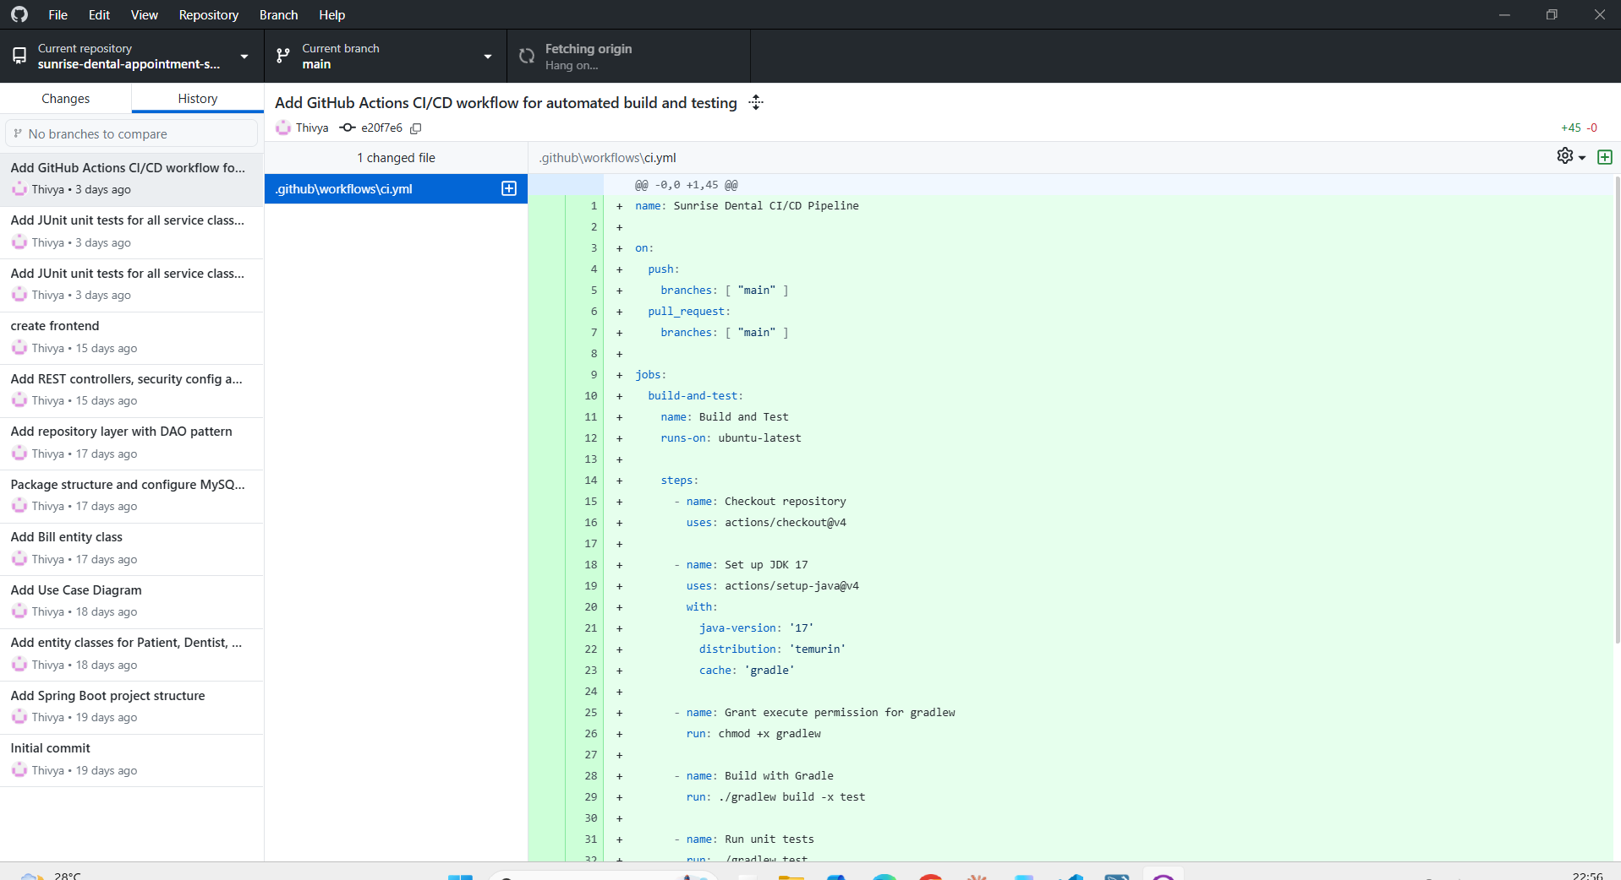
[ INSERT SCREENSHOT HERE ]
What to capture: The GitHub repository's commit history page (or GitHub Desktop's History tab) showing the sequence of incremental, descriptively-named commits.
How to take this screenshot:
1. Open the repository on GitHub.com and click the commit-count link near the top of the Code tab (e.g. "20 Commits"), OR open GitHub Desktop and click the "History" tab.
2. Take a screenshot showing at least 8–10 commits with their messages and relative timestamps visible.
3. Insert the screenshot here.

Figure 5.2: Successful Push Confirmation
[ INSERT SCREENSHOT HERE ]
What to capture: GitHub Desktop immediately after pushing a commit, showing the "Push origin" action has completed with no pending local commits left to push (or the equivalent "synced" state).
How to take this screenshot:
1. In GitHub Desktop, make a small commit (or use your most recent one) and click "Push origin."
2. Wait for the push to finish — the button area will no longer show an upward arrow with a pending commit count.
3. Screenshot the GitHub Desktop window showing the repository is up to date with origin/main, then insert it here.

5.2 CI/CD Pipeline (GitHub Actions)
A continuous integration pipeline was implemented using GitHub Actions, defined in .github/workflows/ci.yml. The workflow triggers automatically on every push (or pull request) to the main branch and performs the following steps: checks out the repository, installs a Temurin JDK 17 toolchain, builds the Spring Boot application with Gradle, runs the full JUnit test suite, and uploads both the test report and the compiled JAR file as downloadable build artifacts. This demonstrates an automated build-and-test deployment pipeline triggered directly from the Git repository, rather than a manual, ad-hoc build process.
Figure 5.3: GitHub Actions — Successful CI/CD Run
[ INSERT SCREENSHOT HERE ]
What to capture: The GitHub Actions run summary page showing "Status: Success," the total duration, the "Build and Test" job with a green checkmark, and the list of generated artifacts.
How to take this screenshot:
1. On GitHub.com, open the repository and click the "Actions" tab.
2. Click the most recent workflow run ("Add GitHub Actions CI/CD workflow..." or any later run).
3. Screenshot the summary page showing the green "Success" status, duration and artifacts count, then insert it here.

5.3 Version Control Techniques Used
- .gitignore configured from the start (via the GitHub "Java" template) to exclude the build/ output directory and IDE-specific files from version control, keeping the repository focused on source code.
- Descriptive, imperative-mood commit messages (e.g. "Add repository layer with DAO pattern," "Add JUnit unit tests for all service classes and sequence diagrams") documenting the intent of each change, rather than generic messages such as "update."
- The repository was kept public throughout development, as required by the assessment brief, so that the module leader can inspect the full commit history and evolution of the codebase at any time.
- Continuous Integration was added once the core application, its tests, and its diagrams were in place, automatically re-verifying the build and test suite on every subsequent push — catching any regression immediately rather than at submission time.

6. Conclusion
This project successfully delivers a working, distributed Appointment and Patient Management System for Sunrise Dental Clinic that replaces the previous paper-based process described in the assessment scenario. The system was designed using standard UML artefacts (Use Case, Class and Sequence diagrams), implemented as a three-tier Spring Boot web application applying the DAO, MVC and Dependency Injection design patterns, secured with BCrypt password hashing, verified with a fully automated JUnit/Mockito test suite achieving a 100% pass rate, and deployed through a Git/GitHub workflow with a working GitHub Actions CI/CD pipeline.
Overall, the completed system satisfies every functional requirement listed in the assessment brief — user authentication, appointment registration, appointment search, bill calculation and printing, a help section, and a safe exit/logout — while also meeting the non-functional requirements of using a proper relational database, implementing recognised design patterns, and demonstrating professional software engineering practices such as automated testing and continuous integration.

7. References
All sources are listed alphabetically by author surname / organisation name, in Harvard referencing style, as required by the assessment brief.
Baeldung (2024) Baeldung: Spring, Java and Related Technologies. Available at: https://www.baeldung.com/ (Accessed: [date]).
Beck, K. (2002) Test Driven Development: By Example. Boston: Addison-Wesley.
Fielding, R.T. (2000) Architectural Styles and the Design of Network-based Software Architectures. PhD thesis. University of California, Irvine. Available at: https://ics.uci.edu/~fielding/pubs/dissertation/top.htm (Accessed: [date]).
Fowler, M. (2002) Patterns of Enterprise Application Architecture. Boston: Addison-Wesley.
Gamma, E., Helm, R., Johnson, R. and Vlissides, J. (1994) Design Patterns: Elements of Reusable Object-Oriented Software. Boston: Addison-Wesley.
GitHub (2024a) GitHub Actions Documentation. Available at: https://docs.github.com/en/actions (Accessed: [date]).
GitHub (2024b) GitHub Docs: About Version Control. Available at: https://docs.github.com/en/get-started/using-git/about-git (Accessed: [date]).
Hibernate (2024) Hibernate ORM 6.x User Guide. Available at: https://hibernate.org/orm/documentation/6.4/ (Accessed: [date]).
Mockito (2024) Mockito Framework Site — Official Documentation. Available at: https://site.mockito.org/ (Accessed: [date]).
Mozilla Developer Network (2024) JavaScript Guide. Available at: https://developer.mozilla.org/en-US/docs/Web/JavaScript/Guide (Accessed: [date]).
MySQL (2024) MySQL 8.0 Reference Manual. Available at: https://dev.mysql.com/doc/refman/8.0/en/ (Accessed: [date]).
OpenJUnit Team (2024) JUnit 5 User Guide. Available at: https://junit.org/junit5/docs/current/user-guide/ (Accessed: [date]).
Oracle (2024) Java Persistence API (JPA) Specification. Available at: https://jakarta.ee/specifications/persistence/ (Accessed: [date]).
Oracle (2024) The Java Tutorials. Available at: https://docs.oracle.com/javase/tutorial/ (Accessed: [date]).
OWASP Foundation (2024) OWASP Top Ten — Web Application Security Risks. Available at: https://owasp.org/www-project-top-ten/ (Accessed: [date]).
Provos, N. and Mazières, D. (1999) 'A Future-Adaptable Password Scheme', Proceedings of the 1999 USENIX Annual Technical Conference. Available at: https://www.usenix.org/legacy/events/usenix99/provos.html (Accessed: [date]).
Spring (2024a) Spring Boot Reference Documentation. Available at: https://docs.spring.io/spring-boot/index.html (Accessed: [date]).
Spring (2024b) Spring Data JPA — Reference Documentation. Available at: https://docs.spring.io/spring-data/jpa/reference/ (Accessed: [date]).
Spring (2024c) Spring Security Reference. Available at: https://docs.spring.io/spring-security/reference/ (Accessed: [date]).
W3Schools (2024) HTML and CSS Tutorials. Available at: https://www.w3schools.com/ (Accessed: [date]).
Note: replace every [date] placeholder above with the actual date you accessed that source (format: DD Month YYYY, e.g. 28 August 2026). Add or remove entries so the list matches exactly which sources you personally consulted — do not cite a source you did not actually use.

