CASE STUDY
PROJECT DESIGN STEPS

STEP 1: Write out the format of every input document and every report, and the input and output screens for every routine transaction to be performed against the database.

STEP 2: Study the environment and write out the list of assumptions for the project.

STEP 3: Draw a Data-flow diagram for the organization

STEP 4: Write out a user-oriented data dictionary, consisting of an alphabetical list of every data item referenced in any report or routine transaction and an informal definition for each item.

STEP 5: Draw cross-reference table showing the data items appear on which documents, reports, or transactions.

STEP 6: Make a list of all entities and their associated attributes.

STEP 7: Make a list of relationships to be represented and any descriptive attributes for them.

STEP 8: Draw an Entity-Relationship Diagram to represent the enterprise. Identify relationship cardinalities, any weak entity sets, and role names, if needed. Also use generalization and aggregation as necessary to express the relationships.

STEP 9: Examine E-R diagram developed in STEP 8 and map it to a relational model using transformation guidelines.

STEP 10: Make a list of all attributes to be stored in the database, called a Universal Relation. Universal relation for the case study consists of the following attributes

STEP 11: Foe each table identified in STEP-10, identify functional dependencies, multi-valued dependencies, and join dependencies, and normalize the relation. Then decide whether the table should be implemented in the highest normal form. If not, explain why.

STEP-12: Write SQL statements to create all Tables needed to implement the design in Oracle

STEP-13: Write SQL statements that will process non-routine requests for information from the database created.

STEP-14: Customize the application by using front-end tools

CASE STUDY

PROBLEM DESCRIPTION:
The Training and Placement (T&P) Cell is an agency within the institute that provides placement assistance to graduating students. The institute is interested in developing a database system to control its operations due to the continuing expansion of recruiting companies and student enrollments.
BASIC OPERATIONS:
The T&P Cell is managed by the Placement Officer. The officer is assisted by student coordinators and department faculty representatives. The Placement Officer oversees all operations of the cell. The student coordinators register students, verify academic credentials, and assist in coordinating interviews. The Placement Officer communicates with all companies, accepts job postings, and enforces the institute's placement policies (such as the 2.5 LPA dream offer rule).
INFORMATION NEEDS:
The database will be used to keep track of student academic records, company profiles, job postings, and applications. The system should be capable of producing a variety of periodic reports and performing several online transactions. The most crucial and time-sensitive transaction is matching students to job requests and verifying their eligibility for "Dream Offers." Performing this step manually is a laborious process that involves cross-checking a student's current highest CTC against the new job's CTC.

PROJECT DESIGN STEPS:
STEP 1: Write out the format of every input document and every report, and the input and output screens for every routine transaction to be performed against the database.
The following forms are used to provide information:
- STUDENT REGISTRATION FORM: This form is filled by a prospective student applying for placements.
Date of application ___________________
Roll Number _______________________ Name_______________________________________ Department______________________________________ Email____________________________________________ Telephone_______________________
*Date of birth __________________ *Gender __________________
Academic Details:
Current CGPA ____________ 10th % ____________ 12th % ____________
Core Skills:
____ C++ _____ Java _____ Python _____ SQL _____ Web Dev
(To be verified by T&P Coordinator)
Verified By _________ Date Verified __________

- COMPANY REGISTRATION FORM: The form shown below is filled in by companies.
Company Name _______________________________________________________ Industry Type _____________________________________________________
HR Contact Person ____________________________________________________ HR Email _________________________________________________________
HR Telephone ___________________________________________________ Company ID (Issued by System) ___________________________________

- JOB POSTING FORM: This form is filled in by the HR representative.
Company ID _____________________________________________________
Job Title _____________________________________________________
Base CTC (in LPA) __________________
Minimum CGPA Required _____________________
Eligible Departments ___________________________________________
Interview Date ______________________
Application Deadline ______________
Job # (Issued by System) _____________

The following reports are needed periodically:
PLACEMENT STATUS REPORT:
Placement Report for period from mm/dd/yy to mm/dd/yy
Roll No | Name | Dept | Company ID | Job Title | CTC Offered
XXXXXX | XXXXXXXXXX | XXXX | XXXXXX | XXXXXXXXXX | 99.99
XXXXXX | XXXXXXXXXX | XXXX | XXXXXX | XXXXXXXXXX | 99.99

TOTAL OFFERS: 9999
CTC UPGRADE ELIGIBILITY REPORT:
Roll No | Name | Current CTC | Job # | New Job Title | New CTC Offered
XXXXXX | XXXXXXXXXX | 99.99 | XXXXXX | XXXXXXXXXX | 99.99
XXXXXX | XXXXXXXXXX | 99.99 | XXXXXX | XXXXXXXXXX | 99.99

STEP 2: Study the environment and write out the list of assumptions for the project.

LIST OF ASSUMPTIONS FOR THE CASE STUDY
A. Student Registration & Eligibility Rules
- Academic Cohort: Only bona fide final-year undergraduate and postgraduate students are permitted to register in the placement database.

- Backlog Constraint: Students must have zero active academic backlogs at the time of registration to be eligible for the standard placement process.

- Data Verification: Student academic data (CGPA, 10th/12th percentages) is imported or manually verified by the T&P Admin. Students cannot unilaterally edit their CGPA after the initial verification.
B. Company & Job Posting Rules
- Job Announcement Form (JAF): Companies must fill out a JAF (equivalent to the Job Posting Form) at least one week prior to their visit.

- Multiple Profiles: A single company can post multiple, distinct job profiles (e.g., Software Developer, Business Analyst) during the same academic year. Each profile will have its own unique JOB_ID.

- Financial Standardization: All salary figures (Cost to Company - CTC) are strictly recorded as decimal values representing Lakhs Per Annum (LPA) to allow for mathematical comparisons (e.g., 10.50 LPA).
C. Application & Interview Rules
- Application Freedom: An unplaced student can concurrently apply to an unlimited number of job profiles, provided they meet the specific MIN_CGPA and department eligibility criteria set by the company.

- Strict Deadlines: The system will not accept any student applications for a job after its specified "Application Deadline" has passed.

- Withdrawal Policy: Once a student applies for a job, they cannot withdraw their application. If shortlisted, they must attend the interview.
D. Offer & Placement Policies (The "Dream Offer" Logic)
- The Baseline Offer: Once a student accepts their first final placement offer, their PLACEMENT_STATUS automatically updates to "Placed."

- Standard Lockout: A "Placed" student is immediately locked out of applying to any regular, newly posted job profiles.

- The "Dream Offer" Exception (2.5 LPA Rule): A placed student may only apply to a new job profile if the base CTC of the new job is strictly 2.5 LPA higher than the student's CURRENT_HIGHEST_CTC.

- Offer Limit: A student can hold a maximum of two offers during the placement season (One standard offer and one "Dream" offer). If a student secures a Dream offer, they are permanently removed from the placement process and cannot participate further, regardless of future CTCs.
E. System & Administrative Assumptions
- Timeframe: The database operations are assumed to be for a single academic placement season (e.g., August to May). Historical data from previous years is archived and not actively queried in the daily routine transactions.

- Status Flow: An application's status moves linearly: Pending Interviewing Offered Accepted/Rejected.

Notes: In real-life, the assumptions listed in Step 2 would be developed and finalized only after extensive meetings and interviews with the Training & Placement Officer, academic deans, and student representatives. For the purpose of this project, assume that these requirements-gathering meetings have already taken place and the placement policies (such as the 2.5 LPA dream offer rule) have been officially signed off by the institute's administration. Additional assumptions can be added to this list as we progress through the database design if new edge cases are discovered.

Instructor Notes: Emphasize the critical importance of Step 2 in the database design lifecycle. Mention what will happen to the design if these business rules are not properly handled early on. For example, failing to identify the "Dream Offer" policy at this stage would result in missing the CURRENT_HIGHEST_CTC attribute in the STUDENT table, which would ultimately break the system's ability to enforce placement rules and require a costly database redesign later.

STEP 3: Draw a Data-flow diagram for the organization
Notes: Data flow diagrams (DFDs) and data dictionaries are highly useful design tools. A DFD is a graphical depiction of the flow of data through an organization. It provides a useful model for communicating with end-users (like the T&P staff and students), other designers, and managers about the present manual system and the proposed automated database system. In your final physical report, the textual flows described above should be translated into standard DFD notation using circles (processes), open rectangles (data stores), squares (external entities), and arrows (data flow).

STEP 4: Write out a user-oriented data dictionary, consisting of an alphabetical list of every data item referenced in any report or routine transaction and an informal definition for each item.
The user-oriented data dictionary for the Campus Placement Management System is:
APP_DATE | The date the student successfully submitted the job application.
APP_ID | A unique, system-generated identifier for a specific student's job application.
APP_STATUS | The current stage of the application in the recruitment pipeline (e.g., Pending, Interviewing, Offered, Accepted, Rejected).
CGPA | The student's current cumulative grade point average (out of 10.00).
COMP_ID | The unique, system-generated identifier assigned to each recruiting company.
COMP_NAME | The official registered name of the recruiting company.
CORE_SKILLS | A list of the student's primary technical competencies (e.g., C++, Java, Python, SQL) verified by the T&P cell.
CTC | The Cost to Company or base salary offered for a specific job profile, recorded strictly as a decimal in Lakhs Per Annum (LPA).
CURRENT_HIGHEST_CTC | The highest CTC a student has officially accepted so far (defaults to 0.00 for unplaced students). Used to calculate eligibility for Dream Offers.
DEPT | The academic department or branch of the registered student (e.g., CSE, ECE, ME, CE).
DOB | The date of birth of the student.
ELIGIBLE_DEPTS | A designated list of academic departments that are permitted by the company to apply for a specific job profile.
EMAIL | The official institute or personal email address of the student used for placement communications.
GENDER | The identified gender of the student.
HR_EMAIL | The official corporate email address of the company's primary HR contact person.
HR_NAME | The full name of the primary HR contact or recruiter representing the company.
HR_PHONE | The direct contact telephone or mobile number for the company's HR representative.
INDUSTRY_TYPE | The primary business sector or domain of the recruiting company (e.g., IT, Finance, Core Engineering, Consulting).
INTERVIEW_DATE | The scheduled date for the company's selection process or interview rounds.
JOB_DESC | A brief textual description or summary of the responsibilities and requirements for a job profile.
JOB_ID | A unique, system-generated identifier for a specific job posting.
JOB_TITLE | The designation or role being offered by the company (e.g., Software Development Engineer, Business Analyst).
MIN_CGPA | The minimum academic grade point average strictly required for a student to be eligible to apply for a job.
NAME | The full legal name of the registered student.
PHONE | The primary mobile or contact number of the student.
PLACEMENT_STATUS | The current overarching placement status of the student within the institute's system (e.g., Unplaced, Placed).
ROLL_NO | The unique university identification number assigned to the student.
TENTH_PCT | The percentage of marks obtained by the student in their 10th standard (matriculation) board examinations.
TWELFTH_PCT | The percentage of marks obtained by the student in their 12th standard (higher secondary) board examinations.
STEP 5: Draw cross-reference table showing the data items appear on which documents, reports, or transactions.

Below is the cross-reference matrix for the Campus Placement Management System. An "X" indicates that the specific data item is captured, displayed, or utilized in the corresponding document, transaction screen, or report.
DATA ITEM | Student Reg. Form | Company Reg. Form | Job Posting Form | Application Screen | Placement Report | CTC Upgrade Report
APP_DATE |  |  |  | X
APP_ID |  |  |  | X
APP_STATUS |  |  |  | X | X
CGPA | X |  | X
COMP_ID |  | X | X |  | X | X
COMP_NAME |  | X |  |  | X
CORE_SKILLS | X
CTC |  |  | X |  | X | X
CURRENT_HIGHEST_CTC |  |  |  | X |  | X
DEPT | X |  |  |  | X
DOB | X
ELIGIBLE_DEPTS |  |  | X
EMAIL | X
GENDER | X
HR_EMAIL |  | X
HR_NAME |  | X
HR_PHONE |  | X
INDUSTRY_TYPE |  | X
INTERVIEW_DATE |  |  | X
JOB_DESC |  |  | X
JOB_ID |  |  | X | X |  | X
JOB_TITLE |  |  | X |  | X | X
MIN_CGPA |  |  | X
NAME | X |  |  |  | X | X
PHONE | X
PLACEMENT_STATUS |  |  |  |  | X
ROLL_NO | X |  |  | X | X | X
TENTH_PCT | X
TWELFTH_PCT | X

STEP 6: Make a list of all entities and their associated attributes.

ENTITY | ATTRIBUTES
STUDENT | ROLL_NO, NAME, DOB, GENDER, PHONE, EMAIL, DEPT, CGPA, TENTH_PCT, TWELFTH_PCT, CORE_SKILLS, PLACEMENT_STATUS, CURRENT_HIGHEST_CTC
COMPANY | COMP_ID, COMP_NAME, INDUSTRY_TYPE, HR_NAME, HR_EMAIL, HR_PHONE
JOB_PROFILE | JOB_ID, JOB_TITLE, JOB_DESC, MIN_CGPA, CTC, ELIGIBLE_DEPTS, INTERVIEW_DATE
APPLICATION | APP_ID, APP_DATE, APP_STATUS

STEP 7: Make a list of relationships to be represented and any descriptive attributes for them.
Based on the business operations and assumptions, the relationship sets for the Campus Placement Management System are:
- POSTS: Connects the COMPANY entity set to the JOB_PROFILE entity set.
  - Description: A single company can post multiple job profiles, but each job profile belongs to exactly one company (1:N cardinality).
  - Descriptive Attributes: None. The relationship is maintained purely by placing the COMP_ID into the job record.
- APPLIES_TO: Connects the STUDENT entity set to the JOB_PROFILE entity set.
  - Description: A student can apply to many job profiles, and a job profile can receive applications from many students (M:N cardinality).
  - Descriptive Attributes: Because a student's application to a specific job has its own unique lifecycle, this relationship contains the descriptive attributes: APP_ID, APP_DATE, and APP_STATUS.
  - Note: Due to the presence of these descriptive attributes and the M:N cardinality, this relationship functionally resolves into the APPLICATION associative/weak entity.

STEP 8: Draw an Entity-Relationship Diagram to represent the enterprise. Identify relationship cardinalities, any weak entity sets, and role names, if needed. Also use generalization and aggregation as necessary to express the relationships.

The ER Diagram for the case study is given below:

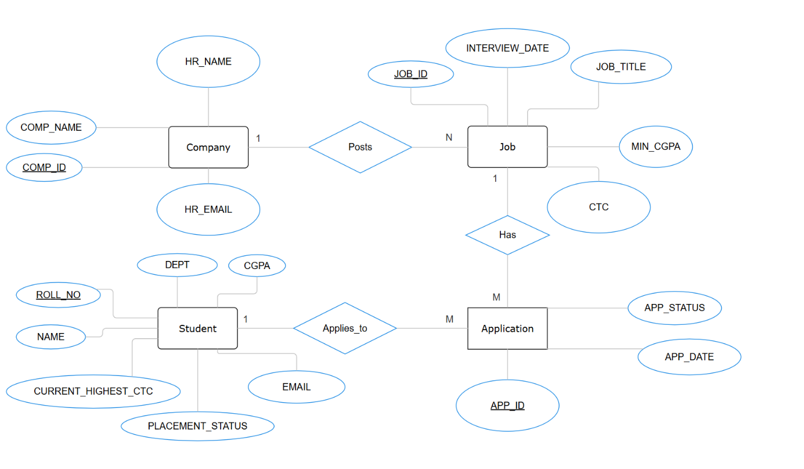

Figure 1: Conceptual ER Diagram for Campus Placement Management System

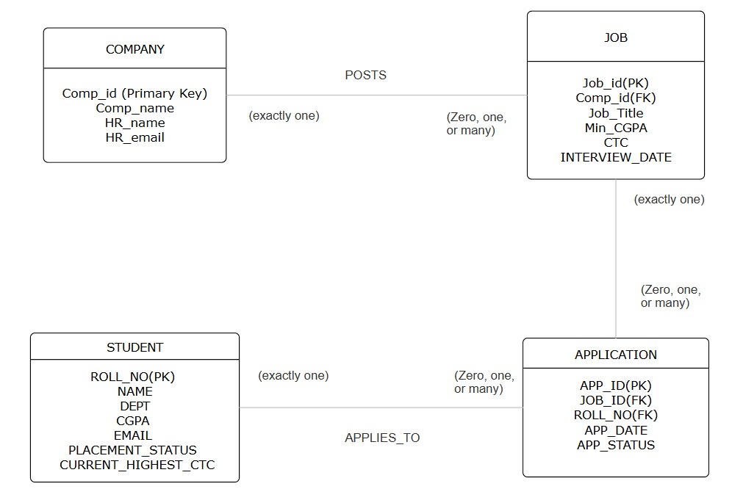
Figure 2: Logical Relational Schema for Campus Placement Management System

STEP 9: Examine E-R diagram developed in STEP 8 and map it to a relational model using transformation guidelines.
Based on the ER diagram developed in Step 8, the following are a set of relational tables mapped for the Campus Placement Management System case study problem:
- STUDENT Relation STUDENT(ROLL_NO, NAME, DOB, GENDER, PHONE, EMAIL, DEPT, CGPA, TENTH_PCT, TWELFTH_PCT, CORE_SKILLS, PLACEMENT_STATUS, CURRENT_HIGHEST_CTC)
- COMPANY Relation COMPANY(COMP_ID, COMP_NAME, INDUSTRY_TYPE, HR_NAME, HR_EMAIL, HR_PHONE)
- JOB Relation JOB(JOB_ID, COMP_ID, JOB_TITLE, JOB_DESC, MIN_CGPA, CTC, ELIGIBLE_DEPTS, INTERVIEW_DATE)
- APPLICATION Relation APPLICATION(APP_ID, ROLL_NO, JOB_ID, APP_DATE, APP_STATUS)

Notes & Transformation Guidelines Applied:
- Strong Entities to Tables: The strong entities STUDENT and COMPANY map directly to tables. Their respective unique identifiers (ROLL_NO and COMP_ID) serve as the primary keys (indicated by the underline).
- 1:N Relationship Mapping (POSTS): The POSTS relationship between Company and Job (1 Company to N Jobs) is resolved by taking the primary key of the "One" side (COMP_ID) and placing it as a foreign key inside the "Many" side table (JOB). This ensures every job links back to the company that posted it without needing a separate relationship table.
- M:N Relationship Mapping (APPLIES_TO / APPLICATION): The Many-to-Many relationship between Student and Job requires the creation of a separate junction table. Because the relationship had its own descriptive attributes (APP_DATE, APP_STATUS), we elevate it to the APPLICATION associative table. It borrows ROLL_NO and JOB_ID as foreign keys to connect the two strong entities. In this design, a surrogate key (APP_ID) is used as the primary identifier.

Instructor Notes: Highlight how the transformation guidelines dictate physical database design. Emphasize why the APPLICATION table was formed. If a student attempts to put APP_STATUS into the STUDENT table, point out that a student applying to five different companies would have five different statuses simultaneously, which violates the fundamental rules of data atomicity.

STEP 10: Make a list of all attributes to be stored in the database, called an Universal Relation.
The Universal Relation () for the Campus Placement Management System consists of every data item identified in the data dictionary that needs to be persistently stored.
Universal relation () = { APP_DATE, APP_ID, APP_STATUS, CGPA, COMP_ID, COMP_NAME, CORE_SKILLS, CTC, CURRENT_HIGHEST_CTC, DEPT, DOB, ELIGIBLE_DEPTS, EMAIL, GENDER, HR_EMAIL, HR_NAME, HR_PHONE, INDUSTRY_TYPE, INTERVIEW_DATE, JOB_DESC, JOB_ID, JOB_TITLE, MIN_CGPA, NAME, PHONE, PLACEMENT_STATUS, ROLL_NO, TENTH_PCT, TWELFTH_PCT }

Notes: The Universal Relation is not a practical table for implementation. If we were to store all data in this single table, it would suffer from severe data redundancy and update anomalies. For instance, if a company posted 50 jobs, their COMP_NAME and HR_EMAIL would be repeated 50 times. If the HR manager changed their email address, we would have to update it in 50 different rows.

STEP 11: For each table identified in STEP-10, identify functional dependencies, multi-valued dependencies, and join dependencies, and normalize the relation. Then decide whether the table should be implemented in the highest normal form. If not, explain why.
1. STUDENT Table STUDENT(ROLL_NO, NAME, DOB, GENDER, PHONE, EMAIL, DEPT, CGPA, TENTH_PCT, TWELFTH_PCT, CORE_SKILLS, PLACEMENT_STATUS, CURRENT_HIGHEST_CTC)
- Functional Dependencies:
  - ROLL_NO All other attributes.
  - EMAIL All other attributes. (Assuming every student has a unique email).
- Normalization Level: BCNF (Boyce-Codd Normal Form)
2. COMPANY Table COMPANY(COMP_ID, COMP_NAME, INDUSTRY_TYPE, HR_NAME, HR_EMAIL, HR_PHONE)
- Functional Dependencies:
  - COMP_ID All other attributes.
- Normalization Level: BCNF
3. JOB Table JOB(JOB_ID, COMP_ID, JOB_TITLE, JOB_DESC, MIN_CGPA, CTC, ELIGIBLE_DEPTS, INTERVIEW_DATE)
- Functional Dependencies:
  - JOB_ID All other attributes.
- Normalization Level: BCNF
4. APPLICATION Table APPLICATION(APP_ID, ROLL_NO, JOB_ID, APP_DATE, APP_STATUS)
- Functional Dependencies:
  - APP_ID ROLL_NO, JOB_ID, APP_DATE, APP_STATUS
  - (ROLL_NO, JOB_ID) APP_ID, APP_DATE, APP_STATUS
- Normalization Level: BCNF

Notes on Normalization Logic:
- For STUDENT Table: Both determinants (ROLL_NO and EMAIL) are candidate keys. Because every determinant is a candidate key, the table satisfies BCNF.
  - Exception Note: Technically, CORE_SKILLS (e.g., "Java, Python, C++") could be considered a Multi-Valued Dependency (MVD). In strict normalization (up to 4NF), we would decompose this into a separate STUDENT_SKILLS(ROLL_NO, SKILL) table. However, to avoid excessive JOIN operations every time we view a student's profile, we assume CORE_SKILLS is stored as a single comma-separated string, keeping the relation in its current form.
- For COMPANY Table: There are no transitive dependencies. The HR details are directly dependent on the COMP_ID for this specific placement cycle, so the relation is in BCNF.
- For JOB Table: While COMP_ID exists in this table as a foreign key, it does not functionally determine the JOB_TITLE or CTC (a company can have many jobs with different salaries). The only determinant is JOB_ID. Thus, it is in BCNF.
- For APPLICATION Table: A student can only apply to a specific job once, meaning the combination of (ROLL_NO, JOB_ID) is a candidate key alongside APP_ID. Since all determinants are candidate keys, it is in BCNF.

STEP-12: Write SQL statements to create all Tables needed to implement the design in Oracle
SQL
CREATE TABLE STUDENT (
ROLL_NO VARCHAR2(10) PRIMARY KEY,
NAME VARCHAR2(50) NOT NULL,
DEPT VARCHAR2(10),
CGPA NUMBER(4,2),
EMAIL VARCHAR2(50),
PLACEMENT_STATUS VARCHAR2(15) DEFAULT 'Unplaced',
CURRENT_HIGHEST_CTC NUMBER(5,2) DEFAULT 0.00
);

CREATE TABLE COMPANY (
COMP_ID VARCHAR2(10) PRIMARY KEY,
COMP_NAME VARCHAR2(50) NOT NULL,
HR_NAME VARCHAR2(50),
HR_EMAIL VARCHAR2(50)
);

CREATE TABLE JOB (
JOB_ID VARCHAR2(10) PRIMARY KEY,
COMP_ID VARCHAR2(10) NOT NULL,
JOB_TITLE VARCHAR2(30),
MIN_CGPA NUMBER(4,2),
CTC NUMBER(5,2),
INTERVIEW_DATE DATE,
FOREIGN KEY (COMP_ID) REFERENCES COMPANY(COMP_ID)
);

CREATE TABLE APPLICATION (
APP_ID VARCHAR2(10) PRIMARY KEY,
ROLL_NO VARCHAR2(10) NOT NULL,
JOB_ID VARCHAR2(10) NOT NULL,
APP_DATE DATE,
APP_STATUS VARCHAR2(20),
FOREIGN KEY (ROLL_NO) REFERENCES STUDENT(ROLL_NO),
FOREIGN KEY (JOB_ID) REFERENCES JOB(JOB_ID)
);

STEP-13: Write SQL statements that will process non-routine requests for information from the database created.
QUERY1: Get a list of all jobs that student '23103027' is eligible for under the 2.5 LPA upgrade rule.
SQL QUERY:
SELECT J.JOB_ID, C.COMP_NAME, J.JOB_TITLE, J.CTC FROM JOB J, COMPANY C, STUDENT S WHERE J.COMP_ID = C.COMP_ID AND S.ROLL_NO = '23103027' AND J.MIN_CGPA <= S.CGPA AND J.CTC >= (S.CURRENT_HIGHEST_CTC + 2.50);
QUERY2: Get a list of all students who have successfully utilized the upgrade rule to get a new Dream CTC.
SQL QUERY:
SELECT S.ROLL_NO, S.NAME, J.JOB_TITLE, J.CTC FROM STUDENT S, APPLICATION A, JOB J WHERE S.ROLL_NO = A.ROLL_NO AND A.JOB_ID = J.JOB_ID AND A.APP_STATUS = 'Accepted' AND J.CTC >= (S.CURRENT_HIGHEST_CTC + 2.50);
QUERY3: Get an alphabetical listing of unplaced students who meet the criteria for jobs requiring an 8.0 CGPA.
SQL QUERY:
SELECT ROLL_NO, NAME, DEPT, CGPA FROM STUDENT WHERE PLACEMENT_STATUS = 'Unplaced' AND CGPA >= 8.00 ORDER BY NAME ASC;
QUERY4: Get a list of Company IDs along with the number of jobs each has offered.
SQL QUERY:
SELECT COMP_ID, COUNT(*) FROM JOB GROUP BY COMP_ID;

STEP-14: Customize the application by using front-end tools The backend Oracle database will be connected to a customized front-end interface built using React.js for the students and Oracle APEX for the T&P Cell administrators to facilitate easy viewing of placement records, application management, and rule enforcement.

