**SYNOPSIS**

The purpose of Online Traffic Offence System is to automate the existing manual system by the help of computerized equipment’s and full-fledged computer software, fulfilling their requirements, so that their valuable data/information can be stored for longer period with easy accessing and manipulation of the same. The required software and hardware are easily available and easy to work with.

Online Traffic Offence System, as described above, can lead to error free, secure, reliable and fast management system. It can assist the user to concentrate on their other activities rather to concentrate on the record keeping. Thus, it will organization in better utilization of resources. The organization can maintain computerized records without redundant entries. That one need not be distracted by information that is not relevant, while being able to reach the information.

The aim is to automate the existing manual system by the help of computerized equipment’s and full-fledged computer software, fulfilling their requirements, so that their valuable data/information can be stored for longer period with easy accessing and manipulation of the same. Basically, the project describes how to manage for good performance and better services for the clients.

**CHAPTER – I**

**INTRODUCTION**

* 1. **ABOUT THE PROJECT**

The "Online Traffic Offence System" has been developed to override the problems prevailing in the practicing manual system. This software is supported to eliminate and, in some cases, reduce the hardships faced by this existing system. Moreover, this system is designed for the particular need of the company to carry out operations in a smooth and effective manner.

The application is reduced as much as possible to avoid errors while entering the data. It also provides error message while entering invalid data. No formal knowledge is needed for the user to use this system. Thus, by this all it proves it is user-friendly. Online Traffic Offence System, as described above, can lead to error free, secure, reliable and fast management system. It can assist the user to concentrate on them other activities rather to concentrate on the record keeping. Thus, it will help organization in better utilization of resources.

Every organization, whether big or small, has challenges to overcome and managing the information of Criminal, Crime, Public, Solutions, Complaint. Every Online Traffic Offence System has different Crime needs; therefore, we design exclusive employee management systems that are adapted to your managerial requirements. This is designed to assist in strategic planning, and will help you ensure that your organization is equipped with the right level of information and details for your future goals. Also, for those busy executives who are always on the go, our systems come with remote access features, which will allow you to manage your workforce anytime, at all times. These systems will ultimately allow you to better manage resources

**1.2 SYSTEM SPECIFICATION**

System Analysis is a detailed study of the various operations performed by a system and their relationship within and outside the system. It is a systematic technique that defines goals and objectives the goal of the development is to deliver the system in the line with the user’s requirements, and analysis is this process.

System study has been conducted with the following objectives in mind

* Identify the client’s need.
* Evaluate the system concept for feasibility.
* Perform economical and technical analysis.
* Allocate functional to hardware, software, people, database and other system elements
* Establish cost and schedule constraints.
* Both hardware and software expertise are required to successfully attain the objectives.

**Requirement Analysis**

Information gathering is usually the first phase of the software development project. The purpose of this phase is to identify and document the exact requirements for the system. The user’s request identifies the need for a new information system and on investigation re-defined the new problem to be based on MIS, which supports management. The objective is to determine whether the request is valid and feasible before a recommendation is made to build a new or existing manual system continues.

The major steps are

* Defining the user requirements.
* Studying the present system to verify the problem.
* Defining the performance expected by the candidate to use requirements.
  + 1. **HARDWARE SPECIFICATION**

**Processor :** Inteli3

**Ram :** 256 MB

**Hard Disk :** 80 GB

**Monitor :** CRT 14” Color Monitor

**Mouse :** Optical Mouse

**Keyboard :** 104 Keys

* + 1. **SOFTWARE SPECIFICATION**

**Operating System :** Windows 10

**Server Side :** PHP

**Web Server :** XAMPP Server

**Back End :** MYSQL

**PHP 5.0**

PHP (acronym for: PHP Hypertext Preprocessor), is a server-side embedded scripting language. This means that it works within an HTML document to confer to it the capacity of generating content on demand. It can convert our site into a web application, not just a collection of static pages with information that may not get updated quite so often, which may be alright for a “personal” website.

**Introduction to PHP 5.0**

PHP is the widely-used, free and efficient alternative to competitors such as Microsoft’s ASP. PHP is perfectly suited for web development and can be embedded directly into the HTML code.

A PHP file may contain text, HTML tags a scripts or scripting or programming language like Perl, Python, etc. PHP was designed to work on the web and in the ambit, it excels connecting and querying a database is a simple task that can be handled in 2 or 3 lines of code. The PHP scripting engine is well optimized for the response times needed on the web applications it can be part of the web server itself improving the throughput even more.

The PHP language features the usual complement of control structure, operators, variable types, functions declarations and class/object declarations that have been accustomed to expect from any compiled interpreted language, yet it also have features of it PHP comes with a myriad of options, both to build the distribution and also to configure an installation. PHP supports several API’s and interfaces to other programming tools. The sheer number of those tools is daunting, not to speak of the configuration possibilities for each of these.

**PHP DATATYPES**

PHP has a total of eight data types which we use to construct our variables:

* + - **Integers**: are whole numbers, without a decimal point, like 4195
    - **Doubles**: are floating-point numbers, like 3.14159 or 49.1
    - **Booleans**: have only two possible values either true or false
    - **Null**: is a special type that only has one value: NUL
    - **Strings**: are sequences if characters, like ‘PHP supports string operations’
    - **Arrays**: are named and indexed collections of other value
    - **Objects**: are instances of programmer-defined classes, which can package up both other kinds of values and functions that are specific to the class
    - **Resources**: are special variables that hold references to resources external to PHP (such database connections)

**BENEFITS OF PHP**

* PHP is open source software
* PHP costs nothing, it is free to download and use
* PHP is a server-side scripting language and for websites and web applications.
* PHP scripts are executed on the serve
* PHP supports a wide range of databases
* PHP runs on various platforms like Linux, Windows, Unix
* PHP supports most web servers (for example Apache, IIS)
* PHP converses with several networks’ protocols

**PLATFORMS & WEB SERVERS**

PHP is supported on a quite a few platforms, many of them UNIX-like and of course on Microsoft’s operating systems supporting the Win32 environment. Since PHP cannot do much without a web server, when it talks of installing PHP on a platform, we also need to talk into consideration the web server that plan to use.

**MYSQL 4.0**

MySQL is a database. The data in MySQL is stored in database objects called tables. A table is a collection related data entry and it consists of columns and rows.

MySQL is a full-featured relational database management system. It is very stable and has proven itself over time. MySQL has been in production for even 10 years. MySQL is a multithreaded server. Multithreaded means that every time someone establishes a connection with the server program creates a thread or process to handle that client’s requests. This makes for an extremely fats server. In effect, every client who connects to a MySQL server gets own thread. Yet another feature of MySQL is its portability – it has been ported to almost every platform. This means that don’t have to change main platform to take advantage of MySQL. And if do want to switch, there is probably a MySQL port for a new platform.

**MYSQL is a Database Management System**

A database is a structured collection of data. It may be anything from a simple shopping list to picture gallery or the vast amounts of information in a corporate network. To add, access, and process data stored in a computer database, you need a database management system such as MYSQL server, since computers are very good at handling large amounts of data, database management systems play a central role in computing, as standalone utilities, or as part of other applications.

**MYSQL software is Open source**

Open Source means that it is possible for anyone to use and modify the software. Anybody can download the MYSQL software from the Internet and use it without paying anything.

**MYSQL Features**

* Because of its unique storage engine architecture MYSQL performance is very high.
* Supports large number of embedded applications which makes MYSQL very flexible
* Use of Triggers, Stored Procedures and Views which allows the developer to give a higher productivity,
* Allows transactions to be rolled back, commit and crash recovery.

**Triggers**

Triggers are SQL commands that are automatically executed by the server in certain database operations (INSERT, UPDATE, and DELETE). MYSQL has supported triggers in a limited form from version 5.0, and automatically functionality is promised for version 5.1.

**Stored Procedures**

Stored Procedures (SP’s for short) are generally used to simplify certain steps, such as inserting or deleting a data record. For client programmers this has the advantage that they do not have to process the tables directly, but can rely on SP’s. Like views, SP’s help in the administration of large database projects. SP’s can also increase efficiency. MYSQL has supported SP’s since version 5.0.

**CHAPTER II**

**SYSTEM STUDY**

System study is the process of gathering and interpreting facts, diagnosing problems and using the information to recommend improvements on the system. System analysis is a problem-solving activity that requires intensive communication between the system users and system developers.

System study is an important phase of any system development process. The system is viewed as a whole, the inputs are identified and the system is subjected to close study to identify the problem areas. The solutions are given as a proposal. The proposal is reviewed on user request and suitable changes are made. This loop ends as soon as the user is satisfied with the proposal.

**2.1 EXISTING SYSTEM**

In the existing system the exams are done only manually but in proposed system we have to computerize the exams using this application.

**2.1.1 DRAWBACK OF EXISTING SYSTEM**

* Lack of security of data.
* More man power.
* Time consuming.
* Consumes large volume of pare work.
* Needs manual calculations.
* No direct role for the higher officials

**2.2 PROPOSED SYSTEM**

The aim of proposed system is to develop a system of improved facilities. The

proposed system can overcome all the limitations of the existing system. The system

provides proper security and reduces the manual work.

**2.2.1 FEATURES OF PROPOSED SYSTEM**

* Security of data.
* Ensure data accuracies.
* Proper control of the higher officials.
* Minimize manual data entry.
* Minimum time needed for the various processing.
* Greater efficiency.
* Better service.
* User friendliness and interactive.
* Minimum time required.

**CHAPTER III**

**3. SYSTEM DESIGN AND DEVELOPMENT**

System design is the solution for the creation of a new system. This phase focuses on the detailed implementation of the feasible system. Its emphasis on translating design. Specifications to performance specification. System design has two phases of development

Logical design

Physical design

**LOGICAL DESIGN**

During logical design phase the analyst describes inputs (sources), output s(destinations), databases (data sores) and procedures (data flows) all in a format that meets the user requirements. The analyst also specifies the needs of the user at a level that virtually determines the information flow in and out of the system and the data resources. Here the logical design is done through data flow diagrams and database design.

**PHYSICAL DESIGN**

The physical design is followed by physical design or coding. Physical design produces the working system by defining the design specifications, which specify exactly what the candidate system must do. The programmers write the necessary programs that accept input from the user, perform necessary processing on accepted data and produce the required report on a hard copy or display it on the screen.

**3.1 INPUT DESIGN**

Input design is the link that ties the information system into the world of its users. The input design involves determining the inputs, validating the data, minimizing the data entry and provides a multi-user facility. Inaccurate inputs are the most common cause of errors in data processing. Errors entered by the data entry operators can be controlled by input design. The user-originated inputs are converted to a computer-based format in the input design. Input data are collected and organized into groups of similar data. Once identified, the appropriate input media are selected for processing. All the input data are validated and if any data violates any conditions, the user is warned by a message. If the data satisfies all the conditions, it is transferred to the appropriate tables in the database. In this project the student details are to be entered at the time of registration. A page is designed for this purpose which is user friendly and easy to use. The design is done such that users get appropriate messages when exceptions occur.

**3.2 OUTPUT DESIGN**

Computer output is the most important and direct source of information to the user. Output design is a very important phase since the output needs to be in an efficient manner. Efficient and intelligible output design improves the system relationship with the user and helps in decision making. Allowing the user to view the sample screen is important because the user is the ultimate judge of the quality of output. The output module of this system is the selected notifications.

**3.3 DATABASE DESIGN**

Databases are the storehouses of data used in the software systems. The data is stored in tables inside the database. Several tables are created for the manipulation of the data for the system. Two essential settings for a database are

Primary Key- the field that is unique for all the record occurrences.

Foreign Key -the field used to set relation between tables. Normalization is a technique to avoid redundancy in the tables.

**3.4 SYSTEM DEVELOPMENT**

The SDLC –Software Development Life Cycle process in systems, information systems and the software are a process of creating or altering information systems, and the models and methodologies that people use to develop the **ONLINE SHOPPING SYSTEM**. In software engineering, the methodologies form the framework for planning and controlling the creation of an information system for the software development process.

The System development life cycle (SDLC) is a process used by a systems analyst to develop an information system, training, and user (stakeholder) ownership. The SDLC aims to produce a high-quality system that meets or exceeds customer expectations, reaches completion within time and cost estimates, works effectively and efficiently in the current and planned Technology infrastructure, and is inexpensive to maintain and cost-effective to enhance.

**3.5.1 DESCRIPTION OF MODULES**

* Admin module
* Police module
* User module

**ADMIN**

* Check officer details and police station details.
* Add, Delete and Edit an officer.
* Check registration.
* Check city and area details.
* Check crime types.
* Add, Delete, View missing persons.
* Add, Delete, View most wanted persons.
* Profile management

**POLICE**

* Check FIR details.
* Check crime details.
* Profile management.

**USER**

* Register complaint.
* Edit FIR details.
* View missing persons.
* Profile management.

**CHAPTER –IV**

**TESTING AND IMPLEMENTATION**

Testing is a process of executing a program with the interest of finding an error. A good test is one that has high probability of finding the yet undiscovered error. Testing should systematically uncover different classes of errors in a minimum amount of time with a minimum amount of efforts. Two classes of inputs are provided to test the process

A software configuration that includes a software requirement specification, a design specification and source code.

A software configuration that includes a test plan and procedure, any testing tool and test cases and their expected results.

Testing is divided into several distinct operations:

**1. Unit Testing**

Unit test comprises of a set tests performed by an individual program prior to the integration of the unit into large system. A program unit is usually the smallest free functioning part of the whole system. Module unit testing should be as exhaustive as possible to ensure that each representation handled by each module has been tested. All the units that makeup the system must be tested independently to ensure that they work as required.

During unit testing some errors were raised and all of them were rectified and handled well.

**2. Integration Testing**

Integration testing is a system technique for constructing the program structure while at the same time conducting tests to uncover errors associated with interfacing. The objective is to take unit tested modules and build a program structure that has been dictated by design. Bottom-up integration is the traditional strategy used to integrate the components of a software system into functioning whole. Bottom-up integration consists of unit test followed by testing of the entire system. A sub-system consists of several modules that communicated with other defined interface.

**3. Validation Testing**

After validation testing, software is completely assembled as a package, interfacing errors that have been uncovered and corrected and the final series of software test; the validation test begins. Steps taken during software design and testing can greatly improve the probability of successful integration in the larger system. System testing is actually a series of different tests whose primary purpose is to fully exercise the compute –based system.

**4. Recovery Testing**

It is a system that forces the software to fail in a variety of ways and verifies that the recovery is properly performed.

**5. Security Testing**

It attempts to verify that protection mechanisms built into a system will in fact protect it from improper penetration. The system’s security must of course be tested from in vulnerability form frontal attack.

**6. Stress Testing**

Stress tools are designed to confront programs with abnormal situations. Stress testing executes a system in a manner that demands resources in abnormal quantity and volume.

**7. Black Box Testing**

Black box testing is done to find out the following information as shown in below:

Incorrect or missing functions.

Interface errors.

Errors or database access.

Performance error.

Termination error.

**CHAPTER – V**

**CONCLUSION AND FUTURE ENHANCEMENT**

**5.1 Conclusion**

The project entitled **Online Traffic Offence System** was completed successfully.

Our project is only a humble venture to satisfy the needs to manage their project work. Several user-friendly coding has also adopted. This package shall prove to be a powerful package in satisfying all the requirements of the school. The objective of software planning is to provide a frame work that enables the manger to make reasonable estimates made within a limited time frame at the beginning of the software project and should be updated regularly as the project progresses.

In the modern world, the use of computer and mobile phones is becoming rampant. More so, recent developments in the industries has revolutionized and consequently brought about a paradigm shift in the way activities are accomplished. As a result, the Traffic Offence system needs to embrace these new technologies. This report has presented a simple, convenient, cost-effective, but efficient online Traffic Offence system with a user-friendly, sensitive and web intelligible interface. Whereby it can be accessed at ay time provided there is internet connection.

**5.2 FUTURE ENHANCEMENT**

* In future system will provide mail facility to editors. Editors can send mail to other station editors.
* In future system will allow user to register complaints online.
* In future system will provide facility to send message.
* The method of video conferencing can be added to make the project livelier.
* Users can view the progress of their complaint online.
* By the future technology user can view the case details and progress of complaints on their mobile phones.

**BIBLIOGRAPHY AND REFERENCE**

**BOOK REFRENCES**

1. **Elias M. Award,** *“System Analysis and Design”,* Galgotiya Publications (P) Ltd,2nd

edition, 2004

1. **Jay Greenspan & Brad Bulgur,** *“MY SQL/PHP Database Applications”*

2nd edition, 2006

3. **Jesus Castagnetto & Sascha Schumann,** *“Professional PHP Programming”*

3rd edition, 2008.

4. **Roger Pressman*,*** *“Software Engineering”*, Tata McGraw Hill Publications (P)

Ltd, 4th edition, 2004

5**. Ragu Ramakrishnan, Johannes Gehrke,** *Database Management System***,**

3rd edition,2005

6. **Robin Nixon**, **Learning PHP, MySQL***, and JavaScript*, First Edition, 2009

**REFERENCES**

* **http://www.php.net**
* **http://www.w3schools.com**
* **http://www.stackoverflow.com**
* **http://www.video-js.com**

**APPENDICES**

1. **DATA FLOW DIAGRAM**



**Login**

**Profile**

**View police**

p

**Emergency Contact**

**FIR Registration**

**View FIR**

**Missing Person**

Complaining Person

FIR Information

Print out of FIR

Submit FIR

Check

FIR

&

Registration

Detail

Received

Detail of FIR

Officer Detail

Investigation FIR

Collection of Crime

Police Station

Company Person

Crime Related Person

Sending info.

Reg. FIR

sending

Sending info.

FIR

On line

Registration

1. **ER DIAGRAM**

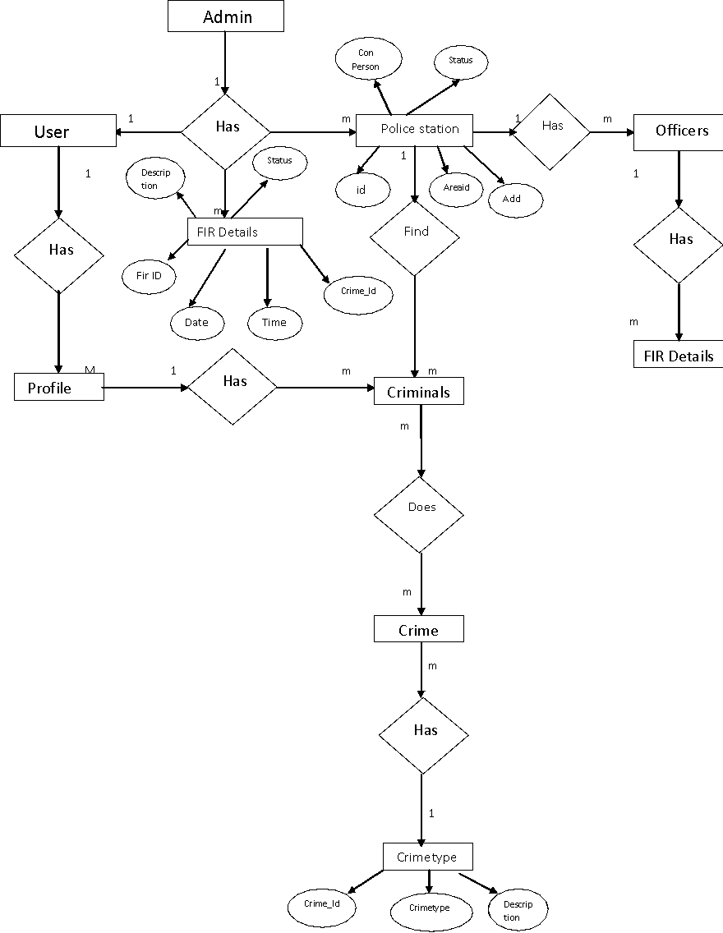

1. **TABLE STRUCTURE**

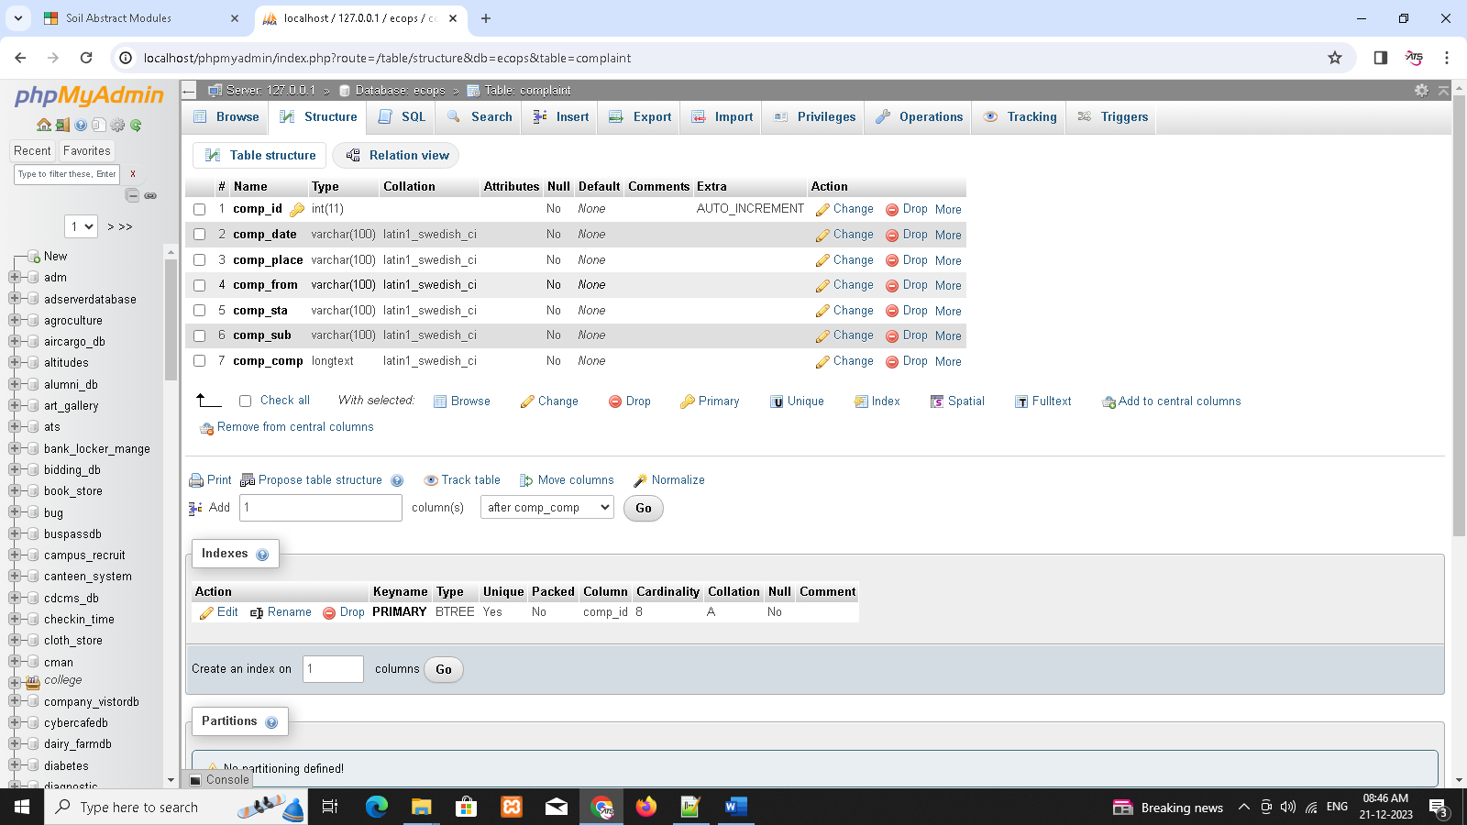

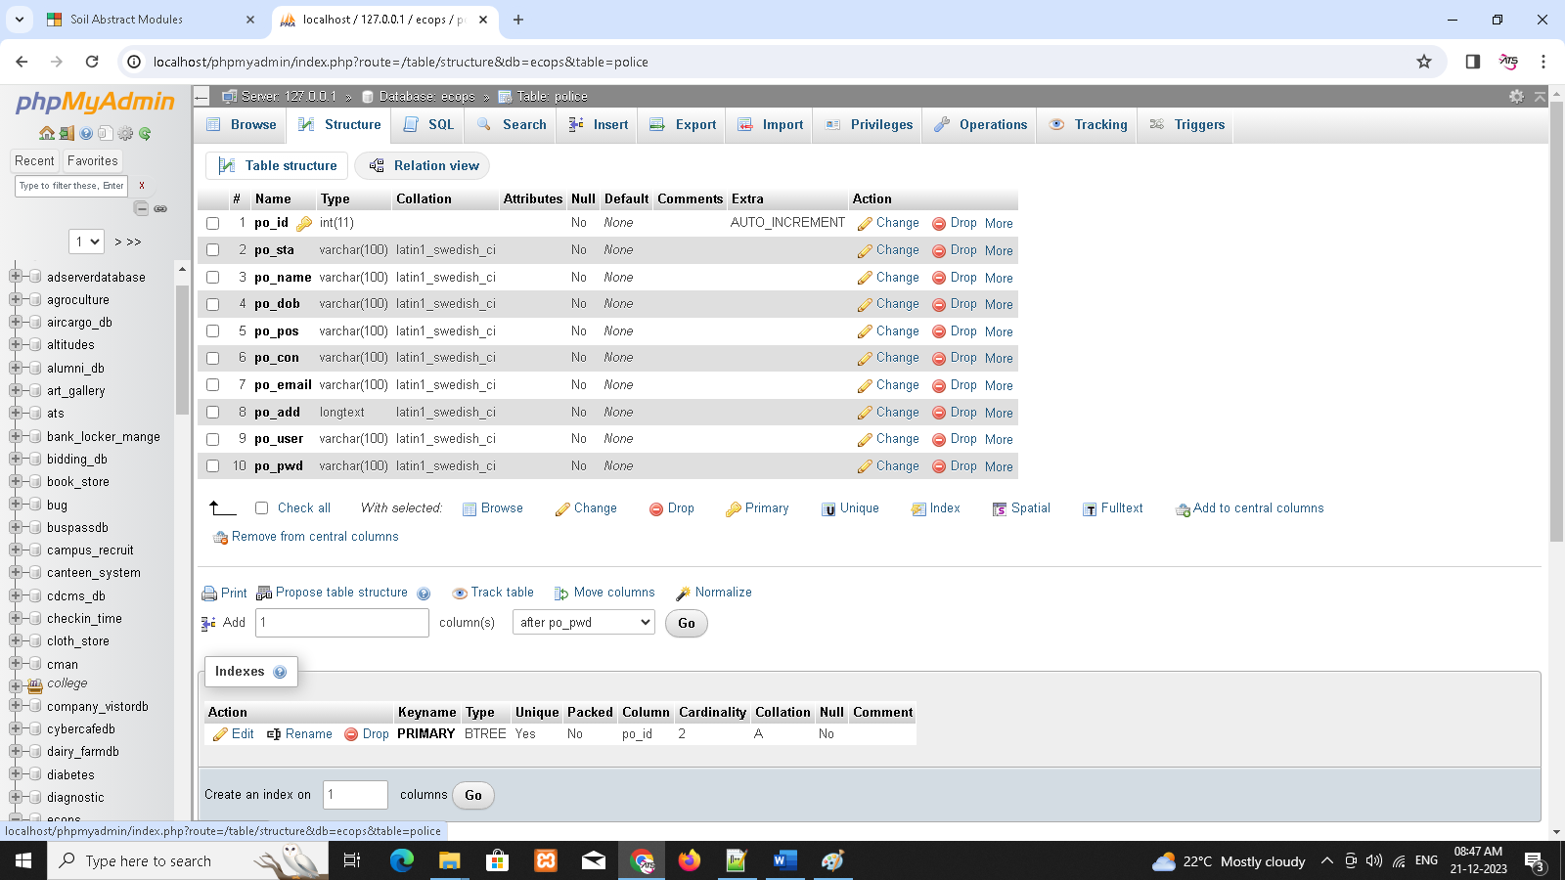

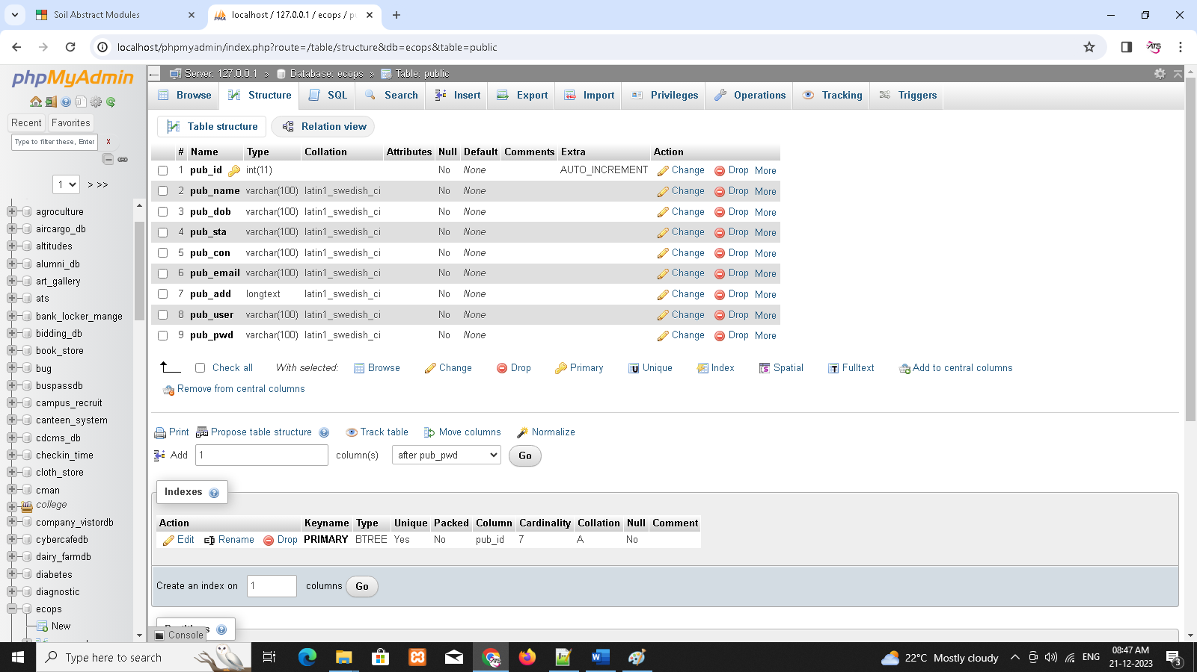

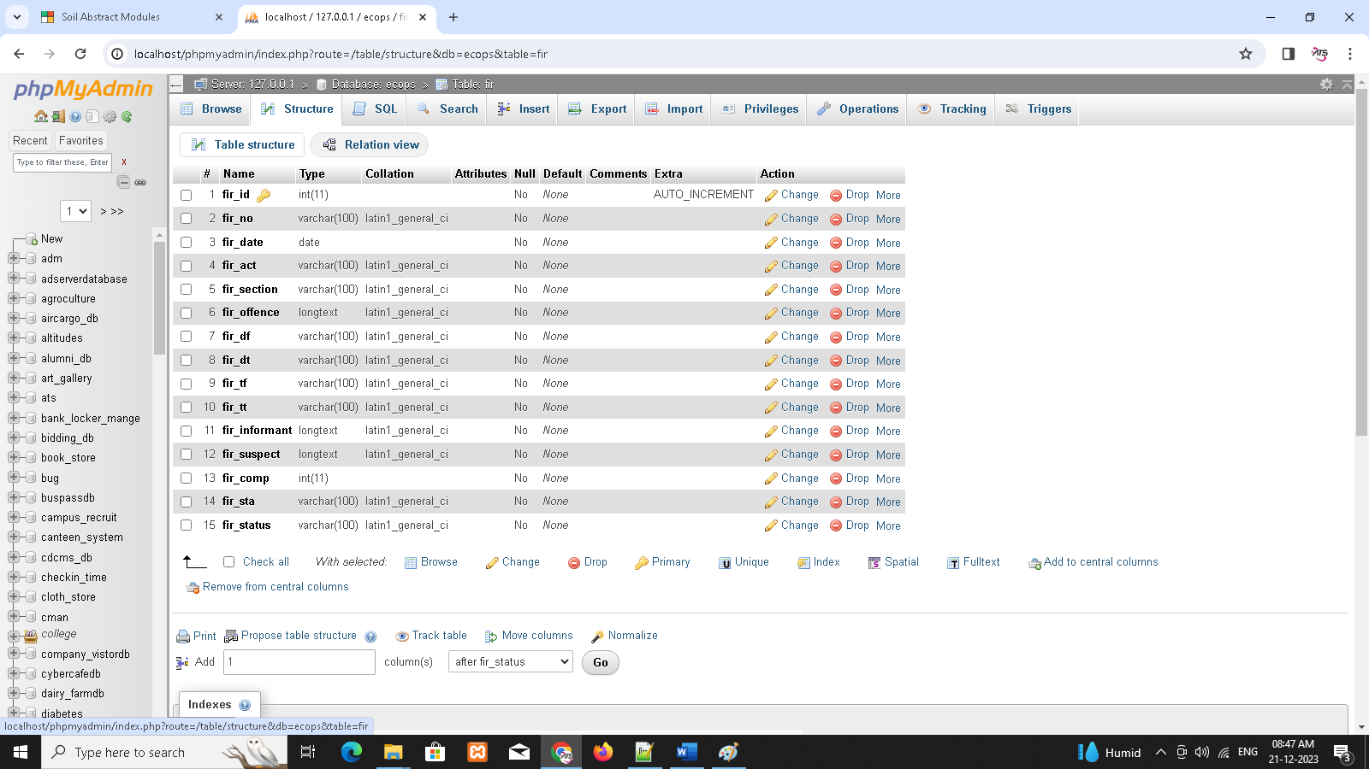

1. **SAMPLE CODING**

<!DOCTYPE HTML

    PUBLIC "-//W3C//DTD XHTML 1.0 Transitional//EN" "http://www.w3.org/TR/xhtml1/DTD/xhtml1-transitional.dtd">

<html dir="ltr" xml:lang="en-gb" xmlns="http://www.w3.org/1999/xhtml" lang="en-gb">

<head>

    <style type="text/css">

    #newsticker-demo {

        width: 310px;

        background: #EAF4F5;

        padding: 5px 5px 0;

        font-family: Verdana, Arial, Sans-Serif;

        font-size: 12px;

        margin: 20px auto;

    }

    #newsticker-demo a {

        text-decoration: none;

    }

    #newsticker-demo img {

        border: 2px solid #FFFFFF;

    }

    #newsticker-demo .title {

        text-align: center;

        font-size: 14px;

        font-weight: bold;

        padding: 5px;

    }

    .newsticker-jcarousellite {

        width: 300px;

    }

    .newsticker-jcarousellite ul li {

        list-style: none;

        display: block;

        padding-bottom: 1px;

        margin-bottom: 5px;

    }

    .newsticker-jcarousellite .thumbnail {

        float: left;

        width: 110px;

    }

    .newsticker-jcarousellite .info {

        width: 190px;

    }

    .newsticker-jcarousellite .info span.cat {

        display: block;

        font-size: 10px;

        color: #808080;

    }

    .clear {

        clear: both;

    }

    </style>

    <title>Welcome to the Traffic Offence System</title>

    <?php include("facebox.php"); ?>

    <script type="text/javascript" src="files/mootools.js"></script>

    <script type="text/javascript" src="files/caption.js"></script>

    <!--StyleSheet included-->

    <link rel="stylesheet" type="text/css" href="css/message.css" media="all">

    <!--Stylesheet ends here-->

    <!--Javascript included-->

    <script type="text/javascript" src="javascript/validation.js"></script>

    <link rel="stylesheet" href="files/template.css" type="text/css">

    <link rel="stylesheet" href="files/constant.css" type="text/css">

    <script src="javascript/jquery-latest.pack.js" type="text/javascript"></script>

    <script src="javascript/jcarousellite_1.0.1c4.js" type="text/javascript"></script>

    <script type="text/javascript">

    $(function() {

        $(".newsticker-jcarousellite").jCarouselLite({

            vertical: true,

            hoverPause: true,

            visible: 3,

            auto: 500,

            speed: 1000

        });

    });

    </script>

</head>

<body id="body">

    <div class="main">

        <!--header-->

        <div class="row-logo clear">

            <div class="fright">

            </div>

            <div class="fleft">

                <h1 id="logo"> <a href="" title="business"><img src="images/crimesolutions_logo1.jpg" alt="logo"

                            width="251" height="95" title="business" /></a> </h1>

            </div>

        </div>

        <div class="header-box clear">

            <!-- <object classid="clsid:166B1BCA-3F9C-11CF-8075-444553540000"

                codebase="http://download.macromedia.com/pub/shockwave/cabs/director/sw.cab#version=8,5,0,0" width="881"

                height="276">

                <param name="src" value="files/flashbanner.swf" />

                <embed src="files/flashbanner.swf" pluginspage="http://www.macromedia.com/shockwave/download/"

                    width="881" height="276"></embed>

            </object> -->

        </div>

        <div class="row-top-menu wrapper-top-menu clear">

            <div class="border-top">

                <div class="border-bottom">

                    <div class="border-left">

                        <div class="border-right">

                            <div class="corner-top-left">

                                <div class="corner-top-right">

                                    <div class="corner-bottom-left">

                                        <div class="corner-bottom-right clear">

                                            <div class="module">

                                                <ul class="menu-nav">

                                                    <li class="item54"><a href="registration.php"><span>Join Us

                                                            </span></a></li>

                                                    <li class="item55"><a href="#"><span>Get Crime Alert </span></a>

                                                    </li>

                                                    <li class="item56"><a href="#"><span>Register FIR </span></a></li>

                                                    <li class="item57"><a

                                                            href="viewmissing_citizen.php"><span>Services</span></a>

                                                    </li>

                                                    <li class="item58"><a href="econtact.php"><span>Emergancy

                                                                Contacts</span></a></li>

                                                    <li class="item53"><a href="aboutus.php"><span>About Us</span></a>

                                                    </li>

                                                </ul>

                                            </div>

                                        </div>

                                    </div>

                                </div>

                            </div>

                        </div>

                    </div>

                </div>

            </div>

        </div>

        <!--content-->

        <div id="content">

            <div class="clear">

                <!--right-->

                <div id="right">

                    <div class="right-indent">

                        <div class="clear">

                            <div class="wrapper-box module-login">

                                <div class="border-top">

                                    <div class="border-bottom">

                                        <div class="border-left">

                                            <div class="border-right">

                                                <div class="corner-top-left">

                                                    <div class="corner-top-right">

                                                        <div class="corner-bottom-left">

                                                            <div class="corner-bottom-right clear">

                                                                <div class="wrapper-box-indent">

                                                                    <div class="box-title">

                                                                        <div class="border1-top">

                                                                            <div class="border1-bottom">

                                                                                <div class="border1-left">

                                                                                    <div class="border1-right">

                                                                                        <div class="corner1-top-left">

                                                                                            <div

                                                                                                class="corner1-top-right">

                                                                                                <div

                                                                                                    class="corner1-bottom-left">

                                                                                                    <div

                                                                                                        class="corner1-bottom-right clear">

                                                                                                        <h3>Login form

                                                                                                        </h3>

                                                                                                    </div>

                                                                                                </div>

                                                                                            </div>

                                                                                        </div>

                                                                                    </div>

                                                                                </div>

                                                                            </div>

                                                                        </div>

                                                                    </div>

                                                                    <div class="main-box">

                                                                        <div class="clear">

                                                                            <form action="checkLogin.php" method="post"

                                                                                name="login" class="form-login">

                                                                                <label for="mod_login_username">

                                                                                    Username </label>

                                                                                <input name="username" id="username"

                                                                                    class="inputbox" alt="username"

                                                                                    type="text">

                                                                                <script type="text/javascript">

                                                                                var f1 = new LiveValidation('username');

                                                                                f1.add(Validate.Presence, {

                                                                                    failureMessage: " Please enter username"

                                                                                });

                                                                                //f1.add(Validate.Format,{pattern: /^[a-zA-Z\s]+$/i ,failureMessage: " It allows                     only characters"});

                                                                                f1.add(Validate.Format, {

                                                                                    pattern: /^[a-zA-Z][a-zA-Z\s]{0,}$/,

                                                                                    failureMessage: " Invalid                 username"

                                                                                });

                                                                                </script>

                                                                                <label for="mod_login_password">

                                                                                    Password </label>

                                                                                <input id="password" name="password"

                                                                                    class="inputbox" alt="password"

                                                                                    type="password">

                                                                                <script type="text/javascript">

                                                                                var f1 = new LiveValidation('password');

                                                                                f1.add(Validate.Presence, {

                                                                                    failureMessage: " Please enter password"

                                                                                });

                                                                                //f1.add(Validate.Format,{pattern: /^[a-zA-Z\s]+$/i ,failureMessage: " It allows only characters"});

                                                                                //f1.add(Validate.Format,{pattern: /^[a-zA-Z][a-zA-Z\s]{0,}$/,failureMessage: " Invalid password"});

                                                                                </script>

                                                                                <div class="indent-button">

                                                                                    <input name="Submit"

                                                                                        class="button png"

                                                                                        value="Log in" type="submit">

                                                                                </div>

                                                                                <div class="logform-indent">

                                                                                    <p> <a href=""> Forgot your

                                                                                            password?</a> </p>

                                                                                    <p> <a href=""> Forgot your

                                                                                            username?</a> </p>

                                                                                </div>

                                                                                <p class="form-indent1"> No Account Yet?

                                                                                    <a href="registration.php"> Create

                                                                                        an account</a> </p>

                                                                                <input name="option" value="com_user"

                                                                                    type="hidden">

                                                                                <input name="task" value="login"

                                                                                    type="hidden">

                                                                                <input name="return"

                                                                                    value="L2pvb21sYV8yNTQ2Ni8jY29udGVudA=="

                                                                                    type="hidden">

                                                                            </form>

                                                                        </div>

                                                                    </div>

                                                                </div>

                                                            </div>

                                                        </div>

                                                    </div>

                                                </div>

                                            </div>

                                        </div>

                                    </div>

                                </div>

                            </div>

                            <div class="wrapper-box module s2">

                                <div class="border-top">

                                    <div class="border-bottom">

                                        <div class="border-left">

                                            <div class="border-right">

                                                <div class="corner-top-left">

                                                    <div class="corner-top-right">

                                                        <div class="corner-bottom-left">

                                                            <div class="corner-bottom-right clear">

                                                                <div class="wrapper-box-indent" style="height:358px">

                                                                    <div class="box-title">

                                                                        <div class="border1-top">

                                                                            <div class="border1-bottom">

                                                                                <div class="border1-left">

                                                                                    <div class="border1-right">

                                                                                        <div class="corner1-top-left">

                                                                                            <div

                                                                                                class="corner1-top-right">

                                                                                                <div

                                                                                                    class="corner1-bottom-left">

                                                                                                    <div

                                                                                                        class="corner1-bottom-right clear">

                                                                                                        <h3>Newsflash

                                                                                                        </h3>

                                                                                                    </div>

                                                                                                </div>

                                                                                            </div>

                                                                                        </div>

                                                                                    </div>

                                                                                </div>

                                                                            </div>

                                                                        </div>

                                                                    </div>

                                                                    <div class="main-box">

                                                                        <div class="clear">

                                                                            <div id="newsticker-demo">

                                                                                <div class="newsticker-jcarousellite">

                                                                                    <ul>

                                                                                        <li>

                                                                                            <div class="thumbnail">

                                                                                                <img src="images/1.jpg">

                                                                                                <div class="info">

                                                                                                    <a

                                                                                                        href="http://www.vladstudio.com/wallpaper/?knight_lady">The

                                                                                                        Knight and the

                                                                                                        Lady</a>

                                                                                                    <span

                                                                                                        class="cat">Category:

                                                                                                        Illustrations</span>

                                                                                                </div>

                                                                                            </div>

                                                                                            <div class="clear"></div>

                                                                                        </li>

                                                                                        <li>

                                                                                            <div class="thumbnail">

                                                                                                <img src="images/2.jpg">

                                                                                                <div class="info">

                                                                                                    <a

                                                                                                        href="http://www.vladstudio.com/wallpaper/?family_of_colors">The

                                                                                                        Family of

                                                                                                        Colors</a>

                                                                                                    <span

                                                                                                        class="cat">Category:

                                                                                                        Creatures</span>

                                                                                                </div>

                                                                                            </div>

                                                                                            <div class="clear"></div>

                                                                                        </li>

                                                                                        <li>

                                                                                            <div class="thumbnail">

                                                                                                <img src="images/3.jpg">

                                                                                                <div class="info">

                                                                                                    <a

                                                                                                        href="http://www.vladstudio.com/wallpaper/?teddybear_mac">Teddy

                                                                                                        Bear and

                                                                                                        MacBook</a>

                                                                                                    <span

                                                                                                        class="cat">Category:

                                                                                                        Photos</span>

                                                                                                </div>

                                                                                            </div>

                                                                                            <div class="clear"></div>

                                                                                        </li>

                                                                                        <li>

                                                                                            <div class="thumbnail">

                                                                                                <img src="images/4.jpg">

                                                                                                <div class="info">

                                                                                                    <a

                                                                                                        href="http://www.vladstudio.com/wallpaper/?rainbow_butterfly">Rainbow

                                                                                                        Butterfly</a>

                                                                                                    <span

                                                                                                        class="cat">Category:

                                                                                                        Abstract

                                                                                                        art</span>

                                                                                                </div>

                                                                                            </div>

                                                                                            <div class="clear"></div>

                                                                                        </li>

                                                                                        <li>

                                                                                            <div class="thumbnail">

                                                                                                <img src="images/5.jpg">

                                                                                                <div class="info">

                                                                                                    <a

                                                                                                        href="http://www.vladstudio.com/wallpaper/?space_travel">Space

                                                                                                        Travel</a>

                                                                                                    <span

                                                                                                        class="cat">Category:

                                                                                                        Abstract

                                                                                                        art</span>

                                                                                                </div>

                                                                                            </div>

                                                                                            <div class="clear"></div>

                                                                                        </li>

                                                                                        <li>

                                                                                            <div class="thumbnail">

                                                                                                <img src="images/6.jpg">

                                                                                                <div class="info">

                                                                                                    <a

                                                                                                        href="http://www.vladstudio.com/wallpaper/?traveling_tree">The

                                                                                                        Traveling

                                                                                                        Tree</a>

                                                                                                    <span

                                                                                                        class="cat">Category:

                                                                                                        Creatures</span>

                                                                                                </div>

                                                                                            </div>

                                                                                            <div class="clear"></div>

                                                                                        </li>

                                                                                    </ul>

                                                                                </div>

                                                                            </div>

                                                                        </div>

                                                                    </div>

                                                                </div>

                                                            </div>

                                                        </div>

                                                    </div>

                                                </div>

                                            </div>

                                        </div>

                                    </div>

                                </div>

                            </div>

                        </div>

                    </div>

                </div>

                <!--left-->

                <div id="left">

                    <div class="left-indent">

                        <div class="clear">

                            <div class="wrapper-box module_menu">

                                <div class="border-top">

                                    <div class="border-bottom">

                                        <div class="border-left">

                                            <div class="border-right">

                                                <div class="corner-top-left">

                                                    <div class="corner-top-right">

                                                        <div class="corner-bottom-left">

                                                            <div class="corner-bottom-right clear">

                                                                <div class="wrapper-box-indent">

                                                                    <div class="box-title">

                                                                        <div class="border1-top">

                                                                            <div class="border1-bottom">

                                                                                <div class="border1-left">

                                                                                    <div class="border1-right">

                                                                                        <div class="corner1-top-left">

                                                                                            <div

                                                                                                class="corner1-top-right">

                                                                                                <div

                                                                                                    class="corner1-bottom-left">

                                                                                                    <div

                                                                                                        class="corner1-bottom-right clear">

                                                                                                        <h3>Main menu

                                                                                                        </h3>

                                                                                                    </div>

                                                                                                </div>

                                                                                            </div>

                                                                                        </div>

                                                                                    </div>

                                                                                </div>

                                                                            </div>

                                                                        </div>

                                                                    </div>

                                                                    <div class="main-box">

                                                                        <div class="clear">

                                                                            <ul class="menu">

                                                                                <li class="item2"><a href="#"><span>Free

                                                                                            FIR Registration </span></a>

                                                                                </li>

                                                                                <li class="item2"><a href="#"><span>Get

                                                                                            Free Crime Alert

                                                                                        </span></a>!!!</li>

                                                                                <li class="item2"><a

                                                                                        href="viewmissing_citizen.php"><span>Missing

                                                                                            Citizens </span></a></li>

                                                                                <li class="item2"><a

                                                                                        href="econtact.php"><span>Important

                                                                                            Contacts </span></a></li>

                                                                                <li class="item60"><a

                                                                                        href="registration.php"><span>Join

                                                                                            with Us </span></a></li>

                                                                                <li class="item61"><a

                                                                                        href="aboutus.php"><span>About

                                                                                            Us</span></a></li>

                                                                                <li class="item63"><a

                                                                                        href="#"><span>What's New?

                                                                                        </span></a></li>

                                                                            </ul>

                                                                        </div>

                                                                    </div>

                                                                </div>

                                                            </div>

                                                        </div>

                                                    </div>

                                                </div>

                                            </div>

                                        </div>

                                    </div>

                                </div>

                            </div>

                            <div class="wrapper-box module s1">

                                <div class="border-top">

                                    <div class="border-bottom">

                                        <div class="border-left">

                                            <div class="border-right">

                                                <div class="corner-top-left">

                                                    <div class="corner-top-right">

                                                        <div class="corner-bottom-left">

                                                            <div class="corner-bottom-right clear">

                                                                <div class="wrapper-box-indent" style="height:400px">

                                                                    <div class="box-title">

                                                                        <div class="border1-top">

                                                                            <div class="border1-bottom">

                                                                                <div class="border1-left">

                                                                                    <div class="border1-right">

                                                                                        <div class="corner1-top-left">

                                                                                            <div

                                                                                                class="corner1-top-right">

                                                                                                <div

                                                                                                    class="corner1-bottom-left">

                                                                                                    <div

                                                                                                        class="corner1-bottom-right clear">

                                                                                                        <h3>Popular</h3>

                                                                                                    </div>

                                                                                                </div>

                                                                                            </div>

                                                                                        </div>

                                                                                    </div>

                                                                                </div>

                                                                            </div>

                                                                        </div>

                                                                    </div>

                                                                    <div class="main-box">

                                                                        <div class="clear">

                                                                            <ul class="mostread s1">

                                                                                <li class="mostread s1"><a

                                                                                        href="econtact.php"

                                                                                        class="mostread s1">Emergancy

                                                                                        Contact Numbers</a></li>

                                                                                <li class="mostread s1"><a

                                                                                        href="articles/FAQ2.php"

                                                                                        class="mostread s1">FIR

                                                                                        Registration Guidelines</a></li>

                                                                                <li class="mostread s1"><a

                                                                                        href="articles/FAQ3.php"

                                                                                        class="mostread s1"> Where

                                                                                        should I report a crime? </a>

                                                                                </li>

                                                                                <li class="mostread s1"><a

                                                                                        href="articles/FAQ4.php"

                                                                                        class="mostread s1">What is

                                                                                        Section 144 ?</a></li>

                                                                                <li class="mostread s1"><a

                                                                                        href="articles/FAQ5.php"

                                                                                        class="mostread s1">For

                                                                                        Recruitement </a></li>

                                                                                <li class="mostread s1"><a

                                                                                        href="articles/FAQ6.php"

                                                                                        class="mostread s1">What to do

                                                                                        in faulty Investigation?</a>

                                                                                </li>

                                                                                <li class="mostread s1"><a

                                                                                        href="articles/FAQ7.php"

                                                                                        class="mostread s1">What to do

                                                                                        in Police Harassement?</a></li>

                                                                            </ul>

                                                                        </div>

                                                                    </div>

                                                                </div>

                                                            </div>

                                                        </div>

                                                    </div>

                                                </div>

                                            </div>

                                        </div>

                                    </div>

                                </div>

                            </div>

                        </div>

                    </div>

                </div>

                <div id="container" class="wrapper-container">

                    <div class="corner-top-left">

                        <div class="corner-top-right">

                            <div class="corner-bottom-left">

                                <div class="corner-bottom-right">

                                    <div class="clear">

                                        <table class="blog" cellpadding="0" cellspacing="0">

                                            <tbody>

                                                <tr>

                                                    <td valign="top">

                                                        <div>

                                                            <div class="wrapper-title">

                                                                <div class="bull-title "></div>

                                                            </div>

                                                            <div class="article-indent">

                                                                <div class="clear">

                                                                    <table class="contentpaneopen">

                                                                        <tbody>

                                                                            <tr>

                                                                                <td width="120" height="98" valign="top"

                                                                                    bordercolor="#000000"><img

                                                                                        width="120" height="109"

                                                                                        src="images/Lalit-Modi3.jpg" />&nbsp;

                                                                                </td>

                                                                                <td width="332" colspan="2"

                                                                                    valign="top">

                                                                                    <h3><a href="http://news.bbc.co.uk/2/hi/south_asia/8638958.stm"

                                                                                            onmousedown="return   clk(this.href,'news_result','','res','1','','0CDAQqQIwAA')">India

                                                                                            IPL chief <em>Lalit

                                                                                                Modi</em> probed over

                                                                                            corruption</a></h3>

                                                                                    Investigators have questioned the

                                                                                    chief of the Indian Premier League

                                                                                    (IPL) over allegations of corruption

                                                                                    linked to the lucrative cricket

                                                                                    tournament.

                                                                                    <div> </div>

                                                                                </td>

                                                                            </tr>

                                                                            <tr>

                                                                                <td>&nbsp;</td>

                                                                                <td colspan="2">

                                                                                    <div class="border-link">

                                                                                        <a href="articles/article_lalitmodi.html"

                                                                                            rel="facebox"

                                                                                            class="readon">Read More</a>

                                                                                    </div>

                                                                                </td>

                                                                            </tr>

                                                                        </tbody>

                                                                    </table>

                                                                </div>

                                                            </div>

                                                            <div class="article-separator-indent"><span

                                                                    class="article_separator">&nbsp;</span></div>

                                                        </div>

                                                    </td>

                                                </tr>

                                                <tr>

                                                    <td valign="top">

                                                        <table cellpadding="0" cellspacing="0" width="100%">

                                                            <tbody>

                                                                <tr>

                                                                    <td class="article_column" valign="top"

                                                                        width="100%">

                                                                        <div class="article-indent">

                                                                            <div class="clear">

                                                                                <table class="contentpaneopen">

                                                                                    <tbody>

                                                                                        <tr>

                                                                                            <td width="120" height="98"

                                                                                                valign="top"

                                                                                                bordercolor="#000000">

                                                                                                <img width="120"

                                                                                                    height="109"

                                                                                                    src="images/modi.jpg" />&nbsp;

                                                                                            </td>

                                                                                            <td width="332" colspan="2"

                                                                                                valign="top">

                                                                                                <h3><a href="http://news.bbc.co.uk/2/hi/south_asia/8638958.stm"

                                                                                                        onmousedown="return   clk(this.href,'news_result','','res','1','','0CDAQqQIwAA')">Gujarat

                                                                                                        Chief minister

                                                                                                        <em>Narendra

                                                                                                            Modi</em>

                                                                                                        getting SIT

                                                                                                        summense</a>

                                                                                                </h3>

                                                                                                Investigators have

                                                                                                questioned the chief of

                                                                                                the Indian Premier

                                                                                                League (IPL) over

                                                                                                allegations of

                                                                                                corruption linked to the

                                                                                                lucrative cricket

                                                                                                tournament.

                                                                                                <div> </div>

                                                                                            </td>

                                                                                        </tr>

                                                                                        <tr>

                                                                                            <td>&nbsp;</td>

                                                                                            <td colspan="2">

                                                                                                <div

                                                                                                    class="border-link">

                                                                                                    <a href="articles/article_narendramodi.html"

                                                                                                        rel="facebox"

                                                                                                        class="readon">Read

                                                                                                        More</a> </div>

                                                                                            </td>

                                                                                        </tr>

                                                                                    </tbody>

                                                                                </table>

                                                                            </div>

                                                                        </div>

                                                                        <div class="article-separator-indent"><span

                                                                                class="article_separator">&nbsp;</span>

                                                                        </div>

                                                                        <div class="article-indent">

                                                                            <div class="clear">

                                                                                <table class="contentpaneopen">

                                                                                    <tbody>

                                                                                        <tr>

                                                                                            <td width="120" height="98"

                                                                                                valign="top"

                                                                                                bordercolor="#000000">

                                                                                                <img width="120"

                                                                                                    height="109"

                                                                                                    src="images/GUN5.jpg" />&nbsp;

                                                                                            </td>

                                                                                            <td width="332" colspan="2"

                                                                                                valign="top">

                                                                                                <h3><a href="http://news.bbc.co.uk/2/hi/south_asia/8638958.stm"

                                                                                                        onmousedown="return   clk(this.href,'news_result','','res','1','','0CDAQqQIwAA')">Gujarat

                                                                                                        Chief

                                                                                                        minister<em>Narendra

                                                                                                            Modi</em>

                                                                                                        getting SIT

                                                                                                        summense</a>

                                                                                                </h3>

                                                                                                Investigators have

                                                                                                questioned the chief of

                                                                                                the Indian Premier

                                                                                                League (IPL) over

                                                                                                allegations of

                                                                                                corruption linked to the

                                                                                                lucrative cricket

                                                                                                tournament.

                                                                                                <div>

                                                                                                </div>

                                                                                            </td>

                                                                                        </tr>

                                                                                        <tr>

                                                                                            <td>&nbsp;</td>

                                                                                            <td colspan="2">

                                                                                                <div

                                                                                                    class="border-link">

                                                                                                    <a href="articles/article_naksalvad.html"

                                                                                                        rel="facebox"

                                                                                                        class="readon">Read

                                                                                                        More</a> </div>

                                                                                            </td>

                                                                                        </tr>

                                                                                    </tbody>

                                                                                </table>

                                                                            </div>

                                                                        </div>

                                                                    </td>

                                                                </tr>

                                                            </tbody>

                                                        </table>

                                                    </td>

                                                </tr>

                                            </tbody>

                                        </table>

                                    </div>

                                </div>

                            </div>

                        </div>

                    </div>

                </div>

            </div>

        </div>

        <?php include( 'footer.php' );

?>

    </div>

    <!--osc3.template-help.com -->

</body>

</html>

1. **SAMPLE INPUT**

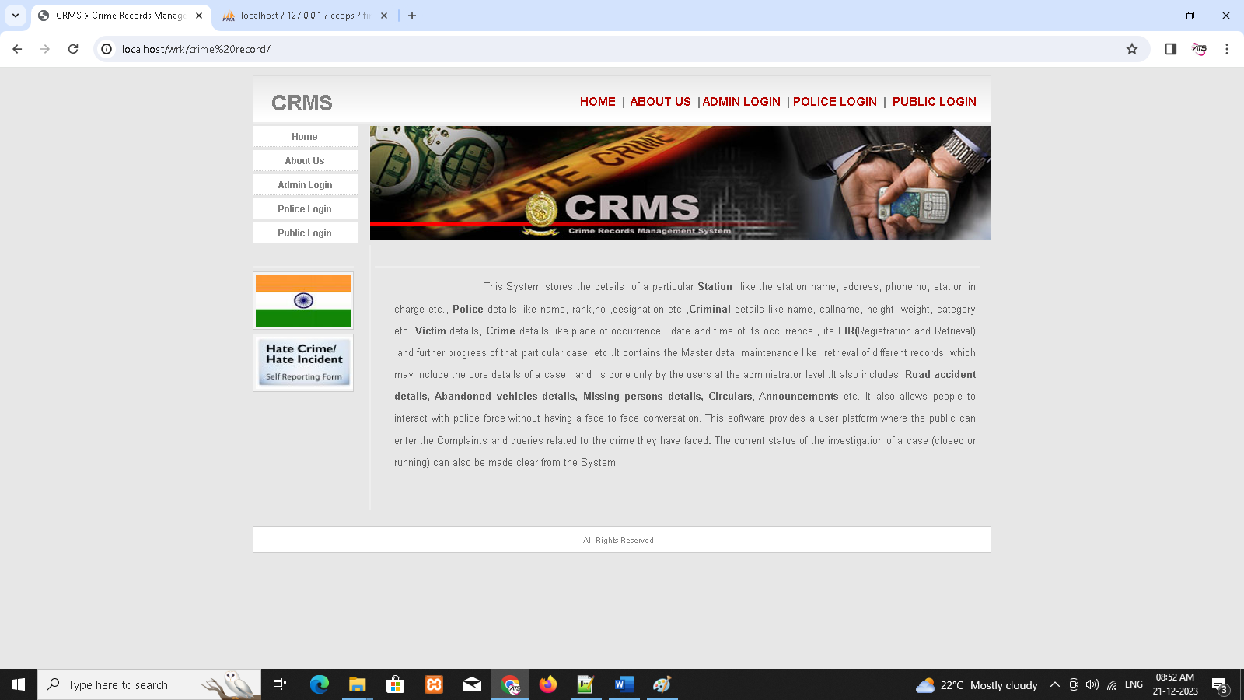

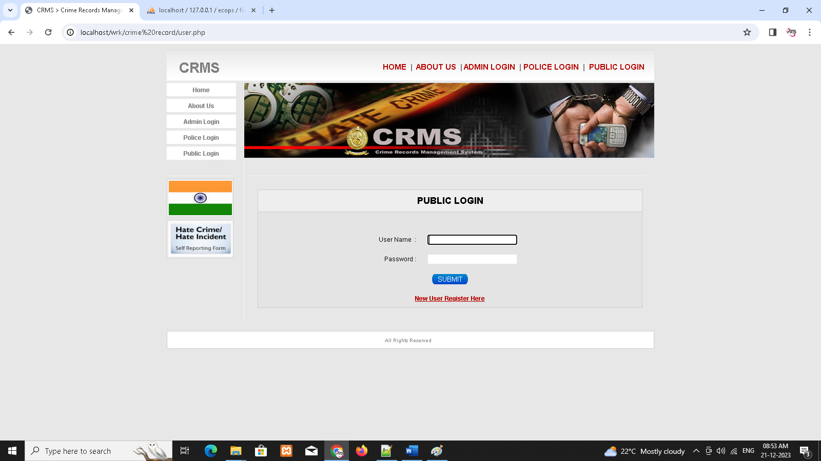

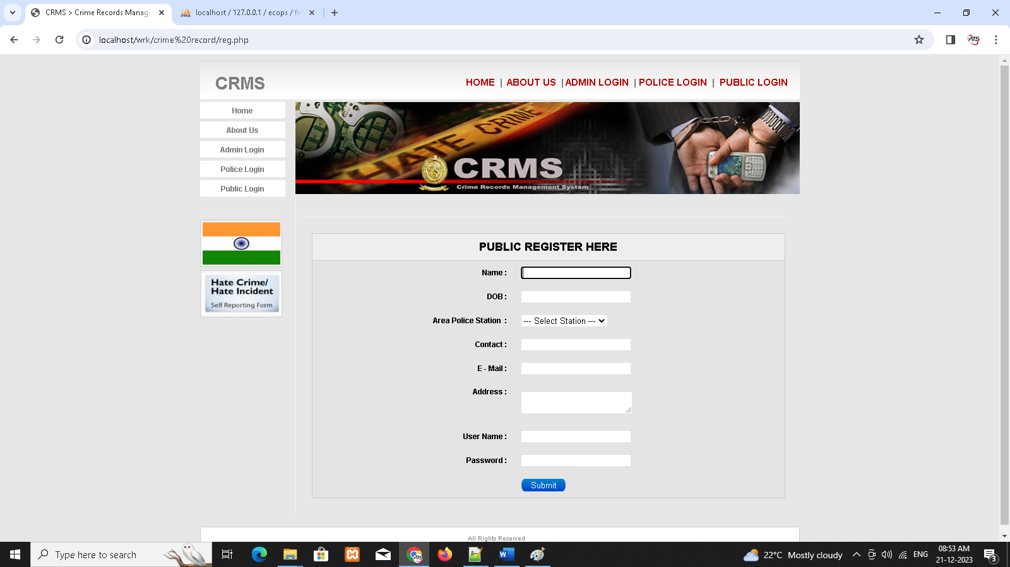

1. **SAMPLE OUTPUT**

