**Docker Commands - Creating Image Manually**

* docker run -dit openjdk:8-jdk-alpine
* docker container exec naughty_knuth ls /tmp
* docker container cp target/hello-world-rest-api.jar naughty_knuth:/tmp
* docker container exec naughty_knuth ls /tmp
* docker container commit naughty_knuth in28min/hello-world-rest-api:manual1
* docker run in28min/hello-world-rest-api:manual1
* docker container ls
* docker container commit --change='CMD ["java","-jar","/tmp/hello-world-rest-api.jar"]' naughty_knuth in28min/hello-world-rest-api:manual2
* docker run -p 8080:8080 in28min/hello-world-rest-api:manual2

**Quick Tip for Windows 10 : Use 192.168.99.100 in URL instead of localhost**

If you are using **Window 10** and are using **docker toolbox**

=> Use **192.168.99.100** instead of **localhost**.

**Note:**If **192.168.99.100** does not work, you can find the IP by using the command docker-machine ip

docker run -p 5000:5000 in28min/todo-rest-api-h2:1.0.0.RELEASE

**Dockerfile: Basic**

Describes specific instructions to execute in order to build an image

**Instructions**

* FROM openjdk:8-jdk-alpine

(base image that the container will be created in)

* ADD target/hello-world-rest-api.jar hello-world-rest-api.jar

(copies the image)

* ENTRYPOINT ["sh", "-c", "java -jar /hello-world-rest-api.jar"]

(Sets command to run at startup/instruction in the shell)

**Docker Commands - Creating Image Aumatically**

**Building an Image from a project in eclipse**

1.Build a Jar - /target/hello-world-rest-api.jar

- run as, maven build, Goals: package DskipTests / from cmd: mvn package -DskipTests

- docker build -t in28min/hello-world-rest-api:dockerfile1 .

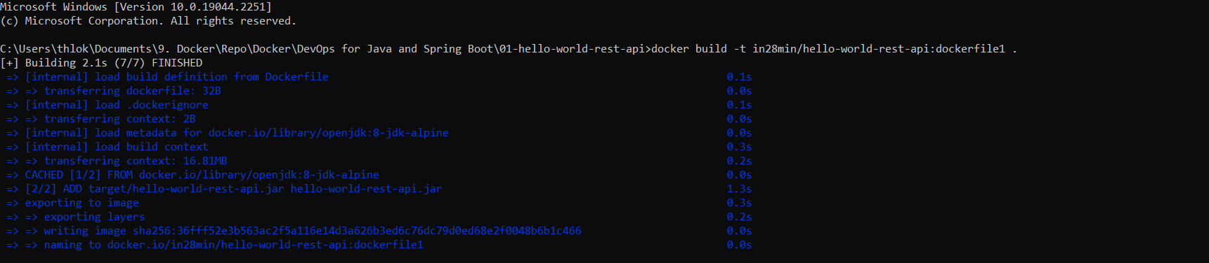

2.Setup the Prerequisites for Running the JAR - openjdk:8-jdk-alpine

3.Copy the jar

4.Run the jar

Docker run -p 8080:8080 in28min/hello-world-rest-api:dockerfile1

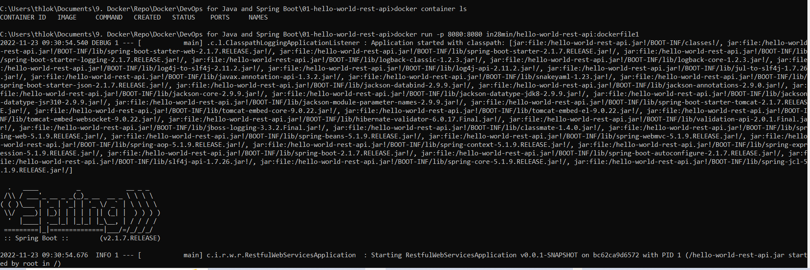

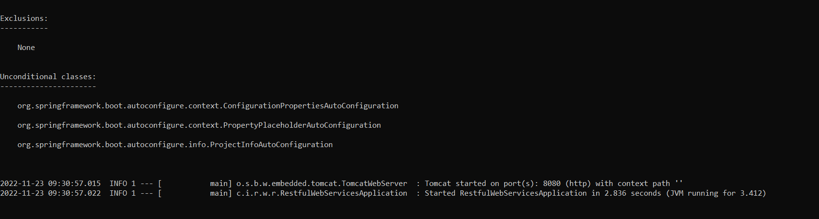

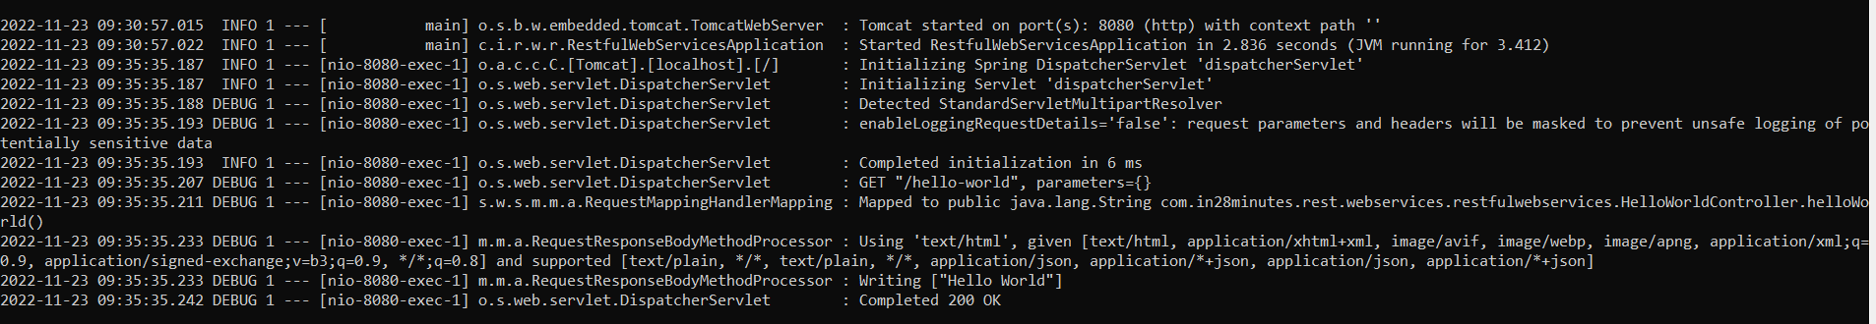

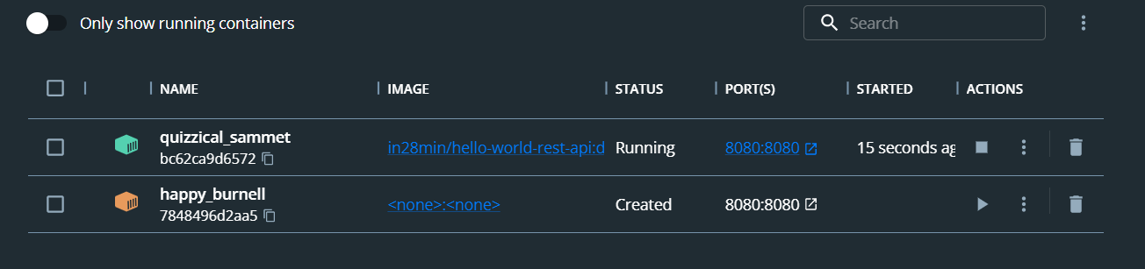

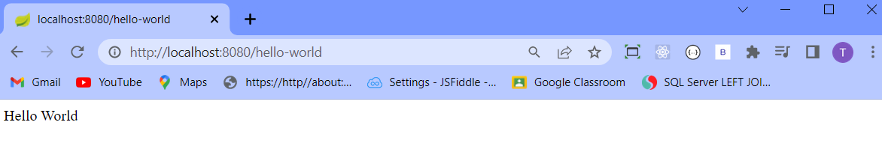

**docker history (gives history of the image)**

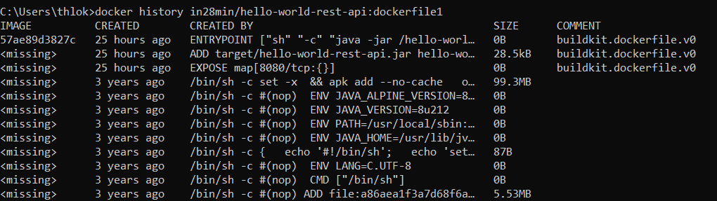

Building image using maven build in eclipse

* Maven build >> insert under Goals “package -DskipTests”

Building image in cmd

* Mvn package -DskipTests

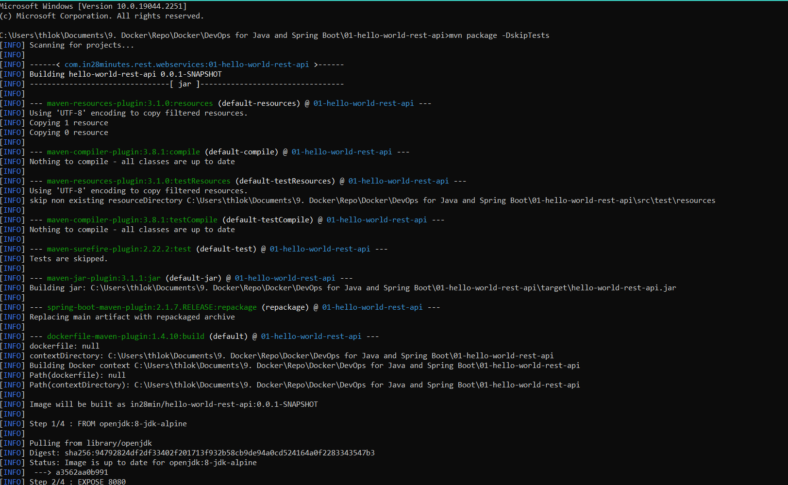

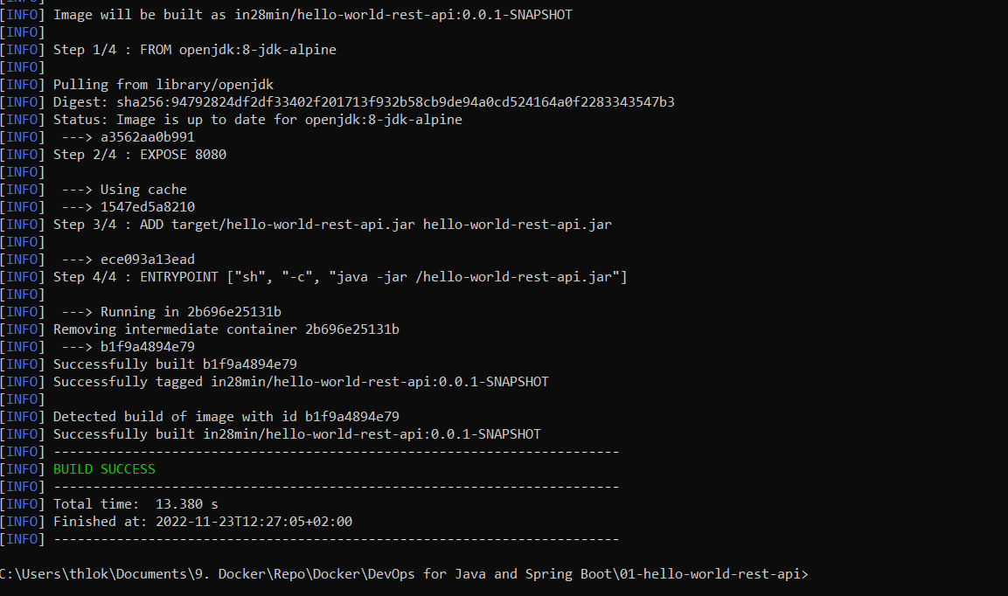

Running the image

docker run -p 8080:8080 in28min/hello-world-rest-api:0.0.1-SNAPSHOT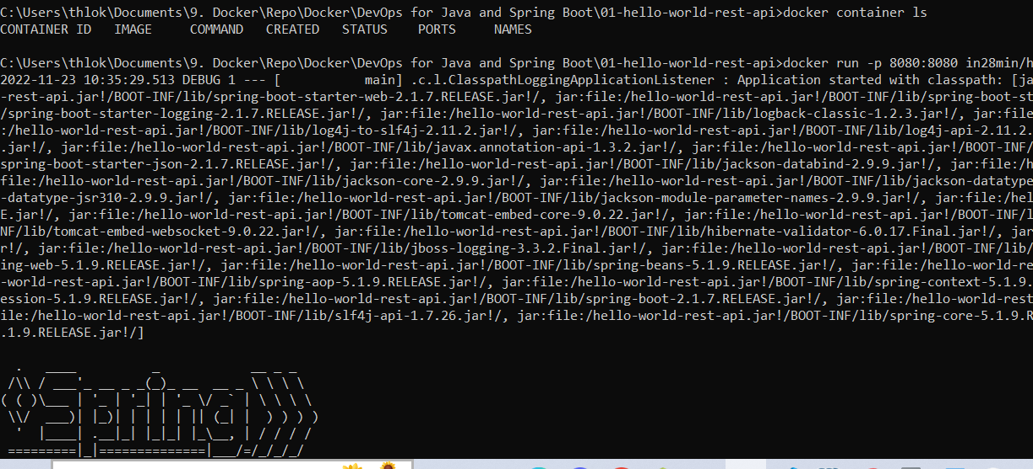

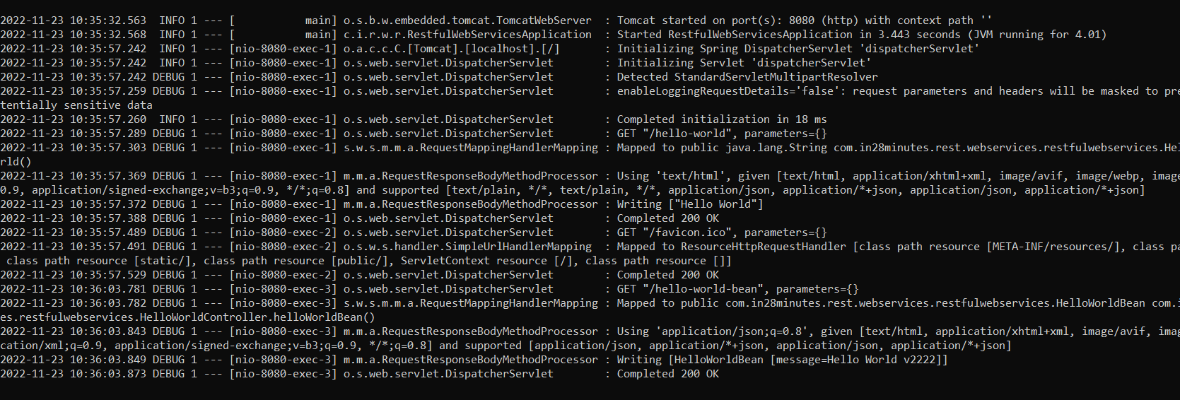

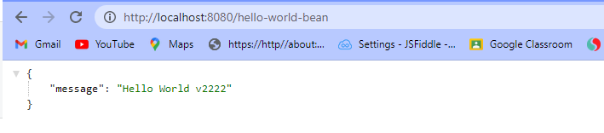

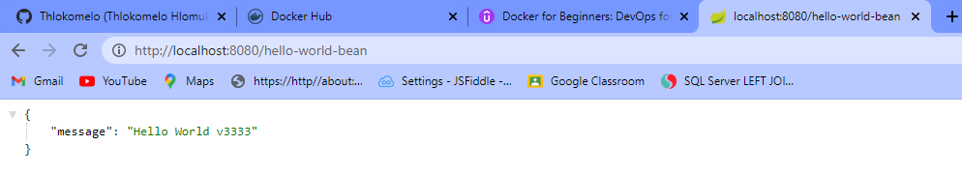

**Other ways to create images**

**Creating generic Dockerfile**

FROM openjdk:8-jdk-alpine

EXPOSE 8080

ADD target/*.jar app.jar

ENTRYPOINT ["sh", "-c", "java -jar /app.jar"]

**Run this after changing the Dockerfile and adding maven plugin**

* mvn clean package -DskipTests

**Creating Level 2 Dockerfile**

FROM openjdk:8-jdk-alpine

//(creates variable in dependency folder)

ARG DEPENDENCY=target/dependency

COPY ${DEPENDENCY}/BOOT-INF/lib /app/lib

COPY ${DEPENDENCY}/META-INF /app/META-INF

COPY ${DEPENDENCY}/BOOT-INF/classes /app

//runs the webservice using all the liabraries

ENTRYPOINT ["java","-cp","app:app/lib/*","com.in28minutes.rest.webservices.restfulwebservices.RestfulWebServicesApplication"]

**Build the image**

* Update controller class
* mvn clean package -DskipTests
* docker build -t in28min/hello-rest-api:dockerfile1 .

